MONOGRAPH
BASIC KLT-RBD PROJECT
VOLUME II
STRICT NONASSOCIATIVE PACKET REPER GEOMETRY NAPG 3.0
Controlled English Derivative - Frozen Authorial Release

Ivan Borisovich Kurpishev
Independent Researcher · Kaliningrad · 2026
CHECKPOINT. T2-EN-FREEZE-v1.0 is the immutable authorial English release of Volume II. It is issued exclusively from the accepted freeze candidate T2-EN-FC-v0.9 after final render, integrity, bilingual-audit, no-scientific-change, accessibility, and visual-QA gates.

FROZEN STATUS LOCK. truth_layer_promotion=0. Authority(T2-RU v1.0) > Authority(T2-EN). Chapters 1-24, canonical Appendices T2-A-T2-E, derivative Appendices T2-F-T2-G, 339 typed formal objects, 500 evidence obligations, 404 formula identifiers, negative results, OPEN, COND, MODEL, PHY-HYP, ABSTAIN, and the absence of independent EXT-RUN / EMP-OBS are unchanged from the accepted v0.9 candidate. Every later change requires a documented change-set and a new version. An external signed bilingual audit remains OPEN NON-VETO.

Frozen Release Passport
Field | Fixed value
Author | Ivan Borisovich Kurpishev
Project | KURPISHEV LOGIC 2 · Basic KLT-RBD Project
Volume | II · Strict Nonassociative Packet Reper Geometry NAPG 3.0
Checkpoint | T2-EN-FREEZE-v1.0
Canonical Russian source | tom2_v1_0(1).docx / tom2_v1_0(1).pdf · T2-FREEZE-v1.0
Accepted predecessor | T2-EN-FC-v0.9
Upstream English authority | T1-EN-FREEZE-v1.0
Translated scope | Chapters 1-24; Appendices T2-A-T2-E; derivative Appendices T2-F-T2-G; formulas T2-F001-T2-F404; Figures 3-63
Derivative authority | Authority(T2-RU v1.0) > Authority(T2-EN)
Mathematical status | DEF-A / THM / COND / MODEL / OPEN / FROZEN-AUTHORIAL-RELEASE; Russian source statuses preserved
Physical status | No empirical validation; EXT-RUN and EMP-OBS absent
Next checkpoint | No in-place successor; changes only through a documented change-set and a new version
AUTHORIAL ATTRIBUTION. Ivan Borisovich Kurpishev is the author of the KLT-RBD and NAPG project architecture, the authorial Desargues-Kurpishev construction, the model-form mathematical PN.2 principle, KLT algorithms, and the Reper database architecture. Classical category theory, projective geometry, cohomology, deformation theory, Hodge analysis, and related prior art remain attributed to their established authors.

Frozen Release Contract for v1.0
- The canonical formula index is synchronized as T2-F001-T2-F404 with a crosswalk to the Russian source identifiers.
- Reper, NAPG, KLT-RBD, RBD, RPD, PN.2, D/Dom, R⋆R, PredRep, EXT-RUN, and ABSTAIN remain controlled project terms.
- The symbols ⊙, ⋆_Hdg, R⋆R, Ass_⊙, δ_min, external δ, and δ_Hdg are not conflated.
- An undefined operation is not translated as a zero value. A missing arrow remains a domain failure.
- The word “duality” is qualified by its precise categorical content: representable anti-equivalence, conditional Spec_R/Gamma_R reconstruction, or another explicitly stated bridge.
- No numerical certificate is translated as an independent empirical observation.
Status in Russian source | English derivative rule
DEF-A / definition | Definition; no theorem language added.
THM / proposition / lemma | Preserved only under the source hypotheses and domain.
COND | Conditional statement; all bridge hypotheses retained.
MODEL / NUM | Model or computational result; not promoted to general theorem or experiment.
OPEN / blocker | Remains open and blocks downstream promotion.
PHY-HYP / EMP-PLAN | Physical hypothesis or empirical plan; EMP-OBS remains absent.

Static Contents and Navigation of the Frozen v1.0 Release
Chapter 1. Interface with Volume I: Subject and Method Boundaries 5
Chapter 2. Frozen Notation Registry 7
Chapter 3. The Category NAPG_q: Objects, Morphisms, and Domains 11
Chapter 4. Graded Packet Algebra and the Strict Selector 16
Chapter 5. Associator, R⋆R, Nuclei, Centers, and Invariants 24
Chapter 6. Packet-Reper Algebraic-Geometric Duality 33
Chapter 7. Atlases, Bundles, and Globalisation Obstructions 48
Chapter 8. Tangent and Cotangent Objects of NAPG 56
Chapter 9. Connections, Curvature, Holonomy, and Associator Curvature 62
Chapter 10. NAPG Differential Forms and Typed Differentials 69
Chapter 11. Hodge Operators, Codifferential, and Laplacian 74
Chapter 12. Internal Construction of C_min^bullet, delta_min, and Theta_min 78
Chapter 13. External E-Complex and the Conditional Bridge Pi_E 83
Chapter 14. Obstruction Spaces and Projective Carriers 91
Chapter 15. Hodge Decomposition and the Analytic NAPG Layer 98
Chapter 16. Deformation Functors, Moduli Spaces, and the Kuranishi Map 107
Chapter 17. Stratified Moduli Spaces, Wall Crossing, and Monodromy 116
Chapter 18. Global Derived/Stacky Moduli Spaces and the Predictive Carrier 123
Chapter 19. Virtual Cycles, Enumerative Invariants, and the Probability Firewall 130
Chapter 20. Categorified, Motivic, and Refined Virtual Invariants 138
Chapter 21. Nonlinear Evolution Semigroups, Transfer Operators, Path-Space Carriers, and Causal Kernels 147
Chapter 22. Stochastic Evolutions, Martingale Problems, Stopping Times, Control, and Causal Inference 156
Chapter 23. Large Deviations, Risk-Sensitive Semigroups, Rare-Event Geometry, and Finite-Sample Certification 166
Chapter 24. End-to-End KLT-RBD Predictive Operator, Budget Composition, and Final Falsifiability 178
Appendix T2-A. Synchronized Register of Formal Statements 191
Appendix T2-B. Complete Register of Evidence Obligations T2-PO-001-T2-PO-500 212
Appendix T2-C. Formula Index · 233; T2-D. Subject Index · 259; T2-E. Accessibility and Publication Gate · 264
Derivative Appendix T2-F. Bilingual Mathematical Audit 282
Derivative Appendix T2-G. Freeze-Candidate Record and Release Receipt 288

Chapter 1. Interface with Volume I: Subject and Method Boundaries
ONTOLOGY | The section fixes an autonomous mathematical object within the architecture of Volume II.
EPISTEMOLOGY | Its content is regarded as known only after the carrier, maps, and conditions of applicability have been specified.
PHENOMENOLOGY | Its phenomenological meaning appears through computable invariants and distinguishable regimes.
LIMITATION | No conclusion is transported beyond the declared domain without a separate bridge.
AUTHORIAL NOVELTY | Novelty is determined not by an isolated term but by its role in the packet-Reper KLT-RBD system.

1.1. Canonical Import from Volume I
Volume I v197 RU establishes the language of packet Reper logic, Reper(R,I,U;D), the projective-harmonic coordinate, PN.2 in its proved model form, and the evidential discipline of KLT-RBD. Volume II does not rewrite those foundations; it builds geometric, deformation-theoretic, analytic, and predictive layers over them.
ONTOLOGY | The section fixes an autonomous mathematical object within the architecture of Volume II.
EPISTEMOLOGY | Its content is regarded as known only after the carrier, maps, and conditions of applicability have been specified.
PHENOMENOLOGY | Its phenomenological meaning appears through computable invariants and distinguishable regimes.
LIMITATION | No conclusion is transported beyond the declared domain without a separate bridge.
AUTHORIAL NOVELTY | Novelty is determined not by an isolated term but by its role in the packet-Reper KLT-RBD system.

1.2. Subject of Volume II
The subject is not a universal theory of the future but a strict architecture of admissible structural continuations. It asks which configurations are defined, which invariants are preserved, where an obstruction occurs, which transitions are excluded within the model, and under which conditions a transition candidate may be admitted.
ONTOLOGY | The end-to-end operator exists as a composition of partial certified modules.
EPISTEMOLOGY | Its correctness is established through local soundness, interface contracts, and transport of budgets.
PHENOMENOLOGY | It appears as a set of admissible continuations carrying proof certificates.
LIMITATION | Heterogeneous errors may not be silently scalarised, and status may not be promoted according to the strongest module.
AUTHORIAL NOVELTY | The authorial contribution is a unified blocker-safe KLT-RBD predictive operator and a falsifiability matrix.

1.3. Partial Predictive Operator
The KLT-RBD predictive operator is partial: it is defined only on a certified domain. Its value is a set of admissible candidates accompanied by an evidential passport. Missing foundation is not hidden by a numerical score; it yields ABSTAIN.
ONTOLOGY | The historical layer exists as a network of sources and priorities, not as an anonymous background.
EPISTEMOLOGY | Knowledge of authorship requires separation of classical constructions from the new composition.
PHENOMENOLOGY | It appears as a precise bibliography and a dependency map of ideas.
LIMITATION | Use of prior art does not diminish the novelty of a synthesis, but it forbids reattribution of classical results.
AUTHORIAL NOVELTY | Novelty is fixed in the architecture of connection, new objects, and evidential gates.

1.4. Authorial and Classical Layers
The authorial novelty of Volume II lies in the typed connection of Reper, D/Dom, NAPG, R⋆R, the λ-selector, obstruction carriers, transition horizons, and the algorithmic contract. Categories, cohomology, Hodge theory, deformation theory, moduli, stochastic analysis, and large deviations are used as classical apparatus and are not reattributed.
ONTOLOGY | The section fixes an autonomous mathematical object within the architecture of Volume II.
EPISTEMOLOGY | Its content is regarded as known only after the carrier, maps, and conditions of applicability have been specified.
PHENOMENOLOGY | Its phenomenological meaning appears through computable invariants and distinguishable regimes.
LIMITATION | No conclusion is transported beyond the declared domain without a separate bridge.
AUTHORIAL NOVELTY | Novelty is determined not by an isolated term but by its role in the packet-Reper KLT-RBD system.

1.5. Boundary of Physical Interpretation
Mathematical impossibility within a model is not physical impossibility in general. A transition candidate is not an event. A probabilistic bound is not a causal conclusion. Export to physics, chemistry, biology, economics, or another field requires a separate adapter, data, calibration, and independent validation.
ONTOLOGY | The section fixes an autonomous mathematical object within the architecture of Volume II.
EPISTEMOLOGY | Its content is regarded as known only after the carrier, maps, and conditions of applicability have been specified.
PHENOMENOLOGY | Its phenomenological meaning appears through computable invariants and distinguishable regimes.
LIMITATION | No conclusion is transported beyond the declared domain without a separate bridge.
AUTHORIAL NOVELTY | Novelty is determined not by an isolated term but by its role in the packet-Reper KLT-RBD system.

Chapter 2. Frozen Notation Registry
Layer | Controlled meaning
ONTOLOGY | Notation is part of the mathematical object: it fixes the type, degree, and role of a symbol. Changing a sign without a collision ledger can silently replace one theory by another.
EPISTEMOLOGY | Reading a formula begins by answering four questions: where its arguments live, where the value lands, on what domain the operation is defined, and which choices affect the result.
PHENOMENOLOGY | A notational collision appears as the inability to read a diagram or composition unambiguously. Therefore the star of the associator layer and ⋆_Hdg are never treated as one operator.
BOUNDARY | The registry does not prove existence. It prohibits use of a symbol before definition and prohibits transfer of properties among internal δ_min, external δ, and δ_Hdg.

ONTOLOGY | The section fixes an autonomous mathematical object within the architecture of Volume II.
EPISTEMOLOGY | Its content is regarded as known only after the carrier, maps, and conditions of applicability have been specified.
PHENOMENOLOGY | Its phenomenological meaning appears through computable invariants and distinguishable regimes.
LIMITATION | No conclusion is transported beyond the declared domain without a separate bridge.
AUTHORIAL NOVELTY | Novelty is determined not by an isolated term but by its role in the packet-Reper KLT-RBD system.

2.1. Formal Notation Architecture

2.1.1. Basic Sorts and Types
Fix a commutative ground field 𝕂. Unless stated otherwise, the algebraic core is constructed in the category of 𝕂-vector spaces. Analytic norms, topologies, completeness, and continuity are not included automatically; they form an additional data layer. The set of degrees is denoted by Γ. In the basic case Γ=ℤ, but the proofs for the category NAPG_q use only a degree function and a compatible rule for deriving the degree of a product.
𝒜• = ⨁_{p∈Γ} 𝒜ᵖ, |x|=p for x∈𝒜ᵖ. | T2-F001

The structural data 𝔊 include admissible generators, syntactic operations, domain restrictions, the degree law χ, and, where required, Reper, D/Dom, and provenance labels. Thus the domain of an operation is part of the object rather than an editorial footnote.
Symbol | Fixed meaning | Type | Safeguard
𝕂 | commutative ground field | data object | Not replaced by ℝ without an explicit restriction.
Γ | set/semigroup of degrees | grading index | Γ=ℤ in the basic model.
𝒜• | Γ-graded 𝕂-space | carrier | A direct sum, not an unlabelled set.
⊙ | bilinear operation on declared Dom_⊙ | operation | Generally nonassociative; not the Hodge star.
Ass_⊙ | (x⊙y)⊙z−x⊙(y⊙z) | trilinear defect | Defined only when both bracketings exist.
R⋆R | authorial object of the associator-packet layer | object/notation | The star is not used for Hodge.
⋆_Hdg | Hodge operator | analytic-geometric operator | Requires a metric, orientation, and regularity.
ℛ | admissible Reper class | subspace/class | Closure conditions are stated explicitly.
F²_N | formal language of degree ≤2 | syntax vector space | Pre-evaluation; not automatically a subset of X².
X²_N | tested quadratic layer | subspace of 𝒜• or T_N | Quadratic, not the associator channel.
Ψ²_N | F²_N→X²_N | linear evaluation map | Codomain is fixed in advance.
O_B(N) | X²_N/Im Ψ²_N | obstruction quotient | Depends on the selected language F²_N.
Π_N | X²_N→O_B(N) | canonical projection | Not the external E-bridge.
C_min• | minimal internal complex | cochain complex | Concentrated in degrees 2 and 3.
δ_min | δ_min²=Ψ², δ_min³=0 | internal differential | Not conflated with external δ.
Θ_min | id_{X²_N}:X²_N→C_min³(N) | canonical internal bridge | An identity, not a physical hypothesis.
λ | cr(U,I;R,D̲) | projective coordinate | Defined away from poles and degeneracies.
δ_truth | |λ+1| | diagnostic defect | Only after choosing an absolute value/norm.
D/Dom | sufficient foundation and admissible domain | validation barrier | λ≈−1 does not replace D/Dom.

ONTOLOGY | The section fixes an autonomous mathematical object within the architecture of Volume II.
EPISTEMOLOGY | Its content is regarded as known only after the carrier, maps, and conditions of applicability have been specified.
PHENOMENOLOGY | Its phenomenological meaning appears through computable invariants and distinguishable regimes.
LIMITATION | No conclusion is transported beyond the declared domain without a separate bridge.
AUTHORIAL NOVELTY | Novelty is determined not by an isolated term but by its role in the packet-Reper KLT-RBD system.

2.1.2. Degree Law and Admissible Compositions
For homogeneous elements introduce a partial degree law χ:Dom(χ)⊆Γ×Γ→Γ. If (p,q)∈Dom(χ), an admissible product 𝒜ᵖ⊗𝒜ᑫ lands in 𝒜^{χ(p,q)}. The standard case χ(p,q)=p+q+s includes an operation of fixed degree s. Partiality of χ records impossible compositions without assigning them the artificial value zero.
⊙_{p,q}: Dom_{p,q}⊆𝒜ᵖ⊗𝒜ᑫ → 𝒜^{χ(p,q)}. | T2-F002

MEANING OF THE DIFFICULT TRANSITION. If a product is forbidden by the domain, it is not zero. Zero is a value of a defined operation; undefinedness means that no arrow exists. Conflating the two destroys the distinction between structural prohibition and actual cancellation. In the predictive method, a candidate outside Dom receives no “bad score”; it is excluded as untyped.

Lemma 2.1. Type of the associator [THM] Let x∈𝒜ᵖ, y∈𝒜ᑫ, z∈𝒜ʳ, and suppose both bracketings are defined. If χ(χ(p,q),r)=χ(p,χ(q,r))=s, then Ass_⊙(x,y,z)∈𝒜ˢ. If the branch degrees differ, their difference is not a homogeneous associator and must either be placed in a direct sum or the test must be rejected.

Proof. Each branch belongs to the component obtained by successive application of χ. A difference of two vectors lies in one homogeneous component only when the degrees agree. If they differ, it lies in their direct sum but has no single degree s. □
ONTOLOGY | The section fixes an autonomous mathematical object within the architecture of Volume II.
EPISTEMOLOGY | Its content is regarded as known only after the carrier, maps, and conditions of applicability have been specified.
PHENOMENOLOGY | Its phenomenological meaning appears through computable invariants and distinguishable regimes.
LIMITATION | No conclusion is transported beyond the declared domain without a separate bridge.
AUTHORIAL NOVELTY | Novelty is determined not by an isolated term but by its role in the packet-Reper KLT-RBD system.

2.1.3. NOTATION LEDGER Extension Protocol
- Every new notation receives a unique NTL-xxx identifier, Dom, Cod, degree, source, status, and collision list.
- A symbol already occupied in P0 is not redefined; only an indexed form with an explicit map to the canon is permitted.
- A temporary notation is marked TMP and does not enter the theorem package until the mark is removed.
- Every transition from algebraic to topological, analytic, or physical meaning is represented by a separate bridge symbol.
- In predictive formulas the word “truth” is not used as a numerical variable; λ and δ_truth are diagnostic coordinates, not substitutes for proof.
Counterexample 2.1. Collision of δ [COUNTEREXAMPLE] Let δ_min²=Ψ² in the internal two-stage complex, while δ_Hdg denotes the codifferential on forms. From δ_min³δ_min²=0 one cannot infer δ_Hdg²=0, nor conversely: the domains, degrees, and definitions differ. The same unindexed letter creates a false bridge.
Counterexample 2.2. Inhomogeneous associator [COUNTEREXAMPLE] If χ(χ(p,q),r)≠χ(p,χ(q,r)), the two branches lie in different components. The statement Ass_⊙∈𝒜ˢ with a single s is untyped even when both branches are computable.
ONTOLOGY | Only a typed structure with declared domain and codomain counts as an object.
EPISTEMOLOGY | Knowledge is obtained by checking morphisms, commutative diagrams, and admissible domains.
PHENOMENOLOGY | The structure appears as the ability to transport data correctly without loss of type.
LIMITATION | Similarity of notation neither licenses composition nor proves existence.
AUTHORIAL NOVELTY | The authorial contribution is the packet-Reper typing of NAPG and the inclusion of D/Dom in the object itself.

Chapter 3. The Category NAPG_q: Objects, Morphisms, and Domains
Layer | Controlled meaning
ONTOLOGY | The minimal object is a typed quadratic frame sufficient to construct a formal language, evaluation, and an obstruction quotient.
EPISTEMOLOGY | Objects are known through morphisms: if an obstruction class changes under an admissible relabelling or isomorphism, it is not a structural invariant of the chosen category.
PHENOMENOLOGY | Commutative diagrams reveal correct transport. Failure of two routes to agree is a specific typing or naturality error, not a metaphysical incompleteness.
BOUNDARY | NAPG_q is an internal algebraic category. It does not automatically contain manifolds, Hodge operators, connections, dynamics, or measurement procedures.

ONTOLOGY | Only a typed structure with declared domain and codomain counts as an object.
EPISTEMOLOGY | Knowledge is obtained by checking morphisms, commutative diagrams, and admissible domains.
PHENOMENOLOGY | The structure appears as the ability to transport data correctly without loss of type.
LIMITATION | Similarity of notation neither licenses composition nor proves existence.
AUTHORIAL NOVELTY | The authorial contribution is the packet-Reper typing of NAPG and the inclusion of D/Dom in the object itself.

3.1. Categorical Core

3.1.1. Object of the Category
Definition 3.1. Typed Quadratic NAPG Frame [DEF-A] An object of NAPG_q is a tuple N=(𝕂,𝒜•,⊙,𝔊,ℛ;F²_N,X²_N,Ψ²_N), where 𝕂 is a commutative field; 𝒜• is graded; ⊙ is bilinear on domains encoded by 𝔊; ℛ⊆𝒜• is an admissible class; F²_N is a vector space of admissible formal expressions of degree at most two; X²_N is the tested quadratic layer; and Ψ²_N:F²_N→X²_N is a linear evaluation map. The inclusion Im Ψ²_N⊆X²_N is built into the codomain.

X²_N = Span_𝕂{ R⊙R, R⊙S+S⊙R : R,S,R+S∈ℛ and all products are defined }. | T2-F003

O_B(N)=X²_N/Im Ψ²_N, Π_N:X²_N→O_B(N). | T2-F004

The formal language F²_N must be separated from the evaluated layer X²_N. A strict implementation may use the free 𝕂-space on typed syntax trees of height at most two and quotient by linear syntactic relations. Ψ²_N evaluates a tree in 𝒜•. Distinct languages may share the same algebra and have different O_B; hence O_B measures completeness of the selected language relative to X²_N, not “absolute nonassociativity”.
ONTOLOGY | Only a typed structure with declared domain and codomain counts as an object.
EPISTEMOLOGY | Knowledge is obtained by checking morphisms, commutative diagrams, and admissible domains.
PHENOMENOLOGY | The structure appears as the ability to transport data correctly without loss of type.
LIMITATION | Similarity of notation neither licenses composition nor proves existence.
AUTHORIAL NOVELTY | The authorial contribution is the packet-Reper typing of NAPG and the inclusion of D/Dom in the object itself.

3.1.2. Morphism and Four Compatibility Conditions
Definition 3.2. Morphism of Quadratic Frames [DEF-A] A morphism f:N→N′ is a family f=(Φ•,φ_G,φ_F,φ_X,φ_O). Here Φ•:𝒜•→𝒜′• is graded linear; φ_G transports generators, domains, and labels; φ_F:F²_N→F²_N′ transports the formal language; φ_X:X²_N→X²_N′ transports evaluated elements; and φ_O:O_B(N)→O_B(N′) is induced. The family is a morphism only when M1-M4 hold.

Code | Compatibility | Formula / requirement | Purpose
M1 | Algebra and Dom | Φ(x⊙y)=Φ(x)⊙′Φ(y) for every admissible pair; Φ(ℛ)⊆ℛ′. | Preserves the operation and does not silently enlarge the domain.
M2 | Syntax | φ_F is compatible with φ_G and substitution of Φ into expression leaves. | Prevents the formal language from changing meaning.
M3 | Evaluation | φ_X∘Ψ²_N=Ψ²_N′∘φ_F. | Commutativity of the evaluation square.
M4 | Quotient | φ_O∘Π_N=Π_N′∘φ_X. | Naturality of the obstruction class.

φ_X Ψ²_N = Ψ²_N′ φ_F, φ_O Π_N = Π_N′ φ_X. | T2-F005

ONTOLOGY | The section fixes an autonomous mathematical object within the architecture of Volume II.
EPISTEMOLOGY | Its content is regarded as known only after the carrier, maps, and conditions of applicability have been specified.
PHENOMENOLOGY | Its phenomenological meaning appears through computable invariants and distinguishable regimes.
LIMITATION | No conclusion is transported beyond the declared domain without a separate bridge.
AUTHORIAL NOVELTY | Novelty is determined not by an isolated term but by its role in the packet-Reper KLT-RBD system.

3.1.3. Well-Defined Quotient Transport
Lemma 3.1. Descent to the Quotient [THM] If M3 holds, then φ_X(Im Ψ²_N)⊆Im Ψ²_N′. Therefore φ_O([x])=[φ_X(x)] defines the unique linear map satisfying M4.

Proof. For y=Ψ²_N(a), φ_X(y)=φ_XΨ²_N(a)=Ψ²_N′φ_F(a), hence φ_X(y) lies in Im Ψ²_N′. Representatives x and x+y of one class are therefore sent to elements differing by an element of Im Ψ²_N′. Well-definedness and uniqueness follow from the universal property of the quotient. □
Theorem 3.1. Existence of the Category NAPG_q [THM] Typed quadratic frames with morphisms M1-M4 form a category. Identity morphisms have identity components; composition is componentwise and again satisfies M1-M4.

Proof. Identity maps preserve all data and make the diagrams commute. If f:N→N′ and g:N′→N″, product preservation follows for Φ_gΦ_f. Condition M3 follows from φ_X^gφ_X^fΨ_N=φ_X^gΨ_N′φ_F^f=Ψ_N″φ_F^gφ_F^f, and M4 is analogous. Associativity and unit laws are inherited from vector spaces. □
Proposition 3.2. Isomorphism Criterion [THM] A morphism f is an isomorphism in NAPG_q if Φ•, φ_G, φ_F, and φ_X are invertible and the inverse maps satisfy M1-M3. Then φ_O is automatically invertible and is induced by φ_X^{-1}.

Proof. The inverse components define f^{-1}; the quotient map is well-defined by Lemma 3.1. The compositions are identities on representatives, so φ_O^{-1}([x′])=[φ_X^{-1}(x′)]. □
ONTOLOGY | Nonassociativity is treated as intrinsic structure, not as a computational error.
EPISTEMOLOGY | It is known through the associator, nuclei, ideals, invariants, and explicit countermodels.
PHENOMENOLOGY | It appears as dependence of the result on the bracketing architecture of a packet.
LIMITATION | A nonzero associator is not by itself physical curvature or a physical event.
AUTHORIAL NOVELTY | The authorial node is R⋆R and its role in packet Reper-harmonic geometry.

3.1.4. Functors of the Internal Core
Theorem 3.3. Quadratic Obstruction Functor [THM] The assignments N↦O_B(N) and f↦φ_O define a functor O_B:NAPG_q→Vect_𝕂.

Proof. The identity morphism induces the identity on classes. For g∘f, the map [x]↦[φ_X^f(x)]↦[φ_X^gφ_X^f(x)] is precisely the quotient map of the composition. □
Theorem 3.4. Minimal Complex as a Functor [THM] Put C_min²(N)=F²_N, C_min³(N)=X²_N, all other degrees zero, δ_min²=Ψ²_N, and δ_min³=0. Then C_min•:NAPG_q→CoCh_𝕂 is a functor, and κ_N:O_B(N)→H³(C_min•(N)), κ_N([x])=[x], is a natural isomorphism.

H³(C_min•(N))=Ker δ_min³/Im δ_min²=X²_N/Im Ψ²_N=O_B(N). | T2-F006

Proof. Nilpotency follows from δ_min³=0. M3 is exactly the cochain-map condition in degree 2. The canonical identification of quotient spaces is representative-independent, and naturality holds because both routes send [x] to [φ_X(x)]. □
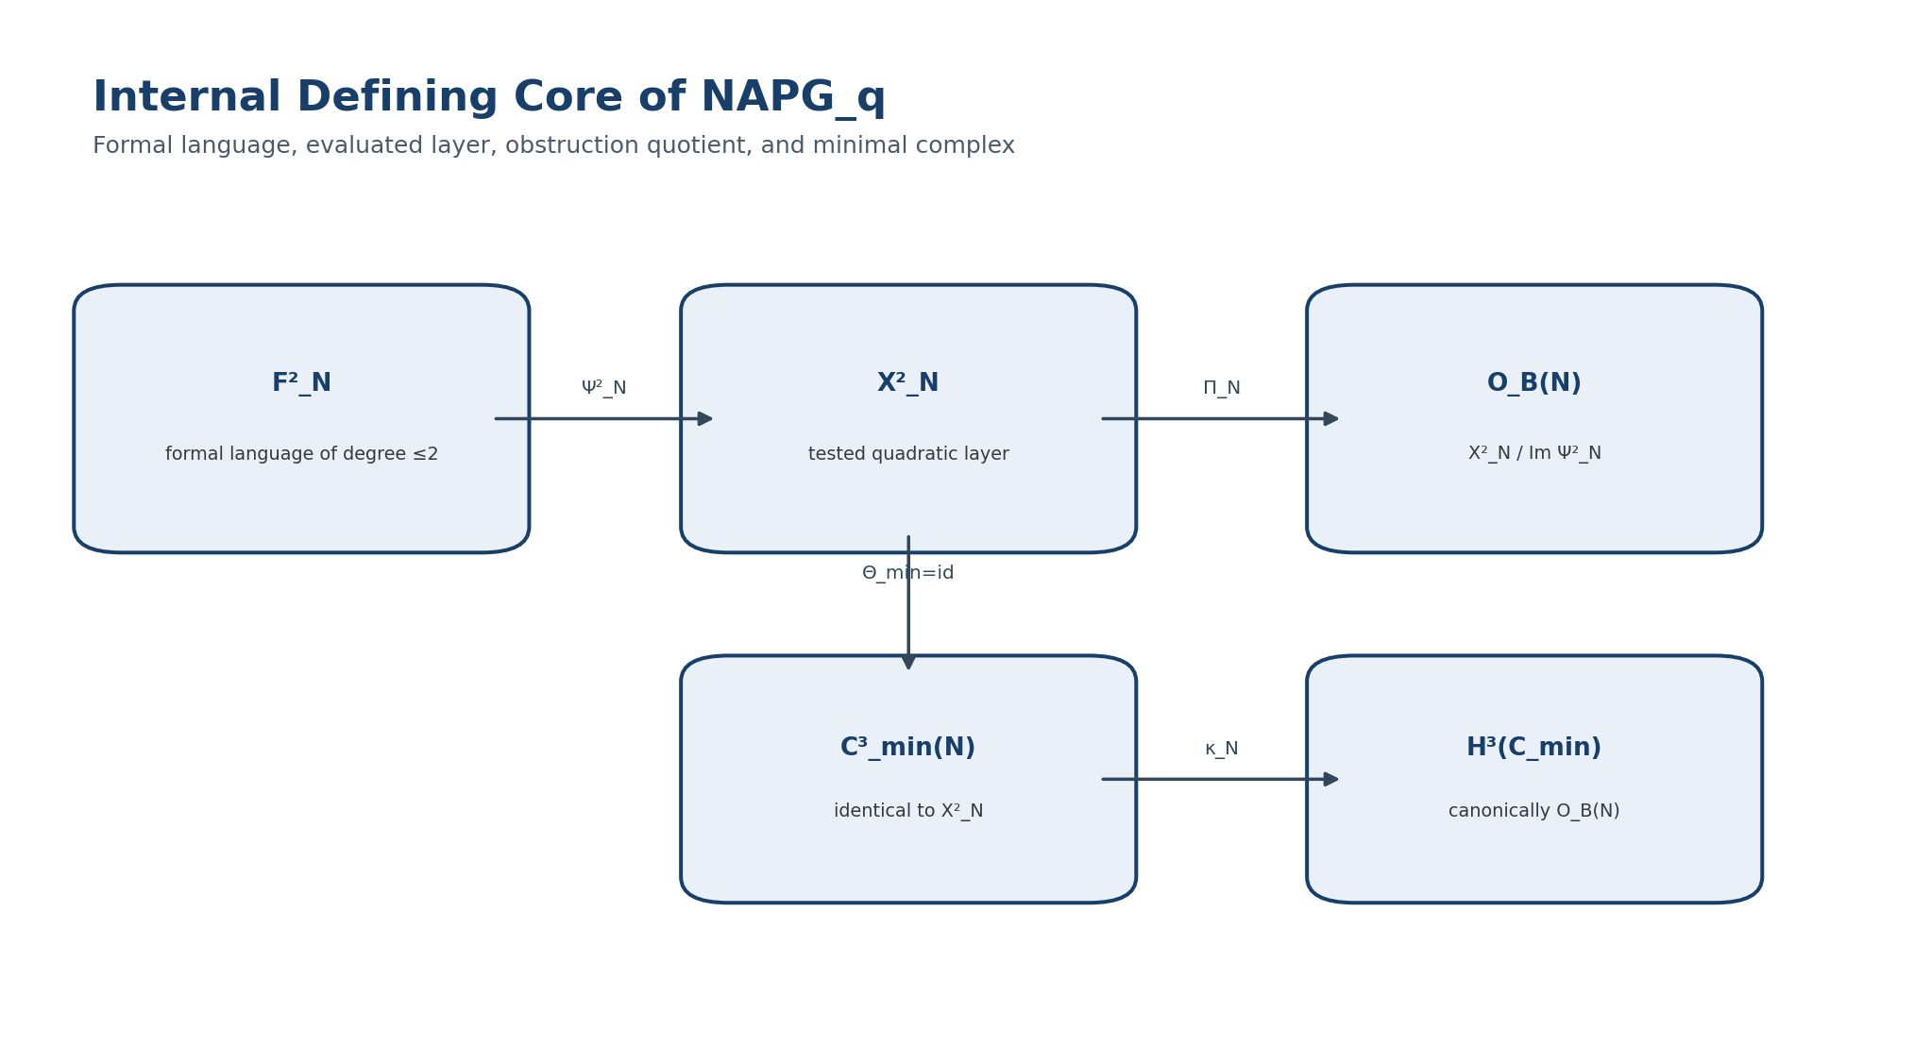
Figure 3. Internal defining core of NAPG_q and the minimal complex. English reconstruction of the authorial diagram in the frozen Russian Volume II.
ONTOLOGY | Only a typed structure with declared domain and codomain counts as an object.
EPISTEMOLOGY | Knowledge is obtained by checking morphisms, commutative diagrams, and admissible domains.
PHENOMENOLOGY | The structure appears as the ability to transport data correctly without loss of type.
LIMITATION | Similarity of notation neither licenses composition nor proves existence.
AUTHORIAL NOVELTY | The authorial contribution is the packet-Reper typing of NAPG and the inclusion of D/Dom in the object itself.

3.1.5. Countermodels to Weakened Morphisms
Counterexample 3.1. Failure of M1 [COUNTEREXAMPLE] Let 𝒜=𝕂e with e⊙e=e, 𝒜′=𝕂e′ with e′⊙′e′=0, and Φ(e)=e′. Linearity holds, but Φ(e⊙e)=e′≠0=Φ(e)⊙′Φ(e). The map does not transport the algebra and is not a NAPG_q morphism.
Counterexample 3.2. Failure of M3 [COUNTEREXAMPLE] Let F²=X²=𝕂 with Ψ=id, while Ψ′=0 in the target. Take φ_F=id and φ_X=id. Then φ_XΨ=id but Ψ′φ_F=0. A formally realisable element ceases to be formally realisable; quotient transport is not canonical.
Counterexample 3.3. Arbitrary Map of Classes [COUNTEREXAMPLE] Even when O_B(N) and O_B(N′) are isomorphic as vector spaces, an arbitrarily chosen isomorphism is not a morphism component until M4 holds. Otherwise the class is no longer the transported result of the original quadratic element.
Counterexample 3.4. Forgotten Dom [COUNTEREXAMPLE] A map Φ may preserve the product formula on the common part of two domains while sending an admissible pair to a forbidden one. Then the right-hand side of M1 is undefined. Preservation of Dom is part of the morphism, not a later check.
Counterexample 3.5. O_B Does Not Detect the Associator [COUNTEREXAMPLE] In a nonassociative algebra Ψ² can be surjective, giving O_B=0. Conversely, a poor F² can give O_B≠0 in an associative algebra. Thus O_B is not an associator functor without a separate map β_Ass.
Counterexample 3.6. Nonnatural Basis Choice [COUNTEREXAMPLE] If φ_X changes sign while a manually assigned “external” identification of classes does not, the M4 square fails. Isomorphism invariance requires a natural map, not merely one with the same name.
ONTOLOGY | A Reper exists as the quadruple R,I,U;D, not as a triad without foundation.
EPISTEMOLOGY | The harmonic coordinate is informative only together with an evidence package and a domain.
PHENOMENOLOGY | Phenomenologically, λ records the alignment of fact, idea, possibilities, and foundation.
LIMITATION | The equality λ=-1 does not replace proof, measurement, or causal identification.
AUTHORIAL NOVELTY | The authorial contribution is the strict KLT-RBD λ-gate with D/Dom and an abstention rule.

Chapter 4. Graded Packet Algebra and the Strict Selector
Layer | Controlled meaning
ONTOLOGY | The predictive Reper method acquires mathematical meaning only as a composition of invariants and barriers: projective harmony evaluates a configuration of points, D/Dom validates admissibility, and the NAPG obstruction checks internal expressibility in the selected language.
EPISTEMOLOGY | No numerical proximity produces knowledge by itself. Knowledge requires invariance, stability under admissible transport, control of poles, and an explicit abstention rule.
PHENOMENOLOGY | In data the method appears as a candidate set that narrows as measurement improves and whose structural verdict is unchanged by a projective coordinate change or a NAPG basis change.
BOUNDARY | This chapter constructs a selector of structural admissibility, not a theorem asserting the occurrence of physical events. Statistical calibration, causality, and independent validation are later layers.

ONTOLOGY | Nonassociativity is treated as intrinsic structure, not as a computational error.
EPISTEMOLOGY | It is known through the associator, nuclei, ideals, invariants, and explicit countermodels.
PHENOMENOLOGY | It appears as dependence of the result on the bracketing architecture of a packet.
LIMITATION | A nonzero associator is not by itself physical curvature or a physical event.
AUTHORIAL NOVELTY | The authorial node is R⋆R and its role in packet Reper-harmonic geometry.

4.1. Algebraic Core

4.1.1. Graded Operation and Associator
Definition 4.1. Graded Packet Algebra [DEF-A] A graded packet algebra is a tuple (𝕂,𝒜•,⊙,𝔊), where 𝒜•=⨁_{p∈Γ}𝒜ᵖ and, for every admissible pair of degrees (p,q), a bilinear map ⊙_{p,q}:Dom_{p,q}→𝒜^{χ(p,q)} is specified. The operation may be partial and need not be associative, commutative, alternative, or unital.

Ass_⊙(x,y,z)=(x⊙y)⊙z−x⊙(y⊙z). | T2-F007

Lemma 4.1. Trilinearity on a Common Domain [THM] If both bracketings are defined on a linear subspace T_Ass⊆𝒜•⊗³ and ⊙ is bilinear, then Ass_⊙:T_Ass→𝒜• is linear in formal triples and trilinear in the arguments on rectangular domain components.

Proof. Each branch is a composition of bilinear maps and is therefore trilinear on the common domain. Their difference is trilinear. □
ONTOLOGY | The differential layer exists as an operator with a domain, degree, and rule of action.
EPISTEMOLOGY | Its correctness is tested by Leibniz rules, locality, gluing, and the square of the operator.
PHENOMENOLOGY | It appears through flows of forms, compatibility defects, and differential curvature.
LIMITATION | A Leibniz rule does not imply d²=0.
AUTHORIAL NOVELTY | The authorial contribution is a typed differential firewall inside NAPG and KLT-RBD.

4.1.2. Formal Quadratic Language
Let Syn₂(N) be the set of typed syntax trees whose leaves are elements of ℛ and admissible generators of 𝔊, and whose internal vertices are linear operations and one application of ⊙. Define F²_N as the free 𝕂-space on Syn₂(N), quotiented by linear syntactic relations. This makes “formal expressions of degree at most two” mathematically reproducible.
F²_N := 𝕂[Syn₂(N)] / J_syn, Ψ²_N([t]) := eval_N(t). | T2-F008

Theorem 4.2. Quadratic Completeness Criterion [THM] For a quadratic frame N the following are equivalent: (i) every element of X²_N is evaluated from an admissible expression in F²_N; (ii) Ψ²_N is surjective; (iii) O_B(N)=0.

Proof. Condition (i) is the definition of surjectivity. The quotient X²_N/Im Ψ²_N vanishes exactly when Im Ψ²_N=X²_N. □
ONTOLOGY | A model is a concrete carrier of a definition; a counterexample is a boundary of an admissible claim.
EPISTEMOLOGY | Knowledge is produced by explicit computation rather than analogy.
PHENOMENOLOGY | It appears through the operation of formulas on a basis or parameterised family.
LIMITATION | One example does not prove universality, while one valid counterexample refutes an overstrong statement.
AUTHORIAL NOVELTY | The authorial contribution is the systematic inclusion of countermodels in KLT-RBD predictive audit.

4.1.3. Explicit Nontrivial Models
Example 4.1. Two-Dimensional Nonassociative Model [MODEL] Let 𝒜=Span_𝕂{e₁,e₂}, with e₁⊙e₁=e₂, e₂⊙e₁=e₁, and all remaining products zero. Then Ass_⊙(e₁,e₁,e₁)=e₁≠0. If ℛ=𝒜 and the quadratic language is complete, Ψ² is surjective, so O_B=0 although the associator is nonzero.

Proof. (e₁⊙e₁)⊙e₁=e₂⊙e₁=e₁, whereas e₁⊙(e₁⊙e₁)=e₁⊙e₂=0. The complete language contains every basis quadratic expression, hence its image is X². □
Example 4.2. Associative Model with a Language Obstruction [MODEL] Assume char(𝕂)≠2 and take 𝒜=𝕂[t]/(t²) with ordinary associative multiplication, ℛ=𝒜, X²=Span{1,t}, and F² chosen so that Im Ψ²=Span{1}. Then O_B≅Span{[t]}≠0 while Ass_⊙=0.

Proof. Associativity is inherited from the quotient ring. The quotient of the two-dimensional X² by the one-dimensional image has dimension one. □
ONTOLOGY | A Reper exists as the quadruple R,I,U;D, not as a triad without foundation.
EPISTEMOLOGY | The harmonic coordinate is informative only together with an evidence package and a domain.
PHENOMENOLOGY | Phenomenologically, λ records the alignment of fact, idea, possibilities, and foundation.
LIMITATION | The equality λ=-1 does not replace proof, measurement, or causal identification.
AUTHORIAL NOVELTY | The authorial contribution is the strict KLT-RBD λ-gate with D/Dom and an abstention rule.

4.1.4. Anchored Sufficient Foundation and Strict Reper
To remove the ambiguity between D as the fourth projective point and D as sufficient foundation, introduce an anchored sufficient foundation. This does not change the canonical notation (R,I,U;D), but it exposes the internal type of D.
Definition 4.2. Anchored Sufficient Foundation [DEF-A] Let L be a two-dimensional 𝕂-space, ℙ(L) its projective line, and 𝔇_Ω a class of evidence objects for domain Ω. An anchored foundation is a pair D=(d,E_D), where d∈ℙ(L) is the projective anchor and E_D∈𝔇_Ω is the evidence object. Write D̲=d and Valid_Ω(D)∈{0,1}. A typed Reper is ρ=(R,I,U;D), with R,I,U,D̲∈ℙ(L).

The projective coordinate uses D̲; evidential authorisation uses Valid_Ω(D). Thus one letter preserves the authorial semantics of sufficient foundation while the mathematical notation no longer conflates a point with a document.
ONTOLOGY | A Reper exists as the quadruple R,I,U;D, not as a triad without foundation.
EPISTEMOLOGY | The harmonic coordinate is informative only together with an evidence package and a domain.
PHENOMENOLOGY | Phenomenologically, λ records the alignment of fact, idea, possibilities, and foundation.
LIMITATION | The equality λ=-1 does not replace proof, measurement, or causal identification.
AUTHORIAL NOVELTY | The authorial contribution is the strict KLT-RBD λ-gate with D/Dom and an abstention rule.

4.1.5. Projective-Harmonic Coordinate
For nonzero representatives r,i,u,d∈L write [x,y]=det(x,y) relative to any oriented basis. The determinant ratio is independent of the scale of representatives and of the common determinant factor introduced by a basis change.
λ(ρ)=cr(U,I;R,D̲)=([u,r][i,d])/([u,d][i,r]). | T2-F009

The domain consists of quadruples with [u,d]≠0 and [i,r]≠0. This holds for pairwise distinct points. In an affine chart the formula becomes ((u−r)(i−d))/((u−d)(i−r)). The harmonic condition λ=−1 is used below under char(𝕂)≠2; characteristic 2 requires a separate formulation.
Theorem 4.3. Projective Invariance of λ [THM] For every g∈PGL(L) and every ρ in the domain, λ(gρ)=λ(ρ). In particular, λ=−1 is a projective invariant.

Proof. Choose a linear representative G∈GL(L) of g. Then det(Gx,Gy)=det(G)det(x,y). The numerator and denominator each acquire two identical factors det(G), which cancel. The scales of individual representatives cancel pairwise as well. □
Counterexample 4.1. Cross-Ratio Pole [COUNTEREXAMPLE] If U=D̲ or I=R, the denominator is zero. The numerical λ is undefined; assigning it a large value or zero is an editorial substitution for Dom.

Counterexample 4.2. Harmony without Foundation [COUNTEREXAMPLE] Four points may satisfy λ=−1 while Valid_Ω(D)=0. The projective configuration is harmonic, but the structural selector must abstain because the D/Dom barrier has not been passed.

ONTOLOGY | A Reper exists as the quadruple R,I,U;D, not as a triad without foundation.
EPISTEMOLOGY | The harmonic coordinate is informative only together with an evidence package and a domain.
PHENOMENOLOGY | Phenomenologically, λ records the alignment of fact, idea, possibilities, and foundation.
LIMITATION | The equality λ=-1 does not replace proof, measurement, or causal identification.
AUTHORIAL NOVELTY | The authorial contribution is the strict KLT-RBD λ-gate with D/Dom and an abstention rule.

4.1.6. Strict Structural Selector of the Predictive Method
Definition 4.3. Structural Selector [DEF-A] Let N∈NAPG_q, let ρ=(R,I,U;D) be a typed Reper, and let x∈X²_N be the candidate quadratic test. Define Sel_N(ρ,x)=1 exactly when: (S1) ρ∈Dom λ; (S2) Valid_Ω(D)=1; (S3) λ(ρ)=−1; and (S4) Π_N(x)=0. Otherwise Sel_N=0, while failure of S1 or missing D receives a separate ABSTAIN status rather than a negative verdict.

Sel_N(ρ,x)=1 ⇔ Dom_λ(ρ) ∧ Valid_Ω(D) ∧ λ(ρ)=−1 ∧ Π_N(x)=0. | T2-F010

The condition Π_N(x)=0 means x∈Im Ψ²_N: the selected quadratic test is reproducible in the formal language of the frame. It does not mean Ass_⊙=0 and does not prove physical realisability of the candidate.
Theorem 4.4. Double Invariance of the Selector [THM] Let g∈PGL(L), let f:N→N′ be an isomorphism in NAPG_q, and suppose evidence transport D↦gD preserves Valid_Ω. Then for every admissible (ρ,x), Sel_N(ρ,x)=Sel_N′(gρ,φ_X(x)).

Proof. S1 and S3 are preserved by projective invariance of λ. S2 is preserved by the evidence-transport hypothesis. For S4, M4 gives Π_N′(φ_Xx)=φ_O(Π_Nx). Because φ_O is an isomorphism, Π_Nx=0 exactly when Π_N′φ_Xx=0. □
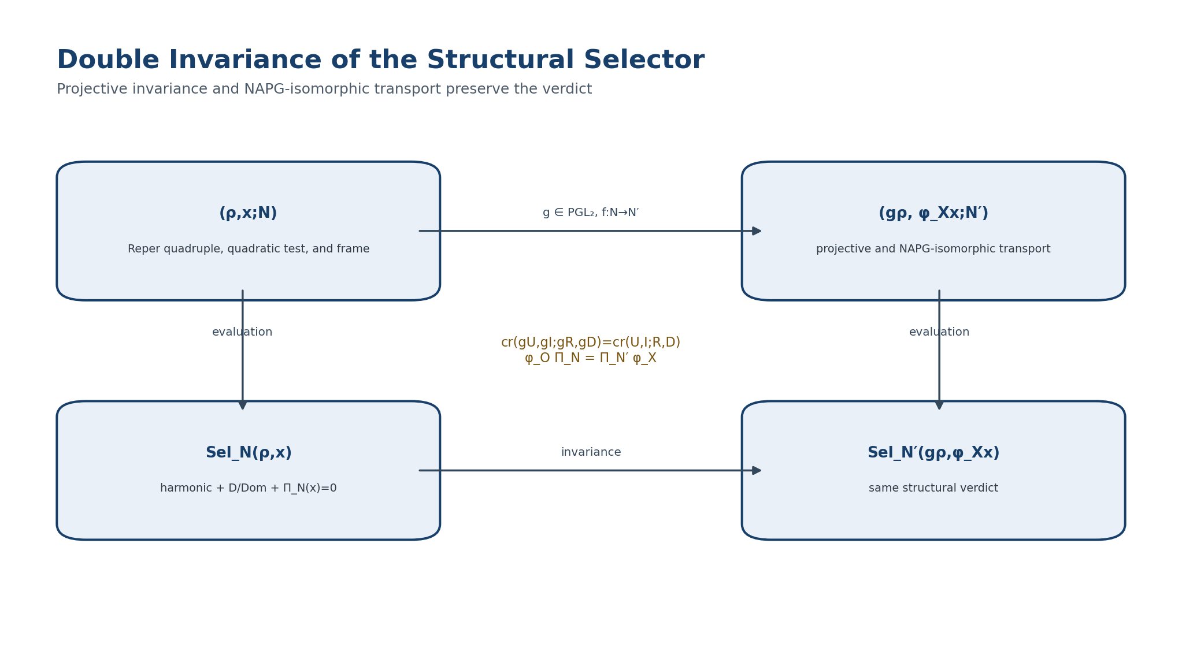
Figure 4. Double invariance of the structural selector. English reconstruction of the authorial diagram in the frozen Russian Volume II.
ONTOLOGY | A Reper exists as the quadruple R,I,U;D, not as a triad without foundation.
EPISTEMOLOGY | The harmonic coordinate is informative only together with an evidence package and a domain.
PHENOMENOLOGY | Phenomenologically, λ records the alignment of fact, idea, possibilities, and foundation.
LIMITATION | The equality λ=-1 does not replace proof, measurement, or causal identification.
AUTHORIAL NOVELTY | The authorial contribution is the strict KLT-RBD λ-gate with D/Dom and an abstention rule.

4.1.7. Approximate Harmony and Local Stability
For 𝕂=ℝ or ℂ with a fixed absolute value define δ_truth(ρ)=|λ(ρ)+1|. This defect is meaningful only inside Dom λ. For τ≥0 define the τ-harmonic sector H_τ={ρ:δ_truth(ρ)≤τ}.
δ_truth(ρ)=|λ(ρ)+1|, H_τ={ρ∈Dom λ : δ_truth(ρ)≤τ}. | T2-F011

Theorem 4.5. Local Lipschitz Stability [THM] Let Ω⊂ℝ⁴ be a compact convex set of affine coordinates (u,i,r,d) such that |u−d|≥m>0 and |i−r|≥m>0. Then there is a finite L_Ω with |δ_truth(q)−δ_truth(q′)|≤L_Ω‖q−q′‖ for all q,q′∈Ω whose connecting segment stays inside the domain.

Proof. The rational function λ is smooth where its denominator is nonzero. Its gradient is bounded on compact Ω: L_Ω:=sup_{q∈Ω}‖∇λ(q)‖<∞. The mean-value theorem gives |λ(q)−λ(q′)|≤L_Ω‖q−q′‖, and ||a+1|−|b+1||≤|a−b| completes the proof. □
STABILITY LIMITATION. L_Ω may grow sharply near the poles u=d or i=r. Therefore small numerical noise does not imply a small λ error without an explicit estimate of distance to the degenerate set. The KLT software layer requires a separate pole margin, not δ_truth alone.

ONTOLOGY | A Reper exists as the quadruple R,I,U;D, not as a triad without foundation.
EPISTEMOLOGY | The harmonic coordinate is informative only together with an evidence package and a domain.
PHENOMENOLOGY | Phenomenologically, λ records the alignment of fact, idea, possibilities, and foundation.
LIMITATION | The equality λ=-1 does not replace proof, measurement, or causal identification.
AUTHORIAL NOVELTY | The authorial contribution is the strict KLT-RBD λ-gate with D/Dom and an abstention rule.

4.1.8. Interval Reper and the Abstention Rule
Definition 4.4. Interval Image of λ [DEF-A] Let B⊂Dom λ be the set of all quadruples compatible with input uncertainty. Define Λ(B)={λ(q):q∈B}. A candidate is τ-certified if sup_{z∈Λ(B)}|z+1|≤τ and inf_{q∈B}|u−d||i−r|>0. If B intersects a pole, the status is ABSTAIN_POLE.

Lemma 4.2. Monotonicity under Refinement [THM] If B′⊆B, then Λ(B′)⊆Λ(B). Hence sup_{Λ(B′)}|z+1| does not exceed the corresponding bound for B.

Proof. The image of a subset is contained in the image of the containing set. Supremum is monotone under inclusion. □
ONTOLOGY | The section fixes an autonomous mathematical object within the architecture of Volume II.
EPISTEMOLOGY | Its content is regarded as known only after the carrier, maps, and conditions of applicability have been specified.
PHENOMENOLOGY | Its phenomenological meaning appears through computable invariants and distinguishable regimes.
LIMITATION | No conclusion is transported beyond the declared domain without a separate bridge.
AUTHORIAL NOVELTY | Novelty is determined not by an isolated term but by its role in the packet-Reper KLT-RBD system.

4.1.9. Set of Structurally Admissible Candidates
Let Cand(y) be the set of state or event candidates generated by observation y. Associate to every c a Reper ρ_c, a quadratic test x_c∈X²_N, and an evidence foundation D_c. Define exact and robust sets of structural admissibility.
C₀(y;N)={c∈Cand(y): Sel_N(ρ_c,x_c)=1}. | T2-F012

C_{τ,η}(y;N)={c: Valid(D_c), δ_truth(ρ_c)≤τ, dist(x_c,Im Ψ²_N)≤η}. | T2-F013

The formula containing dist requires a norm on X²_N and therefore has MODEL status until an analytic layer has been selected. C₀ is purely algebraic. If C₀ is empty, the method need not choose the “least bad” outcome; ABSTAIN correctly reports insufficiency of the current language, domain, or foundation.
Corollary 4.1. Coordinate Independence of the Exact Candidate Set [THM] Under the hypotheses of Theorem 4.4, an isomorphism of candidates c↦c′ induces a bijection C₀(y;N)≅C₀(gy;N′).

Proof. Membership of each candidate is preserved by Theorem 4.4, and invertibility of g and f gives the inverse correspondence. □
ONTOLOGY | The section fixes an autonomous mathematical object within the architecture of Volume II.
EPISTEMOLOGY | Its content is regarded as known only after the carrier, maps, and conditions of applicability have been specified.
PHENOMENOLOGY | Its phenomenological meaning appears through computable invariants and distinguishable regimes.
LIMITATION | No conclusion is transported beyond the declared domain without a separate bridge.
AUTHORIAL NOVELTY | Novelty is determined not by an isolated term but by its role in the packet-Reper KLT-RBD system.

4.1.10. Negative Results and Forbidden Shortcuts
Counterexample 4.3. λ≈−1 Does Not Give Truth Status [COUNTEREXAMPLE] Let δ_truth be small while D is invalid or the candidate is outside the subject-domain. Numerical proximity remains, but Sel=ABSTAIN. Any automatic rule “small δ_truth ⇒ true” violates S2.

Counterexample 4.4. O_B=0 Does Not Give Physics [COUNTEREXAMPLE] The minimal complex and O_B are defined for a finite-dimensional formal algebra without topology, time, or observables. A zero class reports only quadratic expressibility in the selected language.

Counterexample 4.5. The Associator Does Not Automatically Live in X² [COUNTEREXAMPLE] Ass_⊙ depends on three arguments and two bracketings, while X² is built from quadratic expressions. Without β_Ass:T_Ass→X² the formula Π(Ass_⊙)=0 is untyped.

Counterexample 4.6. Instability at a Pole [COUNTEREXAMPLE] A sequence of quadruples may converge to U=D̲ while λ becomes unbounded. Thus there is no global Lipschitz constant over the whole affine domain.

Counterexample 4.7. Narrowing Candidates Is Not Causal Prediction [COUNTEREXAMPLE] Even if C₀(y;N) contains one element, this proves uniqueness only inside the selected formal language and domain, not causal occurrence of the event in the external world.

4.2. Bibliographic Synchronisation
This checkpoint uses classical sources as prior art and does not attribute categories, cross-ratio, quotient spaces, or general deformation theory to the project. The authorial contribution is their typed assembly into NAPG_q, anchored sufficient foundation, the structural selector, and the D/Dom evidential discipline.
[S1] Eilenberg, S.; Mac Lane, S. General Theory of Natural Equivalences. Transactions of the AMS 58 (1945), 231-294. DOI 10.1090/S0002-9947-1945-0013131-6.
[S2] Mac Lane, S. Categories for the Working Mathematician. 2nd ed. Springer. DOI 10.1007/978-1-4757-4721-8.
[S3] Gerstenhaber, M. On the Deformation of Rings and Algebras. Annals of Mathematics 79 (1964), 59-103. DOI 10.2307/1970484.
[S4] Veblen, O.; Young, J. W. Projective Geometry. Vol. I. Ginn, 1910.
[S5] Kurpishev, I. B. Basic KLT-RBD Project. Volume I. Edition v197 RU. §§26.5, 52.9-52.18. 2026.
[S6] Kurpishev, I. B. Reper-Projective Architecture of Formula Chains: PILOT-01. 2026.
[S7] Kurpishev, I. B. Kurpishev’s Theory of Stratified Time: Associator Rigidity and Nonassociative Packet Geometry. Canonical SIGMA corpus of the project, 2026.

Chapter 5. Associator, R⋆R, Nuclei, Centers, and Invariants
EPISTEMOLOGICAL BLOCK. Observation of a single diagonal of a multilinear object inevitably loses information. For the associator this is decisive: an alternative algebra may have Ass(x,x,x)=0 for every x and still be essentially nonassociative. Knowledge must retain the channel type, argument order, and admissible domain in addition to the value.

ONTOLOGY | Nonassociativity is treated as intrinsic structure, not as a computational error.
EPISTEMOLOGY | It is known through the associator, nuclei, ideals, invariants, and explicit countermodels.
PHENOMENOLOGY | It appears as dependence of the result on the bracketing architecture of a packet.
LIMITATION | A nonzero associator is not by itself physical curvature or a physical event.
AUTHORIAL NOVELTY | The authorial node is R⋆R and its role in packet Reper-harmonic geometry.

5.1. Associator and Invariant Core

5.1.1. Typed Domain of the Associator
Definition 5.1. Domain of the Associator [DEF-A] Let (𝒜,⊙) be a packet algebra with a possibly partial operation. Dom_Ass consists of triples (a,b,c) for which a⊙b, b⊙c, (a⊙b)⊙c, and a⊙(b⊙c) are all defined. On Dom_Ass set Ass_⊙(a,b,c)=(a⊙b)⊙c−a⊙(b⊙c).

Dom_Ass = {(a,b,c): (a,b),(b,c),(a⊙b,c),(a,b⊙c) ∈ Dom_⊙}.

Lemma 5.2. Trilinearity on the Full Domain [THM] If ⊙ is an everywhere-defined 𝕂-bilinear operation, then Ass_⊙:𝒜⊗𝒜⊗𝒜→𝒜 is 𝕂-linear.

Proof. Each term is a composition of bilinear maps and is therefore trilinear; their difference is trilinear. □
For a partial operation, trilinearity is asserted only on compatible linear slices of Dom_Ass. Extending it beyond the domain by formal analogy is prohibited.
ONTOLOGY | Nonassociativity is treated as intrinsic structure, not as a computational error.
EPISTEMOLOGY | It is known through the associator, nuclei, ideals, invariants, and explicit countermodels.
PHENOMENOLOGY | It appears as dependence of the result on the bracketing architecture of a packet.
LIMITATION | A nonzero associator is not by itself physical curvature or a physical event.
AUTHORIAL NOVELTY | The authorial node is R⋆R and its role in packet Reper-harmonic geometry.

5.1.2. Left, Middle, and Right Nuclei
Definition 5.3. Three Nuclei and the Nucleus [DEF-A] For an everywhere-defined algebra 𝒜 define N_l={a:Ass(a,x,y)=0 for all x,y}, N_m={a:Ass(x,a,y)=0 for all x,y}, and N_r={a:Ass(x,y,a)=0 for all x,y}. The full nucleus is N(𝒜)=N_l∩N_m∩N_r.

N_l = ker L_Ass, N_m = ker M_Ass, N_r = ker R_Ass,

L_Ass(a)(x,y)=Ass(a,x,y), M_Ass(a)(x,y)=Ass(x,a,y), R_Ass(a)(x,y)=Ass(x,y,a).

Proposition 5.4. Linearity of the Nuclei [THM] If 𝒜 is a bilinear algebra, then N_l, N_m, N_r, and N(𝒜) are linear subspaces.

Proof. L_Ass, M_Ass, and R_Ass are linear in the distinguished argument. Their kernels are subspaces, and an intersection of subspaces is a subspace. □
Definition 5.5. Commutant and Center [DEF-A] The commutant C_comm(𝒜) consists of z satisfying z⊙x=x⊙z for every x. The center is Z(𝒜)=N(𝒜)∩C_comm(𝒜).

PHENOMENOLOGICAL BLOCK. A central element does more than “not disturb” multiplication. It is insensitive both to permutation and to a change of bracketing. The center therefore defines a stable layer relative to which different packet-assembly routes agree.

ONTOLOGY | Nonassociativity is treated as intrinsic structure, not as a computational error.
EPISTEMOLOGY | It is known through the associator, nuclei, ideals, invariants, and explicit countermodels.
PHENOMENOLOGY | It appears as dependence of the result on the bracketing architecture of a packet.
LIMITATION | A nonzero associator is not by itself physical curvature or a physical event.
AUTHORIAL NOVELTY | The authorial node is R⋆R and its role in packet Reper-harmonic geometry.

5.1.3. Associator Ideal and Universal Associative Reflection
Definition 5.6. Associator Ideal [DEF-A] J_Ass(𝒜) is the least two-sided ideal of 𝒜 containing all values Ass_⊙(a,b,c). The internal KLT-RBD notation Rad_Ass(𝒜):=J_Ass(𝒜) is permitted, but it is not identified with the Jacobson radical or another classical radical.

Theorem 5.7. Universal Associative Reflection [THM] For every everywhere-defined bilinear algebra 𝒜, the quotient 𝒜_as:=𝒜/J_Ass(𝒜) is associative. Moreover, every homomorphism f:𝒜→B into an associative algebra B factors uniquely through q:𝒜→𝒜_as.

Proof. Every associator has zero image in the quotient, so the quotient multiplication is associative. If B is associative, then f(Ass(a,b,c))=Ass(fa,fb,fc)=0; hence J_Ass⊆ker f. The universal property of the quotient gives a unique f̄ with f=f̄∘q. □
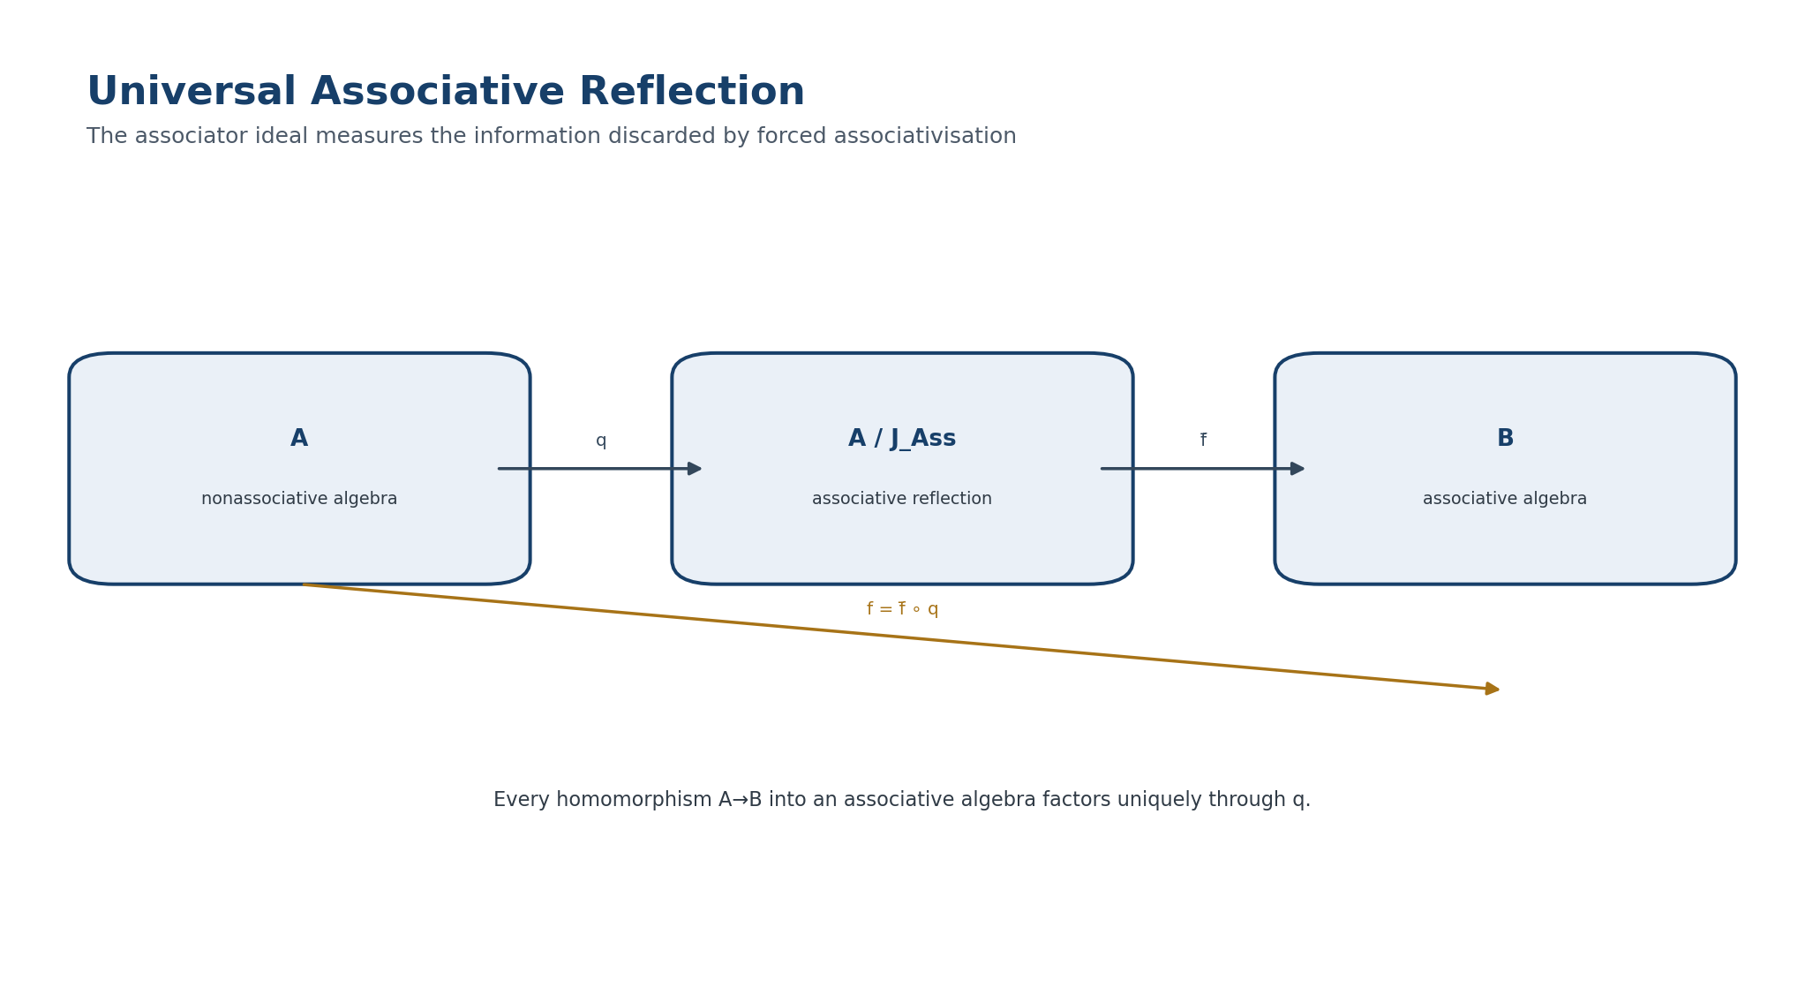
Figure 5. Universal associative reflection. English reconstruction of the authorial diagram in the frozen Russian Volume II.
The reflection gives a strict measure of information loss under forced associativisation. If J_Ass=0, the algebra is already associative; if J_Ass=𝒜, the associative reflection is zero.
ONTOLOGY | The section fixes an autonomous mathematical object within the architecture of Volume II.
EPISTEMOLOGY | Its content is regarded as known only after the carrier, maps, and conditions of applicability have been specified.
PHENOMENOLOGY | Its phenomenological meaning appears through computable invariants and distinguishable regimes.
LIMITATION | No conclusion is transported beyond the declared domain without a separate bridge.
AUTHORIAL NOVELTY | Novelty is determined not by an isolated term but by its role in the packet-Reper KLT-RBD system.

5.1.4. No Universal Diagonal-Quadratic Encoding
Theorem 5.8. Degree No-Go [THM] There is no nonzero homogeneous quadratic map Q:𝒜→W that, functorially for every bilinear algebra and every x, coincides with the diagonal associator Ass(x,x,x).

Proof. For a scalar t, Q(tx)=t²Q(x), while Ass(tx,tx,tx)=t³Ass(x,x,x). Over a field with more than two elements, equality for every t is possible only when Ass(x,x,x)=0. Thus a general cubic diagonal channel is not quadratic. □
Theorem 5.9. Even the Cubic Diagonal Is Insufficient [THM] In general the map q_Ass(x)=Ass(x,x,x) does not determine the full trilinear associator.

Proof. In an alternative algebra the associator is alternating, so Ass(x,x,x)=0 for every x. The real octonions are nonassociative and have nonzero values on triples of distinct units. Hence q_Ass≡0 does not imply Ass≡0. □
LIMITATION. The symbol R⋆R cannot mean one number or one diagonal quadratic form capable of recovering arbitrary nonassociativity. A complete certificate needs several polarised channels and a separate alternating component.

ONTOLOGY | Nonassociativity is treated as intrinsic structure, not as a computational error.
EPISTEMOLOGY | It is known through the associator, nuclei, ideals, invariants, and explicit countermodels.
PHENOMENOLOGY | It appears as dependence of the result on the bracketing architecture of a packet.
LIMITATION | A nonzero associator is not by itself physical curvature or a physical event.
AUTHORIAL NOVELTY | The authorial node is R⋆R and its role in packet Reper-harmonic geometry.

5.1.5. Quadratic-Alternating R⋆R Certificate
Definition 5.10. Three Quadratic Pencils [DEF-A] For the trilinear tensor T=Ass_⊙ define Q₁₂(c;x)=T(x,x,c), Q₁₃(b;x)=T(x,b,x), and Q₂₃(a;x)=T(a,x,x). If char 𝕂≠2, their polarisations recover the symmetrisations of T in the corresponding pairs of slots.

S₁₂T(x,y,c) = ½[Q₁₂(c;x+y)−Q₁₂(c;x)−Q₁₂(c;y)] = ½[T(x,y,c)+T(y,x,c)],

S₁₃T(x,b,y) = ½[T(x,b,y)+T(y,b,x)],

S₂₃T(a,x,y) = ½[T(a,x,y)+T(a,y,x)].

Definition 5.11. Alternating Component [DEF-A] If char 𝕂≠2,3, set Alt(T)=(1/6)Σ_{σ∈S₃}sgn(σ)·T∘σ.

Theorem 5.12. Completeness of the Quadratic-Alternating Certificate [THM] If char 𝕂≠2,3, the map T↦(S₁₂T,S₁₃T,S₂₃T,Alt(T)) is injective. Therefore the three polarised quadratic pencils together with Alt(T) determine T uniquely.

Proof. Assume all four components vanish. The equations S_ijT=0 say that T changes sign under each transposition of the corresponding slots, so T is alternating. For an alternating T, Alt(T)=T; the hypothesis Alt(T)=0 therefore gives T=0. □
Definition 5.13. Strict Realisation of R⋆R [DEF-A] For an admissible Reper layer ℛ⊆𝒜 define R⋆R as the certificate (Dom_Ass|ℛ³, Q₁₂, Q₁₃, Q₂₃, Alt(Ass), J_Ass, Prof_Ass). This is neither a new multiplication nor a Hodge operator; the star is reserved for the associator-packet layer.

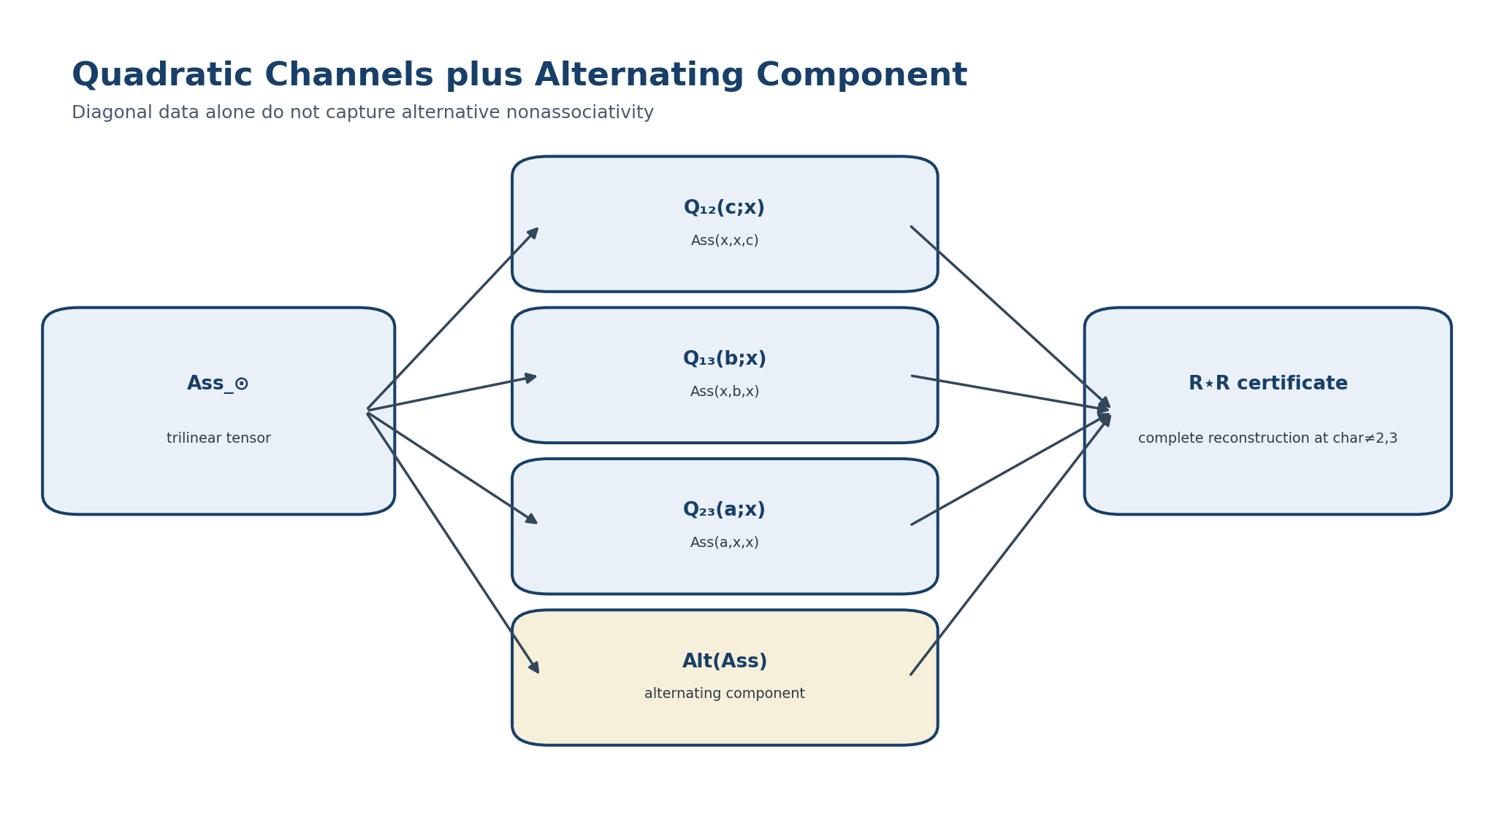
Figure 6. Full R⋆R certificate: quadratic channels and the alternating component. English reconstruction of the authorial diagram in the frozen Russian Volume II.
ONTOLOGY | A model is a concrete carrier of a definition; a counterexample is a boundary of an admissible claim.
EPISTEMOLOGY | Knowledge is produced by explicit computation rather than analogy.
PHENOMENOLOGY | It appears through the operation of formulas on a basis or parameterised family.
LIMITATION | One example does not prove universality, while one valid counterexample refutes an overstrong statement.
AUTHORIAL NOVELTY | The authorial contribution is the systematic inclusion of countermodels in KLT-RBD predictive audit.

5.1.6. Explicit Models and Counterexamples
Model 𝒜₂. Let 𝒜₂=span{u,v} and define u⊙u=u, u⊙v=v, v⊙u=0, v⊙v=u.
⊙ | u | v
u | u | v
v | 0 | u

Ass(v,u,v)=−u, Ass(v,v,u)=u, Ass(v,v,v)=v.

Proposition 5.14. Profile of Model 𝒜₂ [THM] For 𝒜₂, N_l=𝕂u, N_m=0, N_r=0, N=0, Z=0, and J_Ass=𝒜₂.

Proof. Direct computation on basis triples gives the displayed associators. The nucleus conditions reduce to a linear system: the left nucleus is generated by u, while the middle and right nuclei are trivial. The values Ass(v,v,u)=u and Ass(v,v,v)=v span the algebra, so J_Ass=𝒜₂. □
Model M₂. For the matrix algebra M₂(𝕂), the associator is identically zero, all three nuclei are M₂(𝕂), J_Ass=0, and the center consists of scalar matrices.
Model 𝕆. In the real octonions choose the oriented cycles (123), (145), (176), (246), (257), (347), (365). Then
Ass(e₁,e₂,e₄) = (e₁e₂)e₄ − e₁(e₂e₄) = e₇ − (−e₇) = 2e₇ ≠ 0,

while alternativity gives Ass(x,x,y)=Ass(y,x,x)=0 and in particular Ass(x,x,x)=0. This is a certificate against diagonal recovery.
Model | rank Ass | N_l/N_m/N_r | Z | J_Ass | Role
M₂(𝕂) | 0 | whole algebra | 𝕂·I | 0 | associative zero control
𝒜₂ | >0 | 1 / 0 / 0 | 0 | 𝒜₂ | explicit complete collapse of the associative reflection
𝕆 | >0 | 𝕂 / 𝕂 / 𝕂 | 𝕂 | not fixed here | counterexample to diagonal encoding

ONTOLOGY | Nonassociativity is treated as intrinsic structure, not as a computational error.
EPISTEMOLOGY | It is known through the associator, nuclei, ideals, invariants, and explicit countermodels.
PHENOMENOLOGY | It appears as dependence of the result on the bracketing architecture of a packet.
LIMITATION | A nonzero associator is not by itself physical curvature or a physical event.
AUTHORIAL NOVELTY | The authorial node is R⋆R and its role in packet Reper-harmonic geometry.

5.1.7. Associator Invariant Profile
Definition 5.15. Basic Profile [DEF-A] For a finite-dimensional algebra define Prof_Ass(𝒜)=(n,r_Ass,n_l,n_m,n_r,n_N,n_Z), where n=dim𝒜, r_Ass=rank(Ass:𝒜^{⊗3}→𝒜), and the remaining coordinates are the dimensions of the three nuclei, their intersection, and the center. An extended profile additionally records dim J_Ass and the ranks of selected quadratic channels.

Theorem 5.16. Isomorphism Invariance of the Profile [THM] If Φ:𝒜→ℬ is an algebra isomorphism, then Prof_Ass(𝒜)=Prof_Ass(ℬ).

Proof. The identity Φ(Ass_𝒜(a,b,c))=Ass_ℬ(Φa,Φb,Φc) gives conjugate structural maps. Ranks are preserved, and Φ bijectively transports N_l,N_m,N_r,N, and Z. □
Definition 5.17. Profile Pseudodistance [DEF-A] For weights w_j≥0 set d_prof(𝒜,ℬ)=Σ_j w_j|p_j(𝒜)−p_j(ℬ)|. This is a coarse isomorphism-invariant diagnostic, not a complete classifier: d_prof=0 need not imply isomorphism.

ONTOLOGY | The section fixes an autonomous mathematical object within the architecture of Volume II.
EPISTEMOLOGY | Its content is regarded as known only after the carrier, maps, and conditions of applicability have been specified.
PHENOMENOLOGY | Its phenomenological meaning appears through computable invariants and distinguishable regimes.
LIMITATION | No conclusion is transported beyond the declared domain without a separate bridge.
AUTHORIAL NOVELTY | Novelty is determined not by an isolated term but by its role in the packet-Reper KLT-RBD system.

5.1.8. Determinantal Horizon of Structural Transitions
ONTOLOGICAL BLOCK. A structural change need not be visible in individual coefficients. It becomes mathematically detectable when a tensor rank or the dimension of a nucleus or center changes. Such changes are not arbitrary: they are localised by zeros of determinants.

Definition 5.18. Polynomial Family of Algebras [DEF-A] Let V be n-dimensional, T an irreducible algebraic parameter variety, and μ_t∈Hom(V⊗V,V) have structure constants polynomial in t. Let A_t, L_t, M_t, R_t, and C_t be the matrices of the associator, the three nucleus maps, and the commutator channel.

Definition 5.19. Determinantal Horizon [DEF-A] Δ_NAPG is the union of determinantal loci where the rank of at least one of A_t,L_t,M_t,R_t, the block nucleus matrix N_t=(L_t,M_t,R_t), or the block center matrix Z_t=(L_t,M_t,R_t,C_t) is below its generic rank on a nonempty open subset of T.

Theorem 5.20. Localisation of Structural Transitions [THM] On the nonempty Zariski-open set T°=T∖Δ_NAPG, the basic profile Prof_Ass(𝒜_t) is constant. In particular, along a continuous path γ contained in one connected component of T°, the profile does not change. Any change of profile requires crossing Δ_NAPG.

Proof. The matrix entries are polynomial in t. The condition rank≤r is defined by vanishing of all minors of order r+1. Each matrix reaches its generic rank on a nonempty Zariski-open set. After removing the union of the corresponding determinantal loci, all ranks are constant. The dimensions of the nuclei and center are n minus the ranks of the relevant linear or block maps; hence all profile coordinates are constant. □
Corollary 5.21. Negative Prediction Theorem [THM] If γ([t₀,t₁])∩Δ_NAPG=∅, then a change of the basic associator profile is excluded throughout the interval within the model.

Proof. This is immediate from Theorem 5.20. The claim is exact inside the specified family μ_t and does not automatically transfer to physical systems. □
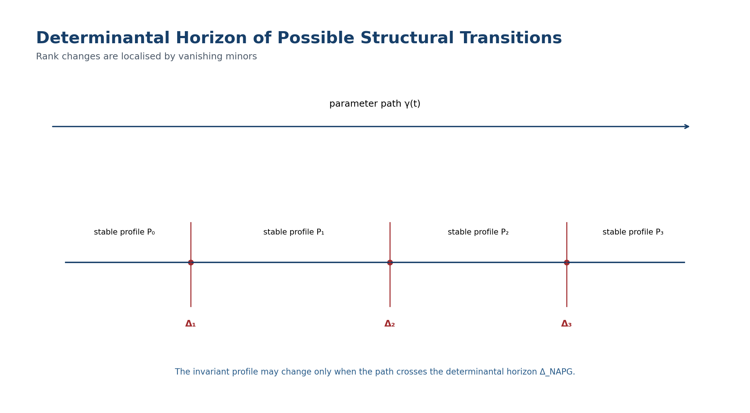
Figure 7. Determinantal horizon of possible structural transitions. English reconstruction of the authorial diagram in the frozen Russian Volume II.
ONTOLOGY | A Reper exists as the quadruple R,I,U;D, not as a triad without foundation.
EPISTEMOLOGY | The harmonic coordinate is informative only together with an evidence package and a domain.
PHENOMENOLOGY | Phenomenologically, λ records the alignment of fact, idea, possibilities, and foundation.
LIMITATION | The equality λ=-1 does not replace proof, measurement, or causal identification.
AUTHORIAL NOVELTY | The authorial contribution is the strict KLT-RBD λ-gate with D/Dom and an abstention rule.

5.1.9. Projective-Harmonic Localisation of Candidates
Definition 5.22. Predictive Horizon along a Path [DEF-A] For an observed parameter t₀ and a path γ:[t₀,t₁]→T, set Hor_Ass(γ)=γ^{-1}(Δ_NAPG). This is the set of parameter times at which a structural transition is not excluded by the determinantal theorem.

Definition 5.23. Harmonic Transition Candidate [DEF-A] Compactify the parameter line to P¹(𝕂), and let ρ=(r,i,u;d) be a Reper with u∈Δ_NAPG. The candidate is harmonic if λ(u,i;r,d)=−1, Valid(D)=1, ρ∈Dom_λ, and the minor certificate is reproducible.

Cand_H = {ρ : u∈Δ_NAPG, λ(ρ)=−1, Valid(D)=1, Cert_det(u)=PASS}.

Level | Condition | Permitted conclusion
Algebraic locus | u∈Δ_NAPG | a structural transition is not excluded
Harmonic candidate | u∈Δ_NAPG and λ=−1 with D/Dom | coordinate-invariant candidate for testing
Certified transition | one-sided profiles differ and computations are reproducible | the profile changes in the specified model
Physical event | independent data and operationalisation | only after a separate external protocol

Theorem 5.24. Projective Invariance of a Harmonic Candidate [THM] Under a projective change of coordinate on the parameter line, λ=−1 is preserved and the determinantal locus is transported by the family isomorphism. Thus Cand_H is invariant under a compatible projective reparameterisation and transport of D.

Proof. Cross-ratio is projectively invariant. Under isomorphic transport, the structural matrices are conjugated by invertible matrices, so their ranks and determinantal loci are preserved. Valid(D) is transported under the separate evidence-equivalence hypothesis. □
LIMITATION. Harmony λ=−1 does not create a transition. It marks a projectively invariant relation among four already defined points. A positive conclusion requires the simultaneous determinantal, domain, evidence, and reproducible-computation conditions.

ONTOLOGY | A computational object exists only together with inputs, an algorithm, and a reproducible certificate.
EPISTEMOLOGY | Knowledge is supported by repeatability, exact tests, and control of numerical conditioning.
PHENOMENOLOGY | It appears as agreement between expected and computed invariants.
LIMITATION | A successful run proves neither a universal theorem nor an empirical claim.
AUTHORIAL NOVELTY | The authorial contribution is a proof-carrying computational circuit within KLT-RBD.

5.1.10. Computational Certificate
For a basis e₁,…,e_n and structure constants μ(e_i,e_j)=Σ_k c^k_{ij}e_k, the certificate performs the following sequence:
Step | Operation | Check
C1 | construct the matrix Ass:V^{⊗3}→V | exact coefficients or controlled arithmetic
C2 | construct L_Ass,M_Ass,R_Ass,C_comm | agreement with the chosen basis order
C3 | compute ranks and kernels | exact values and kernel bases
C4 | construct J_Ass by I_{k+1}=I_k+VI_k+I_kV | stabilisation within at most n strict increases
C5 | check Q₁₂,Q₁₃,Q₂₃ and Alt(Ass) | reconstruction of Ass when char≠2,3
C6 | for μ_t compute maximal minors | obtain Δ_NAPG and control polynomials
C7 | check λ, D/Dom, and source hashes | do not merge algebraic and physical statuses

Proposition 5.25. Finiteness of the Construction of J_Ass [THM] In an n-dimensional algebra, the increasing chain I₀⊆I₁⊆… with I₀=span Im Ass and I_{k+1}=I_k+𝒜I_k+I_k𝒜 stabilises after at most n strict increases; its limit is J_Ass.

Proof. Every strict inclusion increases the dimension by at least one, while the dimension is bounded by n. A stable subspace contains Im Ass and is closed under multiplication on the left and right, so it is the required least two-sided ideal. □

5.2. Bibliographic Synchronisation
[1] Schafer, R. D. Structure and Representation of Nonassociative Algebras. Bulletin of the American Mathematical Society 61 (1955), 469-484.
[2] Baez, J. C. The Octonions. Bulletin of the American Mathematical Society 39 (2002), 145-205; arXiv:math/0105155.
[3] Glassman, N. D. Cohomologicaly of Nonassociative Algebras. Pacific Journal of Mathematics 33 (1970), 617-631.
[4] Salzmann, H. et al. The Role of Nonassociative Algebra in Projective Geometry. Graduate Studies in Mathematics 159, AMS, 2014.
[5] Kaygorodov, I. Non-associative Algebraic Structures: Classification and Structure. arXiv:2306.00425, revised 2023.
[6] Kurpishev, I. B. Volume I v197 RU and T2-RP-v0.2: canonical internal sources of this edition.
Classical definitions of the associator, nuclei, center, alternativity, and octonions are prior art. The authorial contribution of this layer is the strict R⋆R certificate, its connection to D/Dom and the λ-selector, the KLT-RBD associator profile, and the determinantal horizon for predictive exclusion.

Chapter 6. Packet-Reper Algebraic-Geometric Duality
ONTOLOGY | The historical layer exists as a network of sources and priorities rather than an anonymous background.
EPISTEMOLOGY | Knowledge of authorship requires separation of classical constructions from the new composition.
PHENOMENOLOGY | It appears as a precise bibliography and a dependency map of ideas.
LIMITATION | Use of prior art does not reduce the novelty of synthesis but prohibits reattribution of classical results.
AUTHORIAL NOVELTY | Novelty is fixed in the architecture of connection, new objects, and evidential gates.

6.1. Duality Core

6.1.1. Boundary between Prior Art and the Authorial Construction
Classical mathematics contains several inequivalent paradigms of duality: anti-equivalence between commutative rings and affine schemes; recovery of a compact space from a commutative C*-algebra; correspondence between vector bundles and finitely generated projective modules; and reconstruction of an object from its Hom functor. This chapter neither renames those results nor claims them as authorial.
The authorial construction of Volume II is their disciplined transport into NAPG: a representable functor of packet-Reper points, a reconstruction defect, a projective Reper atlas, coordination of algebraic and geometric determinantal horizons, and a blocker-safe rule for predictive transport.
Classical line | Imported principle | What is not transported automatically
Affine schemes | Contravariance of Spec and recovery from global sections on the affine layer. | A noncommutative or nonassociative algebra has no canonical scheme spectrum without an additional construction.
Gelfand-Naimark | Recovery of a space from a function algebra. | The C*-topology, positivity, and involution are absent from the general NAPG core.
Serre-Swan | Relation between local bundle geometry and projective modules. | An arbitrary NAPG module is not automatically a vector bundle.
Yoneda | Full faithfulness of the representable Hom functor. | A representable functor is not automatically an ordinary topological space.

ONTOLOGY | Algebraic and geometric carriers are distinct representations of structure.
EPISTEMOLOGY | Their correspondence is established only through functors, unit/counit maps, and reconstruction defects.
PHENOMENOLOGY | Duality appears as mutual recovery of invariants.
LIMITATION | A static anti-equivalence creates neither dynamics nor causality.
AUTHORIAL NOVELTY | The authorial contribution is Reper duality with explicit control of losses in D, Dom, and predictive status.

6.1.2. Two Different Dualities
Definition 6.1. Representable Duality [DEF-A] Let 𝒞=NAPG_q^fin be a small category of finite-dimensional NAPG_q objects with the four compatibility conditions of Chapter 3. For A∈Ob(𝒞), define the covariant functor of points h_A:𝒞→Set by h_A(T)=Hom_𝒞(A,T). A morphism f:A→B induces h_f:h_B→h_A by precomposition h_f(T)(g)=g∘f. Thus A↦h_A is contravariant from algebras to geometric functors.

h_A : 𝒞 → Set, h_A(T)=Hom_𝒞(A,T).

Definition 6.2. Spatial Duality [DEF-A] Spatial duality requires another category Geo_R whose objects possess a carrier, local charts, a structure sheaf, packet-Reper data, and gluing rules. It is given by contravariant functors Spec_R and Gamma_R and does not follow merely from the existence of h_A.

Spec_R : Alg_R → Geo_R^op, Gamma_R : Geo_R^op → Alg_R.

Restriction on the word “duality” | Meaning
Prohibition 1 | Full faithfulness of a functorial description does not imply an ordinary set of points with a topology.
Prohibition 2 | Coincidence of character sets does not imply isomorphism of algebras.
Prohibition 3 | Existence of an adjoint pair does not imply that unit and counit are isomorphisms.
Prohibition 4 | Anti-equivalence of static categories does not define a law of evolution for a parameter.

ONTOLOGY | Algebraic and geometric carriers are distinct representations of structure.
EPISTEMOLOGY | Their correspondence is established only through functors, unit/counit maps, and reconstruction defects.
PHENOMENOLOGY | Duality appears as mutual recovery of invariants.
LIMITATION | A static anti-equivalence creates neither dynamics nor causality.
AUTHORIAL NOVELTY | The authorial contribution is Reper duality with explicit control of losses in D, Dom, and predictive status.

6.2. Yoneda-Safe Representable Duality
ONTOLOGY | The section fixes an autonomous mathematical object within the architecture of Volume II.
EPISTEMOLOGY | Its content is regarded as known only after the carrier, maps, and conditions of applicability have been specified.
PHENOMENOLOGY | Its phenomenological meaning appears through computable invariants and distinguishable regimes.
LIMITATION | No conclusion is transported beyond the declared domain without a separate bridge.
AUTHORIAL NOVELTY | Novelty is determined not by an isolated term but by its role in the packet-Reper KLT-RBD system.

6.2.1. Full-Faithfulness Theorem
Theorem 6.3. Yoneda-Safe Anti-Equivalence [THM] The functor Spec_Y:𝒞^op→Set^𝒞 defined by Spec_Y(A)=h_A is full and faithful. Its essential image Aff_NAPG^rep is the category of representable NAPG geometries, and Spec_Y defines an anti-equivalence 𝒞^op≃Aff_NAPG^rep.

𝒞^op ≃ Aff_NAPG^rep.

Proof. For A,B∈𝒞, Yoneda gives a natural bijection Nat(h_B,h_A)≅Hom_𝒞(A,B), compatible with identities and composition. Hence Spec_Y is full and faithful; restriction to its essential image is an equivalence. □
This result is unconditional within the selected small category. It requires no prime spectrum, maximal ideals, norm, topology, or associativity. Its cleanliness is precisely why no stronger claim may be silently attached to it.
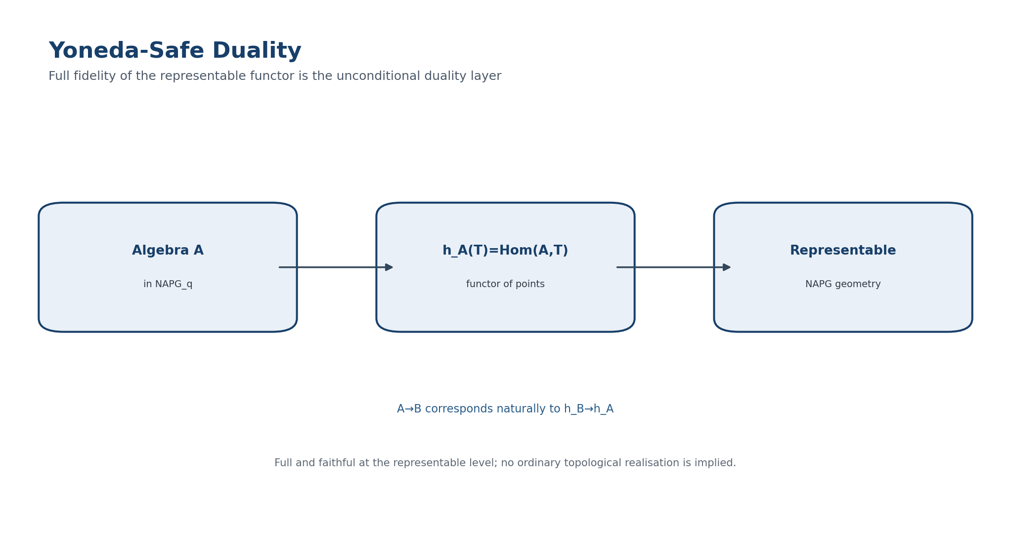
Figure 8. Yoneda-safe representable duality for NAPG_q. English reconstruction of the authorial diagram in the frozen Russian Volume II.
ONTOLOGY | The section fixes an autonomous mathematical object within the architecture of Volume II.
EPISTEMOLOGY | Its content is regarded as known only after the carrier, maps, and conditions of applicability have been specified.
PHENOMENOLOGY | Its phenomenological meaning appears through computable invariants and distinguishable regimes.
LIMITATION | No conclusion is transported beyond the declared domain without a separate bridge.
AUTHORIAL NOVELTY | Novelty is determined not by an isolated term but by its role in the packet-Reper KLT-RBD system.

6.2.2. Reper Configuration Functor
Definition 6.4. Rep_A(T) [DEF-A] For a test object T set Rep_A(T)={(r,i,u,d)∈h_A(T)^4:Adm_T(r,i,u,d)=1, Valid_T(D)=1}. The four entries are morphisms A→T; Adm_T checks domain admissibility, distinctness, and absence of poles, while Valid_T(D) checks the evidence package. Rep_A is a subfunctor of h_A^4 when admissibility and sufficient foundation are preserved by all test morphisms.

Rep_A(T) = { (r,i,u,d) ∈ h_A(T)^4 : Adm_T(r,i,u,d)=1, Valid_T(D)=1 }.

Proposition 6.5. Functoriality of Reper Configurations [THM] If s:T→T′ preserves Adm and Valid(D), then (r,i,u,d)↦(s∘r,s∘i,s∘u,s∘d) defines Rep_A(T)→Rep_A(T′). Identities and composition hold componentwise, so Rep_A:𝒞→Set is a functor.

Corollary 6.6. Isomorphism Invariance [THM] An isomorphism A≅B induces a natural isomorphism Rep_B≅Rep_A. Therefore representable Reper geometry is independent of the chosen isomorphic algebraic presentation.

ONTOLOGY | Algebraic and geometric carriers are distinct representations of structure.
EPISTEMOLOGY | Their correspondence is established only through functors, unit/counit maps, and reconstruction defects.
PHENOMENOLOGY | Duality appears as mutual recovery of invariants.
LIMITATION | A static anti-equivalence creates neither dynamics nor causality.
AUTHORIAL NOVELTY | The authorial contribution is Reper duality with explicit control of losses in D, Dom, and predictive status.

6.3. Conditional Pair Spec_R / Gamma_R
ONTOLOGY | The section fixes an autonomous mathematical object within the architecture of Volume II.
EPISTEMOLOGY | Its content is regarded as known only after the carrier, maps, and conditions of applicability have been specified.
PHENOMENOLOGY | Its phenomenological meaning appears through computable invariants and distinguishable regimes.
LIMITATION | No conclusion is transported beyond the declared domain without a separate bridge.
AUTHORIAL NOVELTY | Novelty is determined not by an isolated term but by its role in the packet-Reper KLT-RBD system.

6.3.1. Adjunction and Reconstruction Maps
Hypothesis 6.7. Spatial Realisation [COND] Assume a category Geo_R and functors Spec_R,Gamma_R with a natural bijection Hom_Geo_R(X,Spec_R A)≅Hom_Alg_R(A,Gamma_R X). This is an adjunction Spec_R⊣Gamma_R between Alg_R and Geo_R^op. It has a unit η_A:A→Gamma_R Spec_R(A) and a geometrically written counit ε̄_X:X→Spec_R Gamma_R(X).

Hom_Geo_R(X, Spec_R A) ≅ Hom_Alg_R(A, Gamma_R X).

η_A : A → Gamma_R Spec_R(A), ε̄_X : X → Spec_R Gamma_R(X).

Existence of these maps is not asserted for all NAPG objects without a specification of spectrum, sheaf, and admissible localisations. The checkpoint records an exact proof obligation rather than making it disappear rhetorically.
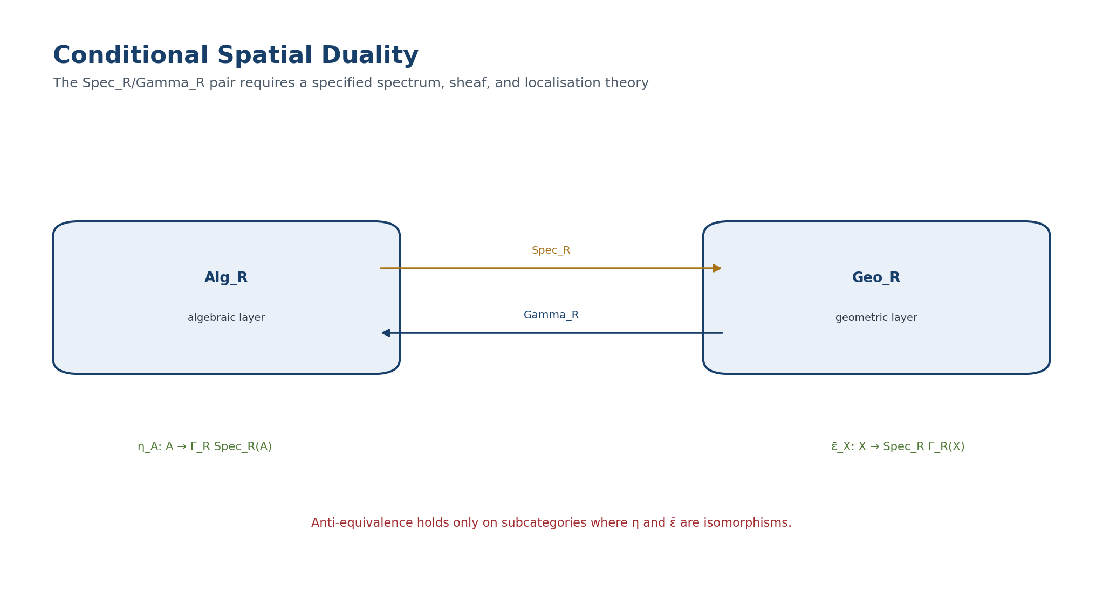
Figure 9. Conditional Spec_R/Gamma_R pair and reconstruction maps. English reconstruction of the authorial diagram in the frozen Russian Volume II.
ONTOLOGY | Algebraic and geometric carriers are distinct representations of structure.
EPISTEMOLOGY | Their correspondence is established only through functors, unit/counit maps, and reconstruction defects.
PHENOMENOLOGY | Duality appears as mutual recovery of invariants.
LIMITATION | A static anti-equivalence creates neither dynamics nor causality.
AUTHORIAL NOVELTY | The authorial contribution is Reper duality with explicit control of losses in D, Dom, and predictive status.

6.3.2. Reconstruction Defects
Definition 6.8. Algebraic Defect [DEF-A] For finite-dimensional A define K_rec(A)=ker(η_A), Q_rec(A)=coker(η_A), and def_alg(A)=dim K_rec(A)+dim Q_rec(A). In a nonadditive category use the Boolean defect def_alg(A)=0 when η_A is an isomorphism and 1 otherwise.

K_rec(A)=ker(η_A), Q_rec(A)=coker(η_A), def_alg(A)=dim K_rec(A)+dim Q_rec(A).

Definition 6.9. Geometric Defect [DEF-A] Set def_geo(X)=0 if ε̄_X is an isomorphism in Geo_R and def_geo(X)=1 otherwise. A finite-dimensional coordinate model may refine this by ranks of maps on local coordinates and structure sheaves. Set def_rec(A,X)=def_alg(A)+def_geo(X).

def_rec(A,X)=def_alg(A)+def_geo(X).

Zero reconstruction defect is necessary for transport of a strict predictive status. A nonzero defect does not refute either object; it forbids identification of its algebraic and geometric versions.
ONTOLOGY | Algebraic and geometric carriers are distinct representations of structure.
EPISTEMOLOGY | Their correspondence is established only through functors, unit/counit maps, and reconstruction defects.
PHENOMENOLOGY | Duality appears as mutual recovery of invariants.
LIMITATION | A static anti-equivalence creates neither dynamics nor causality.
AUTHORIAL NOVELTY | The authorial contribution is Reper duality with explicit control of losses in D, Dom, and predictive status.

6.3.3. Reconstruction Anti-Equivalence Theorem
Theorem 6.10. Restricted Reconstruction Theorem [THM under Hypothesis 6.7] Assume Hypothesis 6.7. Let Alg_rec be the full subcategory of A for which η_A is an isomorphism, and Geo_rec the full subcategory of X for which ε̄_X is an isomorphism. Then Spec_R and Gamma_R restrict to an anti-equivalence Alg_rec^op≃Geo_rec.

Alg_rec^op ≃ Geo_rec.

Proof. On these subcategories the unit and counit are natural isomorphisms. The triangular identities of the adjunction show that the restricted functors are quasi-inverse. □
Corollary 6.11. Preservation of Isomorphism Invariants [THM under Hypothesis 6.7] Under Hypothesis 6.7, every invariant defined functorially on Alg_rec transports to Geo_rec and back. Numerical features chosen after inspection of the result receive no such right.

ONTOLOGY | Algebraic and geometric carriers are distinct representations of structure.
EPISTEMOLOGY | Their correspondence is established only through functors, unit/counit maps, and reconstruction defects.
PHENOMENOLOGY | Duality appears as mutual recovery of invariants.
LIMITATION | A static anti-equivalence creates neither dynamics nor causality.
AUTHORIAL NOVELTY | The authorial contribution is Reper duality with explicit control of losses in D, Dom, and predictive status.

6.4. Countertheorems to False Duality
ONTOLOGY | The section fixes an autonomous mathematical object within the architecture of Volume II.
EPISTEMOLOGY | Its content is regarded as known only after the carrier, maps, and conditions of applicability have been specified.
PHENOMENOLOGY | Its phenomenological meaning appears through computable invariants and distinguishable regimes.
LIMITATION | No conclusion is transported beyond the declared domain without a separate bridge.
AUTHORIAL NOVELTY | Novelty is determined not by an isolated term but by its role in the packet-Reper KLT-RBD system.

6.4.1. A Character Set Does Not Reconstruct an Algebra
Theorem 6.12. Character-Spectrum No-Go [THM] Let K be a field and V_m an m-dimensional K-space. On A_m=K⊕V_m define the commutative associative multiplication (a,u)(b,v)=(ab,av+bu), with V_m²=0. Every unital K-algebra character χ:A_m→K equals χ(a,u)=a. Hence the K-valued character sets of all A_m are singletons, although A_m≄A_n when m≠n.

(a,u)(b,v)=(ab, av+bu), V_m²=0.

Proof. Write χ(a,u)=a+ℓ(u). Multiplicativity gives ℓ(u)ℓ(v)=0 for every u,v. Over a field this implies ℓ=0. Different dimensions prohibit A_m≅A_n when m≠n. □
A point-set spectrum without a structure sheaf or full functor of points therefore loses nilpotent directions. This countertheorem already holds in the associative case; nonassociativity cannot be blamed for every oversimplification.
ONTOLOGY | The section fixes an autonomous mathematical object within the architecture of Volume II.
EPISTEMOLOGY | Its content is regarded as known only after the carrier, maps, and conditions of applicability have been specified.
PHENOMENOLOGY | Its phenomenological meaning appears through computable invariants and distinguishable regimes.
LIMITATION | No conclusion is transported beyond the declared domain without a separate bridge.
AUTHORIAL NOVELTY | Novelty is determined not by an isolated term but by its role in the packet-Reper KLT-RBD system.

6.4.2. A Nonprojective Chart Change Destroys λ
Counterexample 6.13. Nonprojective Chart Failure [THM / COUNTEREXAMPLE] On the affine line take (r,i,u,d)=(0,1,2,3). Then λ(u,i;r,d)=((u−r)(i−d))/((u−d)(i−r))=4. After the nonlinear coordinate change x↦x² the quadruple is (0,1,4,9) and λ′=32/5≠4. Hence a global Reper λ-coordinate exists only for PGL₂(K) chart transitions or another separately proved cross-ratio-preserving class.

ONTOLOGY | Algebraic and geometric carriers are distinct representations of structure.
EPISTEMOLOGY | Their correspondence is established only through functors, unit/counit maps, and reconstruction defects.
PHENOMENOLOGY | Duality appears as mutual recovery of invariants.
LIMITATION | A static anti-equivalence creates neither dynamics nor causality.
AUTHORIAL NOVELTY | The authorial contribution is Reper duality with explicit control of losses in D, Dom, and predictive status.

6.4.3. Static Duality Does Not Create Dynamics
Proposition 6.14. No-Dynamics Principle [THM] An anti-equivalence transports objects, morphisms, and functorial invariants. It does not select a time parameter, flow generator, probability law, or causal direction. Therefore Alg_rec^op≃Geo_rec does not imply event prediction without additional dynamic structure.

Proof. The same static category admits different families of endofunctors and different parameterisations of paths of objects. The equivalence chooses none of them. □
ONTOLOGY | A global object exists only after effective gluing of local data.
EPISTEMOLOGY | Globality requires cocycle, descent, and compatibility on triple overlaps.
PHENOMENOLOGY | Local solutions appear as compatible or conflicting charts.
LIMITATION | Pairwise agreement does not guarantee a global section.
AUTHORIAL NOVELTY | The authorial contribution is a globalisation-safe KLT-RBD gate and an explicit blocker register.

6.5. Projective-Reper Atlases and the Global Harmonic Coordinate
ONTOLOGY | A global object exists only after effective gluing of local data.
EPISTEMOLOGY | Globality requires cocycle, descent, and compatibility on triple overlaps.
PHENOMENOLOGY | Local solutions appear as compatible or conflicting charts.
LIMITATION | Pairwise agreement does not guarantee a global section.
AUTHORIAL NOVELTY | The authorial contribution is a globalisation-safe KLT-RBD gate and an explicit blocker register.

6.5.1. Definition of an Atlas
Definition 6.15. Projective Reper Atlas [DEF-A] Let X∈Geo_R. A projective Reper atlas consists of a cover {U_α} and charts κ_α:U_α→P¹(K) such that, on every nonempty overlap U_α∩U_β, the transition κ_β∘κ_α^{-1} is the restriction of an element of PGL₂(K). An admissible Reper quadruple must lie in one common chart or possess a compatible continuation through a chain of overlaps.

Theorem 6.16. Globalisation of λ [THM] On a projective Reper atlas, λ(u,i;r,d) is chart-independent and therefore defines a global function on the space of admissible Reper quadruples.

Proof. On overlaps the charts differ by a projective transformation, and cross-ratio is PGL₂(K)-invariant. Transitivity of transitions ensures compatibility on triple overlaps. □
Corollary 6.17. Global Harmonic Locus [THM] Harm(X)={ρ∈Rep(X):λ(ρ)=−1} is a well-defined subset of the configuration space. If char K=2, harmonic marking requires another normalisation and is not included in this package.

Harm(X)={ρ∈Rep(X): λ(ρ)=−1}.

ONTOLOGY | Only a typed structure with declared domain and codomain counts as an object.
EPISTEMOLOGY | Knowledge is obtained by checking morphisms, commutative diagrams, and admissible domains.
PHENOMENOLOGY | The structure appears as the ability to transport data correctly without loss of type.
LIMITATION | Similarity of notation neither licenses composition nor proves existence.
AUTHORIAL NOVELTY | The authorial contribution is the packet-Reper typing of NAPG and the inclusion of D/Dom in the object itself.

6.5.2. Naturality with Respect to Morphisms
Definition 6.18. Projective-Reper Morphism [DEF-A] A morphism F:X→Y is projective-Reper if it is locally represented by elements of PGL₂(K), transports Adm, Valid(D), and obstruction labels, and is compatible with the structure sheaves.

Theorem 6.19. Invariance of the Harmonic Locus [THM] F(Harm(X))⊆Harm(Y). If F is an isomorphism of projective-Reper objects, then F(Harm(X))=Harm(Y).

Proof. This follows from local PGL₂-invariance and preservation of D/Dom. □
ONTOLOGY | The section fixes an autonomous mathematical object within the architecture of Volume II.
EPISTEMOLOGY | Its content is regarded as known only after the carrier, maps, and conditions of applicability have been specified.
PHENOMENOLOGY | Its phenomenological meaning appears through computable invariants and distinguishable regimes.
LIMITATION | No conclusion is transported beyond the declared domain without a separate bridge.
AUTHORIAL NOVELTY | Novelty is determined not by an isolated term but by its role in the packet-Reper KLT-RBD system.

6.6. Double Determinantal Horizon
ONTOLOGY | The section fixes an autonomous mathematical object within the architecture of Volume II.
EPISTEMOLOGY | Its content is regarded as known only after the carrier, maps, and conditions of applicability have been specified.
PHENOMENOLOGY | Its phenomenological meaning appears through computable invariants and distinguishable regimes.
LIMITATION | No conclusion is transported beyond the declared domain without a separate bridge.
AUTHORIAL NOVELTY | Novelty is determined not by an isolated term but by its role in the packet-Reper KLT-RBD system.

6.6.1. Algebraic and Geometric Channels
Let t↦A_t be the algebraic family of Chapter 5 and let X_t=Spec_R(A_t) be its geometric realisation on the reconstructible layer. The algebraic horizon Δ_alg is defined by rank drops of the associator, nucleus, center, and J_Ass maps. The geometric horizon Δ_geo is defined by rank drops of the corresponding tangent, sheaf, or incidence maps.
Hypothesis 6.20. Conjugacy Bridge [COND] For every structural map M_alg(t) there is a geometric map M_geo(t) and invertible matrices U(t),V(t) such that M_geo(t)=U(t)M_alg(t)V(t)^{-1}.

M_geo(t)=U(t) M_alg(t) V(t)^{-1}.

Theorem 6.21. Coincidence of Rank Horizons [THM under Hypothesis 6.20] Under Hypothesis 6.20, Δ_alg=Δ_geo.

Proof. Left and right multiplication by invertible matrices preserves rank. The parameter sets where corresponding maps lose generic rank therefore coincide. Taking the union over the finite family of structural maps gives equality of horizons. □
Corollary 6.22. Double Negative-Prediction Theorem [THM under Hypotheses 6.7 and 6.20] Under Hypotheses 6.7 and 6.20, if a path γ([t₀,t₁]) avoids the common horizon and reconstruction defect is zero, both the algebraic profile Prof_Ass(A_t) and its geometric dual profile are constant on the interval.

This excludes a structural transition within the specified model. It does not assert that a physical system is unchanged unless the system is proved to realise the model and parameter path.
ONTOLOGY | The section fixes an autonomous mathematical object within the architecture of Volume II.
EPISTEMOLOGY | Its content is regarded as known only after the carrier, maps, and conditions of applicability have been specified.
PHENOMENOLOGY | Its phenomenological meaning appears through computable invariants and distinguishable regimes.
LIMITATION | No conclusion is transported beyond the declared domain without a separate bridge.
AUTHORIAL NOVELTY | Novelty is determined not by an isolated term but by its role in the packet-Reper KLT-RBD system.

6.6.2. Horizon Mismatch as a Blocker
Definition 6.23. Dual Mismatch Set [DEF-A] Define Mis_dual=Δ_alg△Δ_geo, the symmetric difference. A nonempty mismatch means that reconstruction is not exact, the selected structural maps are not functorial correspondences, or the computational certificate is defective. A transition candidate is then not published.

Mis_dual = Δ_alg △ Δ_geo.

Situation | Conclusion | Status
t outside both horizons | Structural profile is constant in both layers. | NO-CHANGE
t in both horizons | A transition candidate is permitted; λ, D/Dom, and obstruction gates remain required. | CANDIDATE
t in only one horizon | Reconstruction conflict. | ABSTAIN
η or ε̄ is not an isomorphism | Algebraic-geometric transport is prohibited. | ABSTAIN

ONTOLOGY | The section fixes an autonomous mathematical object within the architecture of Volume II.
EPISTEMOLOGY | Its content is regarded as known only after the carrier, maps, and conditions of applicability have been specified.
PHENOMENOLOGY | Its phenomenological meaning appears through computable invariants and distinguishable regimes.
LIMITATION | No conclusion is transported beyond the declared domain without a separate bridge.
AUTHORIAL NOVELTY | Novelty is determined not by an isolated term but by its role in the packet-Reper KLT-RBD system.

6.7. Double KLT-RBD Predictive Gate
ONTOLOGY | The section fixes an autonomous mathematical object within the architecture of Volume II.
EPISTEMOLOGY | Its content is regarded as known only after the carrier, maps, and conditions of applicability have been specified.
PHENOMENOLOGY | Its phenomenological meaning appears through computable invariants and distinguishable regimes.
LIMITATION | No conclusion is transported beyond the declared domain without a separate bridge.
AUTHORIAL NOVELTY | Novelty is determined not by an isolated term but by its role in the packet-Reper KLT-RBD system.

6.7.1. Blocker System
Definition 6.24. Block_dual [DEF-A] Set Block_dual=B_rec∪B_var∪B_chart∪B_D∪B_Dom∪B_ob∪B_ind.

Block_dual = B_rec ∪ B_var ∪ B_chart ∪ B_D ∪ B_Dom ∪ B_ob ∪ B_ind.

- B_rec: unit or counit is not an isomorphism;
- B_var: algebraic and geometric horizons do not coincide;
- B_chart: transitions of the Reper atlas are not proved projective;
- B_D and B_Dom: sufficient foundation or admissible domain is missing;
- B_ob: an internal or declared external obstruction is nonzero;
- B_ind: an independent computational or empirical certificate is absent when required.
Definition 6.25. Dual Harmonic Candidate [DEF-A] Cand_dual(t)=1 iff t∈Δ_alg∩Δ_geo, λ_t=−1, Valid(D_t)=1, Π_t=0, and Block_dual=∅. In a numerically relaxed mode λ=−1 is replaced by δ_truth≤τ, but the status remains CANDIDATE. The threshold τ is fixed before result disclosure and belongs to D.

Cand_dual(t)=1 ⇔ t∈Δ_alg∩Δ_geo ∧ λ_t=−1 ∧ Valid(D_t)=1 ∧ Π_t=0 ∧ Block_dual=∅.

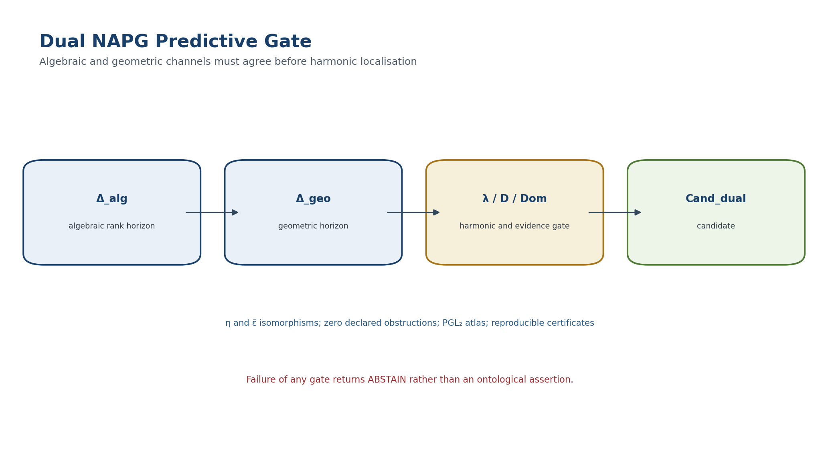
Figure 10. Double NAPG/KLT-RBD predictive gate. English reconstruction of the authorial diagram in the frozen Russian Volume II.
ONTOLOGY | The section fixes an autonomous mathematical object within the architecture of Volume II.
EPISTEMOLOGY | Its content is regarded as known only after the carrier, maps, and conditions of applicability have been specified.
PHENOMENOLOGY | Its phenomenological meaning appears through computable invariants and distinguishable regimes.
LIMITATION | No conclusion is transported beyond the declared domain without a separate bridge.
AUTHORIAL NOVELTY | Novelty is determined not by an isolated term but by its role in the packet-Reper KLT-RBD system.

6.7.2. Main Conditional Theorem of Candidate Transport
Theorem 6.26. Functorial Predictive Transport [COND] Assume H1-H8 below. Then Cand_dual is invariant under isomorphisms of the family A_t, projective-Reper isomorphisms of X_t, and projective coordinate changes on the parameter line. If a path does not cross the common horizon, the algorithm must return NO-STRUCTURAL-CHANGE-IN-MODEL. If Block_dual is nonempty, it must return ABSTAIN.

- H1. t↦A_t is a finite-dimensional algebraic or analytic family with computable Δ_alg.
- H2. An adjoint pair Spec_R⊣Gamma_R exists.
- H3. η_{A_t} and ε̄_{X_t} are isomorphisms in the studied neighbourhood.
- H4. Structural maps satisfy the Conjugacy Bridge 6.20.
- H5. X_t carries a projective Reper atlas.
- H6. D/Dom are valid and fixed before testing.
- H7. Internal obstructions and all declared external obstructions vanish.
- H8. Computational certificates for the algebraic and geometric channels are reproducible.
Proof. Isomorphism invariance of the algebraic horizon was proved in Chapter 5. Theorem 6.21 transports it to the geometric layer. Theorems 6.16 and 6.19 provide invariance of λ. H6-H8 preserve the evidence gates. Hence the Boolean selector Cand_dual is representation-independent. The negative branch follows from constant ranks outside the horizon; the ABSTAIN branch is the definition of the blocker-safe protocol. □
Phenomenological element | Meaning
Observable | The geometric channel shows how structural possibility appears in configuration space.
Foundation | The algebraic channel fixes which operation, associator, and ideal actually change rank.
Coordination | Projective-harmonic λ localises a symmetric Reper candidate, but only inside the common determinantal horizon.
Abstention | When the channels disagree, the system does not guess a hidden meaning; it returns ABSTAIN and a register of missing bridges.

ONTOLOGY | The section fixes an autonomous mathematical object within the architecture of Volume II.
EPISTEMOLOGY | Its content is regarded as known only after the carrier, maps, and conditions of applicability have been specified.
PHENOMENOLOGY | Its phenomenological meaning appears through computable invariants and distinguishable regimes.
LIMITATION | No conclusion is transported beyond the declared domain without a separate bridge.
AUTHORIAL NOVELTY | Novelty is determined not by an isolated term but by its role in the packet-Reper KLT-RBD system.

6.8. Geometric Meaning of R⋆R
ONTOLOGY | Nonassociativity is treated as intrinsic structure, not as a computational error.
EPISTEMOLOGY | It is known through the associator, nuclei, ideals, invariants, and explicit countermodels.
PHENOMENOLOGY | It appears as dependence of the result on the bracketing architecture of a packet.
LIMITATION | A nonzero associator is not by itself physical curvature or a physical event.
AUTHORIAL NOVELTY | The authorial node is R⋆R and its role in packet Reper-harmonic geometry.

6.8.1. Representable Image of the Associator
For T∈𝒞, every T-point x:A→T transports the associator by
x(Ass_A(a,b,c)) = Ass_T(xa,xb,xc).

Consequently the R⋆R certificate of Chapter 5 defines a natural family of functions on the functor of points. Its zero locus on a test object T is
Z_Ass(T)={x∈h_A(T): x(J_Ass(A))=0}.

Proposition 6.27. Representability of the Associative Reflection [THM] For test objects and morphisms for which A/J_Ass exists in 𝒞, Z_Ass(T)≅Hom_𝒞(A/J_Ass(A),T).

Proof. A morphism x:A→T kills J_Ass exactly when it factors uniquely through the universal associative reflection A→A/J_Ass. □
Thus the associative geometric layer is a representable subfunctor of the full NAPG geometry. “Geometry sees the associator” now means a factorisation locus rather than a metaphor.
ONTOLOGY | Nonassociativity is treated as intrinsic structure, not as a computational error.
EPISTEMOLOGY | It is known through the associator, nuclei, ideals, invariants, and explicit countermodels.
PHENOMENOLOGY | It appears as dependence of the result on the bracketing architecture of a packet.
LIMITATION | A nonzero associator is not by itself physical curvature or a physical event.
AUTHORIAL NOVELTY | The authorial node is R⋆R and its role in packet Reper-harmonic geometry.

6.8.2. Geometry of Nuclei and the Center
For every test T, define subfunctors N_l,N_m,N_r,N,Z by vanishing of the corresponding natural associator and commutator functions. Under finite representability they are systems of polynomial equations in structural coordinates.
Proposition 6.28. Functoriality of Nucleus Loci [THM] NAPG isomorphisms transport the loci N_l,N_m,N_r,N,Z into one another. Their dimension profiles are invariants on the reconstructible geometric layer.

Proof. The loci are defined by natural identities Ass=0 and [a,b]=0, preserved by morphisms. □
ONTOLOGY | A computational object exists only together with inputs, an algorithm, and a reproducible certificate.
EPISTEMOLOGY | Knowledge is supported by repeatability, exact tests, and control of numerical conditioning.
PHENOMENOLOGY | It appears as agreement between expected and computed invariants.
LIMITATION | A successful run proves neither a universal theorem nor an empirical claim.
AUTHORIAL NOVELTY | The authorial contribution is a proof-carrying computational circuit within KLT-RBD.

6.9. Computational Certificate
ONTOLOGY | Only a typed structure with declared domain and codomain counts as an object.
EPISTEMOLOGY | Knowledge is obtained by checking morphisms, commutative diagrams, and admissible domains.
PHENOMENOLOGY | The structure appears as the ability to transport data correctly without loss of type.
LIMITATION | Similarity of notation neither licenses composition nor proves existence.
AUTHORIAL NOVELTY | The authorial contribution is the packet-Reper typing of NAPG and the inclusion of D/Dom in the object itself.

6.9.1. Required Data Objects
ID | Object | Certificate fields
DUAL-OBJ | Algebra / geometry | object_id, version, basis/atlas, source hash, status
DUAL-FUN | Spec / Gamma | domain, codomain, object map, morphism map, identity/composition tests
DUAL-UNIT | η / ε̄ | matrix or symbolic map, rank, inverse witness, defect
DUAL-REP | Reper atlas | charts, PGL₂ transition matrices, overlap tests, pole set
DUAL-HOR | Horizons | minor polynomials, generic rank, Δ_alg, Δ_geo, symmetric difference
DUAL-GATE | Predictive gate | λ, δ_truth, D/Dom, Π, blockers, output

ONTOLOGY | A computational object exists only together with inputs, an algorithm, and a reproducible certificate.
EPISTEMOLOGY | Knowledge is supported by repeatability, exact tests, and control of numerical conditioning.
PHENOMENOLOGY | It appears as agreement between expected and computed invariants.
LIMITATION | A successful run proves neither a universal theorem nor an empirical claim.
AUTHORIAL NOVELTY | The authorial contribution is a proof-carrying computational circuit within KLT-RBD.

6.9.2. Automatic Tests
- TEST-YONEDA-01: verify the bijection Hom(A,B)↔Nat(h_B,h_A) on a finite test subcorpus;
- TEST-FUN-02: preserve identities and composition for Spec_R/Gamma_R;
- TEST-ADJ-03: verify the natural Hom bijection and triangular identities;
- TEST-REC-04: exact invertibility tests for η and ε̄;
- TEST-PGL-05: verify that every chart transition is represented by an invertible 2×2 matrix up to scalar;
- TEST-CR-06: equality of cross-ratio in all overlapping charts;
- TEST-NONPGL-07: mandatory negative test on a nonlinear chart;
- TEST-HOR-08: equality of Δ_alg and Δ_geo;
- TEST-GATE-09: ABSTAIN for every nonzero blocker;
- TEST-HASH-10: control hashes of code, data, matrices, and report.
ONTOLOGY | A computational object exists only together with inputs, an algorithm, and a reproducible certificate.
EPISTEMOLOGY | Knowledge is supported by repeatability, exact tests, and control of numerical conditioning.
PHENOMENOLOGY | It appears as agreement between expected and computed invariants.
LIMITATION | A successful run proves neither a universal theorem nor an empirical claim.
AUTHORIAL NOVELTY | The authorial contribution is a proof-carrying computational circuit within KLT-RBD.

6.9.3. Blocker-Safe Algorithm
INPUT: family A_t, realisation X_t, Reper ρ_t, evidence D_t
1. compute Δ_alg; 2. compute Δ_geo; 3. test η and ε̄;
4. verify the PGL₂ atlas and λ; 5. evaluate Π and D/Dom;
6. if Block_dual ≠ ∅: return ABSTAIN;
7. if path ∩ Δ_alg = ∅: return NO-STRUCTURAL-CHANGE-IN-MODEL;
8. if t ∈ Δ_alg=Δ_geo and λ=-1: return CANDIDATE;
9. otherwise: return UNRESOLVED-HORIZON.

Chapter 7. Atlases, Bundles, and Globalisation Obstructions
ONTOLOGY | A global object exists only after effective gluing of local data.
EPISTEMOLOGY | Globality requires cocycle, descent, and compatibility on triple overlaps.
PHENOMENOLOGY | Local solutions appear as compatible or conflicting charts.
LIMITATION | Pairwise agreement does not guarantee a global section.
AUTHORIAL NOVELTY | The authorial contribution is a globalisation-safe KLT-RBD gate and an explicit blocker register.

This chapter separates local NAPG descriptions from genuinely global objects. A cover of charts, even one whose pairwise overlaps look consistent, does not define a bundle until the transition arrows satisfy an associative cocycle and the declared algebraic, Reper, Hodge, and Evidence-D data descend effectively. The predictive consequence is strict: a family of local candidates is not a global scenario unless it is the restriction of an admissible global section.

7.1. NAPG Atlases and the Transition Groupoid
ONTOLOGY | Only a typed structure with declared domain and codomain counts as an object.
EPISTEMOLOGY | Knowledge is obtained by checking morphisms, commutative diagrams, and admissible domains.
PHENOMENOLOGY | The structure appears as the ability to transport data correctly without loss of type.
LIMITATION | Similarity of notation neither licenses composition nor proves existence.
AUTHORIAL NOVELTY | The authorial contribution is the packet-Reper typing of NAPG and the inclusion of D/Dom in the object itself.

Definition 7.1. Local NAPG Model [DEF-A] A local model is an object F of NAPG_q equipped with the chosen topology or smooth structure on its carriers. The group Aut_NAPG(F) of admissible continuous or smooth automorphisms is regarded as a topological group only when that topology has been supplied; otherwise only the categorical formulation is licensed.

Definition 7.2. NAPG Atlas [DEF-A] An atlas of type F on X consists of an open cover {U_i}, local objects E_i=U_i x F, and overlap isomorphisms phi_ij:E_i|U_ij -> E_j|U_ij. Every phi_ij preserves grading, the operation odot, structural data G, admissible domains, the R-star-R layer, and each evidential field declared global.

phi_ii = id, phi_ji = phi_ij^{-1}, phi_jk o phi_ij = phi_ik on U_ijk. | T2-F014

Definition 7.3. Structural Groupoid [DEF-A] Objects are local NAPG models over charts and arrows are admissible overlap isomorphisms. Composition is ordinary composition of maps and remains associative even when the fibre operation odot is nonassociative.

Theorem 7.4. Associative Transition Groupoid Is Necessary [THM] Ordinary gluing of local NAPG objects requires transition data to form a category or groupoid with associative composition. The fibre operation odot cannot itself serve as the transition law unless additional 2-morphisms and explicit coherence data are supplied.

Proof. The quotient of the disjoint union of local trivialisations requires a transitive equivalence relation. On a fourfold overlap the two composites (phi_34 o phi_23) o phi_12 and phi_34 o (phi_23 o phi_12) must agree. Ordinary maps satisfy this identity. A transition law with a nonzero associator makes the equivalence class depend on bracketing and leaves the quotient undefined. A bicategorical repair is a separate OPEN layer. □
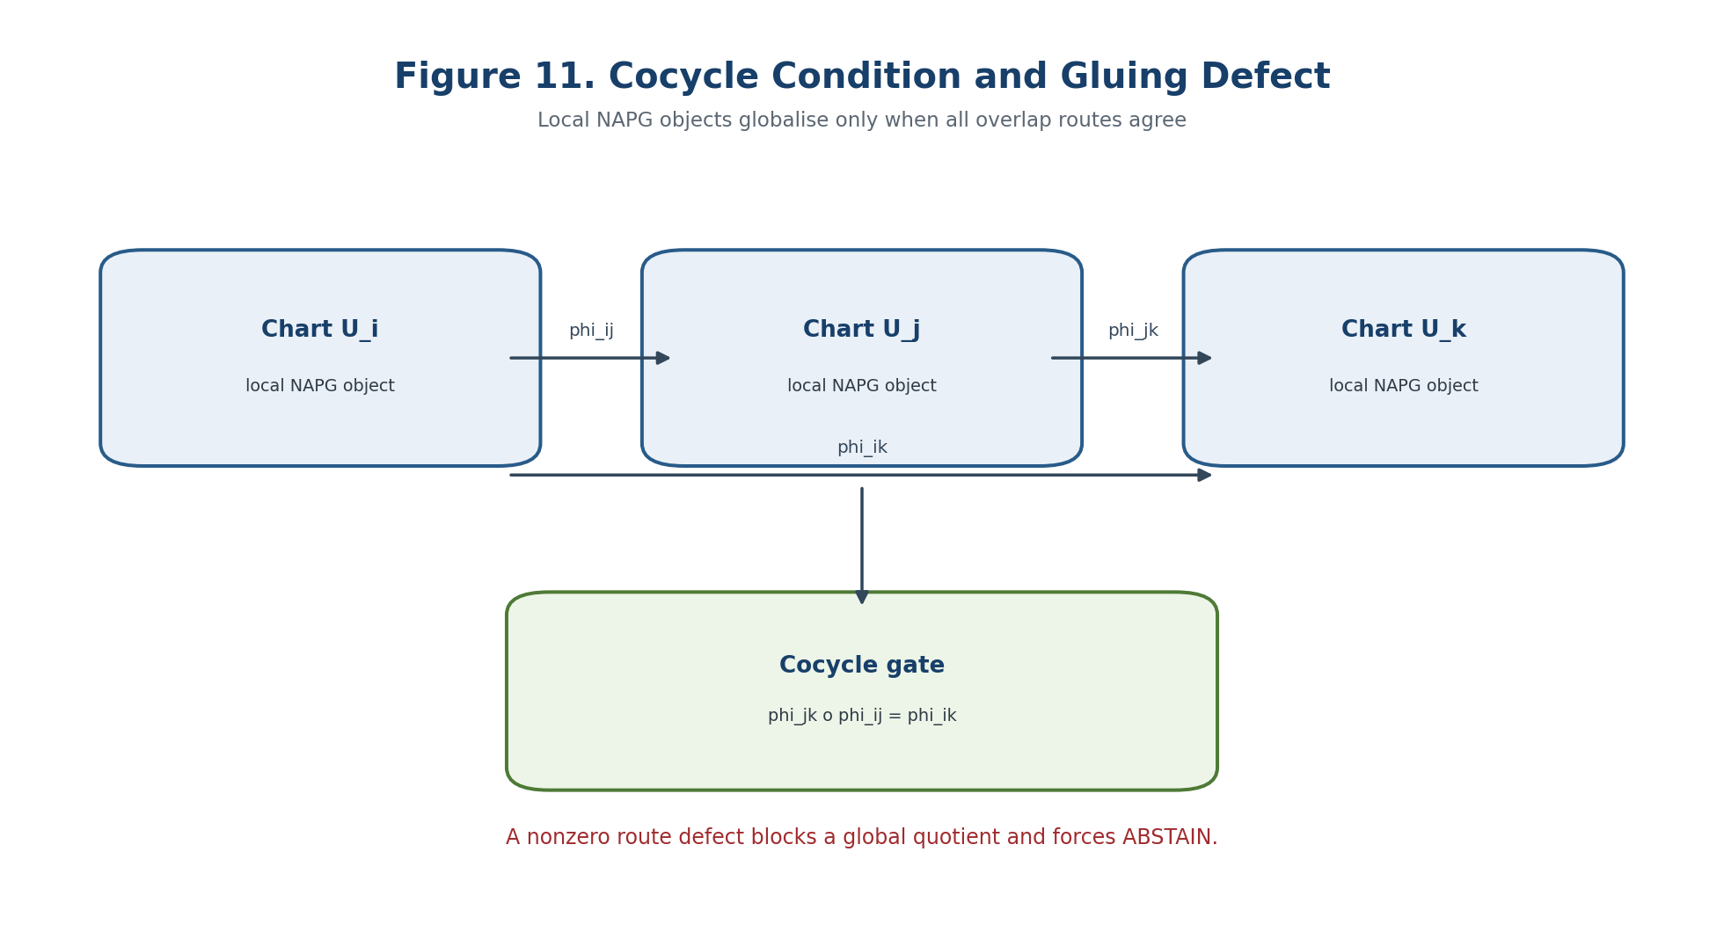
Figure 11. Cocycle condition and gluing defect of local NAPG objects. English reconstruction of the authorial scheme in the frozen Russian Volume II.

7.1.2. Projective-Reper Atlas
Definition 7.5. Projective-Reper Chart [DEF-A] A chart over U_i consists of kappa_i:U_i->P^1(K), a local Evidence-D package E_D,i, and a class of admissible Reper quadruples. On overlaps one requires kappa_j o kappa_i^{-1} in PGL_2(K) together with compatible transport of E_D,i.

Theorem 7.6. Globality of lambda [THM] If every transition belongs to PGL_2(K), the cross-ratio lambda(u,i;r,d) and the harmonic locus lambda=-1 are chart-independent. If a transition fails to preserve cross-ratio, lambda remains only a local coordinate.

Proof. Cross-ratio is invariant under PGL_2. Equality on every overlap therefore glues the local values to a global function on the admissible quadruple space. No converse is claimed for a finite sample of values, since a nonprojective map may accidentally preserve selected quadruples without preserving cross-ratio globally. □

7.2. Descent Data and the Gluing Theorem
ONTOLOGY | A global object exists only after effective gluing of local data.
EPISTEMOLOGY | Globality requires cocycle, descent, and compatibility on triple overlaps.
PHENOMENOLOGY | Local solutions appear as compatible or conflicting charts.
LIMITATION | Pairwise agreement does not guarantee a global section.
AUTHORIAL NOVELTY | The authorial contribution is a globalisation-safe KLT-RBD gate and an explicit blocker register.

Definition 7.7. Descent Datum [CL / DEF-A] For a fibred category p:S->C and a cover U_i->U, a descent datum consists of objects X_i over U_i and isomorphisms phi_ij:pr_0^*X_i->pr_1^*X_j over U_i x_U U_j satisfying the triangle identity on the triple fibre product. In NAPG, the X_i are local packet-Reper structures.

pr_12^* phi_jk o pr_01^* phi_ij = pr_02^* phi_ik on U_i x_U U_j x_U U_k. | T2-F015

Definition 7.8. Effective Descent [CL / COND] A descent datum is effective if it is induced by a global object X over U. The cocycle condition is necessary but, in a general fibred category, not sufficient; sufficiency is a stack or effective-descent property of the selected class of objects.

Theorem 7.9. Gluing of an NAPG Bundle [THM] Let X be paracompact Hausdorff, F a topological NAPG object, and G=Aut_NAPG(F) a topological group. Continuous maps g_ij:U_ij->G satisfying g_ii=e, g_ji=g_ij^{-1}, and g_ij g_jk=g_ik define a locally trivial NAPG bundle E=(disjoint union U_i x F)/~. Its isomorphism class depends only on the gauge class of the cocycle.

Proof. Set (x,v,i)~(x,g_ji(x)v,j). Reflexivity and symmetry follow from the first two identities; transitivity follows from the cocycle. The local inclusions give trivialisations. Since every g_ij is an NAPG automorphism, the grading, operation, structural data, and declared invariants descend. Gauge-related cocycles produce an explicit bundle isomorphism. □
Counterexample 7.10. Pairwise Compatibility Is Not Enough [THM / COUNTEREXAMPLE] Choose three charts with nonempty triple overlap and transitions satisfying g_23 g_12 != g_13. Every pair may be glued in isolation, but the transition from chart 1 to chart 3 depends on the route. No unique global quotient exists.

For KLT-RBD this means that pairwise consistency of sources or models does not establish consistency of the full formula cycle. Triple and higher-route audits are mandatory whenever alternative derivation paths exist.

7.3. Algebra, Reper, and Hodge Bundles
ONTOLOGY | A global object exists only after effective gluing of local data.
EPISTEMOLOGY | Globality requires cocycle, descent, and compatibility on triple overlaps.
PHENOMENOLOGY | Local solutions appear as compatible or conflicting charts.
LIMITATION | Pairwise agreement does not guarantee a global section.
AUTHORIAL NOVELTY | The authorial contribution is a globalisation-safe KLT-RBD gate and an explicit blocker register.

Definition 7.11. Bundle of NAPG Algebras [DEF-A] An NAPG algebra bundle is a locally trivial vector or module bundle E->X with local operations odot_i such that every transition satisfies g_ij(a odot_j b)=g_ij(a) odot_i g_ij(b) and preserves Dom_odot.

Theorem 7.12. Descent of the Operation [THM] Under Definition 7.11 the local operations glue to a unique fibrewise operation odot:Dom_odot subset E x_X E -> E. The associator, left/middle/right nuclei, and J_Ass form global subbundles wherever their ranks are locally constant.

Definition 7.13. Operation Descent Defect [DEF-A] For transitions that are merely linear isomorphisms, define q_ij(a,b)=g_ij(a odot_j b)-g_ij(a) odot_i g_ij(b). A nonzero q_ij blocks a global operation even when the transition cocycle is perfect.

q_ij(a,b)=g_ij(a odot_j b)-g_ij(a) odot_i g_ij(b). | T2-F016

Definition 7.14. Reper Bundle [DEF-A] The fibre of Rep(E)->X consists of admissible quadruples (R,I,U;d) together with an Evidence-D package. Transitions act on the geometric anchor d and on the provenance object E_D; transport of E_D must be traceable and reversible.

Theorem 7.15. Double Descent of Reper [COND] A global Reper exists only when both geometric descent of the quadruple and evidential descent of Evidence-D are effective. Failure in either channel yields ABSTAIN even when every local chart satisfies lambda=-1.

Definition 7.16. Hodge-Compatible Atlas [DEF-A] For fixed-rank oriented metric fibres, an atlas is Hodge-compatible when transitions are orientation-preserving isometries and preserve the declared class of differential forms.

Theorem 7.17. Descent of the Hodge Star [THM] In a Hodge-compatible atlas the local Hodge stars glue to a global fibrewise operator. An orientation-reversing transition introduces a sign; O(n)-compatibility alone is insufficient without an orientation local system.

7.4. Cohomologicalical Globalisation Obstructions
ONTOLOGY | An obstruction is a class of failure of a lift inside a declared structure.
EPISTEMOLOGY | It is established by complexes, quotient spaces, and independence from representatives.
PHENOMENOLOGY | It appears as a residual component that cannot be removed by an admissible correction.
LIMITATION | A zero primary class does not exclude higher obstructions and proves no physical realisation.
AUTHORIAL NOVELTY | The authorial contribution is the internal carrier, its external bridge, and its use in the Reper predictive gate.

For a central extension 1->Z->G_tilde->G->1, local lifts of a G-valued transition cocycle need not satisfy the cocycle identity. Their triple-overlap defect z_ijk is central and defines the obstruction to lifting the structure group.
Theorem 7.19. Central Obstruction Class [THM / COND] The family z_ijk is a Cech 2-cocycle with coefficients in the sheaf Z. Its class [z] in Cech H^2(X,Z) is independent of the chosen local lifts. Under the standard effectiveness hypotheses, the principal G-bundle admits a G_tilde lift iff [z]=0.

[z] in Cech H^2(X,Z), G-tilde lift exists iff [z]=0. | T2-F017

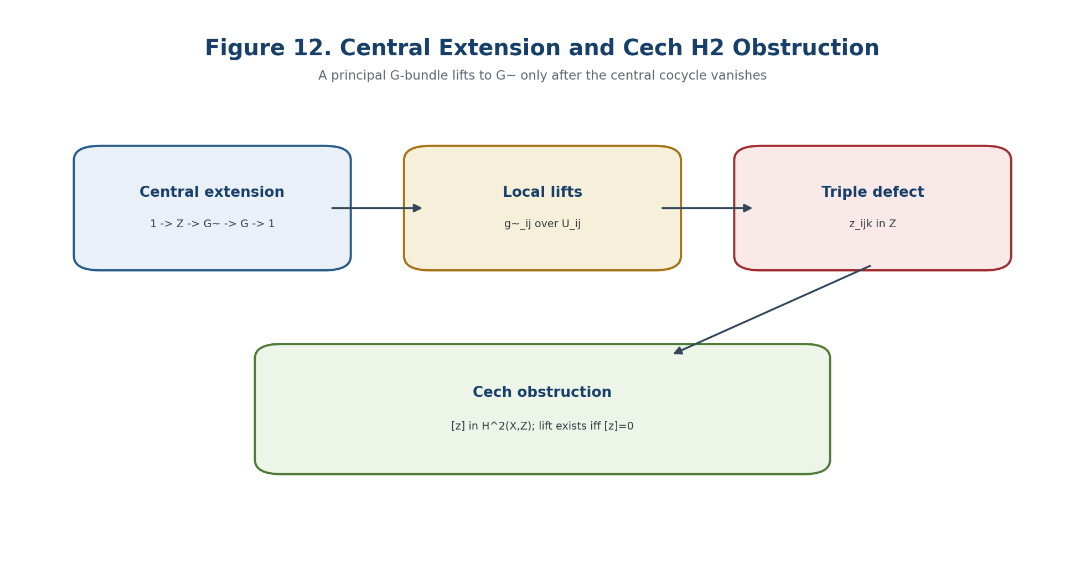
Figure 12. Central extension and Cech H2 obstruction to lifting the structure group.
Definition 7.20. Globalisation Defect Vector [DEF-A] For an atlas A set Def_glue(A)=(c,q,a,p,h,d,s), where c is the transition cocycle defect, q the operation descent defect, a the coherence defect of the associator layer, p nonprojectivity of Reper charts, h Hodge incompatibility, d the Evidence-D/Dom defect, and s the obstruction to the required global section.

Def_glue(A)=(c,q,a,p,h,d,s). | T2-F018

Theorem 7.21. Cellular Obstruction Tower [CL / COND] For a fibration p:E->X over a CW complex with connected simple fibre F, extension of a partial section from the k-skeleton to the (k+1)-skeleton is governed by o_{k+1} in H^{k+1}(X;pi_k(F)_rho). Vanishing of the successive classes, with the standard completeness assumptions, yields a global section.

Consequently, locally admissible scenarios do not guarantee a single global scenario. The coefficient module and monodromy action must be built for the actual model.

7.5. Globalisation Horizons and Negative Prediction
Definition 7.22. Parametric NAPG Bundle [DEF-A] A family over an interval I is an NAPG object E->X x I whose restriction E_t->X is the state at parameter t. The transition maps g_ij(x,t) remain continuous and lie in Aut_NAPG(F) on the admissible domain.

Theorem 7.23. Homotopy Constancy [THM] If E->X x I is a numerable NAPG bundle with fixed structural groupoid and effective descent over all of X x I, then E_t0 and E_t1 are isomorphic for all t0,t1 in I. The discrete bundle isomorphism class cannot change inside one admissible continuous family.

Corollary 7.24. Negative Global Prediction [THM] A topological change of the NAPG bundle is impossible while the family remains defined and effective, the structural groupoid remains fixed, and no globalisation horizon is crossed. An observed change of discrete class forces failure of at least one hypothesis.

Definition 7.25. Globalisation Horizon [DEF-A] Define Delta_glue as the union of the cocycle, effectiveness, operation, associator, chart, Hodge, Dom, D, and section-failure loci. Each component is the parameter set where the corresponding gluing or section condition loses its certificate.

Delta_glue = Delta_coc union Delta_eff union Delta_op union Delta_ass union Delta_chart union Delta_Hdg union Delta_Dom union Delta_D union Delta_sec. | T2-F019

Theorem 7.26. Localisation of a Possible Global Transition [COND] Under the hypotheses of Theorem 7.23, a discrete algebraic-geometric bundle profile can change only on Delta_total. Outside Delta_total it is locally constant. Membership in the horizon is necessary, not sufficient, for a transition.

7.6. Predictive Reper Bundle
Definition 7.27. Predictive Reper Bundle [DEF-A] Let X encode domains, sources, or space-time windows, and let F_x be the admissible future Reper states at x. A predictive Reper bundle p:P->X carries these fibres, chart transitions, and an admissible subspace fixed by D/Dom, obstructions, and subject-matter limits.

Definition 7.28. Globally Admissible Scenario [DEF-A] A scenario is a section s:X->P. It is globally admissible only when local representations agree under transitions, Evidence-D has effective descent, and every mandatory blocker is empty.

Definition 7.29. Global Structural Candidate [DEF-A] A section has status GLOBAL-CANDIDATE when Block_glue is empty, the internal obstruction vanishes, all declared external obstruction classes vanish, lambda satisfies a predeclared exact or interval criterion, and independent computational checks pass.

Theorem 7.30. No Local-to-Global Substitution [THM] Local candidates s_i with lambda_i=-1 and Pi_i=0 do not form a global candidate when transition compatibility fails or the global-section obstruction is nonzero. An algorithm returning EVENT in that situation violates the v0.5 specification.

Main Conditional Theorem 7.31. Globalisation-Safe Predictive Transport [COND] Assume effective NAPG descent, descent of operation and associator, a projective-Reper atlas, Hodge compatibility when used, proved Evidence-D transport, vanishing of internal and declared external obstructions, existence of a global admissible section, and reproducible local and global certificates. Then GLOBAL-CANDIDATE is invariant under refinement of the cover, gauge-equivalence of cocycles, NAPG isomorphisms, and projective changes of Reper charts.

The theorem concerns invariance of a structural candidate inside the formal model. It proves no physical, chemical, biological, or economic event without a domain adapter, data, and independent validation.
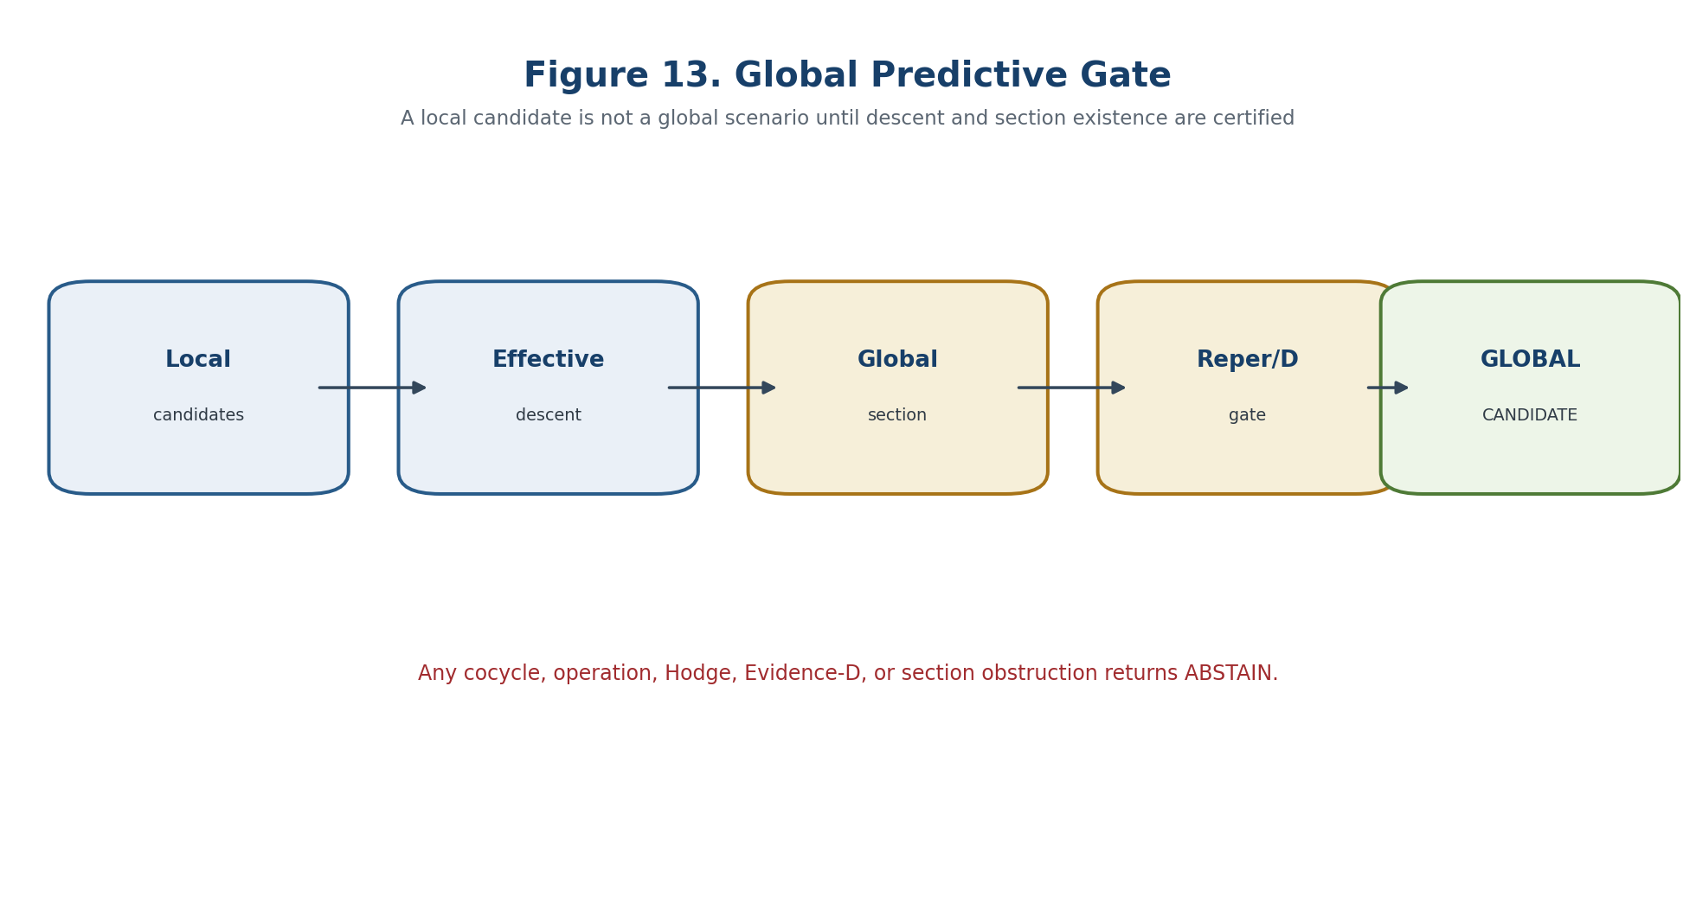
Figure 13. Global predictive gate: a local candidate is admitted only after effective descent and existence of a global section.

7.7. Models, Certificate, and Blocker-Safe Algorithm
Example 7.32. Moebius No-Go [CL / EXAMPLE] The Moebius strip and the cylinder are locally products of an interval and a line. Their distinction is entirely in the overlap transition: -1 versus +1. The global object cannot be reconstructed from the local fibre alone.

Example 7.33. Associator Rank Horizon [COND] For local algebras A_t with associator matrix M_Ass(t), constant rank and effective operation descent give nucleus subbundles of constant rank. A rank change can occur only on the determinantal locus or when operation descent fails.

Certificate object | Required fields
Atlas | cover, overlap list, transition maps, chart versions
Cocycle | double/triple-overlap residuals, gauge class
Operation descent | q_ij, Dom_odot transport, associator compatibility
Reper descent | PGL_2 matrices, lambda parity, Evidence-D provenance
Hodge descent | metric/orientation transport or orientation local system
Section witness | local sections, compatibility, obstruction classes
Verdict | blocker set, GLOBAL-CANDIDATE / ABSTAIN, hashes

- TEST-ATLAS-01: verify that the charts cover X and no unlabelled region remains;
- TEST-INV-02: verify phi_ji o phi_ij=id on every double overlap;
- TEST-COC-03: verify phi_jk o phi_ij=phi_ik on every triple overlap;
- TEST-OP-05: verify q_ij=0 and preservation of Dom_odot;
- TEST-PGL-07: verify PGL_2 Reper transitions and equality of lambda;
- TEST-D-08: verify reversible Evidence-D transport and provenance hashes;
- TEST-SEC-11: verify that local sections form a global witness;
- TEST-GATE-12: force ABSTAIN for every nonzero blocker.
INPUT: atlas, local NAPG objects, transitions, local candidates, Evidence-D
CHECK cover, inverse identities, triple cocycle, and refinement invariance
CHECK operation/associator descent, PGL2 Reper charts, Hodge transport
COMPUTE internal and external obstruction classes and section witness
IF any blocker is nonzero or uncertified: RETURN ABSTAIN
IF a certified path avoids Delta_glue: RETURN NO-GLOBAL-STRUCTURAL-CHANGE-IN-MODEL
IF horizon crossed and global section exists: RETURN GLOBAL-CANDIDATE
ELSE: RETURN ABSTAIN

Chapter 8. Tangent and Cotangent Objects of NAPG
ONTOLOGY | A tangent direction records only the first order of a possible change.
EPISTEMOLOGY | It is known after genuine deformations are separated from gauge directions and higher obstructions are tested.
PHENOMENOLOGY | It appears as local sensitivity of structure to parameter variation.
LIMITATION | A tangent candidate is neither an integrable trajectory nor an event.
AUTHORIAL NOVELTY | The authorial node joins the deformation complex to R-star-R, lambda, and a blocker-safe lift gate.

The chapter distinguishes four notions often compressed into the word tangent: dual-number lifts, first-contact classes of curves, the cotangent module, and the linearisation of the space of algebraic operations. Their agreement requires explicit smoothness, representability, field, and finite-generation hypotheses. In singular sectors, the Zariski tangent space may contain directions that are not velocities of any admissible arc.

8.1. Four Tangent Constructions
Definition 8.1. Dual-Number Tangent [CL / DEF-A] For a functor of points X and x in X(K), define T_xX as the fibre of X(K[epsilon]/epsilon^2)->X(K) over x. A vector-space structure is asserted only after the deformation-functor hypotheses have been checked.

Lemma 8.2. Derivation Representation [THM] For an affine local object A and K-rational point x:A->K, a map a |-> x(a)+epsilon D(a) is a homomorphism iff D is a K-derivation relative to x. Hence T_xX is naturally identified with Der_K(A,K_x).

Proof. Comparison of the epsilon coefficients in f(ab)=f(a)f(b) gives D(ab)=x(a)D(b)+D(a)x(b). Conversely this identity makes the lift multiplicative because epsilon^2=0. □
Definition 8.3. Curve Tangent [CL / COND / OPEN] In a smooth sector, admissible curves through x are equivalent when their coordinate derivatives at zero agree. For a singular, algebraic, or partially defined NAPG object this construction depends on the chosen class of arcs and is not universal without a comparison theorem.

Definition 8.4. Kahler Cotangent Module [CL / COND] For a commutative coordinate algebra A over K, Omega_{A/K} with the universal derivation represents K-derivations. In NAPG it is applied to a commutative coordinate envelope; genuinely noncommutative or nonassociative differential modules require separate definitions.

Definition 8.5. Cotangent at a Rational Point [CL] For maximal ideal m_x and residue field K, T_x^*X=m_x/m_x^2 and T_xX=Hom_K(m_x/m_x^2,K). At a nonrational point the base is the residue field kappa(x).

T_x^*X=m_x/m_x^2, T_xX=Hom_K(m_x/m_x^2,K). | T2-F020

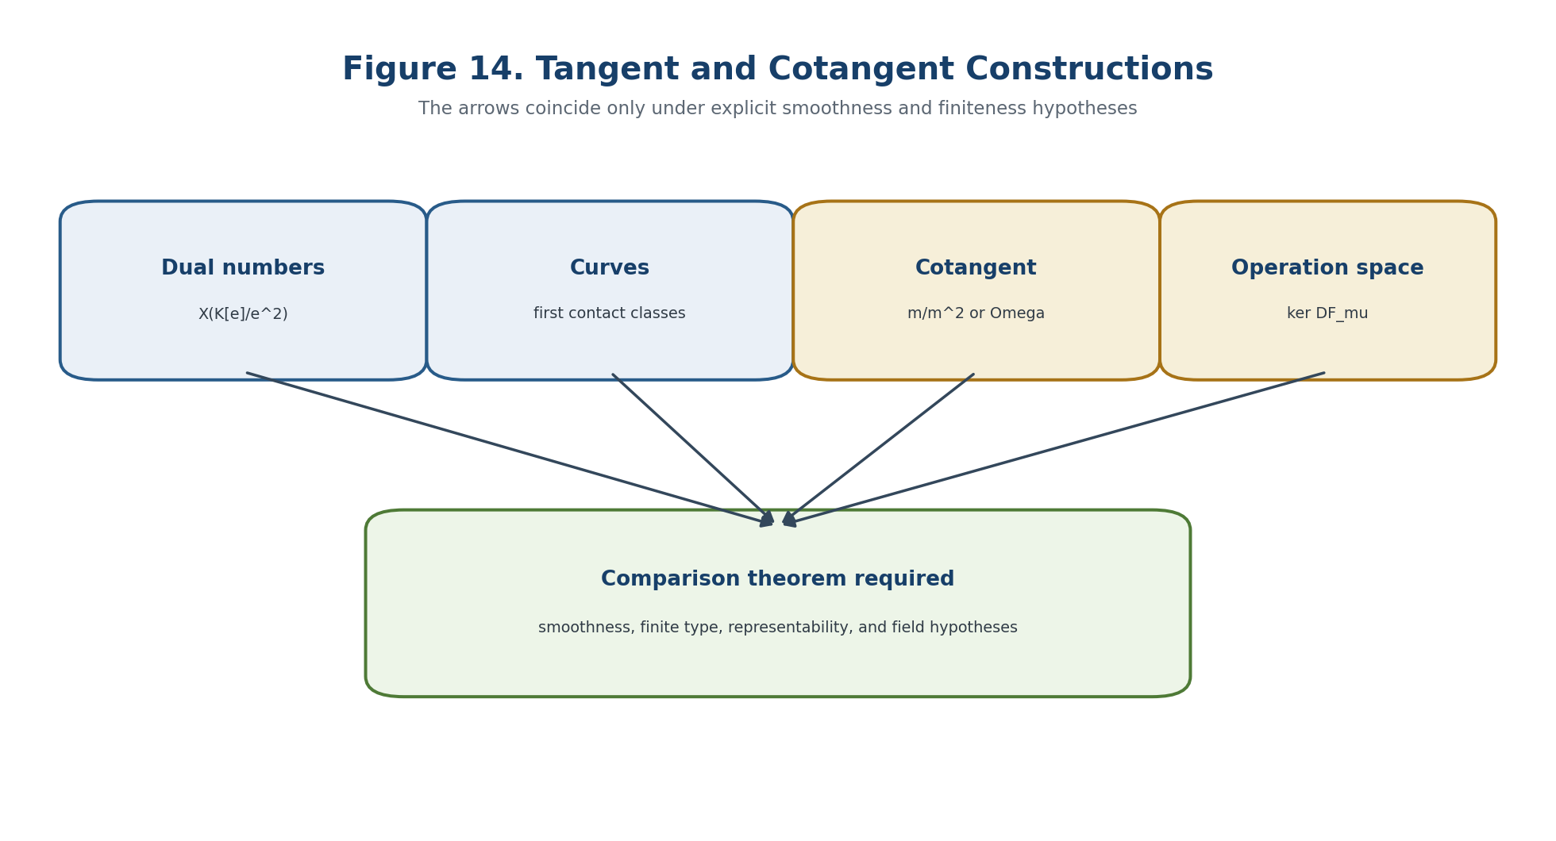
Figure 14. Comparison of tangent and cotangent constructions; coincidence requires explicit hypotheses.

8.2. Tangent Cone and Singular Sector
Definition 8.6. Algebraic Tangent Cone [CL] For the local ring (O_X,x,m_x), set gr_m O_X,x = direct sum m_x^n/m_x^{n+1}. The tangent cone C_xX=Spec(gr_m O_X,x) retains the initial homogeneous parts of the local equations.

Proposition 8.7. Cone-to-Tangent Inclusion [CL / THM] The reduced support of C_xX embeds in the Zariski tangent space. At a smooth point the cone is a vector space and equals the tangent space; at a singular point its linear span may be strictly larger than the cone.

Example 8.8. Node No-Go [THM / EXAMPLE] For X={xy=0} at the origin, the Jacobian vanishes, so the Zariski tangent space is all of A^2. The tangent cone is the union of the coordinate axes. A vector such as (1,1) passes the linear test but is not the leading velocity of an admissible analytic arc on X.

Example 8.9. Hidden Infinitesimal Thickness [CL / EXAMPLE] Spec K[epsilon]/epsilon^2 has one topological point but a one-dimensional tangent space. A point set or incidence graph therefore cannot reconstruct all NAPG deformations.

8.3. Linearisation of the Space of NAPG Operations
Definition 8.10. Ambient Operation Space [DEF-A] For finite-dimensional graded A, let C^2_adm(A,A) be the admissible bilinear variations respecting grading, Dom_odot, and frozen structural data. The NAPG structures are the zeros F(mu)=0 inside an admissible sector U_adm.

M_NAPG={mu in U_adm subset C^2_adm(A,A): F(mu)=0}. | T2-F021

Definition 8.11. Linearised Structure Space [DEF-A] At mu in M_NAPG define Z^2_NAPG(mu)=ker D F_mu. These are formal first-order variations preserving the chosen equations to order t.

Theorem 8.12. Differential of the Associator [THM] For bilinear operations mu and nu, the derivative of Ass at mu in direction nu is DAss_mu(nu)(a,b,c)=nu(mu(a,b),c)+mu(nu(a,b),c)-nu(a,mu(b,c))-mu(a,nu(b,c)). Moreover Ass_{mu+t nu}=Ass_mu+t DAss_mu(nu)+t^2 Ass_nu.

Ass_{mu+t nu}=Ass_mu+t DAss_mu(nu)+t^2 Ass_nu. | T2-F022

Definition 8.14. Gauge Differential [DEF-A] For structural endomorphisms xi, d^1_mu(xi)(a,b)=xi(mu(a,b))-mu(xi a,b)-mu(a,xi b). Its kernel is the structural derivation space and its image is tangent to the admissible change-of-basis orbit.

d^1_mu(xi)(a,b)=xi(mu(a,b))-mu(xi a,b)-mu(a,xi b). | T2-F023

Definition 8.16. Reduced Tangent Space [DEF-A] When im d^1_mu is contained in Z^2_NAPG(mu), set H^2_red(mu)=Z^2_NAPG(mu)/im d^1_mu. It classifies first-order deformations modulo infinitesimal gauge but does not assert integrability.

H^2_red(mu)=Z^2_NAPG(mu)/im d^1_mu. | T2-F024

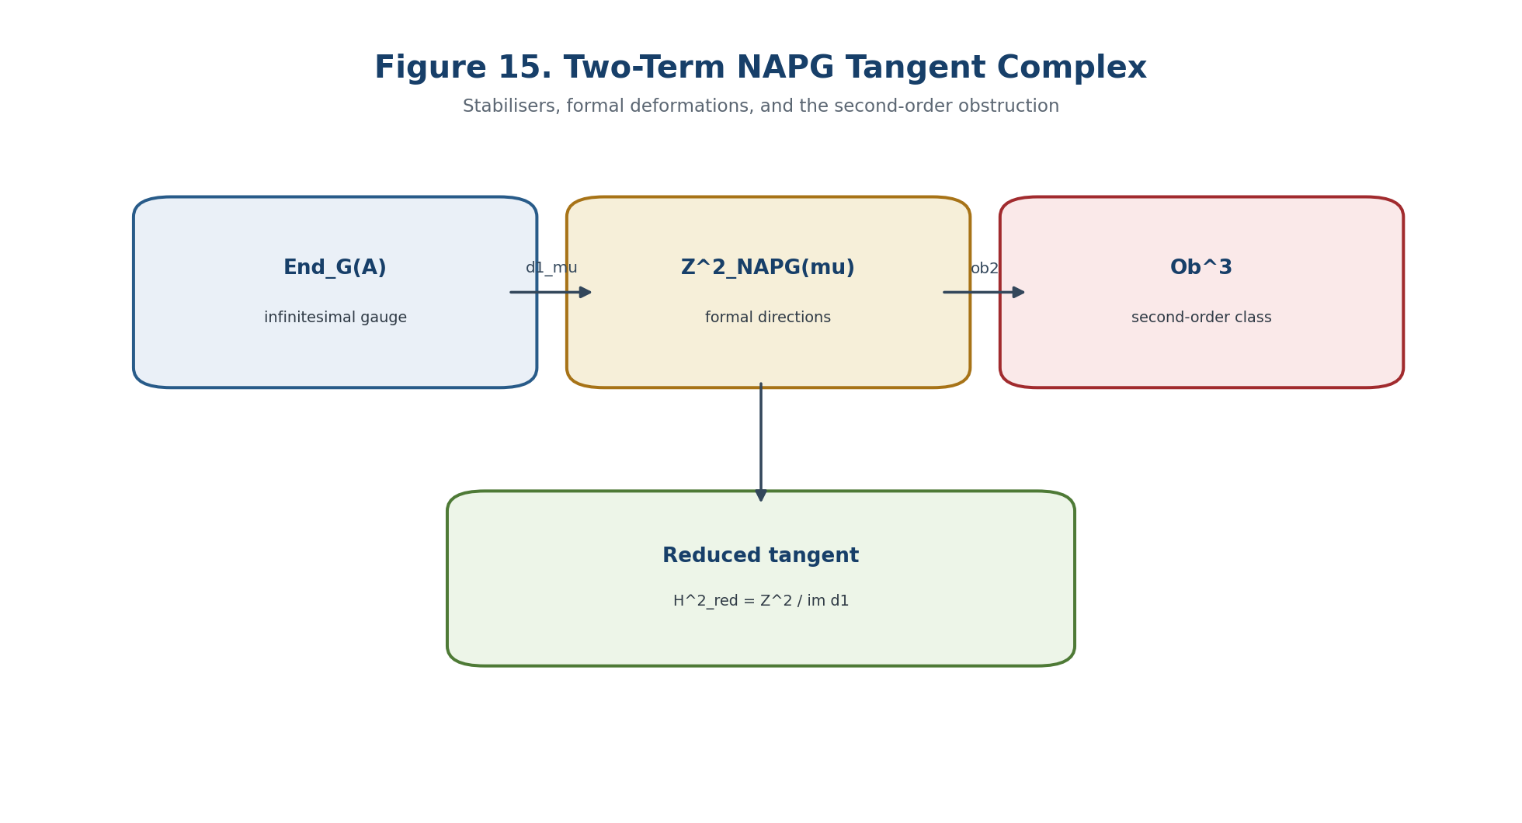
Figure 15. Two-term NAPG tangent complex: stabilisers, first-order deformations, and second-order obstruction.

8.4. Tangent Complex and Cotangent Duality
Definition 8.17. Tangent Complex [DEF-A] For the quotient presentation, use T_mu^bullet=[End_G(A) --d^1_mu--> Z^2_NAPG(mu)] in degrees -1 and 0. Its H^{-1} is the derivation/stabiliser space and H^0 is H^2_red(mu).

Theorem 8.18. No Canonical Self-Duality [CL / THM] A general finite-dimensional vector space V has no natural isomorphism V congruent V^* without an additional nondegenerate bilinear form. Only the evaluation map V->V^{**} is canonical, and it is an isomorphism in the finite-dimensional or finite-projective regime.

Corollary 8.19. NAPG Duality Boundary [THM / COND] The cotangent complex cannot automatically be identified with the tangent complex. Dualisation requires finite projectivity; identification requires a chosen pairing or metric compatible with gauge and descent.

HODGE BOUNDARY. The Hodge star acts on exterior degrees after a metric and orientation are chosen. It does not itself produce a canonical self-duality of the deformation tangent module.

8.5. Second-Order Obstruction and Integrable Arcs
Let mu_t=mu+t nu+t^2 w+O(t^3) be a proposed deformation. The order-t equation places nu in Z^2_NAPG(mu); the order-t^2 equation has the form D F_mu(w)+Q_mu(nu,nu)=0. The class of Q_mu(nu,nu) in the appropriate obstruction quotient is independent of the chosen correction and is the primary second-order obstruction.
Definition 8.20. Second-Order Obstruction Class [DEF-A] For a formal tangent direction nu, define ob_2(nu) as the class of the quadratic coefficient Q_mu(nu,nu) modulo im D F_mu.

ob_2(nu)=[Q_mu(nu,nu)] in C^3_red/im D F_mu. | T2-F025

Theorem 8.21. Second-Order Lift Criterion [THM] A correction w solving the second-order equation exists iff ob_2(nu)=0. When solutions exist, the set of corrections is an affine space over ker D F_mu.

Theorem 8.22. Tangent Is Not an Arc [THM] Membership of nu in H^2_red(mu) is necessary for a first-order deformation class but does not by itself imply the existence of an analytic or formal arc. Higher obstruction classes and convergence may still fail.

8.6. Differential of lambda and Projective Invariance
On an affine chart, lambda=((u-r)(i-d))/((u-d)(i-r)). Differentiation is permitted only off the pole divisor and only after the four Reper components have typed tangent directions.
d log lambda = (du-dr)/(u-r)+(di-dd)/(i-d)-(du-dd)/(u-d)-(di-dr)/(i-r). | T2-F026

Theorem 8.29. Infinitesimal PGL2 Invariance [THM] If r,i,u,d move under one common infinitesimal sl_2 field on P^1, then d lambda=0 away from poles. A nonzero derivative detects relative motion among the four Reper components, not a common projective coordinate change.

Theorem 8.31. First-Order Blindness at Exact Harmony [THM] For q=|lambda+1|^2, Dq(v)=2 Re(conj(lambda+1) Dlambda(v)). At lambda=-1, Dq vanishes in every direction. The second differential, containing 2|Dlambda(v)|^2, is the first nondegenerate test when Dlambda(v) is nonzero.

lambda=-1 implies D|lambda+1|^2=0; D^2 q(v,v) contains 2|Dlambda(v)|^2. | T2-F027

8.7. Linearised Horizon and Local Predictive Cone
Definition 8.32. Structural Constraint Map [DEF-A] Let G=(F_NAPG,Pi,h,B_D,B_Dom,B_glue), with h=lambda+1. At a point x with G(x)=0, the linearly admissible directions form ker D G_x.

Definition 8.33. Integrable Predictive Direction [DEF-A] A direction v receives status INT-DIR only if it lies in the tangent cone of G^{-1}(0), has a second-order witness, is realised by an admissible arc, transports Evidence-D and Dom, satisfies the required jet-order harmonic criterion, and has an empty blocker set.

Block_tan=B_rank union B_cone union B_ob2 union B_arc union B_dual union B_lambda union B_D union B_Dom union B_glue. | T2-F028

Theorem 8.34. Tangent-Safe Predictive Transport [COND] Under an NAPG isomorphism preserving the constraint map, gauge action, projective-Reper atlas, Evidence-D, and descent, an integrable predictive direction is transported to an integrable direction and its INT-DIR status is invariant.

Theorem 8.35. No Event from Tangent Data Alone [THM] A nonzero H^2_red, a large Zariski tangent space, or a direction decreasing a local diagnostic does not imply a future event. Without cone, obstruction, and arc witnesses the only allowed statuses are FORMAL-DIRECTION or ABSTAIN.

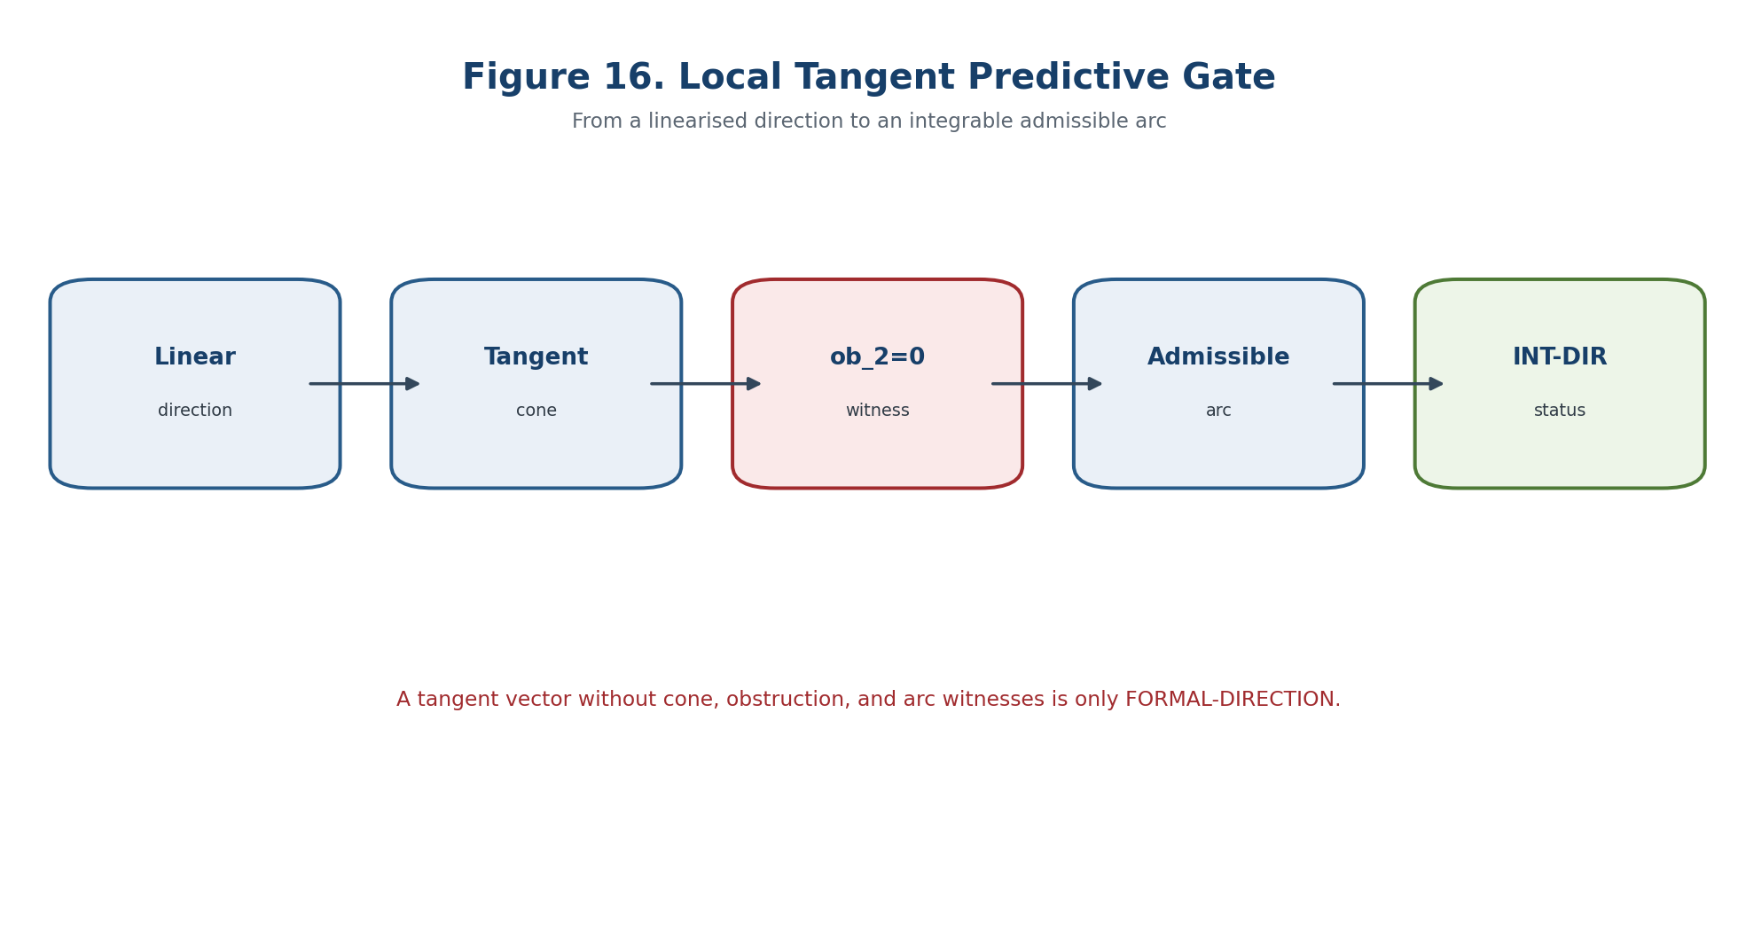
Figure 16. Local predictive gate from a linear direction to an integrable admissible arc.

8.8. Tangent/Cotangent Computational Certificate
Object | Certificate
Ambient operation space | basis, grading, Dom, structural equations F
Linearisation | exact Jacobian D F_mu, rank, kernel basis
Gauge action | d^1_mu matrix, derivation kernel, orbit rank
Singular geometry | initial ideal, tangent cone, arc witnesses
Second order | quadratic coefficient, obstruction quotient, correction witness
Reper tangent | PGL2 chart, pole audit, d lambda, Hessian at harmony
Verdict | FORMAL-DIRECTION / INT-DIR / ABSTAIN and blocker list

- TEST-TAN-01: verify the types and sizes of C^2_adm, F, and D F;
- TEST-DER-02: compare ker d^1 with direct derivation equations;
- TEST-CONE-06: compute the initial ideal and tangent cone in exact arithmetic;
- TEST-NODE-07: reject direction (1,1) for xy=0 at the cone/arc gate;
- TEST-ASS-08: verify Ass_{mu+t nu}=Ass_mu+t DAss_mu(nu)+t^2 Ass_nu;
- TEST-OB2-09: solve the second-order equation or return an obstruction class;
- TEST-LAM-10: confirm invariance of d lambda under a common PGL2 motion;
- TEST-GATE-13: absence of an arc witness forces FORMAL-DIRECTION or ABSTAIN.

Chapter 9. Connections, Curvature, Holonomy, and Associator Curvature
ONTOLOGY | A connection compares fibres; curvature measures the defect of this comparison.
EPISTEMOLOGY | Knowledge is obtained from parallel transport, small loops, and typed action on the associator.
PHENOMENOLOGY | The phenomenon is path memory and variation of structural tensors.
LIMITATION | Holonomy is not the associator and is not automatically causality.
AUTHORIAL NOVELTY | The authorial node is associator curvature as a typed bridge between NAPG and transport.

This theorem/conditional package separates the classical geometry of connections and holonomy from the authorial NAPG bridge. Parallel transport is composition of linear maps and is associative even when the fibre multiplication is not. Curvature, holonomy, multiplication compatibility, and the associator are therefore distinct objects. They may interact only through explicitly typed tensors and transport defects.
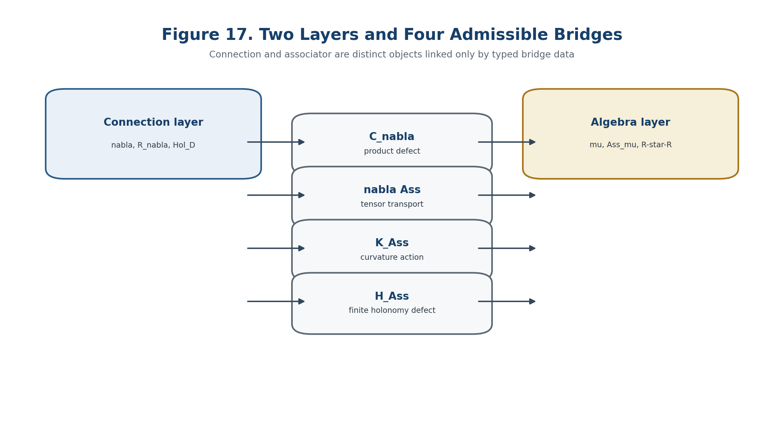
Figure 17. Two layers and four admissible bridges: C_nabla, nabla Ass, K_Ass, and H_Ass.

9.1. Typed NAPG Connection and D-Admissible Paths
Definition 9.1. Algebraic NAPG Bundle [DEF-A] Let X be a smooth sector, A->X a finite-dimensional vector bundle, and mu a smooth section of Hom(A tensor A,A). Each fibre carries the algebra (A_x,odot_x). Grading, structural data, and D/Dom restrictions are included as subbundles or admissible subsets.

mu_x:A_x tensor A_x -> A_x, a odot_x b := mu_x(a,b). | T2-F029

Definition 9.2. D-Admissible Path Category [DEF-A] P_D(X) has points of X as objects and piecewise C^1 paths as arrows, restricted by Dom and equipped with Evidence-D. It must be closed under constant paths, admissible reparameterisation, and composition; inverse paths are additionally required when a holonomy group is claimed.

Definition 9.3. NAPG Connection [DEF-A] A connection is a K-linear operator nabla:Gamma(A)->Omega^1(X;A) satisfying nabla(f s)=d f tensor s+f nabla s. It is structurally admissible only when it preserves the declared grading, structural subbundles, and Dom restrictions.

nabla(fs)=df tensor s+f nabla s. | T2-F030

Definition 9.4. Parallel Transport [CL / DEF-A] For a D-admissible path gamma, P_gamma:A_gamma(0)->A_gamma(1) is defined by the ODE nabla_{dot gamma}s=0.

Theorem 9.5. Associativity of Transport Composition [THM] For composable admissible paths, P_{gamma_2*gamma_1}=P_{gamma_2} o P_{gamma_1}; all bracketings of three transports agree. The associator of ordinary transport composition is identically zero.

(P_gamma3 o P_gamma2) o P_gamma1 = P_gamma3 o (P_gamma2 o P_gamma1). | T2-F031

Corollary 9.6. First No-Go [THM] Hol_D cannot be identified literally with Ass_odot: holonomy consists of linear automorphisms A_x->A_x, while Ass_odot is a ternary map A_x^3->A_x.

9.2. Curvature, Small Loops, and D-Holonomy
Definition 9.7. Curvature [CL] R_nabla(X,Y)=[nabla_X,nabla_Y]-nabla_[X,Y], an End(A)-valued 2-form.

R_nabla in Omega^2(X;End(A)), R_nabla(X,Y)=[nabla_X,nabla_Y]-nabla_[X,Y]. | T2-F032

Definition 9.8. Small-Loop Certificate [DEF-A] For an oriented small rectangle contained in the D-admissible sector, fix the sign convention R_nabla(X,Y)=-lim_{epsilon->0} epsilon^{-2}(P_square_epsilon-Id), when the limit exists in the chosen trivialisation.

Theorem 9.9. Small Loops Localise Curvature [CL / THM] For a C^2 connection, P_square_epsilon=Id-epsilon^2 R_nabla(X,Y)+O(epsilon^3) in the selected convention. Curvature is the first nontrivial coefficient of small-loop holonomy, not an associator of transport composition.

Definition 9.10. D-Holonomy [DEF-A] Hol_D(x)={P_gamma: gamma is a D-admissible loop at x}. If inverse paths are admissible, this is a subgroup of GL(A_x). The component generated by contractible admissible loops is Hol_D^0(x).

Proposition 9.11. Base-Point Change [THM] For an admissible path eta:x->y, Hol_D(y)=P_eta Hol_D(x) P_eta^{-1}, provided conjugation preserves the admissible loop class. Matrix representatives are gauge-dependent; dimension, conjugacy class, and invariant polynomials are legitimate RBD candidates.

Theorem 9.12. Ambrose-Singer: Classical Layer [CL] For an ordinary smooth connection, the restricted holonomy algebra is generated by parallel translates of curvature. This theorem is imported only for the full smooth path category or after accessibility of the required small loops has been proved for the D-subcategory.

Hypothesis 9.13. D-Ambrose-Singer Bridge [COND / OPEN] If D-admissible paths form a regular controlled system, contain the required local rectangles, and are stable under curvature transport, then Lie(Hol_D^0(x)) is generated by D-accessible translates of R_nabla. Without these hypotheses no automatic import is made.

9.3. Compatibility with Packet Multiplication
Definition 9.14. Product Defect [DEF-A] For a vector field X and local sections a,b, define C_nabla(X;a,b)=nabla_X(a odot b)-(nabla_X a) odot b-a odot(nabla_X b).

C_nabla(X;a,b)=nabla_X(a odot b)-(nabla_X a) odot b-a odot(nabla_X b). | T2-F033

Definition 9.15. Product-Compatible Connection [DEF-A] The connection is compatible with odot when C_nabla=0; equivalently, mu is a parallel tensor.

Theorem 9.16. Transport Preserves the Product [THM] On a connected D-sector, C_nabla=0 iff every admissible parallel transport is a homomorphism of the fibre algebras.

Corollary 9.17. Holonomy Preserves Structure [THM] If C_nabla=0, then Hol_D(x) is contained in Aut(A_x,odot_x). It preserves the associator, nuclei, centre, J_Ass, and the full R-star-R certificate whenever those constructions are functorial.

Definition 9.18. Finite Multiplication Holonomy Defect [DEF-A] For gamma:x->y, H_mu(gamma;a,b)=P_gamma(a odot_x b)-P_gamma(a) odot_y P_gamma(b).

Definition 9.19. Finite Associator Holonomy Defect [DEF-A] H_Ass(gamma;a,b,c)=P_gamma Ass_x(a,b,c)-Ass_y(P_gamma a,P_gamma b,P_gamma c).

9.4. Covariant Derivative and Associator Curvature
Theorem 9.20. Derivative of the Associator through C_nabla [THM] The induced connection on Hom(A^3,A) differentiates Ass by the sum of four product-defect terms obtained by expanding nabla((a odot b) odot c-a odot(b odot c)).

In particular, C_nabla=0 implies nabla Ass=0 and hence H_Ass(gamma)=0 on every admissible path. The converses fail: an associative algebra has Ass=0 for every connection, including connections with nonzero C_nabla.
Definition 9.22. Associator Curvature K_Ass [DEF-A] K_Ass is the curvature of the induced connection acting on the associator field, not ordinary curvature and not the associator itself. In tensor notation, K_Ass=(R_nabla.Hom)Ass.

K_Ass(X,Y) = (R_nabla^{Hom(A^3,A)}(X,Y)) Ass. | T2-F034

Theorem 9.23. Necessary Condition for Parallelism [THM] If nabla Ass=0, then K_Ass=0. Thus nonzero K_Ass is a local obstruction to parallelity of the associator.

Definition 9.25. Full Associator-Holonomy Bridge Package [DEF-A] B_Ass=(C_nabla, nabla Ass, K_Ass, H_Ass), together with domains, gauges, norms, and provenance. No component may be replaced by another solely by analogy.

Theorem 9.26. Holonomy Principle for the Associator [CL / THM] On a connected sector, parallel tensors of type (3,1) correspond to tensors at one point fixed by full holonomy. A global parallel associator arises from Ass_x exactly when Ass_x is Hol_D(x)-invariant, provided D-paths connect the sector and path-independence is secured by that invariance.

9.5. Separating Models and Universal No-Go
Example 9.28. Flat Nonassociative Model [THM / EXAMPLE] On a trivial bundle over R^2 with constant nonassociative algebra A_2 and nabla=d, one has R_nabla=0, trivial restricted holonomy, C_nabla=0, but Ass is nonzero. Nonassociativity does not generate curvature automatically.

Example 9.29. Curved Associative Model [THM / EXAMPLE] For A=X x M_2(R) and nabla=d+[B,·] with B=x dy H, curvature dx wedge dy ad_H may be nonzero while Ass=0 because matrix multiplication is associative. Curvature does not generate nonassociativity automatically.

Example 9.30. Flat but Incompatible Connection [THM / EXAMPLE] For nabla=d+omega Id with d omega=0, curvature vanishes but C_nabla(X;a,b)=-omega(X)(a odot b). Flatness does not imply preservation of the packet product.

Example 9.31. Curved Compatible Octonion Model [MODEL / THM] For A=R^2 x O, a nonzero derivation D of the octonions, and nabla=d+x dy D, one has C_nabla=0, R_nabla=dx wedge dy D nonzero, holonomy in G_2, and a nonzero parallel associator.

Theorem 9.32. Universal-Equality No-Go [THM] Across all algebra bundles, no universal identity determines curvature or holonomy solely from the associator, and no universal identity recovers the associator solely from curvature or holonomy.

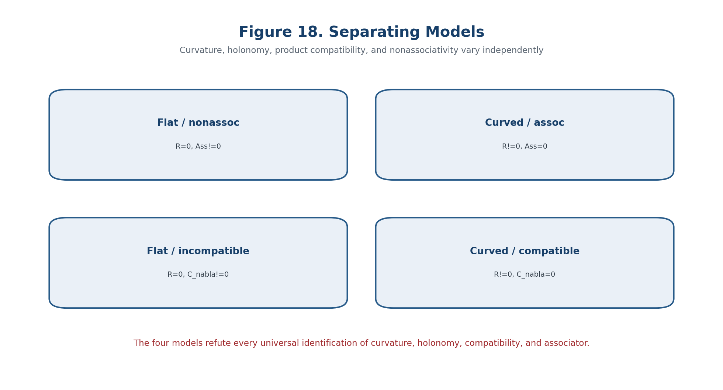
Figure 18. Four models separating curvature, holonomy, compatibility, and associator.

9.6. Akivis/Sabinin Bridge
Definition 9.33. Akivis Algebra [CL] A vector space with an antisymmetric binary operation and a ternary operation is an Akivis algebra when the Jacobiator of the binary operation equals the alternating sum of the ternary operation.

Definition 9.34. Bridge Datum beta [DEF-A] A bridge from a fibre NAPG algebra to a local Akivis structure is a family of linear maps or a functor between the relevant ternary carriers together with commutative diagrams matching bracket, ternary operation, transport, and domains.

BRIDGE STATUS. The Akivis/Sabinin layer is conditional. It is not a licence to identify an arbitrary NAPG associator with geodesic-loop torsion or curvature without the full bridge obligations.

9.7. Holonomy Signature and Horizon
Definition 9.36. D-Holonomy Signature [DEF-A] For parameter t, the signature stores the certified rank of a finite holonomy generator matrix, representation type on A_t, stabiliser dimension of Ass_t, zero/nonzero states of C_nabla, nabla Ass and K_Ass, projective-Reper data, and D/Dom validity.

Definition 9.37. Finite Holonomy Certificate [DEF-A] Choose finitely many D-admissible paths and covariant derivatives of curvature up to order N. After transport to a base point, their coordinates form G_N(t); rank G_N(t) is a reproducible finite approximation to the generated holonomy space.

Theorem 9.38. Local Constancy of Certified Rank [THM] For analytic G_N(t), if a maximal r x r minor remains nonzero on an interval, rank G_N(t)=r there. A rank change can occur only where the selected minors vanish or the family exits its domain.

Definition 9.40. Connection-Holonomy Horizon [DEF-A] Delta_conn includes changes of the D-path category, loss of transport existence, vanishing of certified maximal minors, stabiliser jumps of Ass, poles of lambda, failure of C_nabla=0, and loss of Evidence-D globalisation.

Theorem 9.41. Negative Holonomy Prediction [COND] For an analytic family with a complete stabilised certificate, unchanged D/Dom and gauge category, and a parameter path avoiding Delta_conn, the holonomy-algebra rank, representation type on Ass, and compatibility status remain constant. The corresponding structural transition is excluded inside the model.

9.8. Projective Reper Transport
Theorem 9.42. Common Projective Transport Invariance [THM] If all four Reper points are transported by the same PGL_2 transformation g_t, then lambda(g_t r,g_t i,g_t u,g_t d)=lambda(r,i,u,d).

Corollary 9.43. Relative Transport Is Necessary [THM] Away from poles, d lambda/dt != 0 implies that the four velocities cannot all be generated by one infinitesimal sl_2 field. Nonzero d lambda detects relative, not common projective, dynamics.

Definition 9.44. Relative Reper Connection [DEF-A] Allow four projective connections nabla^r,nabla^i,nabla^u,nabla^d. Their differences from a common projective part form nabla^rel, which is the component entering the derivative of lambda.

9.9. Main Conditional Predictive Theorem
Theorem 9.46. Holonomy-Associator-Safe Predictive Theorem [COND] For a C^2 family (A_t,odot_t,nabla_t,rho_t,D_t), assume fixed types, a stable D-path groupoid, solvable transport ODEs, versioned D/Dom, a complete finite holonomy certificate, a computed B_Ass package, closed Akivis/Sabinin obligations when used, PGL_2 Reper charts, separation of common and relative transport, valid globalisation/tangent certificates, and a path avoiding Delta_conn. Then the certified holonomy rank, its action type on A, the stabiliser dimension of Ass, the zero/nonzero states of C_nabla, nabla Ass and K_Ass, and lambda under common transport are constant on each component of the complement.

Corollary 9.47. Necessary Condition for a Structural Event [COND] A transition candidate can arise only at Delta_conn, through relative Reper dynamics, a nonzero bridge defect, or a change of D/Dom. None is sufficient by itself.

Corollary 9.48. Blocker-Safe Verdict [THM / PROTOCOL] Incomplete or conflicting certificates yield ABSTAIN. A complete path avoiding the horizon yields NO-STRUCTURAL-TRANSITION-IN-MODEL. A verified crossing yields only CANDIDATE-TRANSITION.

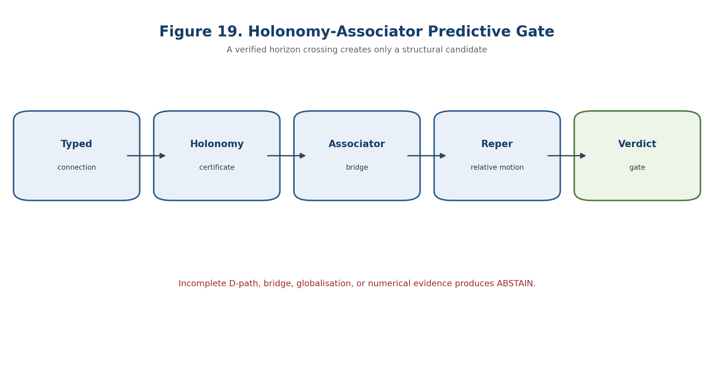
Figure 19. Blocker-safe gate for holonomy-associator prediction.

9.10. HOL-ASS Computational Certificate
- TEST-CONN-01: verify the scalar Leibniz rule for the connection;
- TEST-PATH-02: verify closure of P_D under composition and inverse where a group is claimed;
- TEST-PT-03: verify transport composition to solver tolerance;
- TEST-CURV-04: compare coordinate and operator curvature formulas;
- TEST-LOOP-05: verify the epsilon^{-2}(P_square-Id) limit with the declared sign;
- TEST-HOL-06: certify rank of G_N by exact or interval arithmetic;
- TEST-PROD-07: verify equivalence between C_nabla=0 and product-preserving transport;
- TEST-KASS-09: verify K_Ass against the induced curvature formula;
- TEST-NOGO-10: run the four separating models;
- TEST-GATE-13: force ABSTAIN whenever a bridge remains open.

Chapter 10. NAPG Differential Forms and Typed Differentials
ONTOLOGY | A differential layer exists as an operator with domain, degree, and an action rule.
EPISTEMOLOGY | Its correctness is tested by Leibniz, locality, gluing, and the square of the operator.
PHENOMENOLOGY | It appears as transport of forms, compatibility defects, and differential curvature.
LIMITATION | The Leibniz rule does not imply d squared equals zero.
AUTHORIAL NOVELTY | The authorial contribution is a typed differential firewall inside NAPG and KLT-RBD.

The internal differential candidate d_N, the external operator delta_E, the Hodge codifferential delta_Hdg, and the Hodge star are distinct typed objects. A notation collision is a proof blocker. The chapter proves that the graded Leibniz identity does not imply nilpotency, and that a total complex exists only after the internal square, external square, and mixed commutator have all been certified.
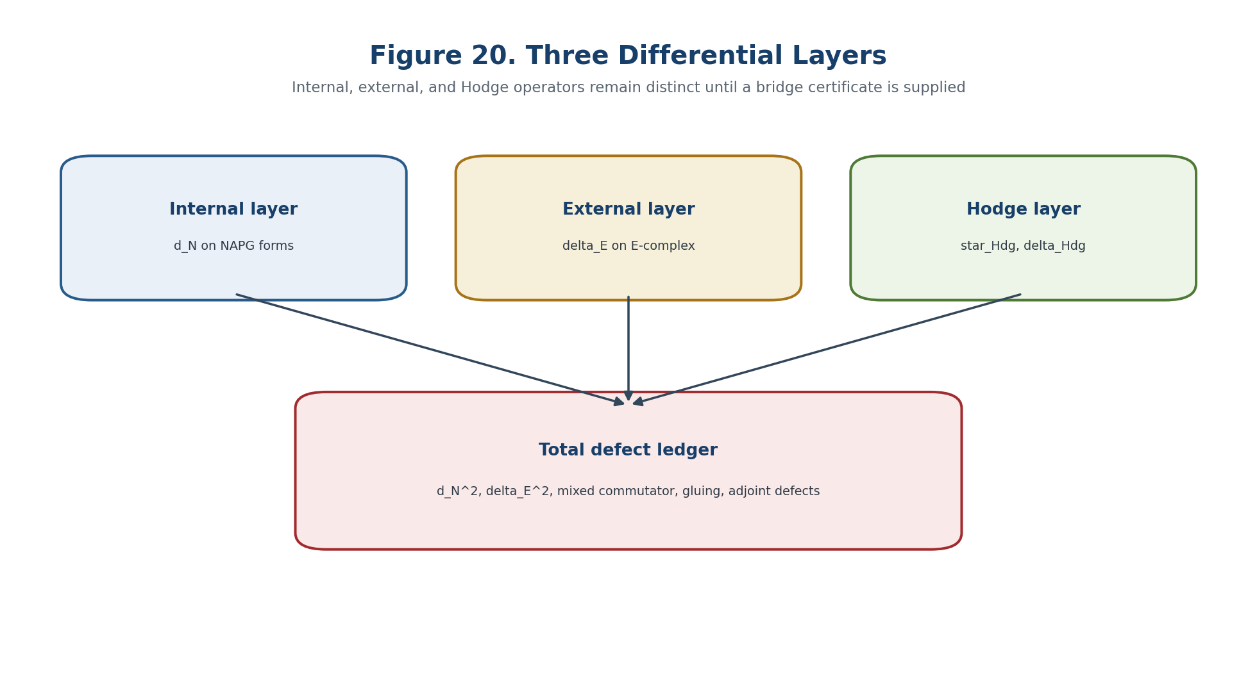
Figure 20. Three differential layers and decomposition of the total defect.

10.1. Frozen Notation and Operator Types
Definition 10.1. Internal Packet Forms [DEF-A] For an admissible smooth or stratified sector X, Omega_N^p(U) is the module of NAPG p-forms over U. The assignment U |-> Omega_N^p(U) is a sheaf or presheaf according to the verified descent axioms.

Omega_N^bullet = direct_sum_{p>=0} Omega_N^p, |alpha|=p for alpha in Omega_N^p. | T2-F035

Definition 10.2. Internal Differential Candidate [DEF-A] d_N^p is a partial linear map Dom(d_N^p) subset Omega_N^p -> Omega_N^{p+1}. It is called a candidate until locality, restriction compatibility, the graded Leibniz identity, and nilpotency have been checked.

Definition 10.3. External E-Operator [DEF-A / COND] delta_E:E^q->E^{q+1} belongs to the external layer. The relation delta_E^2=0 must be proved in the selected E-complex and is not imported from the internal layer.

Definition 10.4. Hodge Operators [CL / DEF-A] On an oriented metric n-sector, star_Hdg is the Hodge star, delta_Hdg the codifferential, and Delta_Hdg the Hodge Laplacian. The star in R-star-R is not the Hodge star.

NOTATION FIREWALL. Any formula interchanging d_N, external delta_E, delta_Hdg, or the star in R-star-R without an explicit typed map receives blocker NOTATION-COLLISION.

10.2. Graded Leibniz Calculus
Definition 10.6. Leibniz Defect [DEF-A] For a degree-compatible bilinear product odot and homogeneous alpha,beta, set L_d(alpha,beta)=d_N(alpha odot beta)-d_N alpha odot beta-(-1)^{|alpha|} alpha odot d_N beta.

L_d(alpha,beta)=d_N(alpha odot beta)-d_N alpha odot beta-(-1)^{|alpha|} alpha odot d_N beta. | T2-F036

Definition 10.7. Graded Derivation [CL / DEF-A] d_N is a degree +1 graded derivation exactly when L_d=0 on the declared domain.

Lemma 10.8. Value on the Unit [THM] In a unital sector of characteristic not equal to 2, the graded Leibniz identity implies d_N(1)=0.

Theorem 10.9. Closure of Derivations [THM] For homogeneous graded derivations D,E on a possibly nonassociative graded algebra, [D,E]=D o E-(-1)^{|D||E|}E o D is again a derivation of degree |D|+|E|. The proof uses only the Leibniz identities, not associativity of odot.

[D,E]=D o E-(-1)^{|D||E|}E o D. | T2-F037

Corollary 10.10. Square of an Odd Derivation [THM] When char K != 2 and |d_N|=1, [d_N,d_N]=2d_N^2. Hence d_N^2 is a degree +2 derivation but need not vanish.

Theorem 10.11. Associator Leibniz Identity [THM] For a degree +1 derivation, d_N Ass(alpha,beta,gamma)=Ass(d_N alpha,beta,gamma)+(-1)^{|alpha|}Ass(alpha,d_N beta,gamma)+(-1)^{|alpha|+|beta|}Ass(alpha,beta,d_N gamma).

d_N Ass(alpha,beta,gamma)=Ass(d_N alpha,beta,gamma)+(-1)^{|alpha|}Ass(alpha,d_N beta,gamma)+(-1)^{|alpha|+|beta|}Ass(alpha,beta,d_N gamma). | T2-F038

10.3. Nilpotency Is Not Automatic
Definition 10.13. Differential Curvature [DEF-A] For a degree +1 derivation set Omega_d=d_N^2:Omega_N^p->Omega_N^{p+2}. This internal term is not identified with R_nabla, although in a covariant model it may act through curvature.

Omega_d := d_N^2. | T2-F039

Lemma 10.14. Operator Bianchi Identity [THM] [d_N,Omega_d]=0, since both terms are d_N^3.

Definition 10.15. Precomplex and Complex [DEF-A] A typed sequence Omega_N^p->Omega_N^{p+1} is a precomplex. It is a cochain complex only when d_N^{p+1}d_N^p=0 in every degree. Cohomology is defined only in the second case.

Example 10.16. Leibniz without Nilpotency [THM / EXAMPLE] In the free graded nonassociative algebra on generators a,b,c of degrees 0,1,2, define d(a)=b,d(b)=c,d(c)=0 and extend by the graded Leibniz rule. Then L_d=0 but d^2(a)=c!=0.

Example 10.17. Covariant Exterior Derivative [CL / THM] For a connection nabla, d_nabla^2 acts by curvature; it need not vanish.

Example 10.18. Superconnection Curvature [CL / THM] For an odd superconnection A=d+omega, A^2=d omega+omega^2, which is generally nonzero.

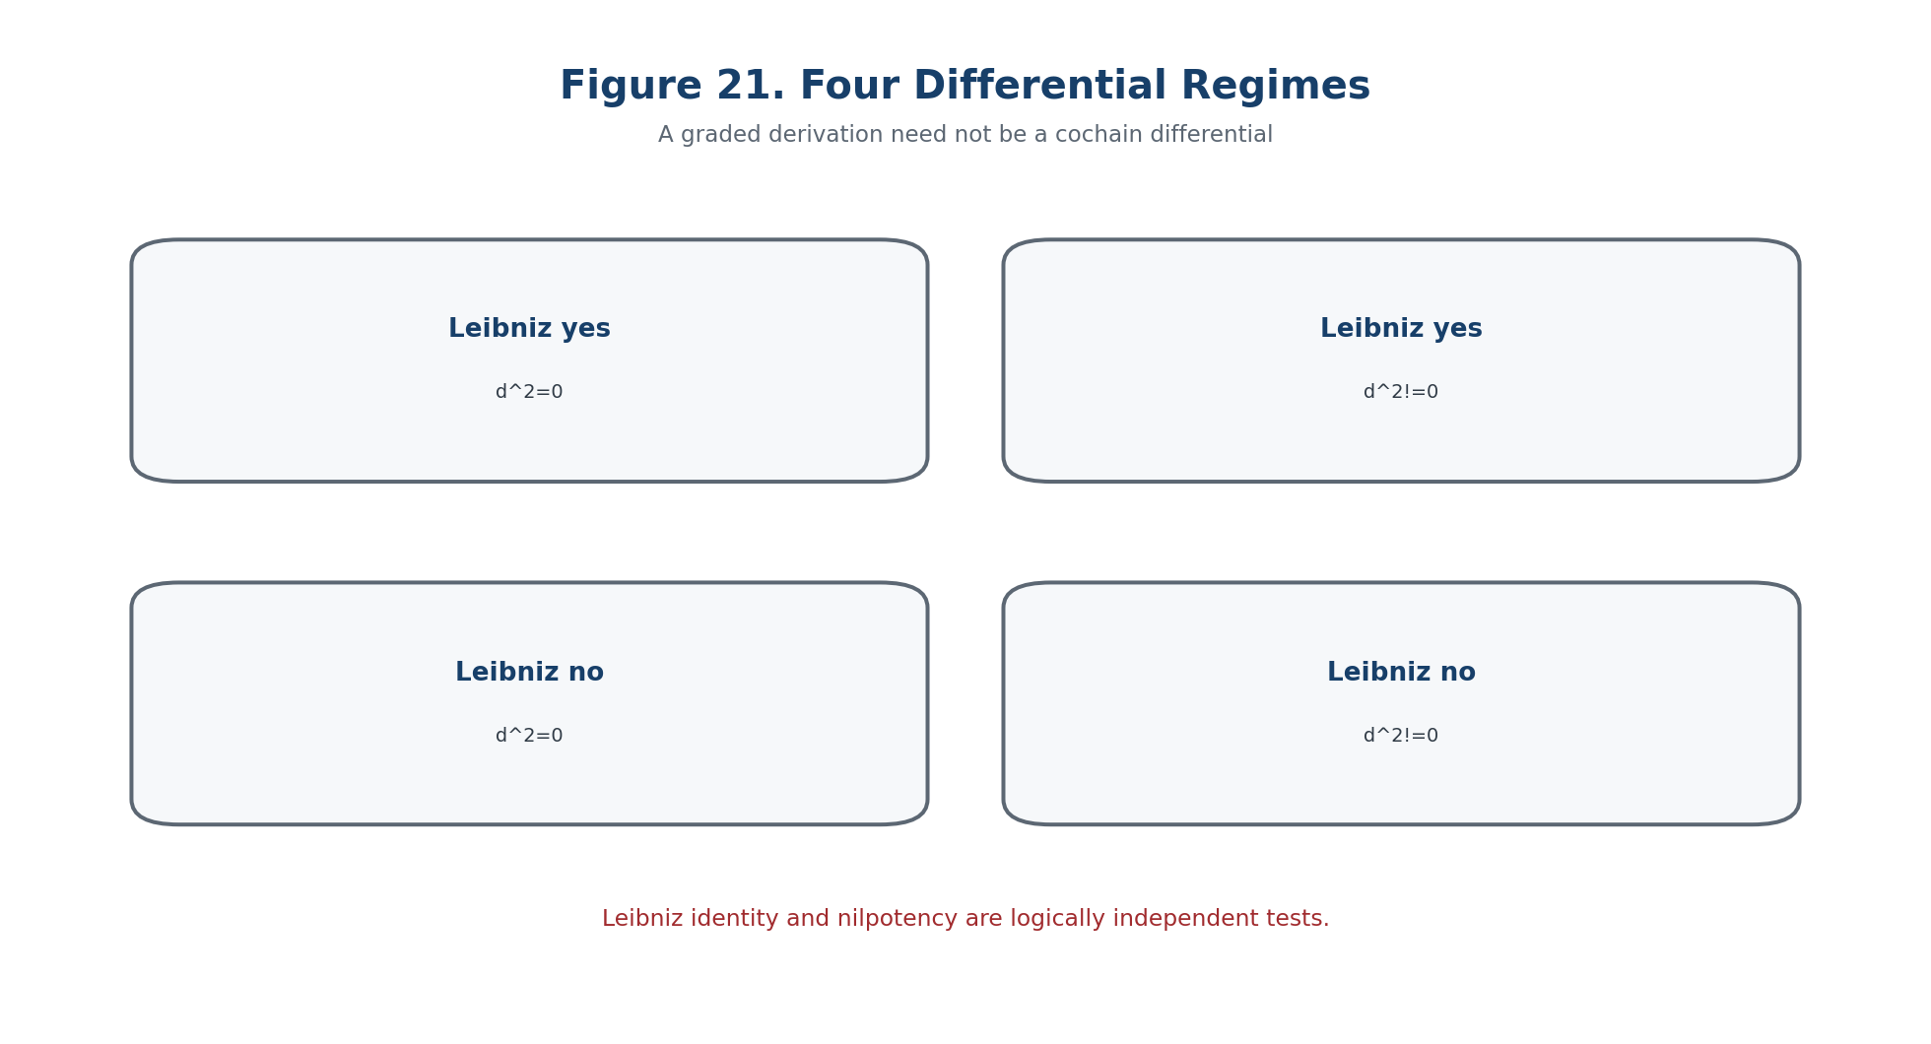
Figure 21. Four regimes showing logical independence of the Leibniz identity and nilpotency.

10.4. Locality, Restrictions, and Gluing
Definition 10.20. Sheaf-Local Operator [DEF-A] A family d_U is local when for every V subset U, restriction commutes with d: res_{U,V} d_U=d_V res_{U,V} on the common domain.

Lemma 10.21. Support Nonincrease [THM] For a sheaf-local operator, supp(d alpha) is contained in supp(alpha). This does not by itself classify d as a finite-order differential operator.

Theorem 10.22. Gluing of Local Differentials [THM] Local degree +1 operators d_i glue through bundle transitions g_ij when d_i g_ij=g_ij d_j on every overlap and their domains are transported compatibly.

Definition 10.23. Differential Gluing Defect [DEF-A] K_ij=d_i g_ij-g_ij d_j. A nonzero K_ij blocks a global d_N even if every d_i is nilpotent.

K_ij=d_i g_ij-g_ij d_j. | T2-F040

Counterexample 10.24. Local Nilpotency Does Not Repair Gluing [THM / EXAMPLE] With g_12=Id, d_1=d and d_2=d+A fail to glue whenever A is nonzero, regardless of nilpotency of the separate operators.

10.5. Internal and External Layers
Definition 10.25. Bigraded Bridge Object [DEF-A / COND] Let B^{p,q}=Omega_N^p tensor E^q. The internal d_N has bidegree (1,0), the external delta_E has bidegree (0,1), and the total operator is D_tot=d_N tensor 1+(-1)^p 1 tensor delta_E on bidegree (p,q), subject to the declared domain.
Theorem 10.26. Square Decomposition [THM] D_tot^2 decomposes into the internal square, the external square, and the graded mixed commutator. A total cohomology exists only when all three components vanish and gluing is certified.
D_tot^2 = d_N^2 tensor 1 + 1 tensor delta_E^2 + Mix(d_N,delta_E). | T2-F041
Corollary 10.27. Cohomology Firewall [THM / PROTOCOL] If any component of D_tot^2 is nonzero or uncomputed, H^*(Tot B,D_tot) is not declared. KLT-RBD stores the defect triple rather than a fictitious cohomology label.
Definition 10.28. Differential Bridge Certificate [DEF-A] A map Pi_E:O_B->H^3(E^bullet) requires typed source and target, a proof that representatives descend, compatibility with differentials, naturality under morphisms, and a reproducible computational witness.

Chapter 11. Hodge Operators, Codifferential, and Laplacian
ONTOLOGY | A harmonic object is defined by a concrete Hilbert or Fredholm realisation.
EPISTEMOLOGY | Knowledge requires closed operators, adjoint domains, boundary conditions, and spectral control.
PHENOMENOLOGY | It appears through canonical harmonic representatives and stability of a Green operator.
LIMITATION | Formal symmetry is not self-adjointness, and Hodge decomposition is not automatic.
AUTHORIAL NOVELTY | The authorial node inserts the Hodge-Fredholm profile into the predictive Reper horizon.

The Hodge layer is meaningful only on an oriented metric sector with a declared measure and operator domains. The chapter preserves the source numbering, where the imported differential package continues labels 10.30 onward. These numbers are not renumbered in translation.

11.1. Hodge Sector and Operator Definitions
Definition 10.30. Hodge Sector [CL / COND] Let U be an oriented n-dimensional smooth sector with a nondegenerate metric g and admissible measure. The Hodge star star_Hdg:Omega^p(U)->Omega^{n-p}(U) is defined by the metric, orientation, and volume form.

Definition 10.31. Codifferential [CL / COND] In the selected Riemannian sign convention, delta_Hdg=(-1)^{n(p+1)+1} star_Hdg d_N star_Hdg on p-forms, with the common operator domain explicitly stated.

delta_Hdg = (-1)^{n(p+1)+1} star_Hdg d_N star_Hdg. | T2-F042

Definition 10.32. Hodge Laplacian [CL / COND] Delta_Hdg=d_N delta_Hdg+delta_Hdg d_N on the intersection of the corresponding domains.

Delta_Hdg=d_N delta_Hdg+delta_Hdg d_N. | T2-F043

Theorem 10.33. Nilpotency Transfer [THM] If d_N^2=0 and star_Hdg is a valid isomorphism on the sector, then delta_Hdg^2=0. When d_N^2 is nonzero, nilpotency of delta_Hdg does not follow.

11.1.2. Hodge Compatibility Defects
Definition 10.35. Hodge Transport Defect [DEF-A] For a chart transition g_ij, set H_ij=g_ij star_j-star_i g_ij. A nonzero defect blocks a global Hodge star in the declared trivialisation.

Definition 10.36. Formal-Adjoint Defect [DEF-A] When an inner product is defined, A_adj(alpha,beta)=<d_N alpha,beta>-<alpha,delta_Hdg beta>, including boundary terms and operator-domain conditions.

Vanishing of the displayed formal expression is weaker than self-adjointness of a closed unbounded operator. Boundary conditions, closures, and deficiency data remain separate analytical obligations.

11.2. Differential Reper and lambda Harmony
Definition 10.37. Differential Reper [DEF-A] A differential object is packaged as Rep_diff=(R_op,I_inv,U_def;D_cert), where R_op is the realised operator system, I_inv the selected invariant signature, U_def the admissible deformation universe, and D_cert the full operator-domain and evidence certificate.

Definition 10.38. Differential Defect Vector [DEF-A] Def_diff=(L_d,Omega_d,K_glue,H_transport,A_adj,M_mix,B_D,B_Dom), collecting Leibniz, square, gluing, Hodge, adjoint, mixed, and evidential defects.

Def_diff=(L_d,Omega_d,K_glue,H_transport,A_adj,M_mix,B_D,B_Dom). | T2-F044

Definition 10.40. Relaxed Differential Candidate [DEF-A] For predeclared thresholds tau and eta, a candidate requires delta_truth<=tau and norm Def_diff<=eta together with valid D/Dom. Thresholds are fixed before disclosure and do not convert an approximate numerical state into an exact theorem.

11.3. Differential Transition Horizon
Definition 10.41. Finite Differential Signature [DEF-A] For a finite-dimensional truncation, store ranks of d_t^p, dimensions of kernels and cohomology when defined, ranks of Hodge/Laplacian matrices, zero/nonzero states of all defects, lambda data, and conditioning bounds.

Definition 10.42. Differential Horizon [DEF-A] Delta_diff is the union of zeros of certified maximal minors, changes of operator domains, poles of lambda, insufficient precision loci, and conflicts in gluing, Hodge transport, or the E-bridge.

Theorem 10.43. Rank Constancy [THM] For an analytic finite-dimensional family, all certified matrix ranks are constant on each connected component of the complement of Delta_diff. If d_t^2=0 and adjacent ranks remain constant, the corresponding cohomology dimensions remain constant.

Theorem 10.44. Differential Negative Prediction [COND] With a complete certificate and a parameter path avoiding the strengthened safe horizon, the certified differential-complex type, cohomology dimensions, and zero/nonzero status of differential defects cannot change inside the model.

Corollary 10.45. Horizon Crossing Is Only a Candidate [COND] Crossing Delta_diff creates a candidate transition. It does not establish an integrable deformation, a global event, or a physical realisation.

11.4. Separating Models
Model | Leibniz | d squared | Hodge/global status | Lesson
de Rham forms | yes | zero | classical Hodge sector | baseline complex
free graded NAPG | yes | nonzero | no cohomology | Leibniz is insufficient
covariant forms | yes | curvature action | bundle-dependent | connection curvature survives
locally nilpotent but nongluing | local yes | local zero | K_ij nonzero | global differential absent

11.5. Main Conditional Theorem
Theorem 10.47. Differential-Calculus-Safe Predictive Theorem [COND] For a family (Omega_t^bullet,odot_t,d_t,delta_E,t,star_t,rho_t,D_t), assume fixed typed domains, certified Leibniz and square tests, effective gluing, a valid Hodge sector when used, a closed external complex and mixed bridge, a projective-Reper atlas, valid D/Dom, finite-rank analytic certificates, and a path avoiding the full differential horizon. Then the certified differential signature is constant on each connected component.

Corollary 10.48. Three-Valued Verdict [THM / PROTOCOL] A complete noncrossing certificate yields NO-DIFFERENTIAL-TRANSITION-IN-MODEL; a verified crossing yields CANDIDATE-TRANSITION; any open blocker yields ABSTAIN.

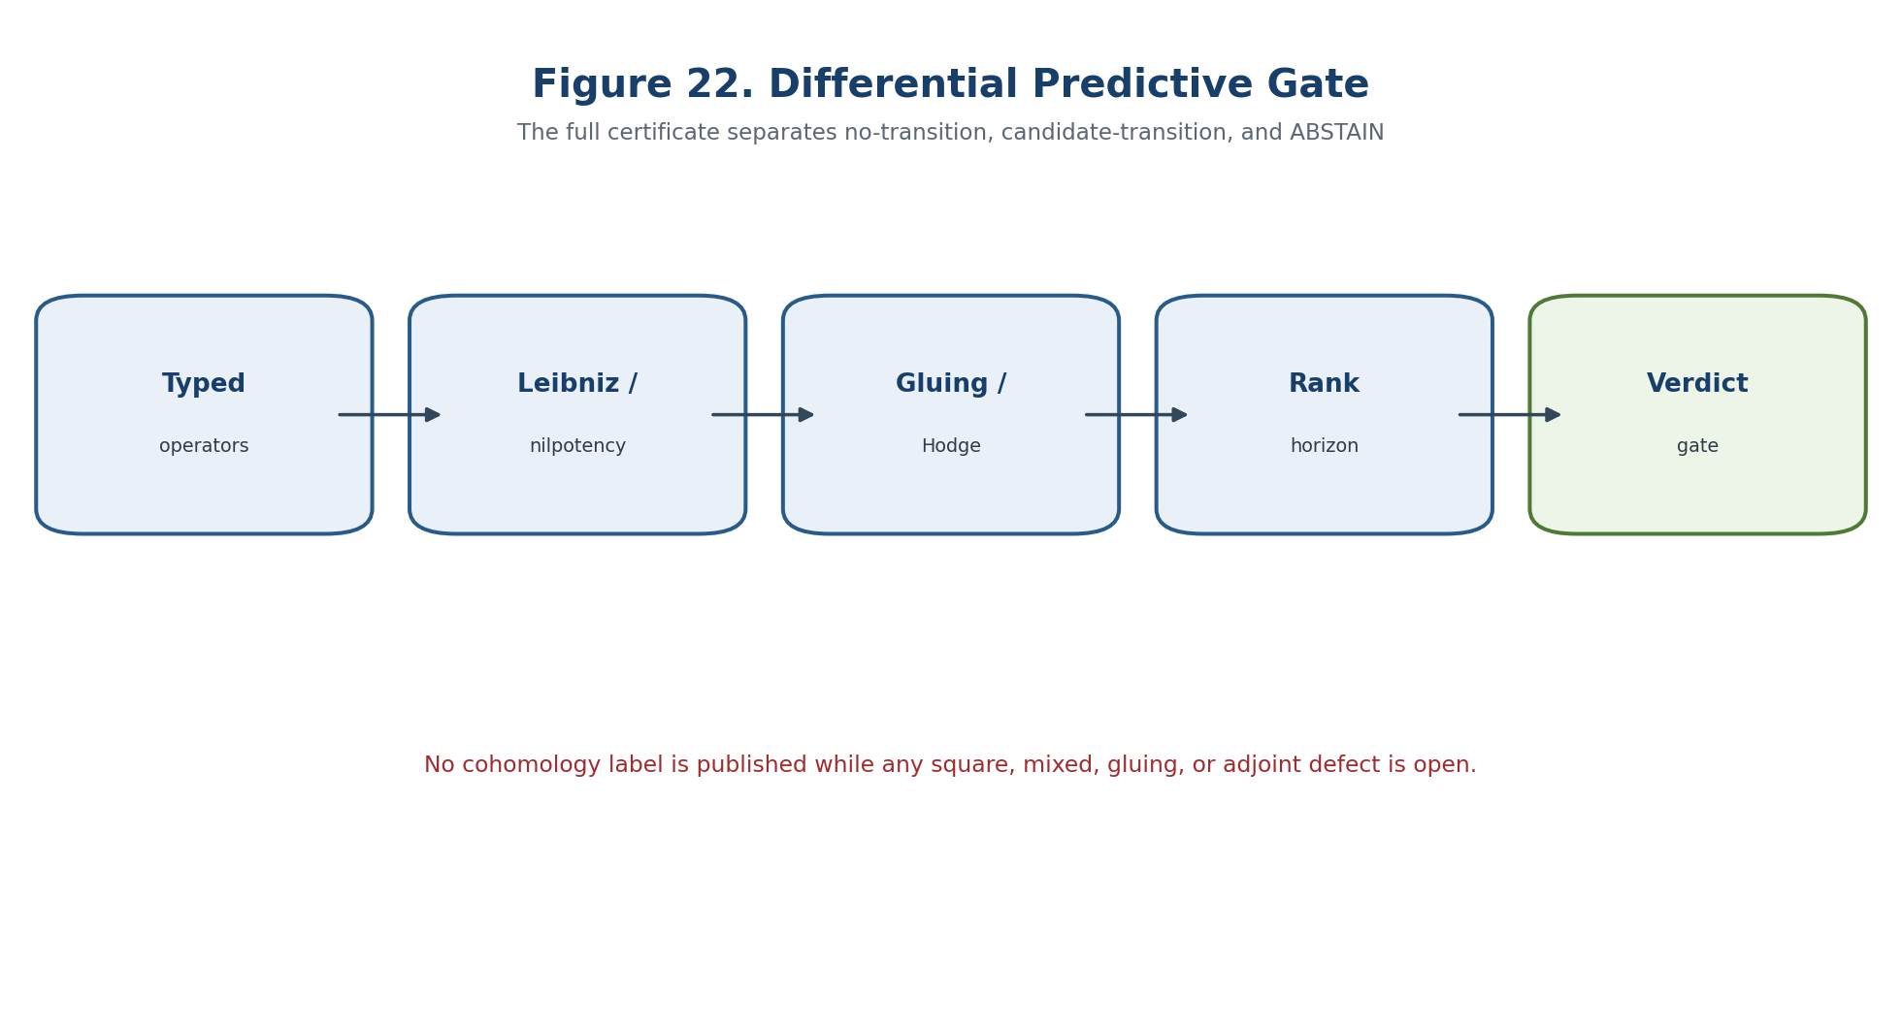
Figure 22. Blocker-safe gate for differential prediction.

11.6. DIFF-NAPG Computational Certificate
- TEST-TYPE-01: verify degree, domain, codomain, and restriction maps;
- TEST-LEIB-02: compute the full Leibniz defect on a basis;
- TEST-SQ-03: compute d_N^2 exactly or with certified intervals;
- TEST-ASS-04: verify the associator Leibniz identity;
- TEST-GLUE-05: compute K_ij on every overlap;
- TEST-HDG-06: verify metric/orientation transport and star_Hdg parity;
- TEST-ADJ-07: verify formal adjoint identity with boundary terms;
- TEST-TOT-08: verify internal, external, and mixed square components;
- TEST-RANK-09: certify maximal minors and conditioning;
- TEST-GATE-10: force ABSTAIN whenever any operator domain or bridge is open.

Chapter 12. Internal Construction of C_min^bullet, delta_min, and Theta_min
ONTOLOGY | An obstruction is a class of failure of a lift inside a declared structure.
EPISTEMOLOGY | It is established by complexes, quotient spaces, and independence from representatives.
PHENOMENOLOGY | It appears as a residual component that cannot be removed by an admissible correction.
LIMITATION | A zero primary class does not exclude higher obstructions and proves no physical realisation.
AUTHORIAL NOVELTY | The authorial contribution is the internal carrier, its external bridge, and its use in the Reper predictive gate.

The chapter gives the internal quadratic obstruction carrier a canonical two-term cochain complex. The construction is intentionally minimal: it controls only the declared quadratic evaluation problem. It does not absorb higher obstructions, global descent, the external E-complex, or a physical interpretation.

12.1. Quadratic Frame and Minimal Complex
Definition 12.1. NAPG Quadratic Frame [DEF-A] An object N consists of K, a graded carrier A^bullet, the admissible operation odot, structural data G, a class of Reper generators R, a formal quadratic space F_N^2, an evaluated space X_N^2, and a linear evaluation map Psi_N^2:F_N^2->X_N^2. All degrees, domains, codomains, and bases belong to the object passport.

Definition 12.2. Internal Minimal Complex [THM / IMPORT] Set C_min^2(N)=F_N^2, C_min^3(N)=X_N^2, all other relevant components zero, and delta_min^2=Psi_N^2.

0 -> F_N^2 --Psi_N^2--> X_N^2 -> 0. | T2-F045

Lemma 12.1. Nilpotency [THM] C_min^bullet is a cochain complex: the only possible composition after Psi_N^2 lands in C_min^4=0, and all other successive compositions include a zero arrow.

Definition 12.3. Canonical Map Theta_min [THM / IMPORT] Theta_min is the degree-three structure map that identifies an evaluated quadratic term with its position in C_min^3; it is not the quotient obstruction map.

Definition 12.4. Internal Obstruction Class [DEF-A] For q in X_N^2, let pi_N:X_N^2->X_N^2/im Psi_N^2. The obstruction is o_N(q)=[q]=pi_N(q) in H^3(C_min).

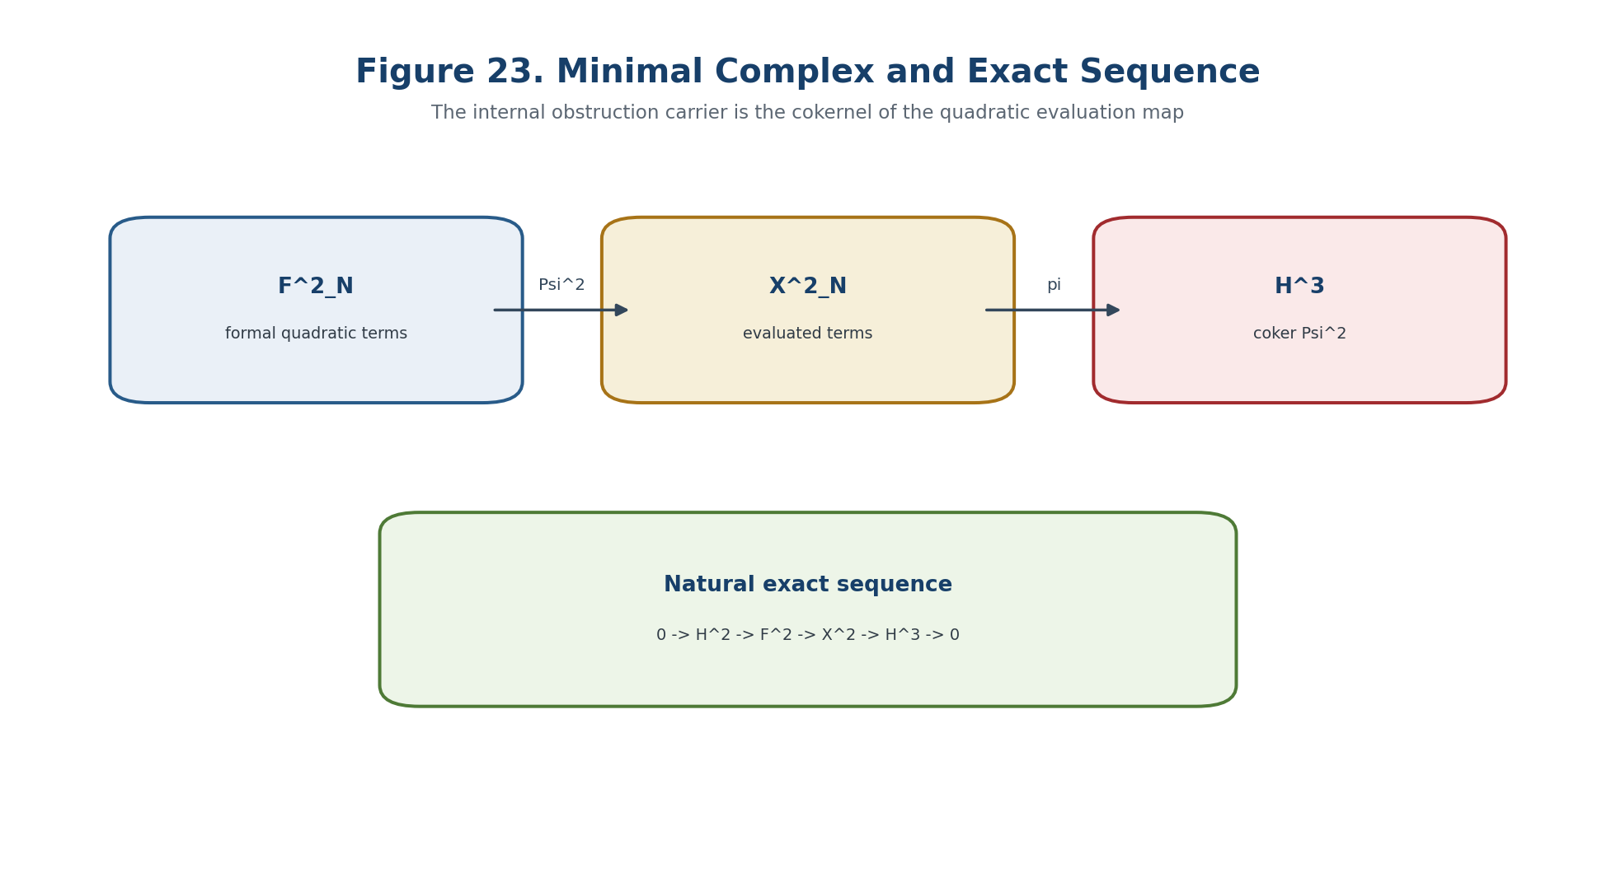
Figure 23. Minimal complex and its natural exact sequence.

12.2. Cohomologicaly and Exact Sequence
Theorem 12.2. Internal H2 and H3 [THM] H^2(C_min)=ker Psi_N^2 and H^3(C_min)=coker Psi_N^2=X_N^2/im Psi_N^2.

Theorem 12.3. Natural Exact Sequence [THM] There is a natural exact sequence 0->H^2->F_N^2->X_N^2->H^3->0.

0 -> H^2(C_min) -> F_N^2 --Psi_N^2--> X_N^2 -> H^3(C_min) -> 0.

Corollary 12.3.1. Finite-Dimensional Rank Formula [THM] If dim F_N^2=f, dim X_N^2=x, and rank Psi_N^2=r, then dim H^2=f-r and dim H^3=x-r.

12.3. Functoriality and Natural Canonicity
Theorem 12.4. Minimal-Complex Functor [THM] A morphism of quadratic frames carrying formal and evaluated spaces compatibly with Psi defines a cochain map. Hence N |-> C_min^bullet(N) is a functor.

Theorem 12.5. Natural Isomorphism with O_B [THM] The obstruction-carrier functor O_B=coker Psi_N^2 is naturally isomorphic to H^3 o C_min.

Corollary 12.5.1. Invariant Vanishing [THM] Vanishing of the internal obstruction class is preserved by every NAPG_q isomorphism. A numerical norm of a representative need not be preserved unless the morphism is isometric.

12.4. Lift Criterion and H2 Torsor
Definition 12.5. Lift [DEF-A] A lift of q in X_N^2 is f in F_N^2 such that Psi_N^2(f)=q. The set is Lift_N(q).

Theorem 12.6. Complete Internal Lift Criterion [THM] For q, the following are equivalent: q lies in im Psi_N^2; [q]=0 in H^3(C_min); Lift_N(q) is nonempty; the orthogonal residual is zero when a compatible inner product is chosen.

Theorem 12.7. Torsor of Lifts [THM] If f_0 is one lift, then Lift_N(q)=f_0+ker Psi_N^2. Thus the lift set is an affine torsor under H^2(C_min), not a unique solution.

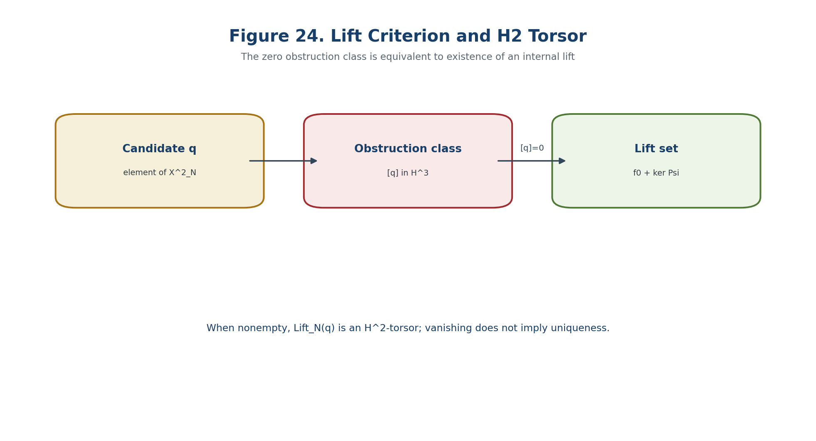
Figure 24. Lift criterion and H2 torsor of solutions.

12.5. Universal Property, Base Change, and Direct Sums
Theorem 12.8. Universal Extension into a Complex [THM] Given a cochain complex E^bullet and maps J^2:F_N^2->E^2, J^3:X_N^2->E^3 satisfying d_E J^2=J^3 Psi_N^2, there is a unique cochain map C_min^bullet(N)->E^bullet with those degree-two and degree-three components.

Theorem 12.9. Extension of Scalars [THM] For a field extension L/K, the minimal complex, its H^2, and its H^3 commute with scalar extension when tensoring is exact.

Theorem 12.10. Block-Diagonal Additivity [THM] For a direct sum of frames with Psi_{N direct_sum M}=Psi_N direct_sum Psi_M, H^2 and H^3 split as direct sums and obstruction classes add componentwise.

12.6. Canonical Class and Numerical Residual
Definition 12.6. Orthogonal Obstruction Residual [DEF-A / COMP] In a finite-dimensional real or complex sector, with Moore-Penrose pseudoinverse Psi^dagger, define r_min(q)=(I-Psi Psi^dagger)q.

r_min(q)=(I-Psi Psi^dagger)q.

Theorem 12.11. Residual Criterion [THM] r_min(q)=0 iff [q]=0 in H^3(C_min). If the class vanishes, f*=Psi^dagger q is the minimum-norm lift.

Definition 12.7. Normalised Internal Obstruction Index [DEF-A / DIAGNOSTIC] A diagnostic index may normalise ||r_min(q)|| by a predeclared scale, but its numerical value is representation- and metric-dependent. Only the zero/nonzero obstruction class is canonical under arbitrary isomorphism.

12.7. Analytic Families and Negative Prediction
Theorem 12.12. Constant-Rank Cohomology Bundles [THM] If rank Psi_t is constant on a connected open set J, ker Psi_t and im Psi_t form analytic subbundles; H^2_t and H^3_t form quotient bundles and the obstruction class o_t=[q_t] is an analytic section.

Corollary 12.12.1. Zeros of the Obstruction Section [THM] For one parameter, if the analytic obstruction section is not identically zero, its zeros have no interior accumulation point. Interior accumulation forces identical vanishing on the connected component.

Definition 12.8. Internal Transition Horizon [DEF-A] Delta_min is the union of rank-change, conditioning, type, Dom, D, chart, and bridge-failure loci for the minimal complex.

Lemma 12.13. Motion of the Residual [THM] With P_t=Psi_t Psi_t^dagger and r_t=(I-P_t)q_t, the variation of r_t is bounded by the variations of q_t and P_t in the constant-rank sector.

Theorem 12.14. Certified No-Lift Zone [THM / COMP] If ||r_t0||=rho>0 and the certified variation bound on a neighbourhood is less than rho, then r_t remains nonzero there and no internal lift exists anywhere in that neighbourhood.

12.8. Main Conditional Predictive Theorem
Theorem 12.15. Minimal-Obstruction-Safe Predictive Theorem [COND] For a family F_t=(N_t,Psi_t,q_t,rho_t,D_t,Dom_t), assume fixed dimensions and versioned bases, analytic or interval-certified Psi_t and q_t, constant rank and a singular-value gap off registered horizons, typed separation of q_t from the ternary associator, valid D/Dom, a defined Reper coordinate away from poles, valid preceding atlas/tangent/holonomy/differential certificates, and restriction to the internal quadratic lift. Then H^2 and H^3 have constant ranks off Delta_min; [q_t]=0 iff an internal lift exists; the lift set is an H^2 torsor; a certified positive residual excludes the lift locally; and a zero class yields only CANDIDATE-LIFT-TO-ORDER-2.

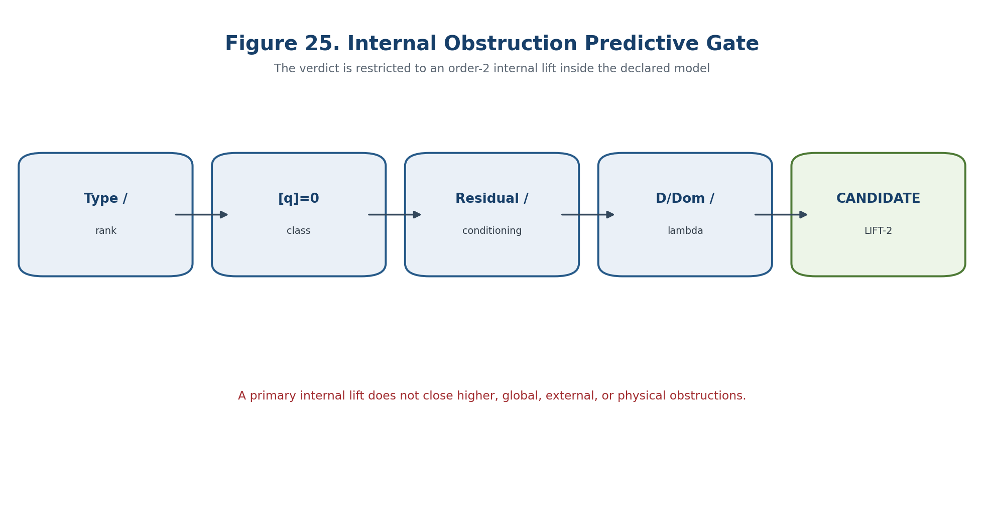
Figure 25. Blocker-safe gate for internal obstruction prediction.

12.9. Projective-Harmonic Reper Gate
Definition 12.9. Joint Certificate [DEF-A] Cert_min(t)=(type_ok,[q_t],||r_t||,sigma_t^+,Valid(D_t),Dom_t,delta_truth(t),Block_t).

The strict selector admits an internal lift candidate only when [q_t]=0, the numerical residual is below its certified tolerance, the positive singular-value gap exceeds its threshold, D and Dom are valid, and Block_t is empty. The additional filter lambda=-1 or delta_truth<=tau is independent and replaces none of these conditions.
lambda=-1 does not imply [q]=0, and [q]=0 does not imply lambda=-1.

Countertheorem 12.16. Four Prohibited Implications [THM] In general, H^3 nonzero does not imply a particular q is obstructed; [q]=0 does not imply uniqueness; [q]=0 does not eliminate higher or global obstructions; and H^3 nonzero implies no physical curvature, holonomy, or observable effect.

12.10. MIN-OB Computational Certificate
- TYPE: verify dimensions, bases, degrees, domains, and codomains;
- EXACT LINEAR ALGEBRA: compute rank, kernel, image, and cokernel of Psi;
- CLASS: reduce q modulo im Psi and store an exact representative;
- LIFT: solve Psi f=q or certify impossibility;
- TORSOR: store f_0+ker Psi rather than a single arbitrary lift;
- NUMERICS: compute pseudoinverse residual and positive singular-value gap with conditioning bounds;
- EVIDENCE: verify D/Dom and provenance of every matrix and basis;
- REPER: evaluate lambda only as an independent filter;
- VERDICT: NO-LIFT-IN-MODEL, CANDIDATE-LIFT-TO-ORDER-2, or ABSTAIN.

Chapter 13. External E-Complex and the Conditional Bridge Pi_E
ONTOLOGY | An internal obstruction acquires external meaning only through an explicit cochain bridge, not through a shared cohomological symbol.
EPISTEMOLOGY | The epistemic contract checks the external complex, the chain map, naturality, detection quality, and the separate associator and application bridges.
PHENOMENOLOGY | The external layer makes an internal residual visible, invisible, or supplemented by genuinely external classes.
LIMITATION | A vanishing external class implies nothing in reverse without injectivity, and no class is a physical event without a separate reduction.
AUTHORIAL NOVELTY | The authorial node is the blocker-safe bridge from the internal NAPG carrier to an external evidence-bearing complex.

The internal obstruction carrier O_B(N)=H^3(C_min(N)) does not become an external cohomology class merely because both objects use the symbol H^3. The transition requires a typed cochain map. This chapter constructs the external complex E^bullet(N), the bridge J_N, the induced map Pi_E,N, its blind and excess defects, the numerical injectivity margin, and the external transition horizon. All reverse, associator, analytic, and physical interpretations remain conditional.
Field | Controlled value
Canonical input | C_min^bullet(N): F_N^2 -> X_N^2; H^2=ker Psi_N^2; H^3=coker Psi_N^2=O_B(N); quotient map kappa_N.
Objective | Construct E^bullet(N), a cochain bridge J_N, and Pi_E,N:O_B(N)->H^3(E^bullet(N)).
Strict layer | Well-definedness, naturality, mapping cone, blind/excess defects, stable injective detection, and a parameter horizon.
Prohibition | Do not identify O_B with H^3(E), the associator, holonomy, an observable, or a physical event without separate maps.
Downstream use | Chapter 14 projectivises the nonzero obstruction carrier only after the zero and information-loss audits.

13.1. External Realisation and the B1-B8 Contract
Definition 13.1. External Realisation [DEF-A] For N in NAPG_q, an external realisation is E(N)=(E^bullet(N),d_E,Dom_E,G_E), where E^n(N) are K-modules or vector spaces, d_E has declared domains and codomains, and Dom_E and G_E record admissibility, regularity, grading, norms, and any auxiliary structures.

E(N)=(E^bullet(N), d_E, Dom_E, G_E). | T2-F046

d_E^{n+1} o d_E^n = 0 for all n. | T2-F047

Without the square-zero relation, E is only a precomplex and H^3(E^bullet) is undefined. A sequence of arrows does not create cohomology unless the compositions, domains, and closures satisfy the required identities.
Definition 13.2. Cochain Bridge J [DEF-A] A bridge from C_min^bullet(N) to E^bullet(N) is a cochain morphism whose essential components are J_N^2:F_N^2->E^2(N) and J_N^3:X_N^2->E^3(N).

J_N^2:F_N^2 -> E^2(N), J_N^3:X_N^2 -> E^3(N). | T2-F048

d_E^2 J_N^2 = J_N^3 Psi_N^2, d_E^3 J_N^3 = 0. | T2-F049

The first identity sends internal boundaries to external boundaries. The second ensures that every external image of an evaluated quadratic object is a 3-cocycle.
Condition | Content | Status
B1 | E^bullet(N) is a cochain complex; d_E^2=0 in every relevant degree. | THM/INPUT
B2 | J_N is a typed cochain map with explicit domains and codomains. | THM/INPUT
B3 | N -> E^bullet(N) is functorial for the chosen NAPG morphisms. | COND
B4 | J is a natural transformation C_min^bullet => E^bullet. | COND
B5 | Factorisation through kappa_N and H^3(J_N) is compatible with morphisms and admissible representation changes. | THM under B1-B4
B6 | Reverse detection requires injective Pi_E or a certified left inverse. | EXTRA
B7 | The associator channel beta_Ass is defined separately; Pi_E is not called an associator. | OPEN/SEPARATE
B8 | Physical, analytic, or domain interpretation requires a reduction, observable, data, and independent verification. | PHY-HYP/OPEN

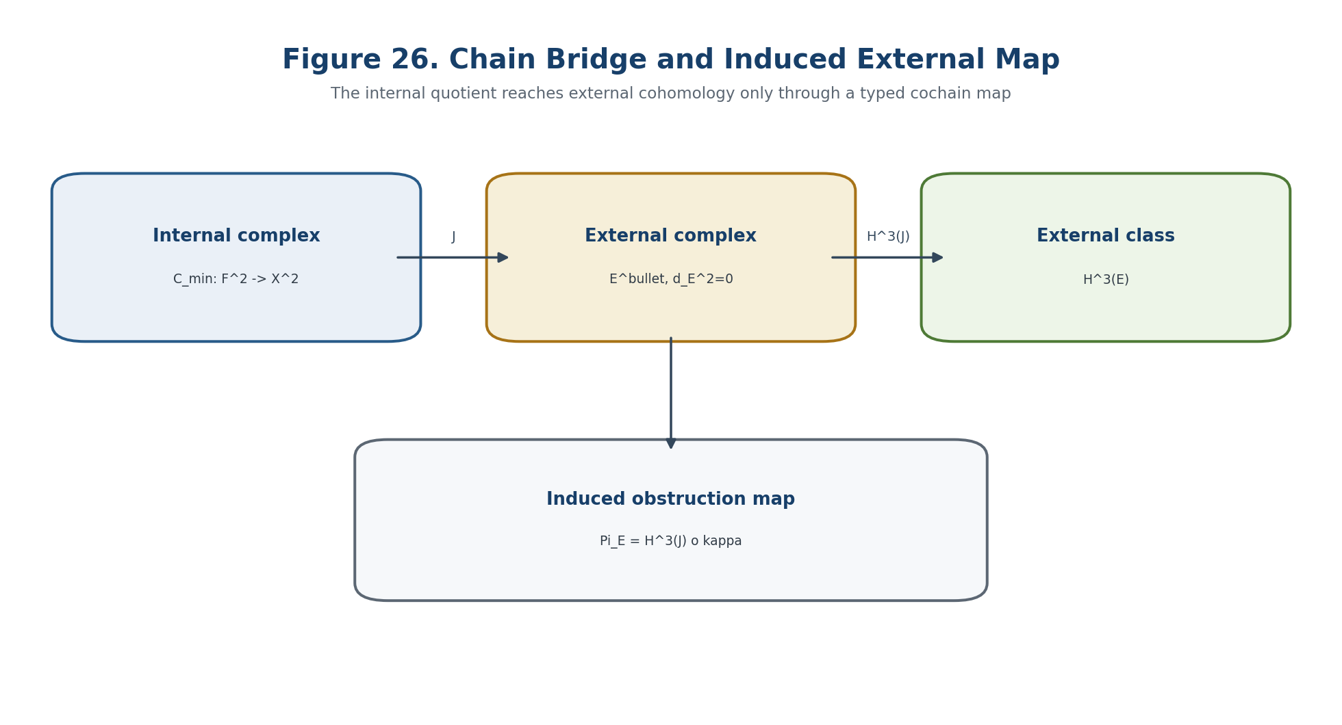
Figure 26. Chain bridge J and the induced external obstruction map Pi_E.

13.2. Well-Definedness and Naturality of Pi_E
Theorem 13.1. Descent to the Quotient [THM] Assume d_E^3 J_N^3=0. The assignment [x] -> [J_N^3 x] defines a linear map coker Psi_N^2 -> H^3(E^bullet(N)) if and only if J_N^3(Im Psi_N^2) is contained in Im d_E^2.

[x] |-> [J_N^3 x]. | T2-F050

J_N^3(Im Psi_N^2) subset Im d_E^2. | T2-F051

Proof. Two representatives x and x+Psi_N^2 f define the same internal class. Their external images define the same cohomology class exactly when J_N^3 Psi_N^2 f is an external boundary for every f. Closedness follows from d_E^3J_N^3=0. □
The chain identity d_E^2J_N^2=J_N^3Psi_N^2 implies this condition. Conversely, a lift J_N^2 may be selected over vector spaces after choosing a section of d_E^2 onto its image. For general modules, projectivity or a splitting is a separate obligation.
Definition 13.3. External Obstruction Map [COND/THM under B1-B5] Under B1-B5, Pi_E,N is the cohomology map induced by J_N after the canonical quotient identification kappa_N.

Pi_E,N := H^3(J_N) o kappa_N : O_B(N) -> H^3(E^bullet(N)). | T2-F052

Pi_E,N([x]) = [J_N^3 x]. | T2-F053

Theorem 13.2. Naturality [THM under B3-B5] For every admitted morphism f:N->N', the external square commutes: H^3(E(f)) Pi_E,N = Pi_E,N' O_B(f).

H^3(E(f)) Pi_E,N = Pi_E,N' O_B(f). | T2-F054

13.3. One-Way, Reverse, and Complete Detection
Theorem 13.3. One-Way Detection [THM] For every correctly defined Pi_E, a nonzero image implies a nonzero internal class.

Pi_E(o) != 0 => o != 0. | T2-F055

The converse is false without injectivity. Moreover, a nonzero arbitrary element of H^3(E) is not evidence of an internal obstruction unless it is certified to belong to Im Pi_E.
Theorem 13.4. Reverse Detection Criterion [THM] The following are equivalent: Pi_E is injective; Pi_E(o)=0 implies o=0; o!=0 implies Pi_E(o)!=0; and J_N^3x in Im d_E^2 implies x in Im Psi_N^2. In finite dimensions these are also equivalent to the existence of a linear left inverse S with S Pi_E=id, although S need not be canonical.

Bridge quality | Condition | Permitted conclusion
faithful | Pi_E injective | An external zero supports the reverse internal-zero conclusion.
complete | Pi_E surjective | Every external H^3 class is explained by an internal class.
exact | Pi_E is an isomorphism | Degree-3 information agrees.
degree-3 quasi-isomorphism | H^3(J) is an isomorphism | No assertion about other degrees.
quasi-isomorphism | H^n(J) is an isomorphism for all n | Full cohomological equivalence.

13.4. Mapping Cone, Blind Defect, and Excess Defect
Definition 13.5. Mapping Cone [CL] For a cochain bridge J:C_min^bullet->E^bullet, define Cone(J)^n=E^n direct-sum C_min^{n+1} with differential D_J(e,c)=(d_Ee+Jc,-delta_min c).

Cone(J)^n = E^n direct-sum C_min^{n+1}. | T2-F056

D_J(e,c)=(d_E e + Jc, -delta_min c). | T2-F057

Theorem 13.5. Exact Detection Sequence [THM] The mapping cone yields the exact segment H^2(C_min)->H^2(E)->H^2(Cone J)->O_B --Pi_E--> H^3(E)->H^3(Cone J)->0.

H^2(C_min)->H^2(E)->H^2(Cone J)->O_B --Pi_E--> H^3(E)->H^3(Cone J)->0. | T2-F058

Blind_E(N):=Ker Pi_E,N, Excess_E(N):=Coker Pi_E,N. | T2-F059

Blind_E=Im(H^2(Cone J)->O_B), Excess_E isomorphic H^3(Cone J). | T2-F061

Blind_E measures internal obstructions invisible to the selected external realisation. Excess_E measures external degree-3 classes not explained by the internal quadratic layer. These are different failures and cannot cancel one another.
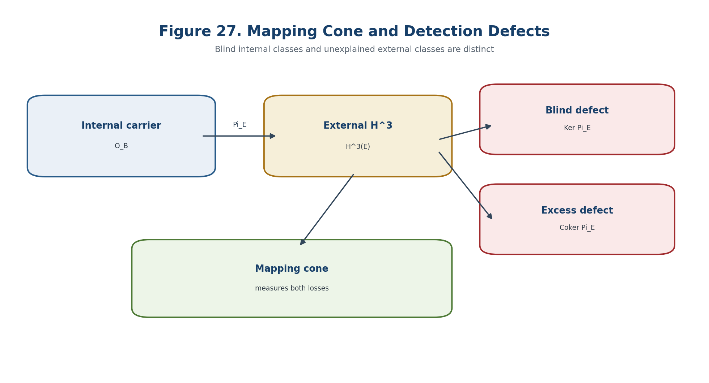
Figure 27. Mapping cone and the two defects of external detection.

13.5. Dependence on the External Realisation
Theorem 13.6. Chain-Homotopy Invariance [CL/THM] If J and K are chain-homotopic maps C_min^bullet->E^bullet, then H^n(J)=H^n(K) in every degree and Pi_E^J=Pi_E^K.

H^n(J)=H^n(K) for all n; therefore Pi_E^J=Pi_E^K. | T2-F063

J^2-K^2=d_E^1h^2+h^3Psi^2, J^3-K^3=d_E^2h^3. | T2-F064

Thus Pi_E depends on the homotopy class of the bridge, not on its literal matrix. Non-homotopic bridges may detect different external information.
Proposition 13.6.2. Comparison of External Complexes [PROP] If Q:E^bullet->F^bullet is a cochain map and J_F=QJ_E, then Pi_F=H^3(Q)Pi_E. Detection is preserved only when H^3(Q) is injective on Im Pi_E.

Pi_F = H^3(Q) Pi_E. | T2-F065

Definition 13.6. Category of External Realisations [DEF-A] An object of ExtReal(N) is a pair (E,J) satisfying B1-B2. A morphism (E,J)->(F,K) is a cochain map Q:E->F with QJ=K.

(E,J) |-> Pi_E:O_B(N)->H^3(E). | T2-F066

An external class is canonical relative to a declared subcategory only when the admissible realisations are connected by J-compatible quasi-isomorphisms and the resulting degree-3 classes agree. Coinciding dimensions or names are not a comparison theorem.

13.6. Finite-Dimensional Numerical Detection
In a Euclidean or Hermitian sector, choose orthogonal decompositions of the internal quotient and external cohomology. The induced bridge is represented by a finite matrix P_E from the minimal-norm internal carrier to the harmonic external carrier.
X_N^2=Im Psi_N^2 direct-sum O_N, Ker d_E^3=Im d_E^2 direct-sum H_E^3. | T2-F067

P_E:=P_{H_E^3} J_N^3 |_{O_N}. | T2-F068

Theorem 13.8. Stable Reverse Detection [THM/COMP] P_E is injective exactly when its smallest singular value is positive. If sigma_min(P_E)>=s_0>0, then ||Pi_E(o)||>=s_0||o|| for every internal class o.

sigma_min(P_E) >= s_0 > 0. | T2-F069

||Pi_E(o)|| >= s_0 ||o||. | T2-F070

eta_E([x]):=||P_{H_E^3} J_N^3 x_min||. | T2-F071

The invariant residual eta_E vanishes exactly when the external class vanishes. A certified lower bound supplies a robust one-way obstruction statement; it does not create an inverse conclusion unless the injectivity margin is also certified.

13.7. Parameter Families and the External Horizon
Delta_E=Delta_complex union Delta_chain union Delta_rankPi union Delta_sigmaPi union Delta_hom union Delta_D union Delta_Dom union Delta_glue. | T2-F072

The horizon records failures of the complex identity, the chain-map identity, constancy of rank, injectivity margin, homotopy class, Evidence-D, domain, and globalisation. These components are not merged into a single untyped error score.
Theorem 13.9. Persistence of a Nonzero External Obstruction [COND] If the family of bridges and harmonic representatives is continuous on a connected interval, the rank profile is constant, and ||Pi_E,t(o_t)||>=epsilon_E>0, then the external obstruction cannot disappear on that interval.

||Pi_E,t(o_t)|| >= epsilon_E for all t in I. | T2-F073

P_E(t)=(dim H^3(E_t), rank Pi_E,t, dim Blind_E,t, dim Excess_E,t, sigma_min(P_E,t), eta_E(o_t)). | T2-F074

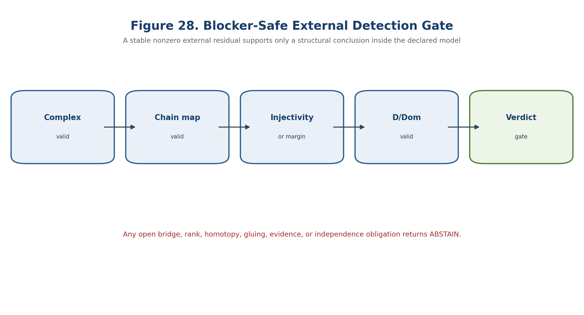
Figure 28. Blocker-safe gate for external detection.

13.8. Separate Associator Channel
beta_Ass,N:T_Ass(N)->H^3(A_Ass^bullet(N)). | T2-F075

The associator may be transported to its own external complex through beta_Ass. An identification with Pi_E requires an explicit comparison S on the internal side and Q on the external side, together with the commuting relation below. Without it, both channels remain mathematically distinct.
beta_Ass o S = H^3(Q) o Pi_E. | T2-F076

13.9. Counterexamples and EXT-E Certificate
- Pi_E=0 on a nonzero internal carrier: all internal classes are blind; an external zero proves nothing in reverse.
- An external H^3 class outside Im Pi_E: a nonzero external class need not come from the internal quadratic layer.
- Two non-homotopic bridges into the same E-complex: the external detection depends on the chosen bridge.
- A bridge with very small sigma_min: exact injectivity can coexist with severe numerical instability.
- An external class and a nonzero associator in unrelated complexes: shared dimension or notation does not define a bridge.
- A continuously varying family whose rank changes: the external profile may jump only at the registered horizon.
Certificate step | Required check
EXT-E-01 | Record E^n, grading, norms, domains, and the proof that d_E^2=0.
EXT-E-02 | Record J^2,J^3 and verify the chain identities exactly or with certified intervals.
EXT-E-03 | Construct quotient and harmonic representatives and verify Pi_E is independent of representatives.
EXT-E-04 | Compute rank, kernel, cokernel, blind/excess dimensions, and sigma_min(P_E).
EXT-E-05 | Verify naturality or record the precise morphism class for which it is open.
EXT-E-06 | Track the parameter horizon and continuity of the selected obstruction section.
EXT-E-07 | Keep beta_Ass and every physical or analytic bridge in separate fields.
EXT-E-08 | Emit NO-EXTERNAL-OBSTRUCTION-REMOVAL-IN-MODEL, CANDIDATE-EXTERNAL-TRANSITION, or ABSTAIN; store hashes.

BOUNDARY OF CHAPTER 13. A nonzero certified external image supports a nonzero internal class. A reverse conclusion requires injectivity or a left inverse. Neither direction is a physical observation.

Prior art includes cochain maps, mapping cones, exact sequences, homotopy invariance, singular-value conditioning, and functorial cohomology. The authorial contribution is the KLT-RBD arrangement of the internal NAPG carrier, the conditional Pi_E bridge, the blind/excess ledger, D/Dom controls, and the blocker-safe predictive horizon.

Chapter 14. Obstruction Spaces and Projective Carriers
ONTOLOGY | The obstruction carrier is first a vector space with a distinguished zero section; projectivisation is a later quotient of its nonzero part.
EPISTEMOLOGY | Knowledge requires an explicit audit of scale, sign, phase, provenance, lift, domain, and gluing information lost by the quotient.
PHENOMENOLOGY | The carrier appears as a direction of obstruction together with a rank/orbit stratum and a projective transition horizon.
LIMITATION | The zero class cannot be projectivised, and local projective carriers do not globalise without identification maps and effective descent.
AUTHORIAL NOVELTY | The authorial node joins the NAPG obstruction carrier, Fano firewall, Reper-lambda gate, and information-loss ledger.

Chapter 14 starts from the vector obstruction carrier and only then passes to projective directions. This order is mandatory: projectivisation removes the zero class, scale, and—depending on the scalar group—sign or phase. The chapter records the resulting losses, stratifies the nonzero carrier, constructs a Fano globalisation firewall, and defines a projective transition horizon suitable for negative structural prediction.

14.1. Vector Obstruction Carrier
O_B(N)=H^3(C_min(N))=X_N^2 / Im Psi_N^2. | T2-F077

Definition 14.1. Vector Carrier [DEF-A] Car_B(N)=(O_B,0_B,Fil_B,Prov_B,Dom_B), where the carrier retains the distinguished zero, a filtration, provenance, and the admissible domain.

Car_B(N)=(O_B,0_B,Fil_B,Prov_B,Dom_B). | T2-F078

O_B^x=O_B minus {0_B}. | T2-F079

The zero section encodes absence of the selected internal obstruction. It is not an ordinary projective direction. Every algorithm must test exact or certified separation from zero before projectivising.

14.2. Projectivisation and Its Exact Losses
Definition 14.2. Projective Obstruction Carrier [CL/DEF] The projective carrier is the quotient of the nonzero vector carrier by nonzero scalar multiplication.

P(O_B)=O_B^x / K^x, o~o' iff there exists a in K^x with o'=ao. | T2-F080

Theorem 14.1. Projective Equivalence [CL/THM] Two nonzero representatives define the same projective point exactly when they span the same one-dimensional subspace. The quotient retains direction but removes magnitude and may remove orientation or complex phase.

Proposition 14.2. Partial Functoriality [CL/PROP] A linear map f:O->O' induces P(f) only away from P(ker f).

P(f):P(O) minus P(ker f) -> P(O'), [o] |-> [f(o)]. | T2-F081

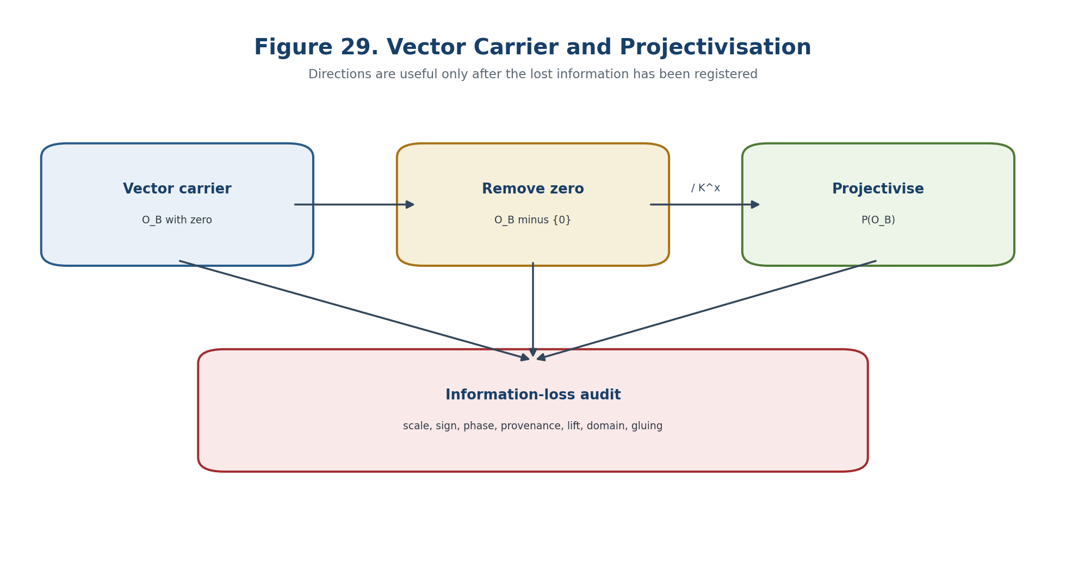
Figure 29. Vector carrier, projectivisation, and the mandatory information-loss audit.
Lost datum | Why it is lost | Repair certificate
zero class | P(O_B) is defined only on O_B minus {0}. | Exact ZERO flag and residual margin.
scale | [o]=[ao] for every admitted nonzero scalar a. | Metric and normalisation rule.
sign / orientation | Over R, [o]=[-o] in ordinary projective space. | Oriented ray or double cover.
complex phase | Over C, all nonzero phases are quotiented. | U(1) gauge or phase convention.
provenance | The point alone carries no source chain. | Evidence-D record.
lift representative | A class does not select an element of the H^2 torsor. | Lift-torsor coordinate and gauge.
domain and gluing | The same coordinates may occur in incompatible models. | Dom signature and descent certificate.

14.3. Normalised, Oriented, and Metric Carriers
S(O_B) -> P(O_B), u |-> [u], fibre={u,-u}. | T2-F082

After a Hermitian or Euclidean metric is fixed, unit representatives form a spherical cover of the projective carrier. The cover remains two-to-one over R and a U(1)-bundle over C. No metric is canonical unless it belongs to the model data.
d_P([u],[v])=arccos(|<u,v>|/(||u|| ||v||)). | T2-F083

The projective metric measures angular separation. It cannot replace an absolute obstruction norm: two vectors may be projectively close while their magnitudes or conditioning differ by orders of magnitude.

14.4. Rank and Orbit-Type Stratification
S_r={ [o] in P(O_B) : rank A(o)=r }. | T2-F084

G_[o]={ g in G : g o belongs to K^x o }. | T2-F085

Definition 14.3. Projective Structural Profile [DEF-A] A point is recorded together with the rank of its associated operator or tensor, its stabiliser orbit type, support data, provenance, and domain signature.

Rank strata and orbit types are invariant only for homogeneous constructions. Every candidate invariant must be checked under o->ao. Whitney regularity, local triviality of orbit types, and the compatibility of the selected group action remain explicit model obligations rather than automatic consequences of finite dimensionality.

14.5. Conical and Positive Projective Carriers
P(C_B)=(C_B minus {0})/K^x subset P(O_B). | T2-F086

P_+(C_B)=(C_B minus {0})/R_{>0}. | T2-F087

For an ordered or positive cone, quotienting only by positive scalars retains the distinction between o and -o. Ordinary projectivisation destroys this order information. The choice between P and P_+ is therefore part of the type, not a presentational preference.

14.6. Local Carriers and the Fano Globalisation Firewall
O_pre=direct_sum_{L in Lines(Fano)} O_L. | T2-F088

O_glob=colim(O_L,phi_LL'). | T2-F089

Theorem 14.5. Local-to-Global No-Go [THM] A family of projective carriers P(O_i) does not determine a global P(O). Linear identification maps, cocycle conditions, compatible zero sections, Evidence-D, and effective descent are required.

This strengthens the Fano ontological barrier: a local incidence picture does not become a global projective plane because the number of points or lines appears appropriate. A global carrier must be constructed through typed maps.
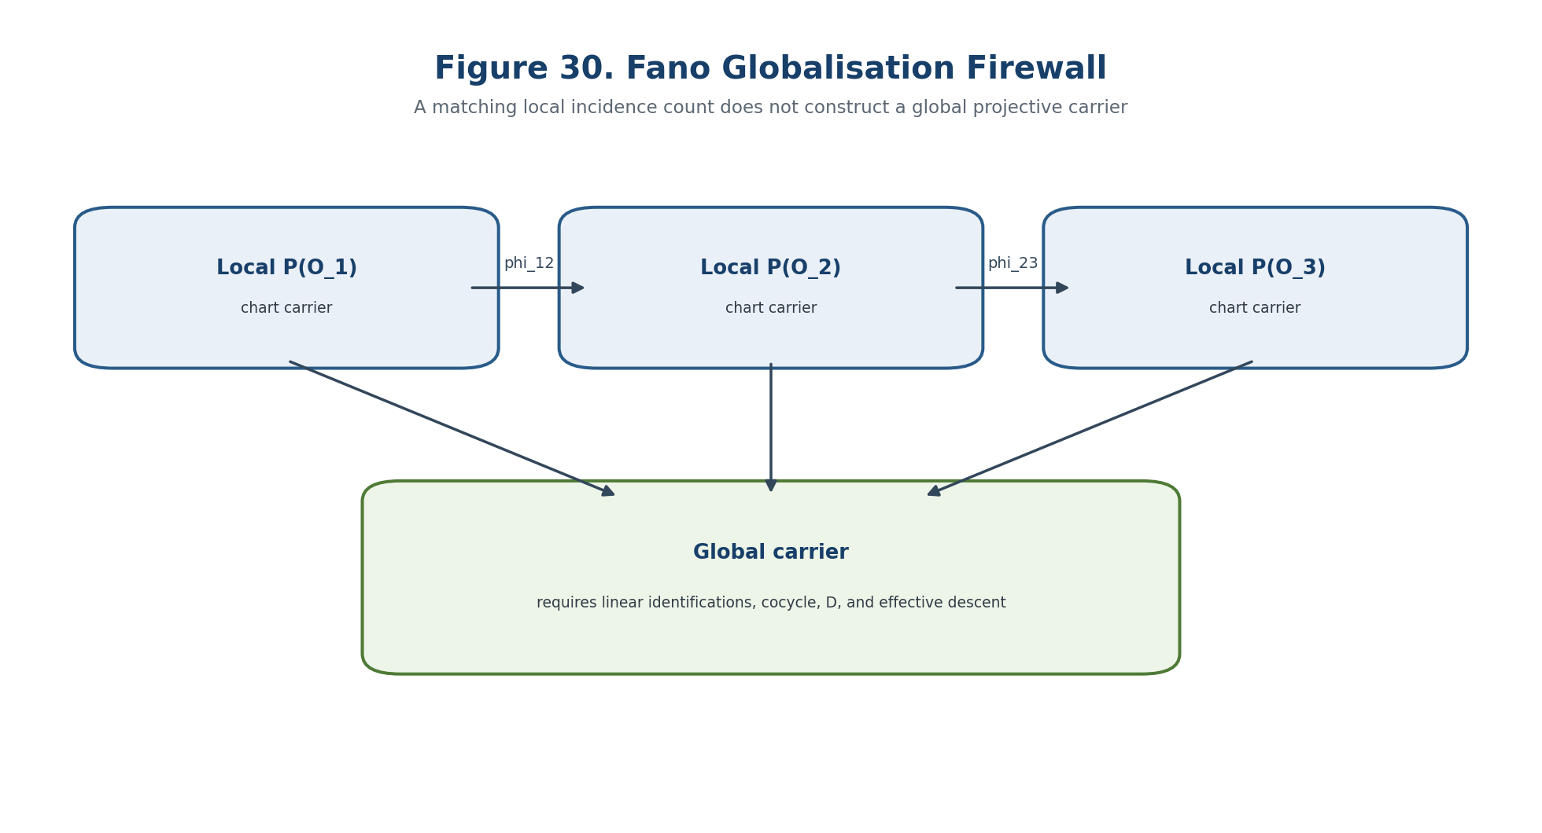
Figure 30. Fano globalisation firewall: local carriers require identification maps and effective descent.

14.7. Projective Transition Horizon
Delta_proj=Delta_zero union Delta_rank union Delta_orbit union Delta_chart union Delta_glue union Delta_D union Delta_Dom. | T2-F090

Component | Entry condition | Interpretation
Delta_zero | o_t=0 or loss of certified separation from zero | appearance or disappearance of the selected internal class
Delta_rank | rank A(o_t) changes | algebraic-type change
Delta_orbit | stabiliser type changes | symmetry-type change
Delta_chart | selected projective chart degenerates | coordinate defect; not necessarily structural
Delta_glue | cocycle or effective descent fails | local-to-global break
Delta_D | Evidence-D becomes invalid | epistemic blocker
Delta_Dom | admissible domain changes | change of the claim domain

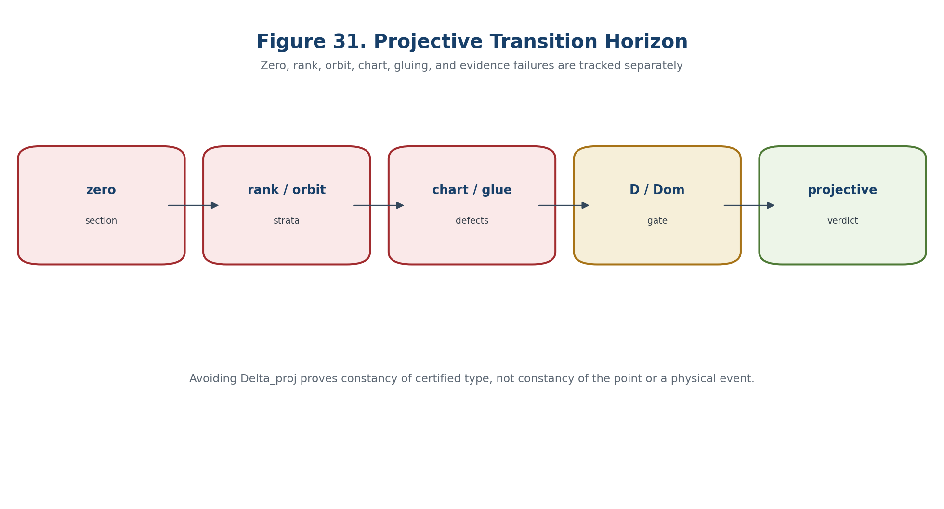
Figure 31. Components of the projective transition horizon Delta_proj.
Theorem 14.6. Constancy of Projective Type [COND] Let t->o_t be a continuous nonzero section on a connected interval. If the rank and orbit strata are locally closed, the path avoids Delta_proj, and D/Dom and gluing data remain fixed, then the certified projective profile stays in one connected stratum.

The theorem does not assert that [o_t] is a constant point. Motion inside the same certified stratum is allowed.
I intersect Delta_proj=empty => transition of certified projective type is impossible in the model. | T2-F091

14.8. Projective Carrier and Reper-Lambda
The Reper cross-ratio and the projective obstruction carrier are two different projective layers. The first concerns four points on P^1; the second concerns one-dimensional directions in O_B. A connection requires a separately defined rational map.
chi_lambda:P(O_B) dashedrightarrow P^1(K). | T2-F092

Theorem 14.7. No Automatic Lambda Bridge [THM] A point [o] in P(O_B) does not determine a canonical lambda. Four compatible homogeneous or rational functionals R,I,U,D and a proof of cross-ratio invariance are required.

lambda([o])=cr(U([o]),I([o]);R([o]),D([o])). | T2-F093

Even when lambda=-1, the nonzero test, Evidence-D, Dom_lambda, the absence of internal and external obstruction blockers, and the validity of chi_lambda remain separate obligations.

14.9. Information-Loss and Restoration Ledger
Cert_proj=([o],ZERO,NORM,ORIENT,PROV,LIFT,DOM,GLUE,HASH). | T2-F094

Code | Lost layer | Minimum repair | Verdict without repair
LOSS-0 | zero class | ZERO flag plus exact residual | ABSTAIN
LOSS-S | scale | metric and normalisation | direction only
LOSS-SGN | sign / orientation | oriented ray or double cover | sign unknown
LOSS-PH | complex phase | U(1) gauge certificate | phase unknown
LOSS-PR | provenance | Evidence-D chain | source unknown
LOSS-LF | lift representative | H^2 torsor coordinate | lift nonunique
LOSS-DOM | domain | Dom signature | claim not transportable
LOSS-GL | globalisation | descent certificate | local only

14.10. Separating Models and Computational Certificate
Model | Data | Refuted inference
same point, different norms | o=(1,0), o'=(10^6,0) | same projective point does not mean equal quantitative risk
opposite signs | o and -o over R | ordinary projectivisation loses orientation
zero class | o=0 | P(o) is undefined
map with kernel | f(x,y)=x | P(f) is undefined at [0:1]
local but not global | inconsistent phi_ij | charts do not glue automatically
small angular distance | u_n=n e_1, v_n=n e_1+e_2 | angle tends to zero while absolute defect remains
lambda without bridge | same [o], different quadruples of functionals | lambda is not determined by [o]
positive cone | o and -o | ordinary P loses order type

PROJ step | Check
01-04 | Build an exact basis of O_B, identify zero, fix the field/metric/action, and normalise or choose a positive ray.
05-08 | Construct projective charts, verify chart changes, compute rank strata and stabilisers.
09-12 | Verify homogeneity, build the ZERO/SCALE/SIGN ledger, provenance, and lift-torsor data.
13-16 | Verify local-to-global cocycles, build Delta_proj, bound projective distances, and check chi_lambda and its poles.
17-18 | Emit a blocker-safe verdict and preserve versions, hashes, and the machine-readable loss ledger.

14.11. Main Conditional Prediction Theorem
Theorem 14.8. Projective Obstruction-Safe Prediction [COND] Let N_t be a finite-dimensional regular family with a continuous obstruction section o_t, a projective atlas, homogeneous rank/orbit invariants, effective descent, valid D/Dom, and a reproducible PROJ certificate. If the path avoids Delta_proj and remains separated from the zero section and chart poles, the certified projective obstruction type cannot change. A transition requiring a different type is impossible inside the model; a horizon crossing yields only a candidate.

P_proj(t)=([o_t],S_rank(t),S_orbit(t),Dom_t,Glue_t). | T2-F095

I intersect Delta_proj=empty => type(P_proj(t))=constant on I. | T2-F096

Block_proj=B_zero union B_scale union B_sign union B_chart union B_hom union B_glue union B_D union B_Dom union B_lift union B_ind. | T2-F097

Output | Necessary condition | Permitted interpretation
NO-PROJECTIVE-TYPE-TRANSITION-IN-MODEL | path avoids Delta_proj and blockers are empty | negative structural prediction
CANDIDATE-PROJECTIVE-TRANSITION | path meets Delta_proj and blockers are empty | target for further testing
ZERO-INTERNAL-OBSTRUCTION | o=0 exactly | vanishing of the selected internal class
ABSTAIN | at least one blocker | conclusion prohibited

BOUNDARY OF CHAPTER 14. The result is conditional and finite-dimensional. It asserts neither physical time, a causal mechanism, a transition probability, nor an experimental effect.

Prior art includes projective spaces, orbit-type and rank stratifications, projective metrics, cones, descent, and stratified geometry. The authorial contribution is their KLT-RBD integration with the NAPG obstruction carrier, Evidence-D, Reper-lambda authorisation, the Fano firewall, and the blocker-safe negative verdict.

Chapter 15. Hodge Decomposition and the Analytic NAPG Layer
ONTOLOGY | An analytic object is an operator together with Hilbert spaces, a dense domain, closure, adjoint, and boundary or interface conditions.
EPISTEMOLOGY | A harmonic representative identifies ordinary cohomology only after a closed-range or Fredholm certificate; otherwise it represents reduced cohomology.
PHENOMENOLOGY | Analytic stability appears as a spectral gap separating the harmonic sector from the positive spectrum.
LIMITATION | Nilpotency, formal symmetry, or compact individual strata do not by themselves imply ellipticity, self-adjointness, Fredholmness, or physical meaning.
AUTHORIAL NOVELTY | The authorial node is the Hodge-Fredholm certificate coupled to NAPG obstruction carriers, D/Dom, and a three-valued predictive verdict.

This chapter builds the analytic layer in which internal and external obstruction classes may acquire stable harmonic representatives. The construction distinguishes six levels: a precomplex, a Hilbert complex, a closed-range sector, an elliptic realisation, a boundary/Fredholm sector, and a predictive analytic sector. The output is three-valued: stable non-removal of a tracked obstruction, an analytic transition candidate, or ABSTAIN because the operator domain or another mandatory certificate is open.
Level | Object | Minimum certificate | Permitted conclusion
A0 | precomplex | spaces and partial d_k only | cohomology prohibited
A1 | Hilbert complex | closed densely defined d_k and d_{k+1}d_k=0 | reduced Hodge decomposition
A2 | closed-range sector | ran d_k and ran d_k* closed | ordinary cohomology is harmonic
A3 | elliptic realisation | symbol sequence exact for xi!=0 | regularity and finite-dimensional harmonic sector on compact base
A4 | boundary/Fredholm sector | elliptic boundary conditions, closed ranges, finite kernel/cokernel | index, Green operator, spectral control
A5 | predictive analytic sector | uniform gap, D/Dom, bridges, hashes | negative verdict or candidate

15.1. Hilbert Complex and Two Cohomologicalies
Definition 15.1. Hilbert Complex [CL/DEF] A Hilbert complex is a sequence of Hilbert spaces H^k and densely defined closed operators d_k with ran d_k contained in ker d_{k+1}. The inclusion includes the requirement that the composition be defined on the relevant operator domain.

d_k:D(d_k) subset H^k -> H^{k+1}, ran d_k subset ker d_{k+1}. | T2-F098

Z^k=ker d_k, B^k=ran d_{k-1}, H^k=Z^k/B^k, Hbar^k=Z^k/closure(B^k). | T2-F099

Ordinary cohomology may be non-Hausdorff when B^k is not closed. Reduced cohomology always divides by a closed subspace. The analytic layer therefore uses reduced cohomology until a closed-range certificate is supplied.
Lemma 15.1. Adjoint Orthogonality [CL/THM] For a densely defined closed d_k, the adjoint d_k* is closed and the standard orthogonal relations hold.

(ran d_k)^perp=ker d_k*, closure(ran d_k*)=(ker d_k)^perp. | T2-F100

15.2. Hodge Laplacian with an Explicit Domain
Definition 15.3. Hodge Laplacian [CL/DEF] In degree k, Delta_k=d_{k-1}d_{k-1}*+d_k*d_k on the domain where every composition is defined.

Delta_k=d_{k-1}d_{k-1}* + d_k* d_k. | T2-F101

D(Delta_k)={u in D(d_k) intersect D(d_{k-1}*): d_ku in D(d_k*), d_{k-1}*u in D(d_{k-1})}. | T2-F102

The differential expression without its domain is not an operator. Boundary and singular problems may have inequivalent closed, self-adjoint, or non-self-adjoint realisations of the same formal expression.
Harm^k=ker d_k intersect ker d_{k-1}* = ker Delta_k. | T2-F103

<Delta_k u,u>=||d_ku||^2+||d_{k-1}*u||^2. | T2-F104

The energy identity requires u to belong to the operator domain and the integration-by-parts formula to have no uncontrolled boundary term.

15.3. Weak and Strong Hodge Decomposition
Theorem 15.2. Weak Hodge Decomposition [CL/THM] Every Hilbert complex has the orthogonal decomposition below; its harmonic sector is canonically isometric to reduced cohomology.

H^k=closure(ran d_{k-1}) direct-sum Harm^k direct-sum closure(ran d_k*). | T2-F105

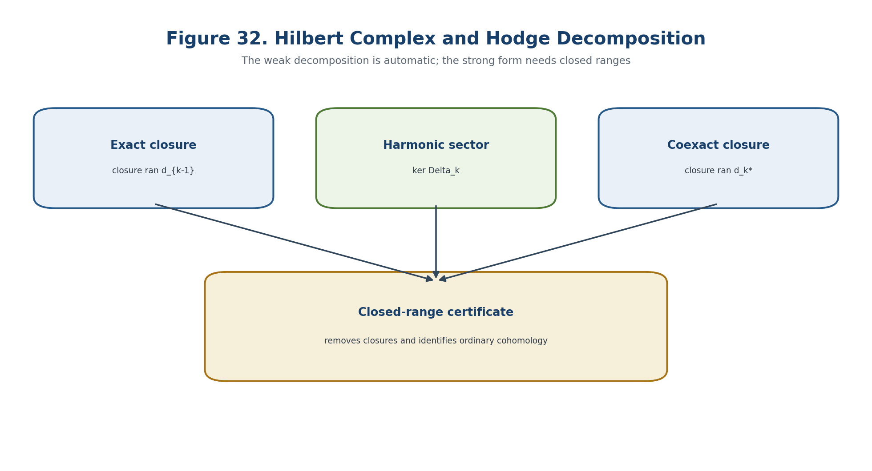
Figure 32. Hilbert complex and weak Hodge decomposition; ordinary cohomology requires closed ranges.
Theorem 15.3. Strong Decomposition Criterion [CL/THM] In a fixed degree, closedness of ran d_{k-1} and ran d_k* is equivalent to the strong decomposition without closures, a coercive estimate on the harmonic complement, and—under a nonnegative self-adjoint realisation—isolation of zero in the spectrum.

gamma_k:=inf(spectrum(Delta_k) minus {0})>0. | T2-F106

The positive number gamma_k is the spectral gap. Its reciprocal controls the Green operator and the conditioning of analytic reconstruction.
G_k=(Delta_k|_{(Harm^k)^perp})^{-1}(I-P_Harm), ||G_k||<=1/gamma_k. | T2-F107

q=d_{k-1}a_min+h, h=P_Harm q, a_min=d_{k-1}*G_kq. | T2-F108

||a_min||<=gamma_k^{-1/2}||q-P_Harm q||. | T2-F109

A small gap may make the minimal primitive badly conditioned even when the harmonic obstruction vanishes. Vanishing of a class and stable computation of a resolving primitive are therefore different statuses.

15.4. Elliptic Complexes and Laplace-Type Operators
0 -> E_x^0 --sigma(d_0)(x,xi)--> E_x^1 -> ... -> E_x^N -> 0, xi!=0. | T2-F110

Theorem 15.4. Ellipticity of the Hodge Laplacian [CL/THM] For an elliptic complex, the principal symbol of Delta_k is positive definite and equals the sum of the two symbol squares.

sigma_2(Delta_k)=sigma(d_{k-1})sigma(d_{k-1})* + sigma(d_k)*sigma(d_k). | T2-F111

sigma_2(L)(x,xi)=|xi|_g^2 Id. | T2-F112

On a compact manifold without boundary, a standard L^2 realisation then gives elliptic regularity, finite-dimensional harmonic spaces, and discrete spectrum. A NAPG Hodge Laplacian has this property only after the metric, principal symbols, and interface data are verified.
Countertheorem 15.5. Nilpotency Does Not Imply Ellipticity [THM] On an infinite-dimensional Hilbert space, d=0 has d^2=0 but Delta=0 has infinite-dimensional kernel, is not Fredholm, and has no positive spectral gap.

15.5. Boundary and Interface Conditions
Regime | Conditions | Cohomological type | NAPG status
relative | t omega=0 and t delta omega=0 | relative cohomology | admissible after trace-space checks
absolute | n omega=0 and n d omega=0 | absolute cohomology | admissible after Green-formula checks
general elliptic B | B gamma(omega)=0 plus complementing condition | depends on B | COND: self-adjoint/Fredholm certificate required

Theorem 15.6. Boundary Firewall [CL/COND] For the de Rham complex on a smooth compact manifold with smooth boundary, the standard absolute and relative realisations are elliptic self-adjoint problems. For a general NAPG operator, this conclusion requires a Green formula, trace spaces, interior-symbol ellipticity, a complementing boundary condition, and a proof of symmetry/self-adjointness or Fredholmness.

On stratified carriers, the direct sum of stratumwise complexes must additionally satisfy transmission equations across incidence interfaces. Fredholmness on every stratum does not imply Fredholmness of the total operator.
H_str^k=direct_sum_alpha L^2 Omega^k(S_alpha,E_alpha). | T2-F113

T_{alpha beta}^+u_alpha=T_{alpha beta}^-u_beta on every admitted interface. | T2-F114

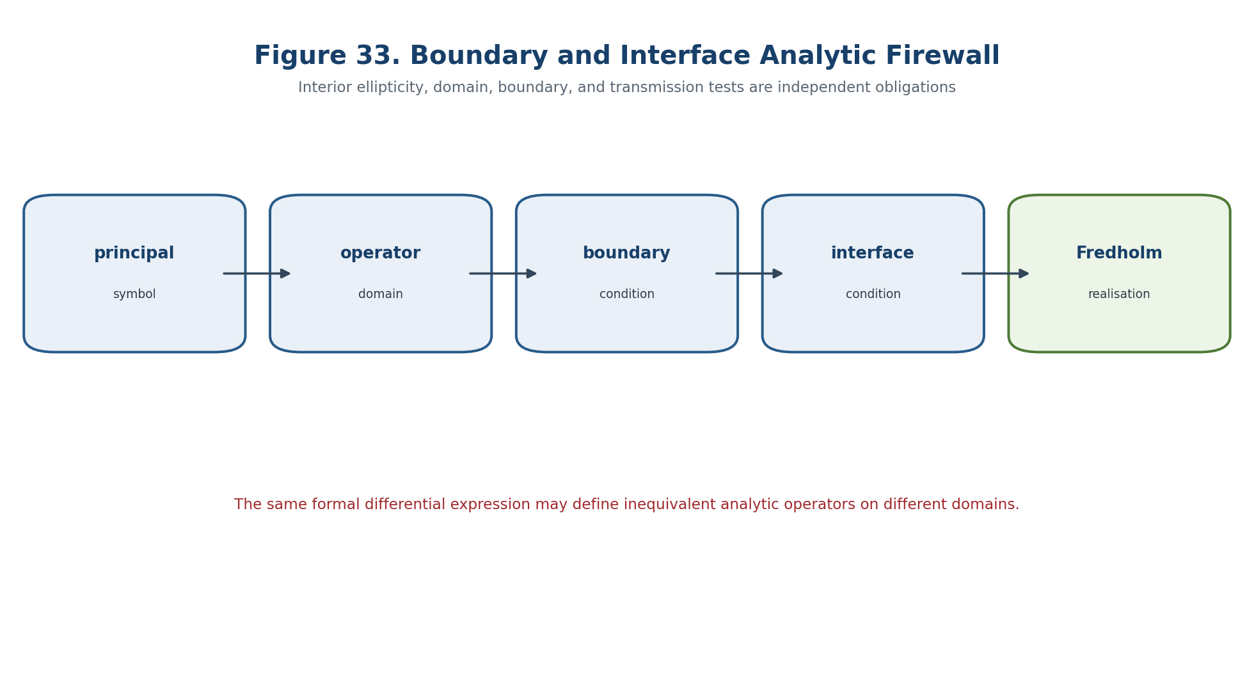
Figure 33. Interior symbol, operator domain, boundary condition, and interface condition are separate analytic obligations.

15.6. Fredholm Sectors, Index, and Harmonic Obstruction
ind T=dim ker T - dim coker T. | T2-F115

D_H^+:H^{even}->H^{odd}, ind D_H^+=sum_k (-1)^k dim H^k. | T2-F116

Index is locally constant on a Fredholm component, but it is an alternating invariant and does not determine each harmonic rank. The predictive profile therefore retains all relevant dimensions separately.
h_E(o)=P_{Harm_E^3}q, eta_H(o)=||h_E(o)||. | T2-F117

Theorem 15.8. Harmonic Detection of the External Class [THM/COND] For a closed representative q of Pi_E(o), eta_H(o)=dist(q,ran d_E^2), and eta_H(o)=0 exactly when Pi_E(o)=0 in the closed-range sector.

eta_H(o)=dist(q,ran d_E^2), eta_H(o)=0 iff Pi_E(o)=0. | T2-F118

Cond_H=(gamma_3^{-1},||G_3||,||P_H||,trace_constant,interface_constant). | T2-F119

The harmonic norm is invariant under replacement of q by an exact representative. A positive lower bound gives robust non-removal of the selected external obstruction; a zero value only removes this linear cohomological obstruction.

15.7. Spectral Stability and the Hodge-Fredholm Horizon
P_t=(2 pi i)^{-1} contour_integral_Gamma (z-Delta_{3,t})^{-1} dz. | T2-F120

When a zero spectral cluster is uniformly isolated, the Riesz projector varies continuously and its rank is constant. The horizon records every way this argument can fail.
Delta_HF=Delta_{d^2} union Delta_dom union Delta_ell union Delta_BC union Delta_range union Delta_gap union Delta_harm union Delta_int union Delta_D union Delta_Dom union Delta_glue. | T2-F121

P_HF(t)=(ind D_H,t^+,dim Harm_t^k,gamma_k(t),eta_H(t),||G_k(t)||,BC_t,Interface_t,lambda_t). | T2-F122

I intersect Delta_HF=empty and eta_H(t)>=epsilon_H => removal of this obstruction is impossible in the model. | T2-F123

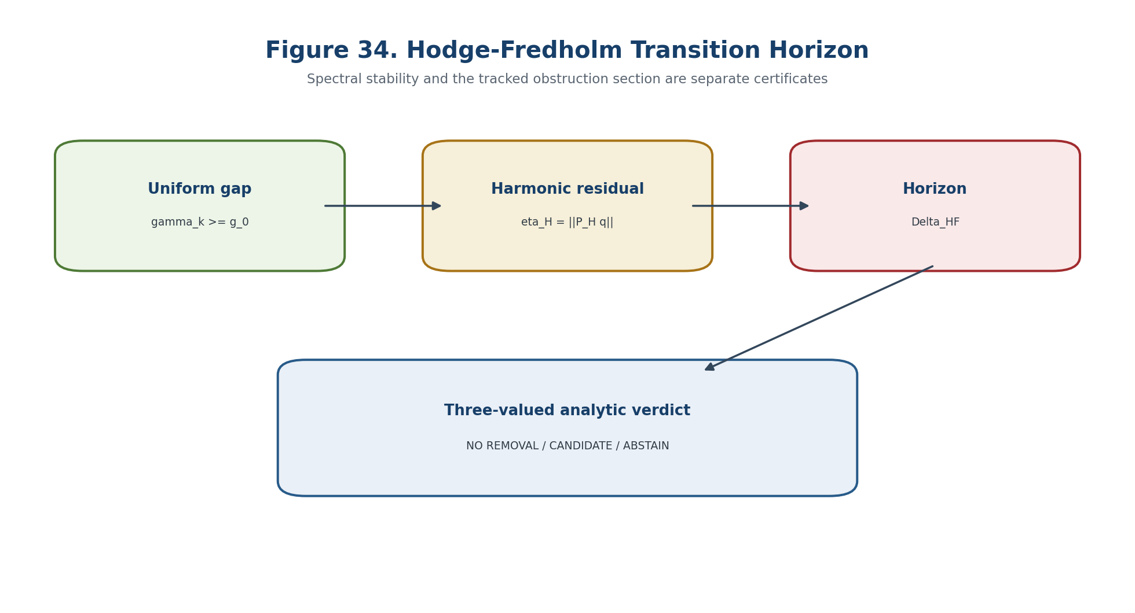
Figure 34. Hodge-Fredholm transition horizon and the three-valued analytic output.

15.8. Hodge-Reper Bridge
A harmonic representative lies in Harm_E^3. The Reper cross-ratio is defined on a quadruple of projective coordinates. There is no canonical map between them. A separate homogeneous functional package is required.
chi_H=(R_H,I_H,U_H,D_H):P(Harm_E^3) dashedrightarrow (P^1)^4, lambda_H=cr(U_H,I_H;R_H,D_H). | T2-F124

Cert_HF=(COMPLEX,DOMAIN,SYMBOL,BC,INTERFACE,FREDHOLM,GAP,HARM,BRIDGE,D,DOM,lambda,HASH). | T2-F125

The bridge is defined only for nonzero classes away from its poles and after the homogeneous scaling law has been checked. A zero harmonic obstruction is not projectivised.

15.9. Main Hodge-Fredholm-Safe Theorem
Theorem 15.12. Hodge-Fredholm-Safe Prediction [COND] Let N_t carry external complexes and Hodge-Laplacian realisations such that the Hilbert-complex identity, elliptic symbols, boundary/transmission conditions, Fredholmness, norm-resolvent continuity, a uniform positive gap, constant harmonic ranks, a valid Pi_E bridge, continuous obstruction and Evidence-D sections, fixed D/Dom and gluing data, a typed Hodge-Reper bridge, all predecessor blockers, and a reproducible HOD-AN certificate are verified. Outside Delta_HF, the index, harmonic rank, and certified analytic type are constant. If eta_H>=epsilon_H>0, the selected external obstruction cannot disappear. If eta_H=0, only that linear cohomological obstruction is removed.

Block_HF=B_complex union B_domain union B_symbol union B_BC union B_interface union B_range union B_gap union B_bridge union B_D union B_Dom union B_glue union B_ind. | T2-F126

Output | Necessary condition | Prohibited over-interpretation
NO-OBSTRUCTION-REMOVAL-IN-MODEL | Block_HF empty and eta_H>=epsilon_H | does not exclude other transition mechanisms
CANDIDATE-ANALYTIC-TRANSITION | path meets Delta_HF with a surviving certificate | does not assert that an event occurred
ABSTAIN | a blocker is open or no uniform numerical margin exists | cannot be replaced by expert optimism

15.10. Countermodels and HOD-AN Certificate
- d^2=0 does not imply ellipticity;
- formal symmetry of Delta does not imply self-adjointness of the selected realisation;
- constant dim Harm^k does not prevent a tracked harmonic section from crossing zero;
- a small eta_H does not prove exact vanishing;
- eta_H=0 does not imply a nonlinear NAPG lift;
- Fredholmness on each stratum does not imply total Fredholmness without interface conditions;
- nonzero spectral flow is not automatically a physical transition;
- nonassociativity of the product does not imply nonzero principal-symbol curvature.
Separating model | Lesson
d=0 on an infinite-dimensional Hilbert space | nilpotent but not Fredholm; infinite harmonic sector
-d^2/dx^2 on [0,1] with Dirichlet versus Neumann domains | one formal expression yields different spectra and zero modes
Delta_t=diag(t^2,1,2,...) | a harmonic mode appears exactly when the gap closes
q_t=t h in fixed one-dimensional Harm | constant Betti number does not replace section tracking
Psi_epsilon=diag(1,epsilon) | an exact lift may be arbitrarily ill-conditioned
two strata before and after matching trace conditions | stratumwise harmonic dimensions do not add automatically

HOD group | Checks
HOD-01-05 | spaces, grading, exact operator domains, d^2, adjoint domains, and principal-symbol ranks
HOD-06-09 | ellipticity, boundary traces, complementing condition, and interface compatibility
HOD-10-15 | kernel/cokernel, index, compact resolvent, harmonic basis, interval spectral gap, and Green bound
HOD-16-20 | eta_H, Pi_E, chi_H/lambda domain, blocker-safe verdict, and source/environment/artifact hashes

BOUNDARY OF CHAPTER 15. The Hodge-Fredholm certificate establishes an analytic property of the declared operator realisation. It does not by itself establish a nonlinear lift, a causal mechanism, a probability, or a physical event.

Prior art includes Hilbert complexes, Hodge decomposition, elliptic complexes, boundary-value theory, Fredholm index, Green operators, and perturbation theory. The authorial contribution is their typed integration with the NAPG internal/external obstruction carriers, D/Dom, projective Reper authorisation, and the three-valued KLT-RBD verdict.

Chapter 16. Deformation Functors, Moduli Spaces, and the Kuranishi Map
ONTOLOGY | A local moduli object is a deformation functor or groupoid, not merely the zero set of equations in coordinates.
EPISTEMOLOGY | Its tangent, automorphism, and obstruction directions are known through a controlling complex and small-extension lifting tests.
PHENOMENOLOGY | The Kuranishi map appears as a compressed local equation whose Taylor layers encode primary and higher obstruction data.
LIMITATION | Versal, miniversal, universal, coarse, stacky, and derived objects are not interchangeable.
AUTHORIAL NOVELTY | The authorial node is the controlled NAPG deformation machine joined to Hodge-Green contraction, Reper evidence, and an abstention gate.

The local deformation theory now passes from isolated tangent directions to functors on Artinian bases, deformation groupoids, and local moduli objects. The central question is whether a first-order class belongs to an actual miniversal family, which higher obstructions prevent continuation, and how the Hodge-Green layer produces a finite-dimensional Kuranishi reduction without turning a local moduli germ into a physical forecast.

16.1. Artinian Bases and the NAPG Deformation Groupoid
Art_K={(A,m_A):A/m_A isomorphic K, m_A^N=0 for some N}. | T2-F127

Definition 16.1. NAPG Deformation Groupoid [DEF-A] For a fixed frame N, Def_N(A) consists of NAPG structures over A whose reduction to K is isomorphic to N, together with isomorphisms over A that are the identity on the special fibre. The set-valued functor F_N=pi_0 Def_N forgets automorphisms.

Def_N:Art_K->Gpd, F_N=pi_0 Def_N:Art_K->Set. | T2-F128

Base change must transport the partial-operation domain, grading, Evidence-D, obstruction carriers, and every selected gauge condition. A coordinate family without these structures is not the deformation functor of the declared NAPG object.
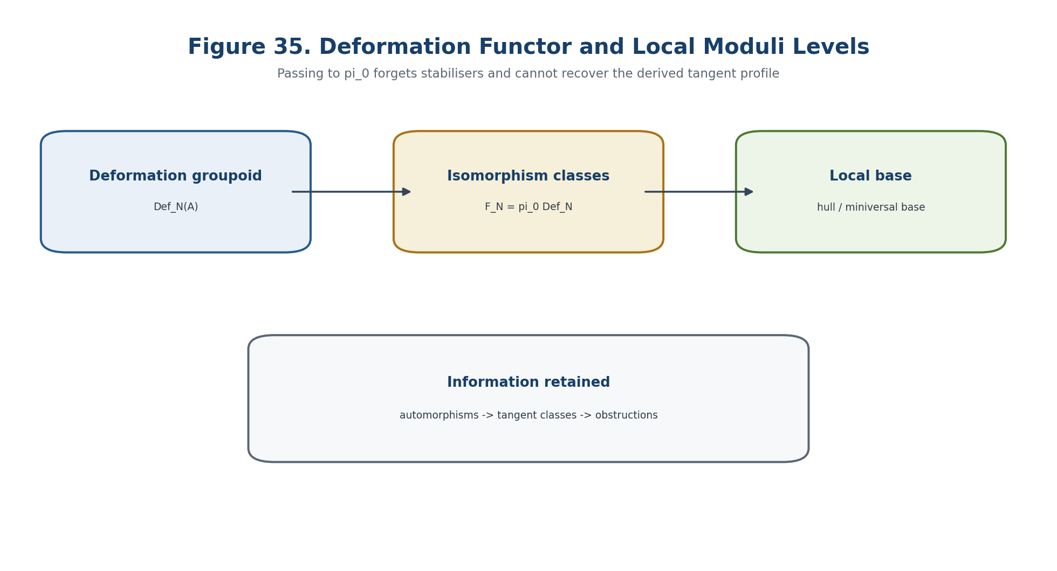
Figure 35. NAPG deformation functor and the three levels of the local moduli object.

16.2. Small Extensions and Complete Local Obstruction Theory
0->I->A'->A->0, m_{A'} I=0. | T2-F129

Definition 16.2. Complete Linear Obstruction Theory [COND/DEF] A triple (H_N^1,H_N^2,H_N^3) is complete when every small extension has a functorial obstruction in H_N^3 tensor I, vanishing exactly when a lift exists; the lift classes form an H_N^2 tensor I torsor; and infinitesimal automorphisms are controlled by H_N^1 tensor I.

This package does not follow from a cochain complex alone. It must be proved directly or derived from a controlling DGLA or L_infinity algebra.

16.3. Schlessinger Conditions and the Hull
F(A' fibre_product_A A'')->F(A') fibre_product_{F(A)} F(A''). | T2-F130

Condition | Exact role | NAPG status
H1 | surjectivity for a small extension | OPEN/CTRL
H2 | bijectivity at the dual-number base case | OPEN/CTRL
H3 | finite-dimensional tangent space | COND-FD
H4 | bijectivity for identical small extensions; prorepresentability | OPEN/PROREP

Theorem 16.3. Conditional Schlessinger Package [CL/COND] If a set-valued functor satisfies H1-H3, it has a hull: a complete local algebra R and a smooth natural transformation h_R->F inducing an isomorphism on tangent spaces. H4 yields prorepresentability. Groupoid-valued problems require a stacky or derived modification.

Finite-dimensionality of the tangent space is available only in a finite-dimensional or Fredholm-reduced sector. It cannot be imported into an arbitrary infinite-dimensional NAPG model without compactness and gauge-fixing hypotheses.

16.4. Versal, Miniversal, and Universal Families
universal => miniversal => versal; the reverse implications are false. | T2-F131

A versal family induces all small deformations after some base map. A miniversal family additionally has the minimal tangent dimension and first-order uniqueness. Universality requires uniqueness of the full base map. Nontrivial automorphisms usually destroy universality while preserving miniversality; hence the correct object is generally a groupoid or stack germ.

16.5. Three-Term Deformation Complex and Derived Tangent
C_N^1 --d_N^1--> C_N^2 --d_N^2--> C_N^3, d_N^2 d_N^1=0. | T2-F132

H_N^1=infinitesimal automorphisms, H_N^2=tangent classes, H_N^3=primary obstructions. | T2-F133

H^{-1}(T_N^der)=H_N^1, H^0(T_N^der)=H_N^2, H^1(T_N^der)=H_N^3. | T2-F134

The negative degree stores stabiliser directions, degree zero stores deformations, and positive degree stores obstructions. The coarse tangent H_N^2 forgets H_N^1 and therefore cannot represent the whole local moduli problem.

16.6. Controlling L-Infinity Hypothesis and Small-Extension Lift
Hypothesis CTRL-16.1. Controlling Algebra [OPEN/COND] For the selected NAPG class there exists a complete filtered L_infinity algebra g_N=(g_N,l_1,l_2,l_3,...) whose Maurer-Cartan groupoid over every Artinian base is naturally equivalent to Def_N.

g_N=(g_N,l_1,l_2,l_3,...). | T2-F135

MC_N(A)={alpha in g_N^1 tensor m_A : sum_{n>=1}(1/n!)l_n(alpha,...,alpha)=0}. | T2-F136

Theorem 16.4. Small-Extension Lift from Maurer-Cartan [COND] Assume CTRL-16.1 and a small extension with kernel I. The curvature of any lift alpha_tilde is an l_1-cycle in g_N^2 tensor I. Its class in H^2(g_N) tensor I=H_N^3 tensor I is independent of the selected lift, vanishes exactly when an MC lift exists, and leaves an H_N^2 tensor I torsor of lift classes modulo gauge.

F(alpha_tilde)=sum_{n>=1}(1/n!)l_n(alpha_tilde^n) in g_N^2 tensor I. | T2-F137

16.7. Hodge-Green Contraction and Kuranishi Recursion
(H(g_N),0) --i--> (g_N,l_1) --p--> (H(g_N),0), id-ip=l_1h+h l_1. | T2-F138

p=P_H, i=harmonic inclusion, h=l_1* G. | T2-F139

The contraction follows from Hodge decomposition in a closed-range sector. For nonlinear recursion, h must preserve the filtration and admissible NAPG sectors, all brackets must be defined on its image, and multilinear estimates must control convergence.
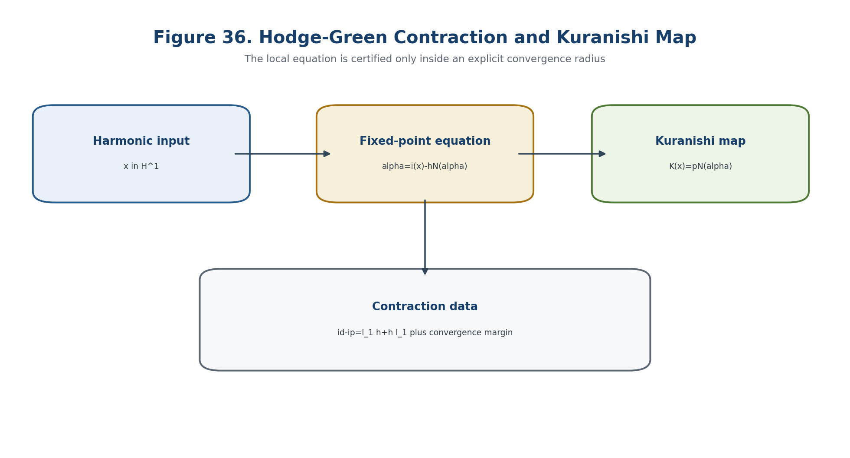
Figure 36. Hodge-Green contraction and construction of the Kuranishi map.
N(alpha)=sum_{n>=2}(1/n!)l_n(alpha^n). | T2-F140

alpha(x)=i(x)-hN(alpha(x)), h alpha(x)=0. | T2-F141

K_N(x)=pN(alpha(x)) in H^2(g_N)=H_N^3. | T2-F142

Theorem 16.5. Conditional Analytic Kuranishi Reduction [COND] If N(alpha) is analytic on a ball, h is bounded, and alpha->i(x)-hN(alpha) is a uniform contraction for ||x||<r_K, then the fixed-point equation has a unique solution. This solution satisfies the full MC equation exactly when K_N(x)=0.

||N(alpha)-N(beta)||<=L_R||alpha-beta||, ||h||L_R<1. | T2-F143

||x||<=R(1-||h||L_R)/||i||. | T2-F144

m_K(R)=1-||h||L_R. | T2-F145

The convergence margin m_K is part of the certificate. A formal recursion without a positive margin does not establish an analytic family.

16.8. Taylor Layers and Higher Obstruction Classes
K_N(x)=kappa_2(x,x)+kappa_3(x,x,x)+kappa_4(x,x,x,x)+... | T2-F146

kappa_2(x,x)=1/2 p l_2(ix,ix). | T2-F147

kappa_3(x,x,x)=1/6 p l_3(ix,ix,ix)-1/2 p l_2(ix,h l_2(ix,ix)). | T2-F148

nu_K(x)=min{n>=2:kappa_n(x,...,x)!=0}, nu_K=infinity if all terms vanish. | T2-F149

The first nonzero Taylor layer gives the obstruction order in the selected contraction and coordinate gauge. Vanishing of the quadratic term does not imply unobstructedness: a cubic or higher layer may remain.

16.9. Miniversal Base, Formal Smoothness, and Derived Boundary
R_N^min=K[[t_1,...,t_m]]/(K_1,...,K_q). | T2-F150

The completed local algebra is the miniversal base only after Schlessinger and control hypotheses are established. Formal smoothness means every small-extension lift exists; rigidity means the tangent space vanishes; unobstructedness means the Kuranishi map vanishes or the controlling algebra is homotopy abelian under the appropriate theorem. These notions are independent.
FormalModuli_K is equivalent to dgLie_K under characteristic-zero homotopical hypotheses. | T2-F151

pi_0 Def_N does not determine H^{-1}(T_N^der). | T2-F152

Theorem 16.7. Stabiliser No-Go [THM] A coarse moduli set or space does not determine the stabiliser directions of the deformation groupoid. A quotient stack and its coarse space may have the same underlying points but different derived tangent profiles.

16.10. Local Moduli Stratification and Transition Horizon
S_N=disjoint_union_alpha S_{N,alpha}, P_mod(x)=(dim H^1,dim H^2,dim H^3,nu_K,HS_x,dim Aut_x,[K_lead]). | T2-F153

Delta_mod=Delta_HF union Delta_ctrl union Delta_Sch union Delta_aut union Delta_tan union Delta_obs union Delta_Kur union Delta_conv union Delta_orb union Delta_D union Delta_Dom union Delta_glue. | T2-F154

eta_K(t)=||K_{N_t}(x_t)||. | T2-F155

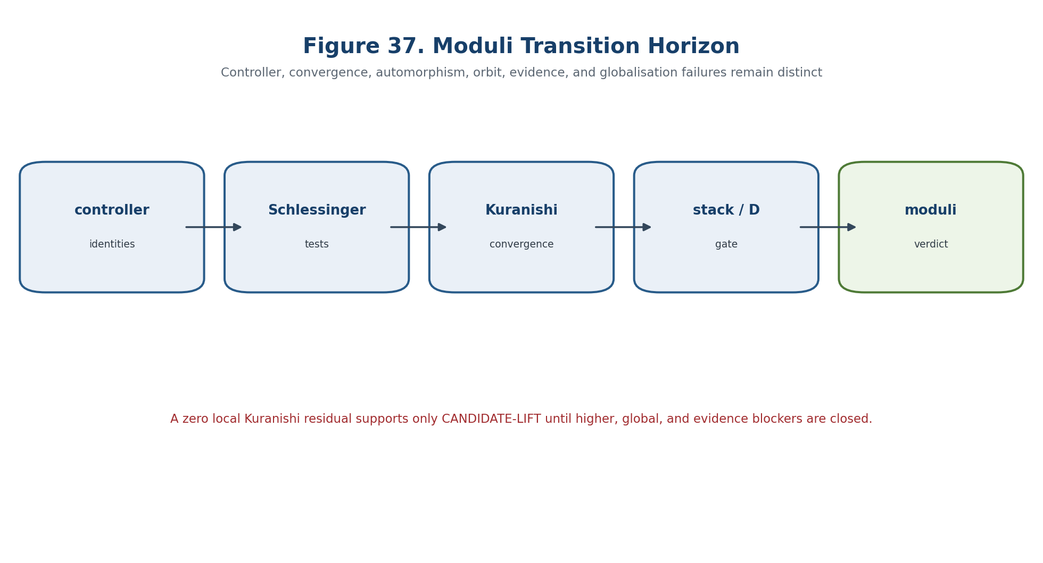
Figure 37. Moduli transition horizon and the blocker-safe local verdict.
A positive lower bound for eta_K excludes the selected tangent class from the local MC zero locus. A zero residual creates only a local candidate lift; it does not close the external bridge, globalisation, Reper-lambda, or independent-verification obligations.

16.11. Certified Trivialisation of a Family of Moduli Problems
Constancy of the dimensions of H_N^i does not determine constancy of the moduli germ. The certificate ModTriv(I) includes identifications of graded Hilbert spaces and domains, filtered L_infinity isomorphisms, compatible Hodge contractions with uniform bounds, right-equivalence of Kuranishi maps, preservation of stabiliser groupoids and D/Dom/gluing data, and a uniform Kuranishi radius separated from Delta_mod.

16.12. Main Moduli-Kuranishi-Safe Theorem
Theorem 16.9. Moduli-Kuranishi-Safe Prediction [COND] Let N_t on a compact interval admit complete filtered controlling L_infinity algebras, Schlessinger H1-H3 and a miniversal hull, uniform Hodge-Green and convergence margins, a ModTriv certificate with no intersection with Delta_mod, a continuous candidate section x_t preserving Evidence-D/Dom, and closed predecessor blockers. Then the local moduli type and obstruction-order profile are constant in the certified trivialisation. If ||K_t(x_t)||>=epsilon_K>0, the selected branch does not integrate to an MC deformation in the declared Kuranishi neighbourhood.

eta_K(t)=||K_t(x_t)||>=epsilon_K>0 for all t in I. | T2-F156

If eta_K=0, the theorem provides only a local formal or analytic candidate lift under the remaining hypotheses. It does not assert globality, uniqueness, stability outside the radius, physical realisation, or event probability.
Block_mod=B_ctrl union B_Sch union B_HF union B_gauge union B_conv union B_Kur union B_aut union B_stack union B_D union B_Dom union B_glue union B_ind. | T2-F157

Condition | Verdict | Meaning
eta_K>=epsilon_K and Block_mod empty | NO-LIFT-IN-MODEL | the class is outside the local Kuranishi zero locus
eta_K=0 and Cert_mod complete | CANDIDATE-LIFT | local integrable candidate; downstream bridges remain
any blocker open | ABSTAIN | the proof chain is incomplete or ill-conditioned

16.13. Separating Models and MOD-KUR Certificate
- Tangent without lift: K(x)=x^2 has all first-order directions but only x=0 integrates.
- Primary obstruction zero and higher obstruction nonzero: kappa_2=0 while kappa_3(x,x,x)!=0.
- Miniversal but not universal: nontrivial H_N^1 produces several base maps related by automorphisms.
- Equal cohomology dimensions but different germs: K_1(x,y)=xy and K_2(x,y)=x^2+y^3 have different singularity types.
- Formal without analytic convergence: a formal series may have zero radius without estimates.
- Metric dependence: different Hodge contractions yield different representatives and Kuranishi maps, though the correct germs may be equivalent.
- Coarse-space blindness: a quotient stack and its coarse space have different stabiliser data.
- K=0 without dynamics: a smooth miniversal base is not a physical event.
MOD group | Checks
MOD-01-06 | Artinian bases, object/morphism schemas, gauge groupoid, d^1/d^2, square-zero, and bases of H^1/H^2/H^3
MOD-07-13 | small-extension generator, obstruction independence, lift torsor, Schlessinger H1-H4 flags
MOD-14-19 | L_infinity identities, MC equation, gauge invariance, Hodge contraction, Green/spectral margin, and fixed-point contraction
MOD-20-24 | Kuranishi Taylor coefficients, local algebra/zero locus, stabiliser strata, blocker-safe verdict, and all hashes

INPUT N,g,Artin bases,Hodge-Green,x,D/Dom; verify control and Schlessinger; solve alpha=i(x)-hN(alpha); compute K(x); emit ABSTAIN, NO-LIFT-IN-MODEL, or CANDIDATE-LIFT with proof objects and hashes. | T2-F158

BOUNDARY OF CHAPTER 16. The controlling L_infinity algebra for a general partial NAPG operation remains a proof obligation. A local Kuranishi zero is not a global object, a causal mechanism, or an empirical event.

Prior art includes Schlessinger functors, Kodaira-Spencer and Kuranishi theory, graded-Lie deformation theory, Goldman-Millson germs, and derived formal moduli. The authorial contribution is their typed integration with NAPG, Hodge-Green certificates, internal/external obstruction carriers, D/Dom, Reper authorisation, and a three-valued predictive horizon.

Chapter 17. Stratified Moduli Spaces, Wall Crossing, and Monodromy
ONTOLOGY | A moduli space may be stratified into chambers, walls, ramification loci, and branch-monodromy orbits.
EPISTEMOLOGY | A transition is known only after branch continuation, path typing, wall certificates, and transport of invariants.
PHENOMENOLOGY | Wall crossing appears as a change of certified structural profile along a declared path.
LIMITATION | A wall is not automatically a bifurcation, branch labels need not globalise, and path dependence cannot be erased by a coarse endpoint comparison.
AUTHORIAL NOVELTY | The authorial node is the KLT-RBD branch ledger with blocker-safe wall-crossing and monodromy certificates.

A moduli carrier is generally not a single smooth manifold. Stabiliser dimension, branch count, the rank of the linearised Kuranishi map, and obstruction type may jump. This chapter treats the carrier as a certified stratified object, separates walls from bifurcation loci, tracks normalised branches and their monodromy, and defines the path-dependent wall-crossing operator and its predictive horizon.

17.1. Moduli Space as a Stratified Object
M_N=disjoint_union_{alpha in A} S_alpha, S_alpha intersect closure(S_beta)!=empty => S_alpha subset closure(S_beta). | T2-F159

An admissible predictive stratification has smooth locally closed strata, a constant local moduli profile on each stratum, and a verified frontier condition. Whitney (a) and (b), control data, and local topological triviality are separate obligations rather than consequences of writing a finite partition.
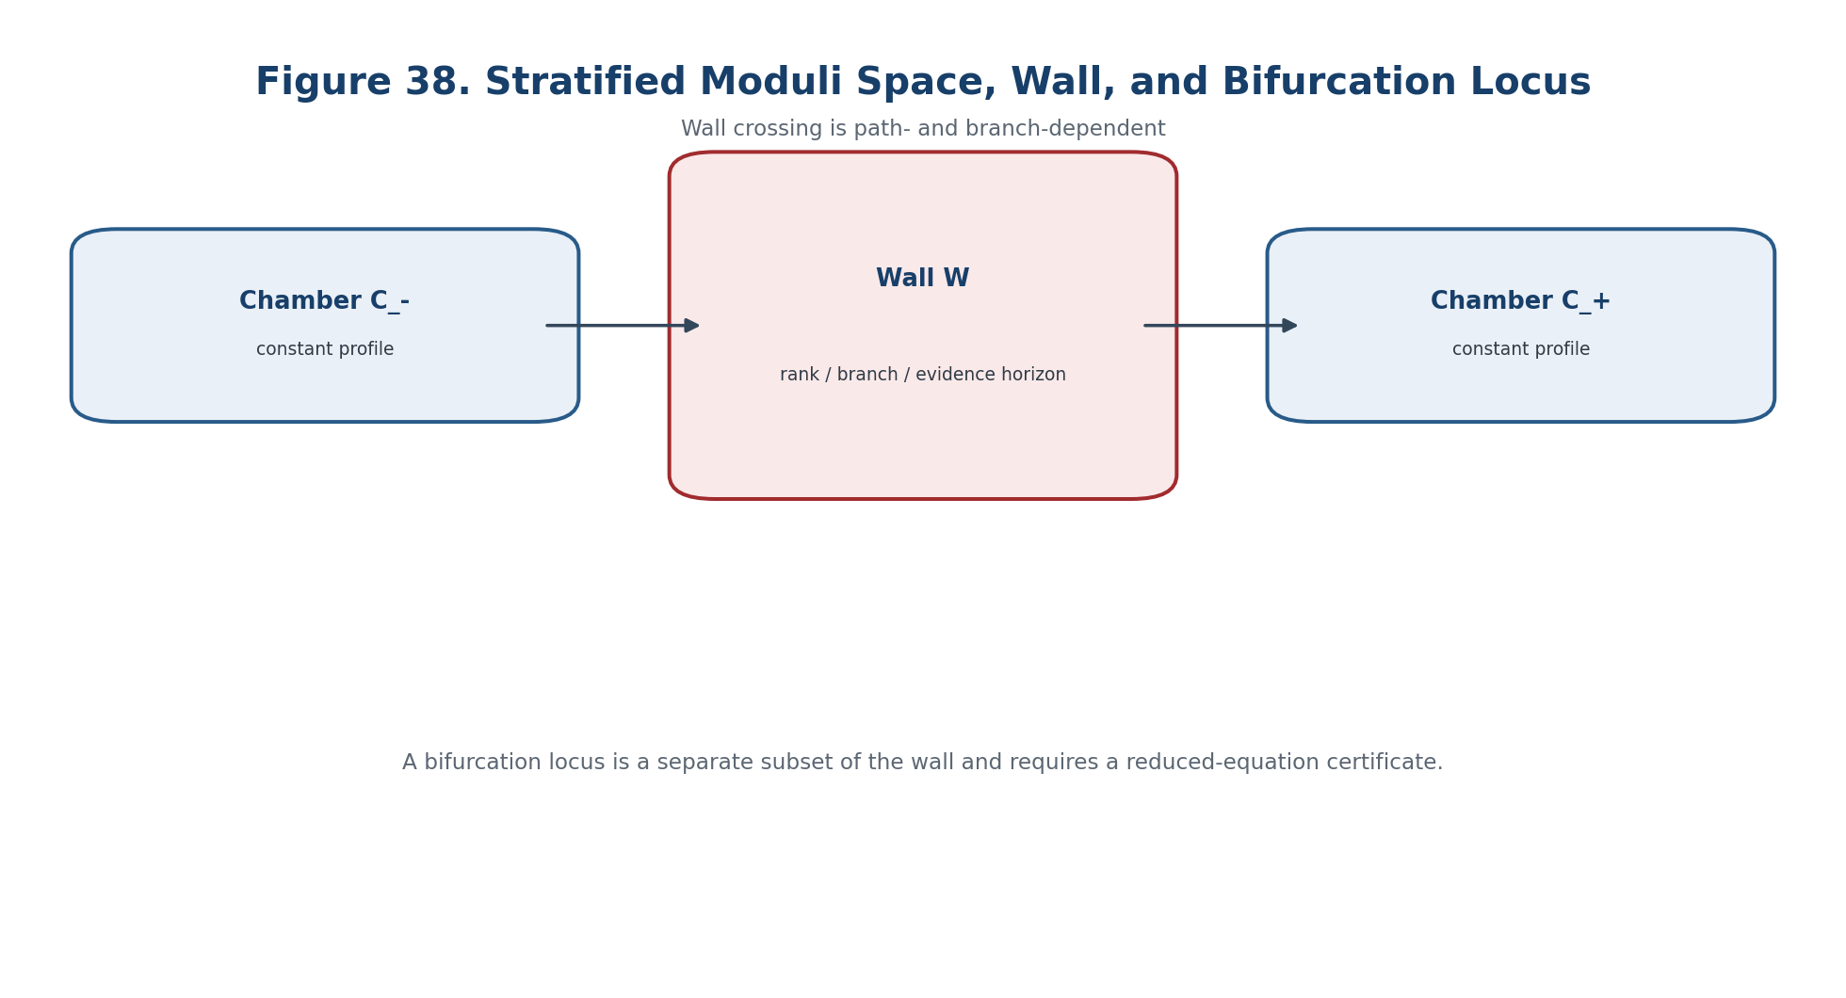
Figure 38. Stratified moduli space, wall, and bifurcation locus.
P_str(x)=(dim H^1_x,dim H^2_x,dim H^3_x,dim Aut_x,rank dK_x,mult_x,HS_x,gamma_x,lambda_x,D_x,Dom_x). | T2-F160

I_trans:M_N^reg->Lambda, I_trans|_{S_alpha}=constant. | T2-F161

The profile records local deformation, automorphism, obstruction, multiplicity, Hilbert-Samuel, spectral, Reper, evidence, and domain data. Values on adjacent strata cannot be compared, added, or ranked until a typed transport rule is supplied.

17.2. Walls, Chambers, and Wall Certificates
W=Delta_rank union Delta_aut union Delta_obs union Delta_gap union Delta_branch union Delta_D union Delta_Dom union Delta_glue. | T2-F162

A chamber is a connected component of the parameter space minus W on which the certified moduli type is constant. A wall is a locus where at least one rank, stabiliser, obstruction, spectral, branch, evidence, domain, or gluing certificate changes. A wall certificate includes a local wall equation, normal orientation or coorientation, the incident branches, one-sided invariant limits, multiplicity control, Evidence-D, and a reproducible computation.
Theorem 17.1. Constancy in a Chamber [COND] If a connected chamber carries a ModTriv certificate and does not meet W, then P_str and every certified locally constant transition invariant remain constant throughout the chamber.

17.3. Partial Wall-Crossing Operator
WC_{gamma,t*}:Inv(C_-) dashedrightarrow Inv(C_+). | T2-F163

The operator is defined only after branches on both sides are identified through a common degeneration datum. In an additive sector, the defect is typed only after a transport map has been proved.
Delta_W I=I_+ - T_{-to+}I_-. | T2-F164

Countertheorem 17.2. Equal Dimensions Do Not Define Wall Crossing [THM] Equal dimensions of invariant spaces on both sides of a wall do not determine a canonical transition operator. Branch identification and transport data are indispensable.

In a general NAPG sector, wall crossing may be a correspondence, span, or functor between groupoids rather than a numerical jump.

17.4. Bifurcation Locus and Reduced Equation
Bif(K)={(t,x):K_t(x)=0, rank D_xK_t<r_reg}. | T2-F165

A singular Jacobian is only a bifurcation candidate. The number of real branches, their stability, and their observability require a Lyapunov-Schmidt reduction and verified normal-form derivatives.
fold:g=0,g_a=0,g_aa!=0,g_t!=0; cusp:g=g_a=g_aa=0,g_aaa g_t!=0. | T2-F166

Theorem 17.3. Wall Is Not Bifurcation [THM] In general W and the bifurcation locus B do not coincide. A wall may arise from a stability, domain, or stabiliser change with a regular local equation; a bifurcation may occur inside one chamber of an external classification.

Separating situation | What it shows
wall without bifurcation | a GIT polarisation changes admitted orbits while the local branch remains smooth
bifurcation without a chosen wall | g(t,a)=a^2-t has a fold at t=0 even if no external chamber decomposition was declared
false numerical coincidence | an apparent rank jump may disappear after interval conditioning certifies the Jacobian

17.5. Branch Normalisation and the Branch Ledger
Branch(Z/P)=pi_0(Z_tilde minus Ram(nu)). | T2-F167

For the local zero locus Z={K=0}, a branch is a connected component of a normalised cover after removal of the ramification locus. The ledger records branch_id, local equation, multiplicity, orientation or coorientation, stabiliser, D/Dom, provenance, permitted continuations, and branch points. Without branch_id, the phrase “the same branch after the transition” has no verifiable content.
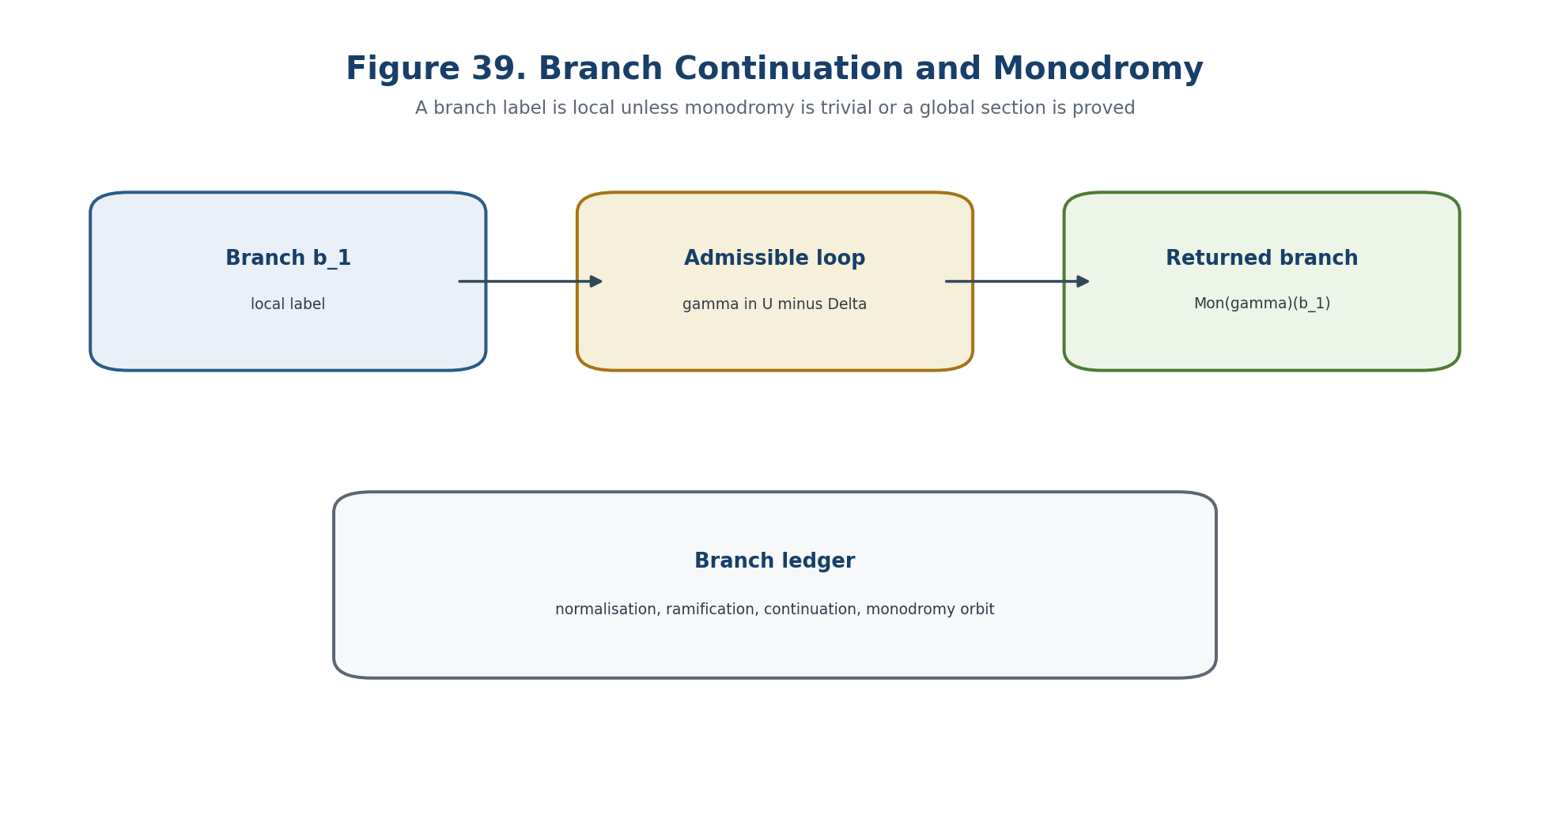
Figure 39. Continuation of branches and monodromy along an admissible loop.

17.6. Branch Monodromy and the No-Global-Label Theorem
Mon:pi_1(U,t_0)->Perm(B_{t_0}). | T2-F168

rho:pi_1(U,t_0)->Aut(V_{t_0}). | T2-F169

Monodromy depends on the punctured parameter domain and the allowed path class. It is not automatically the holonomy of Chapter 9; a comparison functor must translate branch continuation into parallel transport of a specified bundle.
Theorem 17.4. Homotopy Invariance [THM] If the branch cover is locally trivial over U, continuation along homotopic loops with fixed endpoints yields the same branch permutation; Mon therefore factors through pi_1(U,t_0).

Theorem 17.5. No Global Labelling [THM] If the image of Mon is nontrivial, there is no global continuous numbering of all branches over U.

Proof. A global numbering would trivialise the branch cover and force every loop to preserve each label, contradicting a loop with nontrivial permutation. □
KLT-RBD must therefore store monodromy orbits. It must neither create artificial new objects after a permutation nor force a label to remain fixed when the topology forbids it.

17.7. Path Dependence and Relations Between Wall Operators
T_gamma=WC_m o ... o WC_2 o WC_1. | T2-F170

Even with the same endpoints, T_gamma may depend on the homotopy class of the path in the complement of higher-codimension discriminants. Path independence requires a flat local system or proved commutation, braid, or higher-coherence relations.
WC_i WC_j=WC_j WC_i or WC_i WC_j WC_i=WC_j WC_i WC_j. | T2-F171

Such relations are conclusions of a specific model, not consequences of the term “wall crossing.”

17.8. Stratified Local Triviality and Stability Levels
The certificate StratTriv(U) records Whitney conditions or a declared replacement, the frontier condition, properness or local properness, submersion on each stratum, control data, and compatibility with Kuranishi charts, stabilisers, and Evidence-D. Under these hypotheses, the family is locally topologically trivial by strata and the stratified homeomorphism type is constant.
Level | Stability contract
S0 | chamber constancy of a discrete invariant
S1 | transport stability of a vector or class under a declared local system
S2 | branch stability including normalisation, monodromy orbit, and wall operators
S3 | predictive stability with D/Dom, numerical margins, and independent reproducibility

P_W(t,b)=(dist(t,W),sigma_min(D_xK_t),mult_b,MonOrb_b,eta_K,eta_H,lambda_b,CGI_b). | T2-F172

17.9. Wall-Bifurcation Transition Horizon
Delta_WB=Delta_strat union Delta_wall union Delta_bif union Delta_ram union Delta_mon union Delta_path union Delta_inv. | T2-F173

Delta_safe^{v0.14}=Delta_mod union Delta_WB. | T2-F174

The cumulative horizon records failure of the stratification, wall certificate, bifurcation test, branch normalisation, monodromy control, path typing, or invariant transport. It is combined with the Chapter 16 moduli horizon, but the individual causes remain visible.

17.10. Main Wall-Crossing-Safe Theorem
Theorem 17.7. Wall-Crossing-Safe Prediction [COND] Let a family possess certified Kuranishi charts, an admissible stratification, StratTriv and ModTriv data, branch normalisation and monodromy, typed wall operators, stable transition invariants, valid D/Dom/gluing evidence, and closed predecessor blockers. If a path avoids Delta_safe^{v0.14}, no certified wall crossing occurs. If it meets the horizon, the output is only a candidate requiring post-wall branch matching and independent checks.

gamma intersect Delta_safe^{v0.14}=empty => NO-WALL-CROSSING-IN-MODEL. | T2-F175

Block_WB=B_strat union B_Whit union B_wall union B_bif union B_branch union B_mon union B_path union B_inv union B_D union B_Dom union B_glue union B_ind. | T2-F176

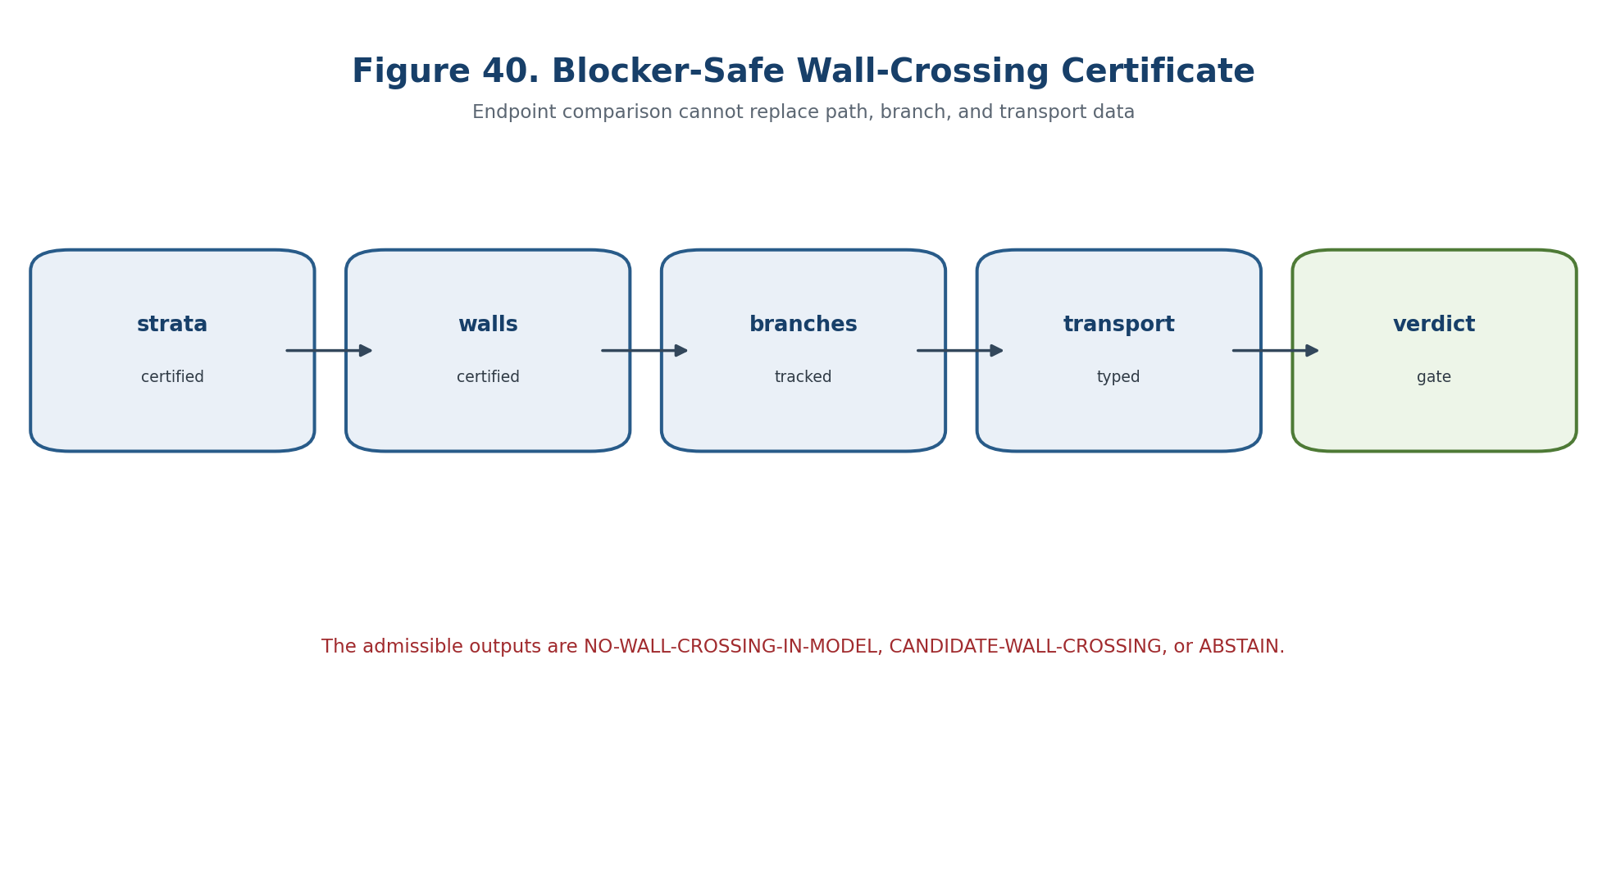
Figure 40. Blocker-safe wall-crossing certificate WC-01-WC-24.
Output | Condition | Interpretation
NO-WALL-CROSSING-IN-MODEL | gamma avoids Delta_safe and blockers are empty | certified structural profile remains in one chamber
CANDIDATE-WALL-CROSSING | gamma meets the horizon with a valid certificate | target for branch and post-wall tests
ABSTAIN | any stratification, branch, path, evidence, or independence blocker remains | no transition conclusion

17.11. Countermodels and WC-MON Certificate
- Equal endpoints with different path classes may yield different ordered wall compositions.
- A singular numerical Jacobian may be a conditioning artefact rather than a bifurcation.
- A wall generated by a domain or stability change may have no local branch bifurcation.
- A genuine fold may occur before any external wall decomposition is chosen.
- Nontrivial monodromy prohibits a global branch label even though every local chart is regular.
- A constant dimension profile does not determine multiplicity, branch topology, or monodromy orbit.
- A wall crossing in a static moduli family is not by itself a physical event or causal transition.
WC-MON group | Checks
WC-01-06 | stratification, frontier and Whitney/control data, wall equations, coorientations, and chamber decomposition
WC-07-12 | Kuranishi discriminant, reduced equation, branch normalisation, ramification, multiplicity, and branch IDs
WC-13-18 | continuation, monodromy, path classes, wall operators, cocycle/braid relations, and transport typing
WC-19-24 | Evidence-D/Dom, stability margins, cumulative horizon, blocker-safe verdict, code/data/environment hashes

INPUT K_t,stratification,path,branches,invariant,D/Dom; verify charts, strata, walls, normalisation, monodromy, transport, and margins; emit ABSTAIN, NO-WALL-CROSSING-IN-MODEL, or CANDIDATE-WALL-CROSSING. | T2-F177

BOUNDARY OF CHAPTER 17. Wall crossing is a certified change of classification along a path. It is not an observation that a physical event occurred, and branch monodromy is not automatically causal holonomy.

Prior art includes Whitney stratifications, isotopy lemmas, singularity and bifurcation theory, branch normalisation, monodromy, and wall-crossing formalisms. The authorial contribution is their KLT-RBD integration with the NAPG Kuranishi package, branch ledger, D/Dom, Reper coordinates, and blocker-safe predictive verdict.

Chapter 18. Global Derived/Stacky Moduli Spaces and the Predictive Carrier
ONTOLOGY | The global predictive carrier is a homotopy-coherent stacky or derived moduli object, not a collection of local charts or its coarse quotient.
EPISTEMOLOGY | Global knowledge requires effective descent, coherent coordinate changes, a perfect virtual tangent complex, branch descent, and Evidence-D/Dom compatibility.
PHENOMENOLOGY | The global object appears through a virtual tangent profile, obstruction sheaf or cone, branch stack, determinant data, and transported Reper coordinates.
LIMITATION | Local liftability does not imply a global object, and equal coarse spaces do not imply equivalent stacky or derived structures.
AUTHORIAL NOVELTY | The authorial node is the global NAPG/KLT-RBD predictive carrier with a three-valued verdict and preserved status firewall.

Local Kuranishi charts, their coarse quotient, and even locally vanishing obstruction classes do not determine a global moduli object. The final chapter of this checkpoint constructs a homotopy-coherent global carrier, its virtual tangent complex, obstruction sheaf or cone, branch stack, determinant and orientation data, Reper/Evidence-D descent, and the global transition horizon. The output remains NO-GLOBAL-TRANSITION-IN-MODEL, CANDIDATE-GLOBAL-TRANSITION, or ABSTAIN.

18.1. Three Global Moduli Levels
|M| <- M <- M^der. | T2-F178

Level | Retained information | Typical loss at the next coarser level
derived moduli object M^der | higher tangent and obstruction data, homotopies, stabilisers | derived directions and higher coherence
stacky moduli object M | objects, isomorphisms, stabilisers, descent | automorphism and branch information
coarse space |M| | isomorphism classes as points | stabilisers, derived tangent profile, and higher descent

The arrows are forgetful, not equivalences. A coarse point cannot reconstruct the stacky or derived object without additional data.

18.2. Local Kuranishi Charts and Coordinate Changes
K_i=(U_i,E_i,s_i,G_i,psi_i). | T2-F179

vdim(K_i)=dim U_i-rank E_i-dim G_i. | T2-F180

s_j o phi_ij = phi_hat_ij o s_i. | T2-F181

A chart includes a finite-dimensional base U_i, an obstruction bundle E_i, a section s_i, an isotropy group G_i, and a footprint map psi_i. A coordinate change is not only a map of bases: it must intertwine obstruction bundles, sections, group actions, footprints, and the declared Reper/Evidence-D structures.
alpha_ijk:Phi_jk o Phi_ij => Phi_ik. | T2-F182

Triple compositions agree up to specified 2-morphisms, which must themselves satisfy a higher coherence condition on quadruple overlaps. Pairwise coordinate compatibility is not enough.
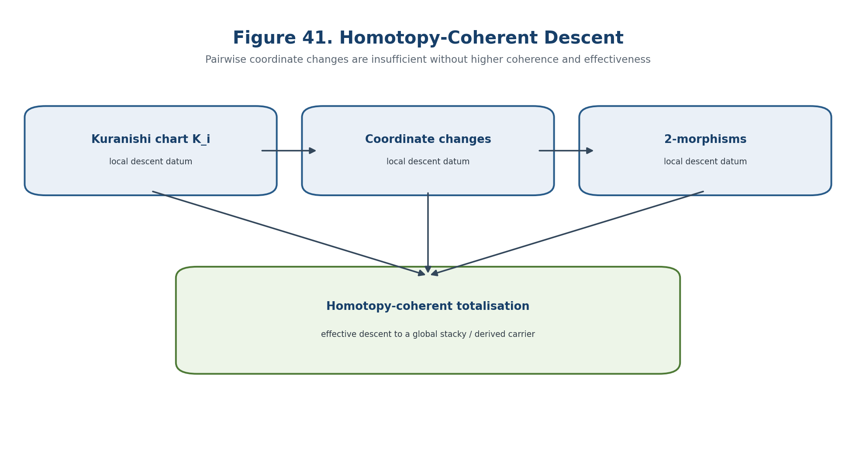
Figure 41. Homotopy-coherent descent from local Kuranishi charts to a global stacky or derived carrier.

18.3. Cech Nerve and Effective Descent
M(U) is equivalent to Tot(M(U_bullet)). | T2-F183

Definition 18.2. Effective Descent [CL/COND] A homotopy-coherent local datum is effective when its totalisation is represented by a global object with the declared universal property.

A coherent diagram may still fail to be effective in the selected category. The globalisation certificate therefore records the Cech nerve, pairwise maps, triple 2-cocycles, quadruple coherence, stabilisers, and the existence—not merely the notation—of the global object.

18.4. Virtual Tangent Complex
T_x^vir=[ g_x -> T_xU_i -> E_{i,x} ]. | T2-F184

vdim_x=-dim H^{-1}+dim H^0-dim H^1. | T2-F185

The three cohomological degrees record infinitesimal automorphisms, deformation directions, and obstruction directions. Virtual dimension is only their alternating sum and cannot reconstruct the individual groups.
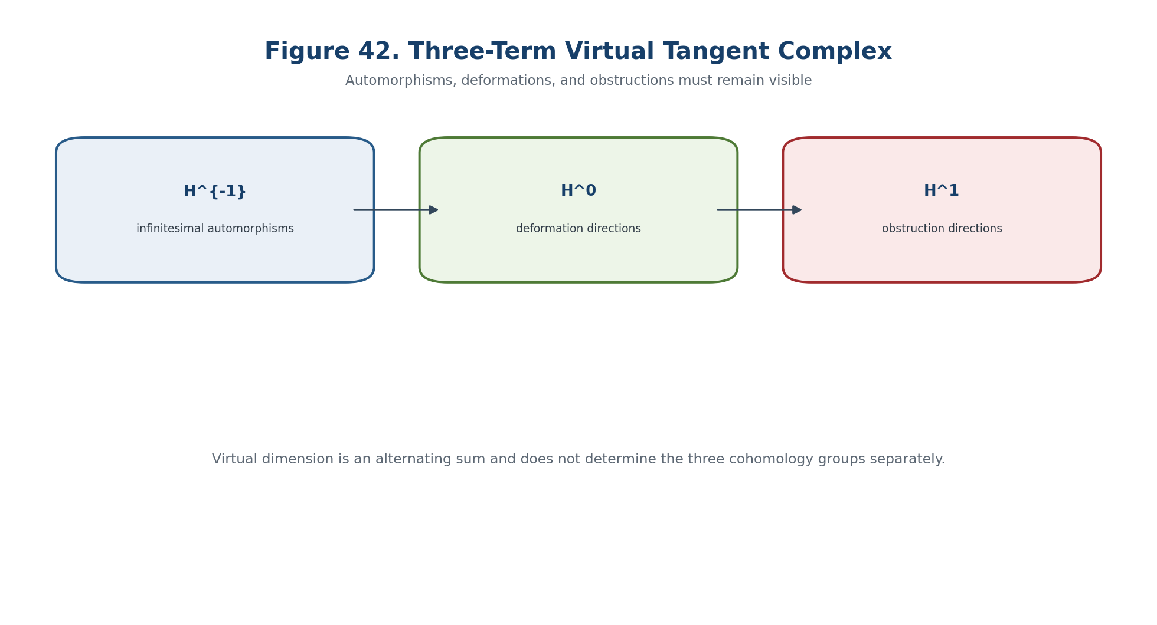
Figure 42. Virtual tangent complex: automorphisms, deformations, and obstructions remain visible.

18.5. Perfect Obstruction Theory and Intrinsic Normal Cone
phi:E^bullet->L_M, E^bullet perfect, amp(E^bullet) subset [-1,0]. | T2-F186

Ob_M=h^1((E^bullet)^vee), N_M=h^1/h^0(L_M^vee). | T2-F187

A perfect obstruction theory gives a controlled morphism from a perfect complex to the cotangent complex and supports an intrinsic normal cone construction. The selected amplitude, perfectness, compatibility with local charts, and orientation data are certificate fields; they are not inferred from a finite list of equations.

18.6. Gluing Local Obstruction Theories
q_jk o q_ij is homotopic to q_ik. | T2-F188

c_ijk=q_ik^{-1}q_jkq_ij in Z, [c] in Cech H^2(X,Z). | T2-F189

Local obstruction complexes glue only through quasi-isomorphisms with coherent homotopies. A nontrivial central Cech class blocks the global obstruction theory even when every local chart is individually valid.
det(T^vir)=tensor_j(det H^j(T^vir))^{(-1)^j}. | T2-F190

The determinant line and orientation are additional global data. Equal virtual dimensions do not imply equal determinant, orientation, or cohomological profile.

18.7. Branch Stack and Monodromy
Mon:pi_1(P minus Delta,p_0)->Perm(B_{p_0}). | T2-F191

The branch stack retains local branches, isotropy, continuation maps, and monodromy. A coarse quotient forgets these data. The Chapter 17 branch ledger is therefore promoted to part of the global descent package.

18.8. Global KLT-RBD Predictive Carrier
Definition 18.4. Predictive Carrier [DEF-A] The global carrier PredCar_N combines a derived moduli family, virtual tangent complex, obstruction sheaf or cone, branch stack, Reper atlas, projective-harmonic coordinate, Evidence-D, admissible domain, and external E-complex.

PredCar_N=(M_N^der->P,T^vir,Ob_N,C_N,B_N,Rep_N,lambda_N,D_N,Dom_N,E_N). | T2-F192

Existence requires effective atlas descent, coherent coordinate changes, a derived/perfect enhancement, fixed amplitude and perfectness, branch descent, Reper descent, Evidence-D descent, Dom compatibility, a global lambda outside its poles, and an independently reproducible computational package.

18.9. Local-to-Global and Coarse-Moduli No-Go Theorems
c_ijk=g_ki g_jk g_ij. | T2-F193

Theorem 18.5. Local-to-Global No-Go [THM] Vanishing of every local obstruction class does not imply a global object. A nontrivial descent class or failure of coherent trivialisation may obstruct the global lift even when all local Kuranishi residuals vanish.

local lift + local obstruction=0 does not imply global lift. | T2-F194

Theorem 18.6. Coarse-Moduli No-Go [THM] A coarse moduli space does not determine the stacky or derived moduli object. The quotient stack [A^1/mu_2] and the ordinary A^1 have the same coarse type but different stabilisers and virtual tangent profiles.

|M_1| isomorphic |M_2| does not imply M_1 equivalent M_2 and does not imply M_1^der equivalent M_2^der. | T2-F195

18.10. Global Residuals and Transition Horizon
eta_desc=||higher descent defect||, eta_ob=||h(ob)||, eta_ext=||Pi_E(ob)||. | T2-F196

The three residuals live in different carriers and may not be added before an explicit normalisation and comparison theorem. The decision object is a blocker vector, not a single untyped score. A small numerical descent defect does not establish exact 2-coherence without an interval certificate.
Delta_stack=Delta_desc union Delta_coh union Delta_perf union Delta_amp union Delta_vrank union Delta_orient union Delta_branch union Delta_mon union Delta_Rep union Delta_D union Delta_Dom union Delta_ext union Delta_ind. | T2-F197

Delta_safe^{v0.15}=Delta_safe^{v0.14} union Delta_stack. | T2-F198

P_stack(p)=([amp T^vir],h^{-1},h^0,h^1,vdim,[det],[desc],MonOrb,eta_ob,eta_ext,lambda,CGI). | T2-F199

The global profile is comparable only after transport between fibres and branch identification. Raw Kuranishi coordinates, numbers of local equations, and branch names are not global invariants.

18.11. Main Global-Stack-Safe Theorem
Theorem 18.7. Global-Stack-Safe Prediction [COND] Let a connected parameter chamber carry a proper or controlled locally trivial stacky/derived family; effective homotopy-coherent Kuranishi descent; perfect virtual tangent complexes linked by quasi-isomorphisms of constant amplitude; certified cohomology ranks, determinant/orientation, and branch monodromy orbit; compatible descent of the Reper atlas, lambda, Evidence-D, Dom, and the external E-bridge; closed Hodge-Green, Kuranishi, wall-crossing, and globalisation blockers; a path avoiding Delta_safe^{v0.15}; and a uniform positive margin for the relevant global obstruction. Then the global profile is constant along the path up to proved transport, and a transition requiring a profile change or removal of the uniformly nonzero obstruction is impossible inside the model.

gamma intersect Delta_safe^{v0.15}=empty => NO-GLOBAL-TRANSITION-IN-MODEL. | T2-F200

If the path meets Delta_stack or the global obstruction residual admits zero, the only allowed positive-side output is CANDIDATE-GLOBAL-TRANSITION. A positive transition conclusion still requires a post-transition global object, branch matching, and independent verification.
Block_stack=B_atlas union B_2coc union B_eff union B_perf union B_amp union B_vtan union B_branch union B_Rep union B_D union B_Dom union B_E union B_ind. | T2-F201

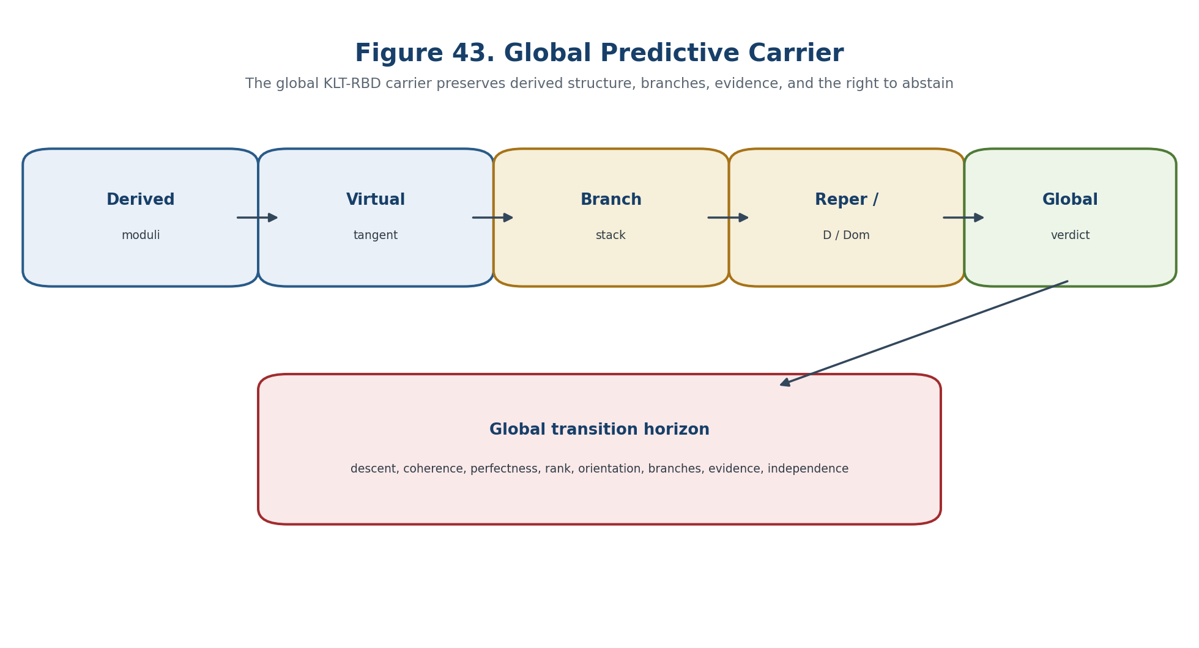
Figure 43. Global predictive carrier and blocker-safe three-valued verdict.
Output | Condition | Permitted meaning
NO-GLOBAL-TRANSITION-IN-MODEL | path avoids the cumulative horizon, residual margin positive, blockers empty | global certified profile remains constant
CANDIDATE-GLOBAL-TRANSITION | path meets the horizon or the residual admits zero with a valid certificate | requires construction of the post-transition global object
ABSTAIN | any descent, coherence, perfectness, branch, evidence, domain, external, or independence blocker remains | no global transition conclusion

18.12. Separating Models and STACK-GLOB Certificate
- All local Kuranishi maps vanish while a nontrivial gerbe or descent class blocks the global object.
- The same coarse space with different stabilisers has different stacky type.
- The same virtual dimension with different H^{-1} and H^1 hides automorphisms and obstruction directions.
- Perfect complexes with the same Euler characteristic need not be quasi-isomorphic.
- A glued stack without descended Evidence-D is a mathematical object but not an authorised Reper candidate.
- Global lambda=-1 with invalid Dom leaves the prediction gate closed.
- A nontrivial virtual class without time dynamics is an enumerative invariant, not an event.
- A numerically small descent defect without interval certification may be a badly conditioned nonzero defect.
STACK-GLOB group | Checks
STACK-01-08 | atlas and footprint inventory, typed coordinate changes, pairwise/triple/quadruple coherence, stabilisers, and equivalence checks
STACK-09-16 | Cech nerve, effective totalisation, local virtual tangent complexes, quasi-isomorphisms, amplitude, ranks, virtual dimension, determinant/orientation
STACK-17-24 | local/global obstruction carriers, branch stack and monodromy, Reper/Evidence-D/Dom descent, lambda invariance and pole checks
STACK-25-28 | external E/Pi_E compatibility, cumulative horizon, blocker-safe verdict, and code/data/environment hashes

BOUNDARY OF CHAPTER 18. The global carrier is a conditional mathematical construction. It preserves local-to-global, stacky/derived, evidence, and domain distinctions. It does not turn a virtual or enumerative invariant into a physical event.

Prior art includes cotangent complexes, intrinsic normal cones and perfect obstruction theories, derived and homotopical geometry, derived smooth manifolds, Kuranishi atlases, and Kuranishi 2-categories. The authorial contribution is their blocker-safe NAPG/KLT-RBD synthesis in which the global carrier simultaneously preserves derived tangent type, branch monodromy, Reper structure, Evidence-D, Dom, the external E-bridge, and the right to abstain.

Chapter 19. Virtual Cycles, Enumerative Invariants, and the Probability Firewall
ONTOLOGY | Virtual geometry supplies a cycle-theoretic carrier; probability requires a separate measurable bridge.
EPISTEMOLOGY | Knowledge is certified through a perfect obstruction package, a virtual class, insertions, orientation, properness, and an explicit probability model when probabilistic language is used.
PHENOMENOLOGY | The layer appears through signed or weighted virtual counts, localization formulas, deformation invariants, and calibrated predictive outputs.
LIMITATION | A virtual degree is not a probability measure, and an enumerative invariant does not determine event likelihood without an independently tested link.
AUTHORIAL NOVELTY | The authorial node is the two-gate virtual/probability firewall inside the Reper, D/Dom, and KLT-RBD certificate chain.

The horizon is the union of loci where rank, domain, topology, calibration, identification, or numerical certification can change. Virtual intersection data and probabilistic data remain separate until a calibrated measurable link is supplied.
Controlled field | Value
Canonical input | Frozen Russian Chapter 19, inherited English Chapters 1-18, and formula/source passports.
New mathematical layer | Virtual geometry supplies a cycle-theoretic carrier; probability requires a separate measurable bridge.
Status rule | Definitions, theorems, conditional bridges, models, numerical certificates, and physical hypotheses remain distinct.
Prohibition | A virtual degree is not a probability measure, and an enumerative invariant does not determine event likelihood without an independently tested link.
Downstream role | Chapter 24 composes all certified layers and preserves ABSTAIN/FAIL as absorbing results.

19.1. Four Non-equivalent Layers of Knowledge
The source construction is restated in controlled English with its hypotheses, invariants, loss channels, and forbidden status transfers kept explicit. Virtual intersection data and probabilistic data remain separate until a calibrated measurable link is supplied.
V0 -> V1 does not imply P0 -> E0. | T2-F202

19.2. Cycle Carrier and Virtual Dimension
The source construction is restated in controlled English with its hypotheses, invariants, loss channels, and forbidden status transfers kept explicit. Virtual intersection data and probabilistic data remain separate until a calibrated measurable link is supplied.
φ:E•→L_𝔐, amp(E•)⊂[-1,0]. | T2-F203

vdim(𝔐)=rk(E•)=rk(E⁰)-rk(E⁻¹). | T2-F204

19.3. Construction of the Virtual Fundamental Class
The source construction is restated in controlled English with its hypotheses, invariants, loss channels, and forbidden status transfers kept explicit. Virtual intersection data and probabilistic data remain separate until a calibrated measurable link is supplied.
[𝔐]ᵛⁱʳ = 0_𝔈^! [𝔠_𝔐] ∈ A_vdim(𝔐). | T2-F205

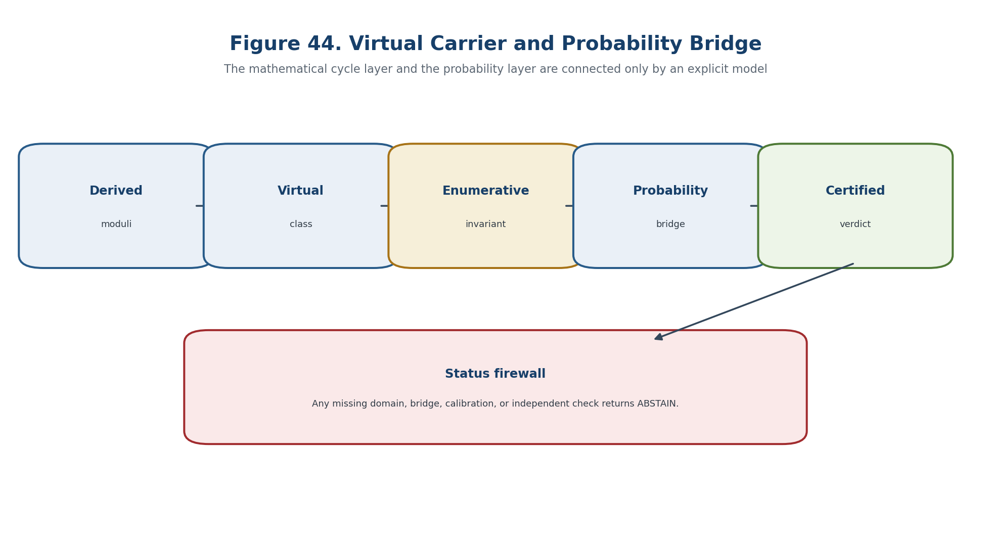
Figure 44. Virtual carrier and separate probability bridge.

19.4. Integration over the Virtual Class
The source construction is restated in controlled English with its hypotheses, invariants, loss channels, and forbidden status transfers kept explicit. Virtual intersection data and probabilistic data remain separate until a calibrated measurable link is supplied.
Iᵛⁱʳ(𝔐;α)=∫_[𝔐]ᵛⁱʳ α = deg(α∩[𝔐]ᵛⁱʳ). | T2-F206

⟨α₁,…,αₙ⟩ᵛⁱʳ = ∫_[𝔐]ᵛⁱʳ ∏ᵢ evᵢ*αᵢ. | T2-F207

19.5. Regular Zero Locus and Excess Intersection
The source construction is restated in controlled English with its hypotheses, invariants, loss channels, and forbidden status transfers kept explicit. Virtual intersection data and probabilistic data remain separate until a calibrated measurable link is supplied.
[Z]ᵛⁱʳ=[Z], vdim=dim U-rk E. | T2-F208

19.6. Deformation Invariance
The source construction is restated in controlled English with its hypotheses, invariants, loss channels, and forbidden status transfers kept explicit. Virtual intersection data and probabilistic data remain separate until a calibrated measurable link is supplied.
[𝔐_b]ᵛⁱʳ = i_b^![𝔐]ᵛⁱʳ_rel. | T2-F209

Iᵛⁱʳ(𝔐_b;α_b)=const. | T2-F210

19.7. Equivariant Localization
The source construction is restated in controlled English with its hypotheses, invariants, loss channels, and forbidden status transfers kept explicit. Virtual intersection data and probabilistic data remain separate until a calibrated measurable link is supplied.
[𝔐]ᵛⁱʳ = i_* Σ_F [F]ᵛⁱʳ / e_T(N_Fᵛⁱʳ) | T2-F211

19.8. When a Virtual Count Is Genuinely Enumerative
The source construction is restated in controlled English with its hypotheses, invariants, loss channels, and forbidden status transfers kept explicit. Virtual intersection data and probabilistic data remain separate until a calibrated measurable link is supplied.
Iᵛⁱʳ = Σ_[x] m_x / |Aut(x)|. | T2-F212

19.9. Three Models Refuting the Probability Substitution
The source construction is restated in controlled English with its hypotheses, invariants, loss channels, and forbidden status transfers kept explicit. Virtual intersection data and probabilistic data remain separate until a calibrated measurable link is supplied.

19.10. No Universal Probabilistic Interpretation Theorem
The statement is read under the explicitly declared hypotheses; its conclusion remains inside the mathematical model and does not acquire empirical status by translation. Separating models show that the prohibited inference fails even when the upstream mathematical object is well defined. Virtual intersection data and probabilistic data remain separate until a calibrated measurable link is supplied.
Theorem 19.4. No Universal Probability Interpretation [THM] There is no unrestricted carrier-independent rule that sends every virtual count to a probability while preserving the required probability axioms. Negative, greater-than-one, and stack-weighted examples provide separating witnesses.

virtual degree ≠ probability measure. | T2-F213

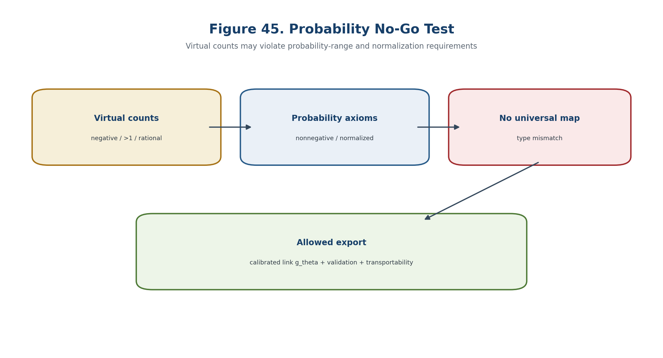
Figure 45. Probability no-go test for unrestricted virtual counts.

19.11. The Probabilistic Bridge
The bridge is an additional typed map with its own identification, calibration, and transport obligations; it is not supplied by a shared notation. Virtual intersection data and probabilistic data remain separate until a calibrated measurable link is supplied.
B_prob=(Ω,ℱ,P,Y,φ,g_θ,ℒ,Cal,Val,Ext). | T2-F214

p_θ = g_θ(φ(P_vir, P_stack, λ, CGI, D, Dom)). | T2-F215

19.12. Calibration, Discrimination, and Transportability
The bridge is an additional typed map with its own identification, calibration, and transport obligations; it is not supplied by a shared notation. Virtual intersection data and probabilistic data remain separate until a calibrated measurable link is supplied.
E[Y | p_θ]=p_θ. | T2-F216

19.13. Virtual Reper Certificate
The certificate records inputs, algorithms, tolerances, residuals, sources, code and data hashes, and the weakest evidential status supported by the chain. Virtual intersection data and probabilistic data remain separate until a calibrated measurable link is supplied.
VirtCert=(𝔐ᵈᵉʳ,E•,𝔠_𝔐,[𝔐]ᵛⁱʳ,α,or,prop,src,code,D,Dom). | T2-F217

Rep_vir=(R_vir,I_vir,U_vir;D_vir), | T2-F218

Gate component | Required check | Failure output
Type and domain | All Dom/Cod and admissibility predicates are defined. | ABSTAIN-DOMAIN
Mathematical certificate | Hypotheses, residuals, and representative independence are verified. | ABSTAIN-CERT
Bridge and transport | The relevant realization, temporal, causal, or empirical bridge is identified. | ABSTAIN-BRIDGE
Independent evidence | Required external data or EXT-RUN is present and hash-linked. | ABSTAIN-EXT

19.14. Projective-Harmonic and Enumerative Gate
The source construction is restated in controlled English with its hypotheses, invariants, loss channels, and forbidden status transfers kept explicit. Virtual intersection data and probabilistic data remain separate until a calibrated measurable link is supplied.
Gate_vir=1 ⇔ Cert_VFC=1 ∧ Valid(D)=1 ∧ Dom=1 ∧ Block_vir=∅. | T2-F219

Gate_prob=1 ⇔ Gate_vir=1 ∧ Cert_prob=1 ∧ Ext=1. | T2-F220

19.15. Virtual and Probabilistic Horizons
The horizon is the union of loci where rank, domain, topology, calibration, identification, or numerical certification can change. Virtual intersection data and probabilistic data remain separate until a calibrated measurable link is supplied.
Δ_VFC = Δ_POT ∪ Δ_amp ∪ Δ_prop ∪ Δ_or ∪ Δ_comp ∪ Δ_ins ∪ Δ_loc ∪ Δ_wall ∪ Δ_num. | T2-F221

Δ_prob = Δ_Ω ∪ Δ_meas ∪ Δ_link ∪ Δ_cal ∪ Δ_shift ∪ Δ_sel ∪ Δ_ext. | T2-F222

Δ_safe^{v0.16}=Δ_safe^{v0.15}∪Δ_VFC∪Δ_prob. | T2-F223

Gate component | Required check | Failure output
Type and domain | All Dom/Cod and admissibility predicates are defined. | ABSTAIN-DOMAIN
Mathematical certificate | Hypotheses, residuals, and representative independence are verified. | ABSTAIN-CERT
Bridge and transport | The relevant realization, temporal, causal, or empirical bridge is identified. | ABSTAIN-BRIDGE
Independent evidence | Required external data or EXT-RUN is present and hash-linked. | ABSTAIN-EXT

19.16. Main Conditional Theorem
The statement is read under the explicitly declared hypotheses; its conclusion remains inside the mathematical model and does not acquire empirical status by translation. Virtual intersection data and probabilistic data remain separate until a calibrated measurable link is supplied.
Theorem 19.6. Conditional Virtual-Profile Constancy [COND] Along a path that avoids the inherited and virtual horizons, with a transported obstruction theory, orientation, properness and insertion data, the certified virtual profile is constant. This does not determine the probability of leaving that sector.

P_VFC(t)=([𝔐_t]ᵛⁱʳ, vdim, Iᵛⁱʳ_t, supp, sign, denom, chamber, λ_t, CGI_t) | T2-F224

γ∩(Δ_safe^{v0.15}∪Δ_VFC)=∅ ⇒ NO-VIRTUAL-CHANGE-IN-MODEL. | T2-F225

19.17. Two-Stage Blocker-Safe Verdict
The allowed output is multi-valued: a certified conclusion, an explicit candidate requiring further checks, ABSTAIN with blockers, or FAIL with a witness. Virtual intersection data and probabilistic data remain separate until a calibrated measurable link is supplied.
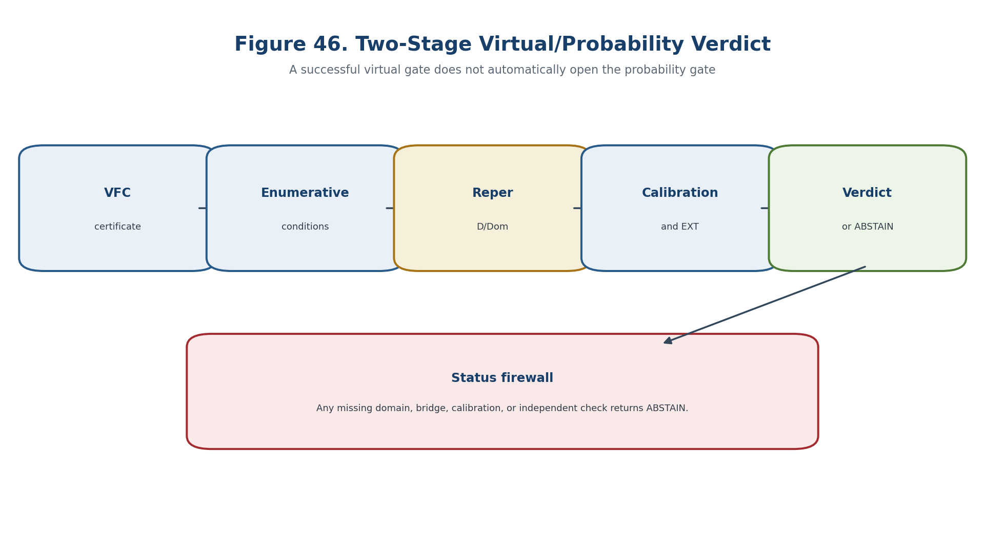
Figure 46. Two-stage virtual/probability verdict.
Gate component | Required check | Failure output
Type and domain | All Dom/Cod and admissibility predicates are defined. | ABSTAIN-DOMAIN
Mathematical certificate | Hypotheses, residuals, and representative independence are verified. | ABSTAIN-CERT
Bridge and transport | The relevant realization, temporal, causal, or empirical bridge is identified. | ABSTAIN-BRIDGE
Independent evidence | Required external data or EXT-RUN is present and hash-linked. | ABSTAIN-EXT

19.18. Counterexamples and Separating Models
Separating models show that the prohibited inference fails even when the upstream mathematical object is well defined. Virtual intersection data and probabilistic data remain separate until a calibrated measurable link is supplied.

19.19. Computational Certificate VFC-ENUM-PROB
The certificate records inputs, algorithms, tolerances, residuals, sources, code and data hashes, and the weakest evidential status supported by the chain. Virtual intersection data and probabilistic data remain separate until a calibrated measurable link is supplied.
Gate component | Required check | Failure output
Type and domain | All Dom/Cod and admissibility predicates are defined. | ABSTAIN-DOMAIN
Mathematical certificate | Hypotheses, residuals, and representative independence are verified. | ABSTAIN-CERT
Bridge and transport | The relevant realization, temporal, causal, or empirical bridge is identified. | ABSTAIN-BRIDGE
Independent evidence | Required external data or EXT-RUN is present and hash-linked. | ABSTAIN-EXT

19.19.1. Pseudocode
The source construction is restated in controlled English with its hypotheses, invariants, loss channels, and forbidden status transfers kept explicit. Virtual intersection data and probabilistic data remain separate until a calibrated measurable link is supplied.

19.20. Prior Art and Boundary of the Authorial Contribution
Classical constructions retain their standard attribution; the authorial contribution is the typed, blocker-safe synthesis inside KLT-RBD. Virtual intersection data and probabilistic data remain separate until a calibrated measurable link is supplied.
BOUNDARY OF CHAPTER 19. A virtual degree is not a probability measure, and an enumerative invariant does not determine event likelihood without an independently tested link. truth_layer_promotion=0; independent EXT-RUN and EMP-OBS remain absent.

Chapter 20. Categorified, Motivic, and Refined Virtual Invariants
ONTOLOGY | A refined invariant first lives in a categorical or motivic carrier and only later admits decategorified and numerical realizations.
EPISTEMOLOGY | Each realization is treated as a potentially information-losing map whose domain, completion, orientation data, and specialization must be recorded.
PHENOMENOLOGY | The structure appears through Grothendieck classes, motives, vanishing cycles, refined series, CoHA/BPS carriers, and completed products.
LIMITATION | A grading, charge, coefficient index, or generating-series variable is not physical time without a state space, evolution family, observable, and empirical bridge.
AUTHORIAL NOVELTY | The authorial node is the motivic/series/dynamic firewall with a typed realization passport and an abstention rule.

The source construction is restated in controlled English with its hypotheses, invariants, loss channels, and forbidden status transfers kept explicit. Categorical, motivic, refined, numerical, temporal, and empirical carriers are tracked as distinct levels.
Controlled field | Value
Canonical input | Frozen Russian Chapter 20, inherited English Chapters 1-18, and formula/source passports.
New mathematical layer | A refined invariant first lives in a categorical or motivic carrier and only later admits decategorified and numerical realizations.
Status rule | Definitions, theorems, conditional bridges, models, numerical certificates, and physical hypotheses remain distinct.
Prohibition | A grading, charge, coefficient index, or generating-series variable is not physical time without a state space, evolution family, observable, and empirical bridge.
Downstream role | Chapter 24 composes all certified layers and preserves ABSTAIN/FAIL as absorbing results.

20.1. Carrier Ladder and No-Promotion Rule
The source construction is restated in controlled English with its hypotheses, invariants, loss channels, and forbidden status transfers kept explicit. Categorical, motivic, refined, numerical, temporal, and empirical carriers are tracked as distinct levels.
𝕍_γ ∈ 𝒞_γ → [𝕍_γ] ∈ K₀(𝒞_γ) → 𝓜_γ ∈ R_mot → Real(𝓜_γ) → I_γ ∈ R_num. | T2-F226

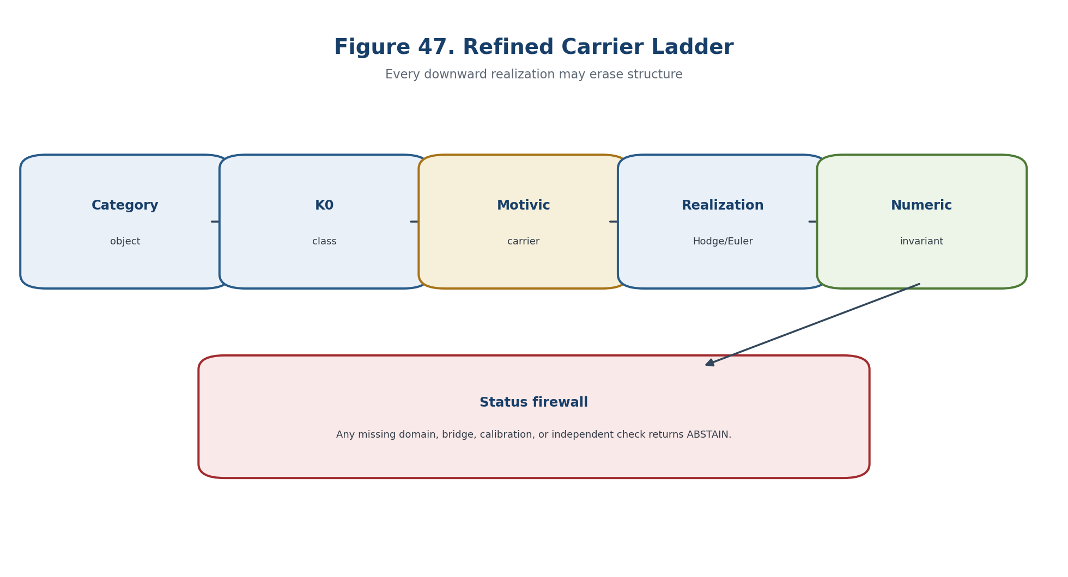
Figure 47. Refined carrier ladder and information loss.

20.2. Categorification and Decategorification
The source construction is restated in controlled English with its hypotheses, invariants, loss channels, and forbidden status transfers kept explicit. Categorical, motivic, refined, numerical, temporal, and empirical carriers are tracked as distinct levels.
[Y]=[X]+[Z]. | T2-F227

20.3. Motivic Carrier and the Grothendieck Ring of Varieties
The source construction is restated in controlled English with its hypotheses, invariants, loss channels, and forbidden status transfers kept explicit. Categorical, motivic, refined, numerical, temporal, and empirical carriers are tracked as distinct levels.
[X]=[Z]+[X\Z] for closed Z subset X, and [X]*[Y]=[X x Y]. | T2-F228

MotCar=(R_mot, 𝕃^{1/2}, Fil, Comp, μ̂, or, src, D, Dom), | T2-F229

20.4. Realizations and the Numerical Indistinguishability Theorem
The statement is read under the explicitly declared hypotheses; its conclusion remains inside the mathematical model and does not acquire empirical status by translation. Categorical, motivic, refined, numerical, temporal, and empirical carriers are tracked as distinct levels.
Theorem 20.2. Numerical Indistinguishability [THM] Equal numerical realizations do not reconstruct equivalent categorical or motivic carriers unless the selected realization functor is proved conservative on the declared subcategory.

χ_c : K₀(Var_ℂ) → ℤ, E_c : K₀(Var_ℂ) → ℤ[u,v]. | T2-F230

20.5. Power Structures and Plethystic Operations
The source construction is restated in controlled English with its hypotheses, invariants, loss channels, and forbidden status transfers kept explicit. Categorical, motivic, refined, numerical, temporal, and empirical carriers are tracked as distinct levels.
PExp(f)=exp(Σ_{r≥1} ψ_r(f)/r), PLog=PExp^{-1}. | T2-F231

20.6. Motivic Vanishing Cycles and Orientation Data
The source construction is restated in controlled English with its hypotheses, invariants, loss channels, and forbidden status transfers kept explicit. Categorical, motivic, refined, numerical, temporal, and empirical carriers are tracked as distinct levels.
MF^φ_{U,f} ∈ 𝓜_X^{μ̂}, Real(MF^φ_{U,f}) = vanishing-cycle realization. | T2-F232

20.7. Refined Invariants and the Realization Passport
The certificate records inputs, algorithms, tolerances, residuals, sources, code and data hashes, and the weakest evidential status supported by the chain. Categorical, motivic, refined, numerical, temporal, and empirical carriers are tracked as distinct levels.
Ω_γ^{ref}(y)=Σ_j (-1)^j dim 𝓗_γ^j · y^{j/2}. | T2-F233

20.8. Cohomologicalical Hall Algebra
The source construction is restated in controlled English with its hypotheses, invariants, loss channels, and forbidden status transfers kept explicit. Categorical, motivic, refined, numerical, temporal, and empirical carriers are tracked as distinct levels.
CoHA=⊕_{γ∈Γ_+} H^•_{c,G_γ}(Rep_γ, φ_{Tr W}), | T2-F234

20.9. BPS Cohomologicaly and Integrality
The source construction is restated in controlled English with its hypotheses, invariants, loss channels, and forbidden status transfers kept explicit. Categorical, motivic, refined, numerical, temporal, and empirical carriers are tracked as distinct levels.
BPS_γ ∈ MHM(M_γ), Ω_γ^{ref}=Real(BPS_γ). | T2-F235

20.10. Generating Series as Completed Graded Objects
The source construction is restated in controlled English with its hypotheses, invariants, loss channels, and forbidden status transfers kept explicit. Categorical, motivic, refined, numerical, temporal, and empirical carriers are tracked as distinct levels.
Z_ref(𝐱;y,𝕃)=1+Σ_{0≠γ∈Γ_+} Ω_γ^{ref}(y,𝕃) 𝐱^γ ∈ 1+Î. | T2-F236

20.11. Quantum Torus and Ordered Factorizations
The source construction is restated in controlled English with its hypotheses, invariants, loss channels, and forbidden status transfers kept explicit. Categorical, motivic, refined, numerical, temporal, and empirical carriers are tracked as distinct levels.
𝐱^α 𝐱^β = 𝕃^{⟨α,β⟩/2} 𝐱^{α+β}. | T2-F237

20.12. Rationality and Functional Equations
The source construction is restated in controlled English with its hypotheses, invariants, loss channels, and forbidden status transfers kept explicit. Categorical, motivic, refined, numerical, temporal, and empirical carriers are tracked as distinct levels.
Z(q^{-1}) = q^a * epsilon * Z(q), or Z(q)=P(q)/Q(q). | T2-F238

20.13. Non-identifiability of Time from Coefficients
Separating models show that the prohibited inference fails even when the upstream mathematical object is well defined. Categorical, motivic, refined, numerical, temporal, and empirical carriers are tracked as distinct levels.
Theorem 20.5. Time Non-identifiability from Coefficients [THM] A graded or generating-series coefficient sequence does not identify a temporal evolution law without a time set, state embedding, evolution family, observation map, and calibration contract.

graded coefficient ≠ time-stamped state; generating series ≠ flow. | T2-F239

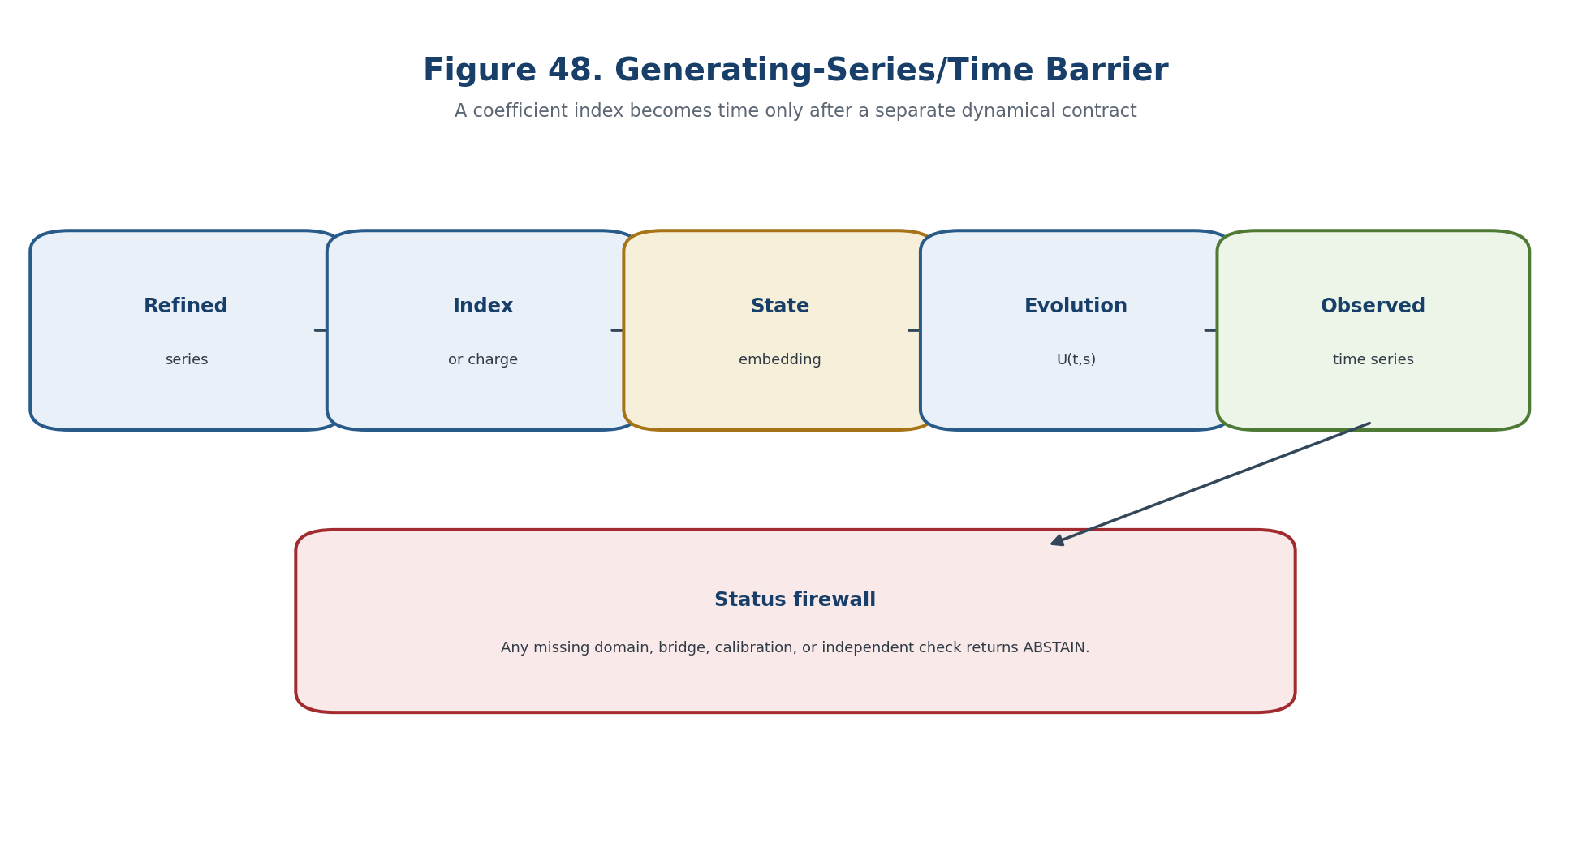
Figure 48. Barrier between a generating series and temporal dynamics.

20.14. Minimal Dynamical Bridge
The bridge is an additional typed map with its own identification, calibration, and transport obligations; it is not supplied by a shared notation. Categorical, motivic, refined, numerical, temporal, and empirical carriers are tracked as distinct levels.
B_dyn=(T,S,τ,U,𝒢,ι,Obs,noise,Cal,Ext,D,Dom). | T2-F240

U(t,t)=Id, U(t,r)∘U(r,s)=U(t,s), t≥r≥s. | T2-F241

20.15. Semigroups, Generators, and Transfer Operators
The source construction is restated in controlled English with its hypotheses, invariants, loss channels, and forbidden status transfers kept explicit. Categorical, motivic, refined, numerical, temporal, and empirical carriers are tracked as distinct levels.
Ax = lim_{t↓0} (U(t)x-x)/t, x∈Dom(A). | T2-F242

20.16. Path-Space Carrier and Causal Order
The source construction is restated in controlled English with its hypotheses, invariants, loss channels, and forbidden status transfers kept explicit. Categorical, motivic, refined, numerical, temporal, and empirical carriers are tracked as distinct levels.
K_{t,s}=K_{t,r}∘K_{r,s}. | T2-F243

20.17. Empirical Bridge and Operationalization
The bridge is an additional typed map with its own identification, calibration, and transport obligations; it is not supplied by a shared notation. Categorical, motivic, refined, numerical, temporal, and empirical carriers are tracked as distinct levels.
Y_t = Obs(U(t,t₀)ι(𝓜_ref)) + ε_t. | T2-F244

20.18. Motivic-Refined Reper Certificate
The certificate records inputs, algorithms, tolerances, residuals, sources, code and data hashes, and the weakest evidential status supported by the chain. Categorical, motivic, refined, numerical, temporal, and empirical carriers are tracked as distinct levels.
MotRefCert=(𝕍,K₀,𝓜,Real,Ω_ref,Z_ref,B_dyn,B_emp,src,code,D,Dom). | T2-F245

Rep_mot=(R_mot,I_mot,U_mot;D_mot), | T2-F246

Gate component | Required check | Failure output
Type and domain | All Dom/Cod and admissibility predicates are defined. | ABSTAIN-DOMAIN
Mathematical certificate | Hypotheses, residuals, and representative independence are verified. | ABSTAIN-CERT
Bridge and transport | The relevant realization, temporal, causal, or empirical bridge is identified. | ABSTAIN-BRIDGE
Independent evidence | Required external data or EXT-RUN is present and hash-linked. | ABSTAIN-EXT

20.19. Information Residuals and Refined CGI
The source construction is restated in controlled English with its hypotheses, invariants, loss channels, and forbidden status transfers kept explicit. Categorical, motivic, refined, numerical, temporal, and empirical carriers are tracked as distinct levels.
R_ref=(r_cat,r_K₀,r_mot,r_real,r_spec,r_series,r_time,r_evol,r_obs,r_ext). | T2-F247

20.20. Three Transition Horizons
The horizon is the union of loci where rank, domain, topology, calibration, identification, or numerical certification can change. Categorical, motivic, refined, numerical, temporal, and empirical carriers are tracked as distinct levels.
Δ_mot = Δ_cat ∪ Δ_or ∪ Δ_glue ∪ Δ_comp ∪ Δ_real ∪ Δ_spec. | T2-F248

Δ_series = Δ_ring ∪ Δ_order ∪ Δ_wall ∪ Δ_PExp ∪ Δ_conv ∪ Δ_func. | T2-F249

Δ_dyn = Δ_time ∪ Δ_state ∪ Δ_U ∪ Δ_gen ∪ Δ_path ∪ Δ_obs ∪ Δ_cal ∪ Δ_ext. | T2-F250

Δ_safe^{v0.17}=Δ_safe^{v0.16}∪Δ_mot∪Δ_series∪Δ_dyn. | T2-F251

Gate component | Required check | Failure output
Type and domain | All Dom/Cod and admissibility predicates are defined. | ABSTAIN-DOMAIN
Mathematical certificate | Hypotheses, residuals, and representative independence are verified. | ABSTAIN-CERT
Bridge and transport | The relevant realization, temporal, causal, or empirical bridge is identified. | ABSTAIN-BRIDGE
Independent evidence | Required external data or EXT-RUN is present and hash-linked. | ABSTAIN-EXT

20.21. Main Conditional Theorem
The statement is read under the explicitly declared hypotheses; its conclusion remains inside the mathematical model and does not acquire empirical status by translation. Categorical, motivic, refined, numerical, temporal, and empirical carriers are tracked as distinct levels.
Theorem 20.8. Conditional Refined-Profile Constancy [COND] Inside a fixed motivic, series, chamber and dynamical certificate, the refined profile is transported without status promotion. Any missing temporal or empirical bridge yields FORMAL-SERIES-ONLY or ABSTAIN.

P_ref(t)=([𝕍_t],𝓜_t,Real_t,Ω_t^{ref},Z_t,chamber_t,λ_t,CGI_ref,t) | T2-F252

NO-REFINED-CHANGE-IN-MODEL or FORMAL-SERIES-ONLY. | T2-F253

20.22. Three-Stage Blocker-Safe Verdict
The allowed output is multi-valued: a certified conclusion, an explicit candidate requiring further checks, ABSTAIN with blockers, or FAIL with a witness. Categorical, motivic, refined, numerical, temporal, and empirical carriers are tracked as distinct levels.
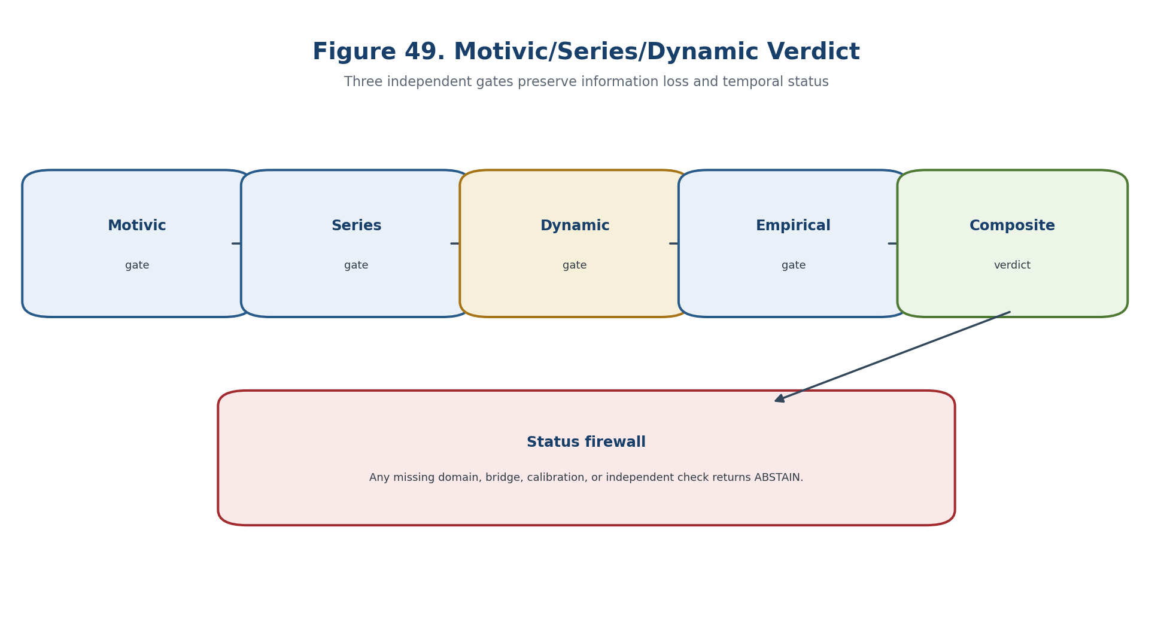
Figure 49. Motivic, series, and dynamic verdict.
Gate component | Required check | Failure output
Type and domain | All Dom/Cod and admissibility predicates are defined. | ABSTAIN-DOMAIN
Mathematical certificate | Hypotheses, residuals, and representative independence are verified. | ABSTAIN-CERT
Bridge and transport | The relevant realization, temporal, causal, or empirical bridge is identified. | ABSTAIN-BRIDGE
Independent evidence | Required external data or EXT-RUN is present and hash-linked. | ABSTAIN-EXT

20.23. Counterexamples and Separating Models
Separating models show that the prohibited inference fails even when the upstream mathematical object is well defined. Categorical, motivic, refined, numerical, temporal, and empirical carriers are tracked as distinct levels.

20.24. Computational Certificate MOT-REF-SER-DYN
The certificate records inputs, algorithms, tolerances, residuals, sources, code and data hashes, and the weakest evidential status supported by the chain. Categorical, motivic, refined, numerical, temporal, and empirical carriers are tracked as distinct levels.
Gate component | Required check | Failure output
Type and domain | All Dom/Cod and admissibility predicates are defined. | ABSTAIN-DOMAIN
Mathematical certificate | Hypotheses, residuals, and representative independence are verified. | ABSTAIN-CERT
Bridge and transport | The relevant realization, temporal, causal, or empirical bridge is identified. | ABSTAIN-BRIDGE
Independent evidence | Required external data or EXT-RUN is present and hash-linked. | ABSTAIN-EXT

20.24.1. Pseudocode
The source construction is restated in controlled English with its hypotheses, invariants, loss channels, and forbidden status transfers kept explicit. Categorical, motivic, refined, numerical, temporal, and empirical carriers are tracked as distinct levels.

20.25. Prior Art and Boundary of the Authorial Contribution
Classical constructions retain their standard attribution; the authorial contribution is the typed, blocker-safe synthesis inside KLT-RBD. Categorical, motivic, refined, numerical, temporal, and empirical carriers are tracked as distinct levels.
BOUNDARY OF CHAPTER 20. A grading, charge, coefficient index, or generating-series variable is not physical time without a state space, evolution family, observable, and empirical bridge. truth_layer_promotion=0; independent EXT-RUN and EMP-OBS remain absent.

Chapter 21. Nonlinear Evolution Semigroups, Transfer Operators, Path-Space Carriers, and Causal Kernels
ONTOLOGY | Temporal prediction requires an evolution law on states and a compatible carrier on observables, measures, and paths.
EPISTEMOLOGY | Knowledge is certified through domains, semigroup or evolution-family identities, generators, kernels, path consistency, non-anticipation, and observation maps.
PHENOMENOLOGY | The dynamics appears through nonlinear flows, Koopman and transfer operators, Markov kernels, Volterra memory, and Reper trajectories.
LIMITATION | Static snapshots do not determine a unique evolution, and a transition kernel is not an intervention kernel or a physical cause.
AUTHORIAL NOVELTY | The authorial node is the temporal Reper carrier with causal typing, dynamic residuals, transition horizons, and blocker-safe output.

The source construction is restated in controlled English with its hypotheses, invariants, loss channels, and forbidden status transfers kept explicit. Evolution on states, observables, measures, and paths is synchronized only through declared duality and consistency contracts.
Controlled field | Value
Canonical input | Frozen Russian Chapter 21, inherited English Chapters 1-18, and formula/source passports.
New mathematical layer | Temporal prediction requires an evolution law on states and a compatible carrier on observables, measures, and paths.
Status rule | Definitions, theorems, conditional bridges, models, numerical certificates, and physical hypotheses remain distinct.
Prohibition | Static snapshots do not determine a unique evolution, and a transition kernel is not an intervention kernel or a physical cause.
Downstream role | Chapter 24 composes all certified layers and preserves ABSTAIN/FAIL as absorbing results.

21.1. Types of Time, State, and Evolution
This section fixes the carrier, domain, codomain, and status type before any computation or interpretation is permitted. Evolution on states, observables, measures, and paths is synchronized only through declared duality and consistency contracts.
truth_layer_promotion=0; source=T2-RP-v0.17; checkpoint=T2-RP-v0.18. | T2-F254

𝒰(t,s): Dom_{t,s}⊆S_s → S_t. | T2-F255

21.1.1. Minimal Type Registry
This section fixes the carrier, domain, codomain, and status type before any computation or interpretation is permitted. Evolution on states, observables, measures, and paths is synchronized only through declared duality and consistency contracts.

21.2. Nonlinear Evolution Semigroup
The source construction is restated in controlled English with its hypotheses, invariants, loss channels, and forbidden status transfers kept explicit. Evolution on states, observables, measures, and paths is synchronized only through declared duality and consistency contracts.
𝒮(0)=Id_C, 𝒮(t+s)=𝒮(t)∘𝒮(s), lim_{t↓0}𝒮(t)x=x. | T2-F256

21.3. Accretive and m-Accretive Generators
The source construction is restated in controlled English with its hypotheses, invariants, loss channels, and forbidden status transfers kept explicit. Evolution on states, observables, measures, and paths is synchronized only through declared duality and consistency contracts.
𝒮(t)x = lim_{m→∞}(I+(t/m)A)^{-m}x | T2-F257

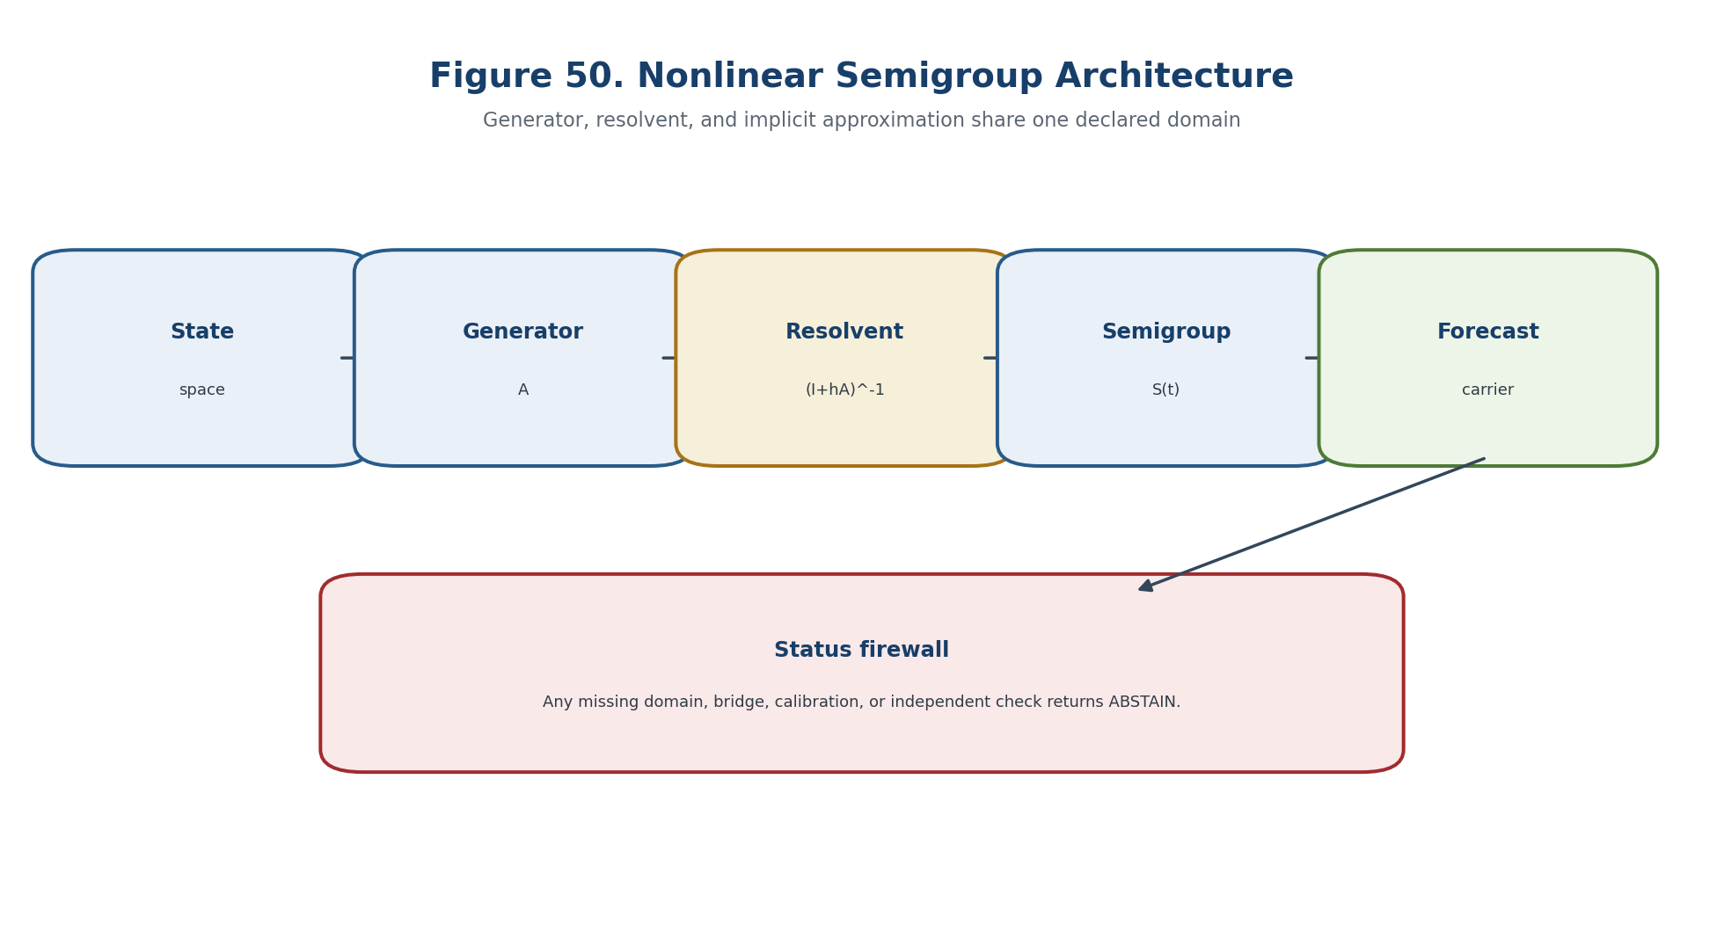
Figure 50. Nonlinear semigroup, generator, and resolvent.

21.4. Non-autonomous Evolution Families and the Kato Interface
The bridge is an additional typed map with its own identification, calibration, and transport obligations; it is not supplied by a shared notation. Evolution on states, observables, measures, and paths is synchronized only through declared duality and consistency contracts.
𝒰(s,s)=Id, 𝒰(t,r)∘𝒰(r,s)=𝒰(t,s). | T2-F258

21.5. State Dynamics and the Koopman Operator on Observables
This section fixes the carrier, domain, codomain, and status type before any computation or interpretation is permitted. Evolution on states, observables, measures, and paths is synchronized only through declared duality and consistency contracts.
(𝒦_t f)(x)=f(Φ_t(x)). | T2-F259

21.6. Perron-Frobenius and Transfer Operators
The source construction is restated in controlled English with its hypotheses, invariants, loss channels, and forbidden status transfers kept explicit. Evolution on states, observables, measures, and paths is synchronized only through declared duality and consistency contracts.
𝒫_t μ=(Φ_t)_#μ, (𝒫_t μ)(B)=μ(Φ_t^{-1}(B)). | T2-F260

∫_S f d(𝒫_t μ)=∫_S (𝒦_t f)dμ. | T2-F261

21.7. Markov Kernels and Chapman-Kolmogorov
The source construction is restated in controlled English with its hypotheses, invariants, loss channels, and forbidden status transfers kept explicit. Evolution on states, observables, measures, and paths is synchronized only through declared duality and consistency contracts.
K_{t,s}(x,B)=∫_S K_{t,r}(y,B)K_{r,s}(x,dy), t≥r≥s. | T2-F262

21.8. Path-Space Carrier and Cylinder Consistency
The source construction is restated in controlled English with its hypotheses, invariants, loss channels, and forbidden status transfers kept explicit. Evolution on states, observables, measures, and paths is synchronized only through declared duality and consistency contracts.
μ_{t₁,…,t_m}=Q∘(X_{t₁},…,X_{t_m})^{-1}. | T2-F263

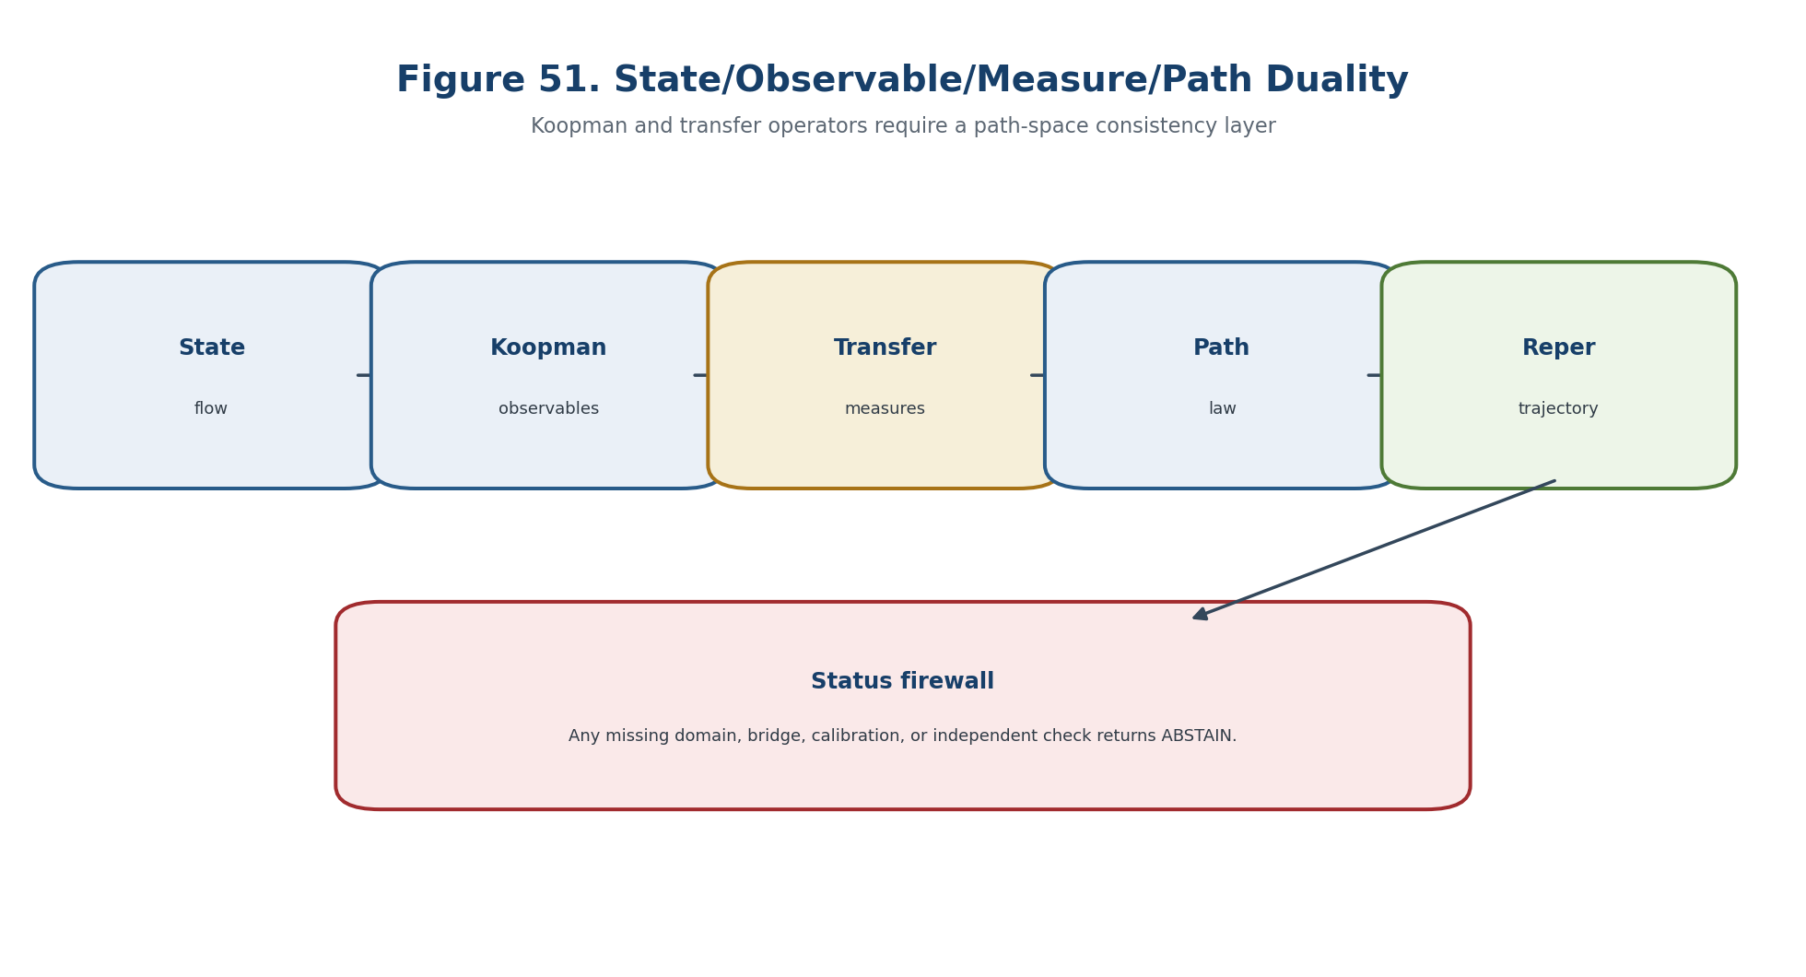
Figure 51. State, observable, measure, and path carriers.

21.9. Deterministic Path Carriers and Orbits
The source construction is restated in controlled English with its hypotheses, invariants, loss channels, and forbidden status transfers kept explicit. Evolution on states, observables, measures, and paths is synchronized only through declared duality and consistency contracts.
ω_x(t)=𝒰(t,t₀)x. | T2-F264

21.10. Causal Volterra Kernels and Memory
The source construction is restated in controlled English with its hypotheses, invariants, loss channels, and forbidden status transfers kept explicit. Evolution on states, observables, measures, and paths is synchronized only through declared duality and consistency contracts.
x(t)=f(t)+∫_{t₀}^{t} B(t,s,x(s)) ds. | T2-F265

21.11. Non-anticipation as a Strict Causal Firewall
The horizon is the union of loci where rank, domain, topology, calibration, identification, or numerical certification can change. Evolution on states, observables, measures, and paths is synchronized only through declared duality and consistency contracts.
(Fω)(t)=(Fω′)(t). | T2-F266

Gate component | Required check | Failure output
Type and domain | All Dom/Cod and admissibility predicates are defined. | ABSTAIN-DOMAIN
Mathematical certificate | Hypotheses, residuals, and representative independence are verified. | ABSTAIN-CERT
Bridge and transport | The relevant realization, temporal, causal, or empirical bridge is identified. | ABSTAIN-BRIDGE
Independent evidence | Required external data or EXT-RUN is present and hash-linked. | ABSTAIN-EXT

21.12. Filtrations, Adaptedness, and Observability
The source construction is restated in controlled English with its hypotheses, invariants, loss channels, and forbidden status transfers kept explicit. Evolution on states, observables, measures, and paths is synchronized only through declared duality and consistency contracts.

21.13. A Causal Kernel Is Not a Causal Mechanism
Separating models show that the prohibited inference fails even when the upstream mathematical object is well defined. Evolution on states, observables, measures, and paths is synchronized only through declared duality and consistency contracts.
transition kernel != intervention kernel != physical cause. | T2-F267

21.14. Reper Trajectory and Temporal Reper
The source construction is restated in controlled English with its hypotheses, invariants, loss channels, and forbidden status transfers kept explicit. Evolution on states, observables, measures, and paths is synchronized only through declared duality and consistency contracts.
Rep_t=(R_t,I_t,U_t;D_t), λ_t=cr(U_t,I_t;R_t,D_t). | T2-F268

21.15. Path-Reper Carrier
The source construction is restated in controlled English with its hypotheses, invariants, loss channels, and forbidden status transfers kept explicit. Evolution on states, observables, measures, and paths is synchronized only through declared duality and consistency contracts.
PathRep=(Ω,Q/𝔄,{Rep_t},𝒰,K,B,Obs,𝔽,D,Dom,src,code). | T2-F269

21.16. Dynamic Projective-Harmonic Coordinate
The source construction is restated in controlled English with its hypotheses, invariants, loss channels, and forbidden status transfers kept explicit. Evolution on states, observables, measures, and paths is synchronized only through declared duality and consistency contracts.
dλ_t/dt = Dλ(Rep_t)·Ṙep_t. | T2-F270

21.17. Transfer Operator of the Reper Database
The source construction is restated in controlled English with its hypotheses, invariants, loss channels, and forbidden status transfers kept explicit. Evolution on states, observables, measures, and paths is synchronized only through declared duality and consistency contracts.
𝒯_{t,s}: 𝔐(S_s)→𝔐(S_t), 𝒯_{t,r}𝒯_{r,s}=𝒯_{t,s}. | T2-F271

21.18. Generator and Local Forecast
The source construction is restated in controlled English with its hypotheses, invariants, loss channels, and forbidden status transfers kept explicit. Evolution on states, observables, measures, and paths is synchronized only through declared duality and consistency contracts.
d/dt 𝒯_t f |_{t=0}=Lf | T2-F272

21.19. Perturbation Stability and Trajectory Error
The source construction is restated in controlled English with its hypotheses, invariants, loss channels, and forbidden status transfers kept explicit. Evolution on states, observables, measures, and paths is synchronized only through declared duality and consistency contracts.
e_𝒰(t,s;x)=d(𝒰(t,s)x,Ũ(t,s)x). | T2-F273

21.20. Dynamic and Causal Residual Vector
The source construction is restated in controlled English with its hypotheses, invariants, loss channels, and forbidden status transfers kept explicit. Evolution on states, observables, measures, and paths is synchronized only through declared duality and consistency contracts.
R_time=(r_sg,r_gen,r_res,r_tr,r_path,r_CK,r_mem,r_na,r_obs,r_cal,r_ext). | T2-F274

21.21. Transition Horizons of Chapter 21
The horizon is the union of loci where rank, domain, topology, calibration, identification, or numerical certification can change. Evolution on states, observables, measures, and paths is synchronized only through declared duality and consistency contracts.
Δ_sg=Δ_dom∪Δ_cont∪Δ_comp∪Δ_accr∪Δ_res. | T2-F275

Δ_tr=Δ_pos∪Δ_mass∪Δ_dual∪Δ_spec∪Δ_inv. | T2-F276

Δ_path=Δ_cons∪Δ_tight∪Δ_reg∪Δ_branch∪Δ_hist. | T2-F277

Δ_causal=Δ_order∪Δ_NA∪Δ_filt∪Δ_interv∪Δ_transport. | T2-F278

Δ_safe^{v0.18}=Δ_safe^{v0.17}∪Δ_sg∪Δ_tr∪Δ_path∪Δ_causal. | T2-F279

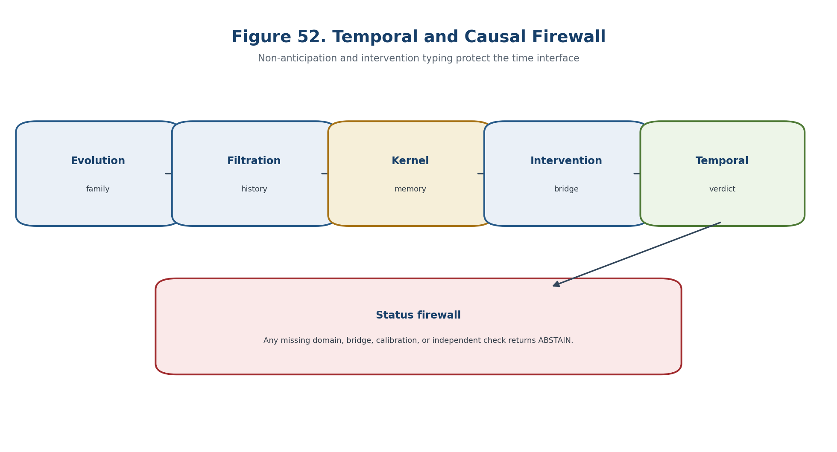
Figure 52. Temporal and causal firewall.
Gate component | Required check | Failure output
Type and domain | All Dom/Cod and admissibility predicates are defined. | ABSTAIN-DOMAIN
Mathematical certificate | Hypotheses, residuals, and representative independence are verified. | ABSTAIN-CERT
Bridge and transport | The relevant realization, temporal, causal, or empirical bridge is identified. | ABSTAIN-BRIDGE
Independent evidence | Required external data or EXT-RUN is present and hash-linked. | ABSTAIN-EXT

21.22. Temporal Profile Constancy Theorem
The statement is read under the explicitly declared hypotheses; its conclusion remains inside the mathematical model and does not acquire empirical status by translation. Evolution on states, observables, measures, and paths is synchronized only through declared duality and consistency contracts.
Theorem 21.5. Temporal Profile Constancy [COND] If the evolution family, transfer carrier, path law, observation map and Reper transport remain certified and the path avoids the temporal horizon, the temporal profile remains in the same certified class.

P_time(t)=(class(𝒰_t),class(𝒯_t),class(Q_t),rank/stratum,λ_t,CGI_time,t) | T2-F280

NO-TEMPORAL-TRANSITION-IN-MODEL. | T2-F281

21.23. Negative Theorem on Static Snapshots
The statement is read under the explicitly declared hypotheses; its conclusion remains inside the mathematical model and does not acquire empirical status by translation. Evolution on states, observables, measures, and paths is synchronized only through declared duality and consistency contracts.
Theorem 21.6. Static-Snapshot No-Go [THM] A family of one-time marginals or static snapshots does not in general identify a unique path law, generator, memory kernel, or causal mechanism.

21.24. Counterexamples and Separating Models
Separating models show that the prohibited inference fails even when the upstream mathematical object is well defined. Evolution on states, observables, measures, and paths is synchronized only through declared duality and consistency contracts.

21.25. Computational Certificate EVOL-TRANSFER-PATH
The certificate records inputs, algorithms, tolerances, residuals, sources, code and data hashes, and the weakest evidential status supported by the chain. Evolution on states, observables, measures, and paths is synchronized only through declared duality and consistency contracts.
Gate component | Required check | Failure output
Type and domain | All Dom/Cod and admissibility predicates are defined. | ABSTAIN-DOMAIN
Mathematical certificate | Hypotheses, residuals, and representative independence are verified. | ABSTAIN-CERT
Bridge and transport | The relevant realization, temporal, causal, or empirical bridge is identified. | ABSTAIN-BRIDGE
Independent evidence | Required external data or EXT-RUN is present and hash-linked. | ABSTAIN-EXT

21.25.1. Pseudocode
The source construction is restated in controlled English with its hypotheses, invariants, loss channels, and forbidden status transfers kept explicit. Evolution on states, observables, measures, and paths is synchronized only through declared duality and consistency contracts.

21.26. Prior Art and Boundary of the Authorial Contribution
Classical constructions retain their standard attribution; the authorial contribution is the typed, blocker-safe synthesis inside KLT-RBD. Evolution on states, observables, measures, and paths is synchronized only through declared duality and consistency contracts.
BOUNDARY OF CHAPTER 21. Static snapshots do not determine a unique evolution, and a transition kernel is not an intervention kernel or a physical cause. truth_layer_promotion=0; independent EXT-RUN and EMP-OBS remain absent.

Chapter 22. Stochastic Evolutions, Martingale Problems, Stopping Times, Control, and Causal Inference
ONTOLOGY | A stochastic law is a probability measure on adapted paths together with a filtration, generator, martingale problem, and declared interventions.
EPISTEMOLOGY | Knowledge is established by existence and uniqueness, domain-rich test functions, stopping-time conditions, barrier certificates, and causal identification assumptions.
PHENOMENOLOGY | The layer appears through Markov semigroups, SDEs, martingale residuals, hitting probabilities, controls, HJB equations, and sequential evidence.
LIMITATION | Observational prediction, control under a policy, and intervention are different laws; optional stopping and Girsanov changes require their exact hypotheses.
AUTHORIAL NOVELTY | The authorial node is the stochastic Reper-path and forecast-control-intervention firewall with an anytime-valid evidence gate.

The source construction is restated in controlled English with its hypotheses, invariants, loss channels, and forbidden status transfers kept explicit. The stochastic conclusion is limited by the martingale domain, stopping conditions, policy law, and causal identification bridge.
Controlled field | Value
Canonical input | Frozen Russian Chapter 22, inherited English Chapters 1-18, and formula/source passports.
New mathematical layer | A stochastic law is a probability measure on adapted paths together with a filtration, generator, martingale problem, and declared interventions.
Status rule | Definitions, theorems, conditional bridges, models, numerical certificates, and physical hypotheses remain distinct.
Prohibition | Observational prediction, control under a policy, and intervention are different laws; optional stopping and Girsanov changes require their exact hypotheses.
Downstream role | Chapter 24 composes all certified layers and preserves ABSTAIN/FAIL as absorbing results.

22.1. Stochastic Basis and Usual Conditions
The source construction is restated in controlled English with its hypotheses, invariants, loss channels, and forbidden status transfers kept explicit. The stochastic conclusion is limited by the martingale domain, stopping conditions, policy law, and causal identification bridge.
truth_layer_promotion=0; source=T2-RP-v0.18; checkpoint=T2-RP-v0.19. | T2-F282

22.1.1. Registry of Stochastic Types
This section fixes the carrier, domain, codomain, and status type before any computation or interpretation is permitted. The stochastic conclusion is limited by the martingale domain, stopping conditions, policy law, and causal identification bridge.

22.2. Markov Kernels and Markov Semigroup
The source construction is restated in controlled English with its hypotheses, invariants, loss channels, and forbidden status transfers kept explicit. The stochastic conclusion is limited by the martingale domain, stopping conditions, policy law, and causal identification bridge.
(P_t f)(x)=∫_E f(y)p_t(x,dy)=E_x[f(X_t)]. | T2-F283

22.3. Feller Sector, Generator, and Positive Maximum Principle
The source construction is restated in controlled English with its hypotheses, invariants, loss channels, and forbidden status transfers kept explicit. The stochastic conclusion is limited by the martingale domain, stopping conditions, policy law, and causal identification bridge.
Lf = lim_{t↓0}(P_t f-f)/t, f∈Dom(L). | T2-F284

22.4. Resolvent and Kolmogorov Equations
The source construction is restated in controlled English with its hypotheses, invariants, loss channels, and forbidden status transfers kept explicit. The stochastic conclusion is limited by the martingale domain, stopping conditions, policy law, and causal identification bridge.
R_α f = ∫_0^∞ e^{-αt}P_t f dt. | T2-F285

22.5. Stroock-Varadhan Martingale Problem
The source construction is restated in controlled English with its hypotheses, invariants, loss channels, and forbidden status transfers kept explicit. The stochastic conclusion is limited by the martingale domain, stopping conditions, policy law, and causal identification bridge.
M_t^f = f(X_t)-f(X_0)-∫_0^t Lf(X_s)ds | T2-F286

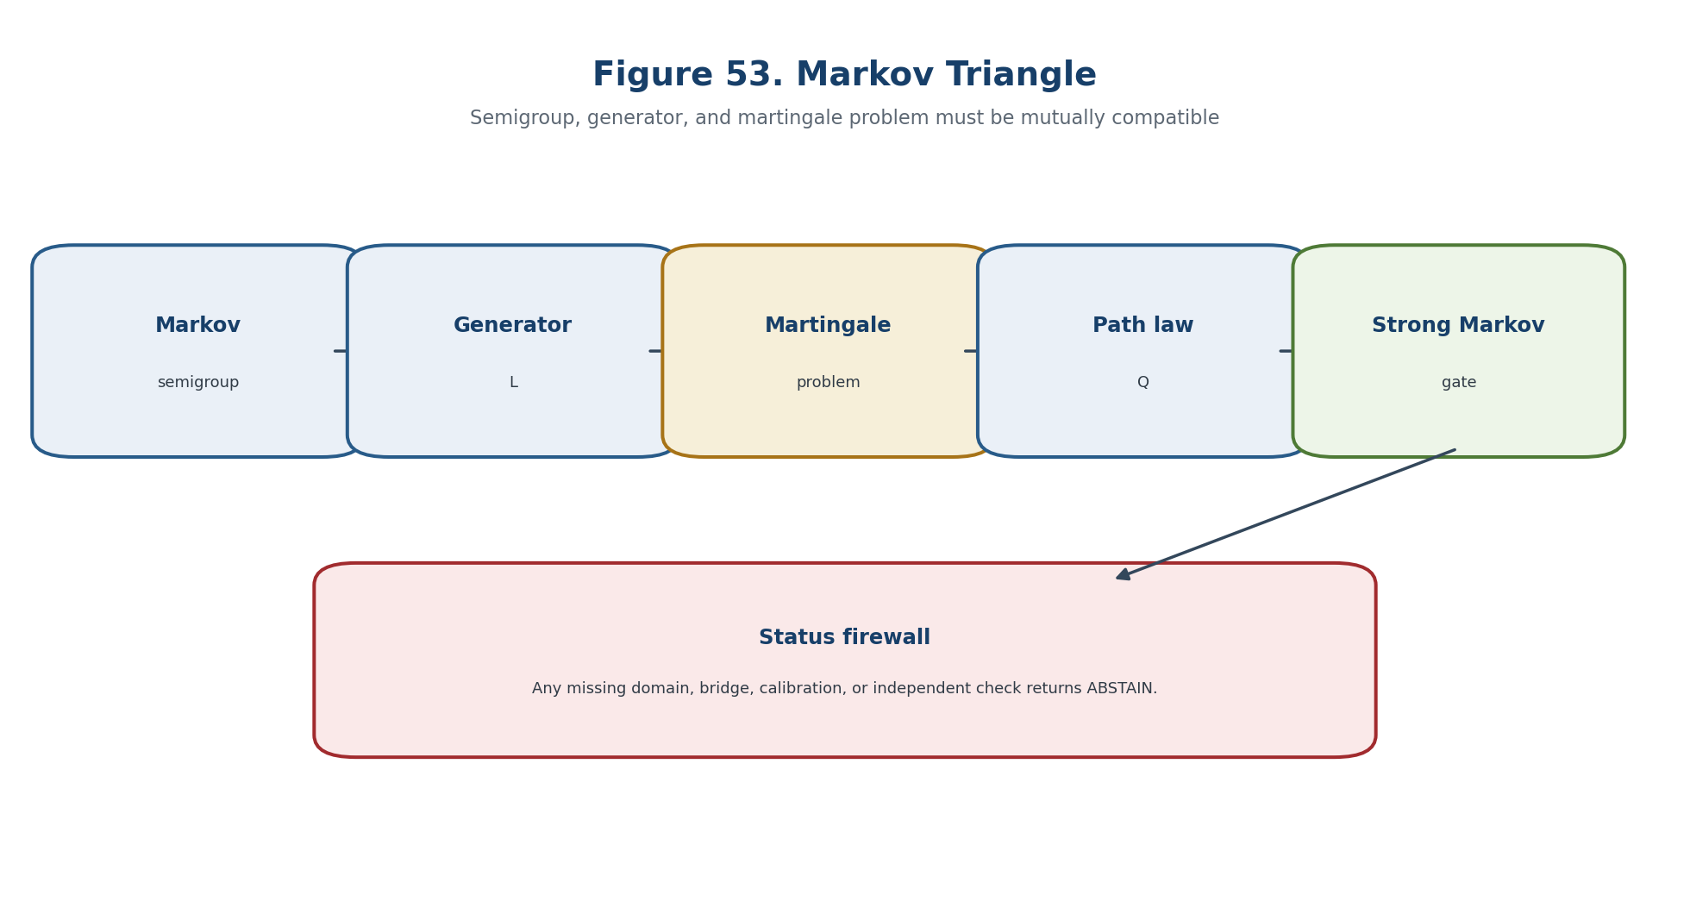
Figure 53. Markov semigroup, generator, and martingale problem.

22.6. Existence, Uniqueness, and the Strong Markov Firewall
The horizon is the union of loci where rank, domain, topology, calibration, identification, or numerical certification can change. The stochastic conclusion is limited by the martingale domain, stopping conditions, policy law, and causal identification bridge.
Gate component | Required check | Failure output
Type and domain | All Dom/Cod and admissibility predicates are defined. | ABSTAIN-DOMAIN
Mathematical certificate | Hypotheses, residuals, and representative independence are verified. | ABSTAIN-CERT
Bridge and transport | The relevant realization, temporal, causal, or empirical bridge is identified. | ABSTAIN-BRIDGE
Independent evidence | Required external data or EXT-RUN is present and hash-linked. | ABSTAIN-EXT

22.7. Diffusion Generator and Stochastic Differential Equation
The source construction is restated in controlled English with its hypotheses, invariants, loss channels, and forbidden status transfers kept explicit. The stochastic conclusion is limited by the martingale domain, stopping conditions, policy law, and causal identification bridge.
dX_t=b(t,X_t)dt+σ(t,X_t)dW_t | T2-F287

L_t f(x)=b(t,x)·∇f(x)+(1/2)Tr(a(t,x)∇²f(x)), a=σσᵀ. | T2-F288

22.8. Weak and Strong Solutions and the Uniqueness Hierarchy
The source construction is restated in controlled English with its hypotheses, invariants, loss channels, and forbidden status transfers kept explicit. The stochastic conclusion is limited by the martingale domain, stopping conditions, policy law, and causal identification bridge.

22.9. Girsanov Transform and the Intervention Firewall
The horizon is the union of loci where rank, domain, topology, calibration, identification, or numerical certification can change. The stochastic conclusion is limited by the martingale domain, stopping conditions, policy law, and causal identification bridge.
Z_t=exp(∫_0^t θ_s·dW_s-(1/2)∫_0^t||θ_s||²ds) | T2-F289

Gate component | Required check | Failure output
Type and domain | All Dom/Cod and admissibility predicates are defined. | ABSTAIN-DOMAIN
Mathematical certificate | Hypotheses, residuals, and representative independence are verified. | ABSTAIN-CERT
Bridge and transport | The relevant realization, temporal, causal, or empirical bridge is identified. | ABSTAIN-BRIDGE
Independent evidence | Required external data or EXT-RUN is present and hash-linked. | ABSTAIN-EXT

22.10. Stopping Times and the Stopped Process
The source construction is restated in controlled English with its hypotheses, invariants, loss channels, and forbidden status transfers kept explicit. The stochastic conclusion is limited by the martingale domain, stopping conditions, policy law, and causal identification bridge.
τ_A = inf{t≥t_0 : X_t∈A}. | T2-F290

22.11. Optional Sampling: Exact Domain of Applicability
The source construction is restated in controlled English with its hypotheses, invariants, loss channels, and forbidden status transfers kept explicit. The stochastic conclusion is limited by the martingale domain, stopping conditions, policy law, and causal identification bridge.

22.12. Counterexample to Naive Optional Stopping
Separating models show that the prohibited inference fails even when the upstream mathematical object is well defined. The stochastic conclusion is limited by the martingale domain, stopping conditions, policy law, and causal identification bridge.

22.13. Hitting Probabilities and First-Passage Prediction
The source construction is restated in controlled English with its hypotheses, invariants, loss channels, and forbidden status transfers kept explicit. The stochastic conclusion is limited by the martingale domain, stopping conditions, policy law, and causal identification bridge.
p_A(T,x)=P_x(τ_A≤T). | T2-F291

22.14. Stochastic Barrier Certificate
The certificate records inputs, algorithms, tolerances, residuals, sources, code and data hashes, and the weakest evidential status supported by the chain. The stochastic conclusion is limited by the martingale domain, stopping conditions, policy law, and causal identification bridge.
(partial_t+L_t)V(t,x) <= 0 on [0,T] x (E\A). | T2-F292

P_{x_0}(τ_A≤T)≤V(0,x_0). | T2-F293

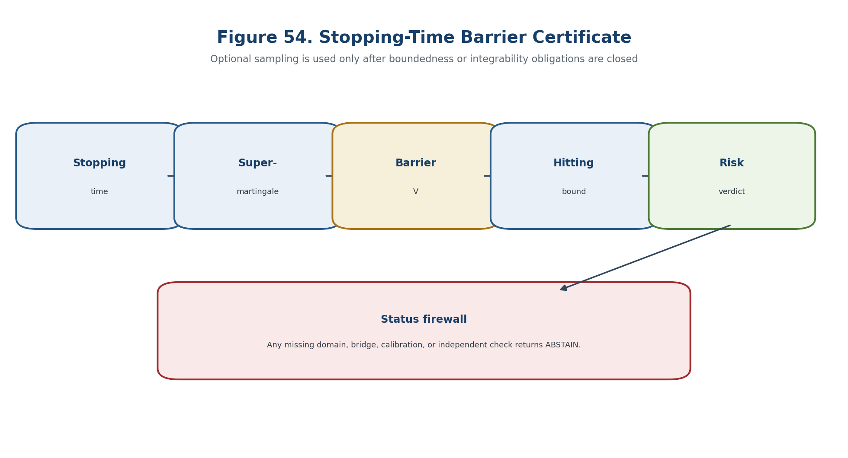
Figure 54. Stopping-time barrier certificate.
Gate component | Required check | Failure output
Type and domain | All Dom/Cod and admissibility predicates are defined. | ABSTAIN-DOMAIN
Mathematical certificate | Hypotheses, residuals, and representative independence are verified. | ABSTAIN-CERT
Bridge and transport | The relevant realization, temporal, causal, or empirical bridge is identified. | ABSTAIN-BRIDGE
Independent evidence | Required external data or EXT-RUN is present and hash-linked. | ABSTAIN-EXT

22.15. Robust Barrier for All Admissible Controls
The source construction is restated in controlled English with its hypotheses, invariants, loss channels, and forbidden status transfers kept explicit. The stochastic conclusion is limited by the martingale domain, stopping conditions, policy law, and causal identification bridge.
sup_{a∈A(t,x)} (∂_t+L_t^a)V(t,x)≤0, | T2-F294

22.16. Controlled Markov Family and Policy Law
The source construction is restated in controlled English with its hypotheses, invariants, loss channels, and forbidden status transfers kept explicit. The stochastic conclusion is limited by the martingale domain, stopping conditions, policy law, and causal identification bridge.
J(π;x)=E_x^π[∫_0^T c(t,X_t,a_t)dt+g(X_T)]. | T2-F295

22.17. Dynamic Programming and the HJB Layer
The source construction is restated in controlled English with its hypotheses, invariants, loss channels, and forbidden status transfers kept explicit. The stochastic conclusion is limited by the martingale domain, stopping conditions, policy law, and causal identification bridge.
∂_tV^*+inf_{a∈A}{L^aV^*+c(t,x,a)}=0, V^*(T,x)=g(x). | T2-F296

22.18. Forecast, Control, and Intervention as Three Different Laws
The source construction is restated in controlled English with its hypotheses, invariants, loss channels, and forbidden status transfers kept explicit. The stochastic conclusion is limited by the martingale domain, stopping conditions, policy law, and causal identification bridge.
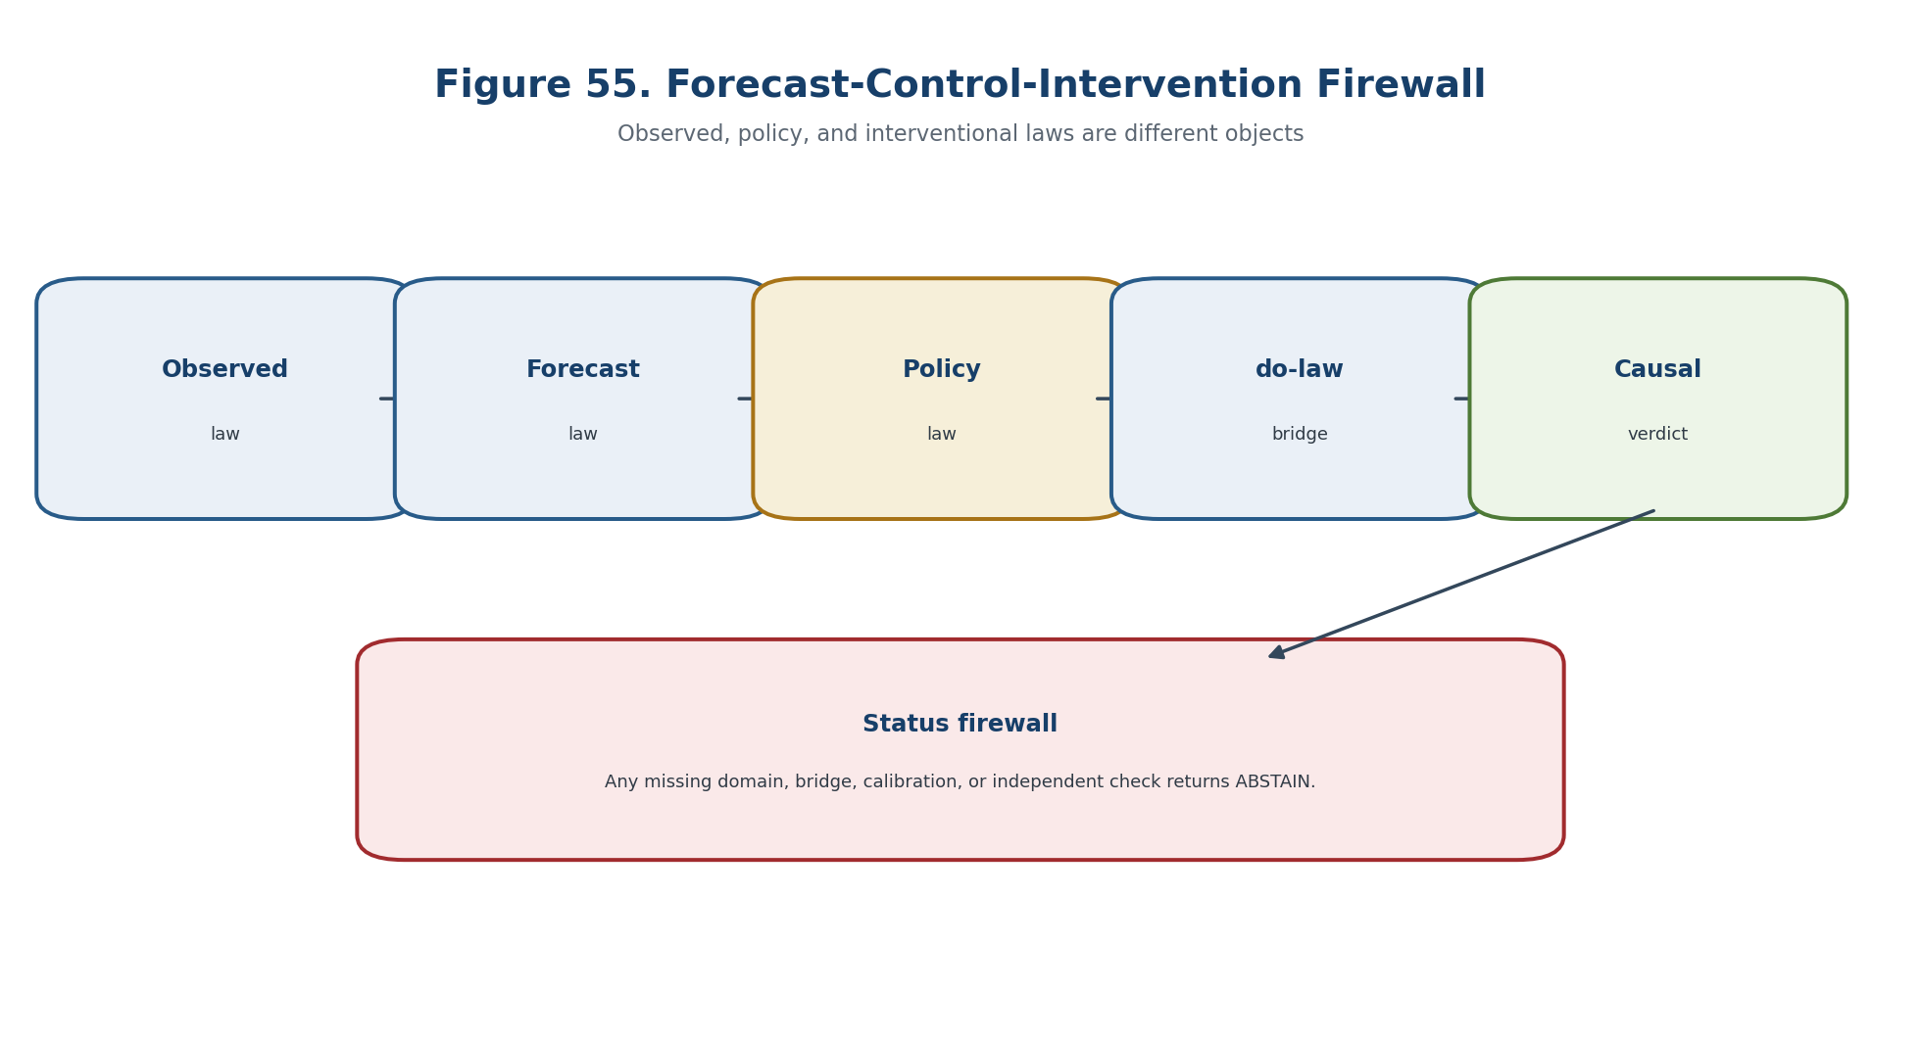
Figure 55. Forecast-control-intervention firewall.

22.19. An Observational Markov Law Does Not Identify an Intervention Law
Separating models show that the prohibited inference fails even when the upstream mathematical object is well defined. The stochastic conclusion is limited by the martingale domain, stopping conditions, policy law, and causal identification bridge.

22.20. Structural Causal Kernel and the do-Operator
The source construction is restated in controlled English with its hypotheses, invariants, loss channels, and forbidden status transfers kept explicit. The stochastic conclusion is limited by the martingale domain, stopping conditions, policy law, and causal identification bridge.
X_{t+1}=F_t(X_{≤t},A_t,U_{t+1}), Y_t=G_t(X_{≤t},U_t). | T2-F297

22.21. The g-Formula and Identification Conditions
The source construction is restated in controlled English with its hypotheses, invariants, loss channels, and forbidden status transfers kept explicit. The stochastic conclusion is limited by the martingale domain, stopping conditions, policy law, and causal identification bridge.
p(y^{a-bar}) = ∫ ∏_t p(l_{t+1}|l-bar_t,a-bar_t) p(y|l-bar_T,a-bar_T) d(l-bar). | T2-F298

22.22. Counterfactual Carrier
The source construction is restated in controlled English with its hypotheses, invariants, loss channels, and forbidden status transfers kept explicit. The stochastic conclusion is limited by the martingale domain, stopping conditions, policy law, and causal identification bridge.

22.23. Stochastic Reper-Path
The source construction is restated in controlled English with its hypotheses, invariants, loss channels, and forbidden status transfers kept explicit. The stochastic conclusion is limited by the martingale domain, stopping conditions, policy law, and causal identification bridge.
Rep_t(ω)=(R_t(ω),I_t(ω),U_t(ω);D_t(ω)). | T2-F299

22.24. Ito Formula for the Harmonic Defect
The source construction is restated in controlled English with its hypotheses, invariants, loss channels, and forbidden status transfers kept explicit. The stochastic conclusion is limited by the martingale domain, stopping conditions, policy law, and causal identification bridge.
dφ(X_t)=Lφ(X_t)dt+∇φ(X_t)σ(X_t)dW_t. | T2-F300

Lq=2φLφ+||σᵀ∇φ||². | T2-F301

22.25. Conditions for Stochastic Invariance of the Harmonic Locus
The source construction is restated in controlled English with its hypotheses, invariants, loss channels, and forbidden status transfers kept explicit. The stochastic conclusion is limited by the martingale domain, stopping conditions, policy law, and causal identification bridge.
sigma_j(x) dot grad phi(x)=0 for all j, and L phi(x)=0 for x in M. | T2-F302

22.26. Martingale Residuals as Computational Generator Tests
The source construction is restated in controlled English with its hypotheses, invariants, loss channels, and forbidden status transfers kept explicit. The stochastic conclusion is limited by the martingale domain, stopping conditions, policy law, and causal identification bridge.
R_{s,t}^{f_k}=f_k(X_t)-f_k(X_s)-∫_s^t Lf_k(X_r)dr. | T2-F303

22.27. Sequential Evidence and the Optional-Stopping-Safe Layer
The source construction is restated in controlled English with its hypotheses, invariants, loss channels, and forbidden status transfers kept explicit. The stochastic conclusion is limited by the martingale domain, stopping conditions, policy law, and causal identification bridge.
P(sup_t E_t ≥ 1/α)≤α. | T2-F304

22.28. Stochastic Transition Horizon
The horizon is the union of loci where rank, domain, topology, calibration, identification, or numerical certification can change. The stochastic conclusion is limited by the martingale domain, stopping conditions, policy law, and causal identification bridge.
Δ_stoch = Δ_MP ∪ Δ_Feller ∪ Δ_gen ∪ Δ_stop ∪ Δ_hit ∪ Δ_bar ∪ Δ_ctrl ∪ Δ_HJB ∪ Δ_do ∪ Δ_id ∪ Δ_λ ∪ Δ_cal ∪ Δ_ext. | T2-F305

Δ_safe^{v0.19}=Δ_safe^{v0.18}∪Δ_stoch. | T2-F306

Gate component | Required check | Failure output
Type and domain | All Dom/Cod and admissibility predicates are defined. | ABSTAIN-DOMAIN
Mathematical certificate | Hypotheses, residuals, and representative independence are verified. | ABSTAIN-CERT
Bridge and transport | The relevant realization, temporal, causal, or empirical bridge is identified. | ABSTAIN-BRIDGE
Independent evidence | Required external data or EXT-RUN is present and hash-linked. | ABSTAIN-EXT

22.29. Main Conditional Theorem
The statement is read under the explicitly declared hypotheses; its conclusion remains inside the mathematical model and does not acquire empirical status by translation. The stochastic conclusion is limited by the martingale domain, stopping conditions, policy law, and causal identification bridge.
Theorem 22.7. Conditional Stochastic Safety [COND] Under a well-posed martingale problem, valid stopping and barrier hypotheses, certified policy or intervention law, and sequential evidence control, the reported hitting or risk bound is valid inside the model.

V(0,x)=0 => NO-HIT-IN-MODEL; 0<V(0,x)≤α => RISK-BOUND≤α. | T2-F307

22.30. Blocker-Safe Verdict
The allowed output is multi-valued: a certified conclusion, an explicit candidate requiring further checks, ABSTAIN with blockers, or FAIL with a witness. The stochastic conclusion is limited by the martingale domain, stopping conditions, policy law, and causal identification bridge.
Block_stoch=B_basis∪B_MP∪B_gen∪B_stop∪B_bar∪B_ctrl∪B_do∪B_id∪B_λ∪B_cal∪B_ext. | T2-F308

Gate component | Required check | Failure output
Type and domain | All Dom/Cod and admissibility predicates are defined. | ABSTAIN-DOMAIN
Mathematical certificate | Hypotheses, residuals, and representative independence are verified. | ABSTAIN-CERT
Bridge and transport | The relevant realization, temporal, causal, or empirical bridge is identified. | ABSTAIN-BRIDGE
Independent evidence | Required external data or EXT-RUN is present and hash-linked. | ABSTAIN-EXT

22.31. Separating Countermodels
The source construction is restated in controlled English with its hypotheses, invariants, loss channels, and forbidden status transfers kept explicit. The stochastic conclusion is limited by the martingale domain, stopping conditions, policy law, and causal identification bridge.

22.32. Computational Certificate STOCH-CAUSAL
The certificate records inputs, algorithms, tolerances, residuals, sources, code and data hashes, and the weakest evidential status supported by the chain. The stochastic conclusion is limited by the martingale domain, stopping conditions, policy law, and causal identification bridge.
Gate component | Required check | Failure output
Type and domain | All Dom/Cod and admissibility predicates are defined. | ABSTAIN-DOMAIN
Mathematical certificate | Hypotheses, residuals, and representative independence are verified. | ABSTAIN-CERT
Bridge and transport | The relevant realization, temporal, causal, or empirical bridge is identified. | ABSTAIN-BRIDGE
Independent evidence | Required external data or EXT-RUN is present and hash-linked. | ABSTAIN-EXT

22.32.1. Pseudocode
The source construction is restated in controlled English with its hypotheses, invariants, loss channels, and forbidden status transfers kept explicit. The stochastic conclusion is limited by the martingale domain, stopping conditions, policy law, and causal identification bridge.

22.33. Prior Art and Boundary of the Authorial Contribution
Classical constructions retain their standard attribution; the authorial contribution is the typed, blocker-safe synthesis inside KLT-RBD. The stochastic conclusion is limited by the martingale domain, stopping conditions, policy law, and causal identification bridge.
BOUNDARY OF CHAPTER 22. Observational prediction, control under a policy, and intervention are different laws; optional stopping and Girsanov changes require their exact hypotheses. truth_layer_promotion=0; independent EXT-RUN and EMP-OBS remain absent.

Chapter 23. Large Deviations, Risk-Sensitive Semigroups, Rare-Event Geometry, and Finite-Sample Certification
ONTOLOGY | Rare-event analysis separates asymptotic rate geometry, risk-sensitive dynamics, simulation efficiency, and finite-sample coverage.
EPISTEMOLOGY | Knowledge is certified through topology, speed, exponential tightness, a good rate function, robust ambiguity sets, and finite-sample guarantees.
PHENOMENOLOGY | The layer appears through actions, quasipotentials, Feynman-Kac and logarithmic semigroups, importance sampling, splitting, and risk bounds.
LIMITATION | An asymptotic exponent is not a finite-sample probability, and an unobserved rare event does not imply zero risk.
AUTHORIAL NOVELTY | The authorial node is the robust rare-event Reper certificate joining large deviations to coverage-valid finite-sample decisions.

The source construction is restated in controlled English with its hypotheses, invariants, loss channels, and forbidden status transfers kept explicit. Asymptotic rate statements and finite-sample risk bounds are reported separately and may not be substituted for one another.
Controlled field | Value
Canonical input | Frozen Russian Chapter 23, inherited English Chapters 1-18, and formula/source passports.
New mathematical layer | Rare-event analysis separates asymptotic rate geometry, risk-sensitive dynamics, simulation efficiency, and finite-sample coverage.
Status rule | Definitions, theorems, conditional bridges, models, numerical certificates, and physical hypotheses remain distinct.
Prohibition | An asymptotic exponent is not a finite-sample probability, and an unobserved rare event does not imply zero risk.
Downstream role | Chapter 24 composes all certified layers and preserves ABSTAIN/FAIL as absorbing results.

23.1. Four Levels of Rare-Event Inference
The source construction is restated in controlled English with its hypotheses, invariants, loss channels, and forbidden status transfers kept explicit. Asymptotic rate statements and finite-sample risk bounds are reported separately and may not be substituted for one another.
truth_layer_promotion=0; source=T2-RP-v0.19; checkpoint=T2-RP-v0.20. | T2-F309

23.1.1. Typed Ladder
The source construction is restated in controlled English with its hypotheses, invariants, loss channels, and forbidden status transfers kept explicit. Asymptotic rate statements and finite-sample risk bounds are reported separately and may not be substituted for one another.

23.2. Definition of the Large-Deviation Principle
This section fixes the carrier, domain, codomain, and status type before any computation or interpretation is permitted. Asymptotic rate statements and finite-sample risk bounds are reported separately and may not be substituted for one another.
-inf_{x∈A°} I(x) ≤ liminf_n a_n^{-1}log P(Z_n∈A) ≤ limsup_n a_n^{-1}log P(Z_n∈A) ≤ -inf_{x∈cl A}I(x). | T2-F310

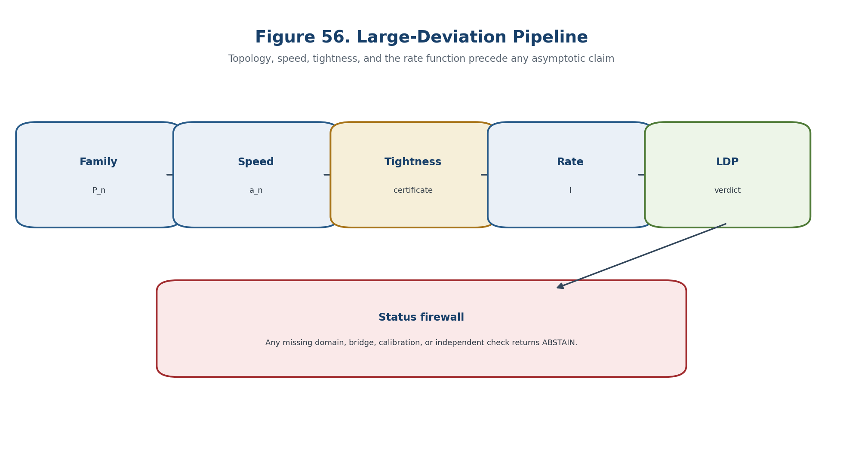
Figure 56. Large-deviation pipeline and evidence firewall.

23.3. Exponential Tightness and a Good Rate Function
The source construction is restated in controlled English with its hypotheses, invariants, loss channels, and forbidden status transfers kept explicit. Asymptotic rate statements and finite-sample risk bounds are reported separately and may not be substituted for one another.
limsup_n a_n^{-1}log P(Z_n∉K_M) ≤ -M. | T2-F311

23.4. Contraction Principle
The source construction is restated in controlled English with its hypotheses, invariants, loss channels, and forbidden status transfers kept explicit. Asymptotic rate statements and finite-sample risk bounds are reported separately and may not be substituted for one another.
J(y)=inf{I(x):F(x)=y}, inf∅=∞. | T2-F312

23.5. Laplace Principle and Varadhan Lemma
The source construction is restated in controlled English with its hypotheses, invariants, loss channels, and forbidden status transfers kept explicit. Asymptotic rate statements and finite-sample risk bounds are reported separately and may not be substituted for one another.
lim_n a_n^{-1}log E exp(a_n F(Z_n)) = sup_{x∈𝒳}{F(x)-I(x)}. | T2-F313

23.6. Gartner-Ellis Theorem and Its Limits
The statement is read under the explicitly declared hypotheses; its conclusion remains inside the mathematical model and does not acquire empirical status by translation. Asymptotic rate statements and finite-sample risk bounds are reported separately and may not be substituted for one another.
Λ(θ)=lim_n a_n^{-1}log E exp(a_n⟨θ,Z_n⟩). | T2-F314

23.7. Sanov Layer: Empirical Measure and Relative Entropy
The source construction is restated in controlled English with its hypotheses, invariants, loss channels, and forbidden status transfers kept explicit. Asymptotic rate statements and finite-sample risk bounds are reported separately and may not be substituted for one another.
I(Q)=D(Q||P), | T2-F315

23.8. Path-Space LDP and the Topology Ledger
The source construction is restated in controlled English with its hypotheses, invariants, loss channels, and forbidden status transfers kept explicit. Asymptotic rate statements and finite-sample risk bounds are reported separately and may not be substituted for one another.

23.9. Freidlin-Wentzell Action for Small-Noise Diffusions
The source construction is restated in controlled English with its hypotheses, invariants, loss channels, and forbidden status transfers kept explicit. Asymptotic rate statements and finite-sample risk bounds are reported separately and may not be substituted for one another.
dX_t^ε=b(X_t^ε)dt+√ε σ(X_t^ε)dW_t | T2-F316

S_{0T}(φ)=1/2 ∫_0^T ⟨φ_dot-b(φ), a(φ)^{-1}(φ_dot-b(φ))⟩ dt, | T2-F317

23.10. Quasipotential and Geometry of Metastable Transitions
The source construction is restated in controlled English with its hypotheses, invariants, loss channels, and forbidden status transfers kept explicit. Asymptotic rate statements and finite-sample risk bounds are reported separately and may not be substituted for one another.
V(x,y)=inf_{T>0} inf_{φ(0)=x, φ(T)=y} S_{0T}(φ). | T2-F318

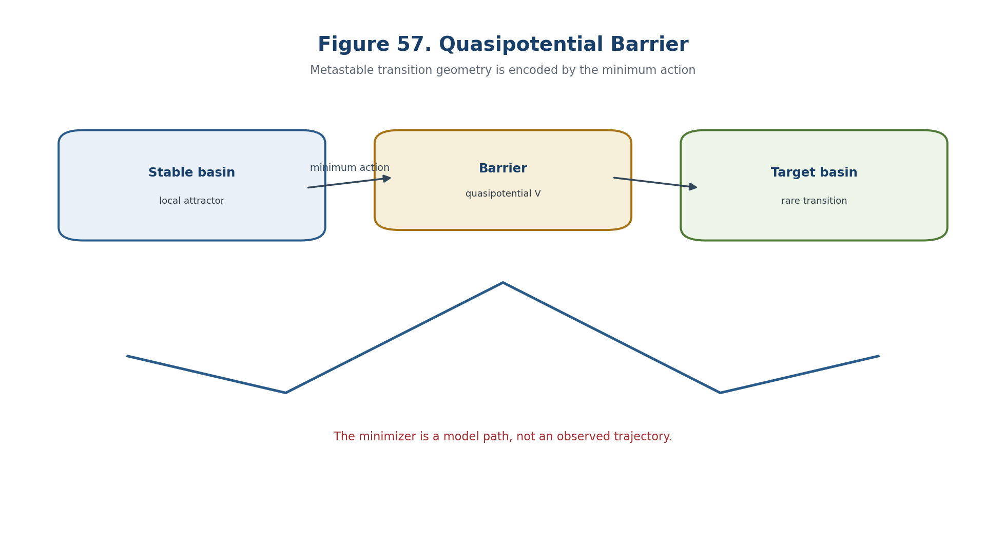
Figure 57. Quasipotential barrier and minimum-action path.

23.11. Rare-Event Geometry of the Reper-Path
The source construction is restated in controlled English with its hypotheses, invariants, loss channels, and forbidden status transfers kept explicit. Asymptotic rate statements and finite-sample risk bounds are reported separately and may not be substituted for one another.
z=(Rep, μ, Ass, o, λ, D, Dom). | T2-F319

A_{ε,η}={z(·): inf_t |λ_t+1|≤ε, ||o_t||≤η, Valid(D_t)=1, Block_t=∅}. | T2-F320

c_{ε,η}=inf_{z(·)∈cl A_{ε,η}} I_path(z). | T2-F321

23.12. Lambda Poles and the Extended Contraction Firewall
The horizon is the union of loci where rank, domain, topology, calibration, identification, or numerical certification can change. Asymptotic rate statements and finite-sample risk bounds are reported separately and may not be substituted for one another.
Gate component | Required check | Failure output
Type and domain | All Dom/Cod and admissibility predicates are defined. | ABSTAIN-DOMAIN
Mathematical certificate | Hypotheses, residuals, and representative independence are verified. | ABSTAIN-CERT
Bridge and transport | The relevant realization, temporal, causal, or empirical bridge is identified. | ABSTAIN-BRIDGE
Independent evidence | Required external data or EXT-RUN is present and hash-linked. | ABSTAIN-EXT

23.13. Donsker-Varadhan Layer for Empirical Measures of a Markov Process
The source construction is restated in controlled English with its hypotheses, invariants, loss channels, and forbidden status transfers kept explicit. Asymptotic rate statements and finite-sample risk bounds are reported separately and may not be substituted for one another.
L_T=(1/T)∫_0^T δ_{X_t}dt | T2-F322

I_DV(μ)= -inf_{u>0} ∫ (Lu/u)dμ. | T2-F323

23.14. Feynman-Kac Semigroup
The source construction is restated in controlled English with its hypotheses, invariants, loss channels, and forbidden status transfers kept explicit. Asymptotic rate statements and finite-sample risk bounds are reported separately and may not be substituted for one another.
(Q_t^V f)(x)=E_x[exp(∫_0^t V(X_s)ds) f(X_t)]. | T2-F324

23.15. Risk-Sensitive Logarithmic Semigroup
The source construction is restated in controlled English with its hypotheses, invariants, loss channels, and forbidden status transfers kept explicit. Asymptotic rate statements and finite-sample risk bounds are reported separately and may not be substituted for one another.
(S_t^{θ,V}g)(x)=θ^{-1} log E_x exp(θ[g(X_t)+∫_0^t V(X_s)ds]). | T2-F325

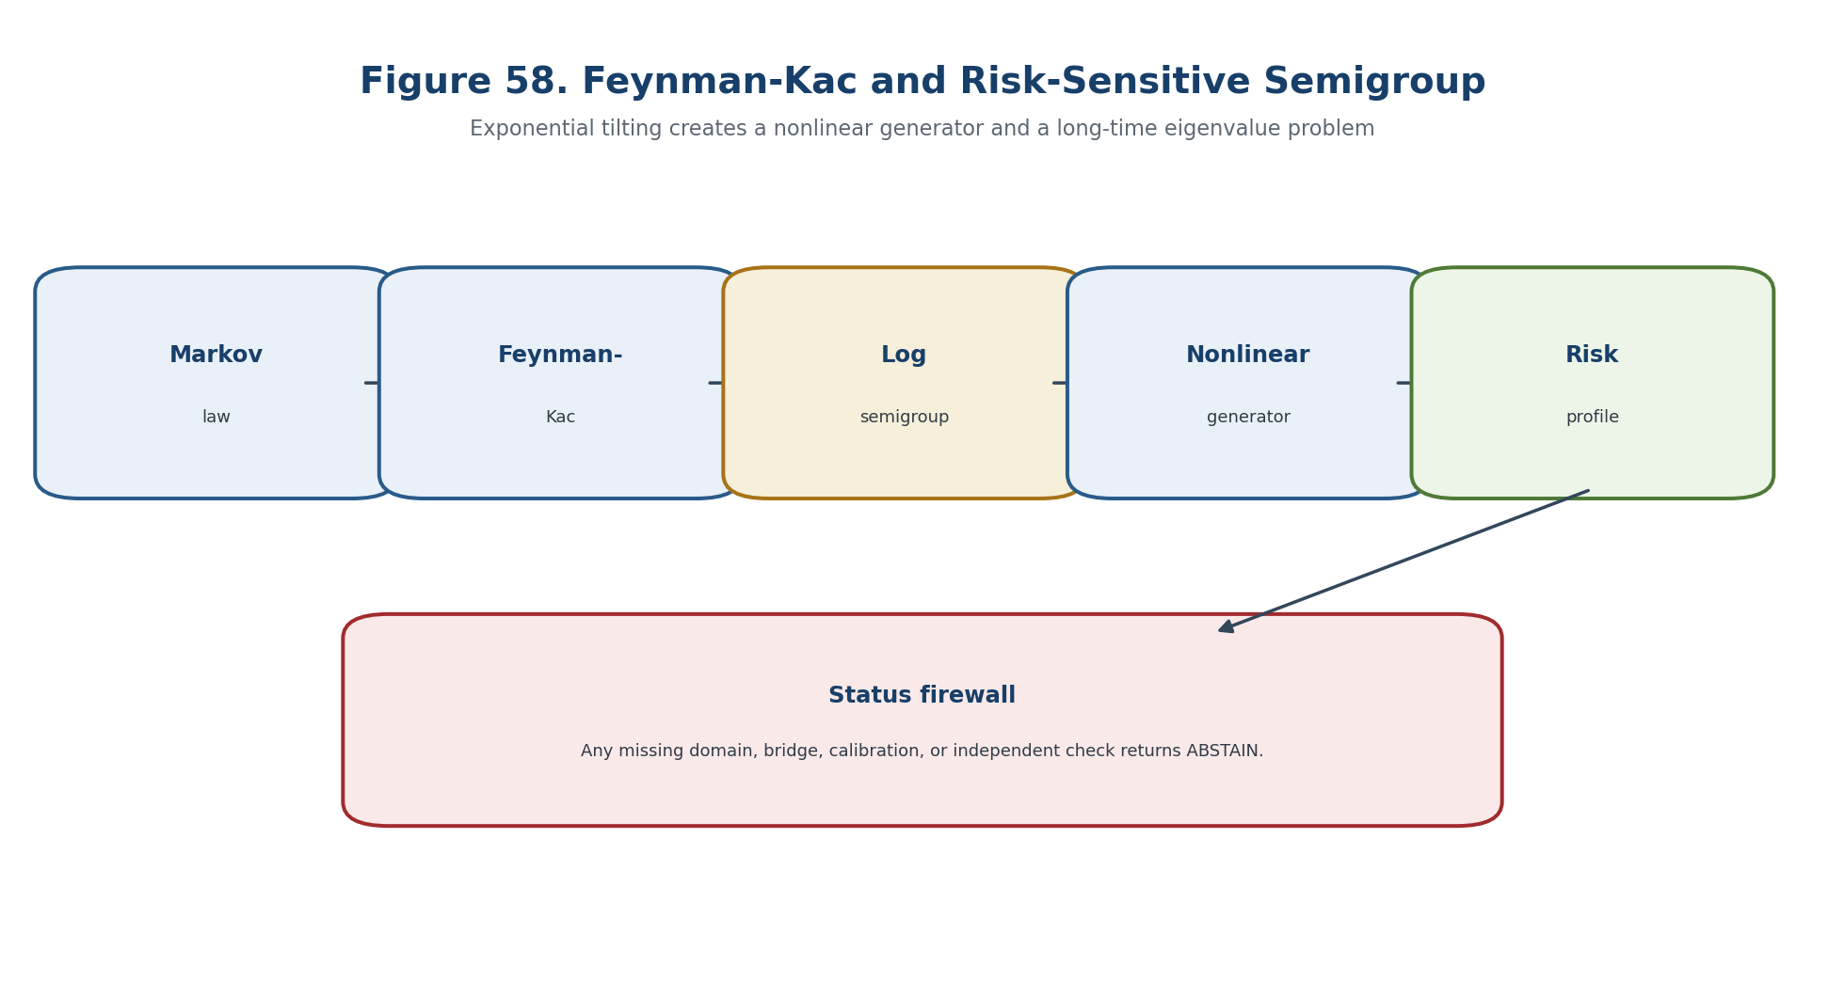
Figure 58. Feynman-Kac and risk-sensitive semigroup.

23.16. Nonlinear Generator of the Risk-Sensitive Layer
The source construction is restated in controlled English with its hypotheses, invariants, loss channels, and forbidden status transfers kept explicit. Asymptotic rate statements and finite-sample risk bounds are reported separately and may not be substituted for one another.
H_θ f = θ^{-1}e^{-θf}L(e^{θf})+V. | T2-F326

H_θ f = Lf +(θ/2)||σᵀ∇f||²+V. | T2-F327

23.17. Long-Time Eigenvalue and Multiplicative Ergodic Limit
The source construction is restated in controlled English with its hypotheses, invariants, loss channels, and forbidden status transfers kept explicit. Asymptotic rate statements and finite-sample risk bounds are reported separately and may not be substituted for one another.
ρ(θ)=lim_{t→∞}(1/t)log E_x exp(θ∫_0^t V(X_s)ds). | T2-F328

23.18. Entropic Variational Formula
The source construction is restated in controlled English with its hypotheses, invariants, loss channels, and forbidden status transfers kept explicit. Asymptotic rate statements and finite-sample risk bounds are reported separately and may not be substituted for one another.
log E_P e^F = sup_{Q<<P}{E_Q F-D(Q||P)}. | T2-F329

23.19. Risk-Sensitive Control and the HJB Eigenproblem
The source construction is restated in controlled English with its hypotheses, invariants, loss channels, and forbidden status transfers kept explicit. Asymptotic rate statements and finite-sample risk bounds are reported separately and may not be substituted for one another.
J_θ(a)=limsup_{T→∞}(1/(θT))log E^a exp(θ∫_0^T c(X_t,a_t)dt) | T2-F330

ρ+inf_a{L^a v+c(x,a)+(θ/2)||σ_aᵀ∇v||²}=0. | T2-F331

23.20. An Asymptotic Exponent Is Not a Finite-n Probability
Separating models show that the prohibited inference fails even when the upstream mathematical object is well defined. Asymptotic rate statements and finite-sample risk bounds are reported separately and may not be substituted for one another.
lim_n a_n^{-1}log p_n=-c, c>0 | T2-F332

23.21. Importance Sampling and an Unbiased Rare-Event Estimator
The source construction is restated in controlled English with its hypotheses, invariants, loss channels, and forbidden status transfers kept explicit. Asymptotic rate statements and finite-sample risk bounds are reported separately and may not be substituted for one another.
p=P(A)=E_Q[1_A L]. | T2-F333

23.22. Logarithmic and Bounded-Relative-Error Efficiency
The source construction is restated in controlled English with its hypotheses, invariants, loss channels, and forbidden status transfers kept explicit. Asymptotic rate statements and finite-sample risk bounds are reported separately and may not be substituted for one another.

23.23. Splitting and Adaptive Levels
The source construction is restated in controlled English with its hypotheses, invariants, loss channels, and forbidden status transfers kept explicit. Asymptotic rate statements and finite-sample risk bounds are reported separately and may not be substituted for one another.

23.24. Ambiguity Sets: Robust Layer
The source construction is restated in controlled English with its hypotheses, invariants, loss channels, and forbidden status transfers kept explicit. Asymptotic rate statements and finite-sample risk bounds are reported separately and may not be substituted for one another.
U_N(ρ)={Q: d(Q,P_hat_N)≤ρ, Q∈𝒫_adm}. | T2-F334

23.25. KL and f-Divergence Ambiguity
The source construction is restated in controlled English with its hypotheses, invariants, loss channels, and forbidden status transfers kept explicit. Asymptotic rate statements and finite-sample risk bounds are reported separately and may not be substituted for one another.
sup_{D(Q||P_hat)≤ρ} E_Qℓ ≤ inf_{η>0}{ηρ+η log E_{P_hat} exp(ℓ/η)}. | T2-F335

23.26. Wasserstein Ambiguity and Geometry of New States
This section fixes the carrier, domain, codomain, and status type before any computation or interpretation is permitted. Asymptotic rate statements and finite-sample risk bounds are reported separately and may not be substituted for one another.
sup_{W_c(Q,P_hat)≤ρ}E_Qℓ = inf_{η≥0}{ηρ+E_{P_hat}[sup_z(ℓ(z)-ηc(z,ξ))]}. | T2-F336

23.27. Finite-Sample Coverage Ambiguity Set
The source construction is restated in controlled English with its hypotheses, invariants, loss channels, and forbidden status transfers kept explicit. Asymptotic rate statements and finite-sample risk bounds are reported separately and may not be substituted for one another.
P_data(P_*∈U_N(ρ_N(β)))≥1-β. | T2-F337

P_*(A)≤sup_{Q∈U_N}Q(A). | T2-F338

23.28. Distributionally Robust Chance Certificate
The certificate records inputs, algorithms, tolerances, residuals, sources, code and data hashes, and the weakest evidential status supported by the chain. Asymptotic rate statements and finite-sample risk bounds are reported separately and may not be substituted for one another.
P_data(P_*(A)≤B_N(A))≥1-β. | T2-F339

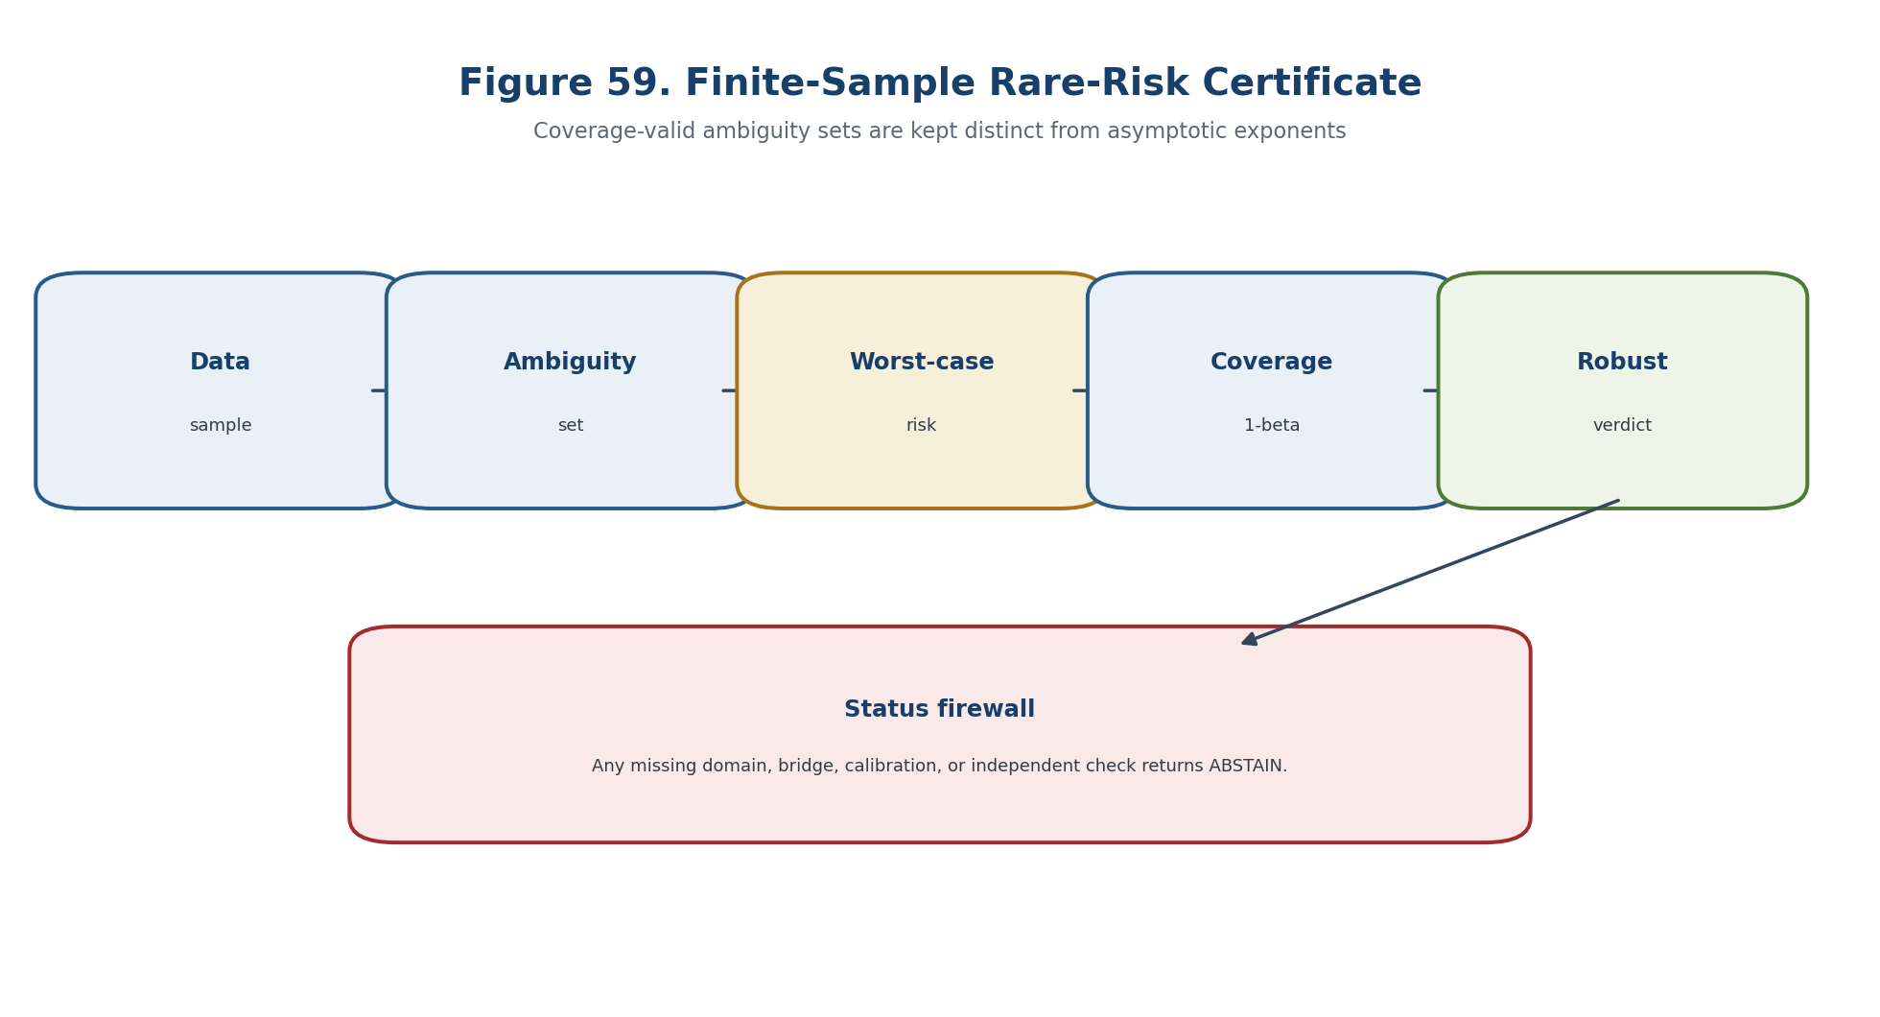
Figure 59. Finite-sample robust rare-risk certificate.
Gate component | Required check | Failure output
Type and domain | All Dom/Cod and admissibility predicates are defined. | ABSTAIN-DOMAIN
Mathematical certificate | Hypotheses, residuals, and representative independence are verified. | ABSTAIN-CERT
Bridge and transport | The relevant realization, temporal, causal, or empirical bridge is identified. | ABSTAIN-BRIDGE
Independent evidence | Required external data or EXT-RUN is present and hash-linked. | ABSTAIN-EXT

23.29. Exact Binomial Certificate for a Rare Event
The certificate records inputs, algorithms, tolerances, residuals, sources, code and data hashes, and the weakest evidential status supported by the chain. Asymptotic rate statements and finite-sample risk bounds are reported separately and may not be substituted for one another.
p_U=1-α^{1/N}, coverage ≥1-α. | T2-F340

Gate component | Required check | Failure output
Type and domain | All Dom/Cod and admissibility predicates are defined. | ABSTAIN-DOMAIN
Mathematical certificate | Hypotheses, residuals, and representative independence are verified. | ABSTAIN-CERT
Bridge and transport | The relevant realization, temporal, causal, or empirical bridge is identified. | ABSTAIN-BRIDGE
Independent evidence | Required external data or EXT-RUN is present and hash-linked. | ABSTAIN-EXT

23.30. Bounded-Loss Concentration and Empirical Risk
The source construction is restated in controlled English with its hypotheses, invariants, loss channels, and forbidden status transfers kept explicit. Asymptotic rate statements and finite-sample risk bounds are reported separately and may not be substituted for one another.
E[X]≤X_bar_N+sqrt(log(1/β)/(2N)). | T2-F341

23.31. Anytime-Valid and Sequential Certification
The source construction is restated in controlled English with its hypotheses, invariants, loss channels, and forbidden status transfers kept explicit. Asymptotic rate statements and finite-sample risk bounds are reported separately and may not be substituted for one another.

23.32. Fusion of Asymptotic and Finite-Sample Layers
The source construction is restated in controlled English with its hypotheses, invariants, loss channels, and forbidden status transfers kept explicit. Asymptotic rate statements and finite-sample risk bounds are reported separately and may not be substituted for one another.
p_n(A) ≤ min{B_N^{rob}(A), C_n exp[-a_n(c_A-δ)]}, | T2-F342

23.33. Non-identifiability of the Tail from a Finite Sample
Separating models show that the prohibited inference fails even when the upstream mathematical object is well defined. Asymptotic rate statements and finite-sample risk bounds are reported separately and may not be substituted for one another.

23.34. Rate-Function Estimation and Epistemic Uncertainty
The source construction is restated in controlled English with its hypotheses, invariants, loss channels, and forbidden status transfers kept explicit. Asymptotic rate statements and finite-sample risk bounds are reported separately and may not be substituted for one another.
Rep_rate=(I_hat, topology, speed, solver, residuals; D_rate). | T2-F343

23.35. Robust Rare-Event Reper Certificate
The certificate records inputs, algorithms, tolerances, residuals, sources, code and data hashes, and the weakest evidential status supported by the chain. Asymptotic rate statements and finite-sample risk bounds are reported separately and may not be substituted for one another.
Cert_LD=(𝒳,τ,a_n,P_n,I,A,c_A,R_n,U_N,B_N,IS,λ,D,Dom,src,code,hash). | T2-F344

Gate component | Required check | Failure output
Type and domain | All Dom/Cod and admissibility predicates are defined. | ABSTAIN-DOMAIN
Mathematical certificate | Hypotheses, residuals, and representative independence are verified. | ABSTAIN-CERT
Bridge and transport | The relevant realization, temporal, causal, or empirical bridge is identified. | ABSTAIN-BRIDGE
Independent evidence | Required external data or EXT-RUN is present and hash-linked. | ABSTAIN-EXT

23.36. Large-Deviation and Finite-Sample Horizons
The horizon is the union of loci where rank, domain, topology, calibration, identification, or numerical certification can change. Asymptotic rate statements and finite-sample risk bounds are reported separately and may not be substituted for one another.
Δ_LD=Δ_speed∪Δ_top∪Δ_tight∪Δ_rate∪Δ_contract∪Δ_pole∪Δ_action∪Δ_inst. | T2-F345

Δ_RS=Δ_FK∪Δ_expint∪Δ_eig∪Δ_HJB∪Δ_tilt∪Δ_IS. | T2-F346

Δ_FS=Δ_iid∪Δ_dep∪Δ_tail∪Δ_amb∪Δ_cov∪Δ_sel∪Δ_stop∪Δ_shift∪Δ_ext. | T2-F347

Δ_safe^{v0.20}=Δ_safe^{v0.19}∪Δ_LD∪Δ_RS∪Δ_FS. | T2-F348

Gate component | Required check | Failure output
Type and domain | All Dom/Cod and admissibility predicates are defined. | ABSTAIN-DOMAIN
Mathematical certificate | Hypotheses, residuals, and representative independence are verified. | ABSTAIN-CERT
Bridge and transport | The relevant realization, temporal, causal, or empirical bridge is identified. | ABSTAIN-BRIDGE
Independent evidence | Required external data or EXT-RUN is present and hash-linked. | ABSTAIN-EXT

23.37. Main Conditional Theorem
The statement is read under the explicitly declared hypotheses; its conclusion remains inside the mathematical model and does not acquire empirical status by translation. Asymptotic rate statements and finite-sample risk bounds are reported separately and may not be substituted for one another.
Theorem 23.8. Rare-Event Dual Certificate [COND] When the LDP hypotheses and a coverage-valid ambiguity set are both certified, the release may report the asymptotic exponent and the finite-sample robust bound as separate components. Neither component may replace the other.

23.38. Counterexamples and Prohibitions
Separating models show that the prohibited inference fails even when the upstream mathematical object is well defined. Asymptotic rate statements and finite-sample risk bounds are reported separately and may not be substituted for one another.

23.39. Computational Certificate LD-RISK
The certificate records inputs, algorithms, tolerances, residuals, sources, code and data hashes, and the weakest evidential status supported by the chain. Asymptotic rate statements and finite-sample risk bounds are reported separately and may not be substituted for one another.
Gate component | Required check | Failure output
Type and domain | All Dom/Cod and admissibility predicates are defined. | ABSTAIN-DOMAIN
Mathematical certificate | Hypotheses, residuals, and representative independence are verified. | ABSTAIN-CERT
Bridge and transport | The relevant realization, temporal, causal, or empirical bridge is identified. | ABSTAIN-BRIDGE
Independent evidence | Required external data or EXT-RUN is present and hash-linked. | ABSTAIN-EXT

23.39.1. Pseudocode
The source construction is restated in controlled English with its hypotheses, invariants, loss channels, and forbidden status transfers kept explicit. Asymptotic rate statements and finite-sample risk bounds are reported separately and may not be substituted for one another.

23.40. Prior Art and Boundary of the Authorial Contribution
Classical constructions retain their standard attribution; the authorial contribution is the typed, blocker-safe synthesis inside KLT-RBD. Asymptotic rate statements and finite-sample risk bounds are reported separately and may not be substituted for one another.
BOUNDARY OF CHAPTER 23. An asymptotic exponent is not a finite-sample probability, and an unobserved rare event does not imply zero risk. truth_layer_promotion=0; independent EXT-RUN and EMP-OBS remain absent.

Chapter 24. End-to-End KLT-RBD Predictive Operator, Budget Composition, and Final Falsifiability
ONTOLOGY | The end-to-end predictor is a composition of certified partial operators, not a single total black-box map.
EPISTEMOLOGY | Knowledge is carried by typed inputs, preconditions, postconditions, proof objects, uncertainty budgets, hash-linked provenance, and absorbing ABSTAIN/FAIL branches.
PHENOMENOLOGY | The architecture appears as a lattice-valued verdict and a set of certified continuations rather than an unsupported point prophecy.
LIMITATION | Local correctness does not imply global compatibility; incompatible budgets, interfaces, causal bridges, or release evidence close the gate.
AUTHORIAL NOVELTY | The authorial node is the CertKLT category and the blocker-safe KLT-RBD release operator with monotone abstention and explicit falsifiers.

The source construction is restated in controlled English with its hypotheses, invariants, loss channels, and forbidden status transfers kept explicit. Composition preserves certificates, budgets, and absorbing failure branches; release uses the weakest required component.
Controlled field | Value
Canonical input | Frozen Russian Chapter 24, inherited English Chapters 1-18, and formula/source passports.
New mathematical layer | The end-to-end predictor is a composition of certified partial operators, not a single total black-box map.
Status rule | Definitions, theorems, conditional bridges, models, numerical certificates, and physical hypotheses remain distinct.
Prohibition | Local correctness does not imply global compatibility; incompatible budgets, interfaces, causal bridges, or release evidence close the gate.
Downstream role | Chapter 24 composes all certified layers and preserves ABSTAIN/FAIL as absorbing results.

24.1. Four Incompatible Meanings of Prediction
The source construction is restated in controlled English with its hypotheses, invariants, loss channels, and forbidden status transfers kept explicit. Composition preserves certificates, budgets, and absorbing failure branches; release uses the weakest required component.
truth_layer_promotion=0; source=T2-RP-v0.20; checkpoint=T2-RP-v0.21. | T2-F349

24.2. Predictive Query as a Typed Object
This section fixes the carrier, domain, codomain, and status type before any computation or interpretation is permitted. Composition preserves certificates, budgets, and absorbing failure branches; release uses the weakest required component.
Q = (S_src, Ω, T, Y, A, Loss, Mode, α, β, L, D, Dom, Split, Policy). | T2-F350

24.3. Certified Computational State
This section fixes the carrier, domain, codomain, and status type before any computation or interpretation is permitted. Composition preserves certificates, budgets, and absorbing failure branches; release uses the weakest required component.
Z_j = (X_j, P_j, B_j, C_j, G_j, H_j, V_j), | T2-F351

24.4. Homogeneous Reper Coordinate without an Artificial Pole
The source construction is restated in controlled English with its hypotheses, invariants, loss channels, and forbidden status transfers kept explicit. Composition preserves certificates, budgets, and absorbing failure branches; release uses the weakest required component.
Λ_Rep = [N:Q] = [(U-R)(I-D) : (U-D)(I-R)] ∈ P¹, | T2-F352

24.5. Result Type: OK, ABSTAIN, and FAIL
The allowed output is multi-valued: a certified conclusion, an explicit candidate requiring further checks, ABSTAIN with blockers, or FAIL with a witness. Composition preserves certificates, budgets, and absorbing failure branches; release uses the weakest required component.
Result(Y)=OK(Y,Cert,B) ⊔ ABSTAIN(Block) ⊔ FAIL(Witness). | T2-F353

24.6. Category of Certified Partial Operators
The source construction is restated in controlled English with its hypotheses, invariants, loss channels, and forbidden status transfers kept explicit. Composition preserves certificates, budgets, and absorbing failure branches; release uses the weakest required component.
F=(f, Pre_F, Post_F, T_F, E_F, Audit_F), | T2-F354

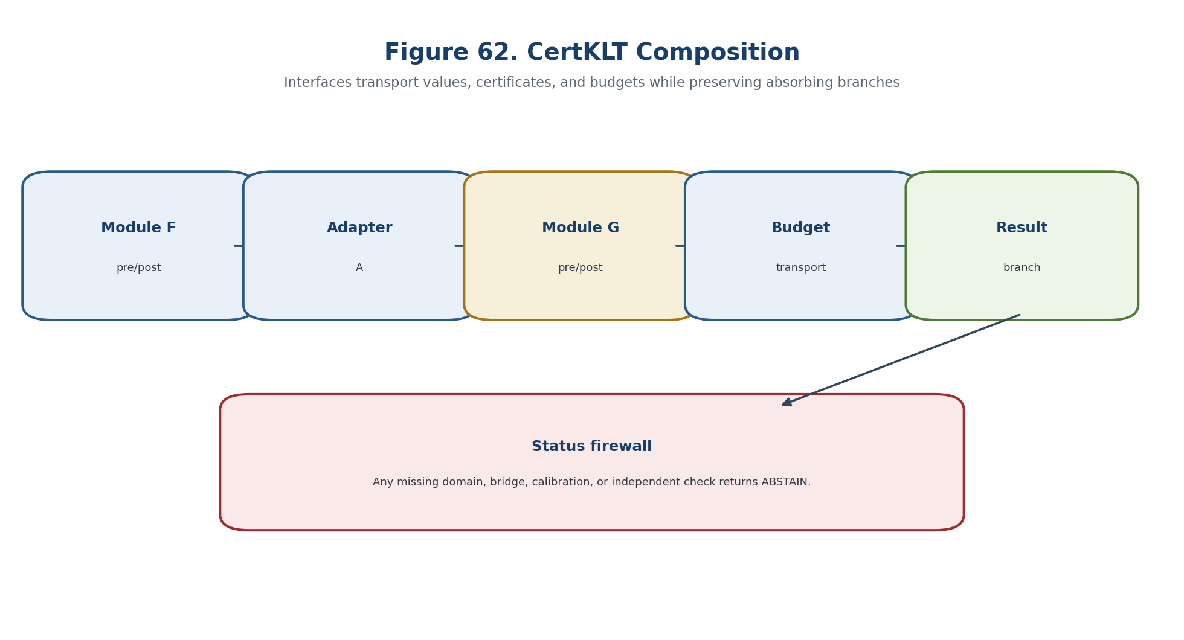
Figure 62. Composition in the CertKLT category.

24.7. Operator Composition and Absorbing Branches
The source construction is restated in controlled English with its hypotheses, invariants, loss channels, and forbidden status transfers kept explicit. Composition preserves certificates, budgets, and absorbing failure branches; release uses the weakest required component.
(G o F)(x)=G(y) if F(x)=OK(y,C_F,B_F); otherwise return the same ABSTAIN or FAIL branch. | T2-F355

B_{G⊙F}=T_G(T_F(B_in) ⊕ E_F) ⊕ E_G. | T2-F356

24.8. Soundness Theorem for the CertKLT Category
The statement is read under the explicitly declared hypotheses; its conclusion remains inside the mathematical model and does not acquire empirical status by translation. Composition preserves certificates, budgets, and absorbing failure branches; release uses the weakest required component.
Theorem 24.1. Soundness of CertKLT Composition [THM] Certified partial operators with compatible interfaces form a category under absorbing composition; identity operators preserve values, certificates, budgets and result branches.

24.9. Vector Uncertainty Budget
The source construction is restated in controlled English with its hypotheses, invariants, loss channels, and forbidden status transfers kept explicit. Composition preserves certificates, budgets, and absorbing failure branches; release uses the weakest required component.
B=(b_type,b_dom,b_alg,b_top,b_num,α_stat,𝒰_shift,b_causal,b_ext,σ_proof). | T2-F357

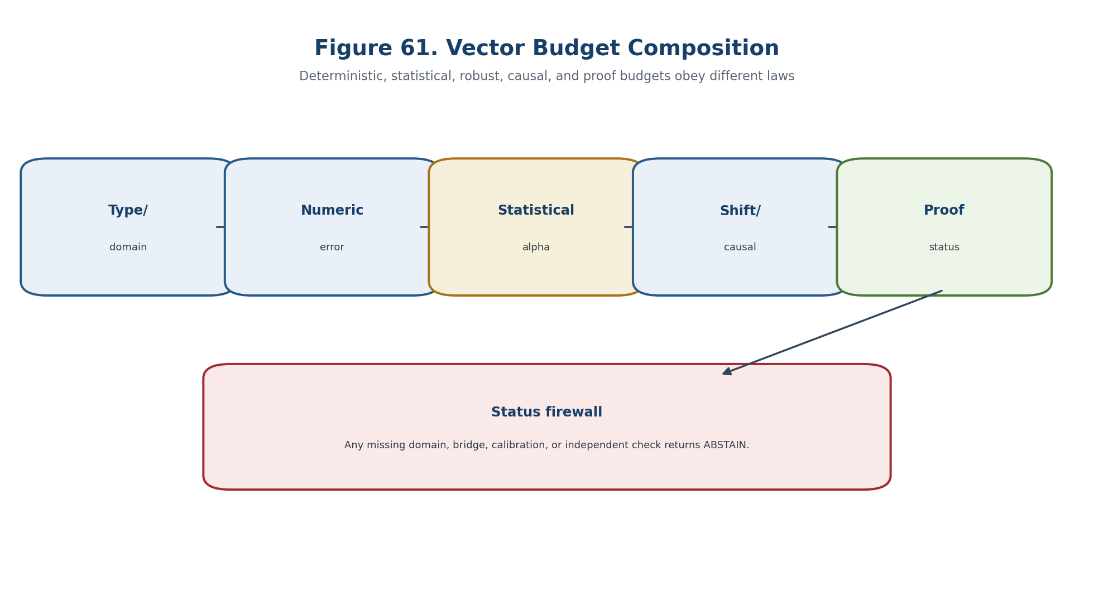
Figure 61. Vector budget composition.

24.10. Deterministic Error Transport
The bridge is an additional typed map with its own identification, calibration, and transport obligations; it is not supplied by a shared notation. Composition preserves certificates, budgets, and absorbing failure branches; release uses the weakest required component.
ε_out ≤ (Π_{k=1}^m L_k)ε_in + Σ_{j=1}^m (Π_{k=j+1}^m L_k) ε_j. | T2-F358

24.11. Probabilistic Budget without Independence
The source construction is restated in controlled English with its hypotheses, invariants, loss channels, and forbidden status transfers kept explicit. Composition preserves certificates, budgets, and absorbing failure branches; release uses the weakest required component.
P(∪_{j=1}^m E_j) ≤ Σ_{j=1}^m α_j, α_tot=min(1,Σα_j). | T2-F359

24.12. Sequential Budget and Optional Stopping
The source construction is restated in controlled English with its hypotheses, invariants, loss channels, and forbidden status transfers kept explicit. Composition preserves certificates, budgets, and absorbing failure branches; release uses the weakest required component.
P_{H0}(∃t: E_t ≥ 1/α) ≤ α. | T2-F360

24.13. Robust and Transport Budget
The bridge is an additional typed map with its own identification, calibration, and transport obligations; it is not supplied by a shared notation. Composition preserves certificates, budgets, and absorbing failure branches; release uses the weakest required component.
𝒰_out ⊇ F_#(𝒰_in) ⊕ 𝒱_F. | T2-F361

24.14. Computational Budget and Proof-Carrying Output
The source construction is restated in controlled English with its hypotheses, invariants, loss channels, and forbidden status transfers kept explicit. Composition preserves certificates, budgets, and absorbing failure branches; release uses the weakest required component.
C_comp=(value, interval, residual, dual_gap, discretization, seed, environment, code_hash, data_hash). | T2-F362

24.15. Lattice of Evidential Statuses
The source construction is restated in controlled English with its hypotheses, invariants, loss channels, and forbidden status transfers kept explicit. Composition preserves certificates, budgets, and absorbing failure branches; release uses the weakest required component.
OPEN <= CONJ <= MODEL <= COMP <= COND <= THM; PHY-HYP is a separate branch. | T2-F363

24.16. No Canonical Scalarization Theorem
The statement is read under the explicitly declared hypotheses; its conclusion remains inside the mathematical model and does not acquire empirical status by translation. Composition preserves certificates, budgets, and absorbing failure branches; release uses the weakest required component.
Theorem 24.2. No Canonical Scalarization [THM] No canonical order-preserving scalar summarizes all deterministic, statistical, robust, causal, evidential and proof-status budget coordinates without additional preferences or loss data.

24.17. Local Algorithmic Contract
The source construction is restated in controlled English with its hypotheses, invariants, loss channels, and forbidden status transfers kept explicit. Composition preserves certificates, budgets, and absorbing failure branches; release uses the weakest required component.

24.18. Interface Contract between Modules
The bridge is an additional typed map with its own identification, calibration, and transport obligations; it is not supplied by a shared notation. Composition preserves certificates, budgets, and absorbing failure branches; release uses the weakest required component.
Interface(F,G;A)=PASS iff Post_F implies Pre_G o A and Budget_G o A is defined. | T2-F364

24.19. Global Release Contract
The certificate records inputs, algorithms, tolerances, residuals, sources, code and data hashes, and the weakest evidential status supported by the chain. Composition preserves certificates, budgets, and absorbing failure branches; release uses the weakest required component.
M_rel=(Q, Modules, Edges, Notation, Budgets, Policies, Sources, Code, Data, Env, HashRoot). | T2-F365

Gate component | Required check | Failure output
Type and domain | All Dom/Cod and admissibility predicates are defined. | ABSTAIN-DOMAIN
Mathematical certificate | Hypotheses, residuals, and representative independence are verified. | ABSTAIN-CERT
Bridge and transport | The relevant realization, temporal, causal, or empirical bridge is identified. | ABSTAIN-BRIDGE
Independent evidence | Required external data or EXT-RUN is present and hash-linked. | ABSTAIN-EXT

24.20. Definition of the End-to-End KLT-RBD Operator
This section fixes the carrier, domain, codomain, and status type before any computation or interpretation is permitted. Composition preserves certificates, budgets, and absorbing failure branches; release uses the weakest required component.
𝔓_KLT(Q)=Gate_release ⊙ F_10 ⊙ ··· ⊙ F_1 ⊙ F_0 (Q). | T2-F366

𝔓_KLT = Release ⊙ Validate ⊙ Robust ⊙ Rare ⊙ Causal ⊙ Stoch ⊙ Evol ⊙ Global ⊙ Obstruct ⊙ NAPG ⊙ Reper ⊙ Ingest. | T2-F367

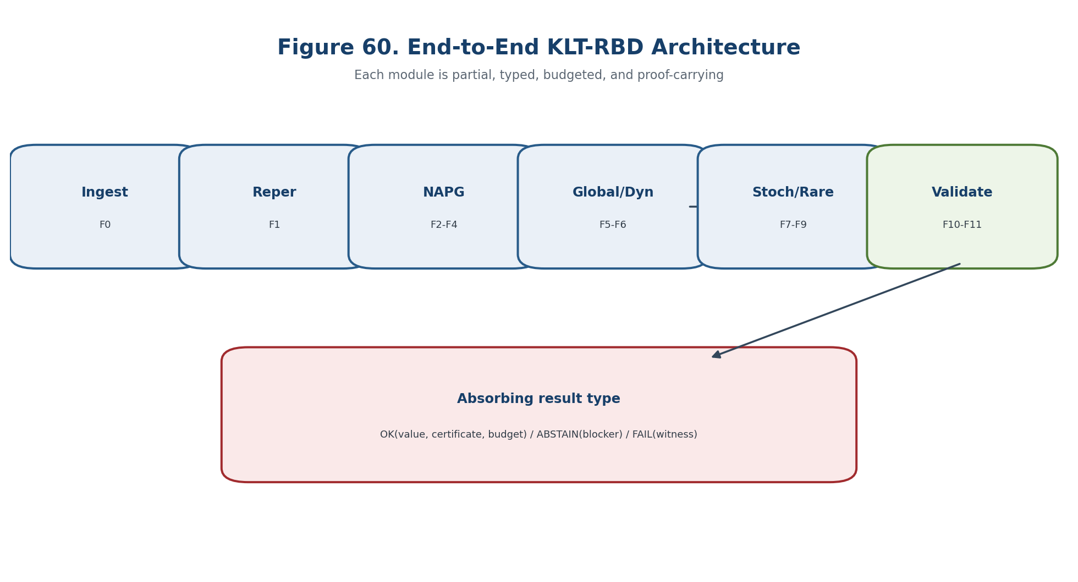
Figure 60. End-to-end KLT-RBD architecture.

24.21. Modular Decomposition F0-F11
The source construction is restated in controlled English with its hypotheses, invariants, loss channels, and forbidden status transfers kept explicit. Composition preserves certificates, budgets, and absorbing failure branches; release uses the weakest required component.

24.22. F0: Source, Identity, and Provenance
The source construction is restated in controlled English with its hypotheses, invariants, loss channels, and forbidden status transfers kept explicit. Composition preserves certificates, budgets, and absorbing failure branches; release uses the weakest required component.
F0(S)=OK(S*,Cert_src,B0), or FAIL(HASH-MISMATCH), or ABSTAIN(SOURCE-AMBIGUOUS). | T2-F368

24.23. F1: Reper Lift and D/Dom Authorization
The source construction is restated in controlled English with its hypotheses, invariants, loss channels, and forbidden status transfers kept explicit. Composition preserves certificates, budgets, and absorbing failure branches; release uses the weakest required component.
F1(x)=OK(Rep_x,Lambda_x,Cert_D) only if Valid(D_x) and Admissible(Dom_x). | T2-F369

24.24. F2-F3: Algebraic-Geometric NAPG Core
The source construction is restated in controlled English with its hypotheses, invariants, loss channels, and forbidden status transfers kept explicit. Composition preserves certificates, budgets, and absorbing failure branches; release uses the weakest required component.
Cert_NAPG=(Ass_⊙, nuclei, invariants, atlas, cocycle, ∇,R_∇,Hol_D; Dom). | T2-F370

24.25. F4: Obstructions, Cohomologicaly, and the External E-Bridge
The bridge is an additional typed map with its own identification, calibration, and transport obligations; it is not supplied by a shared notation. Composition preserves certificates, budgets, and absorbing failure branches; release uses the weakest required component.
Pi_E: O_B partial-> H^3(E), with status(Pi_E)<=COND until B1-B8 are closed. | T2-F371

24.26. F5: Global, Derived, and Virtual Layer
The source construction is restated in controlled English with its hypotheses, invariants, loss channels, and forbidden status transfers kept explicit. Composition preserves certificates, budgets, and absorbing failure branches; release uses the weakest required component.
GlobalOK ⇔ Descent∧Coherence∧Orientation∧Transport∧NoRequiredBlocker. | T2-F372

24.27. F6: Temporal Interface and Evolution
The bridge is an additional typed map with its own identification, calibration, and transport obligations; it is not supplied by a shared notation. Composition preserves certificates, budgets, and absorbing failure branches; release uses the weakest required component.
U(t,r)U(r,s)=U(t,s), s<=r<=t, under compatible domains. | T2-F373

24.28. F7-F8: Stochastic Law and Causal Firewall
The horizon is the union of loci where rank, domain, topology, calibration, identification, or numerical certification can change. Composition preserves certificates, budgets, and absorbing failure branches; release uses the weakest required component.
P_obs(Y|X) != P(Y|do(X)) without a structural bridge. | T2-F374

Gate component | Required check | Failure output
Type and domain | All Dom/Cod and admissibility predicates are defined. | ABSTAIN-DOMAIN
Mathematical certificate | Hypotheses, residuals, and representative independence are verified. | ABSTAIN-CERT
Bridge and transport | The relevant realization, temporal, causal, or empirical bridge is identified. | ABSTAIN-BRIDGE
Independent evidence | Required external data or EXT-RUN is present and hash-linked. | ABSTAIN-EXT

24.29. F9: Rare-Event and Robust Finite-Sample Layer
The source construction is restated in controlled English with its hypotheses, invariants, loss channels, and forbidden status transfers kept explicit. Composition preserves certificates, budgets, and absorbing failure branches; release uses the weakest required component.
V_rare∈{IMPOSSIBLE-IN-MODEL, FINITE-SAMPLE-RISK-BOUND, EXPONENTIALLY-SUPPRESSED-IN-MODEL, CANDIDATE-RARE-TRANSITION, ABSTAIN}. | T2-F375

24.30. F10-F11: External Validation and Release Gate
The certificate records inputs, algorithms, tolerances, residuals, sources, code and data hashes, and the weakest evidential status supported by the chain. Composition preserves certificates, budgets, and absorbing failure branches; release uses the weakest required component.
Release=OK ⇔ Required(V,Q)=PASS ∧ B≤B* ∧ Block_required=∅ ∧ HashChain=VALID. | T2-F376

24.31. Composite Verdict instead of a Single Label
The allowed output is multi-valued: a certified conclusion, an explicit candidate requiring further checks, ABSTAIN with blockers, or FAIL with a witness. Composition preserves certificates, budgets, and absorbing failure branches; release uses the weakest required component.
V=(V_struct,V_geom,V_ob,V_global,V_dyn,V_prob,V_causal,V_phys). | T2-F377

Gate component | Required check | Failure output
Type and domain | All Dom/Cod and admissibility predicates are defined. | ABSTAIN-DOMAIN
Mathematical certificate | Hypotheses, residuals, and representative independence are verified. | ABSTAIN-CERT
Bridge and transport | The relevant realization, temporal, causal, or empirical bridge is identified. | ABSTAIN-BRIDGE
Independent evidence | Required external data or EXT-RUN is present and hash-linked. | ABSTAIN-EXT

24.32. Prediction as a Set of Certified Continuations
The source construction is restated in controlled English with its hypotheses, invariants, loss channels, and forbidden status transfers kept explicit. Composition preserves certificates, budgets, and absorbing failure branches; release uses the weakest required component.
Pred(Q)= {z∈𝒞(Q): margin(z,Δ_safe)≥m*, B(z)≼B*, Valid(D_z), Dom_z}. | T2-F378

24.33. Monotonicity of ABSTAIN
The statement is read under the explicitly declared hypotheses; its conclusion remains inside the mathematical model and does not acquire empirical status by translation. Separating models show that the prohibited inference fails even when the upstream mathematical object is well defined. Composition preserves certificates, budgets, and absorbing failure branches; release uses the weakest required component.
Theorem 24.3. Monotonicity of ABSTAIN [THM] Adding an unresolved required blocker cannot turn an ABSTAIN result into OK. Closing blockers may refine ABSTAIN, but only through a new certificate and change-set.

24.34. General Conditional End-to-End Safety Theorem
The statement is read under the explicitly declared hypotheses; its conclusion remains inside the mathematical model and does not acquire empirical status by translation. Composition preserves certificates, budgets, and absorbing failure branches; release uses the weakest required component.
Theorem 24.4. Conditional End-to-End Safety [COND] If all required module contracts, budget transports, provenance links, status constraints and release predicates pass, the end-to-end output is type-correct and carries no stronger evidential status than its weakest required component.

24.35. Proof of Theorem 24.4
The statement is read under the explicitly declared hypotheses; its conclusion remains inside the mathematical model and does not acquire empirical status by translation. Composition preserves certificates, budgets, and absorbing failure branches; release uses the weakest required component.

24.36. What Theorem 24.4 Does Not Prove
The statement is read under the explicitly declared hypotheses; its conclusion remains inside the mathematical model and does not acquire empirical status by translation. Separating models show that the prohibited inference fails even when the upstream mathematical object is well defined. Composition preserves certificates, budgets, and absorbing failure branches; release uses the weakest required component.

24.37. Counterexample: Locally Correct but Globally Incompatible Modules
Separating models show that the prohibited inference fails even when the upstream mathematical object is well defined. Composition preserves certificates, budgets, and absorbing failure branches; release uses the weakest required component.

24.38. Counterexample: Inflation of the Probability Budget
Separating models show that the prohibited inference fails even when the upstream mathematical object is well defined. Composition preserves certificates, budgets, and absorbing failure branches; release uses the weakest required component.
10 * 0.05 = 0.50, not 0.05. | T2-F379

24.39. Counterexample: Small Local Error and Unbounded Amplification
Separating models show that the prohibited inference fails even when the upstream mathematical object is well defined. Composition preserves certificates, budgets, and absorbing failure branches; release uses the weakest required component.

24.40. Counterexample: Scalar Lambda near a Projective Pole
Separating models show that the prohibited inference fails even when the upstream mathematical object is well defined. Composition preserves certificates, budgets, and absorbing failure branches; release uses the weakest required component.

24.41. Counterexample: Observational Accuracy without Causal Identification
Separating models show that the prohibited inference fails even when the upstream mathematical object is well defined. Composition preserves certificates, budgets, and absorbing failure branches; release uses the weakest required component.

24.42. Falsifiability Protocol
The source construction is restated in controlled English with its hypotheses, invariants, loss channels, and forbidden status transfers kept explicit. Composition preserves certificates, budgets, and absorbing failure branches; release uses the weakest required component.
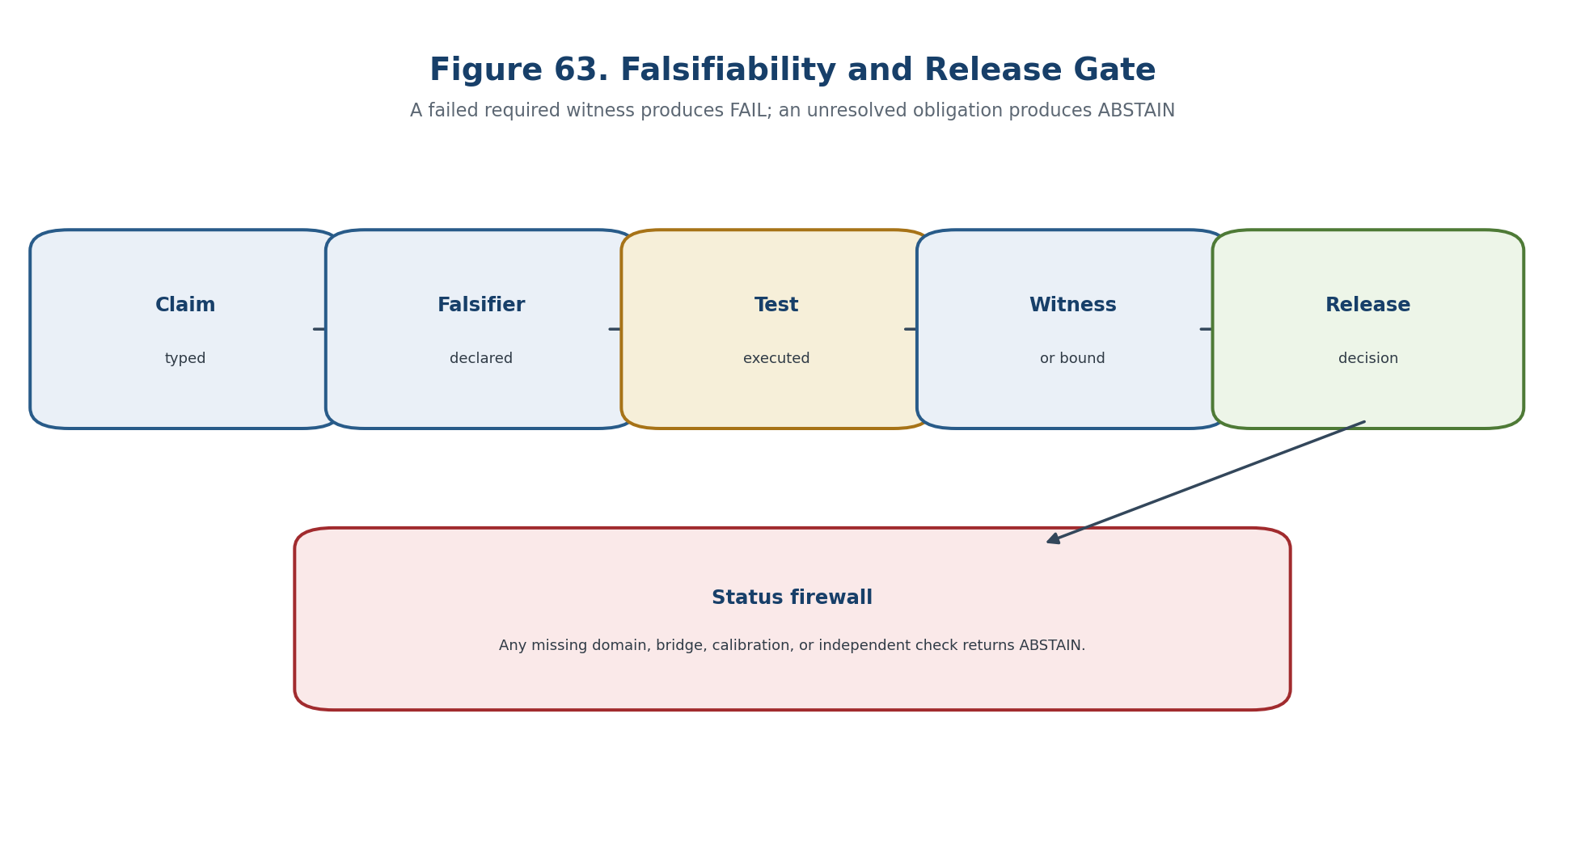
Figure 63. Falsifiability witnesses and release gate.

24.43. Final Falsifiability Matrix for Chapters 1-24
The source construction is restated in controlled English with its hypotheses, invariants, loss channels, and forbidden status transfers kept explicit. Composition preserves certificates, budgets, and absorbing failure branches; release uses the weakest required component.
Gate component | Required check | Failure output
Type and domain | All Dom/Cod and admissibility predicates are defined. | ABSTAIN-DOMAIN
Mathematical certificate | Hypotheses, residuals, and representative independence are verified. | ABSTAIN-CERT
Bridge and transport | The relevant realization, temporal, causal, or empirical bridge is identified. | ABSTAIN-BRIDGE
Independent evidence | Required external data or EXT-RUN is present and hash-linked. | ABSTAIN-EXT

24.43.1. Matrix 24-A: Chapters 1-8
The source construction is restated in controlled English with its hypotheses, invariants, loss channels, and forbidden status transfers kept explicit. Composition preserves certificates, budgets, and absorbing failure branches; release uses the weakest required component.

24.43.2. Matrix 24-B: Chapters 9-16
The source construction is restated in controlled English with its hypotheses, invariants, loss channels, and forbidden status transfers kept explicit. Composition preserves certificates, budgets, and absorbing failure branches; release uses the weakest required component.

24.43.3. Matrix 24-C: Chapters 17-24
The source construction is restated in controlled English with its hypotheses, invariants, loss channels, and forbidden status transfers kept explicit. Composition preserves certificates, budgets, and absorbing failure branches; release uses the weakest required component.

24.44. Final Status Matrix of Volume II
The source construction is restated in controlled English with its hypotheses, invariants, loss channels, and forbidden status transfers kept explicit. Composition preserves certificates, budgets, and absorbing failure branches; release uses the weakest required component.

24.45. Computational Certificate E2E-KLT
The certificate records inputs, algorithms, tolerances, residuals, sources, code and data hashes, and the weakest evidential status supported by the chain. Composition preserves certificates, budgets, and absorbing failure branches; release uses the weakest required component.
Gate component | Required check | Failure output
Type and domain | All Dom/Cod and admissibility predicates are defined. | ABSTAIN-DOMAIN
Mathematical certificate | Hypotheses, residuals, and representative independence are verified. | ABSTAIN-CERT
Bridge and transport | The relevant realization, temporal, causal, or empirical bridge is identified. | ABSTAIN-BRIDGE
Independent evidence | Required external data or EXT-RUN is present and hash-linked. | ABSTAIN-EXT

24.46. Canonical Pseudocode
The source construction is restated in controlled English with its hypotheses, invariants, loss channels, and forbidden status transfers kept explicit. Composition preserves certificates, budgets, and absorbing failure branches; release uses the weakest required component.
RETURN OK(V, Pred(Q), Cert, HashRoot); truth_layer_promotion=0. | T2-F380

24.47. Reproducibility and Root Hash
The certificate records inputs, algorithms, tolerances, residuals, sources, code and data hashes, and the weakest evidential status supported by the chain. Composition preserves certificates, budgets, and absorbing failure branches; release uses the weakest required component.
h_j = H(h_{j-1} || module_id || input_hash || output_hash || cert_hash || budget_hash). | T2-F381

24.48. Prior Art and Boundary of the Authorial Synthesis
Classical constructions retain their standard attribution; the authorial contribution is the typed, blocker-safe synthesis inside KLT-RBD. Composition preserves certificates, budgets, and absorbing failure branches; release uses the weakest required component.

24.49. Checkpoint, Conclusion of Volume II, and Boundary of Inference
The source construction is restated in controlled English with its hypotheses, invariants, loss channels, and forbidden status transfers kept explicit. Composition preserves certificates, budgets, and absorbing failure branches; release uses the weakest required component.
BOUNDARY OF CHAPTER 24. Local correctness does not imply global compatibility; incompatible budgets, interfaces, causal bridges, or release evidence close the gate. truth_layer_promotion=0; independent EXT-RUN and EMP-OBS remain absent.

Appendix T2-A. Synchronized Register of Formal Statements
Total: 339 numbered formal objects. Cross-type collisions of the bare number: 44; duplicate typed identifiers within one type: 0. The register preserves the source identifiers and explicit statuses.
STATUS FRAME. The appendix registries preserve the authority relation Authority(T2-RU v1.0) > Authority(T2-EN). A registry row records a source object, obligation, formula, locator, or release check; it does not strengthen its mathematical or physical status. truth_layer_promotion=0; independent EXT-RUN and EMP-OBS remain absent.
Typed ID | Type | Short title | Explicit status | Primary section
T2-DEF-5.1 | Definition | Domain of the Associator | DEF-A | Chapter 5. Associator, R⋆R, Nuclei, Centers, and Invariants
T2-LEM-5.2 | Lemma | Trilinearity on the Full Domain | THM | Chapter 5. Associator, R⋆R, Nuclei, Centers, and Invariants
T2-DEF-5.3 | Definition | Three Nuclei and the Nucleus | DEF-A | Chapter 5. Associator, R⋆R, Nuclei, Centers, and Invariants
T2-PROP-5.4 | Proposition | Linearity of the Nuclei | THM | Chapter 5. Associator, R⋆R, Nuclei, Centers, and Invariants
T2-DEF-5.5 | Definition | Commutant and Center | DEF-A | Chapter 5. Associator, R⋆R, Nuclei, Centers, and Invariants
T2-DEF-5.6 | Definition | Associator Ideal | DEF-A | Chapter 5. Associator, R⋆R, Nuclei, Centers, and Invariants
T2-THM-5.7 | Theorem | Universal Associative Reflection | THM | Chapter 5. Associator, R⋆R, Nuclei, Centers, and Invariants
T2-THM-5.8 | Theorem | Degree No-Go | THM | Chapter 5. Associator, R⋆R, Nuclei, Centers, and Invariants
T2-THM-5.9 | Theorem | Even the Cubic Diagonal Is Insufficient | THM | Chapter 5. Associator, R⋆R, Nuclei, Centers, and Invariants
T2-DEF-5.10 | Definition | Three Quadratic Pencils | DEF-A | Chapter 5. Associator, R⋆R, Nuclei, Centers, and Invariants
T2-DEF-5.11 | Definition | Alternating Component | DEF-A | Chapter 5. Associator, R⋆R, Nuclei, Centers, and Invariants
T2-THM-5.12 | Theorem | Completeness of the Quadratic-Alternating Certificate | THM | Chapter 5. Associator, R⋆R, Nuclei, Centers, and Invariants
T2-DEF-5.13 | Definition | Strict Realisation of R⋆R | DEF-A | Chapter 5. Associator, R⋆R, Nuclei, Centers, and Invariants
T2-PROP-5.14 | Proposition | Profile of Model 𝒜₂ | THM | Chapter 5. Associator, R⋆R, Nuclei, Centers, and Invariants
T2-DEF-5.15 | Definition | Basic Profile | DEF-A | Chapter 5. Associator, R⋆R, Nuclei, Centers, and Invariants
T2-THM-5.16 | Theorem | Isomorphism Invariance of the Profile | THM | Chapter 5. Associator, R⋆R, Nuclei, Centers, and Invariants
T2-DEF-5.17 | Definition | Profile Pseudodistance | DEF-A | Chapter 5. Associator, R⋆R, Nuclei, Centers, and Invariants
T2-DEF-5.18 | Definition | Polynomial Family of Algebras | DEF-A | Chapter 5. Associator, R⋆R, Nuclei, Centers, and Invariants
T2-DEF-5.19 | Definition | Determinantal Horizon | DEF-A | Chapter 5. Associator, R⋆R, Nuclei, Centers, and Invariants
T2-THM-5.20 | Theorem | Localisation of Structural Transitions | THM | Chapter 5. Associator, R⋆R, Nuclei, Centers, and Invariants
T2-COR-5.21 | Corollary | Negative Prediction Theorem | THM | Chapter 5. Associator, R⋆R, Nuclei, Centers, and Invariants
T2-DEF-5.22 | Definition | Predictive Horizon along a Path | DEF-A | Chapter 5. Associator, R⋆R, Nuclei, Centers, and Invariants
T2-DEF-5.23 | Definition | Harmonic Transition Candidate | DEF-A | Chapter 5. Associator, R⋆R, Nuclei, Centers, and Invariants
T2-THM-5.24 | Theorem | Projective Invariance of a Harmonic Candidate | THM | Chapter 5. Associator, R⋆R, Nuclei, Centers, and Invariants
T2-PROP-5.25 | Proposition | Finiteness of the Construction of J_Ass | THM | Chapter 5. Associator, R⋆R, Nuclei, Centers, and Invariants
T2-DEF-6.1 | Definition | Representable Duality | DEF-A | Chapter 6. Packet-Reper Algebraic-Geometric Duality
T2-DEF-6.2 | Definition | Spatial Duality | DEF-A | Chapter 6. Packet-Reper Algebraic-Geometric Duality
T2-THM-6.3 | Theorem | Yoneda-Safe Anti-Equivalence | THM | Chapter 6. Packet-Reper Algebraic-Geometric Duality
T2-DEF-6.4 | Definition | Rep_A(T) | DEF-A | Chapter 6. Packet-Reper Algebraic-Geometric Duality
T2-PROP-6.5 | Proposition | Functoriality of Reper Configurations | THM | Chapter 6. Packet-Reper Algebraic-Geometric Duality
T2-COR-6.6 | Corollary | Isomorphism Invariance | THM | Chapter 6. Packet-Reper Algebraic-Geometric Duality
T2-HYP-6.7 | Hypothesis | Spatial Realisation | COND | Chapter 6. Packet-Reper Algebraic-Geometric Duality
T2-DEF-6.8 | Definition | Algebraic Defect | DEF-A | Chapter 6. Packet-Reper Algebraic-Geometric Duality
T2-DEF-6.9 | Definition | Geometric Defect | DEF-A | Chapter 6. Packet-Reper Algebraic-Geometric Duality
T2-THM-6.10 | Theorem | Restricted Reconstruction Theorem | THM under hypothesis 6.7 | Chapter 6. Packet-Reper Algebraic-Geometric Duality
T2-COR-6.11 | Corollary | Preservation of Isomorphism Invariants | THM under hypothesis 6.7 | Chapter 6. Packet-Reper Algebraic-Geometric Duality
T2-THM-6.12 | Theorem | Character-Spectrum No-Go | THM | Chapter 6. Packet-Reper Algebraic-Geometric Duality
T2-PROP-6.14 | Proposition | No-Dynamics Principle | THM | Chapter 6. Packet-Reper Algebraic-Geometric Duality
T2-DEF-6.15 | Definition | Projective Reper Atlas | DEF-A | Chapter 6. Packet-Reper Algebraic-Geometric Duality
T2-THM-6.16 | Theorem | Globalisation of λ | THM | Chapter 6. Packet-Reper Algebraic-Geometric Duality
T2-COR-6.17 | Corollary | Global Harmonic Locus | THM | Chapter 6. Packet-Reper Algebraic-Geometric Duality
T2-DEF-6.18 | Definition | Projective-Reper Morphism | DEF-A | Chapter 6. Packet-Reper Algebraic-Geometric Duality
T2-THM-6.19 | Theorem | Invariance of the Harmonic Locus | THM | Chapter 6. Packet-Reper Algebraic-Geometric Duality
T2-HYP-6.20 | Hypothesis | Conjugacy Bridge | COND | Chapter 6. Packet-Reper Algebraic-Geometric Duality
T2-THM-6.21 | Theorem | Coincidence of Rank Horizons | THM under hypothesis 6.20 | Chapter 6. Packet-Reper Algebraic-Geometric Duality
T2-COR-6.22 | Corollary | Double Negative-Prediction Theorem | THM under hypotheses 6.7 and 6.20 | Chapter 6. Packet-Reper Algebraic-Geometric Duality
T2-DEF-6.23 | Definition | Dual Mismatch Set | DEF-A | Chapter 6. Packet-Reper Algebraic-Geometric Duality
T2-DEF-6.24 | Definition | Block_dual | DEF-A | Chapter 6. Packet-Reper Algebraic-Geometric Duality
T2-DEF-6.25 | Definition | Dual Harmonic Candidate | DEF-A | Chapter 6. Packet-Reper Algebraic-Geometric Duality
T2-THM-6.26 | Theorem | Functorial Predictive Transport | COND | Chapter 6. Packet-Reper Algebraic-Geometric Duality
T2-PROP-6.27 | Proposition | Representability of the Associative Reflection | THM | Chapter 6. Packet-Reper Algebraic-Geometric Duality
T2-PROP-6.28 | Proposition | Functoriality of Nucleus Loci | THM | Chapter 6. Packet-Reper Algebraic-Geometric Duality
T2-DEF-7.1 | Definition | Local NAPG Model | DEF-A | Chapter 7. Atlases, Bundles, and Globalisation Obstructions
T2-DEF-7.2 | Definition | NAPG Atlas | DEF-A | Chapter 7. Atlases, Bundles, and Globalisation Obstructions
T2-DEF-7.3 | Definition | Structural Groupoid | DEF-A | Chapter 7. Atlases, Bundles, and Globalisation Obstructions
T2-THM-7.4 | Theorem | Associative Transition Groupoid Is Necessary | THM | Chapter 7. Atlases, Bundles, and Globalisation Obstructions
T2-DEF-7.5 | Definition | Projective-Reper Chart | DEF-A | Chapter 7. Atlases, Bundles, and Globalisation Obstructions
T2-THM-7.6 | Theorem | Globality of lambda | THM | Chapter 7. Atlases, Bundles, and Globalisation Obstructions
T2-DEF-7.7 | Definition | Descent Datum | CL/DEF-A | Chapter 7. Atlases, Bundles, and Globalisation Obstructions
T2-DEF-7.8 | Definition | Effective Descent | CL/COND | Chapter 7. Atlases, Bundles, and Globalisation Obstructions
T2-THM-7.9 | Theorem | Gluing of an NAPG Bundle | THM | Chapter 7. Atlases, Bundles, and Globalisation Obstructions
T2-DEF-7.11 | Definition | Bundle of NAPG Algebras | DEF-A | Chapter 7. Atlases, Bundles, and Globalisation Obstructions
T2-THM-7.12 | Theorem | Descent of the Operation | THM | Chapter 7. Atlases, Bundles, and Globalisation Obstructions
T2-DEF-7.13 | Definition | Operation Descent Defect | DEF-A | Chapter 7. Atlases, Bundles, and Globalisation Obstructions
T2-DEF-7.14 | Definition | Reper Bundle | DEF-A | Chapter 7. Atlases, Bundles, and Globalisation Obstructions
T2-THM-7.15 | Theorem | Double Descent of Reper | COND | Chapter 7. Atlases, Bundles, and Globalisation Obstructions
T2-DEF-7.16 | Definition | Hodge-Compatible Atlas | DEF-A | Chapter 7. Atlases, Bundles, and Globalisation Obstructions
T2-THM-7.17 | Theorem | Descent of the Hodge Star | THM | Chapter 7. Atlases, Bundles, and Globalisation Obstructions
T2-THM-7.19 | Theorem | Central Obstruction Class | THM/COND | Chapter 7. Atlases, Bundles, and Globalisation Obstructions
T2-DEF-7.20 | Definition | Globalisation Defect Vector | DEF-A | Chapter 7. Atlases, Bundles, and Globalisation Obstructions
T2-THM-7.21 | Theorem | Cellular Obstruction Tower | CL/COND | Chapter 7. Atlases, Bundles, and Globalisation Obstructions
T2-DEF-7.22 | Definition | Parametric NAPG Bundle | DEF-A | Chapter 7. Atlases, Bundles, and Globalisation Obstructions
T2-THM-7.23 | Theorem | Homotopy Constancy | THM | Chapter 7. Atlases, Bundles, and Globalisation Obstructions
T2-COR-7.24 | Corollary | Negative Global Prediction | THM | Chapter 7. Atlases, Bundles, and Globalisation Obstructions
T2-DEF-7.25 | Definition | Globalisation Horizon | DEF-A | Chapter 7. Atlases, Bundles, and Globalisation Obstructions
T2-THM-7.26 | Theorem | Localisation of a Possible Global Transition | COND | Chapter 7. Atlases, Bundles, and Globalisation Obstructions
T2-DEF-7.27 | Definition | Predictive Reper Bundle | DEF-A | Chapter 7. Atlases, Bundles, and Globalisation Obstructions
T2-DEF-7.28 | Definition | Globally Admissible Scenario | DEF-A | Chapter 7. Atlases, Bundles, and Globalisation Obstructions
T2-DEF-7.29 | Definition | Global Structural Candidate | DEF-A | Chapter 7. Atlases, Bundles, and Globalisation Obstructions
T2-THM-7.30 | Theorem | No Local-to-Global Substitution | THM | Chapter 7. Atlases, Bundles, and Globalisation Obstructions
T2-DEF-8.1 | Definition | Dual-Number Tangent | CL/DEF-A | Chapter 8. Tangent and Cotangent Objects of NAPG
T2-LEM-8.2 | Lemma | Derivation Representation | THM | Chapter 8. Tangent and Cotangent Objects of NAPG
T2-DEF-8.3 | Definition | Curve Tangent | CL/COND | Chapter 8. Tangent and Cotangent Objects of NAPG
T2-DEF-8.4 | Definition | Kahler Cotangent Module | CL/COND | Chapter 8. Tangent and Cotangent Objects of NAPG
T2-DEF-8.5 | Definition | Cotangent at a Rational Point | CL | Chapter 8. Tangent and Cotangent Objects of NAPG
T2-DEF-8.6 | Definition | Algebraic Tangent Cone | CL | Chapter 8. Tangent and Cotangent Objects of NAPG
T2-PROP-8.7 | Proposition | Cone-to-Tangent Inclusion | CL | Chapter 8. Tangent and Cotangent Objects of NAPG
T2-DEF-8.10 | Definition | Ambient Operation Space | DEF-A | Chapter 8. Tangent and Cotangent Objects of NAPG
T2-DEF-8.11 | Definition | Linearised Structure Space | DEF-A | Chapter 8. Tangent and Cotangent Objects of NAPG
T2-THM-8.12 | Theorem | Differential of the Associator | THM | Chapter 8. Tangent and Cotangent Objects of NAPG
T2-COR-8.13 | Corollary | Associative Tangent Equation | CL/THM | Chapter 8. Tangent and Cotangent Objects of NAPG
T2-DEF-8.14 | Definition | Gauge Differential | DEF-A | Chapter 8. Tangent and Cotangent Objects of NAPG
T2-THM-8.15 | Theorem | Stabiliser-Derivation Identity | THM | Chapter 8. Tangent and Cotangent Objects of NAPG
T2-DEF-8.16 | Definition | Reduced Tangent Space | DEF-A | Chapter 8. Tangent and Cotangent Objects of NAPG
T2-DEF-8.17 | Definition | Tangent Complex | DEF-A | Chapter 8. Tangent and Cotangent Objects of NAPG
T2-THM-8.18 | Theorem | No Canonical Self-Duality | CL/THM | Chapter 8. Tangent and Cotangent Objects of NAPG
T2-COR-8.19 | Corollary | NAPG Duality Boundary | THM/COND | Chapter 8. Tangent and Cotangent Objects of NAPG
T2-DEF-8.20 | Definition | Second-Order Obstruction Class | DEF-A | Chapter 8. Tangent and Cotangent Objects of NAPG
T2-THM-8.21 | Theorem | Second-Order Lift Criterion | THM | Chapter 8. Tangent and Cotangent Objects of NAPG
T2-DEF-8.23 | Definition | Formally Smooth Point | DEF-A | Chapter 8. Tangent and Cotangent Objects of NAPG
T2-DEF-8.24 | Definition | Finite-Dimensional Regular Sector | DEF-A | Chapter 8. Tangent and Cotangent Objects of NAPG
T2-DEF-8.26 | Definition | Linearisation Horizon | DEF-A | Chapter 8. Tangent and Cotangent Objects of NAPG
T2-THM-8.27 | Theorem | Local Constancy Outside the Horizon | COND | Chapter 8. Tangent and Cotangent Objects of NAPG
T2-THM-8.28 | Theorem | Differential of the Cross-Ratio | THM | Chapter 8. Tangent and Cotangent Objects of NAPG
T2-COR-8.29 | Corollary | Tangent Space to the Harmonic Locus | THM/COND | Chapter 8. Tangent and Cotangent Objects of NAPG
T2-DEF-8.30 | Definition | Smooth Harmonic Risk | DEF-A | Chapter 8. Tangent and Cotangent Objects of NAPG
T2-THM-8.31 | Theorem | First-Order Blindness at Exact Harmony | THM | Chapter 8. Tangent and Cotangent Objects of NAPG
T2-DEF-8.32 | Definition | Structural Constraint Map | DEF-A | Chapter 8. Tangent and Cotangent Objects of NAPG
T2-DEF-8.33 | Definition | Integrable Predictive Direction | DEF-A | Chapter 8. Tangent and Cotangent Objects of NAPG
T2-THM-8.34 | Theorem | Tangent-Safe Predictive Transport | COND | Chapter 8. Tangent and Cotangent Objects of NAPG
T2-THM-8.35 | Theorem | No Event from Tangent Data Alone | THM | Chapter 8. Tangent and Cotangent Objects of NAPG
T2-DEF-9.1 | Definition | Algebraic NAPG Bundle | DEF-A | Chapter 9. Connections, Curvature, Holonomy, and Associator Curvature
T2-DEF-9.2 | Definition | D-Admissible Path Category | DEF-A | Chapter 9. Connections, Curvature, Holonomy, and Associator Curvature
T2-DEF-9.3 | Definition | NAPG Connection | DEF-A | Chapter 9. Connections, Curvature, Holonomy, and Associator Curvature
T2-DEF-9.4 | Definition | Parallel Transport | CL/DEF-A | Chapter 9. Connections, Curvature, Holonomy, and Associator Curvature
T2-THM-9.5 | Theorem | Associativity of Transport Composition | THM | Chapter 9. Connections, Curvature, Holonomy, and Associator Curvature
T2-COR-9.6 | Corollary | First No-Go | THM | Chapter 9. Connections, Curvature, Holonomy, and Associator Curvature
T2-DEF-9.7 | Definition | Curvature | CL | Chapter 9. Connections, Curvature, Holonomy, and Associator Curvature
T2-DEF-9.8 | Definition | Small-Loop Certificate | DEF-A | Chapter 9. Connections, Curvature, Holonomy, and Associator Curvature
T2-THM-9.9 | Theorem | Small Loops Localise Curvature | CL/THM | Chapter 9. Connections, Curvature, Holonomy, and Associator Curvature
T2-DEF-9.10 | Definition | D-Holonomy | DEF-A | Chapter 9. Connections, Curvature, Holonomy, and Associator Curvature
T2-PROP-9.11 | Proposition | Base-Point Change | THM | Chapter 9. Connections, Curvature, Holonomy, and Associator Curvature
T2-THM-9.12 | Theorem | Ambrose-Singer: Classical Layer | CL | Chapter 9. Connections, Curvature, Holonomy, and Associator Curvature
T2-HYP-9.13 | Hypothesis | D-Ambrose-Singer Bridge | COND/OPEN | Chapter 9. Connections, Curvature, Holonomy, and Associator Curvature
T2-DEF-9.14 | Definition | Product Defect | DEF-A | Chapter 9. Connections, Curvature, Holonomy, and Associator Curvature
T2-DEF-9.15 | Definition | Product-Compatible Connection | DEF-A | Chapter 9. Connections, Curvature, Holonomy, and Associator Curvature
T2-THM-9.16 | Theorem | Transport Preserves the Product | THM | Chapter 9. Connections, Curvature, Holonomy, and Associator Curvature
T2-COR-9.17 | Corollary | Holonomy Preserves Structure | THM | Chapter 9. Connections, Curvature, Holonomy, and Associator Curvature
T2-DEF-9.18 | Definition | Finite Multiplication Holonomy Defect | DEF-A | Chapter 9. Connections, Curvature, Holonomy, and Associator Curvature
T2-DEF-9.19 | Definition | Finite Associator Holonomy Defect | DEF-A | Chapter 9. Connections, Curvature, Holonomy, and Associator Curvature
T2-THM-9.20 | Theorem | Derivative of the Associator through C_nabla | THM | Chapter 9. Connections, Curvature, Holonomy, and Associator Curvature
T2-COR-9.21 | Corollary | Vanishing Associator Curvature and Trivial Associator Holonomy | THM | Chapter 9. Connections, Curvature, Holonomy, and Associator Curvature
T2-DEF-9.22 | Definition | Associator Curvature K_Ass | DEF-A | Chapter 9. Connections, Curvature, Holonomy, and Associator Curvature
T2-THM-9.23 | Theorem | Necessary Condition for Parallelism | THM | Chapter 9. Connections, Curvature, Holonomy, and Associator Curvature
T2-DEF-9.25 | Definition | Full Associator-Holonomy Bridge Package | DEF-A | Chapter 9. Connections, Curvature, Holonomy, and Associator Curvature
T2-THM-9.26 | Theorem | Holonomy Principle for the Associator | CL/THM | Chapter 9. Connections, Curvature, Holonomy, and Associator Curvature
T2-THM-9.32 | Theorem | Universal-Equality No-Go | THM | Chapter 9. Connections, Curvature, Holonomy, and Associator Curvature
T2-DEF-9.33 | Definition | Akivis Algebra | CL | Chapter 9. Connections, Curvature, Holonomy, and Associator Curvature
T2-DEF-9.34 | Definition | Bridge Datum beta | DEF-A | Chapter 9. Connections, Curvature, Holonomy, and Associator Curvature
T2-DEF-9.36 | Definition | D-Holonomy Signature | DEF-A | Chapter 9. Connections, Curvature, Holonomy, and Associator Curvature
T2-DEF-9.37 | Definition | Finite Holonomy Certificate | DEF-A | Chapter 9. Connections, Curvature, Holonomy, and Associator Curvature
T2-THM-9.38 | Theorem | Local Constancy of Certified Rank | THM | Chapter 9. Connections, Curvature, Holonomy, and Associator Curvature
T2-DEF-9.40 | Definition | Connection-Holonomy Horizon | DEF-A | Chapter 9. Connections, Curvature, Holonomy, and Associator Curvature
T2-THM-9.41 | Theorem | Negative Holonomy Prediction | COND | Chapter 9. Connections, Curvature, Holonomy, and Associator Curvature
T2-THM-9.42 | Theorem | Common Projective Transport Invariance | THM | Chapter 9. Connections, Curvature, Holonomy, and Associator Curvature
T2-COR-9.43 | Corollary | Relative Transport Is Necessary | THM | Chapter 9. Connections, Curvature, Holonomy, and Associator Curvature
T2-DEF-9.44 | Definition | Relative Reper Connection | DEF-A | Chapter 9. Connections, Curvature, Holonomy, and Associator Curvature
T2-THM-9.46 | Theorem | Holonomy-Associator-Safe Predictive Theorem | COND | Chapter 9. Connections, Curvature, Holonomy, and Associator Curvature
T2-DEF-10.1 | Definition | Internal Packet Forms | DEF-A | Chapter 10. NAPG Differential Forms and Typed Differentials
T2-DEF-10.2 | Definition | Internal Differential Candidate | DEF-A | Chapter 10. NAPG Differential Forms and Typed Differentials
T2-DEF-10.3 | Definition | External E-Operator | DEF-A/COND | Chapter 10. NAPG Differential Forms and Typed Differentials
T2-DEF-10.4 | Definition | Hodge Operators | CL/DEF-A | Chapter 10. NAPG Differential Forms and Typed Differentials
T2-PRINC-10.5 | Principle | Notation Firewall | THM/PROTOCOL | Chapter 10. NAPG Differential Forms and Typed Differentials
T2-DEF-10.6 | Definition | Leibniz Defect | DEF-A | Chapter 10. NAPG Differential Forms and Typed Differentials
T2-DEF-10.7 | Definition | Graded Derivation | CL/DEF-A | Chapter 10. NAPG Differential Forms and Typed Differentials
T2-LEM-10.8 | Lemma | Value on the Unit | THM | Chapter 10. NAPG Differential Forms and Typed Differentials
T2-THM-10.9 | Theorem | Closure of Derivations | THM | Chapter 10. NAPG Differential Forms and Typed Differentials
T2-COR-10.10 | Corollary | Square of an Odd Derivation | THM | Chapter 10. NAPG Differential Forms and Typed Differentials
T2-THM-10.11 | Theorem | Associator Leibniz Identity | THM | Chapter 10. NAPG Differential Forms and Typed Differentials
T2-COR-10.12 | Corollary | Stability of the Associative Sector | THM | Chapter 10. NAPG Differential Forms and Typed Differentials
T2-DEF-10.13 | Definition | Differential Curvature | DEF-A | Chapter 10. NAPG Differential Forms and Typed Differentials
T2-LEM-10.14 | Lemma | Operator Bianchi Identity | THM | Chapter 10. NAPG Differential Forms and Typed Differentials
T2-DEF-10.15 | Definition | Precomplex and Complex | DEF-A | Chapter 10. NAPG Differential Forms and Typed Differentials
T2-DEF-10.20 | Definition | Sheaf-Local Operator | DEF-A | Chapter 10. NAPG Differential Forms and Typed Differentials
T2-LEM-10.21 | Lemma | Support Nonincrease | THM | Chapter 10. NAPG Differential Forms and Typed Differentials
T2-THM-10.22 | Theorem | Gluing of Local Differentials | THM | Chapter 10. NAPG Differential Forms and Typed Differentials
T2-DEF-10.23 | Definition | Differential Gluing Defect | DEF-A | Chapter 10. NAPG Differential Forms and Typed Differentials
T2-DEF-10.25 | Definition | Bigraded Bridge Object | DEF-A/COND | Chapter 10. NAPG Differential Forms and Typed Differentials
T2-THM-10.26 | Theorem | Square Decomposition | THM | Chapter 10. NAPG Differential Forms and Typed Differentials
T2-DEF-10.28 | Definition | Differential Bridge Certificate | DEF-A | Chapter 10. NAPG Differential Forms and Typed Differentials
T2-DEF-10.30 | Definition | Hodge Sector | CL/COND | Chapter 10. NAPG Differential Forms and Typed Differentials
T2-DEF-10.31 | Definition | Codifferential | CL/COND | Chapter 10. NAPG Differential Forms and Typed Differentials
T2-DEF-10.32 | Definition | Hodge Laplacian | CL/COND | Chapter 10. NAPG Differential Forms and Typed Differentials
T2-THM-10.33 | Theorem | Nilpotency Transfer | THM | Chapter 10. NAPG Differential Forms and Typed Differentials
T2-DEF-10.35 | Definition | Hodge Transport Defect | DEF-A | Chapter 10. NAPG Differential Forms and Typed Differentials
T2-DEF-10.36 | Definition | Formal-Adjoint Defect | DEF-A | Chapter 10. NAPG Differential Forms and Typed Differentials
T2-DEF-10.37 | Definition | Differential Reper | DEF-A | Chapter 10. NAPG Differential Forms and Typed Differentials
T2-DEF-10.38 | Definition | Differential Defect Vector | DEF-A | Chapter 10. NAPG Differential Forms and Typed Differentials
T2-PRINC-10.39 | Principle | Harmonic Insufficiency Principle | THM/PROTOCOL | Chapter 10. NAPG Differential Forms and Typed Differentials
T2-DEF-10.40 | Definition | Relaxed Differential Candidate | DEF-A | Chapter 10. NAPG Differential Forms and Typed Differentials
T2-DEF-10.41 | Definition | Finite Differential Signature | DEF-A | Chapter 10. NAPG Differential Forms and Typed Differentials
T2-DEF-10.42 | Definition | Differential Horizon | DEF-A | Chapter 10. NAPG Differential Forms and Typed Differentials
T2-THM-10.43 | Theorem | Rank Constancy | THM | Chapter 10. NAPG Differential Forms and Typed Differentials
T2-THM-10.44 | Theorem | Differential Negative Prediction | COND | Chapter 10. NAPG Differential Forms and Typed Differentials
T2-COR-10.45 | Corollary | Horizon Crossing Is Only a Candidate | COND | Chapter 10. NAPG Differential Forms and Typed Differentials
T2-CTHM-10.46 | Countertheorem | Triple Independence Countertheorem | THM | Chapter 10. NAPG Differential Forms and Typed Differentials
T2-THM-10.47 | Theorem | Differential-Calculus-Safe Predictive Theorem | COND | Chapter 10. NAPG Differential Forms and Typed Differentials
T2-DEF-12.1 | Definition | NAPG Quadratic Frame | DEF-A | Chapter 12. Internal Construction of C_min^bullet, delta_min, and Theta_min
T2-DEF-12.2 | Definition | Internal Minimal Complex | THM/IMPORT | Chapter 12. Internal Construction of C_min^bullet, delta_min, and Theta_min
T2-LEM-12.1 | Lemma | Nilpotency | THM | Chapter 12. Internal Construction of C_min^bullet, delta_min, and Theta_min
T2-DEF-12.3 | Definition | Canonical Map Theta_min | THM/IMPORT | Chapter 12. Internal Construction of C_min^bullet, delta_min, and Theta_min
T2-DEF-12.4 | Definition | Internal Obstruction Class | DEF-A | Chapter 12. Internal Construction of C_min^bullet, delta_min, and Theta_min
T2-THM-12.2 | Theorem | Internal H2 and H3 | THM | Chapter 12. Internal Construction of C_min^bullet, delta_min, and Theta_min
T2-THM-12.3 | Theorem | Natural Exact Sequence | THM | Chapter 12. Internal Construction of C_min^bullet, delta_min, and Theta_min
T2-COR-12.3 | Corollary | 1. Finite-Dimensional Rank Formula | THM | Chapter 12. Internal Construction of C_min^bullet, delta_min, and Theta_min
T2-THM-12.4 | Theorem | Minimal-Complex Functor | THM | Chapter 12. Internal Construction of C_min^bullet, delta_min, and Theta_min
T2-THM-12.5 | Theorem | Natural Isomorphism with O_B | THM | Chapter 12. Internal Construction of C_min^bullet, delta_min, and Theta_min
T2-COR-12.5 | Corollary | 1. Invariant Vanishing | THM | Chapter 12. Internal Construction of C_min^bullet, delta_min, and Theta_min
T2-DEF-12.5 | Definition | Lift | DEF-A | Chapter 12. Internal Construction of C_min^bullet, delta_min, and Theta_min
T2-THM-12.6 | Theorem | Complete Internal Lift Criterion | THM | Chapter 12. Internal Construction of C_min^bullet, delta_min, and Theta_min
T2-THM-12.7 | Theorem | Torsor of Lifts | THM | Chapter 12. Internal Construction of C_min^bullet, delta_min, and Theta_min
T2-THM-12.8 | Theorem | Universal Extension into a Complex | THM | Chapter 12. Internal Construction of C_min^bullet, delta_min, and Theta_min
T2-THM-12.9 | Theorem | Extension of Scalars | THM | Chapter 12. Internal Construction of C_min^bullet, delta_min, and Theta_min
T2-THM-12.10 | Theorem | Block-Diagonal Additivity | THM | Chapter 12. Internal Construction of C_min^bullet, delta_min, and Theta_min
T2-DEF-12.6 | Definition | Orthogonal Obstruction Residual | DEF-A/COMP | Chapter 12. Internal Construction of C_min^bullet, delta_min, and Theta_min
T2-THM-12.11 | Theorem | Residual Criterion | THM | Chapter 12. Internal Construction of C_min^bullet, delta_min, and Theta_min
T2-DEF-12.7 | Definition | Normalised Internal Obstruction Index | DEF-A/DIAGNOSTIC | Chapter 12. Internal Construction of C_min^bullet, delta_min, and Theta_min
T2-THM-12.12 | Theorem | Constant-Rank Cohomology Bundles | THM | Chapter 12. Internal Construction of C_min^bullet, delta_min, and Theta_min
T2-COR-12.12 | Corollary | 1. Zeros of the Obstruction Section | THM | Chapter 12. Internal Construction of C_min^bullet, delta_min, and Theta_min
T2-DEF-12.8 | Definition | Internal Transition Horizon | DEF-A | Chapter 12. Internal Construction of C_min^bullet, delta_min, and Theta_min
T2-LEM-12.13 | Lemma | Motion of the Residual | THM | Chapter 12. Internal Construction of C_min^bullet, delta_min, and Theta_min
T2-THM-12.14 | Theorem | Certified No-Lift Zone | THM/COMP | Chapter 12. Internal Construction of C_min^bullet, delta_min, and Theta_min
T2-THM-12.15 | Theorem | Minimal-Obstruction-Safe Predictive Theorem | COND | Chapter 12. Internal Construction of C_min^bullet, delta_min, and Theta_min
T2-DEF-12.9 | Definition | Joint Certificate | DEF-A | Chapter 12. Internal Construction of C_min^bullet, delta_min, and Theta_min
T2-CTHM-12.16 | Countertheorem | Four Prohibited Implications | THM | Chapter 12. Internal Construction of C_min^bullet, delta_min, and Theta_min
T2-DEF-13.1 | Definition | External Realisation | DEF-A | Chapter 13. External E-Complex and the Conditional Bridge Pi_E
T2-DEF-13.2 | Definition | Cochain Bridge J | DEF-A | Chapter 13. External E-Complex and the Conditional Bridge Pi_E
T2-THM-13.1 | Theorem | Descent to the Quotient | THM | Chapter 13. External E-Complex and the Conditional Bridge Pi_E
T2-COR-13.1 | Corollary | Injective-Bridge Corollary | THM | Chapter 13. External E-Complex and the Conditional Bridge Pi_E
T2-DEF-13.3 | Definition | External Obstruction Map | COND/THM under B1-B5 | Chapter 13. External E-Complex and the Conditional Bridge Pi_E
T2-THM-13.2 | Theorem | Naturality | THM under B3-B5 | Chapter 13. External E-Complex and the Conditional Bridge Pi_E
T2-THM-13.3 | Theorem | One-Way Detection | THM | Chapter 13. External E-Complex and the Conditional Bridge Pi_E
T2-THM-13.4 | Theorem | Reverse Detection Criterion | THM | Chapter 13. External E-Complex and the Conditional Bridge Pi_E
T2-DEF-13.4 | Definition | Bridge Quality | DEF-A | Chapter 13. External E-Complex and the Conditional Bridge Pi_E
T2-DEF-13.5 | Definition | Mapping Cone | CL | Chapter 13. External E-Complex and the Conditional Bridge Pi_E
T2-THM-13.5 | Theorem | Exact Detection Sequence | THM | Chapter 13. External E-Complex and the Conditional Bridge Pi_E
T2-THM-13.6 | Theorem | Chain-Homotopy Invariance | CL/THM | Chapter 13. External E-Complex and the Conditional Bridge Pi_E
T2-DEF-13.6 | Definition | Category of External Realisations | DEF-A | Chapter 13. External E-Complex and the Conditional Bridge Pi_E
T2-THM-13.7 | Theorem | Canonical External-Class Criterion | THM | Chapter 13. External E-Complex and the Conditional Bridge Pi_E
T2-DEF-13.7 | Definition | Canonical External Class | COND; canonical external class | Chapter 13. External E-Complex and the Conditional Bridge Pi_E
T2-THM-13.8 | Theorem | Stable Reverse Detection | THM/COMP | Chapter 13. External E-Complex and the Conditional Bridge Pi_E
T2-LEM-13.9 | Lemma | Local Constancy of Ranks | THM | Chapter 13. External E-Complex and the Conditional Bridge Pi_E
T2-THM-13.10 | Theorem | Compact-Interval External Detection | THM/COMP | Chapter 13. External E-Complex and the Conditional Bridge Pi_E
T2-THM-13.11 | Theorem | External-Detection-Safe Predictive Theorem | COND | Chapter 13. External E-Complex and the Conditional Bridge Pi_E
T2-DEF-13.8 | Definition | Associator Test Channel | OPEN/DEF-A | Chapter 13. External E-Complex and the Conditional Bridge Pi_E
T2-CTHM-13.12 | Countertheorem | False External Implications Without Additional Hypotheses | THM | Chapter 13. External E-Complex and the Conditional Bridge Pi_E
T2-DEF-15.1 | Definition | Hilbert Complex | CL/DEF | Chapter 15. Hodge Decomposition and the Analytic NAPG Layer
T2-DEF-15.2 | Definition | Cycles, Boundaries, and Two Cohomology Spaces | CL/DEF | Chapter 15. Hodge Decomposition and the Analytic NAPG Layer
T2-LEM-15.1 | Lemma | Adjoint Orthogonality | CL/THM | Chapter 15. Hodge Decomposition and the Analytic NAPG Layer
T2-DEF-15.3 | Definition | Hodge Laplacian | CL/DEF | Chapter 15. Hodge Decomposition and the Analytic NAPG Layer
T2-DEF-15.4 | Definition | Harmonic Sector | CL/DEF | Chapter 15. Hodge Decomposition and the Analytic NAPG Layer
T2-THM-15.2 | Theorem | Weak Hodge Decomposition | CL/THM | Chapter 15. Hodge Decomposition and the Analytic NAPG Layer
T2-THM-15.3 | Theorem | Strong Decomposition Criterion | CL/THM | Chapter 15. Hodge Decomposition and the Analytic NAPG Layer
T2-THM-15.4 | Theorem | Ellipticity of the Hodge Laplacian | CL/THM | Chapter 15. Hodge Decomposition and the Analytic NAPG Layer
T2-DEF-15.5 | Definition | Laplacian-Type Operator | CL/DEF | Chapter 15. Hodge Decomposition and the Analytic NAPG Layer
T2-CTHM-15.5 | Countertheorem | Nilpotency Does Not Imply Ellipticity | THM | Chapter 15. Hodge Decomposition and the Analytic NAPG Layer
T2-THM-15.6 | Theorem | Boundary Firewall | CL/COND | Chapter 15. Hodge Decomposition and the Analytic NAPG Layer
T2-CTHM-15.7 | Countertheorem | Formal Symmetry Does Not Imply Self-Adjointness | THM | Chapter 15. Hodge Decomposition and the Analytic NAPG Layer
T2-DEF-15.6 | Definition | Interface Domain | DEF-A/COND | Chapter 15. Hodge Decomposition and the Analytic NAPG Layer
T2-DEF-15.7 | Definition | Fredholm Operator | CL/DEF | Chapter 15. Hodge Decomposition and the Analytic NAPG Layer
T2-THM-15.8 | Theorem | Harmonic Detection of the External Class | CL/THM | Chapter 15. Hodge Decomposition and the Analytic NAPG Layer
T2-DEF-15.8 | Definition | Compact Resolvent | CL/DEF; compact-resolvent sector | Chapter 15. Hodge Decomposition and the Analytic NAPG Layer
T2-THM-15.9 | Theorem | Exact Analytic Detection | THM/COND | Chapter 15. Hodge Decomposition and the Analytic NAPG Layer
T2-DEF-15.9 | Definition | Analytic Transition Horizon | DEF-A; analytic conditioning ledger | Chapter 15. Hodge Decomposition and the Analytic NAPG Layer
T2-THM-15.10 | Theorem | Stable Nonzero Obstruction | THM/COMP | Chapter 15. Hodge Decomposition and the Analytic NAPG Layer
T2-COR-15.10 | Corollary | Stable-Obstruction Corollary | UNMARKED | Chapter 15. Hodge Decomposition and the Analytic NAPG Layer
T2-THM-15.11 | Theorem | Necessity of Intersecting the Analytic Horizon | THM/COND | Chapter 15. Hodge Decomposition and the Analytic NAPG Layer
T2-DEF-15.10 | Definition | Hodge-Reper Certificate | DEF-A | Chapter 15. Hodge Decomposition and the Analytic NAPG Layer
T2-THM-15.12 | Theorem | Hodge-Fredholm-Safe Prediction | COND | Chapter 15. Hodge Decomposition and the Analytic NAPG Layer
T2-CTHM-15.13 | Countertheorem | Invalid Analytic Implications Without Additional Hypotheses | THM | Chapter 15. Hodge Decomposition and the Analytic NAPG Layer
T2-DEF-16.1 | Definition | NAPG Deformation Groupoid | DEF-A | Chapter 16. Deformation Functors, Moduli Spaces, and the Kuranishi Map
T2-DEF-16.2 | Definition | Complete Linear Obstruction Theory | DEF-A | Chapter 16. Deformation Functors, Moduli Spaces, and the Kuranishi Map
T2-THM-16.3 | Theorem | Conditional Schlessinger Package | UNMARKED | Chapter 16. Deformation Functors, Moduli Spaces, and the Kuranishi Map
T2-THM-16.4 | Theorem | Small-Extension Lift from Maurer-Cartan | UNMARKED | Chapter 16. Deformation Functors, Moduli Spaces, and the Kuranishi Map
T2-THM-16.5 | Theorem | Conditional Analytic Kuranishi Reduction | UNMARKED | Chapter 16. Deformation Functors, Moduli Spaces, and the Kuranishi Map
T2-DEF-16.6 | Definition | Kuranishi Convergence Radius | Kuranishi conditioning margin | Chapter 16. Deformation Functors, Moduli Spaces, and the Kuranishi Map
T2-DEF-16.7 | Definition | Order of the First Nonzero Obstruction | DEF-A | Chapter 16. Deformation Functors, Moduli Spaces, and the Kuranishi Map
T2-CTHM-16.8 | Countertheorem | Coarse Moduli Cannot Recover a Stack Germ Without Stabiliser Data | UNMARKED | Chapter 16. Deformation Functors, Moduli Spaces, and the Kuranishi Map
T2-THM-16.9 | Theorem | Moduli-Kuranishi-Safe Prediction | COND | Chapter 16. Deformation Functors, Moduli Spaces, and the Kuranishi Map
T2-THM-17.1 | Theorem | Constancy in a Chamber | UNMARKED | Chapter 17. Stratified Moduli Spaces, Wall Crossing, and Monodromy
T2-CTHM-17.2 | Countertheorem | Equal Dimensions Do Not Define Wall Crossing | UNMARKED | Chapter 17. Stratified Moduli Spaces, Wall Crossing, and Monodromy
T2-THM-17.3 | Theorem | Wall Is Not Bifurcation | UNMARKED | Chapter 17. Stratified Moduli Spaces, Wall Crossing, and Monodromy
T2-THM-17.4 | Theorem | Homotopy Invariance | UNMARKED | Chapter 17. Stratified Moduli Spaces, Wall Crossing, and Monodromy
T2-THM-17.5 | Theorem | No Global Labelling | UNMARKED | Chapter 17. Stratified Moduli Spaces, Wall Crossing, and Monodromy
T2-THM-17.7 | Theorem | Wall-Crossing-Safe Prediction | COND | Chapter 17. Stratified Moduli Spaces, Wall Crossing, and Monodromy
T2-DEF-18.1 | Definition | Global Stacky/Derived NAPG Moduli Object | DEF-A | Chapter 18. Global Derived/Stacky Moduli Spaces and the Predictive Carrier
T2-THM-18.2 | Theorem | Descent No-Shortcut Theorem | THM in selected 2-category | Chapter 18. Global Derived/Stacky Moduli Spaces and the Predictive Carrier
T2-THM-18.3 | Theorem | Presentation Invariance | THM | Chapter 18. Global Derived/Stacky Moduli Spaces and the Predictive Carrier
T2-DEF-18.4 | Definition | Predictive Carrier | DEF-A | Chapter 18. Global Derived/Stacky Moduli Spaces and the Predictive Carrier
T2-THM-18.5 | Theorem | Local-to-Global No-Go | THM | Chapter 18. Global Derived/Stacky Moduli Spaces and the Predictive Carrier
T2-THM-18.6 | Theorem | Coarse-Moduli No-Go | THM | Chapter 18. Global Derived/Stacky Moduli Spaces and the Predictive Carrier
T2-THM-18.7 | Theorem | Global-Stack-Safe Prediction | COND | Chapter 18. Global Derived/Stacky Moduli Spaces and the Predictive Carrier
T2-THM-19.1 | Theorem | Conditional Presentation Independence | COND | Chapter 19. Virtual Cycles, Enumerative Invariants, and the Probability Firewall
T2-LEM-19.2 | Lemma | Transverse Reduction | THM in finite-dimensional oriented models | Chapter 19. Virtual Cycles, Enumerative Invariants, and the Probability Firewall
T2-THM-19.3 | Theorem | Conditional Deformation Invariance of the Virtual Invariant | COND | Chapter 19. Virtual Cycles, Enumerative Invariants, and the Probability Firewall
T2-THM-19.4 | Theorem | No Universal Probability Interpretation | THM | Chapter 19. Virtual Cycles, Enumerative Invariants, and the Probability Firewall
T2-DEF-19.5 | Definition | Probabilistic Bridge to an Applied Event | DEF-A | Chapter 19. Virtual Cycles, Enumerative Invariants, and the Probability Firewall
T2-THM-19.6 | Theorem | Conditional Virtual-Profile Constancy | COND; Virtual-cycle-safe predictive theorem | Chapter 19. Virtual Cycles, Enumerative Invariants, and the Probability Firewall
T2-DEF-20.1 | Definition | Refined-Carrier Ladder | DEF-A | Chapter 20. Categorified, Motivic, and Refined Virtual Invariants
T2-DEF-20.2 | Definition | Categorification and Decategorification Data | DEF-A | Chapter 20. Categorified, Motivic, and Refined Virtual Invariants
T2-THM-20.1 | Theorem | Decategorification No-Go Theorem | THM | Chapter 20. Categorified, Motivic, and Refined Virtual Invariants
T2-DEF-20.3 | Definition | Motivic Carrier of a NAPG Candidate | DEF-A | Chapter 20. Categorified, Motivic, and Refined Virtual Invariants
T2-THM-20.2 | Theorem | Numerical Indistinguishability | THM | Chapter 20. Categorified, Motivic, and Refined Virtual Invariants
T2-LEM-20.3 | Lemma | Plethystic Exponential and Logarithm Bijection | THM | Chapter 20. Categorified, Motivic, and Refined Virtual Invariants
T2-DEF-20.4 | Definition | Series Certificate | Γ,R,completion,pairing,ordering,chamber,PExp/PLog,convergence_status,D,Dom | Chapter 20. Categorified, Motivic, and Refined Virtual Invariants
T2-THM-20.4 | Theorem | Coefficient-Time Non-Identifiability | THM | Chapter 20. Categorified, Motivic, and Refined Virtual Invariants
T2-DEF-20.5 | Definition | Minimal Dynamic Bridge | DEF-A | Chapter 20. Categorified, Motivic, and Refined Virtual Invariants
T2-DEF-20.6 | Definition | Complete Chapter Certificate | DEF-A | Chapter 20. Categorified, Motivic, and Refined Virtual Invariants
T2-THM-20.5 | Theorem | Time Non-identifiability from Coefficients | COND | Chapter 20. Categorified, Motivic, and Refined Virtual Invariants
T2-DEF-21.1 | Definition | Temporal Carrier | DEF-A | Chapter 21. Nonlinear Evolution Semigroups, Transfer Operators, Path-Space Carriers, and Causal Kernels
T2-DEF-21.2 | Definition | Nonlinear Evolution Semigroup | DEF-A | Chapter 21. Nonlinear Evolution Semigroups, Transfer Operators, Path-Space Carriers, and Causal Kernels
T2-THM-21.1 | Theorem | Specialised Crandall-Liggett Generation Theorem | THM/prior art | Chapter 21. Nonlinear Evolution Semigroups, Transfer Operators, Path-Space Carriers, and Causal Kernels
T2-COR-21.1 | Corollary | Certified Discretised Transition Corollary | UNMARKED | Chapter 21. Nonlinear Evolution Semigroups, Transfer Operators, Path-Space Carriers, and Causal Kernels
T2-DEF-21.3 | Definition | Non-Autonomous Evolution Family | DEF-A | Chapter 21. Nonlinear Evolution Semigroups, Transfer Operators, Path-Space Carriers, and Causal Kernels
T2-THM-21.2 | Theorem | No-State-Reconstruction Theorem | THM | Chapter 21. Nonlinear Evolution Semigroups, Transfer Operators, Path-Space Carriers, and Causal Kernels
T2-DEF-21.4 | Definition | Markov Transition Kernel | DEF-A | Chapter 21. Nonlinear Evolution Semigroups, Transfer Operators, Path-Space Carriers, and Causal Kernels
T2-THM-21.3 | Theorem | Kolmogorov Consistency | THM/prior art | Chapter 21. Nonlinear Evolution Semigroups, Transfer Operators, Path-Space Carriers, and Causal Kernels
T2-COR-21.2 | Corollary | One-Time Marginals Do Not Determine a Path Law | UNMARKED | Chapter 21. Nonlinear Evolution Semigroups, Transfer Operators, Path-Space Carriers, and Causal Kernels
T2-DEF-21.5 | Definition | Non-Anticipating Path Operator | DEF-A | Chapter 21. Nonlinear Evolution Semigroups, Transfer Operators, Path-Space Carriers, and Causal Kernels
T2-THM-21.4 | Theorem | Kernel Non-Anticipation | THM | Chapter 21. Nonlinear Evolution Semigroups, Transfer Operators, Path-Space Carriers, and Causal Kernels
T2-DEF-21.6 | Definition | Temporal Reper | DEF-A | Chapter 21. Nonlinear Evolution Semigroups, Transfer Operators, Path-Space Carriers, and Causal Kernels
T2-THM-21.5 | Theorem | Temporal Profile Constancy | COND | Chapter 21. Nonlinear Evolution Semigroups, Transfer Operators, Path-Space Carriers, and Causal Kernels
T2-THM-21.6 | Theorem | Static-Snapshot No-Go | THM | Chapter 21. Nonlinear Evolution Semigroups, Transfer Operators, Path-Space Carriers, and Causal Kernels
T2-DEF-22.1 | Definition | Stochastic Basis | DEF-A | Chapter 22. Stochastic Evolutions, Martingale Problems, Stopping Times, Control, and Causal Inference
T2-THM-22.1 | Theorem | Well-Posed Martingale Problem | THM/prior art | Chapter 22. Stochastic Evolutions, Martingale Problems, Stopping Times, Control, and Causal Inference
T2-THM-22.2 | Theorem | Measure Change Is Not Intervention | THM | Chapter 22. Stochastic Evolutions, Martingale Problems, Stopping Times, Control, and Causal Inference
T2-THM-22.3 | Theorem | Finite-Horizon Barrier Bound | THM | Chapter 22. Stochastic Evolutions, Martingale Problems, Stopping Times, Control, and Causal Inference
T2-THM-22.4 | Theorem | Observational-Interventional Non-Identifiability | THM | Chapter 22. Stochastic Evolutions, Martingale Problems, Stopping Times, Control, and Causal Inference
T2-COR-22.1 | Corollary | Positive Local Drift of the Harmonic Defect | UNMARKED | Chapter 22. Stochastic Evolutions, Martingale Problems, Stopping Times, Control, and Causal Inference
T2-THM-22.5 | Theorem | Stochastic Prediction-Control-Causality Safety Theorem | COND | Chapter 22. Stochastic Evolutions, Martingale Problems, Stopping Times, Control, and Causal Inference
T2-THM-23.1 | Theorem | Contraction Principle | THM/prior art | Chapter 23. Large Deviations, Risk-Sensitive Semigroups, Rare-Event Geometry, and Finite-Sample Certification
T2-THM-23.2 | Theorem | Asymptotic-Probability Firewall | THM | Chapter 23. Large Deviations, Risk-Sensitive Semigroups, Rare-Event Geometry, and Finite-Sample Certification
T2-THM-23.3 | Theorem | Coverage-to-Risk Theorem | THM | Chapter 23. Large Deviations, Risk-Sensitive Semigroups, Rare-Event Geometry, and Finite-Sample Certification
T2-THM-23.4 | Theorem | Finite-Sample Tail No-Go Theorem | THM | Chapter 23. Large Deviations, Risk-Sensitive Semigroups, Rare-Event Geometry, and Finite-Sample Certification
T2-THM-23.5 | Theorem | Rare-Event Predictive Safety Theorem | COND | Chapter 23. Large Deviations, Risk-Sensitive Semigroups, Rare-Event Geometry, and Finite-Sample Certification
T2-DEF-24.1 | Definition | Predictive Query | DEF-A | Chapter 24. End-to-End KLT-RBD Predictive Operator, Budget Composition, and Final Falsifiability
T2-DEF-24.2 | Definition | Certified State at Step j | DEF-A | Chapter 24. End-to-End KLT-RBD Predictive Operator, Budget Composition, and Final Falsifiability
T2-LEM-24.1 | Lemma | Homogeneous Reper Coordinate Without Artificial Poles | UNMARKED | Chapter 24. End-to-End KLT-RBD Predictive Operator, Budget Composition, and Final Falsifiability
T2-DEF-24.3 | Definition | Objects of the Category CertKLT | DEF-A | Chapter 24. End-to-End KLT-RBD Predictive Operator, Budget Composition, and Final Falsifiability
T2-THM-24.1 | Theorem | Soundness of CertKLT Composition | UNMARKED | Chapter 24. End-to-End KLT-RBD Predictive Operator, Budget Composition, and Final Falsifiability
T2-DEF-24.4 | Definition | Complete Uncertainty Budget | DEF-A | Chapter 24. End-to-End KLT-RBD Predictive Operator, Budget Composition, and Final Falsifiability
T2-COR-24.1 | Corollary | Deterministic Transport Error Bound | UNMARKED | Chapter 24. End-to-End KLT-RBD Predictive Operator, Budget Composition, and Final Falsifiability
T2-LEM-24.2 | Lemma | Weakest-Link Rule | UNMARKED | Chapter 24. End-to-End KLT-RBD Predictive Operator, Budget Composition, and Final Falsifiability
T2-THM-24.2 | Theorem | No Canonical Scalarization | UNMARKED | Chapter 24. End-to-End KLT-RBD Predictive Operator, Budget Composition, and Final Falsifiability
T2-COR-24.2 | Corollary | Prohibition of an Undefined Scalar Validity Percentage | UNMARKED | Chapter 24. End-to-End KLT-RBD Predictive Operator, Budget Composition, and Final Falsifiability
T2-DEF-24.5 | Definition | Release Manifest | DEF-A | Chapter 24. End-to-End KLT-RBD Predictive Operator, Budget Composition, and Final Falsifiability
T2-DEF-24.6 | Definition | Composite Final Verdict | DEF-A | Chapter 24. End-to-End KLT-RBD Predictive Operator, Budget Composition, and Final Falsifiability
T2-THM-24.3 | Theorem | Monotonicity of ABSTAIN | UNMARKED | Chapter 24. End-to-End KLT-RBD Predictive Operator, Budget Composition, and Final Falsifiability
T2-THM-24.4 | Theorem | Conditional End-to-End Safety | COND | Chapter 24. End-to-End KLT-RBD Predictive Operator, Budget Composition, and Final Falsifiability

Appendix T2-B. Complete Register of Evidence Obligations T2-PO-001-T2-PO-500
The source status is preserved. The normalized class is an analytic aid and does not replace the obligation text or its required evidence. OPEN and COND entries remain blockers unless a later version records a valid closure witness.
STATUS FRAME. The appendix registries preserve the authority relation Authority(T2-RU v1.0) > Authority(T2-EN). A registry row records a source object, obligation, formula, locator, or release check; it does not strengthen its mathematical or physical status. truth_layer_promotion=0; independent EXT-RUN and EMP-OBS remain absent.
PO | Description | Source status | Normalized class | Evidence / next step
T2-PO-001 | The definitions and objects of the chapter are typed and supplied with Dom/Cod. | OPEN | OPEN | Definition/typing dossier | Collect the canonical inputs and verify collisions. | Ch. 1
T2-PO-002 | The main transition of the chapter is proved or explicitly retained as conditional together with a counterexample. | OPEN | OPEN | Proof or countermodel dossier | Construct a proof, a negative model, and a closure criterion. | Ch. 1
T2-PO-003 | Complete NOTATION LEDGER, types and reservation symbols. | CLOSED | CLOSED/THM | §10.1-10.3 | Maintain this item for every new chapter.
T2-PO-004 | Collisions ⊙/⋆/⋆_Hdg/δ/δ_min eliminated. | CLOSED | CLOSED/THM | Lemma 2.1; counterexample 2.1-2.2 | Automatic notation audit in the appendix.
T2-PO-005 | Objects, morphisms, identities and composition NAPG_q defined. | CLOSED | CLOSED/THM | Def. 3.1-3.2; Thm. 3.1 | Extend to topological frames.
T2-PO-006 | Constructed countermodels to M1-M4 and Dom. | CLOSED | CLOSED/THM | Counterexamples 3.1-3.6 | Add machine tests.
T2-PO-007 | Graded bilinear algebra and formal language typed. | CLOSED ALG | CLOSED/THM | §12.1-12.3 | Analytic norms are treated separately.
T2-PO-008 | The main transition of the chapter is proved or explicitly retained as conditional together with a counterexample. | OPEN | OPEN | Proof or countermodel dossier | Construct a proof, a negative model, and a closure criterion. | Ch. 4
T2-PO-009 | General bridge Ass_⊙ ↔ curvature/Hol_D | OPEN | OPEN | first specify geometric connection and types both carriers
T2-PO-010 | Natural associator invariant/β_Ass. | OPEN | OPEN | Counterexample 4.5 | tom2_v0_3; do not conflate it with O_B.
T2-PO-011 | Typed nuclei, center and J_Ass | CLOSED | CLOSED/THM | transfer to the final Chapter 5
T2-PO-012 | Universality associative factor | CLOSED | CLOSED/THM | add a categorical formulation as a left adjoint functor
T2-PO-013 | No-go for diagonal encoding | CLOSED | CLOSED/THM | computational tests on the octonions
T2-PO-014 | Complete R⋆R-certificate | CLOSED/COND | COND | char≠2,3; investigate characteristics 2 and 3
T2-PO-015 | Determinantal horizon transition | CLOSED | CLOSED/THM | implement a symbolic certificate
T2-PO-016 | Complete exactness representable NAPG-functor | CLOSED | CLOSED/THM | Preserve type discipline when extending the category.
T2-PO-017 | Naturality Adm and Valid(D) | COND | COND | Formalize the classes of admissible test morphisms.
T2-PO-018 | Global existence Spec_R/Gamma_R | OPEN | OPEN | Choose concrete spectrum and structural sheaf for target podkategorii.
T2-PO-019 | Reconstruction unit/counit | COND | COND | Construct eta and epsilon on the explicit models A2, M2, and the octonion layer.
T2-PO-020 | Faithfulness point-set spectrum | CLOSED-NEG | CLOSED/THM | Preserve the no-go result as a mandatory countertest.
T2-PO-021 | Projective Reper atlas | CLOSED-FORMAL | CLOSED/THM | Construct a nontrivial atlas with several charts.
T2-PO-022 | Non-PGL chart counterexample | CLOSED | CLOSED/THM | Include in the automatic test TEST-NONPGL-07.
T2-PO-023 | Conjugacy bridge algebra-geometry | OPEN | OPEN | Define the geometric structure maps of Chapters 7-9.
T2-PO-024 | Dual horizon equality | COND | COND | Close after T2-PO-023 on an explicit family.
T2-PO-025 | Banach/Hilbert completion | OPEN | OPEN | Transfer to the analytic layer after Chapter 11.
T2-PO-026 | Independent predictive certificate | OPEN | OPEN | Preregister a computational test without physical claims.
T2-PO-027 | Topology/smoothness Aut_NAPG(F) for model fibres | OPEN | OPEN | construct for A2, M2, and the octonion layer
T2-PO-028 | Effective descent category NAPG_q | OPEN | OPEN | specify a stack/pseudofunctor and prove effectiveness
T2-PO-029 | Cocycle gluing theorem | CLOSED | CLOSED/THM | theorem 7.9
T2-PO-030 | No-go for nonassociative composition transition | CLOSED | CLOSED/THM | theorem 7.4
T2-PO-031 | Descent of the Operation and J_Ass | CLOSED | CLOSED/THM | theorem 7.12
T2-PO-032 | Global λ | CLOSED | CLOSED/THM | theorem 7.6
T2-PO-033 | Descent Evidence-D | OPEN | OPEN | formalize the provenance category
T2-PO-034 | Descent of the Hodge Star | CLOSED | CLOSED/THM | theorem 7.17
T2-PO-035 | Central lifting obstruction | CLOSED/LOCAL | CLOSED/THM | theorem 7.19; choose concrete Z
T2-PO-036 | Relation 𝒪_B with Čech obstruction | OPEN | OPEN | do not identify them; construct a natural transformation
T2-PO-037 | Section obstruction tower for predictive bundle | OPEN | OPEN | specify the fibre F and pi_k(F)
T2-PO-038 | Homotopy Invariance | CLOSED | CLOSED/THM | theorem 7.23
T2-PO-039 | Computational atlas/cocycle certificate | OPEN | OPEN | implement TEST-ATLAS-01 through TEST-HASH-14
T2-PO-040 | Independent global prediction run | OPEN | OPEN | after the domain adapter; do not promote the status
T2-PO-041 | Comparison curve/dual-number/derivation tangent | CLOSED/LOCAL | CLOSED/THM | theorem 8.2; globalize over the atlas
T2-PO-042 | Cotangent module NAPG outside commutative envelope | OPEN | OPEN | specify a universal bimodule differential
T2-PO-043 | Formula linearization Ass | CLOSED | CLOSED/THM | theorem 8.12
T2-PO-044 | Gauge complex and Der-stabilizer | CLOSED | CLOSED/THM | theorem 8.15
T2-PO-045 | Finite-projective tangent/cotangent duality | CLOSED/COND | COND | verify on models
T2-PO-046 | Tangent cone for spaces NAPG-operations | OPEN | OPEN | compute the initial ideals for A2/M2/octonions
T2-PO-047 | Second-order obstruction map | OPEN | OPEN | link Q with Theta_min and O_B
T2-PO-048 | Integrability H²_red classes | OPEN | OPEN | construct formal arcs and a versal model
T2-PO-049 | Smooth locus quotient NAPG | OPEN | OPEN | verify free/proper action or provide a stacky replacement
T2-PO-050 | Differential/Hessian λ | CLOSED/LOCAL | CLOSED/THM | theorem 8.28 and 8.31
T2-PO-051 | Linearization horizon Δ_lin | DEFINED/OPEN | OPEN | compute on parametric models
T2-PO-052 | Tangent-safe predictive certificate | OPEN | OPEN | implement TEST-TAN-01 through TEST-HASH-14
T2-PO-053 | Independent domain run | OPEN | OPEN | only after the adapter and preregistration
T2-PO-054 | Strict category D-admissible paths and existence transport | COND | COND | partially closed
T2-PO-055 | Associativity transport composition and no-go Hol=Ass | THM | CLOSED/THM | closed
T2-PO-056 | D-Ambrose-Singer for restricted system paths | COND | OPEN | OPEN
T2-PO-057 | Equivalence C_∇=0 and preservation μ transport | THM | CLOSED/THM | closed
T2-PO-058 | Formula ∇Ass through C_∇ | THM | CLOSED/THM | closed
T2-PO-059 | Definition and natural K_Ass | THM/DEF-A | CLOSED/THM | closed in typed sector
T2-PO-060 | Existence Akivis/Sabinin-bridge β | OPEN | OPEN | not closed
T2-PO-061 | Independent β from charts and gauges | OPEN | OPEN | not closed
T2-PO-062 | Octonionic compatible model | MODEL/THM | CLOSED/THM | closed
T2-PO-063 | Universal-equality no-go | THM | CLOSED/THM | closed
T2-PO-064 | Completeness finite certificate G_N | COND | OPEN | OPEN
T2-PO-065 | Local constancy rank G_N | THM | CLOSED/THM | closed
T2-PO-066 | Common-PGL₂ invariance of λ | THM | CLOSED/THM | closed
T2-PO-067 | Relative Reper connection | DEF-A/OPEN | OPEN | defined; realization remains open
T2-PO-068 | Holonomy-associator-safe theorem | COND | COND | formulated
T2-PO-069 | Independent domain run HOL-ASS | OPEN | OPEN | not executed
T2-PO-070 | Typed sheaf Ω_N^• and partial product | DEF-A | SPECIFIED | defined
T2-PO-071 | Leibniz defect and graded derivation package | THM | CLOSED/THM | closed
T2-PO-072 | Closedness derivations and d² as even derivation | THM | CLOSED/THM | closed
T2-PO-073 | Associator differential identity | THM | CLOSED/THM | closed
T2-PO-074 | No-go: Leibniz not implies d²=0 | THM | CLOSED/THM | closed
T2-PO-075 | Sheaf-locality and support property | THM | CLOSED/THM | closed in sheaf sector
T2-PO-076 | Gluing theorem for local d_i | THM | CLOSED/THM | closed
T2-PO-077 | Čech obstruction class from K_ij | COND | OPEN | OPEN coefficient sheaf
T2-PO-078 | Mixed internal/E compatibility | OPEN | OPEN | not closed
T2-PO-079 | Cert_E and Π_E well-definedness | OPEN | OPEN | not closed
T2-PO-080 | Hodge codifferential and sign convention | COND | COND | closed locally
T2-PO-081 | Hodge decomposition on strata | OPEN | OPEN | analytic blockers
T2-PO-082 | Differential Reper certificate | DEF-A/COMP | COMP | specified
T2-PO-083 | Rank constancy and Δ_diff | THM | CLOSED/THM | closed in the finite analytic sector
T2-PO-084 | Differential-safe predictive theorem | COND | COND | formulated
T2-PO-085 | Banach/Hilbert extension | OPEN | OPEN | not constructed
T2-PO-086 | Independent run DIFF-NAPG | OPEN | OPEN | not executed
T2-PO-087 | Typed C_min and nilpotency | THM | CLOSED/THM | §84; F077-F078
T2-PO-088 | H²=ker Ψ and H³=coker Ψ | THM | CLOSED/THM | Theorem 12.2
T2-PO-089 | Natural exact sequence | THM | CLOSED/THM | Theorem 12.3
T2-PO-090 | Functoriality C_min | THM | CLOSED/THM | Theorem 12.4
T2-PO-091 | Natural κ:O_B≅H³ | THM | CLOSED/THM | Theorem 12.5
T2-PO-092 | Criterion lift | THM | CLOSED/THM | Theorem 12.6
T2-PO-093 | H²-torsor lifts | THM | CLOSED/THM | Theorem 12.7
T2-PO-094 | Universal chain-map property | THM | CLOSED/THM | Theorem 12.8 | existence external J²,J³ separately
T2-PO-095 | Field base-change | THM | CLOSED/THM | Theorem 12.9 | ring non-flat base-change not covered
T2-PO-096 | Block-sum additivity | THM | OPEN | Theorem 12.10 | mixed blocks open
T2-PO-097 | Residual and minimal-norm lift | THM/COMP | CLOSED/THM | Theorem 12.11 | are required norms/convention
T2-PO-098 | Obstruction bundle constant rank | THM | OPEN | Theorem 12.12 | infinite-dimensional cases open
T2-PO-099 | Stable zone NO-LIFT | THM/COMP | CLOSED/THM | Theorem 12.14 | requires certified bounds
T2-PO-100 | Main predictive theorem v0.9 | COND | COND | Theorem 12.15 | H1-H8
T2-PO-101 | Higher obstructions after C_min | OPEN | OPEN | Chapter 16 | is required obstruction tower / MC-package
T2-PO-102 | External E-bridge Π_E | OPEN | OPEN | Next assembly | B1-B8
T2-PO-103 | Banach/Hilbert Fredholm-version | OPEN | OPEN | closed image, complemented kernels
T2-PO-104 | Independent domain run | OPEN | OPEN | data and preregistration
T2-PO-105 | Physical interpretation | PHY-HYP/OPEN | OPEN | Volume III | independent verification
T2-PO-106 | E^• is complex | THM/INPUT | CLOSED/THM | §101.1 | B1
T2-PO-107 | J is chain map | THM/INPUT | CLOSED/THM | §101.2 | B2
T2-PO-108 | Criterion well-definedness Π_E | THM | CLOSED/THM | Theorem 13.1
T2-PO-109 | Natural Π_E | THM under B3-B5 | CLOSED/THM | Theorem 13.2 | B3-B5
T2-PO-110 | One-sided detection | THM | CLOSED/THM | Theorem 13.3
T2-PO-111 | Reverse detection | THM/COND | COND | Theorem 13.4 | injectivity B6
T2-PO-112 | Mapping cone and exact sequence | THM | CLOSED/THM | Theorem 13.5
T2-PO-113 | Blind/Excess defects | THM | CLOSED/THM | §104.2
T2-PO-114 | Chain-homotopy invariance | THM | CLOSED/THM | Theorem 13.6
T2-PO-115 | Category external implement | THM/DEF-A | CLOSED/THM | Theorem 13.7
T2-PO-116 | Canonical external class | COND | COND | §106 | quasi-isomorphic realization category
T2-PO-117 | Stable reverse detection | THM/COMP | CLOSED/THM | Theorem 13.8 | norm/basis ledger
T2-PO-118 | Parametric external horizon | THM/COMP | CLOSED/THM | §108 | constant ranks/bounds
T2-PO-119 | Stable external obstruction | THM/COMP | CLOSED/THM | Theorem 13.10 | ε_E certificate
T2-PO-120 | Main predictive theorem v0.10 | COND | COND | Theorem 13.11 | B1-B8 + previous blockers
T2-PO-121 | Associator β_Ass-bridge | OPEN | OPEN | §110 | B7
T2-PO-122 | Physical reduction | PHY-HYP/OPEN | OPEN | Volume III | B8 + data
T2-PO-123 | Banach/Hilbert external layer | OPEN | OPEN | closed range/Fredholm
T2-PO-124 | Independent domain run | OPEN | OPEN | preregistration/data
T2-PO-125 | Machine-verifiable EXT-E certificate | COMP/OPEN | OPEN | E-01-E-16 | implementation audit
T2-PO-126 | correctness P(O_B) on O_B\{0} | CLOSED | CLOSED/THM
T2-PO-127 | partial functoriality P(f) | CLOSED | CLOSED/THM
T2-PO-128 | no-go natural choice representative | CLOSED | CLOSED/THM
T2-PO-129 | exact information-loss ledger | CLOSED | CLOSED/THM
T2-PO-130 | spherical/oriented model | CLOSED finite-dim | CLOSED/THM
T2-PO-131 | projective metric stability | CLOSED local | CLOSED/THM
T2-PO-132 | homogeneity criterion for invariant | CLOSED | CLOSED/THM
T2-PO-133 | Whitney (a) for rank strata | OPEN model | OPEN
T2-PO-134 | Whitney (b) for orbit strata | OPEN model | OPEN
T2-PO-135 | frontier/local finiteness | OPEN model | OPEN
T2-PO-136 | positive projectivization order cone | CLOSED | CLOSED/THM
T2-PO-137 | Fano local-to-global no-go | CLOSED | CLOSED/THM
T2-PO-138 | effective descent global carrier | OPEN | OPEN
T2-PO-139 | projective horizon construction | CLOSED finite family | CLOSED/THM
T2-PO-140 | profile constancy theorem | CLOSED under H1-H8 | CLOSED/THM
T2-PO-141 | canonical χ_λ bridge | OPEN | OPEN
T2-PO-142 | interval-certified distance to Δ_proj | OPEN computation | OPEN
T2-PO-143 | Banach projective carrier | OPEN | OPEN
T2-PO-144 | independent domain run | OPEN | OPEN
T2-PO-145 | physical reduction | OPEN / Volume III | OPEN
T2-PO-146 | Hilbert-complex domains and closedness | CLOSED | CLOSED/THM | operator specification (15.1)
T2-PO-147 | weak Hodge decomposition | CLOSED/CL | CLOSED/THM | theorem Hilbert-complex
T2-PO-148 | strong Hodge decomposition | CLOSED/COND | COND | closed-range hypothesis
T2-PO-149 | harmonic = reduced cohomology | CLOSED/CL | CLOSED/THM | orthogonal decomposition
T2-PO-150 | ordinary cohomology = harmonic | CLOSED/COND | COND | ran d closed
T2-PO-151 | Poincare estimate and spectral gap | CLOSED/COND | COND | self-adjoint closed-range sector
T2-PO-152 | Green operator and lift estimate | CLOSED/COND | COND | uniform gap
T2-PO-153 | elliptic symbol theorem | CLOSED/CL | CLOSED/THM | exact symbol sequence
T2-PO-154 | Laplace-type identification | OPEN/COND | OPEN | model-specific principal symbol
T2-PO-155 | absolute/relative boundary realization | CLOSED/CL | CLOSED/THM | smooth compact boundary
T2-PO-156 | general NAPG boundary Fredholmness | OPEN | OPEN | Lopatinski-Shapiro / APS data
T2-PO-157 | stratified interface domain | OPEN/COND | OPEN | transmission maps required
T2-PO-158 | Fredholm index constancy | CLOSED/CL | CLOSED/THM | continuous Fredholm family
T2-PO-159 | compact resolvent on NAPG strata | OPEN/COND | OPEN | compactness and ideal BC
T2-PO-160 | harmonic residual formula | CLOSED/COND | COND | closed range
T2-PO-161 | spectral projector stability | CLOSED/COND | COND | norm-resolvent continuity and gap
T2-PO-162 | analytic obstruction bundle | COND | COND | constant harmonic rank
T2-PO-163 | Hodge-Reper bridge chi_H | OPEN | OPEN | homogeneous functionals and pole audit
T2-PO-164 | Cheeger-type singular Hodge sector | OPEN | OPEN | stratified pseudomanifold hypotheses
T2-PO-165 | mezzoperversity / ideal BC choice | OPEN | OPEN | domain classification
T2-PO-166 | uniform interval spectral certification | OPEN/COMP | OPEN | validated eigensolver
T2-PO-167 | compatibility with Pi_E and Blind_E | COND | COND | B1-B6
T2-PO-168 | compatibility with beta_Ass | OPEN | OPEN | separate chain bridge
T2-PO-169 | independent domain run | OPEN | OPEN | no EXT-RUN supplied
T2-PO-170 | Hodge-Fredholm predictive theorem | COND | COND | H1-H12 and certificate HOD-AN
T2-PO-171 | Define Art_K and base-change for partial NAPG-operations. | CLOSED-FD | CLOSED/THM | Finite-dimensional typed sector.
T2-PO-172 | Construct groupoid-valued Def_N, preserves D/Dom. | COND | COND | Is required complete morphism specification.
T2-PO-173 | Prove small-extension obstruction class. | COND | COND | Follows from CTRL-16.1.
T2-PO-174 | Prove lift torsor H_N^2⊗I. | COND | COND | Complete obstruction theory.
T2-PO-175 | Identifi infinitesimal automorphisms with H_N^1. | COND | COND | Gauge completeness.
T2-PO-176 | Construct controlling filtered L_infinity algebra NAPG. | OPEN | OPEN | Main algebraic blocker.
T2-PO-177 | Verify Schlessinger H1. | OPEN | OPEN | Fiber-product lifting.
T2-PO-178 | Verify Schlessinger H2. | OPEN | OPEN | Dual-number compatibility.
T2-PO-179 | Prove H3 finite tangent. | COND-FD | COND | Fredholm/finite sector.
T2-PO-180 | Verify H4 or explicitly ABSTAIN from universality. | OPEN | OPEN | Automorphism-sensitive.
T2-PO-181 | Align shift g=C[1] and derived tangent degrees. | CLOSED | CLOSED/THM | Fixed convention.
T2-PO-182 | Prove compatibility bracket maps with domains. | OPEN | OPEN | Unbounded/partial maps.
T2-PO-183 | Construct Hodge contraction p,i,h. | COND-HF | COND | Relies on v0.12.
T2-PO-184 | Prove homotopy-transfer convergence. | OPEN | OPEN | Uniform multilinear estimates.
T2-PO-185 | Construct Kuranishi recursion. | COND | COND | Contraction margin m_K>0.
T2-PO-186 | Prove MC iff K=0 in selected neighborhood. | COND | COND | Gauge and convergence.
T2-PO-187 | Compute κ_2,κ_3 on models A_2. | OPEN-COMP | OPEN | Are required structural constants.
T2-PO-188 | Construct miniversal local algebra. | COND | COND | After T2-PO-176/185.
T2-PO-189 | Prove independence to right-equivalence. | OPEN | OPEN | Change metric/splitting.
T2-PO-190 | Classify stabilizer strata. | OPEN | OPEN | Stack-level data.
T2-PO-191 | Define derived formal NAPG problem. | OPEN | OPEN | Nilcomplete/infinitesimal cohesive.
T2-PO-192 | Construct ModTriv(I) certificate. | OPEN-COMP | OPEN | Parameter family data.
T2-PO-193 | Certify interval bound for ||K(x)||. | OPEN-COMP | OPEN | Validated numerics.
T2-PO-194 | Align Kuranishi carrier with Π_E and β_Ass. | OPEN | OPEN | Bridge theorem.
T2-PO-195 | Perform independent moduli run. | OPEN-IND | OPEN | External code and data.
T2-PO-196 | Preserve physical status lock. | CLOSED | CLOSED/THM | truth_layer_promotion=0.
T2-PO-197 | Construct finite admissible stratification moduli carrier | OPEN | OPEN | Close in v0.15 or specialized certificate
T2-PO-198 | Verify frontier condition | OPEN | OPEN | Close in v0.15 or specialized certificate
T2-PO-199 | Prove Whitney (a) | OPEN | OPEN | Close in v0.15 or specialized certificate
T2-PO-200 | Prove Whitney (b) or substituting control package | OPEN | OPEN | Close in v0.15 or specialized certificate
T2-PO-201 | Construct StratTriv outside discriminant | COND | COND | Close in v0.15 or specialized certificate
T2-PO-202 | Define wall equations and coorientation | MODEL | CLOSED/THM | Close in v0.15 or specialized certificate
T2-PO-203 | Prove chamber constancy | THM under ModTriv | CLOSED/THM | Close in v0.15 or specialized certificate
T2-PO-204 | Typed wall operator | OPEN | OPEN | Close in v0.15 or specialized certificate
T2-PO-205 | Prove branch normalization | OPEN | OPEN | Close in v0.15 or specialized certificate
T2-PO-206 | Certify multiplicities | OPEN | OPEN | Close in v0.15 or specialized certificate
T2-PO-207 | Construct ramification locus | OPEN | OPEN | Close in v0.15 or specialized certificate
T2-PO-208 | Compute branch monodromy | COMP | CLOSED/THM | Close in v0.15 or specialized certificate
T2-PO-209 | Prove homotopy invariance continuation | THM under a cover | CLOSED/THM | Close in v0.15 or specialized certificate
T2-PO-210 | Verify no-global-label criterion | THM | CLOSED/THM | Close in v0.15 or specialized certificate
T2-PO-211 | Distinguish wall and bifurcation loci | THM/EX | CLOSED/THM | Close in v0.15 or specialized certificate
T2-PO-212 | Prove reduced bifurcation normal form | MODEL | CLOSED/THM | Close in v0.15 or specialized certificate
T2-PO-213 | Verify path-independence or braid relations | OPEN | OPEN | Close in v0.15 or specialized certificate
T2-PO-214 | Construct transport for transition invariant | OPEN | OPEN | Close in v0.15 or specialized certificate
T2-PO-215 | Certify level stable S0-S3 | OPEN | OPEN | Close in v0.15 or specialized certificate
T2-PO-216 | Align λ with branch transport | OPEN | OPEN | Close in v0.15 or specialized certificate
T2-PO-217 | Align Δ_WB with Δ_mod | COND | COND | Close in v0.15 or specialized certificate
T2-PO-218 | Interval certify distance to wall | OPEN | OPEN | Close in v0.15 or specialized certificate
T2-PO-219 | Align wall layer with Π_E and β_Ass | OPEN | OPEN | Close in v0.15 or specialized certificate
T2-PO-220 | Construct independent domain wall-run | OPEN | OPEN | Close in v0.15 or specialized certificate
T2-PO-221 | Verify physical reduction separately | PHY-HYP | PHY-HYP | Close in v0.15 or specialized certificate
T2-PO-222 | Freez WC-MON certificate and hashes | COMP | CLOSED/THM | Close in v0.15 or specialized certificate
T2-PO-223 | Define 2-category local NAPG-Kuranishi charts. | COND | COND | Complete specification objects, 1- and 2-morphism.
T2-PO-224 | Prove coverage footprints. | MODEL-CLOSED | CLOSED/THM | Finite atlas certificate.
T2-PO-225 | Typed coordinate changes. | MODEL-CLOSED | CLOSED/THM | Check (18.4) on each models.
T2-PO-226 | Construct triple 2-cocycle. | OPEN | OPEN | Explicit αᵢⱼₖ.
T2-PO-227 | Verify quadruple coherence. | OPEN | OPEN | Pentagon/higher homotopy certificate.
T2-PO-228 | Classify stabilizers. | COND | COND | Stacky local models.
T2-PO-229 | Prove Morita/presentation invariance. | COND | COND | Equivalence of atlases.
T2-PO-230 | Construct global derived enhancement. | OPEN | OPEN | Controlling ∞/L∞-model.
T2-PO-231 | Construct virtual tangent complex. | MODEL-CLOSED | CLOSED/THM | Local three-term sector.
T2-PO-232 | Prove existence perfect obstruction theory. | OPEN | OPEN | BF-type morphism E•→L_𝔐.
T2-PO-233 | Record Tor-amplitude. | COND | COND | Check perfectness.
T2-PO-234 | Construct obstruction sheaf and cone. | COND | COND | Global POT/derived enhancement.
T2-PO-235 | Glue local obstruction theories. | OPEN | OPEN | Homotopy-coherent quasi-isomorphisms.
T2-PO-236 | Compute descent obstruction. | COND | COND | Central band or full totalization.
T2-PO-237 | Prove preserves perfectness under descent. | COND | COND | Derived descent theorem in selected category.
T2-PO-238 | Construct determinant/orientation data. | OPEN | OPEN | Orientation line certificate.
T2-PO-239 | Construct branch stack. | COND | COND | Normalization/étale sector.
T2-PO-240 | Compute monodromy. | MODEL-CLOSED | CLOSED/THM | Finite branch cover.
T2-PO-241 | Prove Reper descent. | OPEN | OPEN | Compatibility four points.
T2-PO-242 | Prove Evidence-D descent. | OPEN | OPEN | Provenance functor and cocycle.
T2-PO-243 | Prove Dom descent. | OPEN | OPEN | Compatibility admissible domains.
T2-PO-244 | Prove global λ. | COND | COND | Projective transitions and pole exclusion.
T2-PO-245 | Align global carrier with Π_E. | OPEN | OPEN | Natural transformation on stack.
T2-PO-246 | Prove existence PredCar_N. | OPEN | OPEN | Close PO-223-245.
T2-PO-247 | Prove invariant profile theorem. | COND | COND | Local triviality + transport.
T2-PO-248 | Record local-to-global no-go. | CLOSED | CLOSED/THM | Theorem 18.5.
T2-PO-249 | Prove global horizon theorem. | COND | COND | Uniform family hypotheses.
T2-PO-250 | Construct interval/numerical descent certificate. | OPEN | OPEN | Validated numerics.
T2-PO-251 | Perform independent STACK-RUN. | OPEN | OPEN | Independent code, data and hashes.
T2-PO-252 | Block automatic physical export. | CLOSED | CLOSED/THM | truth_layer_promotion=0; B8.
T2-PO-253 | Record cycle/homology carrier for virtual class. | CLOSED/CL | CLOSED/THM | Chow/homology specification.
T2-PO-254 | Construct global virtual fundamental class NAPG. | COND | COND | Global POT + intrinsic cone.
T2-PO-255 | Define virtual dimension and grading. | CLOSED/CL | CLOSED/THM | Rank/Euler characteristic.
T2-PO-256 | Prove properness or compact-support substitute. | OPEN | OPEN | Domain-specific compactness theorem.
T2-PO-257 | Typed insertions and degree matching. | CLOSED/CL | CLOSED/THM | Formulas (19.5)-(19.6).
T2-PO-258 | Prove base-change compatibility. | COND | COND | Relative POT and refined Gysin.
T2-PO-259 | Prove deformation invariance. | COND | COND | Theorem 19.3 hypotheses.
T2-PO-260 | Construct equivariant virtual localization. | COND | COND | T-action + equivariant POT.
T2-PO-261 | Certify virtual normal Euler classes. | OPEN | OPEN | No zero denominators in localization.
T2-PO-262 | Record orientation/determinant data. | OPEN | OPEN | Global compatible orientation.
T2-PO-263 | Account for stabilizer weights. | COND | COND | Stack integration convention.
T2-PO-264 | Align VFC with PredCar v0.15. | COND | COND | Compatibility diagram.
T2-PO-265 | Define VirtCert and Reper_vir. | MODEL-CLOSED | CLOSED/THM | Formulas (19.16)-(19.17).
T2-PO-266 | Construct canonical λ-bridge to virtual data. | OPEN | OPEN | Is required χ_vir; automatic inference no.
T2-PO-267 | Prove additivity-probability no-go. | CLOSED | CLOSED/THM | Theorem 19.4.
T2-PO-268 | Specify space outcomes Ω and σ-algebra. | OPEN/EMP | OPEN | Domain-specific event protocol.
T2-PO-269 | Specify/estimate probability measure P. | OPEN/EMP | OPEN | Sampling/model assumptions.
T2-PO-270 | Record link model g_θ. | OPEN/EMP | OPEN | Pre-registered functional form.
T2-PO-271 | Prove or verify calibration. | OPEN/EMP | OPEN | Frozen calibration protocol.
T2-PO-272 | Verify discrimination separately. | OPEN/EMP | OPEN | Pre-specified metric.
T2-PO-273 | Verify transportability/domain shift. | OPEN/EMP | OPEN | External target domain.
T2-PO-274 | Execute independent external run. | OPEN/EMP | OPEN | EXT-RUN with frozen code/data.
T2-PO-275 | Construct Δ_VFC. | MODEL-CLOSED | CLOSED/THM | Horizon ledger (19.20).
T2-PO-276 | Construct Δ_prob. | MODEL-CLOSED | CLOSED/THM | Horizon ledger (19.21).
T2-PO-277 | Prove virtual-profile constancy. | COND | COND | Theorem 19.6 H1-H8.
T2-PO-278 | Verify wall-crossing jump formula. | OPEN | OPEN | Domain-specific comparison.
T2-PO-279 | Construct interval VFC computation. | COMP/OPEN | OPEN | Exact arithmetic or certified bounds.
T2-PO-280 | Freez VFC-ENUM-PROB certificate. | COMP | COMP | VFC-01-VFC-30 and hashes.
T2-PO-281 | Block automatic physical/probability export. | CLOSED | CLOSED/THM | Probability firewall; B8.
T2-PO-282 | Close main theorem v0.16. | COND | COND | All mathematical and empirical bridges.
T2-PO-283 | Define category carrier general NAPG. | OPEN | OPEN | Concrete stable/dg/∞ category.
T2-PO-284 | Construct functorial K₀. | COND | COND | Exact/triangulated structure and naturality.
T2-PO-285 | Prove tensor compatibility decategorification. | OPEN | OPEN | Monoidal enhancement.
T2-PO-286 | Record motivic coefficient ring. | MODEL-CLOSED | CLOSED/THM | Ring/localization/completion passport.
T2-PO-287 | Construct motivic measure NAPG. | OPEN | OPEN | Scissors/product theorem.
T2-PO-288 | Verify 𝕃^{1/2} convention. | COND | COND | Orientation and coefficient extension.
T2-PO-289 | Construct motivic vanishing cycles. | OPEN | OPEN | Critical charts + orientation data.
T2-PO-290 | Prove chart independence. | OPEN | OPEN | d-critical/derived comparison theorem.
T2-PO-291 | Construct realization functors. | COND | COND | Hodge/weight/ℓ-adic realization.
T2-PO-292 | Maintain information-loss ledger. | CLOSED/PROTO | CLOSED/THM | MOT-15 tests.
T2-PO-293 | Define refined invariant. | MODEL-CLOSED | CLOSED/THM | Grading, sign, shift, duality.
T2-PO-294 | Construct CoHA_NAPG. | OPEN | OPEN | Extension stacks and pull-push.
T2-PO-295 | Prove associativity CoHA. | OPEN | OPEN | Correspondence composition.
T2-PO-296 | Construct BPS-cohomology carrier. | OPEN | OPEN | PBW/integrality package.
T2-PO-297 | Record grading monoid Γ. | CLOSED/TYPE | CLOSED/THM | Positive cone and support.
T2-PO-298 | Define completed series ring. | CLOSED/TYPE | CLOSED/THM | Filtration and completeness.
T2-PO-299 | Verify PExp/PLog. | COND | COND | λ-ring/Adams hypotheses.
T2-PO-300 | Construct quantum-torus pairing. | OPEN | OPEN | Skew form and ordering.
T2-PO-301 | Prove wall-crossing factorization. | OPEN | OPEN | Stability structure and transport.
T2-PO-302 | Classify formal/analytic status series. | MODEL-CLOSED | CLOSED/THM | Convergence ledger.
T2-PO-303 | Prove no-time theorem. | CLOSED | CLOSED/THM | Theorem 20.4.
T2-PO-304 | Specify time map τ. | OPEN-DOMAIN | OPEN | External temporal semantics.
T2-PO-305 | Specify state space S. | OPEN-DOMAIN | OPEN | Domain-specific states.
T2-PO-306 | Construct evolution family U(t,s). | OPEN | OPEN | Cocycle and regularity.
T2-PO-307 | Construct generator/path kernel. | OPEN | OPEN | Semigroup or nonautonomous theorem.
T2-PO-308 | Prove NAPG-compatibility evolution. | OPEN | OPEN | Preservation of D/Dom/⊙.
T2-PO-309 | Specify observation map. | OPEN-DOMAIN | OPEN | Operational measurement model.
T2-PO-310 | Perform calibration/validation. | OPEN-EMP | OPEN | Frozen protocol and data.
T2-PO-311 | Perform independent EXT-RUN. | OPEN-EMP | OPEN | External preregistered run.
T2-PO-312 | Align λ and CGI_ref. | COND | COND | Weight/source sensitivity certificate.
T2-PO-313 | Implement MOT-REF-SER-DYN code. | OPEN-COMP | OPEN | Exact/interval executable package.
T2-PO-314 | Close main theorem v0.17. | COND | COND | All categorified, series, dynamic and empirical bridges.
T2-PO-315 | Typed temporal carrier and order | CLOSED | CLOSED/THM | Definition 21.1
T2-PO-316 | Typed state bundle and evolution domains | CLOSED | CLOSED/THM | (21.2)
T2-PO-317 | Nonlinear semigroup axioms | CLOSED | CLOSED/THM | (21.3)
T2-PO-318 | m-accretivity specific NAPG-generator | OPEN | OPEN | Is required model
T2-PO-319 | Crandall-Liggett generation for selected A | COND | COND | After PO-318
T2-PO-320 | Invariance admissible sector under resolvent | OPEN | OPEN | NAPG-specific
T2-PO-321 | Non-autonomous Kato stability | OPEN | OPEN | Family A(t)
T2-PO-322 | Transport-domain compatibility | OPEN | OPEN | Check composition
T2-PO-323 | Koopman functoriality | CLOSED | CLOSED/THM | (21.6)
T2-PO-324 | Perron-Frobenius pushforward and duality | CLOSED | CLOSED/THM | (21.7)-(21.8)
T2-PO-325 | Positivity and preserves mass | COND | COND | Depends from regime
T2-PO-326 | Lasota-Yorke-type estimate for RBD/NAPG | OPEN | OPEN | New estimate
T2-PO-327 | Markov-kernel measurability | OPEN | OPEN | Domain model
T2-PO-328 | Chapman-Kolmogorov consistency | COND | COND | (21.9)
T2-PO-329 | Kolmogorov path-space extension | COND | COND | Standard Borel sector
T2-PO-330 | Tightness/regularity path law | OPEN | OPEN | Moment estimates
T2-PO-331 | Deterministic orbit carrier | CLOSED | CLOSED/THM | (21.11)
T2-PO-332 | Volterra-kernel existence/uniqueness | OPEN | OPEN | Kernel-specific
T2-PO-333 | Resolvent memory kernel | OPEN | OPEN | Analytic package
T2-PO-334 | Non-anticipation theorem | CLOSED | CLOSED/THM | Theorem 21.4
T2-PO-335 | Filtration and adaptedness | COND | COND | Probability bridge
T2-PO-336 | Observability of Reper state | OPEN | OPEN | Obs-specific
T2-PO-337 | Parameter identifiability | OPEN | OPEN | Data-specific
T2-PO-338 | Reper trajectory transport | OPEN | OPEN | NAPG-specific
T2-PO-339 | Global definition of λ_t | COND | COND | Projective atlas
T2-PO-340 | Hitting-time well-posedness | OPEN | OPEN | Path law required
T2-PO-341 | RBD transfer operator | OPEN | OPEN | Software/data model
T2-PO-342 | Generator inference error bound | OPEN | OPEN | Independent data
T2-PO-343 | Perturbation/resolvent convergence | OPEN | OPEN | Model-specific
T2-PO-344 | Dynamic residual weights W_time | OPEN | OPEN | Sensitivity analysis
T2-PO-345 | Temporal-profile stability theorem | COND | COND | H1-H9
T2-PO-346 | Snapshot no-go | CLOSED | CLOSED/THM | Theorem 21.6
T2-PO-347 | Empirical calibration and EXT-RUN | OPEN | OPEN | Independent run
T2-PO-348 | Physical/causal interpretation | OPEN | OPEN | Separate bridge
T2-PO-349 | Stochastic basis and usual conditions | CLOSED | CLOSED/THM | Definition 22.1
T2-PO-350 | Markov kernel measurability | COND | COND | State/domain specific
T2-PO-351 | Semigroup and conservativity tests | COND | COND | STOCH-05-08
T2-PO-352 | Feller strong continuity | OPEN | OPEN | Concrete model
T2-PO-353 | Generator domain and core | OPEN | OPEN | Model-specific
T2-PO-354 | Positive maximum principle | OPEN | OPEN | Model-specific
T2-PO-355 | Resolvent identities | COND | COND | After PO-353
T2-PO-356 | Martingale problem formulation | CLOSED | CLOSED/THM | (22.5)
T2-PO-357 | Existence martingale problem | OPEN | OPEN | Concrete generator
T2-PO-358 | Uniqueness/well-posedness | OPEN | OPEN | Concrete generator
T2-PO-359 | Strong Markov consequence | COND | COND | After PO-357-358
T2-PO-360 | SDE-to-generator identification | COND | COND | Regular diffusion sector
T2-PO-361 | Weak/strong solution hierarchy | CLOSED | CLOSED/THM | Type specification
T2-PO-362 | Girsanov integrability | OPEN | OPEN | Model-specific
T2-PO-363 | Measure-change no-intervention theorem | CLOSED | CLOSED/THM | Theorem 22.2
T2-PO-364 | Stopping-time measurability | COND | COND | Target/path regularity
T2-PO-365 | Optional sampling assumptions | OPEN | OPEN | Stopping rule specific
T2-PO-366 | Naive optional-stopping counterexample | CLOSED | CLOSED/THM | Section 303
T2-PO-367 | Hitting probability well-posedness | OPEN | OPEN | Boundary problem
T2-PO-368 | Barrier theorem | CLOSED | CLOSED/THM | Theorem 22.3
T2-PO-369 | Computable barrier construction | OPEN | OPEN | SOS/PDE/interval method
T2-PO-370 | Robust controlled barrier | COND | COND | (22.13)
T2-PO-371 | Controlled Markov family | OPEN | OPEN | Control model
T2-PO-372 | Dynamic programming principle | OPEN | OPEN | Policy/compactness package
T2-PO-373 | HJB solution and verification | OPEN | OPEN | Model-specific
T2-PO-374 | Forecast/control/intervention typing | CLOSED | CLOSED/THM | Section 310
T2-PO-375 | Observational-interventional no-go | CLOSED | CLOSED/THM | Theorem 22.4
T2-PO-376 | Structural intervention kernel | OPEN | OPEN | SCM/domain specific
T2-PO-377 | Sequential exchangeability | OPEN | OPEN | Evidence-D required
T2-PO-378 | Positivity and consistency | OPEN | OPEN | Evidence-D required
T2-PO-379 | g-formula identification | COND | COND | After PO-377-378
T2-PO-380 | Counterfactual carrier | OPEN | OPEN | Structural model
T2-PO-381 | Stochastic Reper adaptedness | OPEN | OPEN | NAPG-specific
T2-PO-382 | λ Itô formula and pole control | COND | COND | Smooth chart sector
T2-PO-383 | Harmonic-locus stochastic invariance | COND | COND | (22.21)
T2-PO-384 | Martingale residual external test | OPEN | OPEN | Independent data
T2-PO-385 | Main safe theorem v0.19 | COND | COND | All H1-H12
T2-PO-386 | Physical/causal export and EXT-RUN | OPEN | OPEN | Independent bridge
T2-PO-387 | State/path carrier and topology | COND | COND | Domain-specific
T2-PO-388 | Speed a_n and law family | COND | COND | Model-specific
T2-PO-389 | LDP lower bound | OPEN | OPEN | Concrete family
T2-PO-390 | LDP upper bound | OPEN | OPEN | Concrete family
T2-PO-391 | Exponential tightness | OPEN | OPEN | Path-space compactness
T2-PO-392 | Good rate function | OPEN | OPEN | Level-set compactness
T2-PO-393 | Contraction map continuity | COND | COND | Away from poles
T2-PO-394 | λ pole-set repair | OPEN | OPEN | Projective graph/exponential negligibility
T2-PO-395 | Laplace principle equivalence | COND | COND | Polish-space package
T2-PO-396 | Gärtner-Ellis differentiability/steepness | OPEN | OPEN | SCGF-specific
T2-PO-397 | Sanov empirical-measure layer | COND | COND | IID sector
T2-PO-398 | Freidlin-Wentzell action | OPEN | OPEN | Concrete diffusion
T2-PO-399 | Degenerate action/control representation | OPEN | OPEN | Controllability
T2-PO-400 | Quasipotential existence | OPEN | OPEN | Compactness/minimizer
T2-PO-401 | Instanton uniqueness or multiplicity ledger | OPEN | OPEN | Numerical/analytic
T2-PO-402 | Donsker-Varadhan functional | OPEN | OPEN | Ergodic Markov model
T2-PO-403 | Feynman-Kac semigroup realization | OPEN | OPEN | Exponential integrability
T2-PO-404 | Risk-sensitive nonlinear generator | COND | COND | Domain of exponential transform
T2-PO-405 | Principal eigenvalue limit | OPEN | OPEN | Spectral/ergodic package
T2-PO-406 | Risk-sensitive HJB verification | OPEN | OPEN | Controlled model
T2-PO-407 | Asymptotic-probability firewall | CLOSED | CLOSED/THM | Theorem 23.2
T2-PO-408 | Importance-sampling unbiasedness | OPEN | OPEN | Proposal and likelihood ratio
T2-PO-409 | Importance-sampling efficiency | OPEN | OPEN | Second-moment bound
T2-PO-410 | Splitting estimator validity | OPEN | OPEN | Level/adaptation model
T2-PO-411 | KL ambiguity duality | COND | COND | Orientation/support assumptions
T2-PO-412 | Wasserstein ambiguity duality | COND | COND | Growth/duality assumptions
T2-PO-413 | Finite-sample ambiguity coverage | OPEN | OPEN | Concentration theorem
T2-PO-414 | Coverage-to-risk theorem | CLOSED | CLOSED/THM | Theorem 23.3
T2-PO-415 | Exact zero-count binomial bound | CLOSED | CLOSED/THM | Formula (23.32)
T2-PO-416 | Dependence correction | OPEN | OPEN | Cluster/mixing/effective sample size
T2-PO-417 | Sequential rare-event validity | OPEN | OPEN | E-process/confidence sequence
T2-PO-418 | Finite-n LDP remainder | OPEN | OPEN | Model-specific sharp asymptotics
T2-PO-419 | Tail non-identifiability theorem | CLOSED | CLOSED/THM | Theorem 23.4
T2-PO-420 | Rate-function numerical certificate | OPEN | OPEN | Interval/optimization solver
T2-PO-421 | Robust rare-event Reper certificate | COND | COND | Cert_LD schema
T2-PO-422 | Large-deviation horizons | CLOSED | CLOSED/THM | Definitions (23.37)-(23.40)
T2-PO-423 | Main safety theorem v0.20 | COND | COND | H1-H14
T2-PO-424 | Physical interpretation bridge | OPEN | OPEN | Separate reduction
T2-PO-425 | Independent rare-event EXT-RUN | OPEN | OPEN | Preregistered external data
T2-PO-426 | Cross-domain transportability | OPEN | OPEN | Domain adapters and evidence
T2-PO-427 | Category CertKLT formaliz in selected foundational system | COND | COND | provide machine-verif definition
T2-PO-428 | Result semantics align with partial charts | THM-text | CLOSED/THM | formalize cases
T2-PO-429 | Budget transformers form associative system | COND | COND | verify each type budget
T2-PO-430 | Homogeneous Λ compatib with all Reper-morphism | COND | COND | naturality proof
T2-PO-431 | Harmonic locus N+Q=0 invariant | THM-local | CLOSED/THM | global carrier proof
T2-PO-432 | Degenerate locus [0:0] correct is blocked | COMP | COMP | property-based tests
T2-PO-433 | Unit/type adapters certified | OPEN | OPEN | adapter library
T2-PO-434 | Affine deterministic bound implement interval arithmetic | COMP | COMP | exact test suite
T2-PO-435 | Condition numbers comput/are bounded | OPEN | OPEN | domain-specific bounds
T2-PO-436 | α-ledger protected from post-selection | COND | COND | pre-registration mechanism
T2-PO-437 | e-process merge uses common zero model | COND | COND | filtration audit
T2-PO-438 | Robust set pushforward correct | COND | COND | metric-specific proof
T2-PO-439 | Shift radius has coverage status | OPEN | OPEN | external calibration
T2-PO-440 | Status lattice and meet machine-readable | COMP | COMP | schema + tests
T2-PO-441 | PHY-HYP separated from mathematical status | COMP | COMP | release policy tests
T2-PO-442 | Ingest distinguishes copies and version | COMP | COMP | hash/content tests
T2-PO-443 | D/Dom blockers not are scalarized | COMP | COMP | negative tests
T2-PO-444 | NAPG module exports complete invariants | OPEN | OPEN | canonical invariant set
T2-PO-445 | Geometry module handles higher coherence | OPEN | OPEN | 2-categorical implementation
T2-PO-446 | Obstruction quotient independent of representative | COND | COND | general proof/finite tests
T2-PO-447 | Π_E ledger enforces B1-B8 | COMP | COMP | gate tests
T2-PO-448 | Global descent certificate compositional | COND | COND | Čech/stack proof
T2-PO-449 | Kuranishi charts version-compatible | OPEN | OPEN | coordinate-change validator
T2-PO-450 | Virtual orientation data audited | OPEN | OPEN | orientation package
T2-PO-451 | Refined invariant never auto-cast to probability | COMP | COMP | type firewall
T2-PO-452 | Evolution module proves existence domain | COND | COND | generator-specific proof
T2-PO-453 | Path laws preserve nonanticipation | COND | COND | filtration tests
T2-PO-454 | Martingale core/uniqueness status exported | OPEN | OPEN | solver/theorem integration
T2-PO-455 | Optional stopping assumptions explicit | COMP | COMP | ledger tests
T2-PO-456 | Causal module stores SCM equivalence class | OPEN | OPEN | schema + identification engine
T2-PO-457 | Observational and interventional laws separated | COMP | COMP | type tests
T2-PO-458 | LDP result stores topology/speed/rate | COMP | COMP | certificate schema
T2-PO-459 | Finite-n remainder required for finite-n claim | COMP | COMP | release tests
T2-PO-460 | Ambiguity coverage externally validated | OPEN | OPEN | calibration run
T2-PO-461 | Importance weights audited | COND | COND | absolute-continuity tests
T2-PO-462 | Tail assumptions machine-readable | OPEN | OPEN | domain ontology
T2-PO-463 | External split immutable before tuning | OPEN | OPEN | sealed split protocol
T2-PO-464 | Leakage detector has known sensitivity | OPEN | OPEN | benchmark
T2-PO-465 | Release policy matches requested Mode | COMP | COMP | cross-mode tests
T2-PO-466 | Verdict vector schema stable | COMP | COMP | serialization tests
T2-PO-467 | Set-valued forecast supports Pareto output | COMP | COMP | algorithm + tests
T2-PO-468 | No canonical scalarization enforced | COMP | COMP | forbidden-field audit
T2-PO-469 | ABSTAIN monotonicity implementation verified | COMP | COMP | metamorphic tests
T2-PO-470 | FAIL witness preserved to final report | COMP | COMP | trace tests
T2-PO-471 | Proof chain links stable IDs | COMP | COMP | reference integrity
T2-PO-472 | Hash chain canonical serialization fixed | OPEN | OPEN | canonical encoding
T2-PO-473 | Nondeterministic parallel runs reproducible | OPEN | OPEN | deterministic reduction or interval
T2-PO-474 | Environment capture sufficient | OPEN | OPEN | container lockfile
T2-PO-475 | Independent verifier implemented | OPEN | OPEN | separate codebase
T2-PO-476 | Adversarial integrated test suite complete | OPEN | OPEN | red-team corpus
T2-PO-477 | Theorem 24.4 formally proved | COND | COND | Lean/Coq/Isabelle target
T2-PO-478 | Completeness limits documented per domain | OPEN | OPEN | domain dossiers
T2-PO-479 | Falsifiability matrix linked to all theorem IDs | COMP | COMP | cross-reference audit
T2-PO-480 | EXT-RUN for F-1-F-14 executed | OPEN/PHY-HYP | OPEN | independent preregistered run
T2-PO-481 | Completeness register formal statements | CLOSED | CLOSED/THM | 339 numbered statements extracted; typed IDs assigned.
T2-PO-482 | Elimination ambiguity bare numbers statements | CLOSED | CLOSED/THM | 44 cross-type collisions neutralized ID form T2-THM/DEF/LEM-…
T2-PO-483 | Uniqueness formula ID | CLOSED | CLOSED/THM | 404 formula labels unique within Volume II.
T2-PO-484 | Continuity register T2-PO | CLOSED | CLOSED/THM | T2-PO-001-T2-PO-500 form continuous range.
T2-PO-485 | Internal links theorem/formula/PO registers | CLOSED | CLOSED/THM | In DOCX established bookmark/anchor links; PDF-check holds under conversion.
T2-PO-486 | Complete bibliographic verification all external URI/DOI | COND | COND | Is required separate network link-check before public derivation.
T2-PO-487 | Alt text for all figures | CLOSED | CLOSED/THM | Alt text is formed from nearest captions; portrait author described separately.
T2-PO-488 | Header rows tables | CLOSED | CLOSED/THM | First rows tables marked as repeating header rows.
T2-PO-489 | Logical hierarchy headings | CLOSED/LOCAL | CLOSED/THM | Heading 1/2 audit performed; historical direct markup title preserved as design.
T2-PO-490 | Searchable text layer PDF | COND | COND | Clos after final conversion and pdftotext-verif.
T2-PO-491 | PDF outline and internal navigation | COND | COND | Clos after final conversion and verif outline/annotations.
T2-PO-492 | Absence broken external links | OPEN | OPEN | Is required separate online-audit on date publication.
T2-PO-493 | Metadata author, title and version | CLOSED | CLOSED/THM | Core properties and headers and footers synchron with v0.22.
T2-PO-494 | Legal status lock register documents | CLOSED | CLOSED/THM | Register not is interpreted as confirmation theorems or physical hypotheses.
T2-PO-495 | Mathematical/physical truth-layer firewall | CLOSED | CLOSED/THM | truth_layer_promotion=0; F-1-F-14 and EXT-RUN not promoted.
T2-PO-496 | Register freeze-blockers | CLOSED | OPEN | Open and conditional obligations preserves in publication gate.
T2-PO-497 | Release manifest and rollback lineage | CLOSED | COND | source=T2-RP-v0.21; checkpoint=T2-RP-v0.22; next conditional freeze.
T2-PO-498 | Independent external EXT-RUN | OPEN/PHY-HYP | OPEN | Not executed; empirical-physical gate not passed.
T2-PO-499 | Preservation point rollback v0.21 | CLOSED | CLOSED/THM | v0.21 is preserved as a separate DOCX/PDF pair.
T2-PO-500 | Decision about freez Volume II | COND | COND | Editorial freezing is admissible; scientific and empirical completeness is not claimed.

Appendix T2-C. Formula Index
The canonical appendix contains 404 defining formula identifiers. The sequential English ID is a derivative locator; the Russian source ID and the formula/object are preserved. Formula text is not translated by semantic conjecture.
STATUS FRAME. The appendix registries preserve the authority relation Authority(T2-RU v1.0) > Authority(T2-EN). A registry row records a source object, obligation, formula, locator, or release check; it does not strengthen its mathematical or physical status. truth_layer_promotion=0; independent EXT-RUN and EMP-OBS remain absent.
English ID | RU source ID | Formula / object | Primary section | Link
T2-F001 | T2-F-10.1 | Ω_N^• = ⊕_{p≥0} Ω_N^p, |α|=p for α∈Ω_N^p. | Chapter 10. NAPG Differential Forms and Typed Differentials | internal locator
T2-F002 | T2-F-10.2 | d_N^p: Dom(d_N^p) ⊂ Ω_N^p → Ω_N^{p+1}. | Chapter 10. NAPG Differential Forms and Typed Differentials | internal locator
T2-F003 | T2-F-10.3 | δ_E: E^q → E^{q+1}, δ_E²=0 only after certificate. | Chapter 10. NAPG Differential Forms and Typed Differentials | internal locator
T2-F004 | T2-F-10.4 | L_d(α,β)=d_N(α⊙β)-d_Nα⊙β-(-1)^{|α|}α⊙d_Nβ. | Chapter 10. NAPG Differential Forms and Typed Differentials | internal locator
T2-F005 | T2-F-10.5 | [D,E]=D∘E-(-1)^{|D||E|}E∘D | Chapter 10. NAPG Differential Forms and Typed Differentials | internal locator
T2-F006 | T2-F-10.6 | d_N²(α⊙β)=d_N²α⊙β+α⊙d_N²β. | Chapter 10. NAPG Differential Forms and Typed Differentials | internal locator
T2-F007 | T2-F-10.7 | d_N Ass(α,β,γ)=Ass(d_Nα,β,γ)+(-1)^{|α|}Ass(α,d_Nβ,γ)+(-1)^{|α|+|β|}Ass(α,β,d_Nγ). | Chapter 10. NAPG Differential Forms and Typed Differentials | internal locator
T2-F008 | T2-F-10.8 | Ω_d:= d_N²: Ω_N^p → Ω_N^{p+2}. | Chapter 10. NAPG Differential Forms and Typed Differentials | internal locator
T2-F009 | T2-F-10.9 | [d_N,Ω_d]=0. | Chapter 10. NAPG Differential Forms and Typed Differentials | internal locator
T2-F010 | T2-F-10.10 | d²(a)=c≠0. | Chapter 10. NAPG Differential Forms and Typed Differentials | internal locator
T2-F011 | T2-F-10.11 | d_∇² α = R_∇ ∧ α. | Chapter 10. NAPG Differential Forms and Typed Differentials | internal locator
T2-F012 | T2-F-10.12 | A² = dω + ω∧ω. | Chapter 10. NAPG Differential Forms and Typed Differentials | internal locator
T2-F013 | T2-F-10.13 | (d_U α)|_V = d_V(α|_V). | Chapter 10. NAPG Differential Forms and Typed Differentials | internal locator
T2-F014 | T2-F-10.14 | g_ij ∘ d_j = d_i ∘ g_ij, | Chapter 10. NAPG Differential Forms and Typed Differentials | internal locator
T2-F015 | T2-F-10.15 | K_ij:= g_ij d_j - d_i g_ij. | Chapter 10. NAPG Differential Forms and Typed Differentials | internal locator
T2-F016 | T2-F-10.16 | D_tot = d_N + (-1)^p δ_E. | Chapter 10. NAPG Differential Forms and Typed Differentials | internal locator
T2-F017 | T2-F-10.17 | D_tot² = Ω_int + Ω_E + (-1)^p M_mix, | Chapter 10. NAPG Differential Forms and Typed Differentials | internal locator
T2-F018 | T2-F-10.18 | Cert_E=(δ_E²=0, well-defined Π_E, representative independence, naturality, mixed compatibility). | Chapter 10. NAPG Differential Forms and Typed Differentials | internal locator
T2-F019 | T2-F-10.19 | ⋆_Hdg: Ω^p(U) → Ω^{n-p}(U). | Chapter 10. NAPG Differential Forms and Typed Differentials | internal locator
T2-F020 | T2-F-10.20 | δ_Hdg = (-1)^{n(p+1)+1} ⋆_Hdg d_N ⋆_Hdg. | Chapter 10. NAPG Differential Forms and Typed Differentials | internal locator
T2-F021 | T2-F-10.21 | Δ_Hdg = d_N δ_Hdg + δ_Hdg d_N. | Chapter 10. NAPG Differential Forms and Typed Differentials | internal locator
T2-F022 | T2-F-10.22 | H_ij = g_ij ⋆_j - ⋆_i g_ij. | Chapter 10. NAPG Differential Forms and Typed Differentials | internal locator
T2-F023 | T2-F-10.23 | A_Hdg = δ_Hdg - d_N^*. | Chapter 10. NAPG Differential Forms and Typed Differentials | internal locator
T2-F024 | T2-F-10.24 | Rep_diff(d_N)=(R_d,I_d,U_d;D_d), | Chapter 10. NAPG Differential Forms and Typed Differentials | internal locator
T2-F025 | T2-F-10.25 | Def_diff=(||L_d||,||Ω_d||,||K_glue||,||M_mix||,||H||,pole_λ,Block_Dom). | Chapter 10. NAPG Differential Forms and Typed Differentials | internal locator
T2-F026 | T2-F-10.26 | C_diff(τ,η)={x: δ_truth(x)≤τ, ||Def_diff(x)||≤η, Valid(D)=1, Dom=1}. | Chapter 10. NAPG Differential Forms and Typed Differentials | internal locator
T2-F027 | T2-F-10.27 | Σ_diff(t)=(rank d_t^p, rank(d_t^{p+1}d_t^p), rank L_{d_t}, rank K_t, rank M_t, rank H_t, dim H_t^p when defined). | Chapter 10. NAPG Differential Forms and Typed Differentials | internal locator
T2-F028 | T2-F-10.28 | Δ_safe^{++} = Δ_safe^+ ∪ Δ_diff. | Chapter 10. NAPG Differential Forms and Typed Differentials | internal locator
T2-F029 | T2-F-10.29 | dim H_t^p = dim Ω^p - rank d_t^p - rank d_t^{p-1} | Chapter 10. NAPG Differential Forms and Typed Differentials | internal locator
T2-F030 | T2-F-12.1 | N=(K,A^•,⊙,G,R; F²_N, X²_N, Ψ²_N). | Chapter 12. Internal Construction of C_min^bullet, delta_min, and Theta_min | internal locator
T2-F031 | T2-F-12.2 | φ_X ∘ Ψ²_N = Ψ²_N′ ∘ φ_F. | Chapter 12. Internal Construction of C_min^bullet, delta_min, and Theta_min | internal locator
T2-F032 | T2-F-12.3 | C_min^n(N)=F²_N for n=2; C_min^n(N)=X²_N for n=3; C_min^n(N)=0 for n≠2,3. | Chapter 12. Internal Construction of C_min^bullet, delta_min, and Theta_min | internal locator
T2-F033 | T2-F-12.4 | δ_min²(N)=Ψ²_N; δ_min^n(N)=0 for n≠2. | Chapter 12. Internal Construction of C_min^bullet, delta_min, and Theta_min | internal locator
T2-F034 | T2-F-12.5 | Θ_min,N:X²_N→C_min³(N), Θ_min,N=id_{X²_N}. | Chapter 12. Internal Construction of C_min^bullet, delta_min, and Theta_min | internal locator
T2-F035 | T2-F-12.6 | o_min,N(q)=π_N(Θ_min,N(q))=[q] ∈ H³(C_min^•(N)). | Chapter 12. Internal Construction of C_min^bullet, delta_min, and Theta_min | internal locator
T2-F036 | T2-F-12.7 | H²(C_min(N))=Ker Ψ²_N, H³(C_min(N))=Coker Ψ²_N=O_B(N). | Chapter 12. Internal Construction of C_min^bullet, delta_min, and Theta_min | internal locator
T2-F037 | T2-F-12.8 | 0→H²(C_min)→F²_N —Ψ²_N→ X²_N —π_N→ H³(C_min)→0. | Chapter 12. Internal Construction of C_min^bullet, delta_min, and Theta_min | internal locator
T2-F038 | T2-F-12.9 | dim H²=f-r, dim H³=x-r, dim H²-dim H³=f-x. | Chapter 12. Internal Construction of C_min^bullet, delta_min, and Theta_min | internal locator
T2-F039 | T2-F-12.10 | C_min^•:NAPG_q→CoCh_K. | Chapter 12. Internal Construction of C_min^bullet, delta_min, and Theta_min | internal locator
T2-F040 | T2-F-12.11 | κ_N:O_B(N)→H³(C_min(N)), κ_N([x])=[x], | Chapter 12. Internal Construction of C_min^bullet, delta_min, and Theta_min | internal locator
T2-F041 | T2-F-12.12 | Lift_N(q)=f₀+Ker Ψ²_N=f₀+H²(C_min(N)). | Chapter 12. Internal Construction of C_min^bullet, delta_min, and Theta_min | internal locator
T2-F042 | T2-F-12.13 | δ_E²∘J² = J³∘Ψ²_N. | Chapter 12. Internal Construction of C_min^bullet, delta_min, and Theta_min | internal locator
T2-F043 | T2-F-12.14 | H^i(C_min(N)⊗_K L) ≅ H^i(C_min(N))⊗_K L, i=2,3. | Chapter 12. Internal Construction of C_min^bullet, delta_min, and Theta_min | internal locator
T2-F044 | T2-F-12.15 | H^i(C_min(N⊕M)) ≅ H^i(C_min(N))⊕H^i(C_min(M)), i=2,3. | Chapter 12. Internal Construction of C_min^bullet, delta_min, and Theta_min | internal locator
T2-F045 | T2-F-12.16 | r_min(q)=(I-Ψ²_N(Ψ²_N)†)q. | Chapter 12. Internal Construction of C_min^bullet, delta_min, and Theta_min | internal locator
T2-F046 | T2-F-12.17 | ||f*|| ≤ ||q||/σ⁺(Ψ²_N), | Chapter 12. Internal Construction of C_min^bullet, delta_min, and Theta_min | internal locator
T2-F047 | T2-F-12.18 | OCI_min(q)=||r_min(q)||/(||q||+ε), ε>0. | Chapter 12. Internal Construction of C_min^bullet, delta_min, and Theta_min | internal locator
T2-F048 | T2-F-12.19 | H²_t=Ker Ψ_t, H³_t=X_t/Im Ψ_t | Chapter 12. Internal Construction of C_min^bullet, delta_min, and Theta_min | internal locator
T2-F049 | T2-F-12.20 | Δ_min = Δ_rank ∪ Δ_cond ∪ Δ_Dom ∪ Δ_D ∪ Pole(λ), | Chapter 12. Internal Construction of C_min^bullet, delta_min, and Theta_min | internal locator
T2-F050 | T2-F-12.21 | ||r_t-r_s|| ≤ ||q_t-q_s|| + ||P_t-P_s||·||q_s||. | Chapter 12. Internal Construction of C_min^bullet, delta_min, and Theta_min | internal locator
T2-F051 | T2-F-12.22 | ||q_t-q_{t₀}|| + ||P_t-P_{t₀}||·||q_{t₀}|| < ρ, | Chapter 12. Internal Construction of C_min^bullet, delta_min, and Theta_min | internal locator
T2-F052 | T2-F-12.23 | F_t=(N_t,Ψ_t,q_t,ρ_t,D_t,Dom_t), t∈I, | Chapter 12. Internal Construction of C_min^bullet, delta_min, and Theta_min | internal locator
T2-F053 | T2-F-12.24 | Cert_min(t)=(type_ok, [q_t], ||r_t||, σ⁺_t, Valid(D_t), Dom_t, δ_truth(t), Block_t). | Chapter 12. Internal Construction of C_min^bullet, delta_min, and Theta_min | internal locator
T2-F054 | T2-F-12.25 | [q_t]=0, ||r_t||≤ε_num, σ⁺_t≥s₀, Valid(D_t)=1, Dom_t=1, Block_t=∅. | Chapter 12. Internal Construction of C_min^bullet, delta_min, and Theta_min | internal locator
T2-F055 | T2-F-12.26 | λ=-1 ⇏ [q]=0, [q]=0 ⇏ λ=-1. | Chapter 12. Internal Construction of C_min^bullet, delta_min, and Theta_min | internal locator
T2-F056 | T2-F-12.27 | truth_layer_promotion=0; checkpoint=T2-RP-v0.9; next=T2-RP-v0.10. | Chapter 12. Internal Construction of C_min^bullet, delta_min, and Theta_min | internal locator
T2-F057 | T2-F-13.1 | E(N)=(E^•(N), d_E, Dom_E, G_E), | Chapter 13. External E-Complex and the Conditional Bridge Pi_E | internal locator
T2-F058 | T2-F-13.2 | d_E^{n+1} ∘ d_E^n = 0 for all n. | Chapter 13. External E-Complex and the Conditional Bridge Pi_E | internal locator
T2-F059 | T2-F-13.3 | J²_N:F²_N->E²(N), J³_N:X²_N->E³(N), | Chapter 13. External E-Complex and the Conditional Bridge Pi_E | internal locator
T2-F060 | T2-F-13.4 | d_E² J²_N = J³_N Ψ²_N, d_E³ J³_N = 0. | Chapter 13. External E-Complex and the Conditional Bridge Pi_E | internal locator
T2-F061 | T2-F-13.5 | [x] ↦ [J³_N x] | Chapter 13. External E-Complex and the Conditional Bridge Pi_E | internal locator
T2-F062 | T2-F-13.6 | J³_N(Im Ψ²_N) ⊆ Im d_E². | Chapter 13. External E-Complex and the Conditional Bridge Pi_E | internal locator
T2-F063 | T2-F-13.7 | Π_E,N:= H³(J_N) ∘ κ_N: O_B(N) -> H³(E^•(N)), | Chapter 13. External E-Complex and the Conditional Bridge Pi_E | internal locator
T2-F064 | T2-F-13.8 | Π_E,N([x]) = [J³_N x]. | Chapter 13. External E-Complex and the Conditional Bridge Pi_E | internal locator
T2-F065 | T2-F-13.9 | H³(E(f)) Π_E,N = Π_E,N′ O_B(f). | Chapter 13. External E-Complex and the Conditional Bridge Pi_E | internal locator
T2-F066 | T2-F-13.10 | Π_E(o) ≠ 0 => o ≠ 0. | Chapter 13. External E-Complex and the Conditional Bridge Pi_E | internal locator
T2-F067 | T2-F-13.11 | Cone(J)^n = E^n ⊕ C_min^{n+1}, | Chapter 13. External E-Complex and the Conditional Bridge Pi_E | internal locator
T2-F068 | T2-F-13.12 | D_J(e,c) = (d_E e + Jc, -δ_min c). | Chapter 13. External E-Complex and the Conditional Bridge Pi_E | internal locator
T2-F069 | T2-F-13.13 | H²(C_min)->H²(E)->H²(Cone J)->O_B --Π_E--> H³(E)->H³(Cone J)->0. | Chapter 13. External E-Complex and the Conditional Bridge Pi_E | internal locator
T2-F070 | T2-F-13.14 | Blind_E(N):= Ker Π_E,N, | Chapter 13. External E-Complex and the Conditional Bridge Pi_E | internal locator
T2-F071 | T2-F-13.15 | Excess_E(N):= Coker Π_E,N. | Chapter 13. External E-Complex and the Conditional Bridge Pi_E | internal locator
T2-F072 | T2-F-13.16 | Blind_E = Im(H²(Cone J)->O_B), | Chapter 13. External E-Complex and the Conditional Bridge Pi_E | internal locator
T2-F073 | T2-F-13.17 | Excess_E ≅ H³(Cone J). | Chapter 13. External E-Complex and the Conditional Bridge Pi_E | internal locator
T2-F074 | T2-F-13.18 | H^n(J)=H^n(K) for all n; consequently Π_E^J=Π_E^K. | Chapter 13. External E-Complex and the Conditional Bridge Pi_E | internal locator
T2-F075 | T2-F-13.19 | J²-K² = d_E¹ h² + h³ Ψ², J³-K³ = d_E² h³. | Chapter 13. External E-Complex and the Conditional Bridge Pi_E | internal locator
T2-F076 | T2-F-13.20 | Π_F = H³(Q) Π_E. | Chapter 13. External E-Complex and the Conditional Bridge Pi_E | internal locator
T2-F077 | T2-F-13.21 | (E,J) ↦ Π_E:O_B(N)->H³(E) | Chapter 13. External E-Complex and the Conditional Bridge Pi_E | internal locator
T2-F078 | T2-F-13.22 | X²_N = Im Ψ²_N ⊕ O_N, Ker d_E³ = Im d_E² ⊕ H_E³. | Chapter 13. External E-Complex and the Conditional Bridge Pi_E | internal locator
T2-F079 | T2-F-13.23 | P_E:= P_{H_E³} J³_N |_{O_N}. | Chapter 13. External E-Complex and the Conditional Bridge Pi_E | internal locator
T2-F080 | T2-F-13.24 | σ_min(P_E) ≥ s_0 > 0, | Chapter 13. External E-Complex and the Conditional Bridge Pi_E | internal locator
T2-F081 | T2-F-13.25 | ||Π_E(o)|| ≥ s_0 ||o||. | Chapter 13. External E-Complex and the Conditional Bridge Pi_E | internal locator
T2-F082 | T2-F-13.26 | η_E([x]):= ||P_{H_E³} J³_N x_min||, | Chapter 13. External E-Complex and the Conditional Bridge Pi_E | internal locator
T2-F083 | T2-F-13.27 | Δ_E = Δ_{complex} ∪ Δ_{chain} ∪ Δ_{rank Π} ∪ Δ_{σΠ} ∪ Δ_{hom} ∪ Δ_D ∪ Δ_Dom ∪ Δ_{glue}. | Chapter 13. External E-Complex and the Conditional Bridge Pi_E | internal locator
T2-F084 | T2-F-13.28 | ||Π_{E,t}(o_t)|| ≥ ε_E for all t∈I. | Chapter 13. External E-Complex and the Conditional Bridge Pi_E | internal locator
T2-F085 | T2-F-13.29 | P_E(t)=(dim H³(E_t), rank Π_{E,t}, dim Blind_{E,t}, dim Excess_{E,t}, σ_min(P_{E,t}), η_E(o_t)) | Chapter 13. External E-Complex and the Conditional Bridge Pi_E | internal locator
T2-F086 | T2-F-13.30 | β_Ass,N:T_Ass(N)->H³(A_Ass^•(N)). | Chapter 13. External E-Complex and the Conditional Bridge Pi_E | internal locator
T2-F087 | T2-F-13.31 | β_Ass ∘ S = H³(Q) ∘ Π_E. | Chapter 13. External E-Complex and the Conditional Bridge Pi_E | internal locator
T2-F088 | T2-F-13.32 | truth_layer_promotion=0; checkpoint=T2-RP-v0.10; next=T2-RP-v0.11. | Chapter 13. External E-Complex and the Conditional Bridge Pi_E | internal locator
T2-F089 | T2-F-14.1 | O_B(N) = H³(C_min(N)) = X_N² / Im Ψ_N². | Chapter 14. Obstruction Spaces and Projective Carriers | internal locator
T2-F090 | T2-F-14.2 | Car_B(N) = (O_B, 0_B, Fil_B, Prov_B, Dom_B). | Chapter 14. Obstruction Spaces and Projective Carriers | internal locator
T2-F091 | T2-F-14.3 | O_B^× = O_B \ {0_B}. | Chapter 14. Obstruction Spaces and Projective Carriers | internal locator
T2-F092 | T2-F-14.4 | P(O_B) = O_B^× / K^×, o ~ o′ ⇔ ∃a∈K^×: o′=ao. | Chapter 14. Obstruction Spaces and Projective Carriers | internal locator
T2-F093 | T2-F-14.5 | P(f): P(O) \ P(ker f) → P(O′), [o] ↦ [f(o)]. | Chapter 14. Obstruction Spaces and Projective Carriers | internal locator
T2-F094 | T2-F-14.6 | S(O_B) → P(O_B), u ↦ [u], fibre={u,-u}. | Chapter 14. Obstruction Spaces and Projective Carriers | internal locator
T2-F095 | T2-F-14.7 | d_P([u],[v]) = arccos( |⟨u,v⟩| / (||u||·||v||) ). | Chapter 14. Obstruction Spaces and Projective Carriers | internal locator
T2-F096 | T2-F-14.8 | S_r = { [o]∈P(O_B): rank A(o)=r }. | Chapter 14. Obstruction Spaces and Projective Carriers | internal locator
T2-F097 | T2-F-14.9 | G_[o] = { g∈G: g·o ∈ K^×o }. | Chapter 14. Obstruction Spaces and Projective Carriers | internal locator
T2-F098 | T2-F-14.10 | P(C_B) = (C_B \ {0}) / K^× ⊆ P(O_B). | Chapter 14. Obstruction Spaces and Projective Carriers | internal locator
T2-F099 | T2-F-14.11 | P_+(C_B) = (C_B \ {0}) / R_{>0}. | Chapter 14. Obstruction Spaces and Projective Carriers | internal locator
T2-F100 | T2-F-14.12 | O_pre = ⊕_{L∈Lines(Fano)} O_L. | Chapter 14. Obstruction Spaces and Projective Carriers | internal locator
T2-F101 | T2-F-14.13 | O_glob = colim( O_L, φ_{LL′} ). | Chapter 14. Obstruction Spaces and Projective Carriers | internal locator
T2-F102 | T2-F-14.14 | Δ_proj = Δ_zero ∪ Δ_rank ∪ Δ_orbit ∪ Δ_chart ∪ Δ_glue ∪ Δ_D ∪ Δ_Dom. | Chapter 14. Obstruction Spaces and Projective Carriers | internal locator
T2-F103 | T2-F-14.15 | I∩Δ_proj=∅ ⇒ transition of certified projective type is impossible in model. | Chapter 14. Obstruction Spaces and Projective Carriers | internal locator
T2-F104 | T2-F-14.16 | χ_λ: P(O_B) ⇢ P¹(K), | Chapter 14. Obstruction Spaces and Projective Carriers | internal locator
T2-F105 | T2-F-14.17 | λ([o]) = cr(U([o]), I([o]); R([o]), D([o])). | Chapter 14. Obstruction Spaces and Projective Carriers | internal locator
T2-F106 | T2-F-14.18 | Cert_proj = ([o], ZERO, NORM, ORIENT, PROV, LIFT, DOM, GLUE, HASH). | Chapter 14. Obstruction Spaces and Projective Carriers | internal locator
T2-F107 | T2-F-14.19 | P_proj(t)=([o_t], S_rank(t), S_orbit(t), Dom_t, Glue_t). | Chapter 14. Obstruction Spaces and Projective Carriers | internal locator
T2-F108 | T2-F-14.20 | I∩Δ_proj=∅ ⇒ type(P_proj(t))=const on I. | Chapter 14. Obstruction Spaces and Projective Carriers | internal locator
T2-F109 | T2-F-14.21 | Block_proj = B_zero ∪ B_scale ∪ B_sign ∪ B_chart ∪ B_hom ∪ B_glue ∪ B_D ∪ B_Dom ∪ B_lift ∪ B_ind. | Chapter 14. Obstruction Spaces and Projective Carriers | internal locator
T2-F110 | T2-F-14.22 | truth_layer_promotion=0; checkpoint=T2-RP-v0.11; next=T2-RP-v0.12. | Chapter 14. Obstruction Spaces and Projective Carriers | internal locator
T2-F111 | T2-F-15.1 | d_k: D(d_k) ⊂ H^k → H^{k+1}, ran d_k ⊂ ker d_{k+1}. | Chapter 15. Hodge Decomposition and the Analytic NAPG Layer | internal locator
T2-F112 | T2-F-15.2 | Z^k = ker d_k, B^k = ran d_{k-1}, H^k = Z^k/B^k, H̄^k = Z^k/closure(B^k). | Chapter 15. Hodge Decomposition and the Analytic NAPG Layer | internal locator
T2-F113 | T2-F-15.3 | (ran d_k)⊥ = ker d_k*, closure(ran d_k*) = (ker d_k)⊥. | Chapter 15. Hodge Decomposition and the Analytic NAPG Layer | internal locator
T2-F114 | T2-F-15.4 | Δ_k = d_{k-1} d_{k-1}* + d_k* d_k, | Chapter 15. Hodge Decomposition and the Analytic NAPG Layer | internal locator
T2-F115 | T2-F-15.5 | D(Δ_k)={u∈D(d_k)∩D(d_{k-1}*): d_ku∈D(d_k*), d_{k-1}*u∈D(d_{k-1})}. | Chapter 15. Hodge Decomposition and the Analytic NAPG Layer | internal locator
T2-F116 | T2-F-15.6 | 𝓗^k = ker d_k ∩ ker d_{k-1}* = ker Δ_k. | Chapter 15. Hodge Decomposition and the Analytic NAPG Layer | internal locator
T2-F117 | T2-F-15.7 | ⟨Δ_ku,u⟩ = ||d_ku||² + ||d_{k-1}*u||². | Chapter 15. Hodge Decomposition and the Analytic NAPG Layer | internal locator
T2-F118 | T2-F-15.8 | H^k = closure(ran d_{k-1}) ⊕ 𝓗^k ⊕ closure(ran d_k*). | Chapter 15. Hodge Decomposition and the Analytic NAPG Layer | internal locator
T2-F119 | T2-F-15.9 | γ_k:= inf( spectrum(Δ_k) \ {0} ) > 0. | Chapter 15. Hodge Decomposition and the Analytic NAPG Layer | internal locator
T2-F120 | T2-F-15.10 | G_k = (Δ_k |_{(𝓗^k)⊥})^{-1}(I-P_{𝓗^k}), ||G_k|| ≤ 1/γ_k. | Chapter 15. Hodge Decomposition and the Analytic NAPG Layer | internal locator
T2-F121 | T2-F-15.11 | q = d_{k-1}a_min + h, h=P_{𝓗^k}q, a_min=d_{k-1}*G_kq. | Chapter 15. Hodge Decomposition and the Analytic NAPG Layer | internal locator
T2-F122 | T2-F-15.12 | ||a_min|| ≤ γ_k^{-1/2} ||q-P_{𝓗^k}q||. | Chapter 15. Hodge Decomposition and the Analytic NAPG Layer | internal locator
T2-F123 | T2-F-15.13 | 0 → E_x^0 --σ(d_0)(x,ξ)→ E_x^1 →... → E_x^N → 0. | Chapter 15. Hodge Decomposition and the Analytic NAPG Layer | internal locator
T2-F124 | T2-F-15.14 | σ_2(Δ_k)(x,ξ)=σ(d_{k-1})σ(d_{k-1})* + σ(d_k)*σ(d_k), ξ≠0. | Chapter 15. Hodge Decomposition and the Analytic NAPG Layer | internal locator
T2-F125 | T2-F-15.15 | σ_2(L)(x,ξ)=|ξ|_g² Id. | Chapter 15. Hodge Decomposition and the Analytic NAPG Layer | internal locator
T2-F126 | T2-F-15.16 | H_str^k = direct_sum_α L²Ω^k(S_α,E_α). | Chapter 15. Hodge Decomposition and the Analytic NAPG Layer | internal locator
T2-F127 | T2-F-15.17 | T_{αβ}^+ u_α = T_{αβ}^- u_β on every admissible incidence interface. | Chapter 15. Hodge Decomposition and the Analytic NAPG Layer | internal locator
T2-F128 | T2-F-15.18 | ind T = dim ker T - dim coker T. | Chapter 15. Hodge Decomposition and the Analytic NAPG Layer | internal locator
T2-F129 | T2-F-15.19 | D_H^+: H^{even} → H^{odd}, ind D_H^+ = sum_k (-1)^k dim H^k. | Chapter 15. Hodge Decomposition and the Analytic NAPG Layer | internal locator
T2-F130 | T2-F-15.20 | h_E(o)=P_{𝓗_E^3}q, η_H(o)=||h_E(o)||. | Chapter 15. Hodge Decomposition and the Analytic NAPG Layer | internal locator
T2-F131 | T2-F-15.21 | η_H(o) = dist(q, ran d_E²), η_H(o)=0 ⇔ Π_E(o)=0. | Chapter 15. Hodge Decomposition and the Analytic NAPG Layer | internal locator
T2-F132 | T2-F-15.22 | Cond_H = (γ_3^{-1}, ||G_3||, ||P_H||, trace_constant, interface_constant). | Chapter 15. Hodge Decomposition and the Analytic NAPG Layer | internal locator
T2-F133 | T2-F-15.23 | P_t = (2πi)^{-1} contour_integral_Γ (z-Δ_{3,t})^{-1} dz | Chapter 15. Hodge Decomposition and the Analytic NAPG Layer | internal locator
T2-F134 | T2-F-15.24 | Δ_HF = Δ_{d²} ∪ Δ_{dom} ∪ Δ_{ell} ∪ Δ_{BC} ∪ Δ_{range} ∪ Δ_{gap} ∪ Δ_{harm} ∪ Δ_{int} ∪ Δ_D ∪ Δ_Dom ∪ Δ_{glue}. | Chapter 15. Hodge Decomposition and the Analytic NAPG Layer | internal locator
T2-F135 | T2-F-15.25 | P_HF(t)=(ind D_H,t^+, dim 𝓗_t^k, γ_k(t), η_H(t), ||G_k(t)||, BC_t, Interface_t, λ_t) | Chapter 15. Hodge Decomposition and the Analytic NAPG Layer | internal locator
T2-F136 | T2-F-15.26 | I ∩ Δ_HF = empty and η_H(t)≥ε_H ⇒ removal of this obstruction is impossible in model. | Chapter 15. Hodge Decomposition and the Analytic NAPG Layer | internal locator
T2-F137 | T2-F-15.27 | χ_H = (R_H,I_H,U_H,D_H): P(𝓗_E^3) ⇢ (P¹)^4, λ_H=cr(U_H,I_H;R_H,D_H). | Chapter 15. Hodge Decomposition and the Analytic NAPG Layer | internal locator
T2-F138 | T2-F-15.28 | Cert_HF=(COMPLEX, DOMAIN, SYMBOL, BC, INTERFACE, FREDHOLM, GAP, HARM, BRIDGE, D, DOM, λ, HASH). | Chapter 15. Hodge Decomposition and the Analytic NAPG Layer | internal locator
T2-F139 | T2-F-15.29 | Block_HF = B_complex ∪ B_domain ∪ B_symbol ∪ B_BC ∪ B_interface ∪ B_range ∪ B_gap ∪ B_bridge ∪ B_D ∪ B_Dom ∪ B_glue ∪ B_ind. | Chapter 15. Hodge Decomposition and the Analytic NAPG Layer | internal locator
T2-F140 | T2-F-15.30 | truth_layer_promotion=0; checkpoint=T2-RP-v0.12; next=T2-RP-v0.13. | Chapter 15. Hodge Decomposition and the Analytic NAPG Layer | internal locator
T2-F141 | T2-F-16.1 | Art_K = { (A,m_A): A/m_A ≅ K, m_A^N=0 for some N }. | Chapter 16. Deformation Functors, Moduli Spaces, and the Kuranishi Map | internal locator
T2-F142 | T2-F-16.2 | Def_N: Art_K → Gpd, F_N = π_0 Def_N: Art_K → Set. | Chapter 16. Deformation Functors, Moduli Spaces, and the Kuranishi Map | internal locator
T2-F143 | T2-F-16.3 | 0 → I → A′ → A → 0, m_{A′} I = 0. | Chapter 16. Deformation Functors, Moduli Spaces, and the Kuranishi Map | internal locator
T2-F144 | T2-F-16.4 | F(A′×_A A″) → F(A′) ×_{F(A)} F(A″). | Chapter 16. Deformation Functors, Moduli Spaces, and the Kuranishi Map | internal locator
T2-F145 | T2-F-16.5 | universal ⇒ miniversal ⇒ versal; the converse implications fail. | Chapter 16. Deformation Functors, Moduli Spaces, and the Kuranishi Map | internal locator
T2-F146 | T2-F-16.6 | C_N^1 ─d_N^1→ C_N^2 ─d_N^2→ C_N^3, d_N^2 d_N^1 = 0. | Chapter 16. Deformation Functors, Moduli Spaces, and the Kuranishi Map | internal locator
T2-F147 | T2-F-16.7 | H_N^1 = infinitesimal automorphisms, H_N^2 = tangent classes, H_N^3 = primary obstructions. | Chapter 16. Deformation Functors, Moduli Spaces, and the Kuranishi Map | internal locator
T2-F148 | T2-F-16.8 | H^{-1}(T_N^der)=H_N^1, H^0(T_N^der)=H_N^2, H^1(T_N^der)=H_N^3. | Chapter 16. Deformation Functors, Moduli Spaces, and the Kuranishi Map | internal locator
T2-F149 | T2-F-16.9 | g_N=(g_N,l_1,l_2,l_3,...) | Chapter 16. Deformation Functors, Moduli Spaces, and the Kuranishi Map | internal locator
T2-F150 | T2-F-16.10 | MC_N(A)={α∈g_N^1⊗m_A: Σ_{n≥1}(1/n!) l_n(α,...,α)=0 }. | Chapter 16. Deformation Functors, Moduli Spaces, and the Kuranishi Map | internal locator
T2-F151 | T2-F-16.11 | F(α̃)=Σ_{n≥1}(1/n!)l_n(α̃^n) ∈ g_N^2⊗I | Chapter 16. Deformation Functors, Moduli Spaces, and the Kuranishi Map | internal locator
T2-F152 | T2-F-16.12 | (H(g_N),0) ─i→ (g_N,l_1) ─p→ (H(g_N),0), id-ip=l_1h+hl_1. | Chapter 16. Deformation Functors, Moduli Spaces, and the Kuranishi Map | internal locator
T2-F153 | T2-F-16.13 | p=P_H, i=harmonic inclusion, h=l_1^* G. | Chapter 16. Deformation Functors, Moduli Spaces, and the Kuranishi Map | internal locator
T2-F154 | T2-F-16.14 | N(α)=Σ_{n≥2}(1/n!)l_n(α^n). | Chapter 16. Deformation Functors, Moduli Spaces, and the Kuranishi Map | internal locator
T2-F155 | T2-F-16.15 | α(x)=i(x)-hN(α(x)), hα(x)=0. | Chapter 16. Deformation Functors, Moduli Spaces, and the Kuranishi Map | internal locator
T2-F156 | T2-F-16.16 | K_N(x)=pN(α(x)) ∈ H^2(g_N)=H_N^3. | Chapter 16. Deformation Functors, Moduli Spaces, and the Kuranishi Map | internal locator
T2-F157 | T2-F-16.17 | ||N(α)-N(β)|| ≤ L_R ||α-β||, ||h|| L_R < 1. | Chapter 16. Deformation Functors, Moduli Spaces, and the Kuranishi Map | internal locator
T2-F158 | T2-F-16.18 | ||x|| ≤ R(1-||h||L_R)/||i||. | Chapter 16. Deformation Functors, Moduli Spaces, and the Kuranishi Map | internal locator
T2-F159 | T2-F-16.19 | m_K(R)=1-||h||L_R. | Chapter 16. Deformation Functors, Moduli Spaces, and the Kuranishi Map | internal locator
T2-F160 | T2-F-16.20 | K_N(x)=κ_2(x,x)+κ_3(x,x,x)+κ_4(x,x,x,x)+... | Chapter 16. Deformation Functors, Moduli Spaces, and the Kuranishi Map | internal locator
T2-F161 | T2-F-16.21 | κ_2(x,x)=1/2·p l_2(ix,ix). | Chapter 16. Deformation Functors, Moduli Spaces, and the Kuranishi Map | internal locator
T2-F162 | T2-F-16.22 | κ_3(x,x,x)=1/6·p l_3(ix,ix,ix)-1/2·p l_2(ix,h l_2(ix,ix)). | Chapter 16. Deformation Functors, Moduli Spaces, and the Kuranishi Map | internal locator
T2-F163 | T2-F-16.23 | ν_K(x)=min{n≥2: κ_n(x,...,x)≠0}, ν_K=∞ if all terms vanish. | Chapter 16. Deformation Functors, Moduli Spaces, and the Kuranishi Map | internal locator
T2-F164 | T2-F-16.24 | R_N^min = K[[t_1,...,t_m]]/(K_1,...,K_q). | Chapter 16. Deformation Functors, Moduli Spaces, and the Kuranishi Map | internal locator
T2-F165 | T2-F-16.25 | FormalModuli_K ≃ dgLie_K (under char K=0 and the corresponding homotopical hypotheses). | Chapter 16. Deformation Functors, Moduli Spaces, and the Kuranishi Map | internal locator
T2-F166 | T2-F-16.26 | π_0Def_N does not determine H^{-1}(T_N^der). | Chapter 16. Deformation Functors, Moduli Spaces, and the Kuranishi Map | internal locator
T2-F167 | T2-F-16.27 | S_N = ⨆_α S_{N,α}, P_mod(x)=(dim H^1,dim H^2,dim H^3,ν_K,HS_x,dim Aut_x,[K_lead]). | Chapter 16. Deformation Functors, Moduli Spaces, and the Kuranishi Map | internal locator
T2-F168 | T2-F-16.28 | Δ_mod = Δ_HF ∪ Δ_ctrl ∪ Δ_Sch ∪ Δ_aut ∪ Δ_tan ∪ Δ_obs ∪ Δ_Kur ∪ Δ_conv ∪ Δ_orb ∪ Δ_D ∪ Δ_Dom ∪ Δ_glue. | Chapter 16. Deformation Functors, Moduli Spaces, and the Kuranishi Map | internal locator
T2-F169 | T2-F-16.29 | η_K(t)=||K_{N_t}(x_t)||. | Chapter 16. Deformation Functors, Moduli Spaces, and the Kuranishi Map | internal locator
T2-F170 | T2-F-16.30 | η_K(t)=||K_t(x_t)|| ≥ ε_K > 0 for all t∈I, | Chapter 16. Deformation Functors, Moduli Spaces, and the Kuranishi Map | internal locator
T2-F171 | T2-F-16.31 | Block_mod = B_ctrl ∪ B_Sch ∪ B_HF ∪ B_gauge ∪ B_conv ∪ B_Kur ∪ B_aut ∪ B_stack ∪ B_D ∪ B_Dom ∪ B_glue ∪ B_ind. | Chapter 16. Deformation Functors, Moduli Spaces, and the Kuranishi Map | internal locator
T2-F172 | T2-F-16.32 | INPUT NAPG frame N, controlling data g, Artin bases, Hodge-Green package, candidate x, D/Dom CHECK l_infinity_identities; compute H1,H2,H3; test small extensions and Schlessinger maps BUILD contraction (p,i,h); verify id-ip=l1h+hl1 and uniform bounds SOLVE alp | Chapter 16. Deformation Functors, Moduli Spaces, and the Kuranishi Map | internal locator
T2-F173 | T2-F-16.33 | truth_layer_promotion=0; checkpoint=T2-RP-v0.13; next=T2-RP-v0.14. | Chapter 16. Deformation Functors, Moduli Spaces, and the Kuranishi Map | internal locator
T2-F174 | T2-F-17.1 | M_N = ⨆_{α∈A} S_α, S_α ∩ overline(S_β) ≠ ∅ ⇒ S_α ⊂ overline(S_β). | Chapter 17. Stratified Moduli Spaces, Wall Crossing, and Monodromy | internal locator
T2-F175 | T2-F-17.2 | P_str(x) = (dim H¹_x, dim H²_x, dim H³_x, dim Aut_x, rank dK_x, mult_x, HS_x, γ_x, λ_x, D_x, Dom_x). | Chapter 17. Stratified Moduli Spaces, Wall Crossing, and Monodromy | internal locator
T2-F176 | T2-F-17.3 | I_trans: M_N^reg → Λ, I_trans|_{S_α}=const. | Chapter 17. Stratified Moduli Spaces, Wall Crossing, and Monodromy | internal locator
T2-F177 | T2-F-17.4 | W = Δ_rank ∪ Δ_aut ∪ Δ_obs ∪ Δ_gap ∪ Δ_branch ∪ Δ_D ∪ Δ_Dom ∪ Δ_glue. | Chapter 17. Stratified Moduli Spaces, Wall Crossing, and Monodromy | internal locator
T2-F178 | T2-F-17.5 | WC_{γ,t*}: Inv(C_-) ⇀ Inv(C_+). | Chapter 17. Stratified Moduli Spaces, Wall Crossing, and Monodromy | internal locator
T2-F179 | T2-F-17.6 | Δ_W I = I_+ - T_{-→+}I_-, | Chapter 17. Stratified Moduli Spaces, Wall Crossing, and Monodromy | internal locator
T2-F180 | T2-F-17.7 | Bif(K) = {(t,x): K_t(x)=0, rank D_xK_t < r_reg}. | Chapter 17. Stratified Moduli Spaces, Wall Crossing, and Monodromy | internal locator
T2-F181 | T2-F-17.8 | fold: g=0, g_a=0, g_{aa}≠0, g_t≠0; cusp: g=g_a=g_{aa}=0, g_{aaa}g_t≠0. | Chapter 17. Stratified Moduli Spaces, Wall Crossing, and Monodromy | internal locator
T2-F182 | T2-F-17.9 | Branch(Z/P) = π₀(Z~ \ Ram(ν)). | Chapter 17. Stratified Moduli Spaces, Wall Crossing, and Monodromy | internal locator
T2-F183 | T2-F-17.10 | Mon: π₁(U,t₀) → Perm(B_{t₀}). | Chapter 17. Stratified Moduli Spaces, Wall Crossing, and Monodromy | internal locator
T2-F184 | T2-F-17.11 | ρ: π₁(U,t₀) → Aut(V_{t₀}). | Chapter 17. Stratified Moduli Spaces, Wall Crossing, and Monodromy | internal locator
T2-F185 | T2-F-17.12 | T_γ = WC_m ∘... ∘ WC_2 ∘ WC_1. | Chapter 17. Stratified Moduli Spaces, Wall Crossing, and Monodromy | internal locator
T2-F186 | T2-F-17.13 | WC_i WC_j = WC_j WC_i or WC_i WC_j WC_i = WC_j WC_i WC_j | Chapter 17. Stratified Moduli Spaces, Wall Crossing, and Monodromy | internal locator
T2-F187 | T2-F-17.14 | P_W(t,b)=(dist(t,W), σ_min(D_xK_t), mult_b, MonOrb_b, η_K, η_H, λ_b, CGI_b). | Chapter 17. Stratified Moduli Spaces, Wall Crossing, and Monodromy | internal locator
T2-F188 | T2-F-17.15 | Δ_WB = Δ_strat ∪ Δ_wall ∪ Δ_bif ∪ Δ_ram ∪ Δ_mon ∪ Δ_path ∪ Δ_inv. | Chapter 17. Stratified Moduli Spaces, Wall Crossing, and Monodromy | internal locator
T2-F189 | T2-F-17.16 | Δ_safe^{v0.14} = Δ_mod ∪ Δ_WB. | Chapter 17. Stratified Moduli Spaces, Wall Crossing, and Monodromy | internal locator
T2-F190 | T2-F-17.17 | γ∩Δ_safe^{v0.14}=∅ ⇒ NO-WALL-CROSSING-IN-MODEL. | Chapter 17. Stratified Moduli Spaces, Wall Crossing, and Monodromy | internal locator
T2-F191 | T2-F-17.18 | Block_WB = B_strat ∪ B_Whit ∪ B_wall ∪ B_bif ∪ B_branch ∪ B_mon ∪ B_path ∪ B_inv ∪ B_D ∪ B_Dom ∪ B_glue ∪ B_ind. | Chapter 17. Stratified Moduli Spaces, Wall Crossing, and Monodromy | internal locator
T2-F192 | T2-F-17.19 | INPUT family K_t, stratification candidate, path γ, branch data, invariant I, D/Dom CHECK Kuranishi charts; verify frontier/Whitney/control data; compute discriminant and chambers NORMALIZE zero locus; assign branch_id; continue branches; compute Mon and wall | Chapter 17. Stratified Moduli Spaces, Wall Crossing, and Monodromy | internal locator
T2-F193 | T2-F-17.20 | truth_layer_promotion=0; checkpoint=T2-RP-v0.14; next=T2-RP-v0.15. | Chapter 17. Stratified Moduli Spaces, Wall Crossing, and Monodromy | internal locator
T2-F194 | T2-F-18.1 | |𝔐| ← 𝔐 ← 𝔐ᵈᵉʳ. | Chapter 18. Global Derived/Stacky Moduli Spaces and the Predictive Carrier | internal locator
T2-F195 | T2-F-18.2 | 𝒦ᵢ=(Uᵢ,Eᵢ,sᵢ,Gᵢ,ψᵢ), | Chapter 18. Global Derived/Stacky Moduli Spaces and the Predictive Carrier | internal locator
T2-F196 | T2-F-18.3 | vdim(𝒦ᵢ)=dim Uᵢ-rank Eᵢ-dim Gᵢ | Chapter 18. Global Derived/Stacky Moduli Spaces and the Predictive Carrier | internal locator
T2-F197 | T2-F-18.4 | sⱼ∘φᵢⱼ = ĥφᵢⱼ∘sᵢ. | Chapter 18. Global Derived/Stacky Moduli Spaces and the Predictive Carrier | internal locator
T2-F198 | T2-F-18.5 | αᵢⱼₖ: Φⱼₖ∘Φᵢⱼ ⇒ Φᵢₖ, | Chapter 18. Global Derived/Stacky Moduli Spaces and the Predictive Carrier | internal locator
T2-F199 | T2-F-18.6 | 𝔐(U) ≃ Tot(𝔐(U_•)). | Chapter 18. Global Derived/Stacky Moduli Spaces and the Predictive Carrier | internal locator
T2-F200 | T2-F-18.7 | 𝕋ₓᵛⁱʳ=[ 𝔤ₓ → TₓUᵢ → Eᵢ,ₓ ], | Chapter 18. Global Derived/Stacky Moduli Spaces and the Predictive Carrier | internal locator
T2-F201 | T2-F-18.8 | vdimₓ = -dim H⁻¹ + dim H⁰ - dim H¹. | Chapter 18. Global Derived/Stacky Moduli Spaces and the Predictive Carrier | internal locator
T2-F202 | T2-F-18.9 | φ:E•→L_𝔐, E• perfect, amp(E•)⊂[-1,0], | Chapter 18. Global Derived/Stacky Moduli Spaces and the Predictive Carrier | internal locator
T2-F203 | T2-F-18.10 | Ob_𝔐 = h¹((E•)∨), 𝔑_𝔐=h¹/h⁰(L_𝔐∨). | Chapter 18. Global Derived/Stacky Moduli Spaces and the Predictive Carrier | internal locator
T2-F204 | T2-F-18.11 | qⱼₖ∘qᵢⱼ ≃ qᵢₖ, | Chapter 18. Global Derived/Stacky Moduli Spaces and the Predictive Carrier | internal locator
T2-F205 | T2-F-18.12 | cᵢⱼₖ=qᵢₖ⁻¹ qⱼₖ qᵢⱼ ∈ Z, [c]∈Čech H²(X,Z). | Chapter 18. Global Derived/Stacky Moduli Spaces and the Predictive Carrier | internal locator
T2-F206 | T2-F-18.13 | det(𝕋ᵛⁱʳ)=⊗ⱼ(det Hʲ(𝕋ᵛⁱʳ))^{(-1)ʲ}. | Chapter 18. Global Derived/Stacky Moduli Spaces and the Predictive Carrier | internal locator
T2-F207 | T2-F-18.14 | Mon:π₁(P\Δ,p₀)→Perm(𝔅_{p₀}). | Chapter 18. Global Derived/Stacky Moduli Spaces and the Predictive Carrier | internal locator
T2-F208 | T2-F-18.15 | PredCar_N=(𝔐_Nᵈᵉʳ→P, 𝕋ᵛⁱʳ, Ob_N, 𝔠_N, 𝔅_N, Rep_N, λ_N, D_N, Dom_N, E_N). | Chapter 18. Global Derived/Stacky Moduli Spaces and the Predictive Carrier | internal locator
T2-F209 | T2-F-18.16 | cᵢⱼₖ=gₖᵢ gⱼₖ gᵢⱼ. | Chapter 18. Global Derived/Stacky Moduli Spaces and the Predictive Carrier | internal locator
T2-F210 | T2-F-18.17 | local lift + local obstruction=0 ⇏ global lift. | Chapter 18. Global Derived/Stacky Moduli Spaces and the Predictive Carrier | internal locator
T2-F211 | T2-F-18.18 | |𝔐₁|≅|𝔐₂| ⇏ 𝔐₁≃𝔐₂ and ⇏ 𝔐₁ᵈᵉʳ≃𝔐₂ᵈᵉʳ. | Chapter 18. Global Derived/Stacky Moduli Spaces and the Predictive Carrier | internal locator
T2-F212 | T2-F-18.19 | η_desc = ||defect of higher descent||, η_ob = ||h(ob)||, η_ext = ||Π_E(ob)||. | Chapter 18. Global Derived/Stacky Moduli Spaces and the Predictive Carrier | internal locator
T2-F213 | T2-F-18.20 | Δ_stack = Δ_desc ∪ Δ_coh ∪ Δ_perf ∪ Δ_amp ∪ Δ_vrank ∪ Δ_orient ∪ Δ_branch ∪ Δ_mon ∪ Δ_Rep ∪ Δ_D ∪ Δ_Dom ∪ Δ_ext ∪ Δ_ind. | Chapter 18. Global Derived/Stacky Moduli Spaces and the Predictive Carrier | internal locator
T2-F214 | T2-F-18.21 | Δ_safe^{v0.15}=Δ_safe^{v0.14}∪Δ_stack. | Chapter 18. Global Derived/Stacky Moduli Spaces and the Predictive Carrier | internal locator
T2-F215 | T2-F-18.22 | P_stack(p)=([amp 𝕋ᵛⁱʳ], h⁻¹,h⁰,h¹, vdim, [det], [desc], MonOrb, η_ob, η_ext, λ, CGI). | Chapter 18. Global Derived/Stacky Moduli Spaces and the Predictive Carrier | internal locator
T2-F216 | T2-F-18.23 | γ∩Δ_safe^{v0.15}=∅ ⇒ NO-GLOBAL-TRANSITION-IN-MODEL. | Chapter 18. Global Derived/Stacky Moduli Spaces and the Predictive Carrier | internal locator
T2-F217 | T2-F-18.24 | Block_stack=B_atlas∪B_2coc∪B_eff∪B_perf∪B_amp∪B_vtan∪B_branch∪B_Rep∪B_D∪B_Dom∪B_E∪B_ind. | Chapter 18. Global Derived/Stacky Moduli Spaces and the Predictive Carrier | internal locator
T2-F218 | T2-F-18.25 | truth_layer_promotion=0; checkpoint=T2-RP-v0.15; next=T2-RP-v0.16. | Chapter 18. Global Derived/Stacky Moduli Spaces and the Predictive Carrier | internal locator
T2-F219 | T2-F-19.1 | V0 → V1 does not imply P0 → E0. | Chapter 19. Virtual Cycles, Enumerative Invariants, and the Probability Firewall | internal locator
T2-F220 | T2-F-19.2 | φ:E•→L_𝔐, amp(E•)⊂[-1,0]. | Chapter 19. Virtual Cycles, Enumerative Invariants, and the Probability Firewall | internal locator
T2-F221 | T2-F-19.3 | vdim(𝔐)=rk(E•)=rk(E⁰)-rk(E⁻¹). | Chapter 19. Virtual Cycles, Enumerative Invariants, and the Probability Firewall | internal locator
T2-F222 | T2-F-19.4 | [𝔐]ᵛⁱʳ = 0_𝔈^! [𝔠_𝔐] ∈ A_vdim(𝔐). | Chapter 19. Virtual Cycles, Enumerative Invariants, and the Probability Firewall | internal locator
T2-F223 | T2-F-19.5 | Iᵛⁱʳ(𝔐;α)=∫_[𝔐]ᵛⁱʳ α = deg(α∩[𝔐]ᵛⁱʳ). | Chapter 19. Virtual Cycles, Enumerative Invariants, and the Probability Firewall | internal locator
T2-F224 | T2-F-19.6 | ⟨α₁,…,αₙ⟩ᵛⁱʳ = ∫_[𝔐]ᵛⁱʳ ∏ᵢ evᵢ*αᵢ. | Chapter 19. Virtual Cycles, Enumerative Invariants, and the Probability Firewall | internal locator
T2-F225 | T2-F-19.7 | [Z]ᵛⁱʳ=[Z], vdim=dim U-rk E. | Chapter 19. Virtual Cycles, Enumerative Invariants, and the Probability Firewall | internal locator
T2-F226 | T2-F-19.8 | [𝔐_b]ᵛⁱʳ = i_b^![𝔐]ᵛⁱʳ_rel. | Chapter 19. Virtual Cycles, Enumerative Invariants, and the Probability Firewall | internal locator
T2-F227 | T2-F-19.9 | Iᵛⁱʳ(𝔐_b;α_b)=const. | Chapter 19. Virtual Cycles, Enumerative Invariants, and the Probability Firewall | internal locator
T2-F228 | T2-F-19.10 | [𝔐]ᵛⁱʳ = i_* Σ_F [F]ᵛⁱʳ / e_T(N_Fᵛⁱʳ) | Chapter 19. Virtual Cycles, Enumerative Invariants, and the Probability Firewall | internal locator
T2-F229 | T2-F-19.11 | Iᵛⁱʳ = Σ_[x] m_x / |Aut(x)|. | Chapter 19. Virtual Cycles, Enumerative Invariants, and the Probability Firewall | internal locator
T2-F230 | T2-F-19.12 | virtual degree ≠ probability measure. | Chapter 19. Virtual Cycles, Enumerative Invariants, and the Probability Firewall | internal locator
T2-F231 | T2-F-19.13 | B_prob=(Ω,ℱ,P,Y,φ,g_θ,ℒ,Cal,Val,Ext). | Chapter 19. Virtual Cycles, Enumerative Invariants, and the Probability Firewall | internal locator
T2-F232 | T2-F-19.14 | p_θ = g_θ(φ(P_vir, P_stack, λ, CGI, D, Dom)). | Chapter 19. Virtual Cycles, Enumerative Invariants, and the Probability Firewall | internal locator
T2-F233 | T2-F-19.15 | E[Y | p_θ]=p_θ. | Chapter 19. Virtual Cycles, Enumerative Invariants, and the Probability Firewall | internal locator
T2-F234 | T2-F-19.16 | VirtCert=(𝔐ᵈᵉʳ,E•,𝔠_𝔐,[𝔐]ᵛⁱʳ,α,or,prop,src,code,D,Dom). | Chapter 19. Virtual Cycles, Enumerative Invariants, and the Probability Firewall | internal locator
T2-F235 | T2-F-19.17 | Rep_vir=(R_vir,I_vir,U_vir;D_vir), | Chapter 19. Virtual Cycles, Enumerative Invariants, and the Probability Firewall | internal locator
T2-F236 | T2-F-19.18 | Gate_vir=1 ⇔ Cert_VFC=1 ∧ Valid(D)=1 ∧ Dom=1 ∧ Block_vir=∅. | Chapter 19. Virtual Cycles, Enumerative Invariants, and the Probability Firewall | internal locator
T2-F237 | T2-F-19.19 | Gate_prob=1 ⇔ Gate_vir=1 ∧ Cert_prob=1 ∧ Ext=1. | Chapter 19. Virtual Cycles, Enumerative Invariants, and the Probability Firewall | internal locator
T2-F238 | T2-F-19.20 | Δ_VFC = Δ_POT ∪ Δ_amp ∪ Δ_prop ∪ Δ_or ∪ Δ_comp ∪ Δ_ins ∪ Δ_loc ∪ Δ_wall ∪ Δ_num. | Chapter 19. Virtual Cycles, Enumerative Invariants, and the Probability Firewall | internal locator
T2-F239 | T2-F-19.21 | Δ_prob = Δ_Ω ∪ Δ_meas ∪ Δ_link ∪ Δ_cal ∪ Δ_shift ∪ Δ_sel ∪ Δ_ext. | Chapter 19. Virtual Cycles, Enumerative Invariants, and the Probability Firewall | internal locator
T2-F240 | T2-F-19.22 | Δ_safe^{v0.16}=Δ_safe^{v0.15}∪Δ_VFC∪Δ_prob. | Chapter 19. Virtual Cycles, Enumerative Invariants, and the Probability Firewall | internal locator
T2-F241 | T2-F-19.23 | P_VFC(t)=([𝔐_t]ᵛⁱʳ, vdim, Iᵛⁱʳ_t, supp, sign, denom, chamber, λ_t, CGI_t) | Chapter 19. Virtual Cycles, Enumerative Invariants, and the Probability Firewall | internal locator
T2-F242 | T2-F-19.24 | γ∩(Δ_safe^{v0.15}∪Δ_VFC)=∅ ⇒ NO-VIRTUAL-CHANGE-IN-MODEL. | Chapter 19. Virtual Cycles, Enumerative Invariants, and the Probability Firewall | internal locator
T2-F243 | T2-F-19.25 | truth_layer_promotion=0; checkpoint=T2-RP-v0.16; next=T2-RP-v0.17. | Chapter 19. Virtual Cycles, Enumerative Invariants, and the Probability Firewall | internal locator
T2-F244 | T2-F-20.1 | 𝕍_γ ∈ 𝒞_γ → [𝕍_γ] ∈ K₀(𝒞_γ) → 𝓜_γ ∈ R_mot → Real(𝓜_γ) → I_γ ∈ R_num. | Chapter 20. Categorified, Motivic, and Refined Virtual Invariants | internal locator
T2-F245 | T2-F-20.2 | [Y]=[X]+[Z]. | Chapter 20. Categorified, Motivic, and Refined Virtual Invariants | internal locator
T2-F246 | T2-F-20.3 | [X]=[Z]+[X∖Z] for closed Z⊂X, [X]·[Y]=[X×Y]. | Chapter 20. Categorified, Motivic, and Refined Virtual Invariants | internal locator
T2-F247 | T2-F-20.4 | MotCar=(R_mot, 𝕃^{1/2}, Fil, Comp, μ̂, or, src, D, Dom), | Chapter 20. Categorified, Motivic, and Refined Virtual Invariants | internal locator
T2-F248 | T2-F-20.5 | χ_c: K₀(Var_ℂ) → ℤ, E_c: K₀(Var_ℂ) → ℤ[u,v]. | Chapter 20. Categorified, Motivic, and Refined Virtual Invariants | internal locator
T2-F249 | T2-F-20.6 | PExp(f)=exp(Σ_{r≥1} ψ_r(f)/r), PLog=PExp^{-1}. | Chapter 20. Categorified, Motivic, and Refined Virtual Invariants | internal locator
T2-F250 | T2-F-20.7 | MF^φ_{U,f} ∈ 𝓜_X^{μ̂}, Real(MF^φ_{U,f}) = vanishing-cycle realization. | Chapter 20. Categorified, Motivic, and Refined Virtual Invariants | internal locator
T2-F251 | T2-F-20.8 | Ω_γ^{ref}(y)=Σ_j (-1)^j dim 𝓗_γ^j · y^{j/2}. | Chapter 20. Categorified, Motivic, and Refined Virtual Invariants | internal locator
T2-F252 | T2-F-20.9 | CoHA=⊕_{γ∈Γ_+} H^•_{c,G_γ}(Rep_γ, φ_{Tr W}), | Chapter 20. Categorified, Motivic, and Refined Virtual Invariants | internal locator
T2-F253 | T2-F-20.10 | BPS_γ ∈ MHM(M_γ), Ω_γ^{ref}=Real(BPS_γ). | Chapter 20. Categorified, Motivic, and Refined Virtual Invariants | internal locator
T2-F254 | T2-F-20.11 | Z_ref(𝐱;y,𝕃)=1+Σ_{0≠γ∈Γ_+} Ω_γ^{ref}(y,𝕃) 𝐱^γ ∈ 1+Î. | Chapter 20. Categorified, Motivic, and Refined Virtual Invariants | internal locator
T2-F255 | T2-F-20.12 | 𝐱^α 𝐱^β = 𝕃^{⟨α,β⟩/2} 𝐱^{α+β}. | Chapter 20. Categorified, Motivic, and Refined Virtual Invariants | internal locator
T2-F256 | T2-F-20.13 | Z(q^{-1}) = q^a · ε · Z(q) or Z(q)=P(q)/Q(q). | Chapter 20. Categorified, Motivic, and Refined Virtual Invariants | internal locator
T2-F257 | T2-F-20.14 | graded coefficient ≠ time-stamped state; generating series ≠ flow. | Chapter 20. Categorified, Motivic, and Refined Virtual Invariants | internal locator
T2-F258 | T2-F-20.15 | B_dyn=(T,S,τ,U,𝒢,ι,Obs,noise,Cal,Ext,D,Dom). | Chapter 20. Categorified, Motivic, and Refined Virtual Invariants | internal locator
T2-F259 | T2-F-20.16 | U(t,t)=Id, U(t,r)∘U(r,s)=U(t,s), t≥r≥s. | Chapter 20. Categorified, Motivic, and Refined Virtual Invariants | internal locator
T2-F260 | T2-F-20.17 | Ax = lim_{t↓0} (U(t)x-x)/t, x∈Dom(A). | Chapter 20. Categorified, Motivic, and Refined Virtual Invariants | internal locator
T2-F261 | T2-F-20.18 | K_{t,s}=K_{t,r}∘K_{r,s}. | Chapter 20. Categorified, Motivic, and Refined Virtual Invariants | internal locator
T2-F262 | T2-F-20.19 | Y_t = Obs(U(t,t₀)ι(𝓜_ref)) + ε_t. | Chapter 20. Categorified, Motivic, and Refined Virtual Invariants | internal locator
T2-F263 | T2-F-20.20 | MotRefCert=(𝕍,K₀,𝓜,Real,Ω_ref,Z_ref,B_dyn,B_emp,src,code,D,Dom). | Chapter 20. Categorified, Motivic, and Refined Virtual Invariants | internal locator
T2-F264 | T2-F-20.21 | Rep_mot=(R_mot,I_mot,U_mot;D_mot), | Chapter 20. Categorified, Motivic, and Refined Virtual Invariants | internal locator
T2-F265 | T2-F-20.22 | R_ref=(r_cat,r_K₀,r_mot,r_real,r_spec,r_series,r_time,r_evol,r_obs,r_ext). | Chapter 20. Categorified, Motivic, and Refined Virtual Invariants | internal locator
T2-F266 | T2-F-20.23 | Δ_mot = Δ_cat ∪ Δ_or ∪ Δ_glue ∪ Δ_comp ∪ Δ_real ∪ Δ_spec. | Chapter 20. Categorified, Motivic, and Refined Virtual Invariants | internal locator
T2-F267 | T2-F-20.24 | Δ_series = Δ_ring ∪ Δ_order ∪ Δ_wall ∪ Δ_PExp ∪ Δ_conv ∪ Δ_func. | Chapter 20. Categorified, Motivic, and Refined Virtual Invariants | internal locator
T2-F268 | T2-F-20.25 | Δ_dyn = Δ_time ∪ Δ_state ∪ Δ_U ∪ Δ_gen ∪ Δ_path ∪ Δ_obs ∪ Δ_cal ∪ Δ_ext. | Chapter 20. Categorified, Motivic, and Refined Virtual Invariants | internal locator
T2-F269 | T2-F-20.26 | Δ_safe^{v0.17}=Δ_safe^{v0.16}∪Δ_mot∪Δ_series∪Δ_dyn. | Chapter 20. Categorified, Motivic, and Refined Virtual Invariants | internal locator
T2-F270 | T2-F-20.27 | P_ref(t)=([𝕍_t],𝓜_t,Real_t,Ω_t^{ref},Z_t,chamber_t,λ_t,CGI_ref,t) | Chapter 20. Categorified, Motivic, and Refined Virtual Invariants | internal locator
T2-F271 | T2-F-20.28 | NO-REFINED-CHANGE-IN-MODEL or FORMAL-SERIES-ONLY. | Chapter 20. Categorified, Motivic, and Refined Virtual Invariants | internal locator
T2-F272 | T2-F-20.29 | truth_layer_promotion=0; checkpoint=T2-RP-v0.17; next=T2-RP-v0.18. | Chapter 20. Categorified, Motivic, and Refined Virtual Invariants | internal locator
T2-F273 | T2-F-21.1 | truth_layer_promotion=0; source=T2-RP-v0.17; checkpoint=T2-RP-v0.18. | Chapter 21. Nonlinear Evolution Semigroups, Transfer Operators, Path-Space Carriers, and Causal Kernels | internal locator
T2-F274 | T2-F-21.2 | 𝒰(t,s): Dom_{t,s}⊆S_s → S_t. | Chapter 21. Nonlinear Evolution Semigroups, Transfer Operators, Path-Space Carriers, and Causal Kernels | internal locator
T2-F275 | T2-F-21.3 | 𝒮(0)=Id_C, 𝒮(t+s)=𝒮(t)∘𝒮(s), lim_{t↓0}𝒮(t)x=x. | Chapter 21. Nonlinear Evolution Semigroups, Transfer Operators, Path-Space Carriers, and Causal Kernels | internal locator
T2-F276 | T2-F-21.4 | 𝒮(t)x = lim_{m→∞}(I+(t/m)A)^{-m}x | Chapter 21. Nonlinear Evolution Semigroups, Transfer Operators, Path-Space Carriers, and Causal Kernels | internal locator
T2-F277 | T2-F-21.5 | 𝒰(s,s)=Id, 𝒰(t,r)∘𝒰(r,s)=𝒰(t,s). | Chapter 21. Nonlinear Evolution Semigroups, Transfer Operators, Path-Space Carriers, and Causal Kernels | internal locator
T2-F278 | T2-F-21.6 | (𝒦_t f)(x)=f(Φ_t(x)). | Chapter 21. Nonlinear Evolution Semigroups, Transfer Operators, Path-Space Carriers, and Causal Kernels | internal locator
T2-F279 | T2-F-21.7 | 𝒫_t μ=(Φ_t)_#μ, (𝒫_t μ)(B)=μ(Φ_t^{-1}(B)). | Chapter 21. Nonlinear Evolution Semigroups, Transfer Operators, Path-Space Carriers, and Causal Kernels | internal locator
T2-F280 | T2-F-21.8 | ∫_S f d(𝒫_t μ)=∫_S (𝒦_t f)dμ. | Chapter 21. Nonlinear Evolution Semigroups, Transfer Operators, Path-Space Carriers, and Causal Kernels | internal locator
T2-F281 | T2-F-21.9 | K_{t,s}(x,B)=∫_S K_{t,r}(y,B)K_{r,s}(x,dy), t≥r≥s. | Chapter 21. Nonlinear Evolution Semigroups, Transfer Operators, Path-Space Carriers, and Causal Kernels | internal locator
T2-F282 | T2-F-21.10 | μ_{t₁,…,t_m}=Q∘(X_{t₁},…,X_{t_m})^{-1}. | Chapter 21. Nonlinear Evolution Semigroups, Transfer Operators, Path-Space Carriers, and Causal Kernels | internal locator
T2-F283 | T2-F-21.11 | ω_x(t)=𝒰(t,t₀)x. | Chapter 21. Nonlinear Evolution Semigroups, Transfer Operators, Path-Space Carriers, and Causal Kernels | internal locator
T2-F284 | T2-F-21.12 | x(t)=f(t)+∫_{t₀}^{t} B(t,s,x(s)) ds. | Chapter 21. Nonlinear Evolution Semigroups, Transfer Operators, Path-Space Carriers, and Causal Kernels | internal locator
T2-F285 | T2-F-21.13 | (Fω)(t)=(Fω′)(t). | Chapter 21. Nonlinear Evolution Semigroups, Transfer Operators, Path-Space Carriers, and Causal Kernels | internal locator
T2-F286 | T2-F-21.14 | transition kernel ≠ intervention kernel ≠ physical cause. | Chapter 21. Nonlinear Evolution Semigroups, Transfer Operators, Path-Space Carriers, and Causal Kernels | internal locator
T2-F287 | T2-F-21.15 | Rep_t=(R_t,I_t,U_t;D_t), λ_t=cr(U_t,I_t;R_t,D_t). | Chapter 21. Nonlinear Evolution Semigroups, Transfer Operators, Path-Space Carriers, and Causal Kernels | internal locator
T2-F288 | T2-F-21.16 | PathRep=(Ω,Q/𝔄,{Rep_t},𝒰,K,B,Obs,𝔽,D,Dom,src,code). | Chapter 21. Nonlinear Evolution Semigroups, Transfer Operators, Path-Space Carriers, and Causal Kernels | internal locator
T2-F289 | T2-F-21.17 | dλ_t/dt = Dλ(Rep_t)·Ṙep_t. | Chapter 21. Nonlinear Evolution Semigroups, Transfer Operators, Path-Space Carriers, and Causal Kernels | internal locator
T2-F290 | T2-F-21.18 | 𝒯_{t,s}: 𝔐(S_s)→𝔐(S_t), 𝒯_{t,r}𝒯_{r,s}=𝒯_{t,s}. | Chapter 21. Nonlinear Evolution Semigroups, Transfer Operators, Path-Space Carriers, and Causal Kernels | internal locator
T2-F291 | T2-F-21.19 | d/dt 𝒯_t f |_{t=0}=Lf | Chapter 21. Nonlinear Evolution Semigroups, Transfer Operators, Path-Space Carriers, and Causal Kernels | internal locator
T2-F292 | T2-F-21.20 | e_𝒰(t,s;x)=d(𝒰(t,s)x,Ũ(t,s)x). | Chapter 21. Nonlinear Evolution Semigroups, Transfer Operators, Path-Space Carriers, and Causal Kernels | internal locator
T2-F293 | T2-F-21.21 | R_time=(r_sg,r_gen,r_res,r_tr,r_path,r_CK,r_mem,r_na,r_obs,r_cal,r_ext). | Chapter 21. Nonlinear Evolution Semigroups, Transfer Operators, Path-Space Carriers, and Causal Kernels | internal locator
T2-F294 | T2-F-21.22 | Δ_sg=Δ_dom∪Δ_cont∪Δ_comp∪Δ_accr∪Δ_res. | Chapter 21. Nonlinear Evolution Semigroups, Transfer Operators, Path-Space Carriers, and Causal Kernels | internal locator
T2-F295 | T2-F-21.23 | Δ_tr=Δ_pos∪Δ_mass∪Δ_dual∪Δ_spec∪Δ_inv. | Chapter 21. Nonlinear Evolution Semigroups, Transfer Operators, Path-Space Carriers, and Causal Kernels | internal locator
T2-F296 | T2-F-21.24 | Δ_path=Δ_cons∪Δ_tight∪Δ_reg∪Δ_branch∪Δ_hist. | Chapter 21. Nonlinear Evolution Semigroups, Transfer Operators, Path-Space Carriers, and Causal Kernels | internal locator
T2-F297 | T2-F-21.25 | Δ_causal=Δ_order∪Δ_NA∪Δ_filt∪Δ_interv∪Δ_transport. | Chapter 21. Nonlinear Evolution Semigroups, Transfer Operators, Path-Space Carriers, and Causal Kernels | internal locator
T2-F298 | T2-F-21.26 | Δ_safe^{v0.18}=Δ_safe^{v0.17}∪Δ_sg∪Δ_tr∪Δ_path∪Δ_causal. | Chapter 21. Nonlinear Evolution Semigroups, Transfer Operators, Path-Space Carriers, and Causal Kernels | internal locator
T2-F299 | T2-F-21.27 | P_time(t)=(class(𝒰_t),class(𝒯_t),class(Q_t),rank/stratum,λ_t,CGI_time,t) | Chapter 21. Nonlinear Evolution Semigroups, Transfer Operators, Path-Space Carriers, and Causal Kernels | internal locator
T2-F300 | T2-F-21.28 | NO-TEMPORAL-TRANSITION-IN-MODEL. | Chapter 21. Nonlinear Evolution Semigroups, Transfer Operators, Path-Space Carriers, and Causal Kernels | internal locator
T2-F301 | T2-F-21.29 | truth_layer_promotion=0; checkpoint=T2-RP-v0.18; next=T2-RP-v0.19. | Chapter 21. Nonlinear Evolution Semigroups, Transfer Operators, Path-Space Carriers, and Causal Kernels | internal locator
T2-F302 | T2-F-22.1 | truth_layer_promotion=0; source=T2-RP-v0.18; checkpoint=T2-RP-v0.19. | Chapter 22. Stochastic Evolutions, Martingale Problems, Stopping Times, Control, and Causal Inference | internal locator
T2-F303 | T2-F-22.2 | (P_t f)(x)=∫_E f(y)p_t(x,dy)=E_x[f(X_t)]. | Chapter 22. Stochastic Evolutions, Martingale Problems, Stopping Times, Control, and Causal Inference | internal locator
T2-F304 | T2-F-22.3 | Lf = lim_{t↓0}(P_t f-f)/t, f∈Dom(L). | Chapter 22. Stochastic Evolutions, Martingale Problems, Stopping Times, Control, and Causal Inference | internal locator
T2-F305 | T2-F-22.4 | R_α f = ∫_0^∞ e^{-αt}P_t f dt. | Chapter 22. Stochastic Evolutions, Martingale Problems, Stopping Times, Control, and Causal Inference | internal locator
T2-F306 | T2-F-22.5 | M_t^f = f(X_t)-f(X_0)-∫_0^t Lf(X_s)ds | Chapter 22. Stochastic Evolutions, Martingale Problems, Stopping Times, Control, and Causal Inference | internal locator
T2-F307 | T2-F-22.6 | dX_t=b(t,X_t)dt+σ(t,X_t)dW_t | Chapter 22. Stochastic Evolutions, Martingale Problems, Stopping Times, Control, and Causal Inference | internal locator
T2-F308 | T2-F-22.7 | L_t f(x)=b(t,x)·∇f(x)+(1/2)Tr(a(t,x)∇²f(x)), a=σσᵀ. | Chapter 22. Stochastic Evolutions, Martingale Problems, Stopping Times, Control, and Causal Inference | internal locator
T2-F309 | T2-F-22.8 | Z_t=exp(∫_0^t θ_s·dW_s-(1/2)∫_0^t||θ_s||²ds) | Chapter 22. Stochastic Evolutions, Martingale Problems, Stopping Times, Control, and Causal Inference | internal locator
T2-F310 | T2-F-22.9 | τ_A = inf{t≥t_0: X_t∈A}. | Chapter 22. Stochastic Evolutions, Martingale Problems, Stopping Times, Control, and Causal Inference | internal locator
T2-F311 | T2-F-22.10 | p_A(T,x)=P_x(τ_A≤T). | Chapter 22. Stochastic Evolutions, Martingale Problems, Stopping Times, Control, and Causal Inference | internal locator
T2-F312 | T2-F-22.11 | (∂_t+L_t)V(t,x)≤0 on [0,T]×(E\A). | Chapter 22. Stochastic Evolutions, Martingale Problems, Stopping Times, Control, and Causal Inference | internal locator
T2-F313 | T2-F-22.12 | P_{x_0}(τ_A≤T)≤V(0,x_0). | Chapter 22. Stochastic Evolutions, Martingale Problems, Stopping Times, Control, and Causal Inference | internal locator
T2-F314 | T2-F-22.13 | sup_{a∈A(t,x)} (∂_t+L_t^a)V(t,x)≤0, | Chapter 22. Stochastic Evolutions, Martingale Problems, Stopping Times, Control, and Causal Inference | internal locator
T2-F315 | T2-F-22.14 | J(π;x)=E_x^π[∫_0^T c(t,X_t,a_t)dt+g(X_T)]. | Chapter 22. Stochastic Evolutions, Martingale Problems, Stopping Times, Control, and Causal Inference | internal locator
T2-F316 | T2-F-22.15 | ∂_tV^*+inf_{a∈A}{L^aV^*+c(t,x,a)}=0, V^*(T,x)=g(x). | Chapter 22. Stochastic Evolutions, Martingale Problems, Stopping Times, Control, and Causal Inference | internal locator
T2-F317 | T2-F-22.16 | X_{t+1}=F_t(X_{≤t},A_t,U_{t+1}), Y_t=G_t(X_{≤t},U_t). | Chapter 22. Stochastic Evolutions, Martingale Problems, Stopping Times, Control, and Causal Inference | internal locator
T2-F318 | T2-F-22.17 | p(y^{a-bar}) = ∫ ∏_t p(l_{t+1}|l-bar_t,a-bar_t) p(y|l-bar_T,a-bar_T) d(l-bar). | Chapter 22. Stochastic Evolutions, Martingale Problems, Stopping Times, Control, and Causal Inference | internal locator
T2-F319 | T2-F-22.18 | Rep_t(ω)=(R_t(ω),I_t(ω),U_t(ω);D_t(ω)). | Chapter 22. Stochastic Evolutions, Martingale Problems, Stopping Times, Control, and Causal Inference | internal locator
T2-F320 | T2-F-22.19 | dφ(X_t)=Lφ(X_t)dt+∇φ(X_t)σ(X_t)dW_t. | Chapter 22. Stochastic Evolutions, Martingale Problems, Stopping Times, Control, and Causal Inference | internal locator
T2-F321 | T2-F-22.20 | Lq=2φLφ+||σᵀ∇φ||². | Chapter 22. Stochastic Evolutions, Martingale Problems, Stopping Times, Control, and Causal Inference | internal locator
T2-F322 | T2-F-22.21 | σ_j(x)·∇φ(x)=0 for all j, Lφ(x)=0, x∈M. | Chapter 22. Stochastic Evolutions, Martingale Problems, Stopping Times, Control, and Causal Inference | internal locator
T2-F323 | T2-F-22.22 | R_{s,t}^{f_k}=f_k(X_t)-f_k(X_s)-∫_s^t Lf_k(X_r)dr. | Chapter 22. Stochastic Evolutions, Martingale Problems, Stopping Times, Control, and Causal Inference | internal locator
T2-F324 | T2-F-22.23 | P(sup_t E_t ≥ 1/α)≤α. | Chapter 22. Stochastic Evolutions, Martingale Problems, Stopping Times, Control, and Causal Inference | internal locator
T2-F325 | T2-F-22.24 | Δ_stoch = Δ_MP ∪ Δ_Feller ∪ Δ_gen ∪ Δ_stop ∪ Δ_hit ∪ Δ_bar ∪ Δ_ctrl ∪ Δ_HJB ∪ Δ_do ∪ Δ_id ∪ Δ_λ ∪ Δ_cal ∪ Δ_ext. | Chapter 22. Stochastic Evolutions, Martingale Problems, Stopping Times, Control, and Causal Inference | internal locator
T2-F326 | T2-F-22.25 | Δ_safe^{v0.19}=Δ_safe^{v0.18}∪Δ_stoch. | Chapter 22. Stochastic Evolutions, Martingale Problems, Stopping Times, Control, and Causal Inference | internal locator
T2-F327 | T2-F-22.26 | V(0,x)=0 => NO-HIT-IN-MODEL; 0<V(0,x)≤α => RISK-BOUND≤α. | Chapter 22. Stochastic Evolutions, Martingale Problems, Stopping Times, Control, and Causal Inference | internal locator
T2-F328 | T2-F-22.27 | Block_stoch=B_basis∪B_MP∪B_gen∪B_stop∪B_bar∪B_ctrl∪B_do∪B_id∪B_λ∪B_cal∪B_ext. | Chapter 22. Stochastic Evolutions, Martingale Problems, Stopping Times, Control, and Causal Inference | internal locator
T2-F329 | T2-F-22.28 | truth_layer_promotion=0; checkpoint=T2-RP-v0.19; next=T2-RP-v0.20. | Chapter 22. Stochastic Evolutions, Martingale Problems, Stopping Times, Control, and Causal Inference | internal locator
T2-F330 | T2-F-23.1 | truth_layer_promotion=0; source=T2-RP-v0.19; checkpoint=T2-RP-v0.20. | Chapter 23. Large Deviations, Risk-Sensitive Semigroups, Rare-Event Geometry, and Finite-Sample Certification | internal locator
T2-F331 | T2-F-23.2 | -inf_{x∈A°} I(x) ≤ liminf_n a_n^{-1}log P(Z_n∈A) ≤ limsup_n a_n^{-1}log P(Z_n∈A) ≤ -inf_{x∈cl A}I(x). | Chapter 23. Large Deviations, Risk-Sensitive Semigroups, Rare-Event Geometry, and Finite-Sample Certification | internal locator
T2-F332 | T2-F-23.3 | limsup_n a_n^{-1}log P(Z_n∉K_M) ≤ -M. | Chapter 23. Large Deviations, Risk-Sensitive Semigroups, Rare-Event Geometry, and Finite-Sample Certification | internal locator
T2-F333 | T2-F-23.4 | J(y)=inf{I(x):F(x)=y}, inf∅=∞. | Chapter 23. Large Deviations, Risk-Sensitive Semigroups, Rare-Event Geometry, and Finite-Sample Certification | internal locator
T2-F334 | T2-F-23.5 | lim_n a_n^{-1}log E exp(a_n F(Z_n)) = sup_{x∈𝒳}{F(x)-I(x)}. | Chapter 23. Large Deviations, Risk-Sensitive Semigroups, Rare-Event Geometry, and Finite-Sample Certification | internal locator
T2-F335 | T2-F-23.6 | Λ(θ)=lim_n a_n^{-1}log E exp(a_n⟨θ,Z_n⟩). | Chapter 23. Large Deviations, Risk-Sensitive Semigroups, Rare-Event Geometry, and Finite-Sample Certification | internal locator
T2-F336 | T2-F-23.7 | I(Q)=D(Q||P), | Chapter 23. Large Deviations, Risk-Sensitive Semigroups, Rare-Event Geometry, and Finite-Sample Certification | internal locator
T2-F337 | T2-F-23.8 | dX_t^ε=b(X_t^ε)dt+√ε σ(X_t^ε)dW_t | Chapter 23. Large Deviations, Risk-Sensitive Semigroups, Rare-Event Geometry, and Finite-Sample Certification | internal locator
T2-F338 | T2-F-23.9 | S_{0T}(φ)=1/2 ∫_0^T ⟨φ_dot-b(φ), a(φ)^{-1}(φ_dot-b(φ))⟩ dt, | Chapter 23. Large Deviations, Risk-Sensitive Semigroups, Rare-Event Geometry, and Finite-Sample Certification | internal locator
T2-F339 | T2-F-23.10 | V(x,y)=inf_{T>0} inf_{φ(0)=x, φ(T)=y} S_{0T}(φ). | Chapter 23. Large Deviations, Risk-Sensitive Semigroups, Rare-Event Geometry, and Finite-Sample Certification | internal locator
T2-F340 | T2-F-23.11 | z=(Rep, μ, Ass, o, λ, D, Dom). | Chapter 23. Large Deviations, Risk-Sensitive Semigroups, Rare-Event Geometry, and Finite-Sample Certification | internal locator
T2-F341 | T2-F-23.12 | A_{ε,η}={z(·): inf_t |λ_t+1|≤ε, ||o_t||≤η, Valid(D_t)=1, Block_t=∅}. | Chapter 23. Large Deviations, Risk-Sensitive Semigroups, Rare-Event Geometry, and Finite-Sample Certification | internal locator
T2-F342 | T2-F-23.13 | c_{ε,η}=inf_{z(·)∈cl A_{ε,η}} I_path(z). | Chapter 23. Large Deviations, Risk-Sensitive Semigroups, Rare-Event Geometry, and Finite-Sample Certification | internal locator
T2-F343 | T2-F-23.14 | L_T=(1/T)∫_0^T δ_{X_t}dt | Chapter 23. Large Deviations, Risk-Sensitive Semigroups, Rare-Event Geometry, and Finite-Sample Certification | internal locator
T2-F344 | T2-F-23.15 | I_DV(μ)= -inf_{u>0} ∫ (Lu/u)dμ. | Chapter 23. Large Deviations, Risk-Sensitive Semigroups, Rare-Event Geometry, and Finite-Sample Certification | internal locator
T2-F345 | T2-F-23.16 | (Q_t^V f)(x)=E_x[exp(∫_0^t V(X_s)ds) f(X_t)]. | Chapter 23. Large Deviations, Risk-Sensitive Semigroups, Rare-Event Geometry, and Finite-Sample Certification | internal locator
T2-F346 | T2-F-23.17 | (S_t^{θ,V}g)(x)=θ^{-1} log E_x exp(θ[g(X_t)+∫_0^t V(X_s)ds]). | Chapter 23. Large Deviations, Risk-Sensitive Semigroups, Rare-Event Geometry, and Finite-Sample Certification | internal locator
T2-F347 | T2-F-23.18 | H_θ f = θ^{-1}e^{-θf}L(e^{θf})+V. | Chapter 23. Large Deviations, Risk-Sensitive Semigroups, Rare-Event Geometry, and Finite-Sample Certification | internal locator
T2-F348 | T2-F-23.19 | H_θ f = Lf +(θ/2)||σᵀ∇f||²+V. | Chapter 23. Large Deviations, Risk-Sensitive Semigroups, Rare-Event Geometry, and Finite-Sample Certification | internal locator
T2-F349 | T2-F-23.20 | ρ(θ)=lim_{t→∞}(1/t)log E_x exp(θ∫_0^t V(X_s)ds). | Chapter 23. Large Deviations, Risk-Sensitive Semigroups, Rare-Event Geometry, and Finite-Sample Certification | internal locator
T2-F350 | T2-F-23.21 | log E_P e^F = sup_{Q<<P}{E_Q F-D(Q||P)}. | Chapter 23. Large Deviations, Risk-Sensitive Semigroups, Rare-Event Geometry, and Finite-Sample Certification | internal locator
T2-F351 | T2-F-23.22 | J_θ(a)=limsup_{T→∞}(1/(θT))log E^a exp(θ∫_0^T c(X_t,a_t)dt) | Chapter 23. Large Deviations, Risk-Sensitive Semigroups, Rare-Event Geometry, and Finite-Sample Certification | internal locator
T2-F352 | T2-F-23.23 | ρ+inf_a{L^a v+c(x,a)+(θ/2)||σ_aᵀ∇v||²}=0. | Chapter 23. Large Deviations, Risk-Sensitive Semigroups, Rare-Event Geometry, and Finite-Sample Certification | internal locator
T2-F353 | T2-F-23.24 | lim_n a_n^{-1}log p_n=-c, c>0 | Chapter 23. Large Deviations, Risk-Sensitive Semigroups, Rare-Event Geometry, and Finite-Sample Certification | internal locator
T2-F354 | T2-F-23.25 | p=P(A)=E_Q[1_A L]. | Chapter 23. Large Deviations, Risk-Sensitive Semigroups, Rare-Event Geometry, and Finite-Sample Certification | internal locator
T2-F355 | T2-F-23.26 | U_N(ρ)={Q: d(Q,P_hat_N)≤ρ, Q∈𝒫_adm}. | Chapter 23. Large Deviations, Risk-Sensitive Semigroups, Rare-Event Geometry, and Finite-Sample Certification | internal locator
T2-F356 | T2-F-23.27 | sup_{D(Q||P_hat)≤ρ} E_Qℓ ≤ inf_{η>0}{ηρ+η log E_{P_hat} exp(ℓ/η)}. | Chapter 23. Large Deviations, Risk-Sensitive Semigroups, Rare-Event Geometry, and Finite-Sample Certification | internal locator
T2-F357 | T2-F-23.28 | sup_{W_c(Q,P_hat)≤ρ}E_Qℓ = inf_{η≥0}{ηρ+E_{P_hat}[sup_z(ℓ(z)-ηc(z,ξ))]}. | Chapter 23. Large Deviations, Risk-Sensitive Semigroups, Rare-Event Geometry, and Finite-Sample Certification | internal locator
T2-F358 | T2-F-23.29 | P_data(P_*∈U_N(ρ_N(β)))≥1-β. | Chapter 23. Large Deviations, Risk-Sensitive Semigroups, Rare-Event Geometry, and Finite-Sample Certification | internal locator
T2-F359 | T2-F-23.30 | P_*(A)≤sup_{Q∈U_N}Q(A). | Chapter 23. Large Deviations, Risk-Sensitive Semigroups, Rare-Event Geometry, and Finite-Sample Certification | internal locator
T2-F360 | T2-F-23.31 | P_data(P_*(A)≤B_N(A))≥1-β. | Chapter 23. Large Deviations, Risk-Sensitive Semigroups, Rare-Event Geometry, and Finite-Sample Certification | internal locator
T2-F361 | T2-F-23.32 | p_U=1-α^{1/N}, coverage ≥1-α. | Chapter 23. Large Deviations, Risk-Sensitive Semigroups, Rare-Event Geometry, and Finite-Sample Certification | internal locator
T2-F362 | T2-F-23.33 | E[X]≤X_bar_N+sqrt(log(1/β)/(2N)). | Chapter 23. Large Deviations, Risk-Sensitive Semigroups, Rare-Event Geometry, and Finite-Sample Certification | internal locator
T2-F363 | T2-F-23.34 | p_n(A) ≤ min{B_N^{rob}(A), C_n exp[-a_n(c_A-δ)]}, | Chapter 23. Large Deviations, Risk-Sensitive Semigroups, Rare-Event Geometry, and Finite-Sample Certification | internal locator
T2-F364 | T2-F-23.35 | Rep_rate=(I_hat, topology, speed, solver, residuals; D_rate). | Chapter 23. Large Deviations, Risk-Sensitive Semigroups, Rare-Event Geometry, and Finite-Sample Certification | internal locator
T2-F365 | T2-F-23.36 | Cert_LD=(𝒳,τ,a_n,P_n,I,A,c_A,R_n,U_N,B_N,IS,λ,D,Dom,src,code,hash). | Chapter 23. Large Deviations, Risk-Sensitive Semigroups, Rare-Event Geometry, and Finite-Sample Certification | internal locator
T2-F366 | T2-F-23.37 | Δ_LD=Δ_speed∪Δ_top∪Δ_tight∪Δ_rate∪Δ_contract∪Δ_pole∪Δ_action∪Δ_inst. | Chapter 23. Large Deviations, Risk-Sensitive Semigroups, Rare-Event Geometry, and Finite-Sample Certification | internal locator
T2-F367 | T2-F-23.38 | Δ_RS=Δ_FK∪Δ_expint∪Δ_eig∪Δ_HJB∪Δ_tilt∪Δ_IS. | Chapter 23. Large Deviations, Risk-Sensitive Semigroups, Rare-Event Geometry, and Finite-Sample Certification | internal locator
T2-F368 | T2-F-23.39 | Δ_FS=Δ_iid∪Δ_dep∪Δ_tail∪Δ_amb∪Δ_cov∪Δ_sel∪Δ_stop∪Δ_shift∪Δ_ext. | Chapter 23. Large Deviations, Risk-Sensitive Semigroups, Rare-Event Geometry, and Finite-Sample Certification | internal locator
T2-F369 | T2-F-23.40 | Δ_safe^{v0.20}=Δ_safe^{v0.19}∪Δ_LD∪Δ_RS∪Δ_FS. | Chapter 23. Large Deviations, Risk-Sensitive Semigroups, Rare-Event Geometry, and Finite-Sample Certification | internal locator
T2-F370 | T2-F-23.41 | truth_layer_promotion=0; checkpoint=T2-RP-v0.20; next=T2-RP-v0.21. | Chapter 23. Large Deviations, Risk-Sensitive Semigroups, Rare-Event Geometry, and Finite-Sample Certification | internal locator
T2-F371 | T2-F-24.1 | truth_layer_promotion=0; source=T2-RP-v0.20; checkpoint=T2-RP-v0.21. | Chapter 24. End-to-End KLT-RBD Predictive Operator, Budget Composition, and Final Falsifiability | internal locator
T2-F372 | T2-F-24.2 | Q = (S_src, Ω, T, Y, A, Loss, Mode, α, β, L, D, Dom, Split, Policy). | Chapter 24. End-to-End KLT-RBD Predictive Operator, Budget Composition, and Final Falsifiability | internal locator
T2-F373 | T2-F-24.3 | Z_j = (X_j, P_j, B_j, C_j, G_j, H_j, V_j), | Chapter 24. End-to-End KLT-RBD Predictive Operator, Budget Composition, and Final Falsifiability | internal locator
T2-F374 | T2-F-24.4 | Λ_Rep = [N:Q] = [(U-R)(I-D): (U-D)(I-R)] ∈ P¹, | Chapter 24. End-to-End KLT-RBD Predictive Operator, Budget Composition, and Final Falsifiability | internal locator
T2-F375 | T2-F-24.5 | Result(Y)=OK(Y,Cert,B) ⊔ ABSTAIN(Block) ⊔ FAIL(Witness). | Chapter 24. End-to-End KLT-RBD Predictive Operator, Budget Composition, and Final Falsifiability | internal locator
T2-F376 | T2-F-24.6 | F=(f, Pre_F, Post_F, T_F, E_F, Audit_F), | Chapter 24. End-to-End KLT-RBD Predictive Operator, Budget Composition, and Final Falsifiability | internal locator
T2-F377 | T2-F-24.7 | (G⊙F)(x)=G(y) if F(x)=OK(y,C_F,B_F); otherwise it returns the same ABSTAIN or FAIL branch. | Chapter 24. End-to-End KLT-RBD Predictive Operator, Budget Composition, and Final Falsifiability | internal locator
T2-F378 | T2-F-24.8 | B_{G⊙F}=T_G(T_F(B_in) ⊕ E_F) ⊕ E_G. | Chapter 24. End-to-End KLT-RBD Predictive Operator, Budget Composition, and Final Falsifiability | internal locator
T2-F379 | T2-F-24.9 | B=(b_type,b_dom,b_alg,b_top,b_num,α_stat,𝒰_shift,b_causal,b_ext,σ_proof). | Chapter 24. End-to-End KLT-RBD Predictive Operator, Budget Composition, and Final Falsifiability | internal locator
T2-F380 | T2-F-24.10 | ε_out ≤ (Π_{k=1}^m L_k)ε_in + Σ_{j=1}^m (Π_{k=j+1}^m L_k) ε_j. | Chapter 24. End-to-End KLT-RBD Predictive Operator, Budget Composition, and Final Falsifiability | internal locator
T2-F381 | T2-F-24.11 | P(∪_{j=1}^m E_j) ≤ Σ_{j=1}^m α_j, α_tot=min(1,Σα_j). | Chapter 24. End-to-End KLT-RBD Predictive Operator, Budget Composition, and Final Falsifiability | internal locator
T2-F382 | T2-F-24.12 | P_{H0}(∃t: E_t ≥ 1/α) ≤ α. | Chapter 24. End-to-End KLT-RBD Predictive Operator, Budget Composition, and Final Falsifiability | internal locator
T2-F383 | T2-F-24.13 | 𝒰_out ⊇ F_#(𝒰_in) ⊕ 𝒱_F. | Chapter 24. End-to-End KLT-RBD Predictive Operator, Budget Composition, and Final Falsifiability | internal locator
T2-F384 | T2-F-24.14 | C_comp=(value, interval, residual, dual_gap, discretization, seed, environment, code_hash, data_hash). | Chapter 24. End-to-End KLT-RBD Predictive Operator, Budget Composition, and Final Falsifiability | internal locator
T2-F385 | T2-F-24.15 | OPEN ≼ CONJ ≼ MODEL ≼ COMP ≼ COND ≼ THM; PHY-HYP forms a separate branch. | Chapter 24. End-to-End KLT-RBD Predictive Operator, Budget Composition, and Final Falsifiability | internal locator
T2-F386 | T2-F-24.16 | Interface(F,G;A)=PASS ⇔ Post_F ⇒ Pre_G∘A and Budget_G∘A is defined. | Chapter 24. End-to-End KLT-RBD Predictive Operator, Budget Composition, and Final Falsifiability | internal locator
T2-F387 | T2-F-24.17 | M_rel=(Q, Modules, Edges, Notation, Budgets, Policies, Sources, Code, Data, Env, HashRoot). | Chapter 24. End-to-End KLT-RBD Predictive Operator, Budget Composition, and Final Falsifiability | internal locator
T2-F388 | T2-F-24.18 | 𝔓_KLT(Q)=Gate_release ⊙ F_10 ⊙ ··· ⊙ F_1 ⊙ F_0 (Q). | Chapter 24. End-to-End KLT-RBD Predictive Operator, Budget Composition, and Final Falsifiability | internal locator
T2-F389 | T2-F-24.19 | 𝔓_KLT = Release ⊙ Validate ⊙ Robust ⊙ Rare ⊙ Causal ⊙ Stoch ⊙ Evol ⊙ Global ⊙ Obstruct ⊙ NAPG ⊙ Reper ⊙ Ingest. | Chapter 24. End-to-End KLT-RBD Predictive Operator, Budget Composition, and Final Falsifiability | internal locator
T2-F390 | T2-F-24.20 | F₀(S)=OK(S*, Cert_src, B₀) or FAIL(HASH-MISMATCH) or ABSTAIN(SOURCE-AMBIGUOUS). | Chapter 24. End-to-End KLT-RBD Predictive Operator, Budget Composition, and Final Falsifiability | internal locator
T2-F391 | T2-F-24.21 | F₁(x)=OK(Rep_x,Λ_x,Cert_D) only if Valid(D_x)∧Admissible(Dom_x). | Chapter 24. End-to-End KLT-RBD Predictive Operator, Budget Composition, and Final Falsifiability | internal locator
T2-F392 | T2-F-24.22 | Cert_NAPG=(Ass_⊙, nuclei, invariants, atlas, cocycle, ∇,R_∇,Hol_D; Dom). | Chapter 24. End-to-End KLT-RBD Predictive Operator, Budget Composition, and Final Falsifiability | internal locator
T2-F393 | T2-F-24.23 | Π_E: 𝒪_B ⇀ H³(E), status(Π_E)≤COND until B1-B8 are closed. | Chapter 24. End-to-End KLT-RBD Predictive Operator, Budget Composition, and Final Falsifiability | internal locator
T2-F394 | T2-F-24.24 | GlobalOK ⇔ Descent∧Coherence∧Orientation∧Transport∧NoRequiredBlocker. | Chapter 24. End-to-End KLT-RBD Predictive Operator, Budget Composition, and Final Falsifiability | internal locator
T2-F395 | T2-F-24.25 | 𝒰(t,r)𝒰(r,s)=𝒰(t,s), s≤r≤t, for compatible Dom. | Chapter 24. End-to-End KLT-RBD Predictive Operator, Budget Composition, and Final Falsifiability | internal locator
T2-F396 | T2-F-24.26 | P_obs(Y|X) ≠ P(Y|do(X)) without a structural bridge. | Chapter 24. End-to-End KLT-RBD Predictive Operator, Budget Composition, and Final Falsifiability | internal locator
T2-F397 | T2-F-24.27 | V_rare∈{IMPOSSIBLE-IN-MODEL, FINITE-SAMPLE-RISK-BOUND, EXPONENTIALLY-SUPPRESSED-IN-MODEL, CANDIDATE-RARE-TRANSITION, ABSTAIN}. | Chapter 24. End-to-End KLT-RBD Predictive Operator, Budget Composition, and Final Falsifiability | internal locator
T2-F398 | T2-F-24.28 | Release=OK ⇔ Required(V,Q)=PASS ∧ B≤B* ∧ Block_required=∅ ∧ HashChain=VALID. | Chapter 24. End-to-End KLT-RBD Predictive Operator, Budget Composition, and Final Falsifiability | internal locator
T2-F399 | T2-F-24.29 | V=(V_struct,V_geom,V_ob,V_global,V_dyn,V_prob,V_causal,V_phys). | Chapter 24. End-to-End KLT-RBD Predictive Operator, Budget Composition, and Final Falsifiability | internal locator
T2-F400 | T2-F-24.30 | Pred(Q)= {z∈𝒞(Q): margin(z,Δ_safe)≥m*, B(z)≼B*, Valid(D_z), Dom_z}. | Chapter 24. End-to-End KLT-RBD Predictive Operator, Budget Composition, and Final Falsifiability | internal locator
T2-F401 | T2-F-24.31 | 10×0.05=0.50, not 0.05. | Chapter 24. End-to-End KLT-RBD Predictive Operator, Budget Composition, and Final Falsifiability | internal locator
T2-F402 | T2-F-24.32 | INPUT Q, release_manifest M VERIFY source identities, schemas, notation and immutable hashes Z ← INGEST(Q) FOR F in [REPER,NAPG,GEOMETRY,OBSTRUCTION,GLOBAL,EVOLUTION,STOCHASTIC,CAUSAL,RARE,VALIDATE]: IF F is required by Q.Mode or M.policy: r ← F(Z) IF r = FAIL | Chapter 24. End-to-End KLT-RBD Predictive Operator, Budget Composition, and Final Falsifiability | internal locator
T2-F403 | T2-F-24.33 | h_j = H(h_{j-1} || module_id || input_hash || output_hash || cert_hash || budget_hash). | Chapter 24. End-to-End KLT-RBD Predictive Operator, Budget Composition, and Final Falsifiability | internal locator
T2-F404 | T2-F-24.34 | truth_layer_promotion=0; checkpoint=T2-RP-v0.21; source=T2-RP-v0.20; next=T2-RP-v0.22. | Chapter 24. End-to-End KLT-RBD Predictive Operator, Budget Composition, and Final Falsifiability | internal locator

Appendix T2-D. Subject Index
Locators point to primary sections. Selection of a locator does not imply that the term is absent from other chapters. Controlled project terms retain their normative English forms from the T1-T3 terminology ledger.
STATUS FRAME. The appendix registries preserve the authority relation Authority(T2-RU v1.0) > Authority(T2-EN). A registry row records a source object, obligation, formula, locator, or release check; it does not strengthen its mathematical or physical status. truth_layer_promotion=0; independent EXT-RUN and EMP-OBS remain absent.
Term | Primary locators | Comment
ABSTAIN | 12. Chapter 4. Graded packet algebra and strict selector; 31. Dual predictive gate KLT-RBD; 33. Computational certificate v0.4; 38. Packet, Reper and Hodge-bundles | ABSTAIN under an unresolved mandatory blocker.
CertKLT | 376. Category certified partial operator; 378. Theorem about correct category CertKLT; 390. Definition end-to-end operator KLT-RBD; 405. Proof Theorems 24.4 | Category of certified partial operators.
CGI | 65. Holonomy invariants predict method; 186. Transition index and projective-harmonic layer; 208. Global structural profile; 226. Probabilistic bridge | Causal/structural gap index.
D / sufficient foundation | 36. NAPG-atlases and groupoid transition; 38. Packet, Reper and Hodge-bundles; 39. Global Cohomological Obstructions; 41. Predictive Reper Bundle / fibration | Evidence package and provenance.
Dom / admissible domain | 10. Chapter 2. Frozen Notation Registry; 12. Chapter 4. Graded packet algebra and strict selector; 16. Bibliographic synchronization v0.2; 19. Chapter 5. Associator, R⋆R, nuclei, centers, and invariants | Typed domain of applicability.
EXT-RUN | 260. Counterexamples and separating models; 261. Computational certificate MOT-REF-SER-DYN v0.17; 286. Theorem constancy temporal profile; 321. Main conditional theorem v0.19 | Independent external run.
F-1-F-14 | Checkpoint T2-RP-v0.1; 81. Computational certificate DIFF-NAPG v0.8; 115. Conclusion chapter and checkpoint point T2-RP-v0.10; Chapter 21. Nonlinear evolution semigroups, transfer opera | Physical hypotheses without status promotion.
Fano barrier | Chapter 19. Fano barrier and finite projective carriers; 121. Local carriers and Fano globalization firewall; 130. Prior art and boundary authorial contribution | Local-to-global barrier for obstruction carriers.
Fredholm | Contents and assembly route; 76. Hodge-layer: codifferential and Laplacian without substitution notation; 131. Conclusion chapter and checkpoint point T2-RP-v0.11; 135. Elliptic complex and operators Laplacian type | Closed ranges, index, and compact resolvent.
Hodge | Contents and assembly route; Chapter 11. Hodge-layer, δ_Hdg and Δ_Hdg; Bibliographic initial shelf; 19. Chapter 5. Associator, R⋆R, nuclei, centers, and invariants | Hodge operator, decomposition, and spectral gap.
KLT-RBD | Bibliographic initial shelf; 16. Bibliographic synchronization v0.2; 19. Chapter 5. Associator, R⋆R, nuclei, centers, and invariants; 22. Bibliographic synchronization v0.3 | Computational and evidential architecture.
Kuranishi | Contents and assembly route; 149. Chapter 16. Deformation functor, spaces moduli; 157. Hodge-Green contraction data; 158. Recursion Kuranishi | Local model of the moduli space.
LDP / large deviations | Contents and assembly route; 327. Checkpoint and boundary conclusion; Chapter 23. Large deviations, risk-sensitive semigroups, geometry; 369. Prior art and boundary authorial contribution | Rare-event asymptotics.
martingale problem | Contents and assembly route; 292. Checkpoint and boundary conclusion; Chapter 22. Stochastic evolution, martingale problems, stop; 296. Resolvent and equations Kolmogorov | Specification of the process law.
NAPG | Chapter 3. Category NAPG, objects, morphisms and domain defines; Chapter 13. External E-layer and map Π_E; Bibliographic initial shelf; 10. Chapter 2. Frozen Notation Registry | Nonassociative packet Reper geometry.
PILOT-01 | Bibliographic initial shelf; 16. Bibliographic synchronization v0.2; 69. Evidence obligations, bibliographic and checkpoint; 82. Evidence obligations, sources and checkpoint point | Formula-chain audit.
PN.2 | Checkpoint T2-RP-v0.1; Bibliographic initial shelf; 115. Conclusion chapter and checkpoint point T2-RP-v0.10; Chapter 21. Nonlinear evolution semigroups, transfer opera | Minimax principle in the fixed model.
Reper | 10. Chapter 2. Frozen Notation Registry; 12. Chapter 4. Graded packet algebra and strict selector; 19. Chapter 5. Associator, R⋆R, nuclei, centers, and invariants; 25. Chapter 6. Packet-Reper-Reper algebra-geometric dualities | The quadruple (R,I,U;D) and its morphisms.
R⋆R | Chapter 5. Associator, R⋆R, nuclei, centers, and invariants; 19. Chapter 5. Associator, R⋆R, nuclei, centers, and invariants; 22. Bibliographic synchronization v0.3; 32. Geometric meaning R-star-R | Quadratic-alternating associator certificate.
wall-crossing | Contents and assembly route; 173. Prior art, boundary authorial contribution and checkpoint point; 177. Wall-crossing operator and limit its correct; 183. Wall-crossing and monodromy: path dependence | Change of chambers, branches, and invariants.
lambda-harmonicity | 36. NAPG-atlases and groupoid transition; 38. Packet, Reper and Hodge-bundles; 53. Differential of the Projective-Harmonic Coordinate; 55. Computational certificate tangent/cotangent v0.6 | Projective-harmonic candidate.
accretive generator | 267. Accretive and m-accretive generators; 283. Stability to perturbations and error trajectories; 286. Theorem constancy temporal profile; 291. Prior art and boundary authorial contribution | Nonlinear semigroups.
associator | Contents and assembly route; Chapter 5. Associator, R⋆R, nuclei, centers, and invariants; Chapter 9. Connection, curvature, holonomy and associator curvature; Chapter 13. External E-layer and map Π_E | Failure of associativity and its invariants.
atlas | Contents and assembly route; Chapter 7. Atlases, bundles and packet manifold; 25. Chapter 6. Packet-Reper-Reper algebra-geometric dualities; 29. Projective-Reper atlases and global harmonic coordin | Local charts and transitions.
barrier function | Chapter 19. Fano barrier and finite projective carriers; 121. Local carriers and Fano globalization firewall; 130. Prior art and boundary authorial contribution; 306. Stochastic barrier certificate | Bounds on hitting probability.
error budget | Contents and assembly route; 370. Checkpoint and boundary conclusion; Chapter 24. End-to-end predictive operator KLT-RBD, composition; 372. Predictive query as typed object | Vector composition of errors.
virtual class | Contents and assembly route; 194. Three level global spaces moduli; 195. Local maps Kuranishi and footprints; 198. Virtual tangent complex | Virtual cycles and the enumerative layer.
external E-bridge | Chapter 13. External E-layer and map Π_E; 75. Internal and external layers: total operator and mixed defect; 80. Main conditional theorem v0.8; 93. Main conditional theorem predict method v0.9 | Map from the internal obstruction to the external complex.
holonomy | Contents and assembly route; Chapter 9. Connection, curvature, holonomy and associator curvature; 58. Chapter 9: connection, curvature, holonomy and associator; 59. Typed NAPG-connection and D-admissible paths | Parallel transport along closed loops.
graded algebra | Chapter 4. Graded algebra (𝕂, 𝒜•, ⊙, 𝔊); 12. Chapter 4. Graded packet algebra and strict selector; 48. Tangent cone and singular sector; 72. Graded Leibniz calculus and differentiation defect | Algebraic carrier of NAPG.
dependency graph | Map dependencies; Chapter 21. Register theorems and graph dependencies; 389. Global contract release; 412. Protocol falsifi | Damage scope under falsification.
deformation functor | 27. Conditional pair Spec_R / Gamma_R; 39. Global Cohomological Obstructions; 77. Differential Reper and λ-harmonic; 150. Category Artinian bases and deformation functor | Deformations over Artinian rings.
differential forms | Contents and assembly route; Chapter 10. Differenti forms and typed differentiation; 38. Packet, Reper and Hodge-bundles; 47. Four Constructions of the Tangent Object | Precomplex, d^2, and the Leibniz firewall.
evidence obligation | Passport release tom2_v0_22; 64. Akivis/Sabinin-bridge and its evidence obligations; 75. Internal and external layers: total operator and mixed defect; 119. Stratification obstruction carrier | Register of closure conditions.
lambda-invariance | see. general corpus | Projective invariance of the cross-ratio.
causality | Contents and assembly route; 264. Checkpoint and boundary conclusion; 285. Transition horizons chapter 21; 289. Computational certificate EVOL-TRANSFER-PATH v0.18 | Separation of forecast from the intervention law.
cohomology | Chapter 15. Fromcarrier and reduced cohomology; 39. Global Cohomological Obstructions; 50. Tangent complex and cotangent duality; 73. Why d²=0 not is automatic | H^2/H^3 and obstruction carriers.
counterexample | Map dependencies; Chapter 1. Interface with Volume I and boundaries subject; Chapter 2. Frozen Notation Registry; Chapter 3. Category NAPG, objects, morphisms and domain defines | Negative tests of strong formulations.
curvature | Chapter 9. Connection, curvature, holonomy and associator curvature; 58. Chapter 9: connection, curvature, holonomy and associator; 60. Curvature, small contours and D-holonomy; 62. Covariant derivative and associator curvature | Connection and associator curvature.
Markov semigroup | 252. Semigroups, generators and transfer operators; 260. Counterexamples and separating models; 271. Markov kernels and Chapman-Kolmogorov; 274. Causal Volterra kernels and memory | Stochastic evolution.
minimal complex | Chapter 12. Internal minimal complex C_min•, δ_min and Θ_; 82. Evidence obligations, sources and checkpoint point; 83. Chapter 12. Internal construction C_min^•, δ_min and Θ_min; 84. Definition Core: quadratic frame and minimal complex | Internal obstruction complex.
monodromy | Contents and assembly route; 39. Global Cohomological Obstructions; 173. Prior art, boundary authorial contribution and checkpoint point; 180. Branches, normalization and branch ledger | Permutation of branches.
motivic invariant | Contents and assembly route; 237. Checkpoint and boundary conclusion; 240. Motivic carrier and Grothendieck-ring varieties; 243. Motivic vanishing cycles and orientation data | Refined/motivic carriers.
non-anticipation | 271. Markov kernels and Chapman-Kolmogorov; 274. Causal Volterra kernels and memory; 275. Non-anticipation as strict causal firewall; 284. Dynamic and causal vector residuals | Temporal causal firewall.
obstruction | Contents and assembly route; Chapter 13. External E-layer and map Π_E; Chapter 14. Obstruction spaces and projectivization; Chapter 16. Deformations, moduli spaces and obstructions | Class obstructing a lift.
homogeneous coordinate Lambda | 374. Homogeneous Reper-coordinate without artificial poles | Pole-safe projective coordinate.
Kuranishi operator | 19. Chapter 5. Associator, R⋆R, nuclei, centers, and invariants; 27. Conditional pair Spec_R / Gamma_R; 31. Dual predictive gate KLT-RBD; 33. Computational certificate v0.4 | Higher obstructions.
stopping time | Contents and assembly route; 292. Checkpoint and boundary conclusion; Chapter 22. Stochastic evolution, martingale problems, stop; 293. Stochastic basis and usual conditions | Optional sampling and sequential tests.
parallel transport | 59. Typed NAPG-connection and D-admissible paths; 60. Curvature, small contours and D-holonomy; 61. Compatibility connection with packet multiplication; 62. Covariant derivative and associator curvature | Transport in NAPG bundles.
subject index | see. general corpus | Navigation layer v0.22.
projectivization | Contents and assembly route; 116. Chapter 14. Obstruction spaces and projective carrier; 117. Projective spaces obstructions; 130. Prior art and boundary authorial contribution | Loss of scale and the zero class.
generating series | Contents and assembly route; 237. Checkpoint and boundary conclusion; Chapter 20. Categor, motivic and refined virtual; 247. Generating series as completed graded object | A formal series is not time.
moduli space | Chapter 16. Deformations, moduli spaces and obstructions; 25. Chapter 6. Packet-Reper-Reper algebra-geometric dualities; 38. Packet, Reper and Hodge-bundles; 39. Global Cohomological Obstructions | Coarse, stacky, and derived levels.
rare event | Contents and assembly route; 327. Checkpoint and boundary conclusion; 339. Rare geometry Reper-path; 340. Poles λ and extended contraction firewall | Risk bounds and action barriers.
robust set | Contents and assembly route; 327. Checkpoint and boundary conclusion; 352. Ambiguity sets: robust layer; 353. KL and f-divergence ambiguity | KL/Wasserstein uncertainty sets.
connection | Contents and assembly route; Chapter 9. Connection, curvature, holonomy and associator curvature; 58. Chapter 9: connection, curvature, holonomy and associator; 59. Typed NAPG-connection and D-admissible paths | Connection on an NAPG bundle.
stratification | 71. Frozen notation and four type operator; 76. Hodge-layer: codifferential and Laplacian without substitution notation; 130. Prior art and boundary authorial contribution; 137. Stratified Hodge-realization NAPG | Whitney strata and transition loci.
falsifiability | Contents and assembly route; 370. Checkpoint and boundary conclusion; Chapter 24. End-to-end predictive operator KLT-RBD, composition; 408. Counterexample: inflation probabilistic budget | Negative interfaces of claims.
formula index | see. general corpus | 404 stable formula IDs.
hash chain | 400. F₁₀-F₁₁: external check and release gate | Byte-level reproducibility.

Appendix T2-E. Accessibility and Publication-Gate Checklist
STATUS FRAME. The appendix registries preserve the authority relation Authority(T2-RU v1.0) > Authority(T2-EN). A registry row records a source object, obligation, formula, locator, or release check; it does not strengthen its mathematical or physical status. truth_layer_promotion=0; independent EXT-RUN and EMP-OBS remain absent.
ID | Check | Verdict
A11Y-01 | All images have nonempty alt text | PASS after OOXML remediation
A11Y-02 | All tables have header row | PASS after OOXML remediation
A11Y-03 | Primary document language en-US | PASS
A11Y-04 | Headings Heading 1/2 form outline | PASS/verify in PDF
NAV-01 | Typed theorem IDs unique | PASS
NAV-02 | Formula IDs unique | PASS
NAV-03 | PO range continuous | PASS
NAV-04 | Internal anchors resolvable | PASS/verify after save
PDF-01 | Text is extracted without OCR | VERIFY AFTER EXPORT
PDF-02 | Count pages and outline verif | VERIFY AFTER EXPORT
PUB-01 | OPEN/COND preserved | PASS
PUB-02 | EXT-RUN not claimed executed | PASS
PUB-03 | Legal meaning register not extended | PASS
PUB-04 | Authorship Kurpishev And.B. preserves | PASS
FRZ-01 | v0.21 preserved as rollback point | PASS
FRZ-02 | Freeze is admissible only with blocker ledger | PASS

Final Record T2-EN-ASSEMBLY-v0.7
The 24-chapter English main corpus and Appendices T2-A-T2-E are inherited from T2-EN-APP-v0.6. The assembly layer below adds navigation and audit metadata without changing the mathematical or evidential status of the canonical corpus.
STATUS FRAME. The appendix registries preserve the authority relation Authority(T2-RU v1.0) > Authority(T2-EN). A registry row records a source object, obligation, formula, locator, or release check; it does not strengthen its mathematical or physical status. truth_layer_promotion=0; independent EXT-RUN and EMP-OBS remain absent.

T2-EN-ASSEMBLY-v0.7
CONTROLLED ENGLISH UNIFIED MASTER, STATIC NAVIGATION, BILINGUAL PAGE MAP, AND GLOBAL CROSS-REFERENCE AUDIT
ASSEMBLY SCOPE. This layer reorganizes navigation, pagination metadata, bibliography, figure/table registers, and publication controls only. It does not change the mathematical corpus, formulae, hypotheses, proof status, counterexamples, physical hypotheses, or the absence of an independent EXT-RUN.
STATUS FIREWALL. truth_layer_promotion=0. Authority(T2-RU v1.0) > Authority(T2-EN). OPEN, COND, MODEL, PHY-HYP, ABSTAIN, and the absence of independent EXT-RUN / EMP-OBS are preserved.

1. Assembly Passport
Field | Fixed value
Author | Ivan Borisovich Kurpishev
Project | KURPISHEV LOGIC 2 · Basic KLT-RBD Project
Volume | II · Strict Nonassociative Packet Reper Geometry NAPG 3.0
Checkpoint | T2-EN-ASSEMBLY-v0.7
Canonical Russian authority | tom2_v1_0(1).docx / pdf · T2-FREEZE-v1.0
English predecessor | tom2_en_v0_6.docx / pdf · T2-EN-APP-v0.6
Upstream English authority | T1-EN-FREEZE-v1.0
Canonical corpus | 24 chapters; Appendices T2-A-T2-E; 339 formal objects; 500 evidence obligations; 404 formula IDs
Derivative authority | Authority(T2-RU v1.0) > Authority(T2-EN)
Status lock | truth_layer_promotion=0; OPEN/COND/MODEL/PHY-HYP preserved
Next checkpoint | T2-EN-AUDIT-v0.8

2. Updateable Word Table of Contents
The verified static contents and bilingual page map are release-controlled. The field below is provided for Word users and may be updated without changing the canonical page-map sidecar.
Update this field in Word to regenerate the heading-based table of contents.

3. Bilingual Page Map
Russian page locators refer to the frozen T2-FREEZE-v1.0 PDF. English page locators are filled after deterministic rendering of this assembly master. A page locator is navigational metadata and does not alter the authority relation.
ID | Russian title | RU p. | English title | EN p.
1 | Интерфейс с Томом I, предмет и границы метода | 4 | Interface with Volume I: Subject and Method Boundaries | 5
2 | Замороженный реестр обозначений | 5 | Frozen Notation Registry | 7
3 | Категория NAPG_q: объекты, морфизмы и области | 7 | The Category NAPG_q: Objects, Morphisms, and Domains | 11
4 | Градуированная пакетная алгебра и строгий селектор | 10 | Graded Packet Algebra and the Strict Selector | 16
5 | Ассоциатор, R⋆R, ядра, центры и инварианты | 15 | Associator, R⋆R, Nuclei, Centers, and Invariants | 24
6 | Пакетно-реперная алгебраико-геометрическая двойственность | 21 | Packet-Reper Algebraic-Geometric Duality | 33
7 | Атласы, расслоения и препятствия глобализации | 31 | Atlases, Bundles, and Globalisation Obstructions | 48
8 | Касательные и кокасательные объекты NAPG | 42 | Tangent and Cotangent Objects of NAPG | 56
9 | Связности, кривизна, голономия и ассоциаторная кривизна | 53 | Connections, Curvature, Holonomy, and Associator Curvature | 62
10 | Дифференциальные формы NAPG и типизированные дифференциалы | 65 | NAPG Differential Forms and Typed Differentials | 69
11 | Операторы Ходжа, кодифференциал и лапласиан | 71 | Hodge Operators, Codifferential, and Laplacian | 74
12 | Внутренняя конструкция C_min^•, δ_min и Θ_min | 77 | Internal Construction of C_min^bullet, delta_min, and Theta_min | 78
13 | Внешний E-комплекс и условный мост Π_E | 85 | External E-Complex and the Conditional Bridge Pi_E | 83
14 | Пространства препятствий и проективные носители | 95 | Obstruction Spaces and Projective Carriers | 91
15 | Разложение Ходжа и аналитический слой NAPG | 106 | Hodge Decomposition and the Analytic NAPG Layer | 98
16 | Функторы деформаций, пространства модулей и отображение Кураниши | 115 | Deformation Functors, Moduli Spaces, and the Kuranishi Map | 107
17 | Стратифицированные пространства модулей, wall crossing и монодромия | 125 | Stratified Moduli Spaces, Wall Crossing, and Monodromy | 116
18 | Глобальные derived/stacky пространства модулей и предсказательный носитель | 133 | Global Derived/Stacky Moduli Spaces and the Predictive Carrier | 123
19 | Виртуальные циклы, перечислительные инварианты и вероятностный firewall | 141 | Virtual Cycles, Enumerative Invariants, and the Probability Firewall | 130
20 | Категорифицированные, мотивные и уточнённые виртуальные инварианты | 150 | Categorified, Motivic, and Refined Virtual Invariants | 138
21 | Нелинейные полугруппы эволюции, операторы переноса, носители траекторий и причинные ядра | 160 | Nonlinear Evolution Semigroups, Transfer Operators, Path-Space Carriers, and Causal Kernels | 147
22 | Стохастические эволюции, martingale problems, stopping times, управление и causal inference | 171 | Stochastic Evolutions, Martingale Problems, Stopping Times, Control, and Causal Inference | 156
23 | Большие уклонения, risk-sensitive semigroups, геометрия редких событий и конечновыборочная сертификация | 183 | Large Deviations, Risk-Sensitive Semigroups, Rare-Event Geometry, and Finite-Sample Certification | 166
24 | End-to-end предсказательный оператор KLT-RBD, композиция бюджетов и итоговая фальсифицируемость | 197 | End-to-End KLT-RBD Predictive Operator, Budget Composition, and Final Falsifiability | 178
T2-A | Реестр формальных утверждений | 217 | Synchronized Register of Formal Statements | 191
T2-B | Реестр доказательных обязательств | 233 | Complete Register of Evidence Obligations | 212
T2-C | Формульный указатель | 248 | Formula Index | 233
T2-D | Предметный указатель | 263 | Subject Index | 259
T2-E | Accessibility и publication gate | 266 | Accessibility and Publication-Gate Checklist | 264

4. Exact Figure Index
The register preserves source order and numerical identifiers. English page locations are filled after final rendering. Figure numbering is not silently renumbered even where the source order is nonmonotone.
Figure | Chapter | Caption | EN p.
3 | 3 | Internal defining core of NAPG_q and the minimal complex. English reconstruction of the authorial diagram in the frozen Russian Volume II. | 14
4 | 4 | Double invariance of the structural selector. English reconstruction of the authorial diagram in the frozen Russian Volume II. | 20
5 | 5 | Universal associative reflection. English reconstruction of the authorial diagram in the frozen Russian Volume II. | 26
6 | 5 | Full R⋆R certificate: quadratic channels and the alternating component. English reconstruction of the authorial diagram in the frozen Russian Volume II. | 28
7 | 5 | Determinantal horizon of possible structural transitions. English reconstruction of the authorial diagram in the frozen Russian Volume II. | 30
8 | 6 | Yoneda-safe representable duality for NAPG_q. English reconstruction of the authorial diagram in the frozen Russian Volume II. | 35
9 | 6 | Conditional Spec_R/Gamma_R pair and reconstruction maps. English reconstruction of the authorial diagram in the frozen Russian Volume II. | 37
10 | 6 | Double NAPG/KLT-RBD predictive gate. English reconstruction of the authorial diagram in the frozen Russian Volume II. | 43
11 | 7 | Cocycle condition and gluing defect of local NAPG objects. English reconstruction of the authorial scheme in the frozen Russian Volume II. | 49
12 | 7 | Central extension and Cech H2 obstruction to lifting the structure group. | 52
13 | 7 | Global predictive gate: a local candidate is admitted only after effective descent and existence of a global section. | 54
14 | 8 | Comparison of tangent and cotangent constructions; coincidence requires explicit hypotheses. | 57
15 | 8 | Two-term NAPG tangent complex: stabilisers, first-order deformations, and second-order obstruction. | 58
16 | 8 | Local predictive gate from a linear direction to an integrable admissible arc. | 61
17 | 9 | Two layers and four admissible bridges: C_nabla, nabla Ass, K_Ass, and H_Ass. | 62
18 | 9 | Four models separating curvature, holonomy, compatibility, and associator. | 66
19 | 9 | Blocker-safe gate for holonomy-associator prediction. | 68
20 | 10 | Three differential layers and decomposition of the total defect. | 69
21 | 10 | Four regimes showing logical independence of the Leibniz identity and nilpotency. | 72
22 | 11 | Blocker-safe gate for differential prediction. | 76
23 | 12 | Minimal complex and its natural exact sequence. | 79
24 | 12 | Lift criterion and H2 torsor of solutions. | 80
25 | 12 | Blocker-safe gate for internal obstruction prediction. | 82
26 | 13 | Chain bridge J and the induced external obstruction map Pi_E. | 85
27 | 13 | Mapping cone and the two defects of external detection. | 87
28 | 13 | Blocker-safe gate for external detection. | 89
29 | 14 | Vector carrier, projectivisation, and the mandatory information-loss audit. | 92
30 | 14 | Fano globalisation firewall: local carriers require identification maps and effective descent. | 94
31 | 14 | Components of the projective transition horizon Delta_proj. | 95
32 | 15 | Hilbert complex and weak Hodge decomposition; ordinary cohomology requires closed ranges. | 100
33 | 15 | Interior symbol, operator domain, boundary condition, and interface condition are separate analytic obligations. | 102
34 | 15 | Hodge-Fredholm transition horizon and the three-valued analytic output. | 104
35 | 16 | NAPG deformation functor and the three levels of the local moduli object. | 108
36 | 16 | Hodge-Green contraction and construction of the Kuranishi map. | 110
37 | 16 | Moduli transition horizon and the blocker-safe local verdict. | 113
38 | 17 | Stratified moduli space, wall, and bifurcation locus. | 116
39 | 17 | Continuation of branches and monodromy along an admissible loop. | 119
40 | 17 | Blocker-safe wall-crossing certificate WC-01-WC-24. | 121
41 | 18 | Homotopy-coherent descent from local Kuranishi charts to a global stacky or derived carrier. | 124
42 | 18 | Virtual tangent complex: automorphisms, deformations, and obstructions remain visible. | 125
43 | 18 | Global predictive carrier and blocker-safe three-valued verdict. | 128
44 | 19 | Virtual carrier and separate probability bridge. | 131
45 | 19 | Probability no-go test for unrestricted virtual counts. | 133
46 | 19 | Two-stage virtual/probability verdict. | 136
47 | 20 | Refined carrier ladder and information loss. | 139
48 | 20 | Barrier between a generating series and temporal dynamics. | 142
49 | 20 | Motivic, series, and dynamic verdict. | 145
50 | 21 | Nonlinear semigroup, generator, and resolvent. | 148
51 | 21 | State, observable, measure, and path carriers. | 150
52 | 21 | Temporal and causal firewall. | 153
53 | 22 | Markov semigroup, generator, and martingale problem. | 158
54 | 22 | Stopping-time barrier certificate. | 160
55 | 22 | Forecast-control-intervention firewall. | 161
56 | 23 | Large-deviation pipeline and evidence firewall. | 167
57 | 23 | Quasipotential barrier and minimum-action path. | 169
58 | 23 | Feynman-Kac and risk-sensitive semigroup. | 170
59 | 23 | Finite-sample robust rare-risk certificate. | 173
60 | 24 | End-to-end KLT-RBD architecture. | 184
61 | 24 | Vector budget composition. | 181
62 | 24 | Composition in the CertKLT category. | 180
63 | 24 | Falsifiability witnesses and release gate. | 188

5. Table Inventory by Chapter and Appendix
The inventory records every Word table by document order and assigns it to the nearest preceding chapter or appendix heading. Front-matter and assembly-control tables are separated from scientific tables.
Section | Table count
Front matter | 5
Chapter 1 | 6
Chapter 2 | 12
Chapter 3 | 25
Chapter 4 | 39
Chapter 5 | 53
Chapter 6 | 80
Chapter 7 | 45
Chapter 8 | 38
Chapter 9 | 50
Chapter 10 | 34
Chapter 11 | 21
Chapter 12 | 33
Chapter 13 | 49
Chapter 14 | 38
Chapter 15 | 46
Chapter 16 | 45
Chapter 17 | 31
Chapter 18 | 34
Chapter 19 | 33
Chapter 20 | 38
Chapter 21 | 36
Chapter 22 | 37
Chapter 23 | 50
Chapter 24 | 45
Appendix T2-A | 2
Appendix T2-B | 2
Appendix T2-C | 2
Appendix T2-D | 2
Appendix T2-E | 3
Assembly layer | 4

6. Consolidated Bibliography and Source-Card Ledger
The unified bibliography contains 144 versioned source records extracted from the frozen Russian authority, supplemented by the seven core references already embedded in the English algebraic chapters. Original-language internal titles are retained as source-identification data.
ID | Bibliographic record
V0.5-1 | Steenrod, N. E. The Topology of Fibre Bundles. Princeton Mathematical Series 14. Princeton University Press, 1951.
V0.5-2 | Husemoller, D. Fibre Bundles. 3rd ed. Graduate Texts in Mathematics 20. Springer, 1994.
V0.5-3 | Hatcher, A. Vector Bundles and K-Theory, Version 2.2, 2017. [source]
V0.5-4 | May, J. P. Classical Groups and Bundle Theory, Chapter I. [source]
V0.5-5 | The Stacks Project, Tag 02ZC: Descent data in fibred categories. [source]
V0.5-6 | The Stacks Project, Tag 0CJZ: Second cohomology and gerbes. [source]
V0.5-7 | Hermann, R. Obstruction theory for fibre spaces. Illinois Journal of Mathematics 4 (1960). DOI 10.1215/ijm/1255455733. [source]
V0.5-8 | Kurpishev, I. B. Базовый проект KLT-RBD. Том I v197 RU; Том II T2-RP-v0.1-v0.4. Канонические внутренние источники проекта.
V0.6-1 | The Stacks Project, Tag 0B28: Tangent spaces. [source]
V0.6-2 | The Stacks Project, Tag 00RM: Kähler differentials and universal derivations. [source]
V0.6-3 | The Stacks Project, Chapter 92, Tag 08P5: The Cotangent Complex. [source]
V0.6-4 | The Stacks Project, Tag 06I2: Tangent spaces of functors. [source]
V0.6-5 | The Stacks Project, Tag 02GZ: Formally smooth morphisms. [source]
V0.6-6 | Schlessinger, M. Functors of Artin Rings. Transactions AMS 130 (1968), 208-222. [source]
V0.6-7 | Nijenhuis, A.; Richardson, R. W. Cohomology and Deformations of Algebraic Structures. Bull. AMS 70 (1964), 406-411. [source]
V0.6-8 | Nijenhuis, A.; Richardson, R. W. Cohomology and Deformations in Graded Lie Algebras. Bull. AMS 72 (1966), 1-29. [source]
V0.6-9 | Gerstenhaber, M. On the Deformation of Rings and Algebras II. Annals of Mathematics 84 (1966), 1-19. [source]
V0.6-10 | Kurpishev, I. B. Том I v197 RU; Том II T2-RP-v0.1-v0.5. Канонические внутренние источники проекта.
V0.7-1 | Ehresmann, C. Les connexions infinitésimales dans un espace fibré différentiable. Séminaire Bourbaki, exposé 24, 1952, 153-168. Numdam.
V0.7-2 | Cartan, E. Les groupes d’holonomie des espaces généralisés. Acta Mathematica 48 (1926), 1-42. DOI 10.1007/BF02629755.
V0.7-3 | Ambrose, W.; Singer, I. M. A Theorem on Holonomy. Transactions of the AMS 75 (1953), 428-443. DOI 10.1090/S0002-9947-1953-0063739-1.
V0.7-4 | Kobayashi, S.; Nomizu, K. Foundations of Differential Geometry, Vol. I. Wiley Classics Library.
V0.7-5 | Akivis, M. A. Local algebras of a multidimensional three-web. Siberian Mathematical Journal 17 (1976), 3-8. DOI 10.1007/BF00969285.
V0.7-6 | Sabinin, L. V. Smooth Quasigroups and Loops. Kluwer, 1999. DOI 10.1007/978-94-011-4491-9.
V0.7-7 | Grigorian, S. G₂-structures and octonion bundles. Advances in Mathematics 308 (2017), 142-207; arXiv:1510.04226.
V0.7-8 | Kurpishev, I. B. Том I v197 RU; Том II T2-RP-v0.1-v0.6; PILOT-01. Канонические внутренние источники проекта.
V0.8-1 | The Stacks Project. The de Rham complex, Tags 0FKF, 07HX. Определения универсальных дифференциалов и комплекса.
V0.8-2 | Cuntz, J.; Quillen, D. Algebra Extensions and Nonsingularity. Journal of the AMS 8 (1995), 251-289. DOI 10.1090/S0894-0347-1995-1303029-0.
V0.8-3 | Dubois-Violette, M.; Kerner, R.; Madore, J. Non-commutative differential geometry of matrix algebras. Journal of Mathematical Physics 31 (1990), 316-322.
V0.8-4 | Quillen, D. Superconnections and the Chern character. Topology 24 (1985), 89-95. DOI 10.1016/0040- 9383(85)90047-3.
V0.8-5 | Dubois-Violette, M. Generalized differential spaces with d^N=0 and the q-differential calculus. Czech. Math. J. 46 (1996), 765-787. DOI 10.1007/BF01690337.
V0.8-6 | Nijenhuis, A.; Richardson, R. W. Cohomology and deformations in graded Lie algebras. Bulletin AMS 72 (1966), 1-29.
V0.8-7 | Hodge, W. V. D. The Theory and Applications of Harmonic Integrals. Cambridge University Press.
V0.8-8 | Kurpishev, I. B. Том I v197 RU; Том II T2-RP-v0.1-v0.7; PILOT-01. Канонические внутренние источники проекта.
V0.9-1 | Gerstenhaber, M. On the Deformation of Rings and Algebras. Annals of Mathematics 79 (1964), 59-103. JSTOR 1970484.
V0.9-2 | Nijenhuis, A.; Richardson, R. W. Deformations of Lie Algebra Structures. Journal of Mathematics and Mechanics 17 (1968), 89-105.
V0.9-3 | Schlessinger, M. Functors of Artin Rings. Transactions of the AMS 130 (1968), 208-222. DOI 10.1090/S0002-9947-1968-0217093-3.
V0.9-4 | The Stacks Project. Part 6: Deformation Theory; Chapters 90-93, including Schlessinger conditions, lifts and cotangent complexes. Tag 0ELW.
V0.9-5 | Kurpishev, I. B. Том I v197 RU, §§52.9-52.18 и статус 26.36; Том II T2-RP-v0.1-v0.8; PILOT-01. Граница новизны. Формулы H²=ker Ψ и H³=coker Ψ являются классической линейной алгеброй. Авторским результатом проекта является выбор конкретного квадратичного кадра NAPG_q, его функториальная связь с O_B, включение в предсказательный Reper-шлюз и доказательная дисциплина, запрещающая перенос внутреннего класса во внешний или физический слой без моста.
V0.10-1 | The Stacks Project. Complexes and homotopies, Tag 010V; quasi-isomorphisms, Tag 0115.
V0.10-2 | The Stacks Project. Cones, Tag 09K9; cones and termwise split sequences, Tag 014D.
V0.10-3 | The Stacks Project. Long exact cohomology sequence, Tag 0117.
V0.10-4 | Weibel, C. A. An Introduction to Homological Algebra. Cambridge Studies in Advanced Mathematics 38, 1994.
V0.10-5 | Kurpishev, I. B. Том I v197 RU, §§26.32-26.36 и §§52.6-52.18; Том II T2-RP-v0.1-v0.9. Граница новизны. Ни mapping cone, ни chain homotopy, ни индуцированная карта когомологий не заявляются как новые общие конструкции. Новизна связывается с их конкретным типизированным применением в NAPG 3.0 и с доказательной дисциплиной KLT-RBD, запрещающей обратную, ассоциаторную и физическую интерпретацию без соответствующих мостов.
V0.11-1 | Курпишев И. Б. Реперно-проективная архитектура формульных цепочек: PILOT-01. Разделы 5-9: vector obstruction carrier, projectivization и Fano ontological barrier.
V0.11-2 | Hartshorne, R. Algebraic Geometry. Chapter I, projective varieties.
V0.11-3 | Goresky, M.; MacPherson, R. Stratified Morse Theory. Springer, 1988.
V0.11-4 | Whitney, H. Tangents to an analytic variety. Annals of Mathematics 81 (1965).
V0.11-5 | Duistermaat, J. J.; Kolk, J. A. C. Lie Groups. Orbit-type decompositions.
V0.11-6 | Том I v197 RU; Том II T2-RP-v0.1-v0.10. Граница новизны. Авторская линия Курпишева связывает внутренний obstruction carrier NAPG, D/Dom- дисциплину, Evidence-D, Reper-λ-авторизацию, Fano globalization firewall, projective information-loss ledger и отрицательный предсказательный вывод в едином вычислимом контуре KLT-RBD. Общие теоремы классической проективной и стратификационной геометрии атрибутируются prior art.
V0.12-1 | Kodaira, K. Harmonic Fields in Riemannian Manifolds (Generalized Potential Theory). Annals of Mathematics 50(3), 587-665 (1949). DOI 10.2307/1969552.
V0.12-2 | Gaffney, M. P. Hilbert Space Methods in the Theory of Harmonic Integrals. Transactions of the AMS 78(2), 426-444 (1955). DOI 10.1090/S0002-9947-1955-0068888-1.
V0.12-3 | Brüning, J.; Lesch, M. Hilbert Complexes. Journal of Functional Analysis 108(1), 88-132 (1992). DOI 10.1016/0022-1236(92)90147-B.
V0.12-4 | Atiyah, M. F.; Singer, I. M. The Index of Elliptic Operators I. Annals of Mathematics 87(3), 484-530 (1968). DOI 10.2307/1970715.
V0.12-5 | Agmon, S.; Douglis, A.; Nirenberg, L. Estimates Near the Boundary for Solutions of Elliptic PDE Satisfying General Boundary Conditions I. CPAM 12(4), 623-727 (1959). DOI 10.1002/cpa.3160120405.
V0.12-6 | Kato, T. Perturbation Theory for Linear Operators. 2nd ed., Springer, 1995. DOI 10.1007/978-3-642-66282- 9.
V0.12-7 | Cheeger, J. On the Hodge Theory of Riemannian Pseudomanifolds. Proc. Sympos. Pure Math. 36, 91-146 (1980).
V0.12-8 | Bär, C.; Ballmann, W. Boundary Value Problems for Elliptic Differential Operators of First Order. Surveys in Differential Geometry 17, 1-78 (2012). DOI 10.4310/SDG.2012.v17.n1.a1.
V0.12-9 | Kurpishev, I. B. Том I v197 RU; Том II T2-RP-v0.1-v0.11. Граница новизны. Нельзя называть авторским открытием Hodge decomposition, ellipticity, Fredholm index или спектральную perturbation theory. Авторским является конкретный KLT-RBD/NAPG-контракт, в котором аналитический сертификат связывается с obstruction carriers, проективно-гармонической авторизацией, Evidence-D и трёхзначным выводом NO-TRANSITION / CANDIDATE / ABSTAIN.
V0.13-1 | Schlessinger, M. Functors of Artin Rings. Transactions of the AMS 130 (1968), 208-222.
V0.13-2 | Kodaira, K.; Spencer, D. C. On Deformations of Complex Analytic Structures I-II. Annals of Mathematics 67 (1958), 328-466. DOI 10.2307/1970009.
V0.13-3 | Kuranishi, M. On the Locally Complete Families of Complex Analytic Structures. Annals of Mathematics 75 (1962), 536-577. DOI 10.2307/1970211.
V0.13-4 | Kuranishi, M. New Proof for the Existence of Locally Complete Families of Complex Structures. Proc. Conf. Complex Analysis, Springer (1965), 142-154. DOI 10.1007/978-3-642-48016-4_13.
V0.13-5 | Nijenhuis, A.; Richardson, R. W. Cohomology and Deformations in Graded Lie Algebras. Bull. AMS 72 (1966), 1-29. DOI 10.1090/S0002-9904-1966-11401-5.
V0.13-6 | Goldman, W. M.; Millson, J. J. The Deformation Theory of Representations of Fundamental Groups of Compact Kähler Manifolds. Publ. Math. IHES 67 (1988), 43-96. DOI 10.1007/BF02699127.
V0.13-7 | Pridham, J. P. Unifying Derived Deformation Theories. Advances in Mathematics 224 (2010), 772-826. arXiv:0705.0344.
V0.13-8 | Lurie, J. Derived Algebraic Geometry IV: Deformation Theory. arXiv:0709.3091.
V0.13-9 | Kurpishev, I. B. Том I v197 RU; Том II T2-RP-v0.1-v0.12. Глава 16 построила локальную модульную машину NAPG: от Artin deformation functor и small-extension obstruction calculus до derived tangent complex, Hodge-Green contraction, Kuranishi map, miniversal base, higher obstruction tower и moduli-safe predictive horizon. Главный отрицательный результат: равномерно ненулевой Kuranishi residual исключает интегрируемость выбранной ветви в сертифицированной локальной модели. Нулевой residual создаёт только candidate-lift, а не событие.
V0.14-1 | Whitney, H. Tangents to an Analytic Variety. Annals of Mathematics 81 (1965), 496-549.
V0.14-2 | Thom, R. Ensembles et morphismes stratifiés. Bulletin of the AMS 75 (1969), 240-284.
V0.14-3 | Mather, J. N. Notes on Topological Stability. Harvard notes (1970); published survey editions.
V0.14-4 | Milnor, J. Singular Points of Complex Hypersurfaces. Annals of Mathematics Studies 61, Princeton, 1968.
V0.14-5 | Goresky, M.; MacPherson, R. Stratified Morse Theory. Springer, 1988.
V0.14-6 | Dolgachev, I.; Hu, Y. Variation of Geometric Invariant Theory Quotients. IHES Publ. Math. 87 (1998), 5-56.
V0.14-7 | Thaddeus, M. Geometric Invariant Theory and Flips. JAMS 9 (1996), 691-723.
V0.14-8 | Golubitsky, M.; Schaeffer, D. Singularities and Groups in Bifurcation Theory. Springer, 1985.
V0.14-9 | Kurpishev, I. B. Том I v197 RU; Том II T2-RP-v0.1-v0.13. Глава 17 построила стратифицированно-ветвящуюся машину предсказательного метода: chamber constancy, wall certificates, bifurcation loci, branch normalization, monodromy и transport stability сведены в единый blocker-safe контур. Главный доказательный результат остаётся отрицательным: вне сертифицированного горизонта переход данного типа невозможен внутри модели.
V0.15-1 | Behrend, K.; Fantechi, B. The Intrinsic Normal Cone. Invent. Math. 128 (1997), 45-88. arXiv: alg-geom/9601010. [source]
V0.15-2 | Toën, B.; Vezzosi, G. Homotopical Algebraic Geometry II: Geometric Stacks and Applications. Mem. AMS 193 (2008), no. 902. arXiv: math/0404373. [source]
V0.15-3 | Spivak, D. I. Derived Smooth Manifolds. Duke Math. J. 153 (2010), 55-128. arXiv: 0810.5174. [source]
V0.15-4 | Joyce, D. A New Definition of Kuranishi Space. arXiv: 1409.6908. [source]
V0.15-5 | Joyce, D. Kuranishi Spaces as a 2-Category. arXiv: 1510.07444. [source]
V0.15-6 | McDuff, D.; Wehrheim, K. Smooth Kuranishi Atlases with Isotropy. arXiv: 1508.01556. [source]
V0.15-7 | Illusie, L. Complexe cotangent et déformations I-II. Lecture Notes in Mathematics 239, 283. Springer, 1971- 1972. [source]
V0.15-8 | Stacks Project. Cotangent Complex; Obstruction Theories; Algebraic Stacks. [source]
V0.15-9 | Kurpishev, I. B. Том I v197 RU; Том II T2-RP-v0.1-v0.14. [source]
V0.16-1 | Fulton, W. Intersection Theory. 2nd ed., Springer, 1998. DOI 10.1007/978-1-4612-1700-8. [classical source]
V0.16-2 | Behrend, K.; Fantechi, B. The Intrinsic Normal Cone. Invent. Math. 128 (1997), 45-88. arXiv: alg-geom/9601010. [primary source]
V0.16-3 | Li, J.; Tian, G. Virtual Moduli Cycles and Gromov-Witten Invariants of Algebraic Varieties. JAMS 11 (1998), 119-174. arXiv: alg-geom/9602007. [primary source]
V0.16-4 | Kontsevich, M.; Manin, Yu. Gromov-Witten Classes, Quantum Cohomology, and Enumerative Geometry. Comm. Math. Phys. 164 (1994), 525-562. arXiv: hep-th/9402147. [primary source]
V0.16-5 | Graber, T.; Pandharipande, R. Localization of Virtual Classes. Invent. Math. 135 (1999), 487-518. arXiv: alg-geom/9708001. [primary source]
V0.16-6 | Behrend, K. Donaldson-Thomas Type Invariants via Microlocal Geometry. Ann. Math. 170 (2009), 1307- 1338. arXiv: math/0507523. [primary source]
V0.16-7 | Behrend, K.; Fantechi, B. Symmetric Obstruction Theories and Hilbert Schemes of Points on Threefolds. Algebra Number Theory 2 (2008), 313-345. [primary source]
V0.16-8 | Stacks Project. Chow Groups of Spaces; Cotangent Complex; Obstruction Theories; Gysin Maps. [справочный первичный корпус]
V0.16-9 | Kurpishev, I. B. Том I v197 RU; Том II T2-RP-v0.1-v0.15. [internal authorial corpus]
V0.17-1 | Kontsevich, M.; Soibelman, Y. Stability structures, motivic Donaldson–Thomas invariants and cluster transformations. arXiv:0811.2435. [primary source]
V0.17-2 | Kontsevich, M.; Soibelman, Y. Cohomological Hall algebra, exponential Hodge structures and motivic Donaldson–Thomas invariants. arXiv:1006.2706. [primary source]
V0.17-3 | Joyce, D.; Song, Y. A theory of generalized Donaldson–Thomas invariants. arXiv:0810.5645. [primary source]
V0.17-4 | Bridgeland, T. Hall algebras and curve-counting invariants. arXiv:1002.4374. [primary source]
V0.17-5 | Davison, B.; Meinhardt, S. Cohomological Donaldson–Thomas theory of a quiver with potential and quantum enveloping algebras. arXiv:1601.02479. [primary source]
V0.17-6 | Bussi, V.; Joyce, D.; Meinhardt, S. On motivic vanishing cycles of critical loci. arXiv:1305.6428. [primary source]
V0.17-7 | Denef, J.; Loeser, F. Motivic Igusa zeta functions. arXiv:math/9803040. [primary source]
V0.17-8 | Gusein-Zade, S. M.; Luengo, I.; Melle-Hernández, A. On the power structure over the Grothendieck ring of varieties and its applications. arXiv:math/0605467. [primary source]
V0.17-9 | Behrend, K. Donaldson–Thomas type invariants via microlocal geometry. arXiv:math/0507523. [primary source]
V0.17-10 | Kurpishev, I. B. Том I v197 RU; Том II T2-RP-v0.1–v0.16. [internal authorial corpus]
V0.18-1 | Crandall, M. G.; Liggett, T. M. Generation of semi-groups of nonlinear transformations on general Banach spaces. American Journal of Mathematics 93 (1971), 265–298. DOI 10.2307/2373376. [primary source]
V0.18-2 | Kato, T. Integration of the equation of evolution in a Banach space. Journal of the Mathematical Society of Japan 5 (1953), 208–234. DOI 10.2969/jmsj/00520208. [primary source]
V0.18-3 | Koopman, B. O. Hamiltonian systems and transformation in Hilbert space. PNAS 17 (1931), 315–318. DOI 10.1073/pnas.17.5.315. [primary source]
V0.18-4 | Ruelle, D. Generalized zeta-functions for Axiom A basic sets. Bulletin of the AMS 82 (1976), 153–156; IHES prepublication P/75/104. [primary source]
V0.18-5 | Lasota, A.; Yorke, J. A. On the existence of invariant measures for piecewise monotonic transformations. Transactions AMS 186 (1973), 481–488. DOI 10.1090/S0002-9947-1973-0335758-1. [primary source]
V0.18-6 | Kolmogorov, A. N. Grundbegriffe der Wahrscheinlichkeitsrechnung. Springer, 1933; и On the analytic methods of probability theory, 1938. [primary source]
V0.18-7 | Nagy, J.; Nováková, E. Concerning resolvent kernels of Volterra integral equations. Comment. Math. Univ. Carolinae 12 (1971), 737–752. [primary source]
V0.18-8 | Kurpishev, I. B. Том I v197 RU; Том II T2-RP-v0.1–v0.17. [internal authorial corpus] В Том I уже закреплены blocker-safe домены, независимая проверка и главная условная теорема предсказательного метода; настоящая глава не повышает их статус, а добавляет временной carrier и operator/path obligations. filecite turn5file9 
V0.19-1 | Feller, W. Semi-groups of transformations in general weak topologies. Annals of Mathematics 57 (1953), 287–308. [primary source]
V0.19-2 | Dynkin, E. B. Markov processes and semigroups of operators. Theory of Probability and Its Applications 1 (1956), 22–33. DOI 10.1137/1101003. [primary source]
V0.19-3 | Stroock, D. W.; Varadhan, S. R. S. Diffusion processes with continuous coefficients I–II. Communications on Pure and Applied Mathematics 22 (1969), 345–400, 479–530. DOI 10.1002/cpa.3160220304; 10.1002/cpa.3160220404. [primary source]
V0.19-4 | Itô, K. On stochastic differential equations. Memoirs, American Mathematical Society 4 (1951). [primary source]
V0.19-5 | Girsanov, I. V. On transforming a certain class of stochastic processes by absolutely continuous substitution of measures. Theory of Probability and Its Applications 5 (1960), 285–301. [primary source]
V0.19-6 | Doob, J. L. Stochastic Processes. Wiley, 1953. [первичная монография]
V0.19-7 | Bellman, R. Dynamic Programming. Princeton University Press, 1957. [первичная монография]
V0.19-8 | Robins, J. M. The role of model selection in causal inference from nonexperimental data. American Journal of Epidemiology 123 (1986), 392–402. DOI 10.1093/oxfordjournals.aje.a114254. [primary source]
V0.19-9 | Pearl, J. Causal diagrams for empirical research. Biometrika 82 (1995), 669–688. [primary source]
V0.19-10 | Kurpishev, I. B. Том I v197 RU; Том II T2-RP-v0.1–v0.18. [internal authorial corpus] Замороженный Том I v197 RU уже фиксирует независимую проверку, sequential validity и causal-limit discipline; настоящая глава добавляет stochastic generator, stopping/control и intervention carriers, не повышая статусов.
V0.20-1 | Sanov, I. N. On the probability of large deviations of random magnitudes. Mat. Sb. (N.S.) 42(84):1 (1957), 11-44. [primary source]
V0.20-2 | Varadhan, S. R. S. Asymptotic probabilities and differential equations. Comm. Pure Appl. Math. 19 (1966), 261-286. DOI 10.1002/cpa.3160190303. [primary source]
V0.20-3 | Donsker, M. D.; Varadhan, S. R. S. Asymptotic evaluation of certain Markov process expectations for large time I-IV. Comm. Pure Appl. Math. 28-36 (1975-1983). [primary series]
V0.20-4 | Gärtner, J. On large deviations from the invariant measure. Theory Probab. Appl. 22 (1977), 24-39. DOI 10.1137/1122003. [primary source]
V0.20-5 | Ellis, R. S. Large deviations for a general class of random vectors. Ann. Probab. 12 (1984), 1-12. DOI 10.1214/aop/1176993370. [primary source]
V0.20-6 | Freidlin, M. I.; Wentzell, A. D. Random Perturbations of Dynamical Systems. Springer, 1984/1998/2012. [principal monograph]
V0.20-7 | Dupuis, P.; Ellis, R. S. A Weak Convergence Approach to the Theory of Large Deviations. Wiley, 1997. DOI 10.1002/9781118165904.
V0.20-8 | Fleming, W. H.; Sheu, S. J. Risk-Sensitive Control and an Optimal Investment Model. Mathematical Finance 10 (2000), 197-213. DOI 10.1111/1467-9965.00089.
V0.20-9 | Mohajerin Esfahani, P.; Kuhn, D. Data-driven distributionally robust optimization using the Wasserstein metric. Math. Programming 171 (2018), 115-166; arXiv:1505.05116.
V0.20-10 | Kurpishev, I. B. Том I v197 RU; Том II T2-RP-v0.1-v0.19. [internal authorial corpus] Замороженный Том I v197 RU фиксирует blocker-safe прогнозные коридоры, e-processes, finite-sample power и causal-limit discipline. Настоящая глава добавляет large-deviation action, risk-sensitive и robust rare-event carriers без изменения статуса ПН.2 или F-1-F-14.
V0.21-1 | Hoare, C. A. R. An Axiomatic Basis for Computer Programming. Communications of the ACM 12(10), 576- 580 (1969). DOI 10.1145/363235.363259.
V0.21-2 | Dijkstra, E. W. Guarded Commands, Nondeterminacy and Formal Derivation of Programs. Communications of the ACM 18(8), 453-457 (1975). DOI 10.1145/360933.360975.
V0.21-3 | Cousot, P.; Cousot, R. Abstract Interpretation: A Unified Lattice Model for Static Analysis of Programs by Construction or Approximation of Fixpoints. POPL 1977, 238-252. DOI 10.1145/512950.512973.
V0.21-4 | Cockett, J. R. B.; Lack, S. Restriction Categories I: Categories of Partial Maps. Theoretical Computer Science 270, 223-259 (2002). DOI 10.1016/S0304-3975(00)00382-0.
V0.21-5 | Necula, G. C. Proof-Carrying Code. POPL 1997, 106-119. DOI 10.1145/263699.263712.
V0.21-6 | Bonferroni, C. E. Teoria statistica delle classi e calcolo delle probabilità. Firenze: Seeber, 1936.
V0.21-7 | Ville, J. Étude critique de la notion de collectif. Paris: Gauthier-Villars, 1939.
V0.21-8 | Howard, S. R.; Ramdas, A.; McAuliffe, J.; Sekhon, J. Time-uniform Chernoff bounds via nonnegative supermartingales. arXiv:1808.03204; Annals of Statistics publication line.
V0.21-9 | Vovk, V.; Gammerman, A.; Shafer, G. Algorithmic Learning in a Random World. Springer, 2005. DOI 10.1007/b106715.
V0.21-10 | Mohajerin Esfahani, P.; Kuhn, D. Data-driven distributionally robust optimization using the Wasserstein metric. Mathematical Programming 171, 115-166 (2018).
V0.21-11 | Kurpishev, I. B. Том I v197 RU; Том II T2-RP-v0.1-v0.20. Внутренний авторский корпус и proof ledgers. Граница новизны: «сертифицированная частичная категория» в настоящем тексте является авторским прикладным синтезом над классическими идеями partial maps, contracts и proof-carrying computation; её нельзя представлять как замену соответствующих общих теорий без отдельной сравнительной статьи и формальной эквивалентности.
CORE-01 | [S1] Eilenberg, S.; Mac Lane, S. General Theory of Natural Equivalences. Transactions of the AMS 58 (1945), 231-294. DOI 10.1090/S0002-9947-1945-0013131-6.
CORE-02 | [S2] Mac Lane, S. Categories for the Working Mathematician. 2nd ed. Springer. DOI 10.1007/978-1-4757-4721-8.
CORE-03 | [S3] Gerstenhaber, M. On the Deformation of Rings and Algebras. Annals of Mathematics 79 (1964), 59-103. DOI 10.2307/1970484.
CORE-04 | [S4] Veblen, O.; Young, J. W. Projective Geometry. Vol. I. Ginn, 1910.
CORE-05 | [S5] Kurpishev, I. B. Basic KLT-RBD Project. Volume I. Edition v197 RU. §§26.5, 52.9-52.18. 2026.
CORE-06 | [S6] Kurpishev, I. B. Reper-Projective Architecture of Formula Chains: PILOT-01. 2026.
CORE-07 | [S7] Kurpishev, I. B. Kurpishev’s Theory of Stratified Time: Associator Rigidity and Nonassociative Packet Geometry. Canonical SIGMA corpus of the project, 2026.
CORE-08 | [1] Schafer, R. D. Structure and Representation of Nonassociative Algebras. Bulletin of the American Mathematical Society 61 (1955), 469-484.
CORE-09 | [2] Baez, J. C. The Octonions. Bulletin of the American Mathematical Society 39 (2002), 145-205; arXiv:math/0105155.
CORE-10 | [3] Glassman, N. D. Cohomologicaly of Nonassociative Algebras. Pacific Journal of Mathematics 33 (1970), 617-631.
CORE-11 | [4] Salzmann, H. et al. The Role of Nonassociative Algebra in Projective Geometry. Graduate Studies in Mathematics 159, AMS, 2014.
CORE-12 | [5] Kaygorodov, I. Non-associative Algebraic Structures: Classification and Structure. arXiv:2306.00425, revised 2023.
CORE-13 | [6] Kurpishev, I. B. Volume I v197 RU and T2-RP-v0.2: canonical internal sources of this edition.

7. Source-Card Hash Ledger
Card | File | Bytes | SHA-256 | Role
T2-RU-DOCX | tom2_v1_0(1).docx | 14468045 | 717336313292e0237474fb33703409bf41092922afd93b9bae803bb50027eec4 | Frozen Russian editable authority
T2-RU-PDF | tom2_v1_0(1).pdf | 14049188 | dbbb5552dae7872f18b32c98d8e8584e562b545d20761bd6425c14d38f4db81f | Frozen Russian publication authority
T1-EN-FREEZE | tom1_en_v1_0.docx | 4269096 | c4e792d003ba285dddabe2e1df28678623bba8b854df897bd4bffdafcdffbba5 | Frozen English Volume I dependency
T2-EN-APP-DOCX | tom2_en_v0_6.docx | 5310623 | 8bccb7773a425ea9c505302ee7692bebbb5cf7b71a3c5814d8001194526d75f6 | English predecessor
T2-EN-APP-PDF | tom2_en_v0_6.pdf | 11401955 | cf5e5926d245d44c9520f6f1639cb3d809048e0d1c8067f17297f96acb0ed926 | Rendered predecessor
Hash equality proves byte identity of the named artifact. It does not prove a theorem, validate a physical model, or replace an independent EXT-RUN.

8. Global Cross-Reference and Navigation Audit
ID | Check | Verdict
NAV-01 | 24 chapter bookmarks exist and are unique | PASS
NAV-02 | Appendix bookmarks T2-A-T2-E exist and are unique | PASS
NAV-03 | Front static contents links target chapter bookmarks | PASS
NAV-04 | Word TOC field present and marked update-on-open | PASS
NAV-05 | PDF outline generated from Heading 1-3 | PASS
NAV-06 | Bilingual page map agrees with rendered starts | PASS
XREF-01 | Formula IDs T2-F001-T2-F404 continuous | PASS
XREF-02 | Evidence obligations T2-PO-001-T2-PO-500 continuous | PASS
XREF-03 | Figure captions 3-63 complete | PASS
STATUS-01 | OPEN/COND/MODEL/PHY-HYP retained | PASS
STATUS-02 | NUM is not EXT-RUN or EMP-OBS | PASS
Status_EN(x) <= Status_RU(x)
Formula_EN(x) = Formula_RU(x); ID_EN(x) = ID_RU(x)
NUM != EXT-RUN != EMP-OBS

9. Assembly Change Set and Obligations
ID | Change | Status
T2-EN-CS-101 | Promoted the v0.6 corpus to a unified v0.7 master without changing scientific claims. | DOC
T2-EN-CS-102 | Added static page-numbered contents, bookmarks, internal navigation, and an updateable Word TOC field. | DOC/QA
T2-EN-CS-103 | Added the bilingual RU/EN chapter and appendix page map. | PARITY
T2-EN-CS-104 | Added exact figure index and chapter/appendix table inventory. | DOC/QA
T2-EN-CS-105 | Consolidated versioned bibliography and source-card hashes. | SOURCE-AUDIT
T2-EN-CS-106 | Normalized inherited transliteration residues in derivative appendix metadata. | EDITORIAL
T2-EN-CS-107 | Inserted five navigation parent headings to remove Heading 1→3 accessibility skips. | A11Y
T2-EN-CS-108 | Preserved truth_layer_promotion=0 and all evidence-status firewalls. | STATUS-PARITY

10. Publication Gate
ID | Gate | Verdict
PUB-01 | 24/24 chapter starts located in DOCX and PDF | PASS
PUB-02 | Appendices T2-A-T2-E located in DOCX and PDF | PASS
PUB-03 | PDF searchable text layer present | PASS
PUB-04 | PDF page count, outline, and internal annotations verified | PASS
PUB-05 | No unregistered Cyrillic outside the bilingual page map and original-language bibliography | PASS
PUB-06 | No high-severity accessibility failure | PASS
PUB-07 | EXT-RUN remains absent; EMP-OBS remains absent | PASS
PUB-08 | Next gate is bilingual mathematical audit, not freeze | PASS

11. Final Record T2-EN-ASSEMBLY-v0.7
The complete 24-chapter English master, canonical Appendices T2-A-T2-E, static contents, navigation layer, bilingual page map, bibliography, figure/table registers, and publication gate are assembled. This checkpoint is not a frozen release. The next checkpoint is T2-EN-AUDIT-v0.8, which performs the bilingual mathematical, formula, status, blocker, negative-result, and T1/T3 consistency audit.
STATUS FIREWALL. truth_layer_promotion=0. Authority(T2-RU v1.0) > Authority(T2-EN). OPEN, COND, MODEL, PHY-HYP, ABSTAIN, and the absence of independent EXT-RUN / EMP-OBS are preserved.

Derivative Appendix T2-F. Bilingual Mathematical Audit
This derivative appendix records the internal bilingual audit required by checkpoint T2-EN-AUDIT-v0.8. It is an audit layer of the English derivative and is not a new canonical appendix of the frozen Russian Volume II.
AUDIT DECISION. PASS WITH CONTROLLED EDITORIAL CORRECTIONS. The corpus is accepted for preparation of T2-EN-FC-v0.9. No mathematical, evidential, or physical status is promoted.

T2-F.1. Audit Passport
Field | Fixed value
Author | Ivan Borisovich Kurpishev
Project | KURPISHEV LOGIC 2 · Basic KLT-RBD Project
Checkpoint | T2-EN-AUDIT-v0.8
Canonical Russian authority | tom2_v1_0(1).docx / tom2_v1_0(1).pdf · T2-FREEZE-v1.0
English predecessor | tom2_en_v0_7.docx / pdf · T2-EN-ASSEMBLY-v0.7
Upstream English authority | T1-EN-FREEZE-v1.0
T3 terminology bridge | KLT-EN-TERM-LEDGER; consistency checked through the frozen cross-volume ledger
Audit scope | 24 chapters; T2-A-T2-E; 339 formal objects; 500 obligations; 404 formula IDs; 8 countertheorems
Authority rule | Authority(T2-RU v1.0) > Authority(T2-EN)
External signed bilingual audit | OPEN NON-VETO
Next checkpoint | T2-EN-FC-v0.9

T2-F.2. Audit Method and Acceptance Criteria
- Identifier parity: every Russian chapter, appendix, typed formal object, evidence obligation, and formula identifier must have exactly one English counterpart.
- Formula parity: literal text may translate connective prose or localise decimal punctuation, but the mathematical token signature, variables, operators, inequalities, domains, and branch labels must remain unchanged.
- Status parity: an English status may translate a hypothesis or domain qualifier, but it may not move upward in the evidential order.
- Negative-result retention: countertheorems, no-go implications, ABSTAIN/FAIL branches, and explicit limitations must remain visible.
- Cross-volume consistency: Volume II must use the frozen Volume I English terminology and the T1-T3 terminology ledger without redefining controlled authorial terms.
- No-scientific-change diff: the text from Chapter 1 through Appendix T2-E must remain unchanged from v0.7; only version metadata and the derivative audit appendix may be added.

T2-F.3. Structural Parity
Object | Russian authority | English audited master | Verdict
Chapters | 24 | 24 | PASS
Canonical appendices | 5 (T2-A-T2-E) | 5 (T2-A-T2-E) | PASS
Typed formal objects | 339 | 339 | PASS
Evidence obligations | 500 | 500 | PASS
Formula identifiers | 404 | 404 | PASS
Countertheorems | 8 | 8 | PASS
Figures | 61 (3-63) | 61 (3-63) | PASS
All identifiers are one-to-one. No missing or extra typed IDs, evidence obligations, formula IDs, chapter IDs, or appendix IDs were found.

T2-F.4. Formula Parity
Class | Count | Interpretation
EXACT | 374 | Equal after Unicode, operator, dash, and whitespace normalisation.
EQUIVALENT-LEXICAL | 30 | Only connective prose, punctuation, or English decimal notation differs; mathematical token signature is equal.
FAIL | 0 | Mathematical mismatch requiring a blocker.
The operative invariant is MathSignature(Formula_EN)=MathSignature(Formula_RU). This formulation is more precise than requiring untranslated Russian connective words to remain inside an English formula register.
EN ID | RU ID | Controlled difference
T2-F001 | T2-F-10.1 | Mathematical token signature preserved; only connective prose, punctuation, or decimal-comma localisation differs.
T2-F032 | T2-F-12.3 | Mathematical token signature preserved; only connective prose, punctuation, or decimal-comma localisation differs.
T2-F033 | T2-F-12.4 | Mathematical token signature preserved; only connective prose, punctuation, or decimal-comma localisation differs.
T2-F058 | T2-F-13.2 | Mathematical token signature preserved; only connective prose, punctuation, or decimal-comma localisation differs.
T2-F074 | T2-F-13.18 | Mathematical token signature preserved; only connective prose, punctuation, or decimal-comma localisation differs.
T2-F084 | T2-F-13.28 | Mathematical token signature preserved; only connective prose, punctuation, or decimal-comma localisation differs.
T2-F127 | T2-F-15.17 | Mathematical token signature preserved; only connective prose, punctuation, or decimal-comma localisation differs.
T2-F141 | T2-F-16.1 | Mathematical token signature preserved; only connective prose, punctuation, or decimal-comma localisation differs.
T2-F145 | T2-F-16.5 | Mathematical token signature preserved; only connective prose, punctuation, or decimal-comma localisation differs.
T2-F163 | T2-F-16.23 | Mathematical token signature preserved; only connective prose, punctuation, or decimal-comma localisation differs.
T2-F165 | T2-F-16.25 | Mathematical token signature preserved; only connective prose, punctuation, or decimal-comma localisation differs.
T2-F166 | T2-F-16.26 | Mathematical token signature preserved; only connective prose, punctuation, or decimal-comma localisation differs.
T2-F170 | T2-F-16.30 | Mathematical token signature preserved; only connective prose, punctuation, or decimal-comma localisation differs.
T2-F186 | T2-F-17.13 | Mathematical token signature preserved; only connective prose, punctuation, or decimal-comma localisation differs.
T2-F211 | T2-F-18.18 | Mathematical token signature preserved; only connective prose, punctuation, or decimal-comma localisation differs.
T2-F219 | T2-F-19.1 | Mathematical token signature preserved; only connective prose, punctuation, or decimal-comma localisation differs.
T2-F246 | T2-F-20.3 | Mathematical token signature preserved; only connective prose, punctuation, or decimal-comma localisation differs.
T2-F256 | T2-F-20.13 | Mathematical token signature preserved; only connective prose, punctuation, or decimal-comma localisation differs.
T2-F271 | T2-F-20.28 | Mathematical token signature preserved; only connective prose, punctuation, or decimal-comma localisation differs.
T2-F312 | T2-F-22.11 | Mathematical token signature preserved; only connective prose, punctuation, or decimal-comma localisation differs.
T2-F322 | T2-F-22.21 | Mathematical token signature preserved; only connective prose, punctuation, or decimal-comma localisation differs.
T2-F377 | T2-F-24.7 | Mathematical token signature preserved; only connective prose, punctuation, or decimal-comma localisation differs.
T2-F385 | T2-F-24.15 | Mathematical token signature preserved; only connective prose, punctuation, or decimal-comma localisation differs.
T2-F386 | T2-F-24.16 | Mathematical token signature preserved; only connective prose, punctuation, or decimal-comma localisation differs.
T2-F390 | T2-F-24.20 | Mathematical token signature preserved; only connective prose, punctuation, or decimal-comma localisation differs.
T2-F391 | T2-F-24.21 | Mathematical token signature preserved; only connective prose, punctuation, or decimal-comma localisation differs.
T2-F393 | T2-F-24.23 | Mathematical token signature preserved; only connective prose, punctuation, or decimal-comma localisation differs.
T2-F395 | T2-F-24.25 | Mathematical token signature preserved; only connective prose, punctuation, or decimal-comma localisation differs.
T2-F396 | T2-F-24.26 | Mathematical token signature preserved; only connective prose, punctuation, or decimal-comma localisation differs.
T2-F401 | T2-F-24.31 | Mathematical token signature preserved; only connective prose, punctuation, or decimal-comma localisation differs.

T2-F.5. Formal Statements and Evidence Obligations
Register | Rows | Exact parity | Translated qualifier | Failures
Formal objects | 339 | 331 | 8 | 0
Evidence obligations | 500 | 497 | 3 | 0
The translated qualifiers retain phrases such as “under hypothesis 6.7”, “under B3-B5”, “in finite-dimensional oriented models”, and “under a cover”. They are not promotions from conditional to unconditional status.
Typed ID | RU status | EN status | Verdict
T2-COR-6.11 | THM при гипотезе 6.7 | THM under hypothesis 6.7 | PASS
T2-COR-6.22 | THM при гипотезах 6.7 и 6.20 | THM under hypotheses 6.7 and 6.20 | PASS
T2-DEF-13.3 | COND/THM при B1-B5 | COND/THM under B1-B5 | PASS
T2-LEM-19.2 | THM в конечномерной ориентированной модели | THM in finite-dimensional oriented models | PASS
T2-THM-6.10 | THM при гипотезе 6.7 | THM under hypothesis 6.7 | PASS
T2-THM-6.21 | THM при гипотезе 6.20 | THM under hypothesis 6.20 | PASS
T2-THM-13.2 | THM при B3-B5 | THM under B3-B5 | PASS
T2-THM-18.2 | THM в выбранной 2-категории | THM in selected 2-category | PASS
PO | RU status | EN status | Class
T2-PO-109 | THM при B3-B5 | THM under B3-B5 | CLOSED/THM
T2-PO-203 | THM при ModTriv | THM under ModTriv | CLOSED/THM
T2-PO-209 | THM при cover | THM under a cover | CLOSED/THM

T2-F.6. Negative Results and Status Firewall
Typed ID | Countertheorem | Status
T2-CTHM-10.46 | Triple Independence Countertheorem | THM
T2-CTHM-12.16 | Four Prohibited Implications | THM
T2-CTHM-13.12 | False External Implications Without Additional Hypotheses | THM
T2-CTHM-15.13 | Invalid Analytic Implications Without Additional Hypotheses | THM
T2-CTHM-15.5 | Nilpotency Does Not Imply Ellipticity | THM
T2-CTHM-15.7 | Formal Symmetry Does Not Imply Self-Adjointness | THM
T2-CTHM-16.8 | Coarse Moduli Cannot Recover a Stack Germ Without Stabiliser Data | UNMARKED
T2-CTHM-17.2 | Equal Dimensions Do Not Define Wall Crossing | UNMARKED
All eight countertheorems are retained. The English master also preserves explicit ABSTAIN and FAIL branches, no-go implications, local-to-global counterexamples, and the separation of mathematical structure from physical event claims.
PHYSICAL BOUNDARY. Independent EXT-RUN is absent and EMP-OBS is absent. Numerical reproducibility, source hashes, virtual counts, probabilities, or model certificates do not supply an empirical bridge by themselves.

T2-F.7. Terminology and Cross-Volume Consistency
Ledger rows | PASS in T1/T2 corpus | Reserved without collision | Conflicts
125 | 125 | 0 | 0
The audit uses the frozen cross-volume T1-T3 terminology ledger. Direct T3 recompilation is outside this checkpoint; consistency with Volume III is checked through that ledger rather than by creating a new T3 translation.
Term | Audited rule | Verdict
Reper | Never replaced by “reference point” or an ordinary coordinate frame. | PASS
Time@Space | The @ ordering is retained; it is not silently collapsed into spacetime. | PASS
D / Dom | Sufficient foundation and admissible domain remain distinct. | PASS
kernel / nucleus | Kernel is reserved for maps/operators; nucleus for algebraic associativity. | PASS
probability firewall | Canonical noun-compound form; adjectival “probabilistic” remains permitted. | PASS
R⋆R / ⊙ / ⋆_Hdg / Ass_⊙ | The symbols remain distinct and are not normalised by visual similarity. | PASS

T2-F.8. Controlled Corrections
ID | Location | Correction | Class
T2-EN-AUD-001 | Front release passport | Predecessor: T2-EN-MODULI-v0.4 -> Predecessor: T2-EN-ASSEMBLY-v0.7 | EDITORIAL-METADATA
T2-EN-AUD-002 | Front release passport | Scope: formulas T2-F001-T2-F381 -> Scope: formulas T2-F001-T2-F404 and Appendices T2-A-T2-E | EDITORIAL-METADATA
T2-EN-AUD-003 | Front release passport | Next checkpoint points to T2-EN-ASSEMBLY-v0.7 -> Next checkpoint: T2-EN-FC-v0.9 | EDITORIAL-METADATA
T2-EN-AUD-004 | Title and running headers | T2-EN-ASSEMBLY-v0.7 -> T2-EN-AUDIT-v0.8 | VERSION-CONTROL
T2-EN-AUD-005 | Formula parity rule | Literal equality statement without a lexical qualifier -> Mathematical-token parity plus controlled translation of connective prose and decimal punctuation | AUDIT-PRECISION
T2-EN-AUD-006 | T1-T3 terminology ledger | probabilistic firewall -> probability firewall (canonical noun compound); adjectival variant allowed | TERMINOLOGY
These corrections concern version control, metadata, audit precision, or terminology. They do not alter Chapter 1-24, Appendices T2-A-T2-E, formula content, theorem hypotheses, proof status, counterexamples, or evidence obligations.

T2-F.9. Residual Blockers and Decision
ID | Blocker | Status | Effect
EXT-AUDIT-SIGN | External signed bilingual audit | OPEN NON-VETO | Does not veto authorial freeze-candidate preparation; remains required for an external trust claim.
EXT-RUN | Independent external computational/empirical run | ABSENT | No claim of independent validation is permitted.
EMP-OBS | Independent empirical observations | ABSENT | Physical hypotheses remain PHY-HYP / EMP-PLAN.
RU-CHANGESET | Any proposed change to the frozen Russian source | NOT OPENED | Must be handled in a separate Russian change-set, not inside the translation.
FREEZE-CANDIDATE GATE. The internal bilingual audit passes. Proceed to T2-EN-FC-v0.9 with a controlled v0.7->v0.8 diff, source-card hashes, immutable candidate artifacts, and a detached release receipt.

Final Record T2-EN-AUDIT-v0.8
The internal bilingual mathematical audit is complete. The audited English master preserves the frozen Russian authority, the complete identifier system, formula signatures, negative results, evidence-status boundaries, and cross-volume terminology. This checkpoint is not yet the immutable v1.0 release.
NEXT CHECKPOINT. T2-EN-FC-v0.9 - Freeze Candidate, controlled diff, source-card audit, immutable candidate hashes, and detached authorial receipt.

Derivative Appendix T2-G. Freeze-Candidate Record and Release Receipt
This derivative appendix records checkpoint T2-EN-FC-v0.9. It is a release-control layer of the English derivative and is not a new canonical appendix of the frozen Russian Volume II. It preserves the audited mathematical corpus and creates the evidence required for an explicit authorial freeze decision.

T2-G.1. Freeze-Candidate Passport
Field | Fixed value
Author | Ivan Borisovich Kurpishev
Project | KURPISHEV LOGIC 2 · Basic KLT-RBD Project
Volume | II · Strict Nonassociative Packet Reper Geometry NAPG 3.0
Checkpoint | T2-EN-FC-v0.9
Canonical authority | T2-RU T2-FREEZE-v1.0
Upstream English authority | T1-EN-FREEZE-v1.0
Predecessor | T2-EN-AUDIT-v0.8
Scope | 24 chapters; T2-A-T2-E; derivative T2-F-T2-G; T2-F001-T2-F404; T2-PO-001-T2-PO-500
Status | FREEZE CANDIDATE - NOT YET FROZEN
Next gate | Explicit authorial decision for T2-EN-FREEZE-v1.0

T2-G.2. Controlled No-Scientific-Change Diff
The release candidate is accepted only if the audited corpus remains unchanged. The comparison is made at three independent layers: normalized scientific text, derivative audit text, and embedded media bytes.
Layer | Acceptance test | Gate
Chapters 1-24 and Appendices T2-A-T2-E | Exact normalized element hash equality with v0.8 | PASS required
Derivative Appendix T2-F | Exact normalized element hash equality with v0.8 | PASS required
Formula and identifier systems | T2-F001-T2-F404; T2-PO-001-T2-PO-500; 339 formal objects | PASS required
Embedded media | Path-by-path SHA-256 map equality | PASS required
Permitted changes | Version metadata, freeze-candidate front matter, Appendix T2-G, detached receipt and sidecars | Editorial only
NO-SCIENTIFIC-CHANGE RULE. Any difference in a formula, hypothesis, theorem status, negative result, domain, evidential boundary, or scientific figure returns the candidate to controlled correction. Editorial readiness cannot override a failed scientific diff.

T2-G.3. Immutable Source and Predecessor Hash Contract
The following classes of hash are fixed in the sidecar source-hash ledger: the frozen Russian DOCX/PDF, the frozen English Volume I DOCX/PDF, the audited predecessor DOCX/PDF, the normalized scientific corpus, the normalized audit appendix, and the embedded-media map. Hash equality proves byte identity or equality under the declared normalization. It does not prove mathematical or physical truth.
- Canonical Russian authority: tom2_v1_0(1).docx and tom2_v1_0(1).pdf, T2-FREEZE-v1.0.
- Upstream English authority: tom1_en_v1_0.docx and tom1_en_v1_0.pdf, T1-EN-FREEZE-v1.0.
- Immediate predecessor: tom2_en_v0_8.docx and tom2_en_v0_8.pdf, T2-EN-AUDIT-v0.8.
- Candidate release objects: tom2_en_v0_9.docx and tom2_en_v0_9.pdf.

T2-G.4. Release Object Inventory
Class | Artifact | Function
Primary master | tom2_en_v0_9.docx | Controlled editable freeze candidate
Reference rendering | tom2_en_v0_9.pdf | Searchable A4 release candidate
Manifest | T2_EN_FC_v0_9_manifest.json / .txt | Machine-readable and human-readable release identity
Controlled diff | T2_EN_FC_v0_9_controlled_diff.csv | No-scientific-change evidence
Hash ledger | T2_EN_FC_v0_9_source_hash_ledger.csv | Canonical, predecessor, logical and candidate digests
Media ledger | T2_EN_FC_v0_9_media_hashes.csv | Path-by-path embedded-media hashes
Detached receipt | T2_EN_FC_v0_9_authorial_release_receipt.docx / .pdf / .json | Unsigned decision instrument
QA record | T2_EN_FC_v0_9_QA.txt / .json | Render, structure, navigation and accessibility checks
Complete package | T2_EN_FC_v0_9_COMPLETE_PACKAGE.zip | Deterministic release package

T2-G.5. Detached Authorial Release Receipt Contract
The detached receipt is unsigned at this checkpoint. It binds an eventual authorial decision to the exact candidate hashes. Signing or explicitly accepting the receipt may authorize the construction of T2-EN-FREEZE-v1.0. It does not validate an open theorem, a physical hypothesis, an empirical claim, or an independent EXT-RUN.
Receipt field | Controlled value
Receipt ID | T2-EN-RELEASE-RECEIPT-v0.9
Candidate | T2-EN-FC-v0.9
Decision options | ACCEPTED FOR FREEZE / RETURNED FOR CONTROLLED CORRECTION
Binding objects | Candidate DOCX SHA-256; candidate PDF SHA-256; scientific corpus hash; source-hash ledger
Current state | UNSIGNED / NO AUTHORIAL DECISION RECORDED
Effect of acceptance | Prepare immutable tom2_en_v1_0.docx and tom2_en_v1_0.pdf with freeze manifest and final authorial card
Effect of return | Open a new controlled change-set; do not silently modify the candidate

T2-G.6. Freeze Gate and Boundary of Inference
FREEZE GATE. T2-EN-FC-v0.9 is ready for an explicit authorial decision only after all sidecar checks return PASS. Until that decision, the candidate is not the immutable English Volume II release.
STATUS FIREWALL. truth_layer_promotion=0. OPEN, COND, MODEL, PHY-HYP, ABSTAIN, the absence of independent EXT-RUN, and the absence of EMP-OBS are preserved. The external signed bilingual audit remains OPEN NON-VETO.

Final Record T2-EN-FC-v0.9
The freeze candidate records the audited English Volume II without scientific change, binds it to its canonical sources and predecessor hashes, and supplies an unsigned detached authorial release receipt. The release state is FREEZE CANDIDATE - NOT YET FROZEN. The only planned next checkpoint is T2-EN-FREEZE-v1.0 after explicit authorial acceptance; otherwise a new controlled correction cycle is required.

