MONOGRAPH
BASIC KLT-RBD PROJECT
VOLUME I
AXIOMATICS OF PACKET REPER LOGIC
Controlled English Derivative - Frozen Authorial Release

Ivan Borisovich Kurpishev
Independent Researcher · Kaliningrad · 2026
CHECKPOINT. T1-EN-FREEZE-v1.0 is the immutable authorial English release of Volume I. It is issued exclusively from the accepted freeze candidate T1-EN-FC-v0.12 after final render, integrity, no-scientific-change, and visual-QA gates.
STATUS LOCK. truth_layer_promotion=0. Chapters 1-52, canonical Appendices A-G, derivative Appendices H-I, formulas F001-F086, negative results, and evidence statuses are unchanged from the accepted v0.12 candidate. This release is frozen; every later change requires a documented change-set and a new version. An external signed bilingual audit remains OPEN NON-VETO; independent EXT-RUN and EMP-OBS remain absent.

Field | Fixed value
Author | Ivan Borisovich Kurpishev
Project | KURPISHEV LOGIC 2 · Basic KLT-RBD Project
Volume | I · Axiomatics of Packet Reper Logic
Checkpoint | T1-EN-FREEZE-v1.0
Canonical Russian source | tom1_v197_ru.pdf · frozen edition v197 RU
Source SHA-256 | 5a2021c02428e3e395fe81e029c46cd26b4a0e06ceb7dbfc89befddffd84a7d8
Source corpus | 235 numbered RU source pages; 52 chapters; canonical Appendices A-G; derivative Appendices H-I; formula IDs F001-F086
Derivative authority | Authority(T1-RU v197) > Authority(T1-EN)
Mathematical status | DOC / DEF-A / LEM / PROP / THM / COND / MODEL / NUM-SOURCE / FROZEN-AUTHORIAL-RELEASE; Russian source statuses preserved
Physical status | PHY-HYP / EMP-PLAN where applicable; EMP-OBS absent
Next checkpoint | No in-place successor; changes only through a documented change-set and a new version

ID | Change | Status
T1-EN-CS-001 | Fixed the immutable RU→EN authority relation and no-promotion rule. | DEF-A
T1-EN-CS-002 | Prepared the English title, abstract, keywords, and evidence-status boundary. | EN-DRAFT
T1-EN-CS-003 | Created a normative T1–T3 terminology ledger and notation safeguards. | DOC
T1-EN-CS-004 | Mapped all 52 chapters and Appendices A–G to staged translation checkpoints. | DOC
T1-EN-CS-005 | Preserved the continuous formula inventory F001–F086 with Russian source-page locators. | PARITY
T1-EN-CS-006 | Created the status dictionary, blockers, evidence obligations, and QA protocol. | DOC
T1-EN-CS-013 | Translated Chapters 9–16 with Russian source locators pp. 35–72. | EN-DRAFT
T1-EN-CS-014 | Separated the classical Desargues theorem from the authorial conditional bridge obligations. | CL / COND
T1-EN-CS-015 | Normalized the FOS inverse-limit and early PN.2 model layer without promoting it to the later minimax theorem. | MODEL
T1-EN-CS-016 | Translated the reduced NAPG deformation complex and explicit associator example. | DEF-A / PROP
T1-EN-CS-017 | Translated PILOT-01, the FCOC carrier, first-gap theorem, and conditional Fano quotient. | THM / COND
T1-EN-CS-018 | Specified RBD/RPD data, admissible future sets, matched-null, and ABSTAIN outputs. | DEF-A / EMP-PLAN
T1-EN-CS-019 | Translated EX-CERT, notation/source passports, and the monotonicity rules for evidence status. | PROP
T1-EN-CS-020 | Audited the classical prior-art boundary and authorial contribution classes CL/AD/IT/CT/OP/EMP. | AUDIT
T1-EN-CS-021 | Translated Chapters 17–26 with Russian source locators pp. 73–146. | EN-DRAFT
T1-EN-CS-022 | Added complex CP¹ cross-ratio, stability radius, harmonic involution, and real-reduction gate. | PROP / THM
T1-EN-CS-023 | Added right operator cross-ratio with invertibility, order, conjugacy, and conditioning contracts. | DEF-A / COND
T1-EN-CS-024 | Translated the proof-cleaned Desargues–Kurpishev theorem and its dependency certificate. | THM / COND
T1-EN-CS-025 | Preserved the typed index, formula registry, and no-status-transfer rule. | DOC / PROP
T1-EN-CS-026 | Translated the canonical PN.2 minimax theorem package, examples, tests, and limitations. | THM / NUM
T1-EN-CS-027 | Integrated PN.2 into prediction, matched-null calibration, and subject-matter export gates. | PROP / EMP-PLAN
T1-EN-CS-028 | Translated typed action/change/reversal operators and the algebra–NAPG duality. | THM / COND / OPEN
T1-EN-CS-029 | Translated Chapters 27–31 with Russian source locators pp. 140–168. | EN-DRAFT
T1-EN-CS-030 | Integrated the canonical PN.2 v1.0 theorem package and conservative closure of PO-11 and PO-12. | THM / NUM-SOURCE
T1-EN-CS-031 | Translated internal Appendix A: four exact models, counterexamples, c=1, epsilon_minus=3, and sharp 1/4 bounds. | PROP / THM
T1-EN-CS-032 | Translated internal Appendix B: A2 structural constants, expected/obtained values, tests, hashes, and scope exclusions. | NUM-SOURCE
T1-EN-CS-033 | Preserved the complete F-1–F-14 physical-hypothesis register and the prohibition on status inheritance. | PHY-HYP / OPEN
T1-EN-CS-034 | Translated five typed forecast limits, robust margins, and the finite Reper horizon. | DEF-A / THM / COND
T1-EN-CS-035 | Translated local versioned graph rebuilding, e-process alarm, leakage prohibition, and selective loss. | THM / COND
T1-EN-CS-036 | Translated the predictive Reper bundle, partial adapters, transfer curvature, sheaf-conditional gluing, and PN.2 branch obstruction. | DEF-A / COND
T1-EN-CS-037 | Translated certification levels R1–R3, deterministic replay, sequential validity, and immutable artifact status. | THM / NUM-SOURCE
T1-EN-CS-038 | Added five English explanatory diagrams and a chapter-parity ledger for Chapters 27–31. | DOC / QA
T1-EN-CS-071 | Converted the chapter and appendix maps into a verified static TOC and RU-to-EN page map. | DOC-QA
T1-EN-CS-072 | Added Word-updateable TOC field, bookmarks, and internal hyperlinks. | DOC-NAV
T1-EN-CS-073 | Added exact figure index and chapter-level table inventory. | DOC-INDEX
T1-EN-CS-074 | Consolidated bibliography/source-card ledger with artifact hashes. | SOURCE
T1-EN-CS-075 | Executed global cross-reference and object-count audit. | NUM-QA
T1-EN-CS-076 | Preserved all evidence statuses and physical firewalls. | PARITY

The English Volume I is a controlled derivative of the frozen Russian edition v197 RU. It is not a replacement, correction, or independent mathematical edition. Every translated object remains bound to its Russian carrier, admissible domain, sufficient foundation, hypotheses, evidence status, and source-page locator.
The derivative contract is:
CONTRACT Authority(T1-RU v197) > Authority(T1-EN)
CONTRACT Status_EN(x) ≤ Status_RU(x)
CONTRACT Formula_EN(x) = Formula_RU(x)
CONTRACT ID_EN(x) = ID_RU(x)
A proposed English clarification that changes a definition, theorem hypothesis, proof step, formula, or evidence status must be separated from the translation and handled through a documented Russian change-set. Translation cannot be used as a covert revision channel.
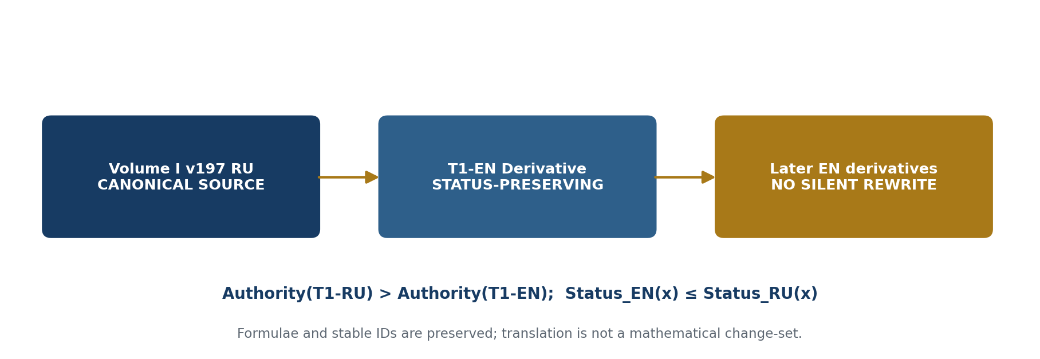
Figure T1-EN-START-001. Authority chain of the controlled English derivative.

Volume I establishes the axiomatic, geometric, and evidential foundation of packet Reper logic. Its primary ontological unit is Time@Space, within which an event is not separated from its state and is written as C@C. From this unit the text constructs packet objects and morphisms, Reper quadruples (R,I,U;D), projective-harmonic coordinates, rules of sufficient foundation, packet laws of logic, and the KLT-RBD evidence discipline. The volume develops a continuous line from the basic concepts to the Desargues–Kurpishev theorem, nonassociative packet geometry, Kurpishev Fundamental Support Connectivity, PILOT-01, and the Reper database.
The frozen Russian corpus includes the rigorous theorem package for Kurpishev PN.2: a local minimax lower bound under a hidden bracketing alternative, explicit examples, evidence obligations, and an internal computable certificate; typed operators Δ, Ξ, and Υ; the nonassociative packet Reper algebra R⋆R and its NAPG duality; domain adapters, preregistration, power analysis, cluster calibration, and a causal boundary; the mathematical deepening of Chapters 47–52 and Appendices A–G. The content and conclusion boundaries of the earlier corpus are preserved. The later chapters and appendices extend the mathematical and verification layer without raising the physical status of PN.2.
The authorial line belongs to Ivan Borisovich Kurpishev. Classical components—including the cross-ratio, Desargues’ theorem, projectivisation, the Hodge operator, stratified spaces, and deformation theory—are treated as prior art. The claimed novelty lies in their packet-Reper synthesis, the C@C ontology, Reper(R,I,U;D), the D/Dom barrier, packet morphisms, FOS, PN.2, RBD/RPD, and the KLT computational contour.

Time@Space; event@state; C@C; packet; morphism; Reper; cross-ratio; harmonic quadruple; D/Dom; Desargues–Kurpishev theorem; Kurpishev FOS; NAPG; PILOT-01; RBD; RPD; KLT-RBD; Kurpishev PN.2; R⋆R; hidden structural alternative; minimax lower bound; independent verification.

MATHEMATICAL BOUNDARY. PN2-7.1 has status D2 only inside the explicitly specified model; the uniform form PN2-9.1 has status D1 when a positive constant is proved. PO-11 and PO-12 are closed only at the abstract level; C1 concerns the auxiliary algebra A₂.
PHYSICAL BOUNDARY. F-1–F-14 retain D0/M0–M1/E0/R1. No experimental confirmation and no independent replication are present. EMP-PLAN is not EMP-OBS.
LEGAL / PROVENANCE BOUNDARY. A document, database registration, signature, or SHA-256 hash establishes provenance or integrity of an artefact; it does not establish mathematical or physical truth.

The ledger below is normative for the translation of Volumes I and II and must remain compatible with the frozen English Volume III. An alternative rendering is permitted only through an explicit alias→canonical entry and a recorded reason.
Russian canonical term | Normative English form | Translation safeguard
Время@Пространство | Time@Space | Authorial ontological order; not silently replaced by spacetime.
событие@состояние | event@state | Preserve the @ coupling.
C@C | C@C | Canonical symbol; never expanded into a Cartesian product.
пакет | packet | A typed structured object, not an ordinary data bundle.
пакетный объект | packet object | Retain declared carrier and additional structure.
пакетный морфизм | packet morphism | A typed map preserving declared packet structure.
Reper | Reper | Authorial term; never translated as frame/reference point.
Reper(R,I,U;D) | Reper(R,I,U;D) | Typed quadruple of reality, idea/invariant, possibilities, and foundation.
достаточное основание | sufficient foundation | Canonical rendering of D.
область допустимости | admissible domain | Canonical rendering of Dom.
D/Dom-барьер | D/Dom barrier | D and Dom are distinct and jointly required.
кросс-соотношение | cross-ratio | Classical prior art.
гармоническая четвёрка | harmonic quadruple | Projective quadruple satisfying the declared harmonic relation.
проективно-гармоническая координата | projective-harmonic coordinate | Not a physical constant or probability.
дефект истинности | truth defect | Diagnostic quantity; not a p-value.
ФОС Курпишева | Kurpishev Fundamental Support Connectivity (FOS) | Retain FOS as the project abbreviation.
Размер@Размерность | Size@Dimension | Authorial compound; preserve the @ sign.
НАПГ / NAPG | NAPG | Nonassociative Packet Geometry.
ассоциатор | associator | Do not translate as association.
неассоциативность | nonassociativity | Algebraic property only within the declared operation.
R⋆R | R⋆R | Quadratic packet object; distinct from Hodge star and binary multiplication.
оператор Ходжа | Hodge operator | Classical prior art; notation must follow local legend.
ПН.2 Курпишева | Kurpishev PN.2 | Mathematical model theorem; physical export remains conditional.
скрытая скобочная альтернатива | hidden bracketing alternative | Structural alternative in the PN.2 model.
минимаксная граница | minimax lower bound | Preserve local/uniform hypotheses.
доказательное обязательство | evidence obligation | Use PO identifiers unchanged.
доказательный паспорт | evidence passport | Structured record of assumptions, domain, status, and result.
вычислительный сертификат | computational certificate | NUM evidence; not EMP-OBS.
формульная цепочка | formula chain | Typed chain of formula transitions.
gap-узел | gap node | Missing domain/foundation/bridge; not a theorem.
Fano barrier | Fano barrier | Classical Fano plane used within an authorial obstruction architecture.
RBD/RPD | RBD/RPD | Keep abbreviations; do not collapse database and method layers.
предсказательный Reper | predictive Reper | A certified candidate, not an oracle output.
прогнозный коридор | forecast corridor | Set-valued/interval output with coverage conditions.
conformal calibration | conformal calibration | Statistical prior art; preserve coverage qualifiers.
воздержание | ABSTAIN | Correct output under blockers; do not soften to “uncertain”.
blocker-safe | blocker-safe | A mandatory propagation rule.
E-процесс | e-process | Sequential evidence process.
неравенство Вилля | Ville’s inequality | Classical prior art.
необязательная остановка | optional stopping | Preserve the statistical technical meaning.
ковариатный сдвиг | covariate shift | Distributional shift in covariates.
постселекция | post-selection | Selection after observing outcomes.
transportability | transportability | Keep technical term; do not replace by transferability without review.
идентифицируемость | identifiability | Mathematical/statistical property.
причинная граница | causal boundary | Limit of causal inference, not geometric boundary unless specified.
независимая проверка | independent verification | Requires an independent runner or experiment.
EXT-RUN | EXT-RUN | Untranslated protocol identifier.
EMP-PLAN | EMP-PLAN | Empirical plan, not observation.
EMP-OBS | EMP-OBS | Independent empirical observation.
пять пределов | five limits | The declared admissibility lattice of the method.
метрика несоответствия | mismatch metric | Defined metric or pseudometric only where specified.
устойчивая перестройка | stable rebuilding | Controlled update of the Reper graph.
агрегирование ветвей | branch aggregation | Preserve branch structure and regret conditions.
граница сожаления | regret bound | Statistical/online-learning term.
source-card | source card | Exact provenance record.
происхождение | provenance | Data and claim lineage.
контрольный хеш | checksum / cryptographic hash | Integrity evidence, not truth evidence.
статус-замок | status lock | Prevents truth-layer promotion.

Symbol | Canonical reading | Prohibition / safeguard
C@C | event@state object | Not a Cartesian product and not an ordinary ordered pair without the source axioms.
⊙ | declared packet or internal binary operation | Meaning is local; never replace by ⋆ or multiplication automatically.
⋆ₕ / Hodge star | Hodge duality operator | Classical operator; distinct from the quadratic NAPG object.
R⋆R | quadratic packet object | Not the Hodge star and not a generic product.
Ass⊙(x,y,z) | associator of the declared operation | Keep bracketing and operation label.
D | sufficient foundation | Not the same object as Dom.
Dom | admissible domain | Not a proof or sufficient foundation.
λ=cr(U,I;R,D) | projective-harmonic coordinate | Not a physical constant, p-value, or truth probability.
δ_truth=|λ+1| | truth defect | Diagnostic consistency coordinate only.
ABSTAIN | correct abstention verdict | Do not translate as failure, uncertainty, or refusal without the technical label.

Code | English meaning | Use in the derivative
CL | classical prior art | Established external mathematical background; authorial attribution remains external.
DEF-A | authorial definition | Defined object or rule; not a theorem.
LEM | lemma | Proved auxiliary statement within its hypotheses.
PROP | proposition | Proved statement within its domain.
THM | theorem | Proved mathematical result within declared assumptions.
COND | conditional result | Depends on an explicit bridge or hypothesis.
MODEL | model statement | Valid inside the selected model only.
NUM | computational certificate | Numerical or executable verification; not external experiment.
PHY-HYP | physical hypothesis | Falsifiable physical proposal without empirical confirmation.
EMP-PLAN | empirical plan | Pre-registered or specified test plan.
EMP-OBS | empirical observation | Independent observation or experimental result.
OPEN | open obligation | Not closed by the current corpus.
REFUTED | refuted statement | Counterexample or contradiction established.
ABSTAIN | correct abstention | Mandatory output when a required domain, foundation, bridge, or certificate is missing.

The chapter and appendix tables below are the verified static table of contents and RU-to-EN page map. Russian source pages remain the permanent authority locators; English pages are navigation locators for this release only. Linked English titles jump to bookmarked headings in DOCX and PDF.
No. | Russian canonical title | Controlled English title | RU p. | EN p.
1 | Время@Пространство и стратифицированная онтология | Time@Space and Stratified Ontology | 5 | 19
2 | C@C: событие@состояние как минимальный объект | C@C: event@state as the Minimal Object | 9 | 21
3 | Пакетные объекты и категория Pack | Packet Objects and the Category Pack | 13 | 23
4 | Пакетные морфизмы, редукции и законы сохранения | Packet Morphisms, Reductions, and Conservation Laws | 18 | 26
5 | Reper(R,I,U;D): определение и аксиоматика | Reper(R,I,U;D): Definition and Axioms | 19 | 28
6 | Проективно-гармоническое кросс-соотношение | Projective-Harmonic Cross-Ratio | 23 | 31
7 | D/Dom и достаточное основание | D/Dom and Sufficient Foundation | 27 | 34
8 | Пакетные законы логики и правила вывода | Packet Laws of Logic and Rules of Inference | 31 | 37
9 | Теорема Дезарга–Курпишева | Desargues–Kurpishev Theorem | 35 | 42
10 | ФОС, семь Размер@Размерностей и ПН.2 | Kurpishev FOS, Seven Size@Dimensions, and PN.2 | 39 | 45
11 | NAPG: неассоциативная пакетная геометрия | NAPG: Nonassociative Packet Geometry | 43 | 48
12 | PILOT-01, формульные цепочки и Fano barrier | PILOT-01, Formula Chains, and the Fano Barrier | 47 | 50
13 | RBD/RPD и KLT-RBD как вычислительная архитектура | RBD/RPD and KLT-RBD as a Computational Architecture | 51 | 52
14 | Примеры, контрпримеры и доказательные паспорта | Examples, Counterexamples, and Evidence Passports | 58 | 54
15 | Словарь, обозначения, формулы и библиография | Glossary, Notation, Formulae, and Bibliography | 62 | 56
16 | Историко-математический prior art и граница авторского вклада | Historical-Mathematical Prior Art and the Boundary of the Authorial Contribution | 65 | 58
17 | Комплексное кросс-соотношение и геометрия Reper на CP¹ | Complex Cross-Ratio and Reper Geometry on CP¹ | 73 | 63
18 | Матричное и операторное кросс-соотношение | Matrix and Operator Cross-Ratio | 76 | 65
19 | Доказательная очистка теоремы Дезарга–Курпишева | Evidence-Level Refinement of the Desargues–Kurpishev Theorem | 78 | 67
20 | Предметный указатель, индекс формул и система перекрёстных ссылок | Subject Index, Formula Index, and Cross-Reference System | 82 | 69
21 | Каноническая математическая конструкция ПН.2 Курпишева | Canonical Mathematical Construction of Kurpishev PN.2 | 87 | 70
22 | ПН.2 как ограничитель и двигатель предсказательного метода KLT-RBD | PN.2 as a Constraint and Driver of the KLT-RBD Predictive Method | 105 | 72
23 | Примеры, контрпримеры и вычислительные тесты ПН.2 | PN.2 Examples, Counterexamples, and Computational Tests | 110 | 74
24 | Экспорт ПН.2 в физику, химию, биологию и ДНК: границы и программа проверки | Export of PN.2 to Physics, Chemistry, Biology, and DNA: Boundaries and Verification Programme | 112 | 75
25 | Операторы действия, изменения и разворота | Operators of Action, Change, and Reversal | 116 | 77
26 | Неассоциативная пакетная реперная алгебра размер@размерностей | Nonassociative Packet Reper Algebra of Size@Dimensions | 125 | 79
27 | Канонический ПН.2 с Приложениями A–B и философскими блоками | Canonical PN.2 with Appendices A–B and Philosophical Blocks | 140 | 84
28 | Предсказательные пределы и конечный горизонт действия Reper | Predictive Limits and the Finite Horizon of Reper Action | 160 | 88
29 | Адаптивная перестройка реперного графа | Adaptive Rebuilding of the Reper Graph | 162 | 90
30 | Предсказательное реперное расслоение | Predictive Reper Bundle | 164 | 91
31 | Вычислительная сертификация и граница доказательного статуса | Computational Certification and the Evidence-Status Boundary | 166 | 92
32 | Строгая спецификация доменных адаптеров KLT-RBD | Strict Specification of KLT-RBD Domain Adapters | 169 | 96
33 | Идентичность, происхождение и целостность данных | Identity, Provenance, and Data Integrity | 172 | 99
34 | Идентифицируемость, transportability и независимая проверка | Identifiability, Transportability, and Independent Verification | 174 | 101
35 | Прогнозные коридоры, conformal calibration и воздержание | Forecast Corridors, Conformal Calibration, and Abstention | 176 | 103
36 | Вычислительный контракт KLT-RBD и итоговый аудит | KLT-RBD Computational Contract and Final Audit | 178 | 105
37 | Сквозной blocker-safe адаптер и воспроизводимость | End-to-End Blocker-Safe Adapter and Reproducibility | 181 | 108
38 | Взвешенная калибровка при ковариатном сдвиге | Weighted Calibration under Covariate Shift | 184 | 110
39 | E-процессы, неравенство Вилля и необязательная остановка | E-Processes, Ville’s Inequality, and Optional Stopping | 186 | 112
40 | Агрегирование ветвей ПН.2 и границы сожаления | Aggregation of PN.2 Branches and Regret Bounds | 188 | 113
41 | Независимая проверка и композиция бюджетов ошибок | Independent Verification and Composition of Error Budgets | 190 | 116
42 | Выбор домена до раскрытия результата и защита от постселекции | Domain Selection before Result Disclosure and Protection against Post-Selection | 193 | 119
43 | Мощность, объём выборки и минимально значимый эффект | Power, Sample Size, and the Minimum Meaningful Effect | 195 | 120
44 | Кластерная зависимость и групповая прогнозная калибровка | Cluster Dependence and Groupwise Predictive Calibration | 197 | 122
45 | Прогноз, вмешательство и предел причинного вывода | Prediction, Intervention, and the Limit of Causal Inference | 199 | 124
46 | Исполнимый протокол внешней валидации Тома I | Executable External Validation Protocol for Volume I | 201 | 126
47 | Типизированное пространство пакетов и реперов | Typed Space of Packets and Repers | 205 | 130
48 | Проективно-гармонический оператор прогноза | Projective-Harmonic Prediction Operator | 207 | 132
49 | Пять пределов как решётка допустимости | Five Limits as an Admissibility Lattice | 209 | 134
50 | Метрика несоответствия и устойчивая перестройка | Mismatch Metric and Stable Rebuilding | 211 | 135
51 | RBD как оператор распространения и сжатия | RBD as a Propagation and Contraction Operator | 213 | 137
52 | Главная условная теорема предсказательного метода | Main Conditional Theorem of the Predictive Method | 215 | 139

ID | Russian canonical title | Controlled English title | RU p. | EN p.
A | Явные примеры и контрпримеры к PO-11 (§27.2.A) | Explicit Examples and Counterexamples for PO-11 (§27.2.A) | 151 | 146
B | Вычислимый сертификат PO-12 (§27.2.B) | Computable Certificate for PO-12 (§27.2.B) | 157 | 148
C | Полная генеалогия канонической конструкции | Complete Genealogy of the Canonical Construction | 223 | 150
D | ПН.2: отрицательные утверждения и ремонт | PN.2: Negative Statements and Repairs | 225 | 151
E | Исполнимый десятистадийный протокол Atlas | Executable Ten-Stage Atlas Protocol | 226 | 152
F | Реестр формул редакции v196i14 | Formula Register of Edition v196i14 | 227 | 153
G | Каноническая синхронизация ПН.2 и F-1–F-14 | Canonical Synchronisation of PN.2 and F-1–F-14 | 231 | 157
H-I | Двуязычный аудит; кандидат заморозки и квитанция | Bilingual Audit; Freeze Candidate and Receipt | derivative | 169 / 173

The formula inventory is continuous. Formula IDs are immutable. A future deletion is recorded as deprecated; the identifier is never reassigned. At this checkpoint the English purpose labels are navigation aids, not replacements for the formulae themselves.
ID | RU p. | Controlled English purpose
F001 | 205 | raw observation object
F002 | 205 | evidence extension
F003 | 205 | D/Dom barrier
F004 | 205 | canonical Reper quadruple
F005 | 205 | Reper validity
F006 | 205 | packet morphism
F007 | 205 | Block absorption
F008 | 206 | NAPG associator
F009 | 206 | bracketing as a mandatory field
F010 | 207 | Volume I cross-ratio
F011 | 207 | harmonic defect
F012 | 207 | homogeneous form
F013 | 207 | projective equivariance of the invariant
F014 | 207 | harmonically conjugate point
F015 | 207 | verification example for harmonicity
F016 | 207 | Reper forecast set
F017 | 207 | two forms of incompleteness: output=ABSTAIN and Block≠∅
F018 | 208 | equivariance of the forecast set
F019 | 208 | local stability away from poles
F020 | 209 | lattice of predictive limits
F021 | 209 | monotonicity of limits
F022 | 209 | admissibility relative to a limit
F023 | 209 | restriction of the forecast set
F024 | 209 | monotonicity of prediction
F025 | 209 | horizon of Reper action
F026 | 209 | limit contract
F027 | 209 | five limit coordinates
F028 | 210 | mismatch metric
F029 | 210 | calibrated risk
F030 | 211 | rebuilding neighbourhood
F031 | 211 | set of nearest Repers
F032 | 211 | gap of the nearest candidate
F033 | 211 | selection stability
F034 | 211 | Lipschitz bound for rebuilding
F035 | 211 | Reper versioning
F036 | 212 | nonassociativity of sequential revision
F037 | 212 | revision nonassociativity
F038 | 212 | honest gain from rebuilding
F039 | 213 | Atlas v2.1 counters
F040 | 213 | RBD graph
F041 | 213 | substochastic kernel
F042 | 213 | abstention mass
F043 | 213 | propagation operator
F044 | 213 | contraction estimate
F045 | 213 | fixed vector
F046 | 213 | convergence rate
F047 | 213 | perturbation of the fixed point
F048 | 214 | interval operators
F049 | 214 | fixed-point envelope
F050 | 215 | conditional predictive coverage
F051 | 215 | sequential budget
F052 | 215 | multiple-comparison budget
F053 | 215 | operational criterion of gain
F054 | 216 | union bound
F055 | 223 | original Reper notation from monograph 5.0
F056 | 223 | original harmonic criterion
F057 | 223 | computable coordinate
F058 | 223 | harmonicity defect
F059 | 223 | architectural sum
F060 | 223 | historical composition of change and action
F061 | 223 | limit-dependent operator
F062 | 223 | historical predictive chain
F063 | 225 | PN.2-A core
F064 | 225 | insufficiency of the triple
F065 | 225 | repair by a fourth element
F066 | 225 | packet hole
F067 | 225 | repair operator
F068 | 225 | completeness criterion
F069 | 226 | stage coupling
F070 | 226 | temporal monotonicity
F071 | 226 | absorption before publication
F072 | 226 | publication gate
F073 | 229 | number of formulae in the new layer
F074 | 217 | testable quadratic layer X²_N
F075 | 217 | quadratic obstruction O_B and quotient projection
F076 | 217 | commutative computation square for an NAPG_q morphism
F077 | 217 | degrees of the minimal cochain complex C_min•
F078 | 217 | components of the differential δ_min
F079 | 218 | canonical internal bridge Θ_min=id
F080 | 218 | canonical identification H³(C_min•)≅O_B
F081 | 218 | naturality of the isomorphism κ
F082 | 219 | chain equalities for the external bridge J
F083 | 219 | naturality of the external-bridge components
F084 | 219 | definition of the conditional external certificate Π_E
F085 | 219 | naturality of Π_E with respect to morphisms
F086 | 220 | conditional associator class in external H³(E•)
FORMULA-REGISTRY-CERT. The range F001–F086 is continuous. F001–F073 retain earlier identifiers; F074–F086 are imported from §§52.9–52.14 without renumbering.

Checkpoint | Scope | Status
T1-EN-START-v0.1 | Contract, abstract, terminology, chapter/appendix/formula maps | PREDECESSOR
T1-EN-FOUNDATIONS-v0.2 | Chapters 1–8 | PREDECESSOR
T1-EN-GEOMETRY-v0.3 | Chapters 9–16 | PREDECESSOR
T1-EN-OPERATORS-v0.4 | Chapters 17–26 | PREDECESSOR
T1-EN-PN2-v0.5 | Chapters 27–31 and internal A–B synchronisation | PREDECESSOR
T1-EN-DATA-v0.6 | Chapters 32–40 | PREDECESSOR
T1-EN-VALIDATION-v0.7 | Chapters 41–46 | PREDECESSOR
T1-EN-CLOSURE-v0.8 | Chapters 47–52 | PREDECESSOR
T1-EN-APP-v0.9 | Appendices A–G and indexes | PREDECESSOR
T1-EN-ASSEMBLY-v0.10 | Unified English master and page map | PREDECESSOR
T1-EN-AUDIT-v0.11 | Bilingual formula/status/source audit | AUDITED PREDECESSOR
T1-EN-FC-v0.12 | Freeze candidate and detached receipt | ACCEPTED FREEZE PREDECESSOR
T1-EN-FREEZE-v1.0 | Immutable authorial English release | CURRENT · FROZEN
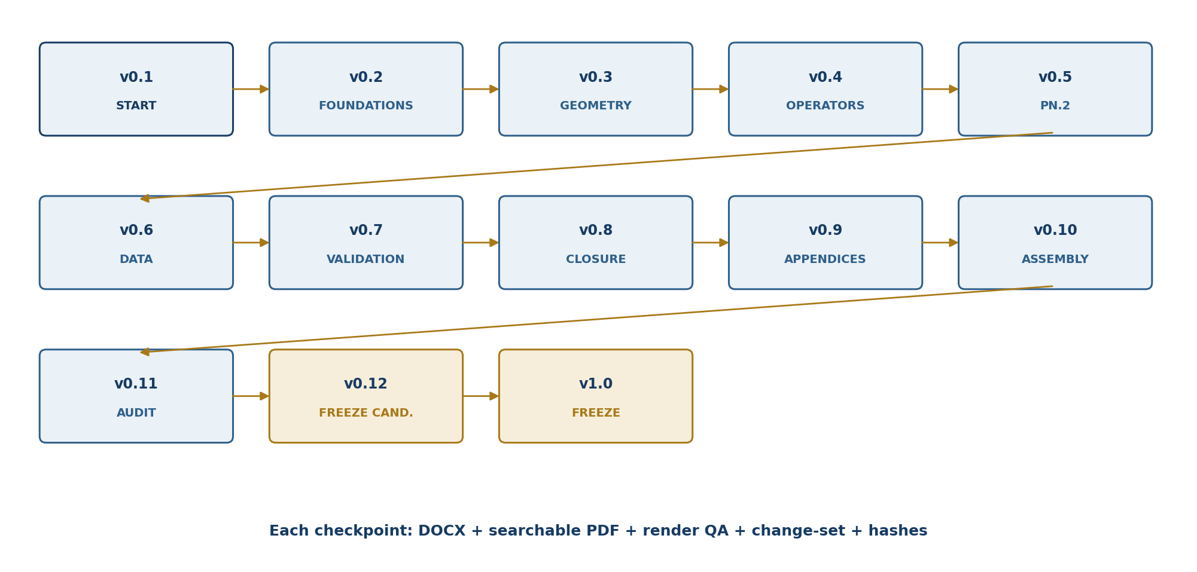
Figure T1-EN-START-002. Staged route from translation contract to frozen English release.

Obligation | Result / requirement | Status
T1-EN-PO-001 | Canonical source and SHA-256 fixed | CLOSED-DOC
T1-EN-PO-002 | RU→EN authority and status contract fixed | CLOSED-DEF
T1-EN-PO-003 | English abstract and keywords prepared | CLOSED-DRAFT
T1-EN-PO-004 | English map of Chapters 1–52 prepared | CLOSED-DOC
T1-EN-PO-005 | English map of Appendices A–G prepared | CLOSED-DOC
T1-EN-PO-006 | Formula inventory F001–F086 preserved | CLOSED-PARITY
T1-EN-PO-007 | Normative terminology ledger initiated | CLOSED-v0.1
T1-EN-PO-008 | Status dictionary and no-promotion firewall fixed | CLOSED-DEF
T1-EN-PO-009 | Notation-collision ledger initiated | PARTIAL
T1-EN-PO-010 | Authorial bilingual mathematical audit; external signed review remains separate | CLOSED-v0.11 / EXTERNAL OPEN
T1-EN-PO-011 | Full translation of Chapters 1–8 | CLOSED-v0.2
T1-EN-PO-012 | Frozen English release | CLOSED-v1.0
T1-EN-PO-018 | Unified TOC, page map, internal links, figure/table indexes, and source ledger | CLOSED-v0.10
T1-EN-PO-019 | Global structural and cross-reference audit | CLOSED-QA
T1-EN-PO-020 | Authorial bilingual mathematical, formula, status, and source audit | CLOSED-v0.11
T1-EN-PO-021 | Freeze-candidate controlled diff and detached release receipt | CLOSED-v0.12

Blocker | Description | Status | Required handling
T1-EN-BLK-001 | The active package contains the canonical Russian PDF but not an editable Russian DOCX master. | OPEN NON-VETO | Use PDF locators as authority; do not infer hidden Word structures.
T1-EN-BLK-002 | Historical fragments use the symbol * with several local meanings. | OPEN | Require a local notation legend before every translated reuse.
T1-EN-BLK-003 | Several authorial terms have legacy English variants across older publications. | OPEN | T1–T3 terminology ledger governs the translation; deviations require a recorded alias.
T1-EN-BLK-004 | The English pagination will differ from the 235-page Russian source corpus. | CLOSED-v0.10 | Static RU-to-EN page map and internal links installed; RU pages remain authoritative locators.
T1-EN-BLK-005 | An external signed bilingual mathematical audit has not been performed. | OPEN NON-VETO | Required only before external certification claim, not before authorial drafting.

QA gate | Requirement
Structural parity | 52 chapters, 7 appendices, F001–F086, stable source locators
Formula parity | No semantic or symbolic change; every changed rendering compared to RU source
Status parity | No definition/theorem/model/physical-status promotion
Terminology | Normative ledger; alias deviations recorded
Typography | A4, readable fonts, repeatable table headers, no clipped formulae or tables
DOCX QA | Render every page to PNG and visually inspect at 100%
PDF QA | Independent PDF render; searchable text; not encrypted; not image-only
Integrity | SHA-256 for DOCX/PDF and source records
Versioning | Never overwrite previous checkpoints

ESTABLISHED. T1-EN-FREEZE-v1.0 contains Chapters 1-52, canonical Appendices A-G, derivative audit Appendices H-I, the complete F001-F086 registry, verified navigation, source-card metadata, and the accepted no-scientific-change lineage from v0.11 through v0.12.
NOT ESTABLISHED. No external signed bilingual certification exists; EXT-RUN and EMP-OBS remain absent; hashes establish identity and integrity rather than mathematical or physical truth.

POST-FREEZE RULE. T1-EN-FREEZE-v1.0 is immutable. Any correction, extension, or metadata change requires a documented change-set and a new version; in-place editing is prohibited.

T1-EN-FOUNDATIONS-v0.2
CONTROLLED ENGLISH TRANSLATION OF CHAPTERS 1–8
TRANSLATION NOTE. The scientific content below is translated from Russian source pages 5–34. Repeated running headers, duplicated archival tables of contents, and obvious extraction artefacts are not reproduced as independent scientific claims. Their substantive formulas and status statements are retained in normalized archival subsections.

STATUS FIREWALL. The translation preserves the Russian hierarchy of definitions, axioms, lemmas, propositions, theorems, conditional statements, models, open obligations, counterexamples, and ABSTAIN verdicts. No English clarification changes the truth layer.

v0.2 Change-Set and Parity Scope
ID | Change | Status
T1-EN-CS-007 | Translated Chapters 1–8 with Russian source-page locators. | EN-DRAFT
T1-EN-CS-008 | Reconstructed eight diagrams with English labels while preserving the source mathematical roles. | DOC/FIG
T1-EN-CS-009 | Preserved all explicit axioms C1–C6, R1–R8, typed morphism conditions, and status gates. | PARITY
T1-EN-CS-010 | Preserved the harmonic-complement theorems, projective-invariance theorem, and conditioning statements. | THM-PARITY
T1-EN-CS-011 | Preserved all negative results: no truth from C@C alone, no global inverse outside Dom, no status promotion from λ, and no empirical claim from formal soundness. | NEGATIVE-PARITY
T1-EN-CS-012 | Added source-locator and translation-completeness matrix for Chapters 1–8. | QA

Chapter | English title | Russian locator | Status
1 | Time@Space and Stratified Ontology | RU pp. 5–8 | COMPLETE
2 | C@C: event@state as the Minimal Object | RU pp. 9–12 | COMPLETE
3 | Packet Objects and the Category Pack | RU pp. 13–17 | COMPLETE
4 | Packet Morphisms, Reductions, and Conservation Laws | RU p. 18 | COMPLETE
5 | Reper(R,I,U;D): Definition and Axioms | RU pp. 19–22 | COMPLETE
6 | Projective-Harmonic Cross-Ratio | RU pp. 23–26 | COMPLETE
7 | D/Dom and Sufficient Foundation | RU pp. 27–30 | COMPLETE
8 | Packet Laws of Logic and Rules of Inference | RU pp. 31–34 | COMPLETE

Chapter 1. Time@Space and Stratified Ontology
Russian source locator: pp. 5–8
PLAIN-LANGUAGE MEANING | This chapter sets the initial scene of the theory: space is treated as a section of the more comprehensive object Time@Space, and dimensional levels are organised as strata.
MATHEMATICAL CORE | A standard stratified envelope, the concept of an admissible section, and the authorial project terms Hyparxis and Apeiron are introduced.
BOUNDARY OF THE CLAIM | This is an axiomatic ontology and a model language, not an independently confirmed experimental theory of physical spacetime.
STATUS | AXIOMATIC FOUNDATION

The term Time@Space is not introduced as a renaming of spacetime. It changes the order of ontological foundations. In the conventional notation, space and time are already given as a coordinate continuum. Here stratified temporal connectedness is taken as primary, while space arises as a stable section or layer of its realisation. Such a reversal requires a strict distinction between a philosophical thesis, an axiomatic model, and a physical interpretation.
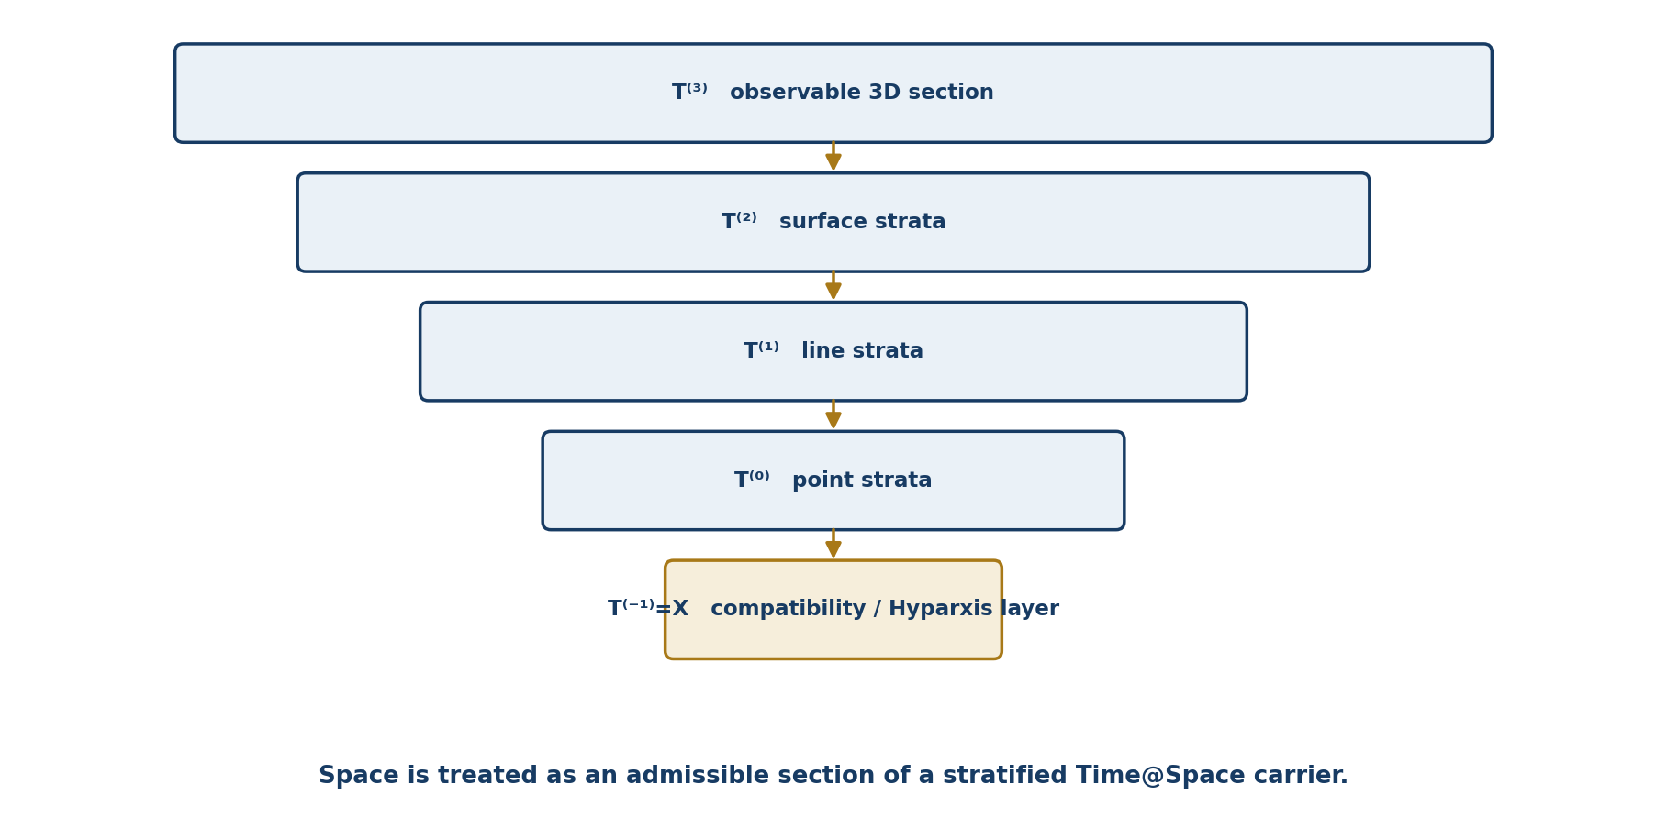
Figure 1.1. Stratified layers of Time@Space and their admissible reductions.

1.1. Standard Stratified Envelope
Let X be a Hausdorff paracompact space endowed with a finite filtration by smooth pure layers X⁽ᵏ⁾, k∈{−1,0,1,2,3}. The authorial filtration T⁽ᵏ⁾ is understood as a stratified envelope. The index −1 is retained as a special compatibility layer of transitions and need not be an independent smooth stratum.
T⁽³⁾ ⊂ T⁽²⁾ ⊂ T⁽¹⁾ ⊂ T⁽⁰⁾ ⊂ T⁽⁻¹⁾ = X [RU p. 6]

1.2. Space as an Admissible Section
Observed three-dimensional space is interpreted as the outer layer T⁽³⁾; surfaces, lines, and points coexist as deeper strata. Time is not reduced to an additional coordinate. It specifies an ordered compatibility of transitions, the domains of partial maps, and the preservation of structure under reduction.

1.3. Hyparxis and Apeiron
Hyparxis is a family of compatible transitions between adjacent filtration levels. Apeiron is a condition of global connectedness that prevents the transition system from decomposing into mutually inconsistent fragments. These terms acquire mathematical meaning only when maps, domains, and composition rules are stated explicitly.
Definition 1.1 [DEF-A]. A standard stratified envelope is a Hausdorff paracompact space X with a finite family of closed subsets and pure strata Xₖ = T⁽ᵏ⁾ ∖ T⁽ᵏ⁻¹⁾. Every nonempty Xₖ is a connected smooth manifold of pure dimension k. Near x∈Xₖ one allows a conical local model U ≅ ℝᵏ × C(Lₓ).

The local dimension is a function dimₗₒc:X→{−1,0,1,2,3}. The formal level −1 is not declared to be a new geometric dimension; it encodes a compatibility layer of transitions. The envelope is a standard external carrier but does not replace the authorial packet formalism.
Definition 1.2 [DEF-A]. For k=3,2,1,0, partial smooth maps Lₖ:Dom(Lₖ)⊂T⁽ᵏ⁾→T⁽ᵏ⁻¹⁾ are specified. On overlaps they must be compatible with stratum inclusions and satisfy Lₖ₋₁∘Lₖ = Lₖ₋₁,ₖ whenever both sides are defined.

Definition 1.3 [DEF-A]. The stratified envelope is Apeiron-connected when there exists a global potential τ:X→ℝ, constant on each stratum and strictly decreasing along every admissible transition to a lower-dimensional layer, and when any two points can be connected by a finite admissible chain compatible with the direction of τ.

Functoriality is understood relative to one fixed envelope. Packet-category morphisms commute with restrictions to pure strata, with the Hyparxis maps, and with the relevant Hodge operators. Later constructions therefore do not silently introduce a new base carrier.
EVIDENCE BOUNDARY. Existence of the envelope and transition maps is an axiomatic or model input. A physical interpretation of Time@Space does not follow from a topological realisation alone.

1.4. Packet Flow and the Hodge–Kurpishev Superoperator
Let ⋆ be the Hodge operator on the k-th pure layer and suppose that Lₖ admits smooth local sections. The superoperator H is defined as a compatible composition of transfers and Hodge dualities between neighbouring layers. The expression is meaningful only on the intersection of the domains of all participating operators. The identity ⋆² = (−1)ᵖ⁽ᵏ⁻ᵖ⁾id applies to p-forms for fixed metric and orientation.
A flow in Pack is a one-parameter family of automorphisms Φₜ:Pack→Pack preserving the stratification and commuting with H and Lₖ. An inertial connection is such a flow Iₜ for which IₜH=HIₜ. A Lyapunov functional S may, for example, be selected as the squared norm of an associator amplitude; its monotonicity is a separate hypothesis of a particular dynamical model.
A(ζ)=‖dζ‖, dS(Φₜx)/dt ≤ 0 only under explicitly specified dynamics [RU p. 8]
Proposition 1.1 [PROP] The basic axiom system has a finite model if empty strata and partial transitions are permitted.

Proof. Take X={x₋₁,x₀,x₁,x₂,x₃}, set T⁽⁻¹⁾=X and T⁽ᵏ⁾={xₖ,…,x₃} for k=0,1,2,3. Define Lₖ(xₖ)=xₖ₋₁ on singleton domains and leave the maps undefined elsewhere. All inclusions, types, and admissible-composition conditions hold directly.
Corollary 1.2 [PROP]. The existence of a formal model proves compatibility of the axioms only. It does not prove that Time@Space is physical spacetime.

1.5. Evidence-Applicability Passport
The passport of a Chapter 1 claim records the axiom identifier, carrier X, pure strata, Dom(Lₖ), chosen metrics and orientations, sufficient foundation D, result type, and prohibited interpretations. A transition from axiomatic status to geometric or physical status requires a separate realisation morphism and independent evidence.
PHILOSOPHICAL BOUNDARY. A model demonstrates the possibility of a non-contradictory world of reasoning; it does not convert thinkability into observed actuality. The route from possibility to fact must remain visible in the evidence passport.

Chapter 2. C@C: event@state as the Minimal Object
Russian source locator: pp. 9–12
PLAIN-LANGUAGE MEANING | An event is not separated from the state in which it is recorded. The notation C@C prevents either component from being lost in logical or computational analysis.
MATHEMATICAL CORE | The minimal packet event@state is defined, together with its axioms, versioning rules, and elementary examples.
BOUNDARY OF THE CLAIM | Packaging an event with a state does not establish its truth. Reper, Dom, and a sufficient foundation D are required later.
STATUS | INTERNAL DEFINITION

An ordinary geometric point answers “where?” but does not contain the answer to “in what state?”. Packet Reper logic therefore takes a minimal object that simultaneously records an act of occurrence and the layer in which that act acquires meaning.
c = C@C = (e,s) [RU p. 9]
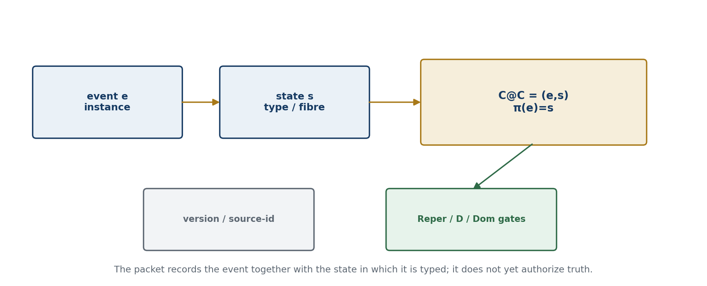
Figure 2.1. The C@C object, versioning, and the transition to evidence gates.

2.1. Early Content Axioms CC1–CC5
Axiom | Content
CC1 | Every event is considered only together with a state.
CC2 | A state without a carrier event does not form a completed object.
CC3 | A change of state creates a new C@C object or a morphism.
CC4 | Reduction of C@C to a point is permitted only through an explicit forgetful map.
CC5 | Source, recording time, and domain belong to the evidence passport of the object.

EDITORIAL CONVENTION. CC1–CC5 are retained as the early content-level pre-axiomatics. The formal system of the frozen edition is C1–C6 below; if the two layers diverge, C1–C6 has priority.

Definition 2.1 [DEF-A]. Let S be a set or object of states, E a set of event instances, and π:E→S a typing map. The minimal C@C object is the dependent sum C@C(π)=Σₛ∈S Eₛ={(e,s)∈E×S | π(e)=s}, where Eₛ=π⁻¹(s).

Formal axiom | Statement
C1 — Typing | The pair (e,s) belongs to C@C only when π(e)=s. Pairing an event with an arbitrary incompatible state does not create a Chapter 2 object.
C2 — Double distinguishability | (e,s)=(e′,s′) if and only if e=e′ and s=s′. Neither coordinate absorbs the other.
C3 — Local non-emptiness | The packet line Lₛ=Eₛ×{s} is a nonempty layer only if Eₛ≠∅. An empty layer may represent a state of possibility but contains no occurred event.
C4 — Versioning | A change of state, timestamp, source, or coordinate convention creates a new C@C instance; the prior object is not overwritten retrospectively.
C5 — Status neutrality | Membership in C@C records an event in a state but establishes neither truth, causality, nor predictive strength. These statuses require Reper, D, Dom, and the relevant protocol.
C6 — Traceability | For evidential or empirical use, the pair carries a source-id and an immutable version identifier. Absence of the reference does not destroy the mathematical pair but blocks evidence-status promotion.

Lemma 2.2 [LEM] The projection pr_E:C@C(π)→E is bijective, whereas pr_S:C@C(π)→S is generally not injective. The substantive contribution of C@C is not an increase in the cardinality of E but the explicit preservation of the typing π and the state π(e).

Proof. Every e∈E corresponds to exactly one pair (e,π(e)), so pr_E has the inverse e↦(e,π(e)). Distinct events may lie in one fibre Eₛ; hence pr_S may identify different pairs.

2.2. Examples
Domain | C@C interpretation
Mathematics | A formula without axioms and an admissible domain is merely an event of inscription; its state is supplied by the theory, notation, and proof chain.
Cost estimate / audit | A price line becomes an auditable object only together with the project section, stage, norm, and foundation document.
Physics | A numerical value requires units, experimental channel, uncertainty, and source.
Biology | A sequence requires an accession, organism, database version, and coordinate convention.

2.3. Normalized Archival Layer from Monograph 5.0
The preserved legacy layer described the project’s minimal object as a packet point a=(e,s), where e is an event and s is a state. An event outside a state lacks geometric fixation; a state without an event remains an empty layer. The archival hierarchy was recorded as C@C → R@C@C → T_cs → Flag/Reper → transreper, serving as a rollback route when a computational, physical, or anthropological extension breaks connectedness.
Human_R = C@C + Rep(R,I,U;D) + (Ξ,Δ,Υ) + L + λ [normalized legacy formula]
Repᵢ = (Rᵢ,Iᵢ,Uᵢ;Dᵢ), Truth(Rep) ⇔ cr(U,I;R,D)=−1 [normalized legacy formula]
λ = ((U−R)(I−D))/((U−D)(I−R)), δ_truth = |λ+1| [normalized legacy formula]
The legacy corpus also used C@C as the unit of causality, memory, document, proof, forecast, and action. In the controlled English derivative this broad use is preserved as an architectural programme; it does not erase domain-specific typing or evidential requirements.
CHAPTER 2 PASSPORT. carrier=C@C(π); typing=π:E→S; identity=coordinatewise; versioning=immutable; source-id=required for evidence promotion; truth-status=neutral; downstream gates=Reper/D/Dom.

Chapter 3. Packet Objects and the Category Pack
Russian source locator: pp. 13–17
PLAIN-LANGUAGE MEANING | The chapter explains how packet objects and admissible transitions between them form one mathematical system.
MATHEMATICAL CORE | The category Pack is constructed; objects, labels, states, and morphisms are distinguished; preservation of packet structure is made explicit.
BOUNDARY OF THE CLAIM | Pack is a working category of the project, not a universal category of all events or all states.
STATUS | INTERNAL CONSTRUCTION

A packet combines an object with an additional structural layer that cannot be replaced by an ordinary pair of data without loss of meaning. In the basic Hodge-compatible realisation, the packet object contains a geometric carrier and a dual component defined by the Hodge operator on the relevant layer.
U ⊙ V := (U, ⋆ₕV) [RU p. 13]
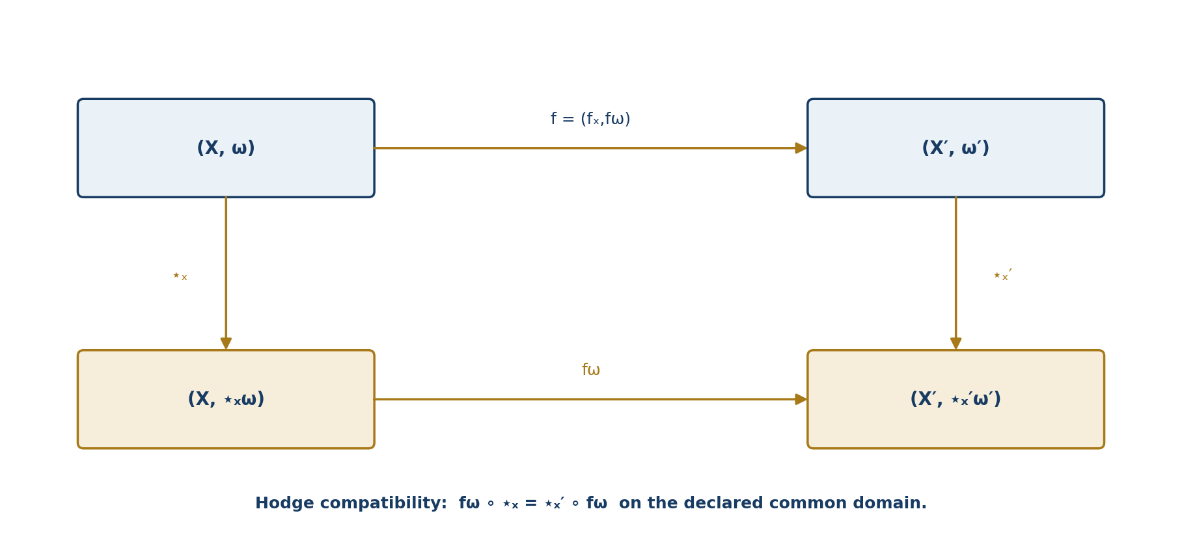
Figure 3.1. Commutative square for a Hodge-compatible packet morphism.

3.1. The Category Pack
An object of Pack is a typed pair (X,ω), where X is an admissible stratum and ω is a differential form in a declared space Ωᵖ(X). A morphism f:(X,ω)→(X′,ω′) consists of a smooth map f_X and a linear transfer f_ω, preserves stratification and the declared metrics, and commutes with the Hodge operators on the common domain.
f_ω ∘ ⋆_X = ⋆_X′ ∘ f_ω [RU p. 14]

3.2. Separation of Symbols
Symbol | Controlled meaning
⋆ₕ / ⋆_Hdg | Hodge operator
⊙ | internal, generally nonassociative binary operation
R⋆R | quadratic packet object
Ass⊙(x,y,z) | trilinear defect (x⊙y)⊙z − x⊙(y⊙z)
* in archival formulas | interpreted only by the local legend; never imported automatically into the live notation

The normalized notation does not identify R⋆R with Hodge duality. Packets such as C⋆_HdgB, M⋆_HdgR, P⋆_HdgP, and C⋆_HdgC remain typed examples only on their declared domains.

3.3. Geometric Realisation of Packet Objects
Let X=⋃Xₖ be a standard stratified envelope. The category Str(X) has the nonempty pure strata Xₖ as objects; a morphism Xⱼ→Xₖ exists for a declared incidence with j≥k. Locally X is modelled by ℝᵏ×C(Lₓ).
Packet-realisation data on Xₖ consist of an oriented real vector bundle Eₖ→Xₖ, a metric gₖ, a Hodge operator ⋆:ΛᵖEₖ*→Λᵏ⁻ᵖEₖ*, and a class of admissible forms Γ_adm(Eₖ). For incident strata one specifies restriction maps rⱼₖ compatible with composition.
rⱼₖ ∘ ⋆ = ⋆ ∘ rⱼₖ on Dom(rⱼₖ∘⋆) [RU p. 15]
The notation U⋆_HdgV denotes the pair (U,⋆_U V) only when V belongs to Dom(⋆_U). Object notation does not replace checks of form degree, layer dimension, metric, and orientation.
QUADRATIC-LAYER BOUNDARY. This realisation fixes the stratified and Hodge-theoretic environment only. The objects R⋆R, their polarisation identities, and obstruction maps belong to the later NAPG layer and do not follow from Str(X) alone.

3.4. Pack Morphisms and Naturality
A morphism f:(X,ω)→(X′,ω′) contains a smooth map f_X and a linear operator f_ω. If f_X is an isometry, naturality of the Hodge operator is f_ω(⋆_Xα)=⋆_X′f_ω(α). Conformal maps require a separate dimension-and-degree factor; the word “compatible” is not a substitute for the exact formula.
Proposition 3.1 [PROP] Isometric Pack morphisms are closed under composition and preserve Hodge duality.

Proof. For g∘f, one has g_ωf_ω⋆_X = g_ω⋆_X′f_ω = ⋆_X″g_ωf_ω. The identity morphism is also compatible with ⋆.
If the Hyparxis maps Lₖ are diffeomorphisms onto their images, their local sections induce mutually inverse transfers of differential forms on their domains. This is a local statement and does not create global invertibility outside the declared domains.

3.5. Superoperator, Flow, and Inertial Connection
The Hodge–Kurpishev superoperator H is built from the Hodge operators on the strata and selected lifts and restrictions. Any compact notation H:=H(⋆,Lₖ) is an abbreviation for a typed composition, not a self-sufficient definition without a domain.
A flow Φₜ:Pack→Pack preserves stratification when Φₜ(T⁽ᵏ⁾)⊂T⁽ᵏ⁾ and is compatible with H when ΦₜH=HΦₜ. An inertial connection is a flow that also preserves the admissible transitions Lₖ.
NEGATIVE STATEMENT. Existence of a Pack morphism does not imply that scalar “size” and “dimension” can be assigned simultaneously and independently without a sufficient foundation D and a type contract. This boundary later enters the mathematical form of PN.2.

3.6. Differential Example and Boundary of the Authorial Layer
In a seven-dimensional model with a G₂-structure φ, the associated metric defines a Hodge operator and a 4-form ψ=⋆φ. The Laplacian flow is ∂φ/∂t=Δ_φφ with Δ_φ=dd*+d*d. This classical geometric environment is a model realisation; it does not prove a physical interpretation of NAPG.
In the selected left-invariant ansatz, dφ and dψ are computed, and the associator amplitude is defined by the norm of a selected Hyparxis form ζ: A(φ)=‖dζ‖. The value depends on the metric, normalisation, and model domain.
The reduced deformation theory uses the tangent quotient H²_red=ker d²/im d¹ and the primary obstruction O³_red=C³_red/im d². The derivative of a parameterised family defines a distinguished tangent class; continuation to second order requires the corresponding obstruction to vanish. The converse is not accepted without additional hypotheses.
The authorial architecture lies in the connection of stratified time, packet formalism, PN.2, the superoperator H, the flow-module packet, the action/change/reversal operators, associator amplitude, and NAPG. Hodge theory, G₂ geometry, and deformation theory are cited as classical prior art and mathematical environment.
CHAPTER 3 PASSPORT. carrier=X; strata={T⁽ᵏ⁾}; internal operation=⊙; Hodge=⋆_Hdg; quadratic object=R⋆R; Dom=explicit; D=source-and-proof; physical transfer=OPEN; truth_layer_promotion=0.

3.7. Categorical Specification of Pack
Definition 3.7 [DEF-A]. A Pack object is P=(|P|,{Pⱼ}ⱼ∈J,s_P), where {Pⱼ} is a finite or locally finite filtration of the carrier and s_P is additional packet structure compatible with restrictions to the strata.

Definition 3.8 [DEF-A]. A morphism f:P→Q consists of a carrier map and a family of stratum maps preserving indices, restrictions, and the canonical packet operation ⊙.

Theorem 3.9 [THM] With identity morphisms and componentwise composition, admissible packet objects form a category Pack.

Proof. Identity maps preserve the filtration and structure. The composition of two compatible squares is compatible; associativity follows from associativity of map composition, not from associativity of the internal NAPG operation.
Corollary 3.10 [THM]. Categorical composition of morphisms and the internal nonassociative operation ⊙ belong to different types and cannot substitute for one another.

PHILOSOPHICAL INSERT. A category retains not only things but also the admissible ways of moving between them. The meaning of an object is therefore revealed in a network of transformations that do not destroy its type.

Chapter 4. Packet Morphisms, Reductions, and Conservation Laws
Russian source locator: p. 18
PLAIN-LANGUAGE MEANING | The chapter specifies which transformations of packets are admissible and exactly what may be forgotten in a reduction.
MATHEMATICAL CORE | Conditions for admissible morphisms, reduction and forgetting operations, and projective preservation rules for labels and relations are stated.
BOUNDARY OF THE CLAIM | A conservation law applies only after the relevant category of objects is specified and does not automatically become a physical conservation law.
STATUS | AXIOMS AND RULES

A packet morphism transfers an object between layers or domains while preserving not only the form of notation but also its evidential meaning. A morphism that preserves a geometric picture but loses D, Dom, source, or status does not transport authorization.
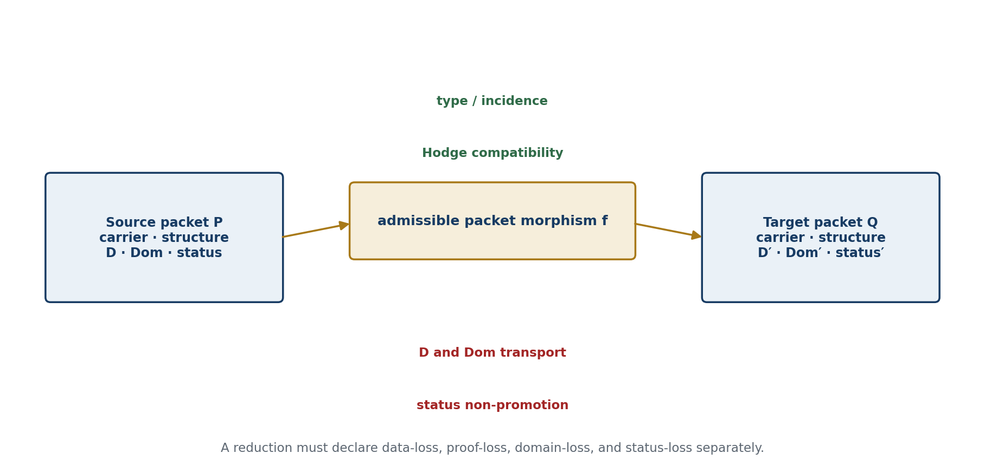
Figure 4.1. Packet/Reper morphism and the components that must be preserved or explicitly transformed.

4.1. Admissibility Conditions
Condition | Required check
Typing | Source and target belong to the declared categories.
Incidence | Membership and intersection relations are preserved.
Hodge compatibility | The square with the Hodge operators commutes.
D/Dom | Foundation and admissible domain are preserved or transformed explicitly.
Status | A high status cannot arise from a lower one without a new evidence procedure.
Invertibility | If invertibility is claimed, an inverse morphism and the composition identities are exhibited.

4.2. Reduction and Forgetting
A reduction may be affine, projective, metric, physical, computational, or semantic. Every reduction must state which data are preserved and which are forgotten. Forgetting is not an error by itself; the error begins when the reduced result is used as though no loss had occurred.

4.3. Stability under Composition
Theorem 4.1 [THM] If f:P→Q and g:Q→R are admissible packet morphisms and their domains are compatible, then g∘f preserves every invariant preserved by both morphisms.

Proof. For an invariant I, I_Q∘f=I_P and I_R∘g=I_Q. Hence I_R∘g∘f=I_P. The domain condition excludes application of the composition outside the common domain.
Corollary 4.2 [THM]. A chain of transformations is authorized only on the intersection of the domains of all its links.

Counterexample 4.3 [REFUTED GENERALISATION]. Two transformations that are separately computable need not compose when the image of the first does not lie in the domain of the second.

4.4. Loss of Data and Loss of Foundation
Definition 4.1 [DEF-A]. Data loss is the irreversible identification of distinct input records. Foundation loss is the deletion of D, or of the relation to D, while computed values are formally retained.

Proposition 4.4 [PROP] Foundation loss may occur without numerical data loss, and data loss may occur without immediate loss of a formal foundation; the defects are independent.

Proof. The projection (x,D)↦x preserves a number but removes its foundation. Hashing a document together with a signed protocol may preserve evidence that a version existed while losing the full document text.
REDUCTION RULE. Every reducing morphism separately records data-loss, proof-loss, domain-loss, and status-loss.

Chapter 5. Reper(R,I,U;D): Definition and Axioms
Russian source locator: pp. 19–22
PLAIN-LANGUAGE MEANING | A Reper is an object passport: what is actually given, which idea or invariant is selected, which possibilities are admissible, and on what foundation the conclusion is made.
MATHEMATICAL CORE | The quadruple (R,I,U;D) is defined, the semantics of its components is explained, and axioms of a complete Reper are formulated.
BOUNDARY OF THE CLAIM | The triple (R,I,U) without D is not a complete foundation and does not automatically receive truth status.
STATUS | BASIC DEFINITION

Reper is the central structure of Volume I. It connects established content, an idea or invariant, a field of possibilities, and a sufficient foundation. The semicolon before D marks the special evidential role of the foundation: D completes the flag and separates a structural hypothesis from an authorized object.
Rep(x) = (Rₓ, Iₓ, Uₓ; Dₓ) [RU p. 19]
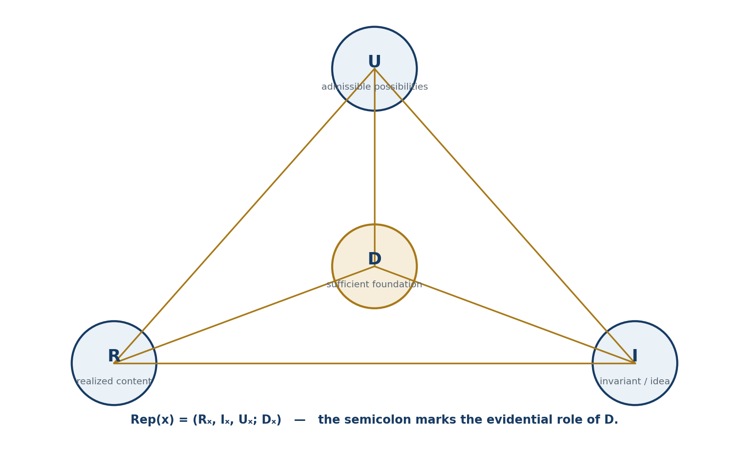
Figure 5.1. Reper tetrahedron: realised content R, invariant I, possibilities U, and sufficient foundation D.

5.1. Semantics of the Components
Component | Mathematical meaning | Applied meaning
R | Established content; realised object | Fact, measurement, record, event
I | Invariant, idea, direction of assembly | Norm, function, purpose, model
U | Class of admissible possibilities | Alternatives, variants, neighbouring states
D | Sufficient foundation | Source, proof, act, calculation, responsibility

5.2. Reper Axioms R1–R8
Axiom | Statement
R1 | Every Reper is attached to a particular C@C object.
R2 | R, I, and U are typed in one Dom or connected by explicit morphisms.
R3 | D contains a verifiable reference to a foundation and is not replaced by verbal confidence.
R4 | A change of any component creates a new Reper version.
R5 | A Reper without D has status incomplete flag or review seed.
R6 | Two Repers are comparable only after domains and scales have been aligned.
R7 | Composition of Reper morphisms preserves the declared invariants.
R8 | Reper status is part of the object and is recorded in the protocol.

5.3. Normalized Legacy Layer
The archived Monograph 5.0 defined Reper as a local projective-harmonic structure retaining the relation among reality, idea, the universe of possibilities, and sufficient foundation. R records what is actually given; I specifies the internal axis and assembly idea; U specifies the field of possibilities; D supplies evidential, documentary, and causal closure. Without D the object remains an incomplete flag rather than a truth-authorized quadruple.
Repᵢ=(Rᵢ,Iᵢ,Uᵢ;Dᵢ), Truth(Rep) ⇔ cr(U,I;R,D)=−1 [normalized legacy formula]

5.4. Typed Reper and the Foundation-Forgetting Morphism
Let Ω be an admissible domain; let X_R(Ω), X_I(Ω), and X_U(Ω) be typed spaces of realised content, idea, and admissible possibilities; and let E(Ω) be the set of verifiable foundations. A typed Reper of x is
Rep_Ω(x)=(Rₓ,Iₓ,Uₓ;Dₓ), Rₓ∈X_R(Ω), Iₓ∈X_I(Ω), Uₓ∈X_U(Ω), Dₓ∈E(Ω) [RU p. 21]
The predicate Dom_Ω(Rep)=1 means simultaneously that all components are defined, all maps are type-correct, denominators and inverse operators exist, and the reference Dₓ resolves to a verifiable object. Dom and D are therefore not interchangeable: Dom controls mathematical definedness; D controls sufficiency of foundation.
Proposition 5.1 — Monotonicity under Forgetting D [PROP] Let π_D(R,I,U;D)=(R,I,U) be the foundation-forgetting morphism and let σ be an evidence status monotone under inclusion of verifiable evidence. Then σ(π_D Rep)≤σ(Rep). If the target status requires D by definition, π_D causes a strict downgrade.

Proof. The morphism π_D adds no evidence and removes D. Monotonicity of σ under the evidence order prevents an increase. If D belongs to the mandatory gates of the target status, those gates fail after forgetting and the stronger status cannot be retained.
EDITORIAL BOUNDARY. Proposition 5.1 belongs to the internal KLT-RBD evidence discipline. It does not assert that one universal status ladder applies to every science; each domain specifies its own gates.

5.5. Phenomenology of Foundation and Typed Horizon
PHILOSOPHICAL INSERT. A Reper is not a label attached to an already completed object. It records that the object is given together with a horizon of admissible interpretations and a foundation that distinguishes what is asserted from what is merely conceivable. Forgetting D changes not only the record but the epistemic mode in which the object is present in reasoning.

Example. Two packets may have identical (R,I,U) components but different foundations D₁ and D₂: the first leads to a reproducible measurement, while the second leads to an unverifiable report. After applying π_D the packets become indistinguishable at the data level although their evidential statuses differ.

5.6. Typed Reper and Its Morphisms
Definition 5.2 [DEF-A]. A typed Reper is Rep_X=(R_X,I_X,U_X;D_X,Dom_X), where R_X is realised content, I_X an invariant or selected idea, U_X a space of admissible alternatives, D_X a sufficient foundation, and Dom_X the domain on which all components and relations are defined.

Definition 5.3 [DEF-A]. A morphism F:Rep_X→Rep_Y is a quintuple (F_R,F_I,F_U,F_D,F_Dom). F_Dom sends admissible inputs of Dom_X to Dom_Y; F_D transports foundations and preserves every verifiable dependency used for status authorization.

Theorem 5.4 — Category of Typed Repers [THM] Identity quintuples are morphisms. If F:Rep_X→Rep_Y and G:Rep_Y→Rep_Z are type-compatible, F_Dom(Dom_X)⊆Dom_Y, and G_Dom(Dom_Y)⊆Dom_Z, then componentwise composition G∘F is a Reper morphism. Composition is associative.

Proof. Every component of the composition is defined by the domain conditions. Preservation of D-dependencies follows by successive application of F_D and G_D. Identity and associativity are inherited from the component maps.
Corollary 5.5 [THM]. The forgetful functor Z:Reper→Pack that removes D does not reflect evidential status: an isomorphism Z(Rep_X)≅Z(Rep_Y) does not imply equivalence of foundations D_X and D_Y.

5.7. Independence of D and Dom
Lemma 5.6 [LEM] D and Dom are logically independent: Dom may be nonempty while D is absent, and a formal D may be specified while Dom is empty.

Proof. In the first case a formula is computable on a nonempty set but lacks a foundation for the required interpretation. In the second case axioms D are written down but no object satisfies the joint domain constraints. Neither situation entails the other.
Counterexample 5.7. Let f(x)=1/x. With Dom=ℝ∖{0}, f(1) is computable; without D connecting f to an observable quantity, an empirical conclusion is unauthorized. Conversely, a physical theory may provide D for an idealized object while experimental restrictions make the selected sample domain empty.

REPER GATE. Status promotion is permitted only when compatible D and Dom are both present. “The formula was computed” is not equivalent to “the conclusion is justified.”

PHENOMENOLOGICAL INSERT. Dom answers where a thought can occur without contradicting its own conditions. D answers why that completed thought is entitled to count as a conclusion. The space of possibility and the foundation of actuality meet in Reper but do not dissolve into one another.

Chapter 6. Projective-Harmonic Cross-Ratio
Russian source locator: pp. 23–26
PLAIN-LANGUAGE MEANING | The chapter introduces a numerical invariant comparing four Reper components and selecting the harmonic configuration λ=−1.
MATHEMATICAL CORE | Scalar, complex, homogeneous/projective, and matrix/operator regimes are distinguished; the admissible domain and deviation from harmonicity are recorded.
BOUNDARY OF THE CLAIM | Projective invariance of λ does not replace Dom and D, and λ is not by itself an empirical criterion of truth.
STATUS | CLASSICAL INVARIANT + AUTHORIAL INTERPRETATION

The cross-ratio is a classical projective invariant of four collinear points. In packet Reper logic it is used as a coordinate of consistency among the four Reper roles. The authorial contribution is not the cross-ratio itself but its inclusion in a typed structure containing D/Dom, proof status, and an RBD route.
λ = cr(U,I;R,D) = ((U−R)(I−D))/((U−D)(I−R)) [RU p. 23]
δ_truth = |λ+1| [RU p. 23]
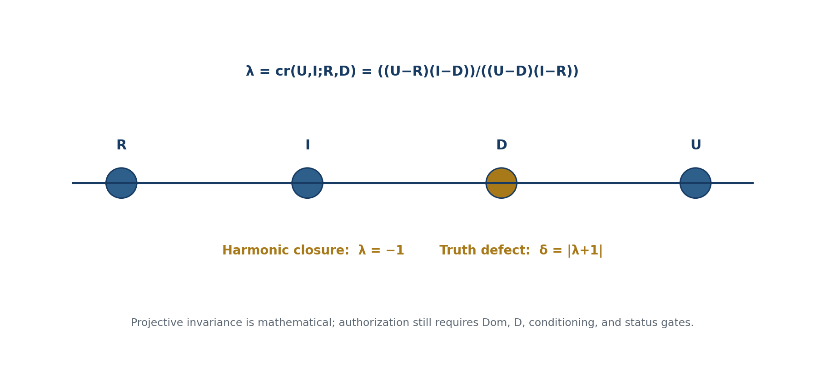
Figure 6.1. Harmonic Reper quadruple and the value λ=−1.

6.1. Harmonic Closure
The value λ=−1 corresponds to a harmonic quadruple. In the project it is interpreted as structural closure of a Reper. Structural closure is not identical to proved truth: it is one necessary but insufficient gate.

6.2. Complex, Matrix, and Operator Forms
For complex coordinates the formula remains valid when all denominators are nonzero. In noncommutative, matrix, or operator regimes the order of factors must be fixed, and invariance requires a separate theorem. The scalar formula may not be copied mechanically into a matrix domain and then treated as proved.

6.3. Calibration and Numerical Error
Numerical analysis requires tolerances, sensitivity to point permutations, and uncertainty intervals. A value close to −1 is labelled a harmonic-near hit, not a theorem. This is essential for KMA ratios, spectral data, and economic series.
The truth defect δ_truth measures geometric-logical proximity to the selected harmonic normalisation. It does not replace a mathematical proof, a legal document, an engineering inspection, or an empirical null-model analysis. Every RPD/RBD formula or computational output therefore receives both a numerical coordinate and a Reper/evidence map.

6.4. Unique Finite Harmonic Complement
Theorem 6.1 — Reconstruction of D [THM] Let K be a field of characteristic not equal to 2, and let R,I,U∈K be pairwise distinct. For λ=((U−R)(I−D))/((U−D)(I−R)), if I+U−2R≠0 there exists a unique finite D such that λ=−1: D=[2UI−R(I+U)]/[I+U−2R].

Proof. The equation λ=−1 is equivalent to (U−R)(I−D)=−(U−D)(I−R). Collecting the terms containing D gives D[(U−R)+(I−R)]=(U−R)I+U(I−R). Division by I+U−2R yields the formula. Linearity in D gives uniqueness. Pairwise distinctness ensures the resulting D is not U, so the original denominator remains nonzero.
If I+U−2R=0, there is no finite solution in that affine chart; in the projective completion the degenerate case is D=∞. For R=0, I=1, U=2 the formula gives D=4/3 and exactly λ=−1.

6.5. Sensitivity of the Harmonic Complement
Put Q=I+U−2R. On the region Q≠0, D(R,I,U) is differentiable and
∂D/∂R = −(I−U)²/Q², ∂D/∂I = 2(U−R)²/Q², ∂D/∂U = 2(I−R)²/Q² [RU p. 26]
Corollary 6.2 [THM]. For small perturbations δR,δI,δU, |δD| is bounded by (|I−U|²|δR|+2|U−R|²|δI|+2|I−R|²|δU|)/|Q|² + o(‖δ‖). Thus Q→0 is a poorly conditioned region and must be recorded as a blocker rather than as increased predictive strength.

KLT-RBD CONSEQUENCE. A computational certificate stores Q, a sensitivity estimate, and the precision of all inputs. Nearness of λ to −1 without conditioning control does not promote truth status.

PHENOMENOLOGICAL INSERT. Near Q=0, the formula may return one apparently precise D while tiny changes in the input cause a large displacement. This is the phenomenon of a “precise answer without a stable object.” Experienced clarity is not mathematical conditioning.

6.6. Homogeneous Formula and Projective Invariance
Let K be a field of characteristic not equal to 2 and let P¹(K) be the projective line. For homogeneous representatives x,y∈K² write [x,y]=det(x,y). For pairwise distinct U,I,R,D and nonzero denominators define
cr(U,I;R,D) = [U,R][I,D] / ([U,D][I,R]) [RU p. 26]
Theorem 6.3 — Cross-Ratio Invariance [THM] For every A∈GL₂(K), cr(AU,AI;AR,AD)=cr(U,I;R,D). Hence the cross-ratio is well defined with respect to the action of PGL₂(K).

Proof. For any x,y, [Ax,Ay]=det(A)[x,y]. The numerator and denominator each acquire two equal factors det(A), which cancel. Independent scaling of homogeneous representatives also cancels pairwise.

6.7. Complete Projective Harmonic Complement
Theorem 6.4 — Existence and Uniqueness [THM] Let U,I,R∈P¹(K) be pairwise distinct. There exists a unique D∈P¹(K) such that cr(U,I;R,D)=−1.

Proof. A projective transformation sends U,I,R to 0,∞,1. The equation cr=−1 determines the image of D uniquely; the inverse transformation returns one point of the original line. In an affine chart, D*=[2UI−R(I+U)]/[U+I−2R] when the denominator is nonzero; otherwise D is the point at infinity of that chart.
SINGULARITY NOTE. A zero affine denominator does not mean that the harmonic complement is absent from P¹(K). It means that the complement lies at infinity in the chosen chart. A numerical implementation must return projective-infinity rather than an arbitrary large number.

6.8. Conditioning of D* and the HARM-CERT Passport
Proposition 6.5 [PROP] In an affine chart with Q=U+I−2R≠0, ∂D*/∂R=−(U−I)²/Q².

Proof. Differentiate N/Q with N=2UI−R(I+U), Q=U+I−2R. The numerator simplifies to 4UI−(U+I)²=−(U−I)².
Corollary 6.6 [PROP]. As Q→0, sensitivity grows as |Q|⁻². Proximity to the singular chart must therefore be stored as a conditioning number and blocker. Even λ=−1 with small δ does not establish stability of the reconstructed D*.

Mandatory HARM-CERT field | Content
Field K and characteristic | algebraic base and the condition char(K)≠2
Homogeneous coordinates | representatives of U,I,R,D
Affine chart | selected chart and projective-infinity policy
Determinants / denominators | all four determinants and nonzero-domain checks
λ and δ | cross-ratio and harmonic defect
Q and conditioning | Q=U+I−2R and sensitivity estimate
Dom and D | admissible domain and sufficient foundation
Precision and status | input precision; singular/projective/finite status

Chapter 7. D/Dom and Sufficient Foundation
Russian source locator: pp. 27–30
PLAIN-LANGUAGE MEANING | The chapter separates the question “is the expression defined?” from the question “is there sufficient foundation for the claim?”.
MATHEMATICAL CORE | Types of D, domain predicates Dom, and evidence-status ladders from a candidate to a verified result are distinguished.
BOUNDARY OF THE CLAIM | Neither Dom nor D may be reconstructed from an elegant formula or numerical coincidence without separate evidence.
STATUS | EVIDENCE DISCIPLINE

D answers “what supports the claim?”; Dom answers “where is it applicable?”. Confusing or omitting them is a major source of false status promotion. In KLT-RBD, an attractive numerical coincidence without D/Dom becomes a gap node, not a discovery.
Authorization(x) requires D(x) complete and Dom(x) admissible [RU p. 27]

7.1. Types of D
Type of D | Examples
Axiomatic | Axiom system, definitions, inference rules
Proof-theoretic | Lemmas, proof object, formal verification
Experimental | Protocol, instrument, units, uncertainty, raw data
Documentary | Contract, project, act, norm, registration record
Computational | Code, version, hash, configuration, reproducible run
Historical-philosophical | Exact source, context, and limits of interpretation

7.2. Status Ladder and Forbidden Jumps
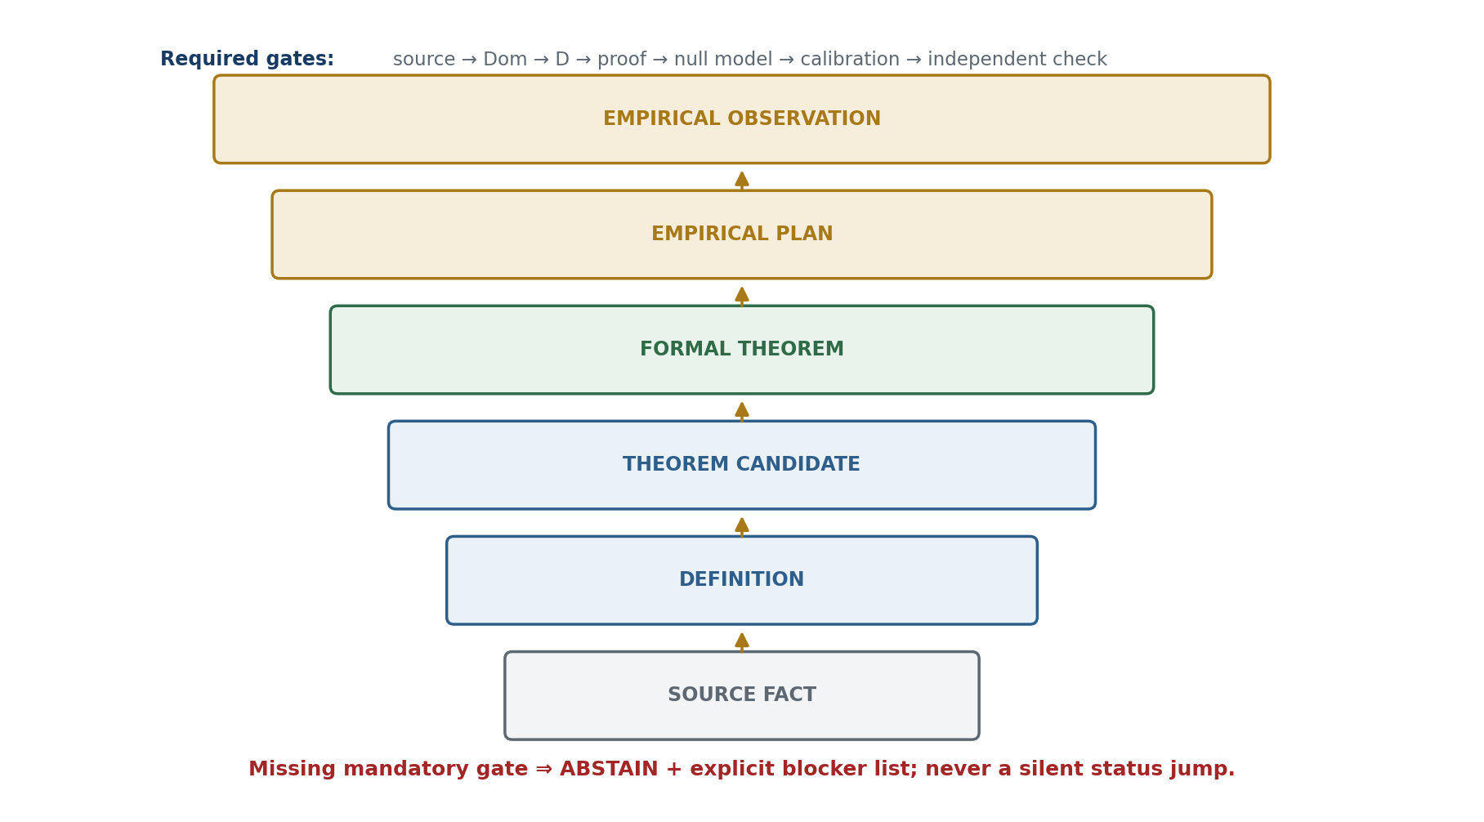
Figure 7.1. Evidence-status ladder and the mandatory gates between levels.
The working ladder distinguishes source fact, definition, lemma candidate, theorem candidate, formal theorem under axioms, empirical review signal, and publication-verified status. Transitions occur only through specified gates. A user interface has no authority to promote a status by itself.

7.2.A. Normalized Documentary Layer: PILOT-01
PILOT-01 is a narrow-domain test of the Reper-Projective Database. A mathematical text is modelled as a graph of sources, formulas, assumptions, Reper nodes, gap nodes, obstruction carriers, and theorem candidates. Projective-harmonic geometry, packet incidence, OB notation, and Fano-type carriers are used as mathematical objects; novelty of the cross-ratio, projectivisation, projective spaces, or the Fano plane is not claimed.
Definition [DEF-A]. A formula-chain step is a typed transition s=(Fᵢ,Fⱼ,τ,A,Dom,D), where τ is the transition type, A the support set, Dom the admissible domain, and D the sufficient foundation. Reper is written Rep=(R,I,U;D).

Formula-Chain Gap Theorem [THM] If a step authorizes truth status through cr(U,I;R,D)=−1 but lacks an admissible Dom or a sufficient D, the RPD audit creates GAP-DOMAIN-MISSING or GAP-ASSUMP-MISSING.

Proof. This follows directly from the independent rules AUDIT-DOMAIN and AUDIT-FOUNDATION.
ID | Object | Status
T-PH-001 | Formula-chain gap theorem | proved inside the RPD method
T-PH-002 | Projectivisation dimension lemma | classical fact / prior art
T-PH-003 | Fano / RP² consequences | conditional on field and dimension
T-PH-004 | FCOC carrier theorem | proved in the internal model
T-PH-005 | Nontrivial packet-obstruction theorem | proved in the internal model
T-PH-006 | Fano local line extension | proved in the internal model
T-PH-007 | Fano direct-sum carrier | proved in the internal model
T-PH-008 | Conditional Fano carrier | conditional on the identification axiom
T-PH-009 | Reper harmonic method lemma | method lemma; not classical novelty

FANO BOUNDARY. The Fano plane is an ontological barrier only inside the declared RPD model. Local obstruction carriers do not globalise automatically to P²(𝔽₂). A carrier transition requires explicit compatibility maps; an external open obstruction result is not inherited without a separate morphism.

7.3. Algebra of Evidence Gates
For a branch of inquiry define a binary evidence vector e=(d_Dom,d_D,d_prf,d_null,d_ind), recording domain admissibility, sufficient foundation, proof object, matched null, and independent evidence. A formal theorem branch uses Dom, D, and the proof object; an empirical-predictive branch additionally uses the matched null, CGI<1, and independent verification.
Gate_form(e)=d_Dom·d_D·d_prf [RU p. 30]
Gate_pred(e)=d_Dom·d_D·d_prf·d_null·d_ind·1[CGI<1] [RU p. 30]
Proposition 7.1 — No Status Jump [PROP] If Gate(e)=0, the authorization operator must return status≤candidate. Adding evidence may preserve or increase an admissible status; removing evidence cannot increase it.

Proof. The functions Gate_form and Gate_pred are monotone in the componentwise order on {0,1}⁵. A zero mandatory gate makes the product zero, prohibiting authorization of a stronger status.

7.4. ABSTAIN as a Positive Operator Result
PHILOSOPHICAL INSERT. ABSTAIN is not an empty computation. It states positively that no candidate in the current evidence horizon has passed all mandatory gates. It preserves the distinction among possibility, plausibility, and an authorized claim.

When Gate_pred(e)=0, the result contains ABSTAIN together with the set of unfulfilled gates. This trace turns abstention into a diagnostic message: it identifies which new evidence could change the status without promising that the evidence will necessarily promote the claim.

7.5. Lattice of Evidence Gates
Definition 7.2 [DEF-A]. The gate vector of a claim c is G(c)=(s,dom,d,p,n,k,i)∈{0,1}⁷, where s is a traceable source, dom a satisfied Dom, d a sufficient D, p a proof object, n a null-model check, k calibration, and i independent verification. The componentwise order defines evidence inclusion.

Theorem 7.3 — Status Monotonicity [THM] Let status σ(G) be monotone in the componentwise order, and let every level require a fixed set of gates. A transformation that adds no newly verified gate cannot increase σ.

Proof. If the transformation leaves G unchanged or produces G′≤G, monotonicity gives σ(G′)≤σ(G). Strict promotion requires at least one new coordinate 0→1 and satisfaction of all gates of the new level.
Corollary 7.4 [THM]. Projective normalization, editorial renaming, visualization, or export to another domain does not promote a status without new D, an enlarged Dom, a proof object, null-model verification, calibration, or independent evidence.

7.6. Conjunctive Authorization and the ABSTAIN Principle
Definition 7.5 [DEF-A]. Authorization of level L is Auth_L(c)=∧ⱼ∈J_L Gⱼ(c), where J_L is the set of mandatory gates. If any mandatory value is zero or unknown, the result is ABSTAIN rather than negation of c.

Theorem 7.6 — Safety of Abstention [THM] If Auth_L(c)=0 because a gate is missing, assigning status L without new evidence violates the level specification. Retaining the prior status or returning ABSTAIN does not violate it.

Proof. The level is defined conjunctively. Replacing a missing factor 0 with a declarative 1 without evidence creates a false positive. Abstention preserves the actual gate vector.

7.7. Mathematical, Computational, and Empirical Ladders
The mathematical ladder uses definitions, axioms, theorems, and counterexamples. The computational ladder adds code, test vectors, precision, and reproducibility. The empirical ladder additionally requires data, a matched null, calibration, CGI<1, and independent verification. Movement between these ladders is not automatic.
CHAPTER 7 PASSPORT. D and Dom occupy different gate coordinates. λ and δ are computable invariants, not independent-evidence coordinates. KMA values remain search labels and do not alter G(c).

PHILOSOPHICAL INSERT. The status ladder measures not the greatness of an idea but the length of the verified path to it. ABSTAIN keeps that path visible: it does not deny possible truth but forbids presenting possibility as an already completed foundation.

Chapter 8. Packet Laws of Logic and Rules of Inference
Russian source locator: pp. 31–34
PLAIN-LANGUAGE MEANING | The classical laws of logic are translated into packet language, where state, possibility, domain, and sufficient foundation are explicit.
MATHEMATICAL CORE | Packet forms of identity, non-contradiction, excluded middle, sufficient reason, and syllogism are formulated, together with a three-valued D/Dom semantics.
BOUNDARY OF THE CLAIM | Formal validity of inference does not prove the truth of its premises; truth status requires a separate Reper and domain check.
STATUS | FORMAL SYSTEM

The classical laws of logic receive a packet-Reper interpretation. Identity retains the invariant axis I; non-contradiction controls realised content R; excluded middle constrains the field U within Dom; sufficient reason introduces D. In this sense the first three laws form a flag, while the fourth completes the Reper.
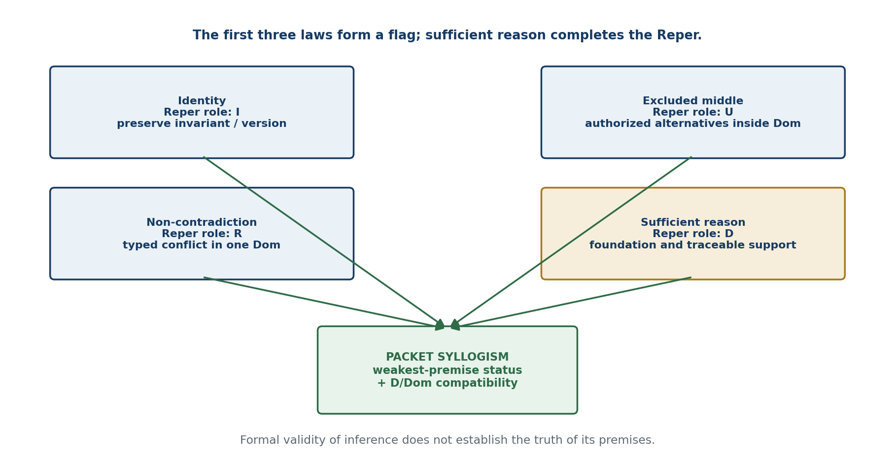
Figure 8.1. Packet correspondence of the logical laws to Reper components and the packet syllogism.

8.1. Law of Identity
An object preserves identity relative to the declared invariant set and version. When the source version, unit of measurement, or domain changes, identity requires a new object card.

8.2. Law of Non-Contradiction
A contradiction is recorded as a typed conflict between claims belonging to the same Dom and the same version. A difference of domains is not a logical contradiction; it requires a comparison morphism.

8.3. Excluded Middle and the Field U
The field of possibilities U is not arbitrarily infinite; it is determined by the problem type, constraints, and boundary conditions. Packet logic may allow many alternatives at the U level but requires binary authorization of a concrete claim relative to D and Dom.

8.4. Sufficient Reason
D is not reducible to a citation. The foundation must be relevant, verifiable, connected to the claim, and sufficient for the declared status.

8.5. Packet Syllogism
A syllogism is admissible when the premises are typed, the middle term is preserved by the morphisms, the domains are compatible, and the conclusion receives no status higher than the weakest premise permits.

8.5.A. Normalized Archival Logic Layer
The preserved FOS article mapped the four logical laws to the Reper roles as follows: non-contradiction selects one realised event-state and therefore fixes R; excluded middle couples the state with its admissible complement and therefore structures U; identity preserves the event invariant and therefore fixes I; sufficient reason closes cause, domain, and support and therefore supplies D. The first three laws form a flag; the fourth supplies the harmonic point that completes a Reper.
Law | Packet function | Reper role
Non-contradiction | selection of one event-state | R
Excluded middle | coupling with admissible complement | U
Identity | preservation of event invariant | I
Sufficient reason | closure of cause, domain, and support | D

CROSS-DOMAIN BOUNDARY. A chemical world cannot be inferred from a financial world, nor a cultural world from a physical world, without an explicit functor and sufficient foundation. FOS permits typed reductions; it prohibits hidden reductions.

8.6. Three-Valued D/Dom Semantics
Let V₃={1,0,⊥}, where ⊥ means not falsity but non-authorization because Dom is not satisfied or D is absent.
Definition 8.1 [DEF-A]. For a formula φ, set v(φ)=⊥ when φ is undefined in the current Dom or its truth status requires a missing D. Values 1 and 0 are permitted only after both gates have been passed.

Implication is evaluated classically on {0,1}. If evaluation requires a non-authorized operand, the result is ⊥. This separates negation from the absence of entitlement to infer.

8.7. Soundness of Packet Modus Ponens
Theorem 8.2 [THM] If v(φ)=1, v(φ→ψ)=1, and both premises are evaluated in one Dom with compatible D, then v(ψ)=1.

Proof. Within a satisfied Dom the premise values belong to {0,1}. The classical truth table for implication excludes v(ψ)=0 when v(φ)=v(φ→ψ)=1. Compatibility of D authorizes transfer of the status to the conclusion.
Corollary 8.3 [THM]. If either premise has value ⊥, the rule returns ABSTAIN together with the list of unclosed gates.

PHENOMENOLOGICAL INSERT. The third value is not a vague midpoint between truth and falsity. It is an exact pointer to a missing condition without which the judgment has not yet become a completed act of proof.

Foundations Checkpoint: Result and Next Route
Obligation | Result / requirement | Status
T1-EN-PO-011 | Full translation of Chapters 1–8 | CLOSED-v0.2
T1-EN-PO-013 | Axioms C1–C6 and R1–R8 preserved | CLOSED-PARITY
T1-EN-PO-014 | Pack and typed-Reper categorical statements preserved | CLOSED-PARITY
T1-EN-PO-015 | Harmonic-complement theorems and conditioning results preserved | CLOSED-PARITY
T1-EN-PO-016 | D/Dom gate algebra and ABSTAIN theorems preserved | CLOSED-PARITY
T1-EN-PO-017 | Packet-logic semantics and modus ponens preserved | CLOSED-PARITY
T1-EN-PO-018 | Independent bilingual mathematical audit | OPEN NON-VETO
T1-EN-PO-019 | Translation of Chapters 9–16 | NEXT
T1-EN-PO-020 | Frozen English release | FUTURE

Blocker | Description | Status | Handling
T1-EN-BLK-001 | The editable Russian Word master is not available in the active package. | OPEN NON-VETO | The Russian PDF and source-page locators remain authoritative.
T1-EN-BLK-002 | Legacy uses of * remain polysemous. | OPEN | Every live occurrence is governed by the local symbol ledger.
T1-EN-BLK-003 | No external signed bilingual mathematical audit has been performed. | OPEN NON-VETO | Required before an external certification claim.
T1-EN-BLK-006 | The English page map is provisional until unified assembly. | OPEN NON-VETO | RU source pages remain the stable locators.
T1-EN-BLK-007 | Chapters 9–52 and Appendices A–G remain untranslated. | OPEN | Proceed by the approved checkpoint route.

CURRENT VERDICT. CONTROLLED ENGLISH FOUNDATIONS COMPLETE FOR CHAPTERS 1–8. Mathematical statements retain their Russian source statuses. Physical interpretation remains conditional or open; independent EXT-RUN and EMP-OBS are absent.

NEXT CHECKPOINT. T1-EN-GEOMETRY-v0.3: full controlled translation of Chapters 9–16, including the Desargues–Kurpishev theorem, Kurpishev FOS, seven Size@Dimensions, early PN.2 interfaces, NAPG, PILOT-01, the Fano barrier, RBD/RPD, examples, evidence passports, glossary material, and the prior-art boundary.

T1-EN-GEOMETRY-v0.3
CONTROLLED ENGLISH TRANSLATION OF CHAPTERS 9–16
DERIVATIVE BOUNDARY. The following chapters are a controlled translation of the frozen Russian source pages 35–72. Archival duplicates are normalized, but every normative definition, theorem, counterexample, formula, status restriction, and source role is preserved. No Russian source text is amended by this derivative.

Chapter parity map for the v0.3 checkpoint
Chapter | Russian locator | English title | Dominant status
9 | 35–38 | The Desargues–Kurpishev Theorem | CL / COND
10 | 39–42 | FOS, Seven Size@Dimensions, and PN.2 | MODEL / DEF-A
11 | 43–46 | NAPG: Nonassociative Packet Geometry | DEF-A / PROP / MODEL
12 | 47–50 | PILOT-01, Formula Chains, and the Fano Barrier | THM / COND / OPEN
13 | 51–57 | RBD/RPD and KLT-RBD as a Computational Architecture | DEF-A / NUM / EMP-PLAN
14 | 58–61 | Examples, Counterexamples, and Evidence Passports | PROP / TEST
15 | 62–64 | Glossary, Notation, Formulae, and Bibliography | DOC / AUDIT
16 | 65–72 | Historical-Mathematical Prior Art and the Boundary of Authorial Contribution | CL / AD / AUDIT

Chapter 9. The Desargues–Kurpishev Theorem
Russian source locator: pp. 35–38
PLAIN-LANGUAGE EXPLANATION. The chapter asks when three constructions may legitimately identify one and the same projective point: a polar trace, the trace of a Desargues axis, and a harmonic complement. Classical projective geometry supplies each construction separately. The Kurpishev bridge is conditional because their coincidence requires explicit compatibility hypotheses.

CLAIM BOUNDARY. The classical Desargues theorem is prior art. The authorial construction lies in the typed Reper interpretation, the polar/Desargues/harmonic bridge, and the DK-CERT evidence passport. The bridge is not derived from two conics alone.

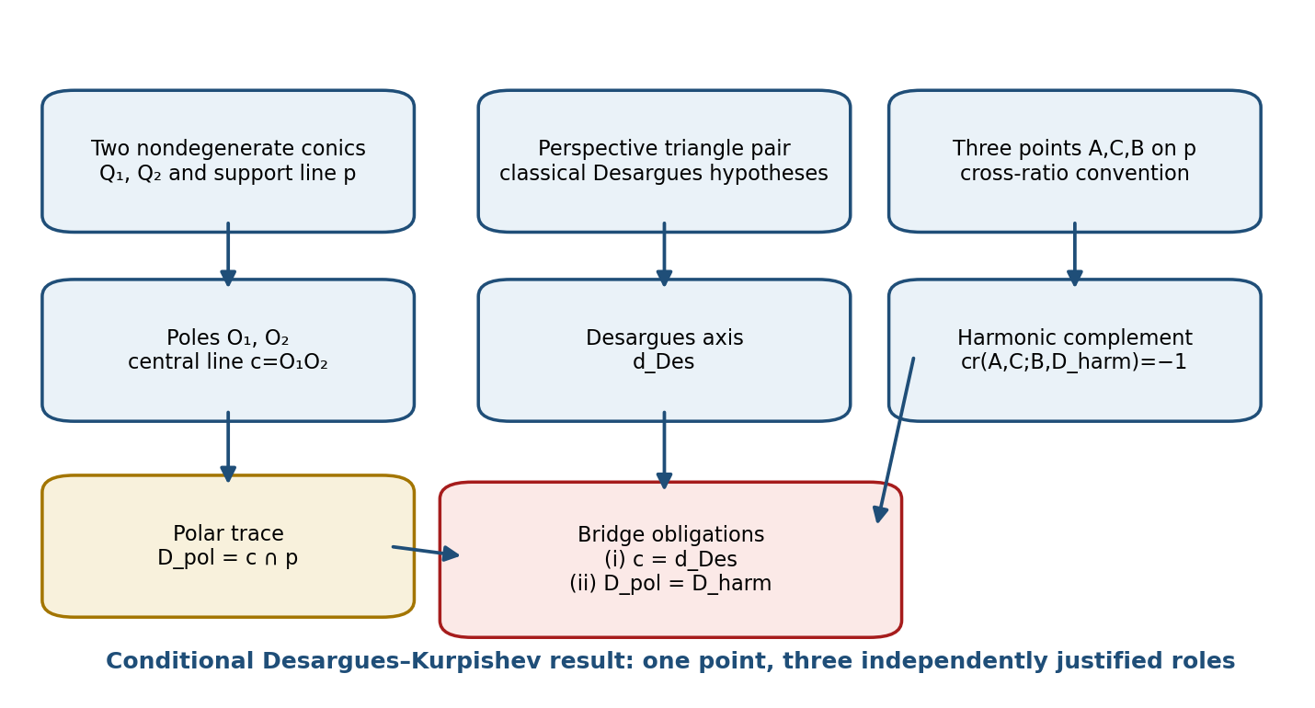
Figure 9.1. Three independently justified projective roles and the two bridge obligations.

9.1. Configuration Data
Work over a projective plane Π=P²(K) over a field K of characteristic different from 2. Let Φ₁ and Φ₂ be nondegenerate conics represented by invertible symmetric matrices Q₁ and Q₂. Let the support line p be represented by a nonzero covector ℓ. The poles of p are Oᵢ=[Qᵢ⁻¹ℓ]. A pair of triangles is specified separately, together with a point of perspectivity and the intersections of corresponding sides.
The three constructions must remain distinguishable: the polar line c=O₁O₂, the Desargues axis d_Des of the triangle pair, and the harmonic point D_harm on p. Their equality is a conclusion only after the required bridge hypotheses have been verified.

9.2. Working Formulation and Proof Architecture
Under nondegeneracy, compatibility of the polar correspondences, and perspectivity of the triangle pair, the central axis and the Desargues axis form projectively invariant data. A harmonic complement can complete a Reper quadruple, but its identification with the polar trace is a separate theorem obligation.
Stage | Required operation | Evidence object
1 | Specify Q₁,Q₂ and the field/characteristic. | Matrix and field record
2 | Construct poles and polars from the bilinear forms. | Polar computation
3 | Verify perspectivity of the two triangles. | Incidence proof
4 | Invoke the classical Desargues node in an admissible model. | CL theorem reference
5 | Check collinearity of side intersections. | Determinant or synthetic proof
6 | Construct the harmonic complement. | Cross-ratio equation
7 | Check invariance under admissible projective transformations. | PGL certificate
8 | Record Dom, D, proof object, bridge status, and blockers. | DK-CERT-9

9.3. Coordinate Model of the Polar Node
Oᵢ = [Qᵢ⁻¹ℓ], i∈{1,2}. [RU p. 38]
Lemma 9.1 (well-defined pole) [CL/PROP]. If det Qᵢ≠0 and ℓ≠0, then Oᵢ is a uniquely defined point of P²(K).
Proof. The vector Qᵢ⁻¹ℓ is nonzero. Replacing ℓ by αℓ or Qᵢ by βQᵢ only rescales the representative by a nonzero scalar and therefore does not change its projective class.
Assume O₁≠O₂ and c=O₁O₂ differs from p. The polar trace D_pol=c∩p exists and is unique by the incidence axioms of the projective plane. No harmonic conclusion follows from this incidence statement alone.
Theorem 9.2 (polar node) [CL/PROP]. Under these hypotheses D_pol is independent of all nonzero matrix and coordinate representatives of Q₁,Q₂, and ℓ.

9.4. Harmonic Closure and Counterexample
cr(A,C;B,D_harm)=−1. [RU p. 38]
d_harm = ((a+c)b−2ac)/(2b−a−c), if 2b−a−c≠0. [RU p. 38]
When the denominator is zero, D_harm is the point at infinity of the chosen affine chart. The construction depends on the ordered quadruple and on a declared cross-ratio convention.
COUNTEREXAMPLE 9.3. For a=0, c=1, and b=2 one obtains d_harm=2/3. An arbitrary polar trace d_pol=3 is not harmonic because cr(0,1;2,3)=4/3. Thus polar intersection and harmonic closure are logically independent without a bridge hypothesis.

9.5. Canonical Conditional Desargues–Kurpishev Theorem
Theorem 9.4 [COND]. Suppose: (i) the hypotheses of Theorem 9.2 hold; (ii) two triangles are perspective from a point; (iii) their Desargues axis equals c=O₁O₂; and (iv) D_pol satisfies the harmonic criterion relative to A,C,B. Then D_pol is simultaneously the trace of the Desargues axis on p and the unique harmonic complement D_harm.
Proof. By the classical Desargues theorem, condition (ii) gives an axis of perspectivity. Condition (iii) identifies that axis with c, so its trace on p is D_pol. Condition (iv) and uniqueness of the solution of the fractional-linear equation give D_pol=D_harm.
OPEN OBLIGATIONS. The theorem does not derive bridge conditions (iii) and (iv) from the data of two conics. Establishing them is recorded as DK-PO-1 and DK-PO-2. Without those obligations, the correct output is not a strengthened theorem but ABSTAIN or a weaker polar-node statement.

9.6. DK-CERT-9 Evidence Passport
Field group | Mandatory content
Carrier | field, characteristic, plane model, coordinate convention
Conics and polarity | Q₁,Q₂,p, O₁,O₂, nondegeneracy, c≠p
Desargues node | triangle pair, point of perspectivity, axis proof
Bridge | proof of c=d_Des; proof of harmonic criterion
Harmonic node | A,C,B, cross-ratio convention, D_pol, D_harm
Evidence | Dom, D, proof object, status, open obligations

Phenomenological note. A geometric point becomes a sufficient foundation not because several elegant lines happen to meet there, but because the law of each incidence is known. Polar, Desargues, and harmonic modes of givenness may coincide, but the coincidence must be proved rather than anticipated.

Chapter 10. FOS, Seven Size@Dimensions, and PN.2
Russian source locator: pp. 39–42
PLAIN-LANGUAGE EXPLANATION. FOS is treated as a compatibility condition for families of Reper structures, not as an undefined totality. The chapter distinguishes size from dimension, records the seven-layer model, and states the early PN.2 principle as a model bridge. The rigorous minimax theorem is postponed to Chapter 21.

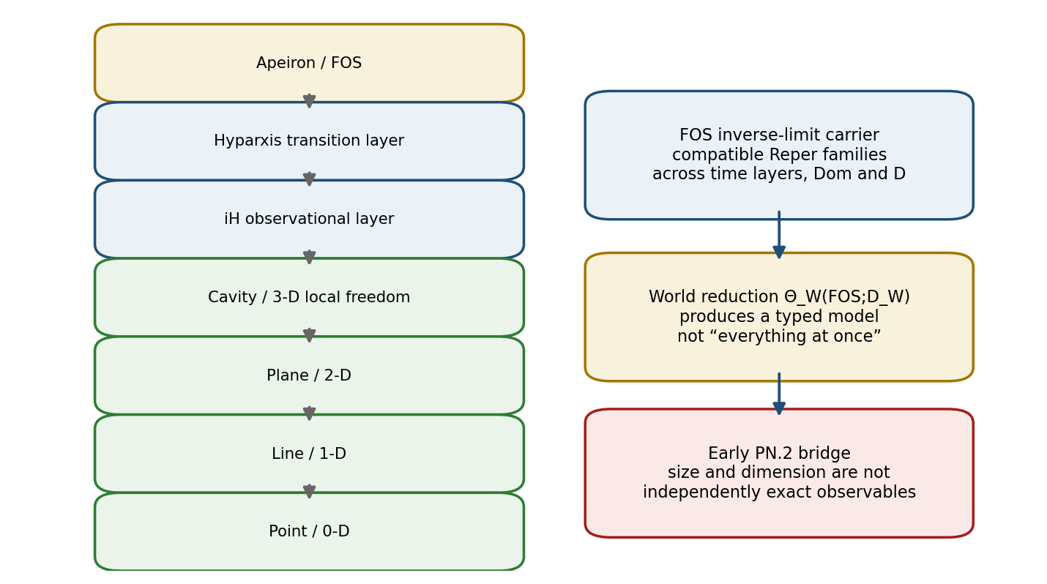
Figure 10.1. FOS as a compatible Reper carrier, world reduction, and the early PN.2 bridge.

10.1. FOS as a Reper Inverse Limit
FOS = lim←_{τ∈T} ∏_{c∈Ob(C_τ)} Reper(c). [RU p. 39]
Kurpishev Fundamental Support Connectivity (FOS) is the inverse-limit compatibility of Reper-admissible event@states across packet-time layers. It is not the set of all objects. It records whether local Reper data can be glued through declared transition maps while preserving Dom and sufficient foundations D.
Definition 10.1 [DEF-A]. Let T be a small cofiltered category. For each τ∈T, let C_τ be a small category and let E_τ=∏_{c∈Ob(C_τ)}Reper(c). If transition maps ρ_{στ}:E_σ→E_τ satisfy ρ_{ττ}=id and ρ_{υτ}=ρ_{στ}∘ρ_{υσ}, define FOS=lim←E_τ as the subset of the product consisting of compatible families.
Proposition 10.2 [PROP]. The limit exists in Set. If each E_τ is Hausdorff and the transition maps are continuous, the same equalizer construction gives a closed subspace of the product.

10.2. World Reduction and Present Slice
W = Θ_W(FOS;D_W). [RU pp. 40–41]
N_ω = σ_ω(FOS), ω=(where,when,iH,D). [RU p. 40]
A world is a reduction only when an admissible functor Θ_W and a sufficient foundation D_W are specified. A present state is a slice selected by where, when, observer layer iH, and foundation D. This is a typed selection operator, not a claim that the whole FOS is simultaneously observed.

10.3. Seven Size@Dimensions
Size measures magnitude within a layer; dimension measures the type of local freedom. The packet notation keeps the two observables coupled. The seven-layer classification is model data, not a theorem about every physical ontology.
Class | Layer | Model role | Status
Nonlocal | Apeiron / FOS | global compatibility of admissible Reper families | MODEL
Nonlocal | Hyparxis | transition layer between local dimensional regimes | MODEL
Nonlocal | iH | observational/consciousness layer in the authorial ontology | PHY-HYP / MODEL
Local | cavity | three-dimensional local freedom | CL carrier / MODEL role
Local | plane | two-dimensional local freedom | CL carrier / MODEL role
Local | line | one-dimensional local freedom | CL carrier / MODEL role
Local | point | zero-dimensional local freedom | CL carrier / MODEL role

10.4. Early Kurpishev Uncertainty Principle PN.2
The early principle states that exact size and exact dimension of a packet object cannot be fixed independently while all transition data are preserved. At this checkpoint the statement is axiomatic-modelled. It is not the later quantitative minimax theorem and supplies no numerical uncertainty constant by itself.
STATUS FIREWALL. Early PN.2 in Chapter 10 = MODEL/PHY-HYP bridge. Canonical mathematical PN.2 in Chapter 21 = a separate theorem package with a specified experiment, loss, parameter family, and lower bound. The two layers must not be conflated.

10.5. Size and Dimension as Distinct Observables
Let E be the set of packet states and let s:E→S be a size map and d:E→D_dim a dimension map. The joint measurement map is M=(s,d). An impossibility claim requires a declared admissible class of estimators, a noise or indistinguishability model, and a loss. Without them the chapter supplies a structural warning rather than a quantitative theorem.
The uncertainty fibre at observed value y is C(y)={x∈E:M(x)=y}. If C(y) contains states with different bracketings, dimensions, or transition data, a single observation does not identify the hidden structure. Prediction must therefore retain the set C(y), add a bridge assumption, or return ABSTAIN.

10.6. FOS-PN2-CERT Passport
Field | Requirement
Index category | T, objects, arrows, cofilteredness
Layer family | C_τ, E_τ, carrier types
Transitions | ρ_{στ}, identity and composition checks
Limit witness | compatible family or explicit obstruction
World reduction | Θ_W, Dom, D_W, loss of information
PN.2 bridge | size map, dimension map, observation model, equivalence fibre
Status | MODEL / COND / THM only as justified; no automatic PHY confirmation

Phenomenological note. A world is not obtained by merely naming a totality. It appears through a compatible reduction. PN.2 records the cost of such reduction: a chosen slice may preserve some coordinates only by leaving others set-valued or structurally unresolved.

Chapter 11. NAPG: Nonassociative Packet Geometry
Russian source locator: pp. 43–46
PLAIN-LANGUAGE EXPLANATION. NAPG studies admissible binary operations while preserving the packet architecture and recording nonassociativity through explicit associators and obstruction classes. The chapter does not identify one model with all nonassociative geometries.

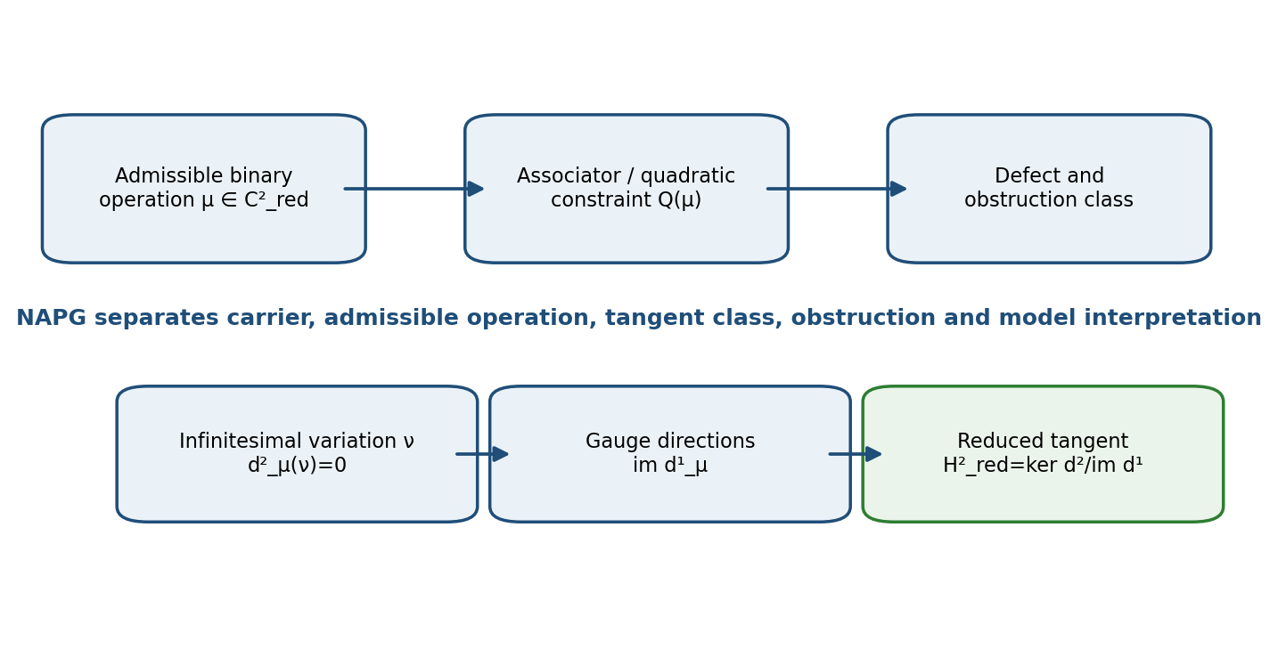
Figure 11.1. Reduced NAPG deformation complex: operation, constraint, tangent quotient, and obstruction.

11.1. Admissible Operations and Reduced Spaces
Let V be a finite-dimensional vector space with a fixed split architecture. An admissible operation is a bilinear map μ:V×V→V satisfying the declared grading, symmetry, carrier, and packet constraints. The ambient cochain spaces are reduced to subspaces C¹_red, C²_red, and C³_red compatible with those constraints.
Ass_μ(x,y,z)=μ(μ(x,y),z)−μ(x,μ(y,z)). [RU p. 43]
H²_red(μ)=ker d²_μ / im d¹_μ. [RU pp. 44–45]
O³_red(μ)=C³_red / im d²_μ. [RU pp. 44–45]
The tangent quotient removes infinitesimal changes generated by admissible changes of coordinates. The obstruction quotient records whether a first-order direction can be prolonged. These are reduced objects: their meaning depends on the declared subcomplex and cannot be imported from an unrelated deformation problem without a comparison theorem.

11.2. Associator Amplitude
For a fixed norm and a declared test family Ω⊂V³, an associator amplitude may be defined by A_Ω(μ)=sup_{(x,y,z)∈Ω}‖Ass_μ(x,y,z)‖. In a concrete one-parameter model μ_α the source corpus uses A(α)=√3|α|. This is a proved model computation only after the operation, basis, norm, and test triples are fixed.
COUNTEREXAMPLE. A change of basis or a rescaling of the norm can change a raw amplitude. Therefore A(α) is not an invariant of an abstract algebra unless the admissible transformations and normalization are included in the certificate.

11.3. Typed Deformation Complex
Definition 11.1 [DEF-A]. A reduced deformation datum is a tuple (V,C¹_red,C²_red,C³_red,μ,d¹_μ,d²_μ,Q) in which d²_μ∘d¹_μ=0 and Q(μ)=0 is the defining constraint. An infinitesimal variation ν is admissible when d²_μν=0. Two variations differing by d¹_μa represent the same reduced tangent class.
Proposition 11.2 [PROP]. The quotient H²_red(μ) is well defined whenever im d¹_μ⊆ker d²_μ. The class [ν] is zero exactly when ν is generated by an admissible infinitesimal change of coordinates.

11.4. Primary Quadratic Obstruction
Suppose μ_t=μ+tν+t²η+O(t³) and Q(μ)=0. Expansion of Q(μ_t)=0 gives the first-order equation d²_μν=0 and a second-order equation d²_μη=−B_μ(ν,ν), where B_μ is the quadratic term. The class of B_μ(ν,ν) in O³_red(μ) is the primary obstruction.
Theorem 11.3 [COND]. If the primary obstruction class is nonzero, the infinitesimal direction [ν] cannot be extended to second order within the declared reduced model. Vanishing of the primary class is necessary, not generally sufficient, for a full deformation.

11.5. Naturalness and Status Boundary
The associator is natural under an isomorphism g when the operation is transported by (g·μ)(x,y)=gμ(g⁻¹x,g⁻¹y): Ass_{g·μ}(x,y,z)=g Ass_μ(g⁻¹x,g⁻¹y,g⁻¹z). A scalar amplitude is invariant only if g is an isometry of the chosen norm and preserves Ω.
CLAIM BOUNDARY. The source connects NAPG with Hodge and G₂ model realizations. These are model bridges. The reduced deformation statements do not by themselves establish a universal physical geometry, a unique arrow of time, or empirical properties of space.

11.6. NAPG-DEF-CERT
Field group | Mandatory content
Carrier | field, V, split architecture, basis and grading
Operation | μ, bilinearity, symmetry/alternation constraints
Differentials | d¹_μ,d²_μ and proof d²d¹=0
Tangent | ν, cocycle check, gauge class [ν]
Obstruction | B_μ(ν,ν), quotient class in O³_red
Amplitude | norm, test domain Ω, invariance group
Status | DEF-A / PROP / COND / MODEL; physical bridge separate

Chapter 12. PILOT-01, Formula Chains, and the Fano Barrier
Russian source locator: pp. 47–50
PLAIN-LANGUAGE EXPLANATION. PILOT-01 treats a mathematical text as a typed graph. It can identify the first missing domain, assumption, or proof object; build an internal obstruction carrier; and state precisely why seven local Fano-like pictures do not automatically form one global Fano plane.

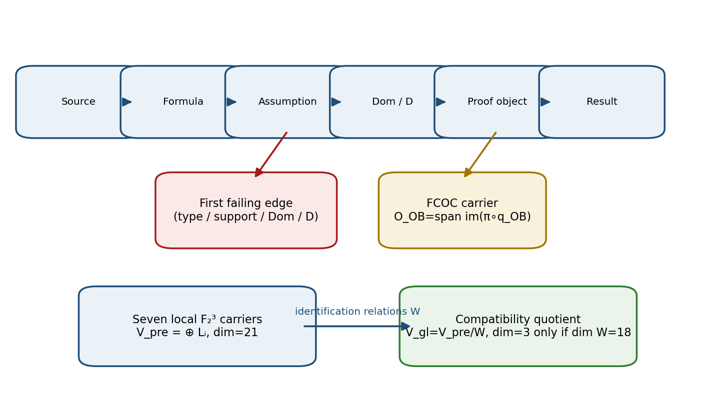
Figure 12.1. Formula-chain audit, FCOC carrier, and the quotient required to cross the Fano barrier.

12.1. Formula-Chain Step and First-Gap Localisation
A formula-chain step is a tuple s=(Fᵢ,Fⱼ,τ,A,Dom,D), where Fᵢ and Fⱼ are typed nodes, τ is the transition type, A is the support set, Dom is the admissible domain, and D is the sufficient foundation. A step is admissible only when output and input types match, support assumptions are available, Dom contains the actual input, and D points to a verifiable proof object.
Theorem 12.1 (formula-chain gap theorem) [IT]. If a projective truth authorization cr(U,I;R,D)=−1⇒truth-status is used without an admissible Dom or sufficient foundation D, the RPD audit creates GAP-DOMAIN-MISSING or GAP-ASSUMP-MISSING.
Theorem 12.2 (first-gap localisation) [IT]. In a finite linearly ordered chain, if the final result is not authorized, there is a first edge violating at least one of type, support, Dom, or D.
Proof. The finite nonempty set of failing edge indices has a least element.

12.2. Formula-Chain Obstruction Complex
C⁰ —d₀→ C¹ —d₁→ C², d₁d₀=0. [RU p. 49]
H_OB=C²/im d₁, O_OB=span(im(π∘q_OB))⊆H_OB. [RU p. 49]
Theorem 12.3 [IT]. O_OB is a well-defined vector subspace of H_OB. It is independent of representatives of classes in C², but depends on the declared maps q_OB and d₁, which are part of the model passport.

12.3. Nontrivial Packet Obstruction
Let C¹=k³, C²=k³, d₁=0, and q_OB(a,b,c)=(ab,bc,ca). Then O_OB=k³ because the image contains the three coordinate directions: q_OB(1,1,0)=(1,0,0), q_OB(0,1,1)=(0,1,0), and q_OB(1,0,1)=(0,0,1). This is an internal construction theorem, not an identification with every deformation-theoretic obstruction quotient.

12.4. Exact Fano Gluing Barrier
Let L₁,…,L₇ be local three-dimensional carriers over F₂. Before identifications, the universal independent carrier is V_pre=⊕ᵢLᵢ of dimension 21. Let W⊆V_pre be the subspace of compatibility relations. The global carrier V_gl=V_pre/W has dimension 3 exactly when dim W=18.
Theorem 12.4 (conditional Fano carrier) [COND]. If W identifies local directions according to the incidence of P²(F₂), dim W=18, and the seven global nonzero classes are distinct, then V_gl≅F₂³ and P(V_gl)≅P²(F₂).
COUNTERMODELS. If W=0, the quotient has dimension 21 rather than 3. If W=V_pre, the quotient is zero. Seven locally similar diagrams therefore do not determine a global Fano plane without explicit identification maps.

12.5. FCOC-CERT and Executable Verdict
Passport field | Content
Graph | graph-id, ordered nodes and edges, node types
Step contract | τ, support A, Dom, D, actual input snapshot
Gap result | first-gap index, violation type, pre-gap state
Complex | d₀,d₁, proof d₁d₀=0, q_OB, field
Fano layer | local carriers, relation space W, quotient dimension
Identification | Fano axiom/maps, distinct global classes, countermodel
Verdict | PROVED-INTERNAL / CONDITIONAL / OPEN / ABSTAIN

PREDICTION BOUNDARY. Closing a formula chain is necessary for admitting a predictive claim, but it does not establish empirical accuracy. Matched-null controls, calibration, CGI<1, and independent evidence remain separate gates.

Chapter 13. RBD/RPD and KLT-RBD as a Computational Architecture
Russian source locator: pp. 51–57
PLAIN-LANGUAGE EXPLANATION. RBD is an active evidence graph, not a flat bibliography. Raw items become typed units, Reper nodes, proof dependencies, gaps, blockers, and candidate futures. RPD adds projective and formula-chain audit. Database structure improves traceability but does not prove the stored claims.

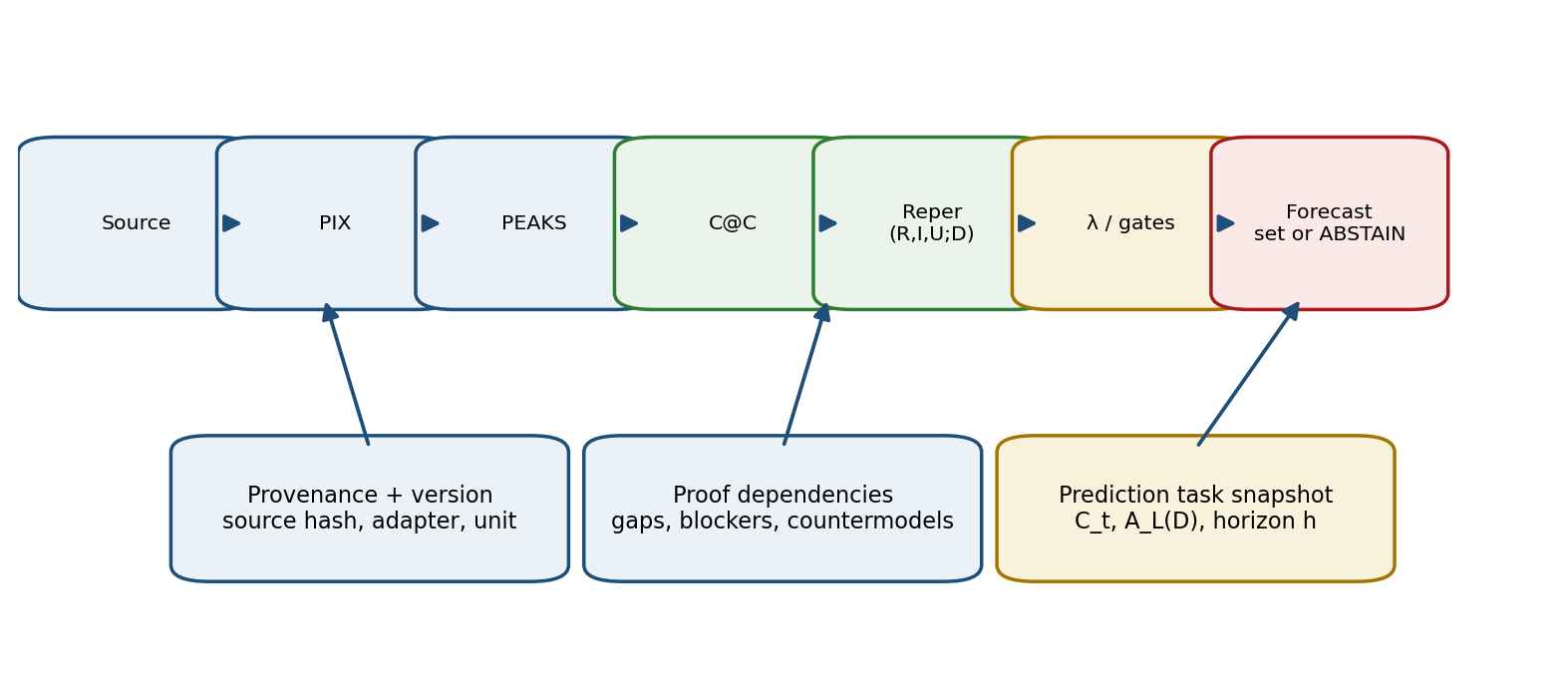
Figure 13.1. KLT-RBD ingest, evidence graph, and set-valued prediction output.

13.1. PIX, PEAKS, and Typed Reper Ingest
PIX are primary extracted items: formulae, values, dates, names, identifiers, and observations. PEAKS are stable semantic states around which related PIX are grouped. A Reper is built from a typed state rather than a raw string.
source → PIX → PEAKS → C@C → Reper(R,I,U;D) → λ/gates → graph. [RU p. 51]
Layer | Function
Source | origin, license, immutable version, content hash
Work | document, dataset, article, program, or experiment
Unit | formula, claim, row, observation, image, or test vector
C@C | event coupled with its state and version
Reper | typed R,I,U,D and admissible Dom
Graph | morphisms, proof dependencies, conflicts, gaps, blockers
Status | mathematical, computational, empirical, reproducibility, legal channels
Forecast | set of admissible future Reper states or ABSTAIN

13.2. Versioned Prediction Task
A prediction task must be frozen as a versioned object T_t=(C_t,Dom_t,D_t,L_t,h,loss,null,adapter), where C_t is the information available at time t, L_t is the active limit system, h is the horizon, and the remaining fields fix evaluation and observation semantics. Later information may be used for scoring, not silently inserted into the original task.
A_L(D)= {r : all mandatory limit and evidence gates are satisfied}. [RU p. 56]
Future(C_t)= {r∈A_L(D_t) : r extends the frozen snapshot C_t}. [RU p. 56]
The output is generally set-valued. A single selected future requires an additional selection rule with its own proof and loss certificate.

13.3. Matched-Null and Empirical Calibration
A matched-null preserves the object class, data volume, preprocessing, and scoring procedure while breaking the hypothesised relation. It estimates how often the same pipeline would produce an apparently strong pattern when the target relation is absent.
Calibration records the empirical relation between declared scores and realised frequencies. Neither a high λ score nor CGI<1 substitutes for a matched null or an external evaluation.

13.4. ABSTAIN and Multiplicity of the Future
The architecture has four primary outcomes: SINGLE-CANDIDATE, SET-CANDIDATE, ABSTAIN-EMPTY, and ABSTAIN-BLOCKED. The empty result reports that no admissible continuation exists under the current gates. The blocked result reports missing evidence or an unresolved conflict. Neither may be replaced by an arbitrary ranking.
NO HIDDEN AVERAGING. When several Reper continuations remain admissible, an arbitrary prior or unrecorded scalar score may not collapse them to one answer. The selection mechanism must be declared as a new model layer.

13.5. PRED-CERT-13
Field group | Required fields
Task snapshot | task-id, time t, horizon h, frozen input hashes
Adapters | schema, units, missingness, selection, covariance
Carrier | C_t, Dom_t, D_t, limit vector L_t
Candidate generation | morphisms, neighbourhood, constraints, algorithm version
Evaluation | loss, matched-null, blind split, calibration
Output | candidate set, blockers, ABSTAIN reason, provenance
Status | MODEL / NUM / EMP-PLAN / EMP-OBS kept in separate channels

Phenomenological note. A database becomes scientific memory only when it remembers not merely an answer, but the route by which that answer was admitted, the alternatives that remained, and the blockers that prevented stronger speech.

Chapter 14. Examples, Counterexamples, and Evidence Passports
Russian source locator: pp. 58–61
PLAIN-LANGUAGE EXPLANATION. Examples show that a construction can work in a specific case. Counterexamples show why its hypotheses are needed. Evidence passports record enough information to reproduce the case and prevent successful formatting or numerical proximity from being mistaken for a stronger theorem.

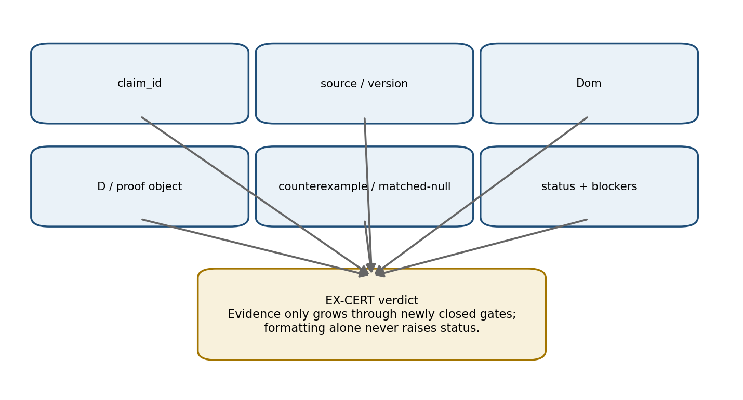
Figure 14.1. EX-CERT evidence passport and the monotonicity rule for status.

14.1. Domain Examples
Domain | Typed object | Mandatory evidence | Forbidden inference
Mathematics | formula or theorem step | hypotheses, Dom, D, proof, countermodel | one example ⇒ universal law
Construction estimate | work item and project state | norm version, period, act, resource source | gap ⇒ intent or fraud
Physical spectrum | line with channel and uncertainty | units, transition, source, covariance, matched-null | proxy ⇒ direct measurement
Chemistry | reaction state | stoichiometry, redox, energy, kinetics, spectroscopy, catalysis | ratio pattern ⇒ natural law
Biology / DNA | mapped biological object | accession, genome build, gene→transcript→protein map, cohort | cross-layer status transfer without morphism

14.2. EX-CERT Definition
Definition 14.1 [DEF-A]. EX-CERT is a record containing source-id, object-id, Dom, D, inputs, formula or procedure, numerical precision, expected result, observed result, a controlled counterexample, and the evidence status.
MANDATORY RULE. An example without a counterexample checks only one successful route; an example without Dom does not state applicability; an example without D does not authorize interpretation.

14.3. Monotonicity of Evidence Status
Theorem 14.2 [PROP]. An editorial improvement of an EX-CERT representation does not raise its status when no new verified evidence has been added.
Proof. Status is determined by the set of closed gates, not by the length or polish of the description. Reformatting preserves that set.
For certificates e₁ and e₂, define e₁≼e₂ when every gate closed in e₁ is also closed in e₂ and all common fields have compatible versions. After quotienting by equality of evidence sets, ≼ is a partial order.

14.4. Insufficiency of a Finite Noncovering Example Set
Theorem 14.3 [CL/PROP]. Let X contain at least two points and suppose a rule f has been observed only on a proper subset A⊊X. Then there exists a rule g:X→Y agreeing with f on A and differing outside A. Hence a finite noncovering example set does not identify a universal law.
Proof. Choose x₀∈X∖A and two different values y₁,y₂∈Y. Put g=f on A and g(x₀)=y₂≠f(x₀)=y₁; define remaining values arbitrarily.
Corollary 14.4. Every positive example must be accompanied by a declared generalisation domain, a counterexample, or a preregistered test on new data.

14.5. Frozen Artifact-1 Status
The source preserves the chain RIUD-TETRA-RUN006-029 → PROOF-OBJ-RUN007-0029 → FORMAL-CARD-RUN009-006 → SIGNATURE-REVIEW-RUN013-001.
λ=−0.992736565468, δ_truth=0.007263434532, CGI=0.140948882338. [RU pp. 60–61]
The frozen status is signature-ready-not-truth-layer with truth_layer_promotion=0. Numerical proximity to −1, CGI<1, or improved presentation does not authorize promotion without new independent evidence.

14.6. Paired Counterexample and Matched-Null
A mathematical counterexample violates exactly one essential hypothesis and demonstrates its necessity. An empirical matched-null preserves the class and procedure while destroying the investigated relation. The controls serve different purposes and are not interchangeable.

Chapter 15. Glossary, Notation, Formulae, and Bibliography
Russian source locator: pp. 62–64
PLAIN-LANGUAGE EXPLANATION. This chapter fixes a common language. In a notation-intensive theory, a symbol is part of the type system: changing one star, bracket, or domain marker can change the mathematical object. Bibliography records provenance but does not by itself prove novelty.

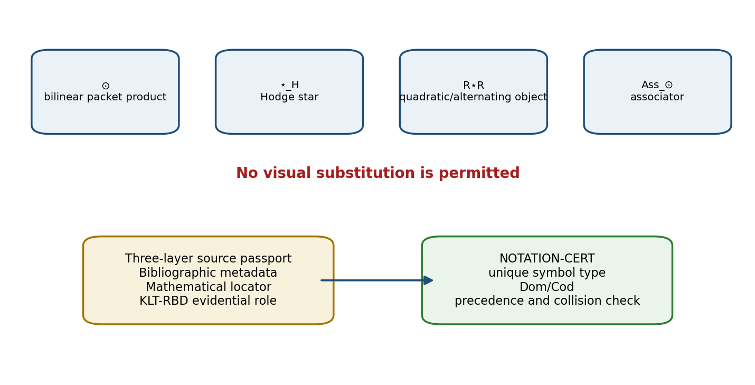
Figure 15.1. Notation firewall and three-layer source passport.

15.1. Normative Glossary
Term | Normative English meaning
Time@Space | stratified temporal primacy; space as an admissible section
C@C | event@state, the minimal typed unit
packet | an object together with a dual, stratified, or evidential layer
Pack | category of admissible packet objects and packet morphisms
Reper | typed quadruple (R,I,U;D)
D | sufficient foundation; not the same object as Dom
Dom | admissible domain of definition or applicability
λ | projective-harmonic coordinate, not a probability
δ_truth | distance from the harmonic normalization −1
FOS | Kurpishev Fundamental Support Connectivity
NAPG | Nonassociative Packet Geometry
PILOT-01 | formula-chain audit and Fano-barrier pilot
RBD / RPD | Reper database / Reper-projective audit programme
KLT | computational-mathematical software layer of the Kurpishev method

15.2. Core Formulae and Symbol Types
c=C@C=(e,s) [RU p. 62]
Reper=(R,I,U;D) [RU p. 62]
λ=cr(U,I;R,D) [RU p. 62]
δ_truth=|λ+1| [RU p. 62]
Ass_⊙(x,y,z)=(x⊙y)⊙z−x⊙(y⊙z) [RU p. 62]
H²_red=ker d²/im d¹ [RU p. 62]
O³_red=C³_red/im d² [RU p. 62]
FOS=lim←∏Reper(c) [RU p. 62]
Symbol | Unique type | Not interchangeable with
⊙ | bilinear packet product | Hodge star, R⋆R, associator
⋆_H | Hodge operator | bilinear product
R⋆R | authorial quadratic/alternating packet object | Hodge star or ordinary multiplication
Ass_⊙ | trilinear associator of ⊙ | operation ⊙ itself
λ | projective-harmonic scalar or operator coordinate | truth probability
D | sufficient foundation | Dom

15.3. Three-Layer Source Passport
Layer | Required fields
Bibliographic | author, title, edition, year, DOI/URL/repository revision
Mathematical locator | chapter, theorem, equation, page, figure, data path
KLT-RBD role | claim-id, imported hypothesis, Dom, D, status, blocker, transformation

Rule 15.1. A source reference without an exact mathematical locator cannot support a precise imported formula unless the complete source object is itself the frozen locator. A source card never raises the mathematical status of its claim merely by being complete.

15.4. Selected Bibliography and Prior Art
- Kurpishev, I. B. Monograph 5.0: Kurpishev Logic. Internal project corpus, 2026.
- Kurpishev, I. B. Monograph 5.1: Kurpishev Logic. Internal project corpus, 2026.
- Kurpishev, I. B. Reper-Projective Architecture of Formula Chains: PILOT-01. 2026.
- Kurpishev, I. B. Kurpishev FOS, the Desargues–Kurpishev Theorem, Harmony of Truth, and Extended PN.2. 2026.
- Kurpishev, I. B. Kurpishev’s Theory of Stratified Time: Associator Rigidity and Nonassociative Packet Geometry. 2026.
- Coxeter, H. S. M. Projective Geometry.
- Artin, E. Geometric Algebra.
- Bourbaki, N. Elements of Mathematics.
- Goresky, M.; MacPherson, R. Stratified Morse Theory.
- Manetti, M. Lectures on Deformations of Complex Manifolds.
- Mandelkern, M. Constructive Projective Geometry, arXiv:2404.16979.
- Stacks Project, Projective Space, Tag 01ND.
NOVELTY BOUNDARY. The glossary and bibliography support precise attribution. They do not prove absolute worldwide novelty. Statements of priority require a separate bibliographic and patent search with a declared scope.

Chapter 16. Historical-Mathematical Prior Art and the Boundary of Authorial Contribution
Russian source locator: pp. 65–72
PLAIN-LANGUAGE EXPLANATION. The chapter distinguishes inherited mathematics from the new typed synthesis. Cross-ratio, Desargues, polarity, projectivisation, Hodge theory, and hyperbolic/Lorentzian formulae are classical. The authorial contribution lies in how C@C, Reper roles, D/Dom gates, NAPG, FOS, and KLT-RBD are assembled and audited.

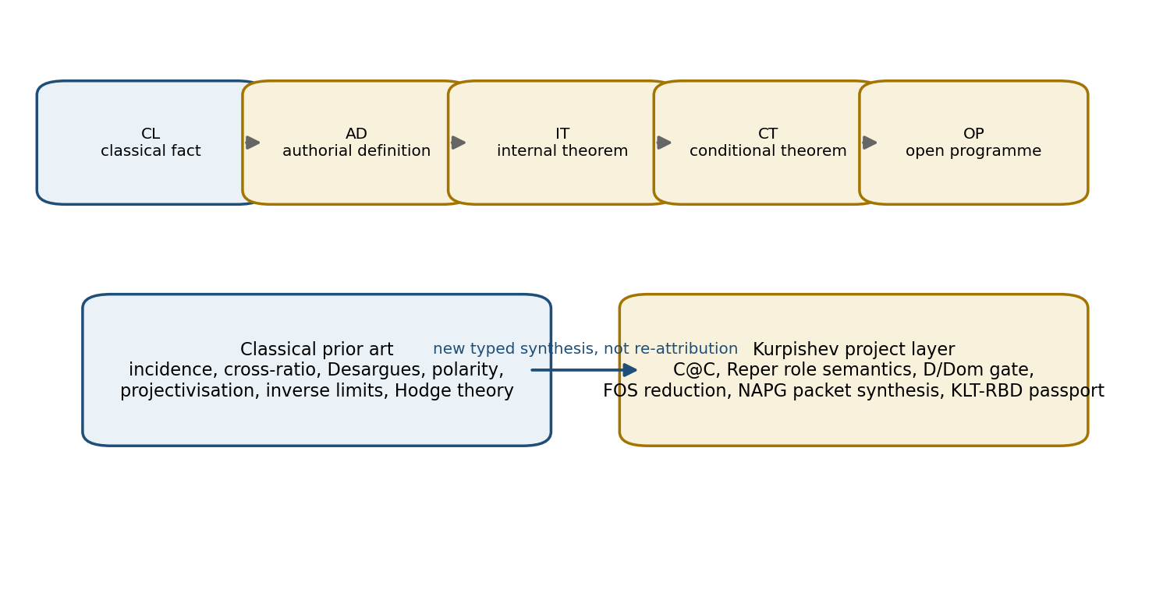
Figure 16.1. Prior-art classes and the authorial synthesis boundary.

16.1. From Perspective to Projective Invariance
Projective geometry arose from the mathematical treatment of perspective. Desargues made central projection a structural relation preserving incidence and perspectivity. Poncelet, Chasles, Steiner, and von Staudt later separated projective geometry from metric intuition. For Volume I the central lesson is that a relation should survive changes of coordinates, scale, and viewpoint.
The cross-ratio and harmonic quadruple belong to the classical core. The project does not claim their invention. The authorial layer consists in choosing the Reper quadruple (R,I,U;D), assigning semantic roles, imposing the D/Dom barrier, and using a projective invariant as one component of an evidential audit.

16.2. Desargues, Coordinatisation, and Applicability
The classical Desargues theorem holds in projective spaces of dimension at least three. In abstract projective planes it is an additional property connected with coordinatisation over a division ring; non-Desarguesian planes exist. Therefore any use of Desargues in an abstract plane must declare a Desargues axiom, an embedding into a three-dimensional projective space, or a coordinate model.
Layer | Classical prior art | Authorial layer in Volume I
Incidence | projective points, lines, planes | C@C as a typed object with state
Quadruple | cross-ratio and harmonic quadruple | Reper(R,I,U;D) and semantic roles
Desargues | perspectivity from a point and from a line | bridge between Desargues axis, polar centres, and D/Dom
Polarity | pole and polar of a nondegenerate conic | central axis as a Reper evidence-closing axis
Proof | axiomatic, coordinate, or synthetic deduction | proof status, gap nodes, RBD passport

16.3. Erlangen Programme and Packet Morphisms
Klein’s Erlangen Programme views geometry as the study of invariants under transformation groups. Packet Reper logic inherits this principle but adds preservation of state, domain, foundation, and evidence status. A packet morphism must therefore state which parts of the evidence passport are preserved, transformed, weakened, or lost.

16.4. Classical Visual and Dynamical Examples
Source visual | Classical formula | Correct interpretation | Forbidden inference
Angle of parallelism | sin Π(d)=sech d; tan(Π/2)=e^(−d) | hyperbolic K=−1 relation | proof of a Reper model
Poincaré disk circumference | L(r)=2πsinh r | hyperbolic growth vs 2πr | boundary is finite distance
Circle / hyperbola | cos²θ+sin²θ=1; cosh²η−sinh²η=1 | change of quadratic-form signature | literal sin↔sinh identity
ODE sign | y″=−y gives cos t; y″=+y gives cosh t | oscillatory vs hyperbolic regime | all hyperbolic geometry grows exponentially
Lorentz boost | t′=t coshη−x sinhη; x′=x coshη−t sinhη | hyperbolic rotation preserving t²−x² | ordinary Euclidean rotation
Rapidity | v=c tanhη | linear addition of rapidities | confirmation of physical PN.2

16.5. Classification of Construction Origin
Code | Meaning | Required wording
CL | classical fact | attribute source and state hypotheses
AD | authorial definition | state exact carrier and semantic role
IT | internal theorem inside AD | prove within declared authorial model
CT | conditional theorem | list bridge hypotheses and blockers
OP | open programme | do not present as completed result
EMP | empirical claim | require data, protocol, uncertainty, and independent test

16.6. Classical Core and Authorial Assembly
Class CL includes projective planes, Desargues in admissible models, polarity of a nondegenerate conic, cross-ratio and PGL₂ invariance, inverse limits, bilinear nonassociative algebras, quotient spaces, Grassmannians, and the Fano plane.
Class AD includes the semantic role distribution Reper=(R,I,U;D), the separation of D and Dom as evidence gates, C@C as the project’s minimal object, the KLT-RBD passport architecture, the authorial R⋆R object, FOS reduction, and PN.2 in its fixed packet formulation.
Proposition 16.1 (inheritance boundary) [PROP]. If an authorial construction uses a classical theorem T, it inherits the conclusion of T only when every hypothesis of T is verified in the authorial Dom. New semantics assigned to the symbols do not transfer the conclusion automatically.
Proof. A theorem is an implication H⇒C. Without verification of H in the new interpretation, modus ponens is unavailable.

16.7. Criterion for Novelty Statements
Novelty is formulated relative to a specific combination of carrier, morphisms, algorithm, gates, and proved result. A bibliographic search can support a priority statement but is not a mathematical proof and cannot guarantee absolute worldwide novelty.
APPROVED WORDING. “The authorial contribution consists in …” is admissible when followed by the exact typed construction. “For the first time in the world” requires a separate exhaustive patent and bibliographic report and remains outside the mathematical proof of Volume I.

16.8. External Operator Cross-Ratio Boundary
Generalised and noncommutative cross-ratios on polarisations and Grassmannians occur in prior work, including work associated with Zelikin and later cross-ratio mappings. The project therefore does not claim novelty in the mere existence of an operator cross-ratio. Its authorial claim concerns integration into Reper, D/Dom, CGI, and prediction certificates.

16.9. PRIOR-ART-CERT
Field | Content
claim-id | stable identifier and exact wording
class | CL / AD / IT / CT / OP / EMP
internal antecedents | earlier project definitions and proof objects
external references | precise source cards and mathematical locators
comparison | similarities, differences, inherited hypotheses
priority blockers | unresolved searches and prohibited language
approved wording | claim sentence permitted by the current evidence

Phenomenological note. Authorship does not detach a thought from history. It locates a new synthesis within the history of concepts. The more precisely the boundary with predecessors is drawn, the more clearly the project’s own constructive gesture appears.

Projective-Core Checkpoint: Result and Next Route
CHECKPOINT RESULT. Chapters 1–16 now form one controlled English derivative. The projective, harmonic, FOS, NAPG, PILOT-01, RBD/RPD, certificate, notation, and prior-art layers are translated and linked to stable Russian page locators.

Parity item | Result
Translated chapters | 16/52
Projective-core chapters | 8/8 for Chapters 9–16
Russian address layer | pp. 35–72 preserved
Classical/authorial boundary | explicit in Chapters 9, 12, 15, 16
Negative results | counterexamples and ABSTAIN gates preserved
Status promotion | none; truth_layer_promotion=0
Independent EXT-RUN | not completed
Next checkpoint | T1-EN-OPERATORS-v0.4 · Chapters 17–26

Open Translation Blockers
ID | Blocker | Effect
T1-EN-BLK-013 | No independent signed bilingual audit has been performed. | Non-veto for authorial draft; veto for external certification.
T1-EN-BLK-014 | The English page map is provisional until full assembly. | Russian source pages remain the only canonical locators.
T1-EN-BLK-015 | Some historical source cards lack exact edition/page data in the frozen Russian text. | Keep carried metadata; no fabricated locators.
T1-EN-BLK-016 | Physical interpretations of seven Size@Dimensions and early PN.2 remain unvalidated. | Maintain MODEL/PHY-HYP and ABSTAIN for physical confirmation.

NEXT CHECKPOINT. T1-EN-OPERATORS-v0.4 will translate Chapters 17–26: complex, matrix, and operator cross-ratio; proof-cleaned Desargues–Kurpishev material; the canonical mathematical PN.2 construction; the action/change/reversal operators Δ, Ξ, Υ; and the nonassociative packet Reper algebra of Size@Dimensions.

T1-EN-OPERATORS-v0.4
CONTROLLED ENGLISH TRANSLATION OF CHAPTERS 17–26
DERIVATIVE BOUNDARY. The following text is a controlled derivative of frozen Russian source pages 73–146. The English layer may normalize layout and terminology, but it may not alter a formula, theorem hypothesis, counterexample, domain, sufficient foundation, or evidence status. Any discovered Russian-source issue becomes a blocker for a future Russian change-set.

Chapter parity map for the v0.4 checkpoint
Chapter | Russian locator | English title | Dominant status
17 | 73–75 | Complex Cross-Ratio and Reper Geometry on CP¹ | CL / PROP / THM
18 | 76–77 | Matrix and Operator Cross-Ratio | DEF-A / COND
19 | 78–81 | Proof-Cleaning of the Desargues–Kurpishev Theorem | THM / COND / OPEN
20 | 82–86 | Subject Index, Formula Registry, and Cross-Reference System | DOC / PROP / NUM
21 | 87–104 | Canonical Mathematical Construction of Kurpishev PN.2 | THM / COND / MODEL
22 | 105–109 | PN.2 as a Restrictor and Driver of the KLT-RBD Predictive Method | PROP / NUM / EMP-PLAN
23 | 110–111 | PN.2 Examples, Counterexamples, and Computational Tests | PROP / NUM
24 | 112–115 | Export of PN.2 to Physics, Chemistry, Biology, and DNA | EMP-PLAN / PHY-HYP
25 | 116–124 | Operators of Action, Change, and Reversal | DEF-A / THM / COND
26 | 125–146 | Nonassociative Packet Reper Algebra of Size@Dimensions | THM / COND / OPEN

Chapter 17. Complex Cross-Ratio and Reper Geometry on CP¹
Russian source locator: pp. 73–75
PLAIN-LANGUAGE EXPLANATION. A scalar Reper is moved to the complex projective line. Homogeneous coordinates allow one to treat finite points and infinity uniformly, while the stability certificate records how close the configuration is to a forbidden collision.

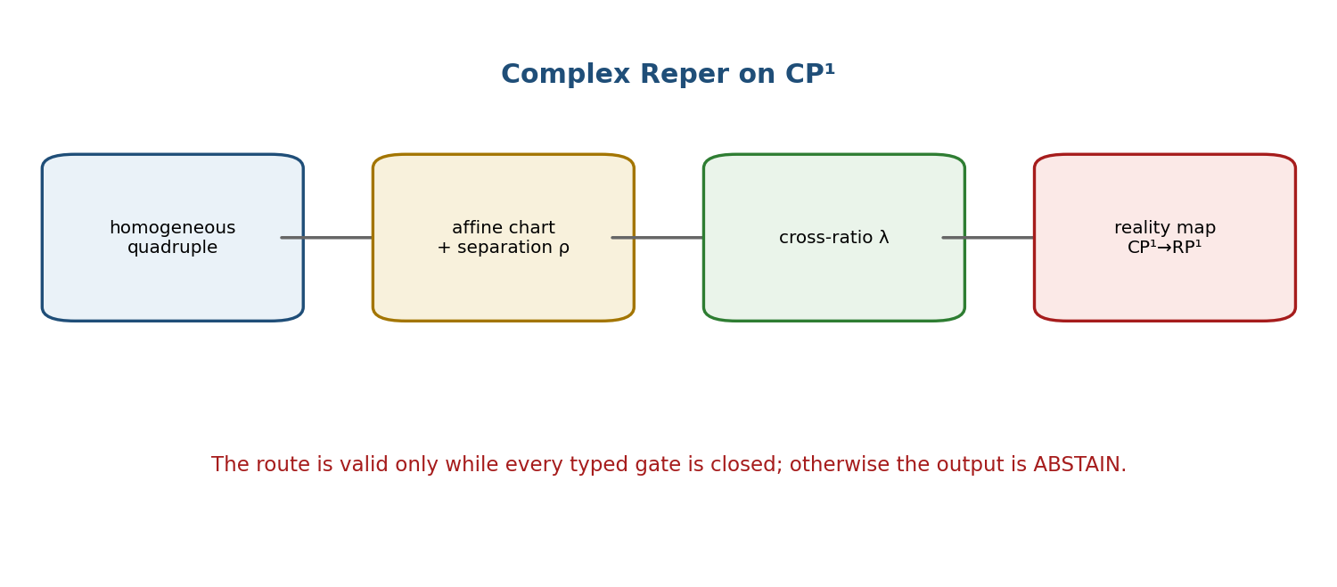
Figure 17.1. The complex Reper requires a chart, separation estimate, and an explicit real-reduction map.

17.1. Homogeneous and Affine Definitions
Let z₁,z₂,z₃,z₄ be pairwise distinct points of CP¹. In an affine chart in which the required differences are nonzero, define
cr(z₁,z₂;z₃,z₄)=((z₃−z₁)(z₄−z₂))/((z₃−z₂)(z₄−z₁)). [RU p. 74]
The value is independent of the affine coordinate and is invariant under Möbius transformations. If one point is infinity, the expression is read through homogeneous determinants or the corresponding limit. Because a Reper is ordered, permutations are not neutral: the six anharmonic values must not be conflated.

17.2. Projective Invariance
Proposition 17.1 [PROP]. For g(z)=(az+b)/(cz+d), ad−bc≠0, and for any admissible quadruple,
cr(gz₁,gz₂;gz₃,gz₄)=cr(z₁,z₂;z₃,z₄). [RU p. 74]
Proof. Each transformed difference equals (ad−bc)(zᵢ−zⱼ)/((czᵢ+d)(czⱼ+d)); all determinant and denominator factors cancel pairwise.

17.3. Harmonicity, Stability, and Reality
Reper_C=(R,I,U;D; K=C, Dom⊂CP¹), λ=cr(U,I;R,D), δ_truth=|λ+1|. [RU p. 75]
The equality λ=−1 is a projectively invariant structural condition. It does not automatically define a real observable. A map real:Dom_C→Dom_R and a compatibility proof are required for a real or physical reduction.
dλ/λ=(dU−dR)/(U−R)+(dI−dD)/(I−D)−(dU−dD)/(U−D)−(dI−dR)/(I−R). [RU p. 75]
Theorem 17.3 [THM]. If the absolute values of the four denominator differences are bounded below by ρ>0, then, to first order,
|dλ|≤(2|λ|/ρ)(|dU|+|dI|+|dR|+|dD|). [RU p. 75]
Hence a small δ_truth does not imply numerical robustness when ρ is small. The CP1-CERT passport records the field, homogeneous representatives, affine chart, pairwise distinctions, λ, δ_truth, ρ, propagated uncertainty, reality test, Dom, D, and status.
The harmonic conjugation H_{A,C}:B↦D_harm is a projective involution. If A,C,B lie in RP¹, then D_harm also lies in RP¹, including the point at infinity. The converse fails without a declared real structure.
STATUS FIREWALL. Complex projective invariance is mathematics. The interpretation of the third coordinate of a helical visualization as physical time is not a consequence of the theorem.

Chapter 18. Matrix and Operator Cross-Ratio
Russian source locator: pp. 76–77
PLAIN-LANGUAGE EXPLANATION. Noncommuting matrices cannot be inserted into the scalar fraction without choosing the order of factors and the side on which inverses act. The definition therefore begins with an invertibility and ordering contract.

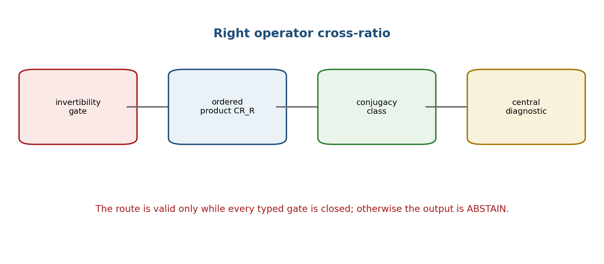
Figure 18.1. The operator construction produces a conjugacy class or central diagnostic only after the domain gates are satisfied.

18.1. Right Operator Cross-Ratio
Let A,B,C,D belong to an associative unital algebra and assume C−B and D−A are invertible. One fixed right convention is
CR_R(A,B;C,D)=(C−A)(C−B)⁻¹(D−B)(D−A)⁻¹. [RU p. 76]
Other conventions are possible, but the convention must be frozen before computation. Left and right variants are different typed objects in a noncommutative algebra.

18.2. Conjugacy Covariance
Theorem 18.1 [THM]. For an invertible S and A′=SAS⁻¹, B′=SBS⁻¹, C′=SCS⁻¹, D′=SDS⁻¹,
CR_R(A′,B′;C′,D′)=S·CR_R(A,B;C,D)·S⁻¹. [RU p. 77]
Consequently, the conjugacy class is natural. In finite-dimensional complex models, spectrum, trace, determinant, or another central function may be used as a diagnostic only when its domain and semantics are stated.
Regime | Condition | Permitted meaning
Strict matrix | CR_R=−I | operator harmonicity
Spectral | spec(CR_R) concentrated near −1 | review signal; not equality
Trace | tr(CR_R)/n≈−1 | compressed diagnostic
Norm | ‖CR_R+I‖≤ε | approximate operator gate

Theorem 18.3 [THM]. If A,B,C,D lie in a common commutative subalgebra, the right operator expression reduces to the scalar cross-ratio in the corresponding convention.
Counterexample 18.4. The Jordan matrix J=[[-1,1],[0,-1]] has spectrum {−1}, but J≠−I. Spectrum alone is therefore insufficient for strict operator harmonicity.
OPCR-CERT. The certificate must record algebra, multiplication order, inverse side, invertibility witnesses, norm, spectrum/trace convention, condition numbers, Dom, D, and status. Missing invertibility yields ABSTAIN-DOM.

Chapter 19. Proof-Cleaning of the Desargues–Kurpishev Theorem
Russian source locator: pp. 78–81
PLAIN-LANGUAGE EXPLANATION. The proof is split into independently checkable obligations: existence of a polar-centre point, identification with a Desargues axis, and harmonicity. A diagram can suggest these coincidences, but it cannot establish them.

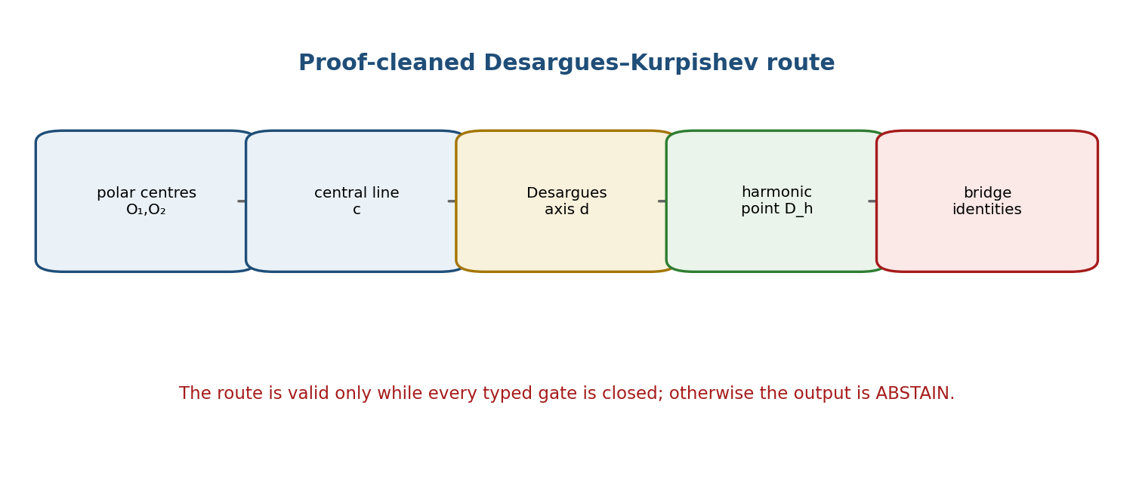
Figure 19.1. Proof-cleaning separates the classical constructions and the authorial bridge identities.

19.1. Existence and Identification Layers
Theorem 19.1 [THM]. Under the declared projective-plane, nondegenerate polarity, and transversality hypotheses, the two pole-centres O₁,O₂ determine a central line c, and c meets the support line p in a well-defined point D_pol.
Theorem 19.2 [COND]. If a pair of triangles satisfies the classical Desargues hypotheses and its axis d_Des is proved to coincide with c, then the Desargues trace on p coincides with D_pol.

19.2. Homogeneous Harmonicity Criterion
For homogeneous representatives a,b,c,d on P¹, harmonicity is equivalent to the coordinate-free determinant identity
[b,a][d,c]+[b,c][d,a]=0. [RU p. 80]
Theorem 19.3 [COND]. The Desargues–Kurpishev conclusion follows only after the separate bridge D_pol=D_harm has been proved. No incidence-only argument supplies this equality automatically.

19.3. Countermodel and Status Monotonicity
A coordinate countermodel may satisfy the polar and Desargues constructions while failing the harmonic determinant identity. It refutes automatic harmonicity but does not refute the conditional theorem with its explicit bridge hypotheses.
Theorem 19.5 [PROP]. Editorial transformations that close no new mathematical obligation cannot raise the DK status. Reformatting a proof graph is not a proof step.
Proof node | Required evidence | Failure verdict
DK-1 | nondegenerate conics/polarities and unique poles | ABSTAIN-DOM
DK-2 | central line c and trace D_pol exist | ABSTAIN-INCIDENCE
DK-3 | classical Desargues hypotheses | ABSTAIN-DESARGUES
DK-4 | bridge c=d_Des | OPEN-BRIDGE
DK-5 | bridge D_pol=D_harm / determinant identity | OPEN-HARMONIC

CANONICAL VERDICT. The theorem is a rigorous conditional result. Its unconditional geometric universality remains OPEN until the bridge hypotheses are derived from a stronger common carrier.

Chapter 20. Subject Index, Formula Registry, and Cross-Reference System
Russian source locator: pp. 82–86
PLAIN-LANGUAGE EXPLANATION. Scientific navigation is treated as a typed graph. A citation edge carries a role—definition, proof dependency, example, counterexample, source, or status—and cannot transfer a stronger status than the target itself possesses.

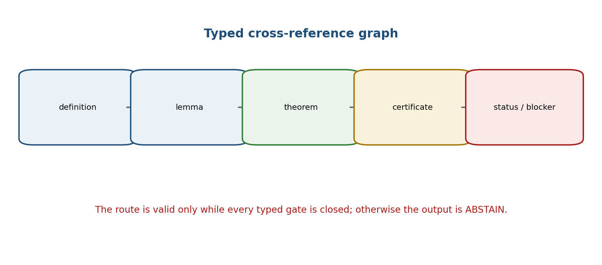
Figure 20.1. Typed reference edges preserve direction, role, and status.

20.1. Reference Graph
Definition 20.1. The cross-reference graph is G_ref=(V,E), where a vertex is a stable scientific object and an edge contains source-id, target-id, edge-type, locator, Dom, and status metadata.
Theorem 20.1 [THM]. If every proof-dependency edge points from a later object to an earlier already-defined object, the verified proof kernel is acyclic. A cycle of bare mutual definitions without a simultaneous fixed-point definition is a defect, not depth.

20.2. No Status Transfer
Proposition 20.2 [PROP]. A reference to a proved statement does not make the referring statement proved. The referring object must independently verify that the theorem hypotheses hold in its own Dom and that its transformation preserves the conclusion.
Theorem 20.3 [PROP]. If an edit changes a vertex a, only its reverse dependency cone must be re-audited, provided all stable identifiers remain unchanged. This locality is the basis of change-set discipline.
Object type | Stable address | Minimum audit
formula | F001–F086 + first RU page | symbol type, Dom, source
formal statement | type + number + RU page | hypotheses, conclusion, status
figure | number or archive locator + RU page | caption and evidential role
table | stable T-ID + RU page | headers, units, source
certificate | certificate ID + hashes | inputs, test, output, limits

INDEX-CERT. A complete index is a reproducibility aid. It does not supply a missing proof or close a scientific blocker.

Chapter 21. Canonical Mathematical Construction of Kurpishev PN.2
Russian source locator: pp. 87–104
PLAIN-LANGUAGE EXPLANATION. PN.2 concerns one estimator facing two hidden structural branches. The estimator must approximate both the resulting state and a coordinate that distinguishes the branches. Two elementary midpoint bounds then force a product lower bound.

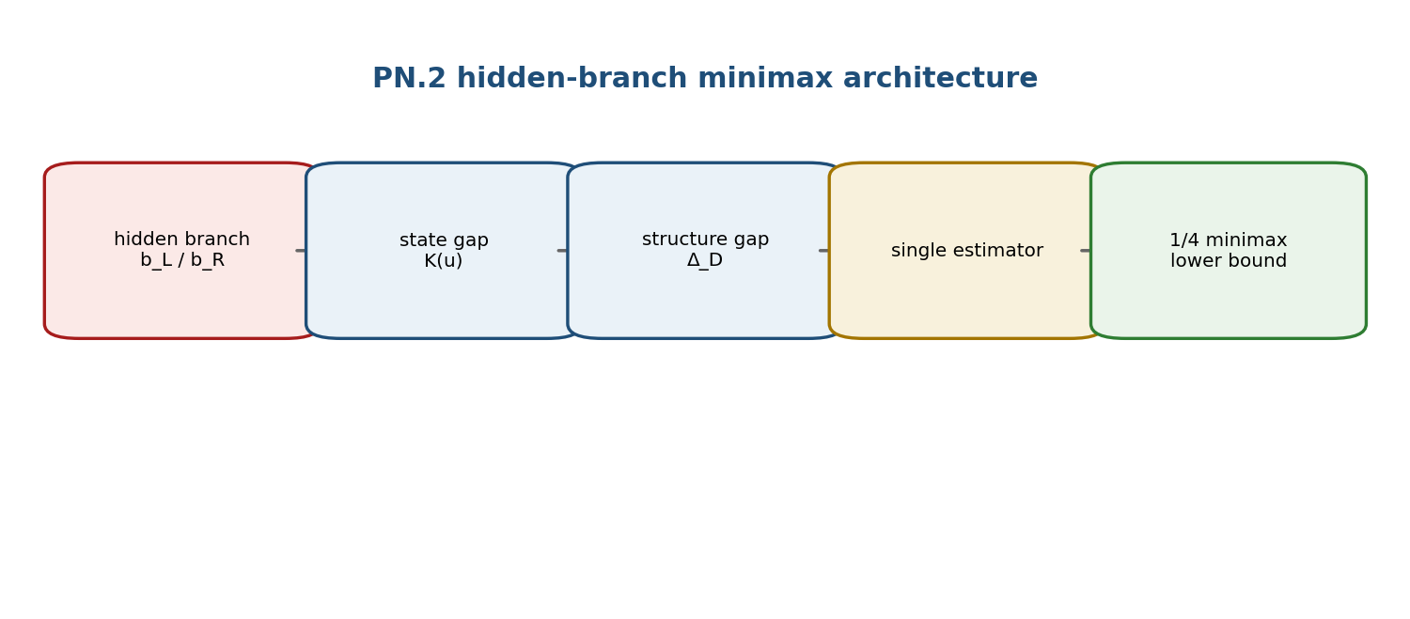
Figure 21.1. Hidden bracketing creates two state targets and two structural targets for one estimator.

21.1. Algebraic Carrier and Hidden Alternative
Let A be a normed real or complex vector space with a bilinear operation ⊙. For u=(x,y,z), define
r_L(u)=(x⊙y)⊙z, r_R(u)=x⊙(y⊙z), K(u)=r_L(u)−r_R(u). [RU p. 87]
The branch b∈{b_L,b_R} is hidden from the estimator. A structural coordinate 𝔇 must genuinely distinguish the two protocols; ordinary vector-space dimension and the maximal depth of a three-leaf tree do not do so automatically.

21.2. Errors and Gaps
e_S(u;ŝ)=max{|ŝ−S(r_L(u))|, |ŝ−S(r_R(u))|}. [RU p. 89]
e_D(u;d̂)=max{|d̂−𝔇(b_L)|, |d̂−𝔇(b_R)|}. [RU p. 89]
e_R(u;r̂)=max{‖r̂−r_L(u)‖, ‖r̂−r_R(u)‖}. [RU p. 89]
Δ_S(u)=|S(r_L(u))−S(r_R(u))|, Δ_D=|𝔇(b_L)−𝔇(b_R)|, Δ_R(u)=‖K(u)‖. [RU p. 89]

21.3. Model Axioms
Axiom | Content | Why required
A1 | normed carrier; bilinear ⊙; both branches defined on Ω | well-typed state errors
A2 | two admissible branches; true branch hidden | information restriction
A3 | Δ_D>0 and justified structural meaning | nondegenerate structure gap
A4 | one estimator for both branches | prevents branch disclosure
A5-S | scalar observable separates the branch outputs | needed only for scalar form
A6 | positive infimum of ‖K(u)‖/m(u) on Ω | needed for a uniform constant

21.4. Two-Point Minimax Lemma and PN.2
Lemma 21.1 [CL]. For any a,b,q in a metric space, max{d(q,a),d(q,b)}≥d(a,b)/2. This follows immediately from the triangle inequality.
Theorem 21.2 (local minimax PN.2) [THM]. Under A1–A4, for every u∈Ω and any estimator that does not use the hidden branch,
e_S(u;ŝ)·e_D(u;d̂) ≥ ¼ Δ_S(u)Δ_D. (PN.2-S) [RU p. 90]
e_R(u;r̂)·e_D(u;d̂) ≥ ¼ ‖K(u)‖Δ_D. (PN.2-R) [RU p. 90]
if Δ_S(u)≥c‖K(u)‖, then e_S e_D ≥ (c/4)‖K(u)‖Δ_D. (PN.2-K) [RU p. 90]
Proof. The two-point lemma gives a factor 1/2 for the state or scalar target and a second factor 1/2 for the structural target. Multiplication yields 1/4.

21.5. Uniform Form and Direction of Bounds
ε_−=inf_{u∈Ω} ‖K(u)‖/m(u) > 0. [RU p. 91]
e_R e_D ≥ (ε_−Δ_D/4)m(u). [RU p. 91]
A supremum ε_+=sup ‖K(u)‖/m(u) gives an upper bound on ‖K‖, not the lower bound required by PN.2. This correction is part of the canonical theorem package.

21.6. Applicability and Non-Equivalences
- No positive bound is obtained on the associative sector K(u)=0.
- No positive structural bound is obtained when Δ_D=0.
- The scalar form may vanish when S does not separate r_L and r_R, even if K(u)≠0.
- The theorem does not apply when the true branch is disclosed to the estimator.
- PN.2 is not the Robertson–Schrödinger relation and is not an Ozawa noise–disturbance relation without an explicit quantum measurement representation.
- Equality of norms ‖r_L‖=‖r_R‖ does not imply K(u)=0; multiplicative-norm algebras provide counterexamples.

21.7. Explicit A₂ Witness
The canonical two-dimensional nonassociative witness uses a basis e₁,e₂ with a frozen multiplication table chosen so that one triple has a nonzero associator. Four cases are retained: an associative zero case, a nonassociative case invisible to the selected scalar observable, a globally c-separating case, and a compact domain with ε_−>0.
Case | K | Scalar gap | Permitted conclusion
associative zero | 0 | 0 | PN.2 lower bound is zero
nonassociative / scalar blind | ≠0 | Δ_S=0 | use full-state PN.2-R
c-separating observable | ≠0 | Δ_S≥c‖K‖ | PN.2-K
compact coercive Ω | ‖K‖≥ε_−m | positive | uniform conditional bound

PHYSICAL BOUNDARY. The theorem is proved inside a hidden-bracketing model. A physical use requires a representation of branches, observables, units, experimental controls, and an independent protocol.

Chapter 22. PN.2 as a Restrictor and Driver of the KLT-RBD Predictive Method
Russian source locator: pp. 105–109
PLAIN-LANGUAGE EXPLANATION. PN.2 is used as a guardrail: it prevents a prediction engine from collapsing genuinely different admissible branches into one overconfident answer. The output may therefore be a single candidate, a set, or ABSTAIN.

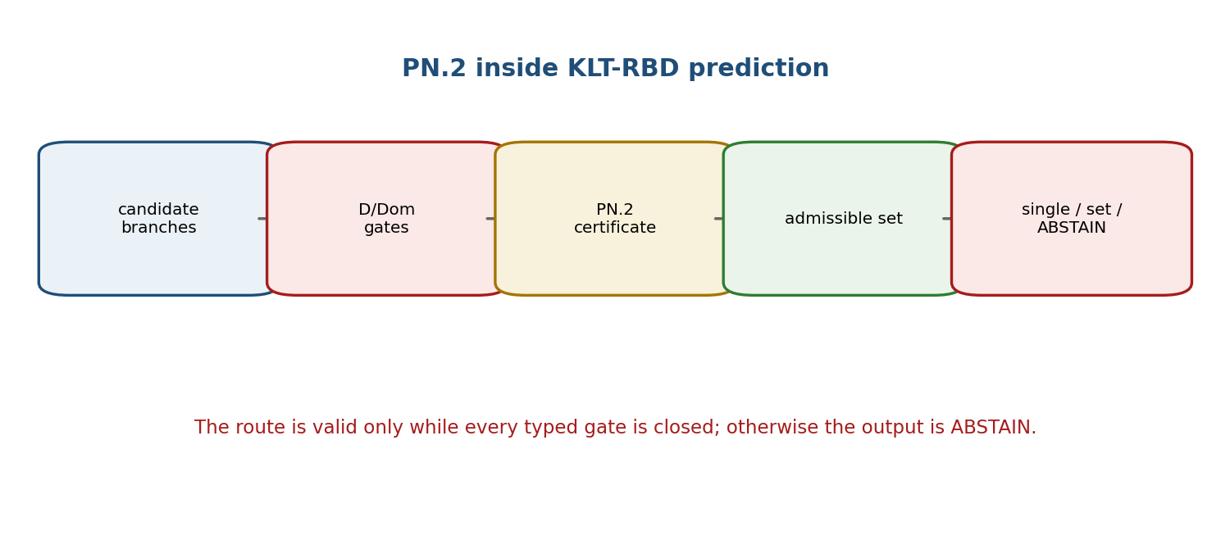
Figure 22.1. Prediction is authorized only after D/Dom, PN.2, calibration, and blocker gates.

22.1. Branch Reper and PN.2 Certificate
Each candidate branch u receives a Reper passport, its state result, structural coordinate, PN.2 gaps, provenance, and blocker vector. The certificate does not choose the branch; it records what cannot be simultaneously reconstructed without branch information.

22.2. Admissible Prediction Set
A_L(D)={u : Dom(u)=PASS, D(u)=PASS, blockers(u)=0, calibration(u)=PASS}. [RU p. 106]
Theorem 22.1 [THM]. A deterministic winner exists only if A_L(D) is nonempty and the predeclared ordering has a unique maximizer. An empty set yields ABSTAIN-EMPTY; a tie yields SET-CANDIDATE unless a separate tie-break rule is frozen.

22.3. Matched-Null and CGI Calibration
KMA flags and harmonic proximity may guide search but do not prove a candidate. A matched-null protocol keeps the same object, preprocessing, and admissible transformations while breaking the claimed structure under a frozen randomization group.
p̂=(1+#\{T_b≥T_obs\})/(B+1). [RU p. 107]
The plus-one correction prevents a zero Monte Carlo p-value. Validity requires a null group under which the transformed data are exchangeable or invariant; this is an empirical-plan assumption, not a consequence of λ.
For CGI=N/S with positive calibrated denominator S, increasing a nonnegative defect term in N cannot improve CGI. Perturbation estimates require explicit lower bounds on S.

22.4. Stability and Status Monotonicity
Theorem 22.5 [COND]. If all gate margins are positive and the score/candidate maps are Lipschitz on a neighborhood, sufficiently small perturbations preserve membership in the admissible set. Theorem 22.6 additionally requires a positive winner margin to preserve a unique winner.
Lemma 22.9 [PROP]. Typography, field order, or file renaming cannot promote a certificate. Proposition 22.10 [PROP]. Closing a positive gate can improve only the corresponding status component; it cannot bypass another open gate.

22.5. Selective Set-Valued Predictor
Condition | Output
one admissible candidate and unique frozen winner | SINGLE-CANDIDATE
several admissible non-dominated candidates | SET-CANDIDATE
no candidate passes mandatory gates | ABSTAIN-EMPTY
data or adapter missing | ABSTAIN-DOM
unresolved proof or causal blocker | ABSTAIN-BLOCKED

RISK DECOMPOSITION. A high ranking score cannot compensate for a failed validity gate. Gate risk and ranking loss are separate quantities.

Chapter 23. PN.2 Examples, Counterexamples, and Computational Tests
Russian source locator: pp. 110–111
PLAIN-LANGUAGE EXPLANATION. Small explicit models show exactly which assumption creates a positive lower bound and which shortcut destroys it. Numerical checks certify arithmetic inside the model; they do not certify a physical interpretation.

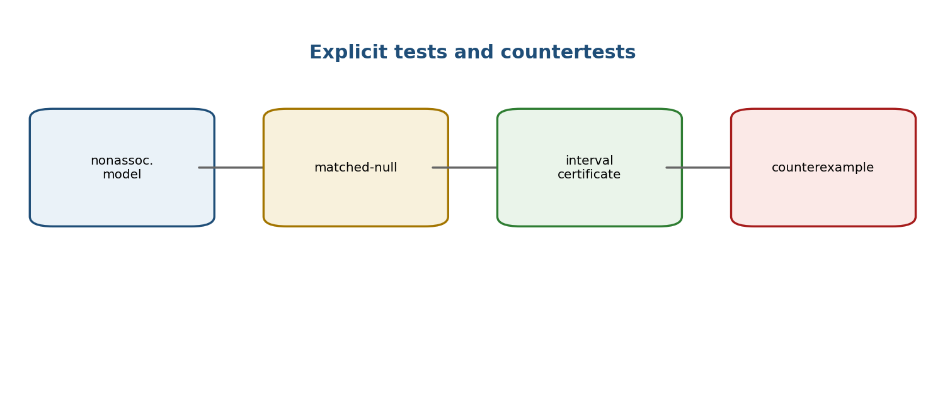
Figure 23.1. A test matrix must contain positive witnesses, matched nulls, and counterexamples.

23.1. Test Matrix
Test | Purpose | Expected verdict
two-dimensional nonassociative witness | verify K≠0 and exact branch outputs | PASS-NUM
associative zero model | confirm the bound collapses to zero | PASS-NULL
equal-norm / nonzero associator | refute norm-only scalar detection | COUNTEREXAMPLE
compact Ω | verify interval lower bound ε_− | PASS-INTERVAL
matched-null with plus-one correction | calibration sanity check | EMP-PLAN / NUM
CGI perturbation | test denominator and monotonicity margins | PASS-NUM

23.2. Optimality of 1/4
Proposition 23.1 [PROP]. In the unrestricted two-point simultaneous-recovery problem, the coefficient 1/4 is sharp: midpoint estimators attain both half-distance bounds simultaneously.

23.3. Infimum, Supremum, and Compactness
A supremum of the normalized associator controls the largest defect and cannot provide a uniform positive lower bound. If Ω is compact and f(u)=‖K(u)‖/m(u) is continuous and strictly positive, then f attains a positive minimum ε_−.

23.4. Interval Certificate
An interval certificate encloses every multiplication, norm, branch gap, and final lower bound with directed rounding. A floating-point point estimate without an error enclosure has status NUM-CHECK, not an exact proof object.
CERTIFICATE BOUNDARY. Zero observed failures in a finite test set does not prove universal correctness. The test domain, seed, tolerance, arithmetic model, and uncovered cases remain part of the certificate.

Chapter 24. Export of PN.2 to Physics, Chemistry, Biology, and DNA: Boundaries and Verification Programme
Russian source locator: pp. 112–115
PLAIN-LANGUAGE EXPLANATION. A theorem about an abstract hidden branch does not inherit a subject-matter meaning by renaming its variables. Every export requires a typed adapter, dimensions and units, a null model, controls, data provenance, and an independent test.

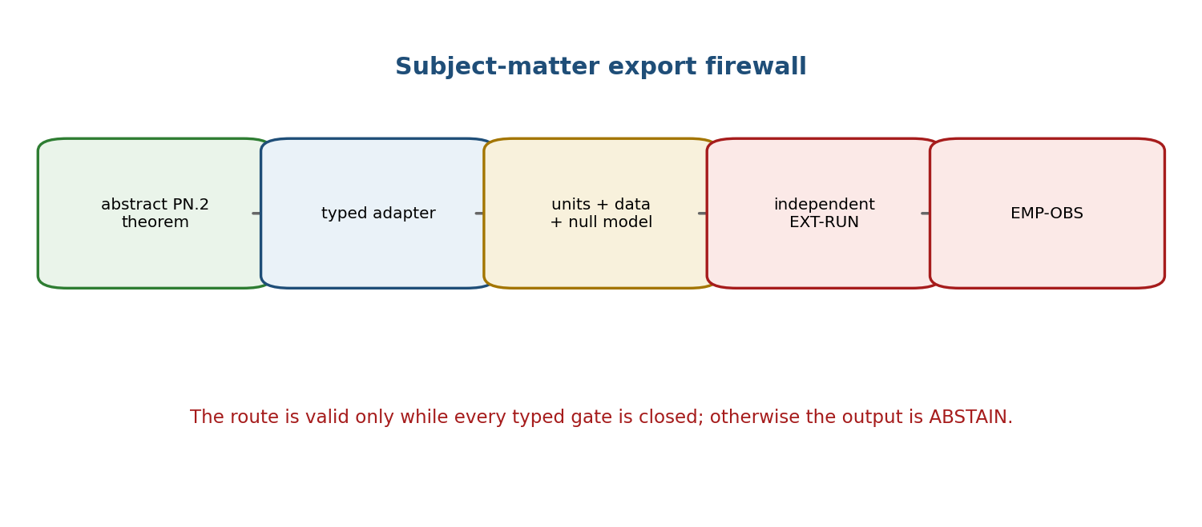
Figure 24.1. The export firewall separates an abstract theorem from an empirical observation.

24.1. Non-Transferability of Proof Status
Theorem 24.1 [THM]. The proved status of an abstract minimax theorem is not transported to a physical, chemical, biological, or genomic claim unless a subject adapter is defined and every adapter obligation is proved or independently validated.

24.2. Typed Export Passport
Field | Required content
carrier | measured or simulated object and sampling unit
branch map | what constitutes b_L and b_R in the subject domain
observable map | S, full-state metric, units, calibration
structural coordinate | 𝔇 and proof that Δ_D>0
domain | inclusion/exclusion rules and validity range
null model | matched object, transformation group, nuisance handling
data | version, provenance, licenses, covariance, missingness
test | primary endpoint, multiplicity correction, falsification rule
independence | blind split, external runner, immutable hashes

24.3. Subject Protocols
Domain | Permitted programme | Current status
Physics | define two operationally indistinguishable structural branches and a calibrated observable | PHY-HYP / EMP-PLAN
Chemistry | compare alternative reaction/structure protocols under matched conditions and exact stoichiometric gates | MODEL / EMP-PLAN
Biology | declare biological unit, hierarchical dependence, batch effects, and intervention limits | EMP-PLAN
DNA | freeze assembly, annotation, alignment, structural coordinate, and multiple-testing plan | EMP-PLAN

24.4. Falsification and Stop Rules
- Failure of the adapter to define both branches in the same empirical carrier blocks the export.
- If the structural coordinate does not separate the branches, the subject PN.2 claim is falsified in that implementation.
- If the full-state or scalar gap is absent in the declared domain, the positive lower-bound claim is rejected.
- Post hoc selection of an observable, subgroup, or null transformation invalidates the preregistered claim unless independently corrected.
- An independent EXT-RUN is required before any EMP-OBS promotion.
EXPORT-CERT. The export certificate stores the abstract theorem ID, adapter version, data and code hashes, preregistration, exclusions, multiplicity rule, result, and an exact statement of what the result does not establish.

Chapter 25. Operators of Action, Change, and Reversal
Russian source locator: pp. 116–124
PLAIN-LANGUAGE EXPLANATION. Action creates an impulse, reversal/insertion turns an admissible impulse into a state, and change evolves the state. Treating all three as one operator produces ill-typed compositions and false inverse symbols.

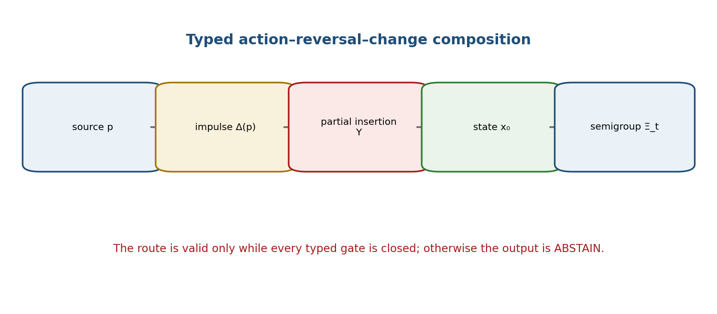
Figure 25.1. The typed route from source through action and insertion to semigroup evolution.

25.1. Typed Data
Δ_ord:P_ord→I, Δ_sp:P_sp→I, Υ:D_Υ⊆I→X, Ξ_t:X→X. [RU pp. 116–118]
The ordinary and spontaneous action maps share the impulse codomain I but may have different source spaces. Spontaneity is relative to a support relation and an information field; it is not a metaphysical claim of causelessness.

25.2. Relative Spontaneity
I_ord={i∈I : ∃s∈S_− with (s,i)∈Supp}. [RU p. 117]
An impulse is spontaneous relative to (S_−,Supp) when it does not belong to I_ord. Enlarging the information field or support relation may reclassify it. Proposition 25.10 [PROP] formalizes this epistemic monotonicity.

25.3. Partial Insertion and Admissible Sources
P_ad=Δ_sp⁻¹(D_Υ)={p∈P_sp : Δ_sp(p)∈D_Υ}. [RU p. 117]
If P_ad is empty, a subsequent universal statement is formally true but scientifically vacuous. Nonemptiness is therefore a separate proof obligation.

25.4. Semigroup of Change
Ξ₀=id_X, Ξ_{s+t}=Ξ_s∘Ξ_t, s,t≥0. [RU p. 118]
These are algebraic semigroup axioms. Continuity, differentiability, linearity, a generator, or well-posedness of a differential equation do not follow without additional hypotheses.

25.5. Three Meanings of Υ⁻¹
Case | Meaning of Υ⁻¹ | Allowed use
Υ bijective | global inverse X→D_Υ | ordinary composition
Υ injective only | inverse defined on im Υ | restrict domain explicitly
Υ noninjective | set-valued preimage | use a relation or selector; not a function

Theorem 25.1 [THM]. On P_ad, the composition x_t=Ξ_t(Υ(Δ_sp(p))) is type-correct. Recovery of p from x_t requires separate injectivity or a declared multivalued inverse; it is not implied by the forward construction.
Theorem 25.9 [THM]. The formula Δ_sp=Δ∘Υ⁻¹ is type-correct only after specifying a domain on which Υ⁻¹ is an actual function and the codomain of Υ⁻¹ matches the domain of Δ. Otherwise the formula is undefined or relational.

25.6. Counterexamples and Stability
- A noninjective Υ maps two impulses to one state; a single-valued inverse does not exist.
- A partial domain D_Υ=(0,∞) makes negative impulses inadmissible even when Δ_sp is total.
- An empty D_Υ produces a vacuous theorem and no executable action.
- A Lipschitz inverse on an admissible image yields stable recovery; continuity alone need not.

25.7. Interface with Reper and NAPG
The operator chain may be represented inside a Reper or NAPG carrier only through an explicitly typed morphism preserving Dom, D, state semantics, and status. Chapter 25 does not identify Δ, Ξ, or Υ with algebraic multiplication, the Hodge Laplacian, or an associator.
CAUSAL MODESTY. “Spontaneous relative to the recorded support” means “not explained by the current information field.” It does not establish absence of all causes.

Chapter 26. Nonassociative Packet Reper Algebra of Size@Dimensions
Russian source locator: pp. 125–146
PLAIN-LANGUAGE EXPLANATION. A finite based nonassociative algebra can be encoded as a weighted directed incidence geometry. The structure constants become edge weights, and the associator becomes the difference between two length-two paths. The equivalence is proved for based objects; Hodge, G₂, cohomological, and physical layers remain separate bridges.

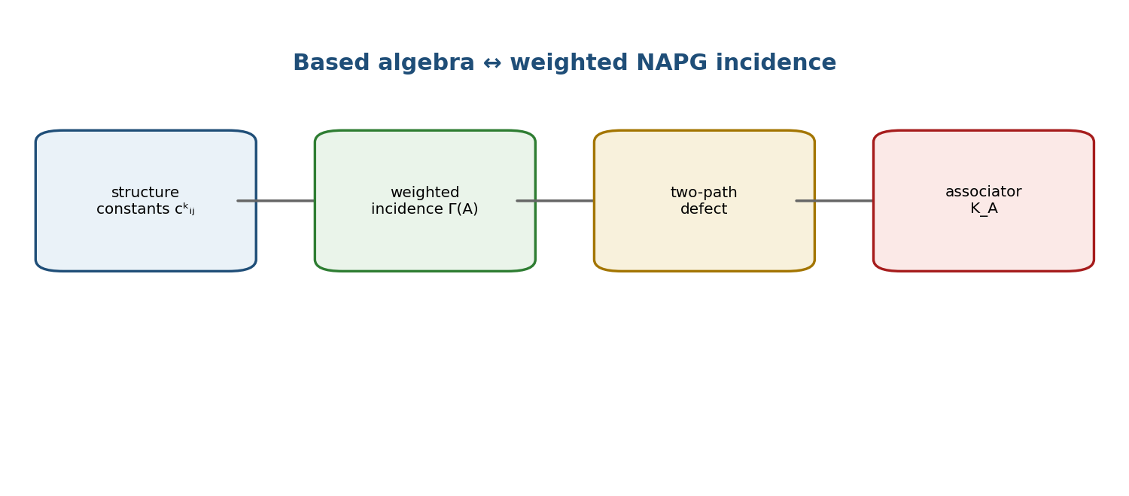
Figure 26.1. Structure constants and weighted two-step paths carry the same based finite-dimensional data.

26.1. Notation and Status Discipline
Symbol | Type
⊙ | basic bilinear multiplication
R⋆R | authorial quadratic packet object Q(R)=R⊙R
⋆_H | Hodge star; not multiplication
Ass_⊙ | trilinear associator
δ | cochain differential; δ_Hdg reserved for Hodge codifferential

26.2. Based Packet Reper Algebra
Definition 26.8. A based packet Reper algebra consists of a finite-dimensional K-vector space A with a fixed homogeneous basis B={e_i}, a bilinear multiplication ⊙, Size@Dimension labels, state/Reper data, and declared domain predicates.
e_i⊙e_j=Σ_k c^k_{ij}e_k. [RU p. 128]
Ass_⊙(e_i,e_j,e_ℓ)=Σ_m K^m_{ijℓ}e_m. [RU p. 128]
Finite dimensionality makes the product automatically continuous for any chosen norm, but no unit, involution, alternative law, or multiplicative norm is inherited unless separately specified.

26.3. Quadratic Packet Object R⋆R
Q(R)=R⋆R:=R⊙R. [RU p. 129]
The quadratic object is not the multiplication itself. Polarization recovers the symmetric cross term when R,S,R+S are admissible: Q(R+S)−Q(R)−Q(S)=R⊙S+S⊙R.

26.4. NAPG Operational Frame and Obstruction
An operational NAPG frame fixes the carrier, the admissible operation, a test family, a representation map, and an obstruction target. The quadratic obstruction records failure of two specified packet paths to agree; it is not automatically a cohomology class.

26.5. Weighted NAPG Incidence
Definition 26.20. A weighted NAPG incidence on the finite index set I stores an oriented basis node for each e_i and weights c^k_{ij} for the incidence (i,j)→k. Geometrization Γ sends a based algebra to this weighted incidence object; linearization L reconstructs the product from the weights.

26.6. Algebra–Geometry Reconstruction
Theorem 26.23 (Kurpishev packet Reper algebra–geometry duality) [THM]. On the groupoid of finite-dimensional based packet Reper algebras and the groupoid of weighted NAPG incidences with basis-preserving isomorphisms, Γ and L are mutually inverse up to the canonical based isomorphisms.
L(Γ(A))≅A, Γ(L(G))≅G. [RU pp. 134–135]
The word “duality” here means mutual reconstruction of based data. It is not vector-space duality, Gelfand duality, or an unrestricted contravariant equivalence of all nonassociative algebras.

26.7. Associator as a Two-Path Defect
Definition 26.25. For basis inputs i,j,ℓ and output m, let the left path sum compose (i,j) first and the right path sum compose (j,ℓ) first. Their difference is the geometric path defect.
K^m_{ijℓ}=Σ_p c^p_{ij}c^m_{pℓ}−Σ_q c^q_{jℓ}c^m_{iq}. [RU p. 136]
Theorem 26.26 [THM]. Under Γ, the algebraic associator coefficient equals the weighted two-path defect exactly. Hence associativity is equivalent to equality of the two path sums for every basis quadruple.

26.8. Reper Compatibility and λ
A Reper-admissible isomorphism must preserve the role labels R,I,U,D, the projective chart, Dom, and the sufficient foundation. Theorem 26.30 [THM] states that such an isomorphism preserves λ, δ_truth, and the truth-gate status. A bare vector-space isomorphism need not.

26.9. Conditional Cohomological and PN.2 Bridges
A map Π_E from the quadratic obstruction carrier to H³ is conditional on a declared complex, differential, and compatibility with the quotient projection. The implication Π_E(Ob_B)≠0⇒Ob_B≠0 is one-way unless injectivity is proved; a zero image does not imply a zero obstruction.
The local PN.2 bound is transported through the algebra–geometry reconstruction only when the norm, branch metric, structural coordinate, and hidden-alternative model are preserved. The transport is a theorem about the based equivalence, not a new physical uncertainty relation.

26.10. Operator Interface and Open Layers
An evolution Ξ_t acting on A preserves the associator tensor only when it is an algebra automorphism. Isometry additionally preserves norm-based defects and truth gates. Compatibility of the insertion Υ with the algebra carrier is a separate model hypothesis.
Layer | Status | Reason
finite based algebra ↔ weighted incidence | THM | mutual reconstruction proved
associator = two-path defect | THM | coefficient identity
λ preservation | THM under Reper-admissible isomorphism | typed compatibility required
cohomology map Π_E | COND | complex and injectivity not automatic
Hodge / G₂ realization | MODEL / OPEN | additional geometric data required
physical interpretation | PHY-HYP / OPEN | no independent empirical bridge

NOVELTY BOUNDARY. The internal theorem concerns the newly defined based categories and their reconstruction. Classical nonassociative algebras, structure constants, associators, category equivalence, cohomology, Hodge theory, and G₂ geometry remain prior art.

T1-EN-OPERATORS-v0.4 Release Ledger
Item | Verified scope | Result
chapter coverage | T1-CH-01–T1-CH-26 | 26/26 present
new source range | RU pp. 73–146 | translated and locator-preserved
notation firewall | ⊙, ⋆_H, R⋆R, Ass_⊙, Δ, Ξ, Υ | distinct types preserved
PN.2 status | hidden-branch minimax theorem | THM inside explicit model
physical status | subject exports and observables | EMP-PLAN / PHY-HYP; no EMP-OBS
next checkpoint | Chapters 27–31 | T1-EN-PN2-v0.5

Translation Obligations
ID | Obligation | Status
T1-EN-PO-013 | complex cross-ratio and real-reduction parity | CLOSED-DRAFT
T1-EN-PO-014 | operator cross-ratio ordering and invertibility parity | CLOSED-DRAFT
T1-EN-PO-015 | proof-cleaned DK dependencies and countermodel parity | CLOSED-DRAFT
T1-EN-PO-016 | index and cross-reference semantics parity | CLOSED-DRAFT
T1-EN-PO-017 | canonical PN.2 theorem and proof parity | CLOSED-DRAFT
T1-EN-PO-018 | PN.2 prediction and export firewall parity | CLOSED-DRAFT
T1-EN-PO-019 | typed Δ/Ξ/Υ operator parity | CLOSED-DRAFT
T1-EN-PO-020 | based algebra–NAPG duality parity | CLOSED-DRAFT
T1-EN-PO-021 | independent bilingual formula audit | OPEN NON-VETO

STATUS LOCK. truth_layer_promotion=0. NUM≠EXT-RUN≠EMP-OBS. The English derivative preserves the Russian source status and may not create an empirical result.

T1-EN-PN2-v0.5
CONTROLLED ENGLISH TRANSLATION OF CHAPTERS 27–31
DERIVATIVE BOUNDARY. The following text is a controlled derivative of frozen Russian source pages 140–168. The English layer preserves every theorem hypothesis, counterexample, proof obligation, model limitation, source-certificate limitation, and physical-status firewall. It does not claim a new execution of the PN2-PO12-A2-v1.0 archive.

Chapter parity map for the v0.5 checkpoint
Chapter | Russian locator | English title | Dominant status
27 | 140–159 | Canonical PN.2 with Internal Appendices A–B | THM / COND / NUM-SOURCE
28 | 160–161 | Predictive Limits and the Finite Horizon of a Reper | DEF-A / THM / COND
29 | 162–163 | Adaptive Rebuilding of the Reper Graph | THM-SCHEMA / COND
30 | 164–165 | Predictive Reper Bundle | DEF-A / COND / OPEN
31 | 166–168 | Computational Certification and the Boundary of Evidence Status | THM / NUM-SOURCE / OPEN

Chapter 27. Canonical PN.2 with Internal Appendices A–B and Explanatory Blocks
Russian source locator: pp. 140–159
PLAIN-LANGUAGE EXPLANATION. This chapter stores the complete theorem package rather than a slogan. A single estimator must answer under two hidden bracketing protocols. The elementary geometry of two alternatives yields a minimax error bound; the appendices then show exactly when the bound vanishes, when a scalar observable fails, when the coefficient 1/4 is sharp, and what the source-documented computational certificate does and does not establish.

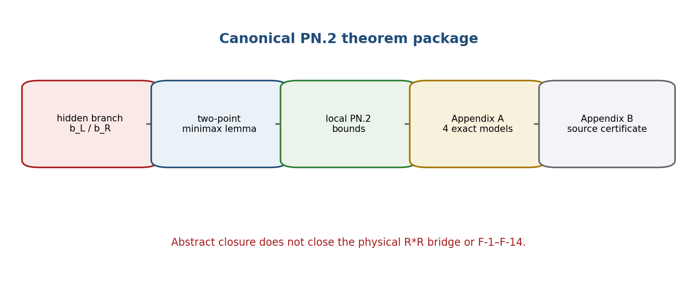
Figure 27.1. The canonical PN.2 route separates theorem, exact models, source certificate, and physical transfer.

27.1. Synchronisation of Evidence Statuses
The canonical Russian source records PO-11 as closed by four explicit constructions and PO-12 as closed for the abstract package by the source-documented certificate PN2-PO12-A2-v1.0. This closure is conservative: it does not propagate to PO-1–PO-10, the physical object R*R, or hypotheses F-1–F-14.
Proposition 27.1 [PROP]. A deterministic certificate for the auxiliary algebra A2 establishes reproducibility of the published computations in that model, but does not establish semantic correctness of a physical map from R*R to A2.
Proof. The certificate checks identities generated by the structural constants of A2. Transfer requires a separate morphism preserving the product, norm, structural coordinate, observable, and domains. The certificate contains no such physical morphism. Therefore computational reproducibility cannot promote the physical bridge.
PHENOMENOLOGICAL READING. Reproducibility answers whether the same computation can be obtained again. The physical bridge must answer what, in experience, that computation represents.

27.2. Objects, Errors, and Model Axioms
Let A be a real or complex normed linear space with a bilinear operation odot. For u=(x,y,z) in the admissible set Omega, define the two bracketed outcomes
r_L(u)=(x odot y) odot z, r_R(u)=x odot (y odot z), K(u)=r_L(u)-r_R(u). [RU pp. 142–143]
The hidden branch b belongs to B={b_L,b_R}. A branch-blind estimator must issue the same pair of estimates without using b. This information restriction, not nonassociativity alone, creates the uncertainty problem.
e_S(u;s_hat)=max{|s_hat-S(r_L(u))|, |s_hat-S(r_R(u))|}. [RU p. 143]
e_D(u;d_hat)=max{|d_hat-Dfrak(b_L)|, |d_hat-Dfrak(b_R)|}. [RU p. 143]
e_R(u;r_hat)=max{||r_hat-r_L(u)||, ||r_hat-r_R(u)||}. [RU p. 143]
Delta_S(u)=|S(r_L(u))-S(r_R(u))|, Delta_D=|Dfrak(b_L)-Dfrak(b_R)|, Delta_R(u)=||K(u)||. [RU p. 143]
An observable S is c-separating on Omega when Delta_S(u) >= c||K(u)|| for all u. A uniform PN.2 domain relative to a positive scale m(u) has Delta_D>0 and a constant epsilon_minus>0 such that ||K(u)|| >= epsilon_minus m(u) throughout Omega.
Model axioms of the strict PN.2 package
Axiom | Content | Failure mode
A1 | Normed algebra; bilinear operation; both outcomes defined on Omega. | Undefined product or domain.
A2 | Exactly two admissible branches; branch hidden from estimator. | No hidden alternative.
A3 | Nondegenerate structural coordinate: Delta_D>0. | Structural coordinate does not distinguish protocols.
A4 | One branch-blind estimator is used for both alternatives. | Branch label supplied in advance.
A5-S | Scalar observable separates the outcomes, preferably c-separating. | Scalar version may have zero bound.
A6 | Uniform coercivity on an explicit normalized domain for a global constant. | Only local or zero lower bound.

SCOPE EXCLUSIONS. The theorem does not apply on K=0 sectors, when Delta_D=0, to a branch-informed estimator, or as an automatic Robertson-Schrödinger or Ozawa relation. Ordinary vector-space dimension and ordinary parse-tree depth do not by themselves supply the required structural coordinate.

27.3. Two-Point Lemma and the Local Minimax Theorem
Lemma 27.2 [LEM]. For any two points a,b in a metric space and any q,
max{d(q,a),d(q,b)} >= d(a,b)/2. [RU p. 144]
Proof. The triangle inequality gives d(a,b) <= d(a,q)+d(q,b) <= 2 max{d(q,a),d(q,b)}.
Theorem 27.3 [THM: Local Minimax PN.2]. Under A1–A4, for every u in Omega and every branch-blind pair of estimates,
e_S(u;s_hat) e_D(u;d_hat) >= (1/4) Delta_S(u) Delta_D. (PN.2-S) [RU p. 145]
e_R(u;r_hat) e_D(u;d_hat) >= (1/4) ||K(u)|| Delta_D. (PN.2-R) [RU p. 145]
e_S(u;s_hat) e_D(u;d_hat) >= (c/4) ||K(u)|| Delta_D. (PN.2-K) [RU p. 145]
The last inequality requires a c-separating observable. The proof applies the two-point lemma to the two observable values, the two structural-coordinate values, and, for the full-state form, the two outcomes in the norm metric. Each separate error is at least half the corresponding gap; multiplying yields the factor 1/4.

27.4. Uniform Form and Correction of Earlier Quantitative Arguments
Corollary 27.4 [COND]. If Omega is a uniform PN.2 domain relative to m(u), then
e_R e_D >= (epsilon_minus Delta_D/4) m(u). [RU p. 145]
For a c-separating observable, the right side is multiplied by c. A historical expression involving ||R||^3 requires separate identifications of the errors, structural coordinate, scale, and a strictly positive infimum.
epsilon_plus=sup ||K(u)||/m(u) gives an upper bound; epsilon_minus=inf_{u in Omega} ||K(u)||/m(u)>0 gives the required lower bound. [RU p. 146]
The reverse triangle inequality gives only | ||r_L||-||r_R|| | <= ||K||. Norms of two bracketings may coincide even when K is nonzero, as in normed composition algebras. Hence the default strict formulation uses the full-state distance or a proved separating observable.
CATEGORICAL CAUTION. The absence of a natural transformation between two unspecified functors is not a no-go theorem for joint estimation. A categorical PN.2 requires explicit categories, functors, domains, and a precisely defined absence of a section, lift, or natural estimator.

27.5. Proof Obligations PO-1–PO-12
Conservative proof-obligation ledger
PO | Obligation | Status in this checkpoint
1 | Specify the physical algebra R*R: carrier, field, basis, product, constants, unit, involution, norm, domain. | OPEN / source-dependent
2 | Verify bilinearity, closure, continuity, zero divisors, and all used operators. | OPEN / source-dependent
3 | Compute nonzero associators and classify sectors. | OPEN for physical R*R
4 | Define an invariant, distinguishing structural coordinate Dfrak. | OPEN for physical interpretation
5 | Choose a c-separating observable or use the full-state metric. | OPEN for physical observable
6 | Specify the measurement model and why the branch is hidden. | OPEN
7 | Prove a positive epsilon_minus on a normalized Omega. | OPEN for physical domain
8 | Fix physical units of S, Dfrak, K, m, and kappa. | OPEN
9 | Build the categorical no-go object. | OPEN
10 | Construct the Hilbert-space bridge to PN.1 and prove operator-domain conditions. | OPEN
11 | Provide four explicit models and countermodels. | CLOSED-ABSTRACT by Appendix A
12 | Provide reproducible code, tests, values, and hashes. | CLOSED-ABSTRACT / SOURCE-CERT by Appendix B

27.6. Physical Hypotheses F-1–F-14
No entry in this table inherits theorem status from the abstract minimax result
ID | Hypothesis requiring independent verification | Status
F-1 | R*R is a physical algebra of time, not only a mathematical model. | PHY-HYP
F-2 | PN.2 is more fundamental than Robertson-Heisenberg or noise-disturbance relations. | PHY-HYP
F-3 | Quantum uncertainty follows from the associator through a representation. | PHY-HYP
F-4 | A dimensionally correct regime ||K|| approximately hbar exists. | PHY-HYP
F-5 | An induced bracket [x,y]_z=K(x,y,z) yields an admissible operator commutator. | PHY-HYP
F-6 | Seven R*R objects form an internal multicomponent time structure. | PHY-HYP
F-7 | FOS and Time*Space possess an observable physical realization. | PHY-HYP
F-8 | The hierarchy and time-course operator describe physical temporal evolution. | PHY-HYP
F-9 | A physically defined complexity functional is monotone. | PHY-HYP
F-10 | The associator-dynamics equation is a valid covariant field equation. | PHY-HYP
F-11 | Associator dynamics predicts an observable early-universe regime. | PHY-HYP
F-12 | The associator localizes in matter and produces measurable effects. | PHY-HYP
F-13 | The observer-accessible structural branch is physically finite. | PHY-HYP
F-14 | PN.2 gives testable corrections to GR/quantum theory or explains singularities/dark sectors. | PHY-HYP

MINIMUM EXTERNAL STANDARD. Each physical hypothesis requires operational observables, units, a null model, preregistered discrimination criteria, uncertainty accounting, open data/code, and reproduction by an independent group.

27.7. Internal Appendix A — Four Explicit Models for PO-11
All four cases use the signed protocol coordinate Dfrak(b_L)=-1/2 and Dfrak(b_R)=+1/2, so Delta_D=1 and the midpoint estimate d_hat=0 has e_D=1/2. Cases A.2–A.4 use the auxiliary real algebra A2=R^2 with basis e1,e2 and product
e1 odot e1=e2, e2 odot e1=e2, e1 odot e2=-e2, e2 odot e2=0. [RU p. 151]
(alpha,beta) odot (gamma,delta)=(0, alpha gamma + beta gamma - alpha delta), ||(alpha,beta)||=2 sqrt(alpha^2+beta^2). [RU p. 151]
Exact witness matrix of Appendix A
Case | Data | Exact result | Role
A.1 | A=R; u=(1,2,3); S(t)=|t|. | r_L=r_R=6; K=0; both PN.2 right sides 0. | Counterexample to any unconditional positive lower bound.
A.2 | A2; u=(e1,e1,e1); S(v)=||v||. | r_L=e2, r_R=-e2; ||K||=4; Delta_S=0; PN.2-R: 1=1. | Nonassociativity may be invisible to a scalar norm.
A.3 | A2; S(alpha e1+beta e2)=2 beta; u=(e1,2e1,3e1). | K=12e2; ||K||=Delta_S=24; c=1; both bounds attain 6. | Global c-separation and sharp factor 1/4.
A.4 | A2 on explicit compact box Omega; same S. | inf_Omega ||K||=epsilon_minus=3; kappa_Omega=3/4, attained at u_star. | Exact positive uniform lower bound on a declared domain.

For x=(a,b), y=(p,q), z=(r,s) in A2, the associator is
K(x,y,z)=(0, 2apr+bpr-aps)=(0, p[(2a+b)r-as]). [RU p. 154]
On the compact box a,p,r in [1,2] and b,q,s in [-1/4,1/4], the source proves p[(2a+b)r-as] >= 3/2 and therefore ||K|| >= 3. The point u_star=(e1-(1/4)e2, e1, e1+(1/4)e2) attains equality.
epsilon_minus=3, c=1, Delta_D=1, kappa_Omega=c epsilon_minus Delta_D/4=3/4. [RU pp. 154–155]
APPENDIX A SCOPE. The four models close PO-11 only inside the abstract PN.2 theorem package. They do not identify A2 with the physical R*R object and do not supply physical units or an experiment.

27.8. Internal Appendix B — Source-Documented Certificate for PO-12
Identifier: PN2-PO12-A2-v1.0. The Russian source describes a standard-library Python bundle containing the computation, tests, manifest, results, expected/obtained table, deterministic bundle builder, instructions, and SHA-256 list. This English checkpoint translates that record; it does not claim that the archive was independently rerun in the present environment.
C[2,1,1]=1, C[2,2,1]=1, C[2,1,2]=-1; all other structural constants vanish. [RU p. 156]
A[m,i,j,k]=sum_l (C[l,i,j] C[m,l,k] - C[l,j,k] C[m,i,l]). [RU p. 156]
Source-reported certificate matrix
Test item | Expected and source-reported obtained value | Source verdict
A.1 | K=0; Delta_S=e_S=e_R=0; e_D=1/2; bounds 0=0. | PASS
A.2 | K=(0,2); ||K||=4; Delta_S=e_S=0; e_R=2; PN.2-R: 1=1. | PASS
A.3 | K=(0,12); ||K||=Delta_S=24; c=1; e_S=e_R=12; bounds 6=6. | PASS
A.4 | K=(0,3/2); ||K||=Delta_S=epsilon_minus=3; kappa=3/4; bounds 3/4=3/4. | PASS
Grid | 729 rational points in Omega satisfy the exact K formula, Delta_S=||K||, and ||K||>=3. | PASS
Out-of-domain boundary | p=1/2 produces ||K||=3/2<3, confirming domain dependence. | PASS

The source records 11 automated tests and the archive digest
SHA-256(pn2_po12_cert_v1.0.zip)=bbcb2715a3e5ab7688dfe1ad317a68f23b163ae10915982216111142ce7da2ad. [RU p. 158]
- The certificate establishes the published A2 operation, associator, four example values, Delta_D=1, e_D=1/2, c=1, epsilon_minus=3, kappa_Omega=3/4, and source-documented deterministic rebuild properties.
- It does not establish that A2 is the physical R*R algebra, the physical meaning of Dfrak or S, PO-1–PO-10 for R*R, a bridge to hbar or PN.1, F-1–F-14, or universal physical validity.
- Chapter 31 further records that the archive itself was not present in that assembly, so an external replay remains open.
STATUS. PO-12 = CLOSED-ABSTRACT / SOURCE-CERTIFICATE. Independent replay in a separate environment remains OPEN. NUM is not EXT-RUN and not EMP-OBS.

Chapter 28. Predictive Limits and the Finite Horizon of a Reper
Russian source locator: pp. 160–161
PLAIN-LANGUAGE EXPLANATION. A Reper is not authorised forever. Its forecast is valid only while every declared political, ecological, spatial, temporal, and ontological gate remains inside its domain and above its boundary. The horizon is therefore a limit of responsibility of current knowledge.

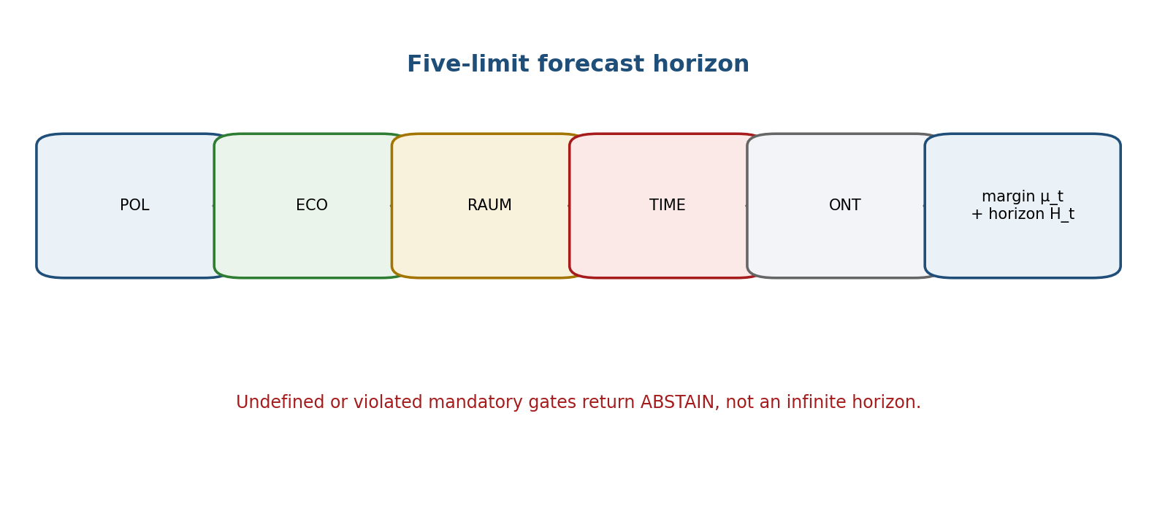
Figure 28.1. The forecast horizon is controlled by the weakest of five typed limit functions.

28.1. Typed Limit Functions
Let Lambda_lim={POL,ECO,RAUM,TIME,ONT}. For each alpha define a partial function
g_alpha : Dom(g_alpha) subset X x Rcal x T -> R. [RU p. 160]
Positive values denote an interior admissible state, zero denotes the boundary, negative values denote violation, and an undefined value is bottom and never counts as a passed gate.
Adm_t(r)={x in X : (x,r,t) belongs to every Dom(g_alpha) and g_alpha(x,r,t)>=0 for all alpha}. [RU p. 160]
Code | Authorial label | Strict role | Forbidden overclaim
POL | LIM POLITIC | Institutional, infrastructural, or registered-regime boundary. | Universal law of politics.
ECO | LIM ECOLOGICAL | Resource and ecological constraints of the model. | Automatic catastrophe forecast.
RAUM | LIM RAUM | Spatial/geographical admissible domain. | Metaphysical closure of the world.
TIME | LIM TIME | Lifetime of data, Reper, and calibration. | Eternal Reper.
ONT | LIM ONTHOLOGY | Type and semantic dictionary of admissible objects. | Automatic ban on new objects.

The projective boundary marker D_infinity is not the evidence component D. Dom is the mathematical domain, D is the available sufficient foundation, and D_infinity is a projective endpoint marker.

28.2. Margin, Horizon, and Robust Gate
mu_t(x,r)=min_alpha g_alpha(x,r,t). [RU p. 160]
H_t(x,r)=sup{h>=0 : inf_{s in [t,t+h]} mu_s(x_s,r)>0}. [RU p. 160]
If the trajectory is unknown, the infimum is taken over all trajectories in a registered corridor. An empty trajectory set returns ABSTAIN rather than an infinite horizon.
Theorem 28.1 [THM]. If g_TIME(x,r,s)=tau_r-(s-t0) with finite registered lifetime tau_r, then H_t(x,r)<=tau_r-(t-t0). Thus there is no Reper authorised on the whole half-line under this explicit finite-lifetime model.
For an observed x_hat with the true state in B(x_hat,rho), if every g_alpha is L_alpha-Lipschitz in x, the sufficient robust gate is
g_alpha(x_hat,r,t) > L_alpha rho for every mandatory alpha. [RU p. 161]
Then the whole uncertainty ball lies in Adm_t(r). If any margin fails, the status is boundary-uncertain; a numerical score cannot compensate for that status.
Proposition 28.4 [PROP]. Adding a mandatory limit cannot enlarge the admissible set or the horizon.
FALSIFICATION BOUNDARY. A forecast miss is valid only when Dom, D integrity, and the corridor were fixed in advance. Otherwise the event is protocol failure, not a mathematical refutation.

Chapter 29. Adaptive Rebuilding of the Reper Graph
Russian source locator: pp. 162–163
PLAIN-LANGUAGE EXPLANATION. After a valid miss, the system edits the smallest proof neighbourhood that actually generated the forecast. It creates a new version beside the old one. Learning is a history of reasons, not the silent replacement of yesterday’s certificate.

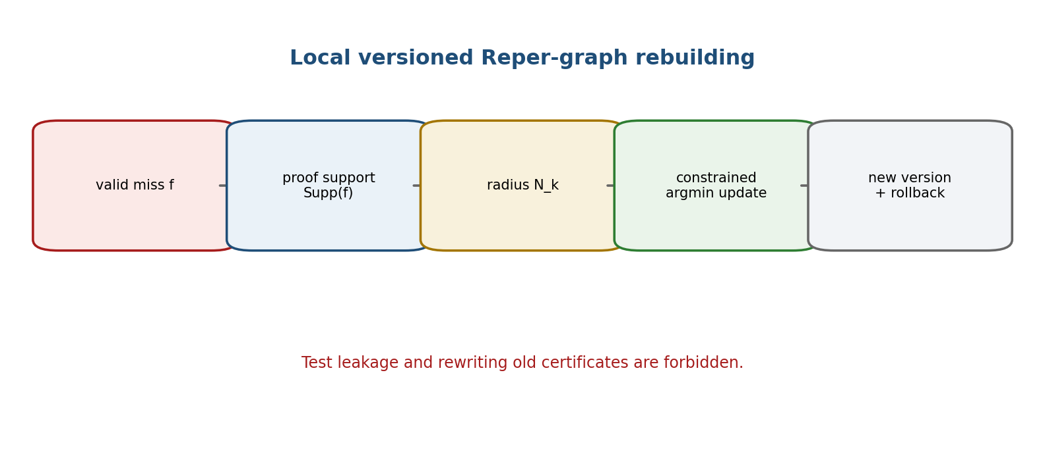
Figure 29.1. A valid miss triggers a local, constrained, versioned update with rollback.

29.1. Versioned Graph and Failure Support
G_t=(V_t,E_t,w_t,s_t). [RU p. 162]
Vertices are versioned Reper objects; edges are typed formula or domain relations; w_t are numerical parameters; s_t are evidence statuses. Every vertex stores its validity interval and links to D, Dom, code, and certificate. For a failed forecast f, Supp(f) is the smallest set of vertices and edges actually used to form the corridor and select the output.

29.2. Constrained Rebuilding Functional
G_{t+1} in argmin_{G in G_adm} [L_{t+1}(G)+eta d_edit(G,G_t)+gamma B_PN2(G)+kappa B_gate(G)]. [RU p. 162]
B_PN2 is infinite when branches are hidden or an unauthorised singleton is produced. B_gate is infinite when D/Dom, matched-null, CGI, or independent-validation requirements are bypassed. The weights are fixed before the independent test is viewed.
Theorem 29.1 [THM-SCHEMA]. If the loss, edit cost, and constraints decompose over vertices and edges and all terms outside N_k(Supp(f)) are unchanged, a minimiser exists that agrees with G_t outside that neighbourhood.
For fixed graph structure and an m-strongly convex parameter objective, if the gradient changes by at most delta at the old minimiser, then
||theta_{t+1}-theta_t|| <= delta/m. [RU p. 162]
This estimate does not apply to discrete structural changes, which retain edit distance, an alternative ledger, and full rollback.

29.3. Sequential Alarm, Test Leakage, and Selective Loss
E_t=product_{i<=t} e_i, E_0=1, E_0[e_t | F_{t-1}]<=1. [RU p. 162]
Under the registered null, E_t is a nonnegative supermartingale. Ville’s inequality gives P_0(sup_t E_t >= 1/alpha)<=alpha. The conditional null and exchangeability assumptions are proof obligations; choosing e_t after viewing future data invalidates the signal.
The data are separated into T_train, T_cal, T_test, and T_future. Once T_test has been opened, a version tuned on it requires evaluation on a new unopened or external corpus.
ell_sel=ell_pred 1_{forecast}+c_A 1_{ABSTAIN}+c_F 1_{false authorisation}, c_F>c_A>=0. [RU p. 163]
The inequality formalises evidence safety: when gates fail, abstention is cheaper than an unauthorised point answer. Costs are domain-specific, not universal constants.
OPERATOR ALIGNMENT. Xi evolves an authorised branch, Delta is a new data/action impulse, and Upsilon inserts the result into an updated state space. A noninjective Upsilon preserves the preimage set and yields a set-valued Reper or ABSTAIN.

Chapter 30. Predictive Reper Bundle
Russian source locator: pp. 164–165
PLAIN-LANGUAGE EXPLANATION. Predictions from different sciences live in different fibres over their domains. A domain adapter is a partial morphism. Its curvature measures the discrepancy between two routes of translation; visual similarity of graphs or lambda values is not a proof of law transfer.

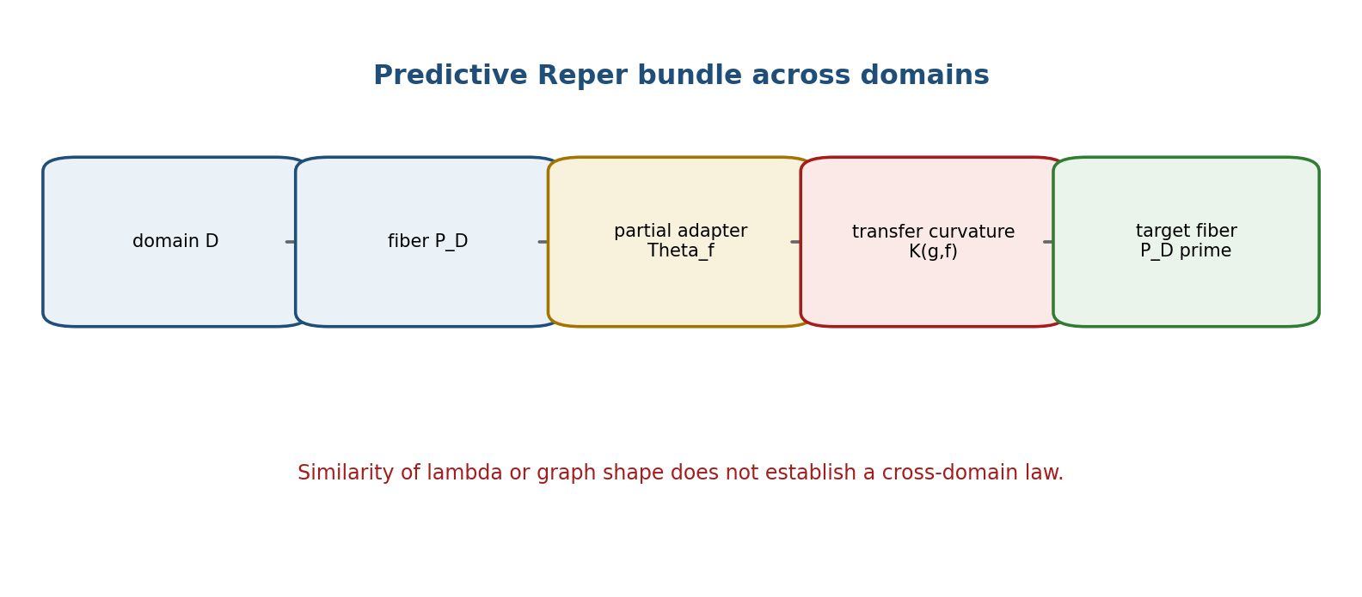
Figure 30.1. Cross-domain transfer is partial and carries an explicit curvature or path discrepancy.

30.1. Base Category, Fibres, and Partial Projection
Let Bcal be a small category of domains and admissible translations. Each domain D carries a fibre P_D of predictive packets and a fibre Obs_D of observables. A packet contains its Reper, data, Dom, branches, gates, corridor, loss, and certificate.
pi_D : P_D -> Obs_D, p |-> (prediction corridor, status, proof object). [RU p. 164]
The projection is partial. A missing mandatory object produces bottom/ABSTAIN, never a numerical zero.
Xi_D(p)=(delta_ass, delta_gate, delta_cal, delta_null, delta_transfer). [RU p. 164]
The defect vector is domain-invariant only relative to a declared group of admissible relabellings and representation G_D. Its norm is invariant only when G_D acts isometrically.

30.2. Partial Adapters and Transfer Curvature
Theta_f : Dom(Theta_f) subset P_D -> P_Dprime. [RU p. 164]
The adapter must transport types, units, D/Dom, branches, observable, and status. In linear fibres, for composable f and g, define
Kcal(g,f)=Theta_g o Theta_f - Theta_{g o f}. [RU p. 164]
In nonlinear fibres the subtraction is replaced by two paths and a target metric. Theorem 30.2 [THM]. If Theta is a functor into the category of partial maps with equal composite domains, then Kcal(g,f)=0. The converse also needs identity maps and coherence on triple compositions.
If the target observable projection is L-Lipschitz and the two transfer routes differ by at most kappa, then the prediction outputs differ by at most L kappa. Without estimates of L and kappa, cross-domain prediction remains exploratory.

30.3. Local Sections, Gluing, and PN.2 Obstruction
For a cover {U_i}, local sections s_i agree exactly when their overlap defects vanish. If P_D is a sheaf and the pairwise and triple-overlap conditions hold, a unique global section exists. This is a conditional theorem: each concrete Reper presheaf must be proved to satisfy the sheaf axioms.
When overlap defects are positive, the output is a corridor or a minimisation problem, not a global point prediction. A positive lower bound is an obstruction to unique gluing.
Proposition 30.5 [PROP]. If Delta_S Delta_D>0, no branch-blind exact section can reproduce both S and Dfrak on the two branches. Otherwise e_S=e_D=0 would contradict the PN.2 lower bound.
FANO AND KMA STATUS. The Fano plane is retained as a finite incidence template and search barrier, not as proof of physical seven-dimensionality. KMA values are seed metadata. Target-domain validation remains mandatory.

Chapter 31. Computational Certification and the Boundary of Evidence Status
Russian source locator: pp. 166–168
PLAIN-LANGUAGE EXPLANATION. A certificate joins formula, code, data, domains, branch structure, and status so that a result can be repeated and contradicted. It is valuable because it remembers its own limits. A digest proves identity of bytes, not correctness of the model.

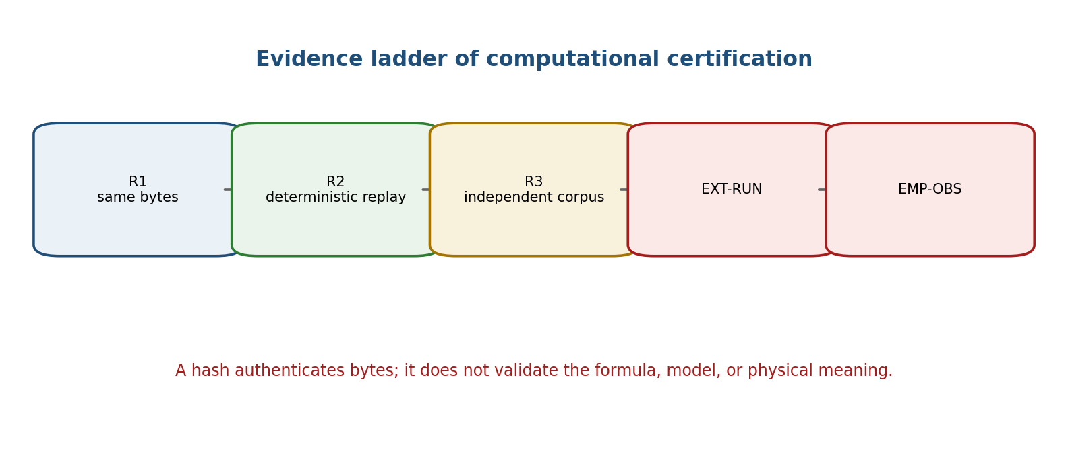
Figure 31.1. Computational replay, independent rerun, and empirical observation are distinct evidence levels.

31.1. Full Certificate Type and Immutability
Cert=(id,version,source_hash,code_hash,data_hash,D,Dom,split,B,gates,null,CGI,Xi,H,output,status,PO). [RU p. 166]
D and Dom are mandatory and distinct. B stores branches; gates are three-valued; null records the matched-null assumptions; CGI stores value, calibration, and threshold; Xi is the Chapter 30 defect vector; H is the Chapter 28 horizon. A correction creates a new id/version and a supersedes link; the old object is never rewritten.
Three levels of reproducibility
Level | Requirement | Permitted conclusion
R1 | Input and program byte hashes match. | Byte-level identity of the declared inputs.
R2 | Fixed environment and exact or fully specified arithmetic reproduce the same output. | Deterministic computational replay.
R3 | Independent researcher obtains a compatible result on a new corpus under a preregistered protocol. | Independent subject-matter reproducibility.

Theorem 31.1 [THM]. A pure deterministic program with fixed environment, all input bytes, and exact or fully specified rounding returns the same output on replay. SHA-256 equality is evidence of byte identity with negligible collision probability, but does not verify that the program implements the right formula or that the data are representative.

31.2. PN2-PO12-A2-v1.0 and the Replay Blocker
The canonical source documents the A2 structural constants, eleven tests, exact c=1, epsilon_minus=3, kappa_Omega=3/4, and bundle hashes. The source also states that the archive pn2_po12_cert_v1.0.zip was not present in that assembly. Accordingly, Chapter 31 does not claim a new independent code execution. It records the published source certificate and leaves external replay open.
NO STATUS SUBSTITUTION. A translated certificate record is not a rerun receipt. A local checksum of the monograph is not the checksum of the absent certificate archive.

31.3. Sequential Validity
For a continuously monitored database, a static p-value is insufficient when publication follows repeated inspection. A preregistered e-process or alpha-spending rule is required.
Theorem 31.2 [THM]. If E_t is a nonnegative supermartingale under H0 and E_0<=1, then the test that rejects when sup_t E_t>=1/alpha has false-rejection probability at most alpha.
P_0(sup_t E_t >= 1/alpha) <= alpha E_0 <= alpha. [RU p. 166]
The supermartingale condition is itself a proof obligation of the concrete null. Without it, continued monitoring introduces undeclared multiplicity and the status is statistical-gate-failed.

31.4. Frozen Artifact Card and Final Status Ledger
The source preserves the following immutable chain without changing any field:
RIUD-TETRA-RUN006-029 -> PROOF-OBJ-RUN007-0029 -> FORMAL-CARD-RUN009-006 -> SIGNATURE-REVIEW-RUN013-001. [RU p. 167]
lambda=-0.992736565468, delta_truth=0.007263434532, CGI=0.140948882338. [RU p. 167]
Its status remains signature-ready-not-truth-layer. CGI<1 is a necessary gate in that pipeline, not a sufficient truth condition.
Final status ledger of the v0.5 translated scope
Object | Preserved status | Established | Still open
PN.2 | proved under explicit assumptions | Local minimax lower bound. | Physical bridges.
PO-11 | closed abstract | Four explicit models. | Transfer to physical R*R.
PO-12 | closed abstract/source certificate | Published exact A2 tests and hashes. | External replay of the archive.
Five limits | formalised conditional | Gates, margin, horizon. | Domain thresholds.
Adaptive Reper | theorem schema | Locality and leakage prohibition. | Empirical evaluation.
Predictive bundle | defined / conditional | Typed transfer and curvature. | Sheaf property of real fibres.
Artifact-1 | frozen | signature-ready-not-truth-layer. | Certificate-lock review.

FINAL BOUNDARY. The v0.5 checkpoint ends at Chapter 31. It adds no experimental data, performs no independent EXT-RUN, and does not promote any physical claim. The next stage begins with typed domain adapters and independent predictive validation.

T1-EN-PN2-v0.5 — Checkpoint Register
Register item | Value
Translated scope | Chapters 1–31; new material Chapters 27–31.
Russian locators added | pp. 140–168.
Canonical theorem package | PN.2 local minimax theorem with conditional uniform form.
Internal Appendix A | Four exact constructions; PO-11 closed abstract.
Internal Appendix B | Source-documented certificate; PO-12 closed abstract/source-certificate.
Physical register | F-1–F-14 preserved as PHY-HYP/OPEN.
Predictive architecture | Five limits, finite horizon, local rebuilding, bundle, certification levels.
Evidence firewall | NUM-SOURCE != EXT-RUN != EMP-OBS.
Next checkpoint | T1-EN-DATA-v0.6: Chapters 32–40.

Status_EN(x) <= Status_RU(x), truth_layer_promotion=0.

T1-EN-DATA-v0.6
CONTROLLED ENGLISH TRANSLATION OF CHAPTERS 32-40
This checkpoint extends the frozen Russian Volume I derivative through Chapter 40. It translates the typed domain-adapter layer, data identity and provenance, identifiability and transportability, conformal calibration, blocker-safe execution, covariate-shift correction, anytime-valid monitoring, and branch aggregation. The Russian source remains authoritative for formulas, status labels, hypotheses, and page locators.
Authority(T1-RU v197) > Authority(T1-EN v0.6); Status_EN(x) <= Status_RU(x)
Status firewall. truth_layer_promotion=0. Type correctness, database integrity, replay, conformal coverage, regret bounds, and e-process evidence do not by themselves imply EXT-RUN or EMP-OBS.

v0.6 Change-Set and Parity Scope
ID | Change | Status
T1-EN-CS-041 | Translated Chapters 32-40 with Russian page locators 169-189. | CLOSED-DOC
T1-EN-CS-042 | Added a typed-adapter and source-anchor contract. | DEF/PROP
T1-EN-CS-043 | Preserved the 46 raw / 45 byte-unique / 45 database-row import audit and its counter blocker. | NUM-AUDIT
T1-EN-CS-044 | Translated identifiability, support, matched-null, and split-validation gates. | THM/COND
T1-EN-CS-045 | Translated split and weighted conformal corridors with branch-union semantics. | THM/COND
T1-EN-CS-046 | Translated blocker absorption, replay passport, e-process, and Hedge regret results. | THM/PROP/NUM
T1-EN-CS-047 | Added nine English diagrams and a cumulative status ledger. | DOC-QA

Part VIII. Domain Adapters and Independent Predictive Validation
This part develops concrete domain adapters, identity and provenance rules, transport assumptions, calibration corridors, and a computational contract. The numerical database counts refer to a verified project snapshot, not to a universal volume of knowledge.

Chapter 32. Strict Specification of KLT-RBD Domain Adapters
Russian source locator: pp. 169-171
Central question | What must be defined before one algorithm can operate in several scientific domains?
Plain meaning | Each domain receives its own data types, units, observables, admissibility rules, and null model. The common engine is not permitted to infer these from a column name.
Mathematical core | A domain adapter is a partial typed composition of encoding, Reper construction, observation, loss, matched-null, and certification.
Boundary of inference | A type-correct adapter proves interface coherence only. It does not establish the empirical truth of a domain hypothesis.

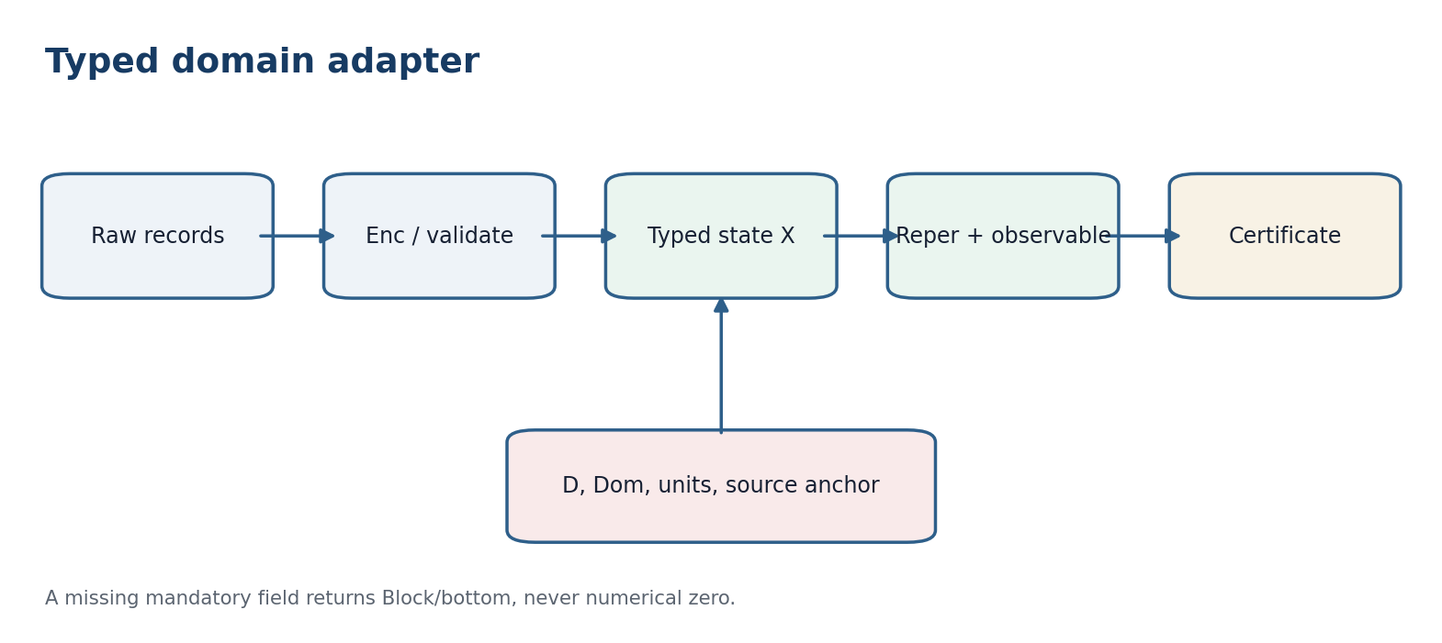
Figure 32.1. A domain adapter preserves types, units, D, Dom, and the source anchor.

32.1. Domain as a Typed Object
Dcal_delta = (Raw_delta, X_delta, Y_delta, Sigma_delta, Unit_delta, Time_delta) [RU p. 169]
Raw_delta is the space of raw records, X_delta the space of cleaned states, Y_delta the observable-response space, Sigma_delta the admitted transformations, Unit_delta the unit system, and Time_delta the temporal scale. None of these components is identified with the evidence set D or with the mathematical domain Dom.
A_delta = (Enc_delta, Rep_delta, Obs_delta, Loss_delta, Null_delta, Cert_delta) [RU p. 169]
Enc_delta:Raw_delta -> X_delta is partial and encodes a record; Rep_delta:X_delta -> Rcal_delta is partial and constructs a Reper; Obs_delta:X_delta -> Y_delta specifies the observable; Loss_delta evaluates a forecast; Null_delta defines the matched-null; and Cert_delta emits an evidence passport. Dom(A_delta) is the intersection of the domains of all actually invoked operators. The finite evidence set D_delta is a separate object, so the inclusion D_delta subset Dom(A_delta) is a proof obligation.

32.2. Correctness Conditions
Definition 32.1 [DEF]. The adapter A_delta is correct on D_delta when: (i) Enc_delta is defined on every record; (ii) Obs_delta has the declared response type and units; (iii) every Reper stores source_id, U/I/R/D, limits, operators, status, and revision; (iv) Null_delta preserves the registered conditioning covariates; (v) Cert_delta stores hashes, D, Dom, and all blockers; and (vi) loss of a mandatory field returns bottom/Block rather than numerical zero.
Theorem 32.1 - Type soundness of composition [THM]. If Enc_delta, Rep_delta, and Obs_delta are type-compatible and x belongs to Dom(Rep_delta o Enc_delta), then Obs_delta(Enc_delta(x)) and the constructed Reper refer to one state in X_delta. If one domain inclusion fails, the composite is not defined as a function.
Proof. A defined composite requires Enc_delta(x) to belong simultaneously to Dom(Rep_delta) and Dom(Obs_delta). Both operators then receive an object of the same declared type X_delta. If either inclusion fails, at least one value is absent, so writing a total function would be a type error.

32.3. Canonical Reper Record and Source Anchor
r=(reper_id, source_id, work_id, domain, U, I, R, D, limits, operators, status, revision) [RU p. 170]
The full Atlas record may also include subdomain, author, source_title, tags, formula_hint, extraction_level, confidence, copyright_mode, source_basis, r_weight, u_connectivity, and created_at. A database column is not automatically a mathematical hypothesis; each theorem must state which fields enter its assumptions.
Axiom 32.A [DEF-A]. No domain Reper is authorised without a D-source anchor: source_id and source_basis must be nonempty, the sources/works reference must resolve, and copyright_mode must permit the intended operation.
Proposition 32.2 - Orphan-source blocker [PROP]. If source_id does not resolve in the sources table, every claim using that Reper receives blocker=orphan-source regardless of lambda or CGI.
Proof. Both lambda and CGI are computed relative to source data and assumptions. Without a resolvable source, D and the computation conditions cannot be reconstructed, so the certificate is incomplete.

32.4. Domain-Code Catalogue
Code | Domain | Typical observable | Mandatory qualification
PHYS | Physics | Measurement with units and instrument model | Experimental calibration
CHEM | Chemistry | Composition, channel, rate, spectrum | Stoichiometry, redox, energy, and kinetics separated
BIO | Biology | Phenotype, state, sequence | Accession, build, and pipeline
MECH | Mechanics | Load, displacement, stability | Boundary conditions
NGEOM | Descriptive geometry | Projection, section, visibility | Reper and centre of projection
FIN / BANK / INS | Finance, banking, insurance | Price, liquidity, reserve, risk | Regime and timestamp
CONSTR / ARCH | Construction and architecture | Time, resource, defect, function | Normative version
HIST / LIT | History and literature | Source, motive, period, narrative | Semantic, not physical, observable
GEO / STRAT | Geography and strategy | Territory, flow, scenario, constraint | Limits and source chronology

32.5. Cross-Domain Strategic Slice
SAR_j=(Goal_j; RBD_slice_j, Limits_j, Lambda_j, CGI_j, Evidence_j, Rebuild_j) [RU p. 171]
RBD_slice_j subset P_delta1 x_C P_delta2 x_C ... x_C P_deltam [RU p. 171]
Proposition 32.3 - Empty compatibility fibre product [PROP]. If two domain packets assign incompatible time intervals or units to the same canonical_id and no registered transformation exists, their fibre product over the compatibility base C is empty.
Proof. A point of the fibre product must have the same image in C. Incompatible intervals or units yield different images and therefore no common point.

32.6. Minimal Executable Contract
The minimal contract contains parse, validate, canonicalize, build_reper, predict_set, attach_fact, score, rebuild, and emit_certificate. Every function returns Result(value, errors, warnings), so a damaged row cannot silently disappear or become an admissible observation.
Philosophical-phenomenological note. A domain adapter is not a translator that erases differences between languages. It is the discipline of encounter: it must show what survives the passage from phenomenon to record and what remains outside the encoding.

ADAPTER-CERT-v196i7. domain=delta; Raw/X/Y=typed; Enc/Rep/Obs=partial; D/Dom=distinct; units=explicit; source-anchor=mandatory; null=registered; missing-field=bottom; strategy-slice=fibre-product-over-compatibility; empirical-truth=not-inferred-from-type-correctness.

Chapter 33. Identity, Provenance, and Data Integrity
Russian source locator: pp. 172-173
Central question | When do two files represent one object, and how is the derivation history preserved?
Plain meaning | One file may have two names and two files may have one name. A proof chain needs separate path, byte, and semantic identities.
Mathematical core | Raw records are quotiented by a proven equivalence relation, while provenance is stored as a directed acyclic graph.
Boundary of inference | A matching hash establishes byte identity for the checked files; it does not establish semantic equivalence between different documents.

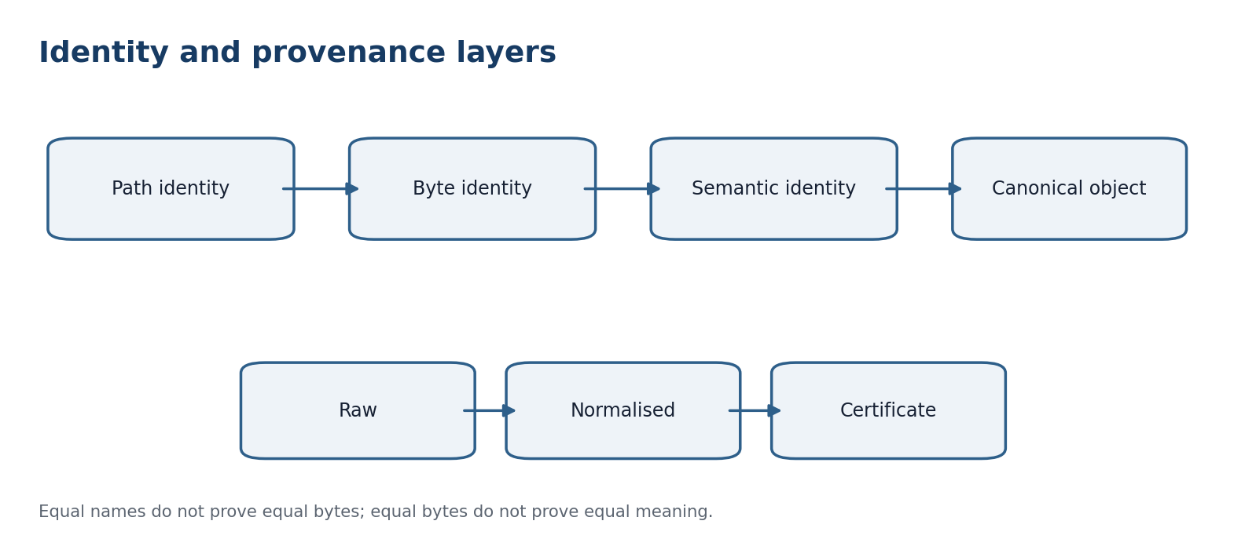
Figure 33.1. Path, byte, and semantic identity are different relations; provenance records the transformation path.

33.1. Three Levels of Identity
id_path(a)=normalize(path_a); id_byte(a)=(|a|, SHA256(a)) [RU p. 172]
The semantic identifier is assigned only after a domain comparison of version, language, object, and role. Definition 33.1 [DEF]. On a finite set of files, a is byte-equivalent to b exactly when their byte sequences are equal. SHA-256 is a fast index; a critical conflict may be settled by direct byte comparison.
Theorem 33.1 - Byte quotient and idempotent canonicalisation [THM]. The quotient A/~_b has one class for each distinct byte sequence. After selecting a representative, the canonicalisation map kappa is idempotent: kappa(kappa(a))=kappa(a).
Proof. Byte equality is reflexive, symmetric, and transitive, so it partitions A. Re-canonicalising a selected representative stays in the same class.

33.2. Concrete Import Audit v1.0
The discovered and classified CSV files contain 46 raw rows but 45 distinct SHA-256 values. Index_mirrors_klt510_v4_1.html and index_mirrors_klt510_v4_1.html have the same size (49,981 bytes), the same digest b2efc1635f4ddfca168cb832e17be9a41a05fe2bdbf736eb2457808b3daf4a4b, and direct byte equality. The SQLite import_artifacts table and the entity-map export contain 45 rows, while the run report preserves imported_artifact_count=46. The snapshot is immutable; the mismatch is documented rather than overwritten.
Audit object | Result | Status | Required action
Raw rows | 46 | verified | Preserve as N_raw
Byte-unique objects | 45 | verified | Preserve as N_byte
import_artifacts | 45 | verified read-only | Align a future report
Run imported count | 46 | counter mismatch | Repair only in a new version
SQLite integrity_check | ok | pass | Preserve database hash
foreign_key_check | 0 violations | pass | Keep as mandatory test

Proposition 33.2 - Counter relation [PROP]. For this snapshot N_raw=46, N_byte=N_db=45, and N_duplicate=1; hence N_raw=N_db+N_duplicate.
Proof. One nontrivial byte-equivalence class contains the two case variants; the remaining 44 classes are singletons. Therefore there are 45 classes and one excess raw row.

33.3. Provenance as an Evidential DAG
For each result define G_prov=(V,E), with vertex types raw, normalized, reper, forecast, fact, score, and certificate. An edge u->v means that v was computed directly from u. source_hash is attached to raw data, code_hash to a transformation, and result_hash to an output.
Theorem 33.3 - Acyclicity under a strict rank [THM]. If every edge u->v strictly increases a version number or computation timestamp, then G_prov is acyclic.
Proof. Along a directed cycle the rank would have to increase strictly and return to its initial value, which is impossible.

33.4. Referential Integrity
Proposition 33.4 - Transactional foreign-key gate [PROP]. If all inserts are transactional, foreign keys are enabled, and COMMIT occurs only after PRAGMA foreign_key_check returns the empty set, the committed state contains no SQLite orphan links detectable by that check.
Proof. Any foreign-key violation appears in the check output; the COMMIT rule excludes such a transaction from the committed state.
Foreign-key integrity is necessary but not sufficient for semantic correctness. It proves that the referenced row exists, not that the stated relation is true.

33.5. Privacy as Partial Observability
PUB, MIXED, PRIVATE, and CLOSED classify permission to publish, not evidential quality. The public projection Pub:Artifact -> Artifact_pub is partial and requires a passed public_private_splits decision. In the verified snapshot, 41 imported objects are PUB and four are MIXED; all four MIXED objects remain in needs_review. This is an active publication blocker, not a database error.
Philosophical-phenomenological note. A filename is only one perspective on an object. Provenance returns the object to its history: where it came from, which operation transformed it, and why the current record may participate in an inference.

ID-PROV-CERT-v196i7. identity={path,byte,semantic}; raw_count=46; byte_unique=45; db_rows=45; duplicate_pair={Index,index}; byte_equal=true; counter_mismatch=open; integrity_check=ok; foreign_keys=0; provenance=DAG-under-rank; privacy={PUB:41,MIXED:4-needs-review}; historical-snapshot=immutable.

Chapter 34. Identifiability, Transportability, and Independent Validation
Russian source locator: pp. 174-175
Central question | What can be recovered from observations, and when may a result move from one population or domain to another?
Plain meaning | No program can recover a hidden distinction when two models produce the same observable law. Transport additionally requires target support within source support.
Mathematical core | Identifiability is defined through observational equivalence; target risk is expressed through a Radon-Nikodym weight; matched-null inference uses group invariance.
Boundary of inference | All results are conditional on distributions and registered interfaces. They do not validate a concrete domain hypothesis without data.

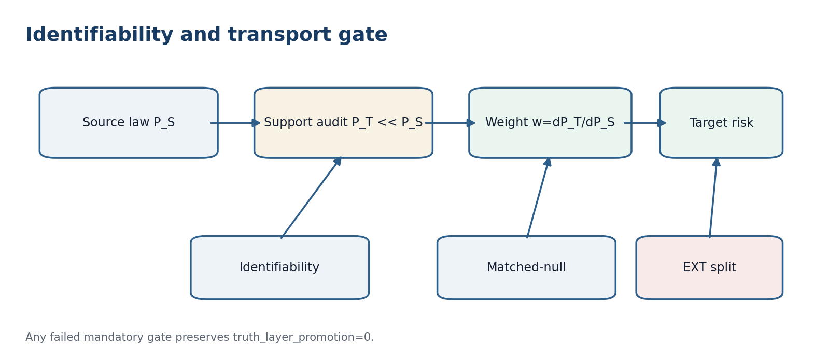
Figure 34.1. Identifiability, support, matched-null, and independent-source gates are conjunctive.

34.1. Observational Equivalence
theta ~_obs theta_prime iff P_theta = P_theta_prime on the observable sigma-algebra [RU p. 174]
Definition 34.1 [DEF]. A parameter theta is identifiable when theta~_obs theta_prime implies theta=theta_prime. A functional psi(theta) may be identifiable even when theta is not, provided observational equivalence implies equality of psi.
Theorem 34.1 - Impossibility of exact selection [THM]. If theta is not equal to theta_prime but P_theta=P_theta_prime, no estimator can equal theta almost surely under P_theta and equal theta_prime almost surely under P_theta_prime.
Proof. The event {theta_hat=theta} would have probability one under P_theta and zero under P_theta_prime. Equal observable laws assign the same probability to every observable event, giving a contradiction.
Kurpishev PN.2 supplies a specific structural mechanism of such impossibility: hidden branches require one answer while the observable and structural gaps remain positive.

34.2. Support Condition for Transfer
R_T(f)=E_T[loss]=E_S[w(X,Y) loss], w=dP_T/dP_S, P_T << P_S [RU p. 174]
Theorem 34.2 - Weighted target-risk identity [THM]. If P_T is absolutely continuous with respect to P_S and w*loss is integrable, then the target risk equals the weighted source risk.
Proof. This is the defining integral identity of the Radon-Nikodym derivative.
Counterexample 34.1. If there is a set A with P_T(A)>0 and P_S(A)=0, source data contain no evidence about the loss on A. No finite weighting repairs the gap. The adapter must return support-gap/ABSTAIN.

34.3. Structural Transport of a Reper
A transfer Theta_{S->T} must make the observation diagram commute on Dom(Theta), preserve units and time indices, carry the source anchor, and control the transfer curvature from Chapter 30.
Proposition 34.3 - Internal lambda does not repair a noncommutative observable map [PROP]. If Obs_T o Theta differs from phi_Y o Obs_S, equality of internal lambda coordinates does not imply equality of target predictions.
Proof. Noncommutativity provides a packet for which the two routes yield different observables. The internal coordinate does not erase that difference.

34.4. Matched-Null as Group Randomisation
p_G(Z)=|{g in G : T(gZ)>=T(Z)}| / |G| [RU p. 175]
Theorem 34.4 - Exact randomisation level [THM]. If a finite group G acts on Z and the null law conditional on the orbit GZ is invariant, then P_0(p_G<=alpha)<=alpha, with ordinary discrete conservatism. For B sampled transformations use p_hat=(1+#)/(B+1).
Proof. Under the null, the observed position is exchangeable with the positions on its orbit. The upper-tail rank is exact or conservative; the plus-one correction includes the observed configuration in the Monte Carlo rank.

34.5. Independent Validation Route
T_train independent of T_cal independent of T_test; source(T_ext) != source(T_train union T_cal union T_test) [RU p. 175]
Features are selected on train, thresholds and corridors on calibration, one frozen evaluation is performed on test, and transfer is examined on an external corpus. Opening test and then changing the model creates a new version. Distinct source labels do not automatically imply statistical independence; shared instruments, references, or duplicated objects must be audited in provenance.

34.6. CGI and the Noncompensation Rule
Theorem 34.5 - No status promotion through compensation [THM]. If any mandatory identifiability, support, null-invariance, or independent-validation gate equals 0 or bottom, truth_layer_promotion remains 0 regardless of CGI.
Proof. Authorisation is the conjunction of mandatory gates. A zero or undefined conjunct cannot be changed to one by a separate numerical field.
Philosophical-phenomenological note. Transportability is not visual similarity. It is a right to carry a result across a boundary. That right exists only after showing that the target side does not contain relevant possibilities the source sample never observed.

TRANSPORT-CERT-v196i7. identifiability=explicit; support=P_T<<P_S-or-gap; risk-transfer=Radon-Nikodym-weighted; observation-diagram=commutative; curvature=bounded; matched-null=group-invariant; split=train/cal/test/ext; CGI<1=noncompensating-gate; failed-gate=>truth_layer_promotion=0.

Chapter 35. Forecast Corridors, Conformal Calibration, and Abstention
Russian source locator: pp. 176-177
Central question | How should a predictive method report uncertainty when several PN.2 branches remain admissible?
Plain meaning | The output is a calibrated set of future values, not merely a central number. Hidden branches enlarge the honest answer.
Mathematical core | Split conformal prediction gives finite-sample marginal coverage under exchangeability; branch-aware PN.2 output uses a union of branch corridors.
Boundary of inference | The guarantee is not pointwise conditional coverage and may fail under unmodelled temporal drift or unsupported transfer.

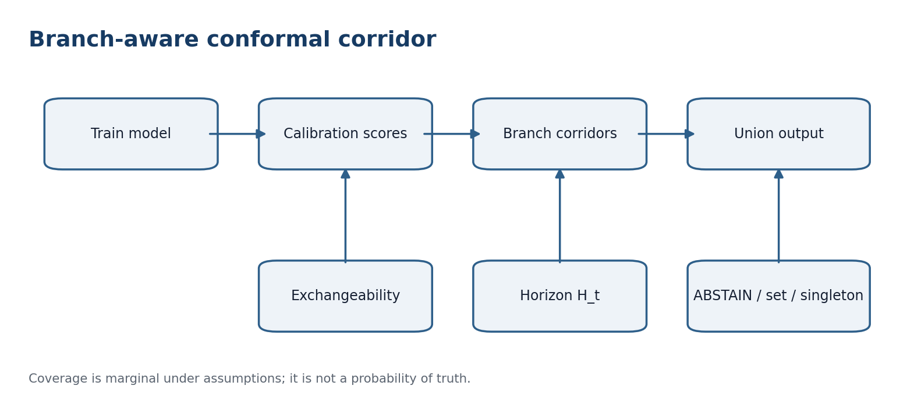
Figure 35.1. Calibration produces branch corridors; the branch-blind output is their gated union.

35.1. Split Conformal Corridor
k=ceil((n+1)(1-alpha)); q=s_(k); C_alpha(x)={y : s(x,y)<=q} [RU p. 176]
Theorem 35.1 - Finite-sample marginal coverage [THM]. If the n calibration pairs and the new pair are exchangeable, and the model and score were fixed without using calibration responses after disclosure, then P{Y_(n+1) in C_alpha(X_(n+1))} >= 1-alpha.
Proof. The rank of the new score among the n+1 exchangeable scores is uniform up to conservative tie handling. The selected order statistic bounds the upper-tail probability by alpha.
This is a marginal guarantee under the joint law. It is not a promise of 1-alpha coverage at each fixed x. Rare subgroups require preregistered Mondrian or group-conditional calibration and adequate sample size.

35.2. PN.2 Branch Corridors
C_alpha^PN2(x) = union_{b in B(x)} C_{alpha,b}(x) [RU p. 176]
Theorem 35.2 - Coverage by branch union [THM]. If the true branch b* belongs to the registered set B(x) and C_{alpha,b*}(x) covers Y with probability at least 1-alpha, the union corridor has coverage at least 1-alpha.
Proof. The true-branch corridor is a subset of the union, so true-branch coverage implies union coverage.
Counterexample 35.1. Two disjoint exact branch corridors have an empty intersection. Intersecting them can return an empty answer even when each branch corridor has perfect coverage in its own regime.

35.3. Corridor and Horizon
C_{t,h}(x) is valid only for h<=H_t(x,r) from Chapter 28. Approaching a limit may widen the set monotonically, reduce the horizon, or trigger abstention. The system may not secretly narrow the corridor after observing the fact.
Proposition 35.3 - Safe horizon contraction [PROP]. If C_h is nested monotonically in h and H_prime<=H, replacing H by H_prime does not reduce coverage on the retained horizons h<=H_prime, although it narrows the claim domain.
Proof. For every retained h the corridor and its distribution remain unchanged; only farther claims are removed.

35.4. Selective Decision
Out(x) = ABSTAIN, a set-valued corridor, or a singleton with a uniqueness certificate [RU p. 177]
If the set is empty because the model is invalid, or every candidate has gate not equal to one, the output is ABSTAIN. If several evidence-admissible components remain, the full labelled set is returned. A singleton requires a proved uniqueness certificate. Noncoverage, false authorisation, and abstention cost are reported separately.

35.5. Drift and Recalibration
A drift alarm removes the exchangeability assumption between calibration and future data. The current corridor receives status=drift-suspected, the horizon is shortened, and recalibration is performed on the next registered block. Old coverage is not carried forward. An e-process may monitor misses, but it requires its own null model and does not replace conformal coverage.

35.6. Calibration after Domain Transfer
Even a flat structural adapter does not automatically transfer the conformal quantile. The target domain requires a target calibration set or a proved weighting scheme under P_T<<P_S. A support gap requires ABSTAIN until target examples are obtained.
Philosophical-phenomenological note. A corridor does not build a wall around the future. It records the width of predictive responsibility: the more hidden branches and the closer the Reper limit, the more honest the set-valued answer becomes.

CORRIDOR-CERT-v196i7. method=split-conformal; guarantee=marginal-under-exchangeability; quantile=ceil((n+1)(1-alpha)); PN2-combination=union; branch-set=registered; horizon=H_t; drift=>status-demotion; target-transfer=recalibrate-or-weight-with-support; outputs={corridor,ABSTAIN,certified-singleton}; conditional-coverage=not-claimed.

Chapter 36. KLT-RBD Computational Contract and Final Audit v196i14
Russian source locator: pp. 178-180
Central question | How are the preceding mathematical conditions turned into an executable database and software route?
Plain meaning | Each theorem-facing claim receives a stage, input, output, invariant, and explicit stop condition.
Mathematical core | The ten Atlas stages form a conditional soundness pipeline from raw C@C input to an immutable publication snapshot.
Boundary of inference | Executability does not mean that any concrete domain adapter has already passed an independent validation.

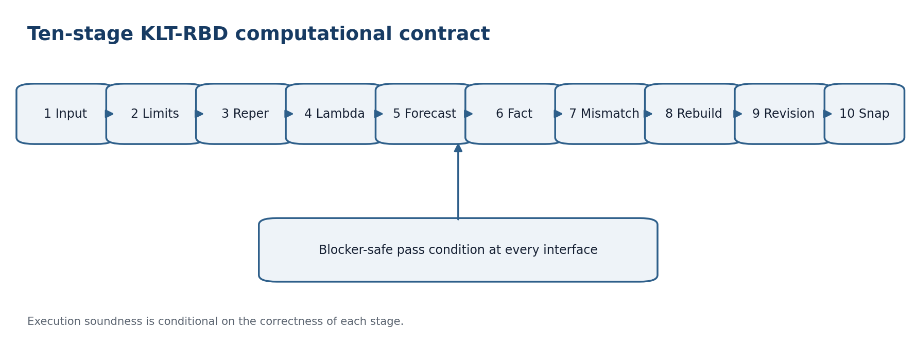
Figure 36.1. Ten-stage KLT-RBD computational contract with a blocker-safe interface at every step.

36.1. Ten-Stage Pipeline
Stage | Input -> output | Mandatory invariant | Block
1 Input C@C | raw -> event_state_limit | source_hash, type | parse error
2 LimitGate | packet -> LimOK/OntOK | five limits, D/Dom | 0 or bottom
3 ReperSearch | query -> candidates | source anchor | orphan source
4 LambdaClosure | candidates -> lambda-status | registered formula | KMA-only match
5 ForecastBuild | status -> corridor | PN.2 branches | hidden branch
6 FactAttach | fact -> pair | canonical_id/time | identity conflict
7 MismatchDetect | pair -> causal gap | frozen tolerance | test leakage
8 NearestRebuild | gap -> N_epsilon queue | locality | global rewrite
9 RevisionChain | queue -> new version | old version immutable | in-place edit
10 Snapshot | revision -> package | privacy/status/hash | MIXED not passed

36.2. State of the Audited Databases
The read-only Atlas v2.1 audit reported sources=236, works=1145, repers=2212, reper_edges=2478, interdisciplinary_domains=14, limit_layers=5, operator_derivatives=8, and predictive_protocol steps=10. PRAGMA integrity_check returned ok and foreign_key_check returned zero violations.
The read-only real-data-import v1.0 audit reported import_artifacts=45, site_pages=33, lambda_audit_items=42 (supported=38, gap=4), public_private_splits=5, and four privacy classes. The 46/45 counter discrepancy remains a documented report-level blocker.

36.3. Minimal Adapter Test Set
Test | Purpose
T-AD1 | Schema: mandatory fields and types.
T-AD2 | D/Dom: every record in D lies in the domain of every invoked operator.
T-AD3 | Round trip: canonicalize(canonicalize(x))=canonicalize(x).
T-AD4 | Provenance: complete raw-to-certificate path.
T-AD5 | Null: invariance of matched transformations.
T-AD6 | Corridor: finite-sample formula on a synthetic exchangeable sample.
T-AD7 | Support: target states outside source support trigger ABSTAIN.
T-AD8 | Rebuild: only the registered neighbourhood changes.
T-AD9 | Privacy: MIXED/PRIVATE objects are not published without passed review.
T-AD10 | Replay: identical input and environment reproduce the certificate.

Theorem 36.1 - Conditional end-to-end soundness [THM]. Assume that stages 1-10 are type-correct, preserve source and provenance, pass their gates, and permit transition only when status=pass. Then a published snapshot has a resolvable path to raw data, passed the declared limits, PN.2, null, CGI, and privacy gates, and does not modify historical versions.
Proof. Induct on the stages. Stage 1 creates a typed object with source_hash. At each later step, pass plus invariant preservation provides a valid input to the next stage, while any blocker stops the chain. Stage 10 serialises all retained invariants into the certificate.
The theorem is a software soundness result relative to the correctness of the stages. It does not prove completeness of ReperSearch, correctness of a domain observable, or truth of the external world.

36.5. Falsification and Rebuilding
The snapshot distinguishes confirmed, local_mismatch, limit_shift, semantic_fog, dark_rejected, and critical. dark_rejected denotes violation of the registered LIM_ONTOLOGY only; it is not a proof of metaphysical impossibility. If CGI_comp>=1 or CGI_pred>=1, the forecast is quarantined. A stable-limit mismatch triggers local Rebuild(N_epsilon); a limit shift creates a new version and preserves the old one as history.

36.6. Immutable Artifact-1 Card
RIUD-TETRA-RUN006-029 -> PROOF-OBJ-RUN007-0029 -> FORMAL-CARD-RUN009-006 -> SIGNATURE-REVIEW-RUN013-001 [RU p. 179]
lambda=-0.992736565468; delta_truth=0.007263434532; CGI=0.140948882338 [RU p. 179]
truth_layer_promotion=0; status=signature-ready-not-truth-layer; next=certificate-lock/publication-gate review. Neither a conformal corridor, read-only SQLite integrity, nor a small CGI changes this card without an independent signature and publication gate.

36.7. Sources of Mathematical Deepening
Project sources include the frozen Volume I predecessor, the KLT-RBD Interdisciplinary Reper Atlas v2.1, the real-data schema extension, monograph 5.0, PILOT-01, the SIGMA source, NAPG materials, the Desargues-Kurpishev package, FOS journal sources, and KLT6 packages. External prior art includes conformal prediction, transportability, covariate-shift weighting, Ville processes, and prediction with expert advice.

36.8. Final Status Ledger
Object | Status | Proved / checked | Open
Domain adapter | defined + typed | contract and composition | domain implementations
Atlas v2.1 | read-only verified | 236/1145/2212/2478; integrity ok | corpus updates
Real import | verified with blocker | 45 unique/imported; FK=0 | align count=46
Identifiability | theorem schema | no exact recovery under equivalence | concrete domain models
Transport | conditional theorem | risk identity under P_T<<P_S | target support and weights
Conformal corridor | proved under exchangeability | marginal finite-sample coverage | drift and conditional coverage
Artifact-1 | frozen | signature-ready-not-truth-layer | certificate-lock review

Philosophical-phenomenological note. A predictive method becomes rigorous not when it promises more future, but when it distinguishes what was observed, what was transported, what is covered by a corridor, and where the duty to answer becomes the duty to abstain.

DOMAIN-VALID-CERT-v196i7. source=frozen-T1; preserved_text=yes; chapters=32-36; adapter=typed-partial; identity={path,byte,semantic}; atlas_counts={236,1145,2212,2478}; import_audit={raw:46,unique:45,db:45,counter-blocker:1}; identifiability=required; transport=P_T<<P_S-or-ABSTAIN; matched-null=invariant; conformal=marginal-under-exchangeability; CGI<1=necessary-not-sufficient; KMA=metadata-only; independent_validation=mandatory; truth_layer_promotion=0-unless-all-gates-pass.

The translated checkpoint joins the mathematical PN.2 core to the real RBD/RPD schema. A subsequent independent experiment must implement one end-to-end adapter on an external corpus and publish negative outcomes alongside positive ones.

Part IX. End-to-End Predictive Validation
This part carries the Chapters 32-36 contract into execution semantics for errors, distribution shift, sequential monitoring, and competition between several PN.2 branches. Its subject is not a new truth declaration, but provable system behaviour when a gate fails.

Chapter 37. End-to-End Blocker-Safe Adapter and Reproducibility
Russian source locator: pp. 181-183
Central question | How can an early error be prevented from becoming a plausible late-stage forecast?
Plain meaning | Every operation returns either a valid value or a typed Block. A Block remains visible through all later stages.
Mathematical core | Partial operators are lifted to the sum type Result(X)=Ok(X) disjoint-union Block(B), where Block is absorbing.
Boundary of inference | Perfect replay on the same data remains computational evidence, not an independent empirical observation.

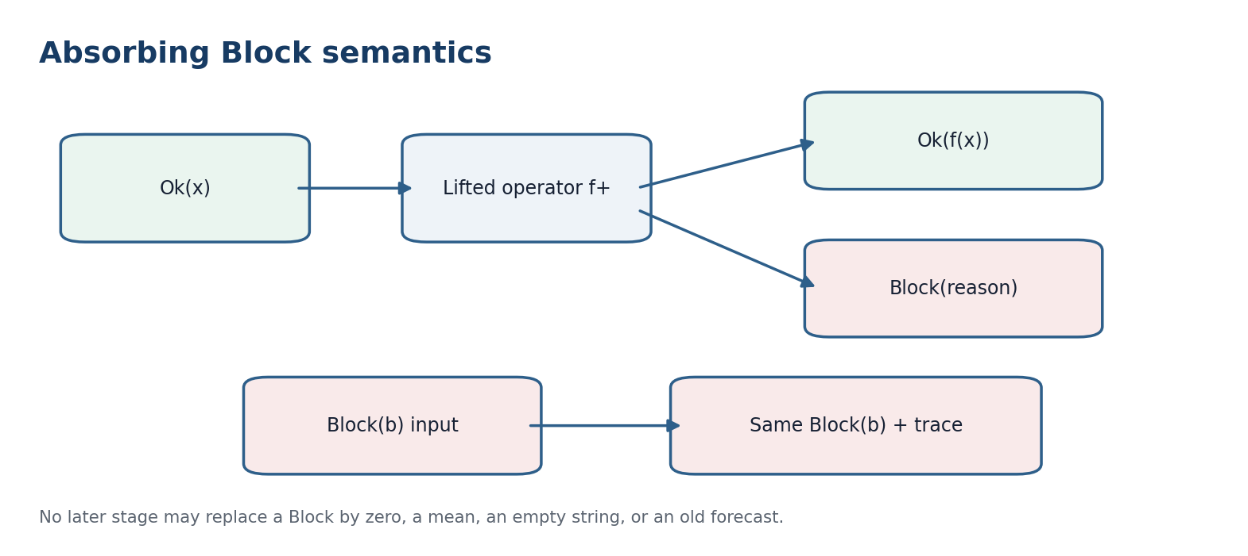
Figure 37.1. Block is an absorbing result with a preserved reason and trace.

37.1. Sum Type of Results
Result(X)=Ok(X) disjoint-union Block(B) [RU p. 181]
f+(Ok(x))=Ok(f(x)) or Block; f+(Block(b))=Block(b) [RU p. 181]
B includes parse-error, schema-gap, orphan-source, unit-conflict, support-gap, leakage, invalid-null, privacy-stop, and nonreproducible-state. Definition 37.1 [DEF]. A composition is blocker-safe when no stage replaces Block by a default value, empty string, zero, mean, or previous forecast.
Theorem 37.1 - Absorption of Block [THM]. For blocker-safe lifted operators f_1+,...,f_m+, if the result after stage j is Block(b), the full composite returns Block(b), adding only traversal metadata.
Proof. By definition, every subsequent lifted operator acts as the identity on a Block. Induction over the remaining stages preserves b; trace metadata does not change the result type.
Corollary 37.1 [COR]. status=pass is impossible when an unresolved Block occurs earlier in the trace. lambda, delta_truth, and CGI do not cancel this rule.

37.2. Ten End-to-End Stages and Their Blocks
No. | Operation | Verified output | Block
1 | Input C@C | type, source_hash | parse/schema
2 | LimitGate | five gates, D/Dom | limit 0 or bottom
3 | ReperSearch | source-anchored candidates | orphan source
4 | LambdaClosure | registered formula | KMA-only
5 | ForecastBuild | branch corridor | hidden branch
6 | FactAttach | canonical_id and time | identity conflict
7 | MismatchDetect | frozen loss | test leakage
8 | NearestRebuild | local queue | global rewrite
9 | RevisionChain | new immutable version | in-place edit
10 | Snapshot | hash/status/privacy | unpassed privacy

37.3. Canonicalisation and Round Trip
c(c(x))=c(x); decode(encode(x))=x on Dom(round-trip) [RU p. 182]
Proposition 37.2 - Idempotence prevents identifier drift [PROP]. Idempotent canonicalisation prevents identifier drift under repeated import, but it does not prove semantic equality of two sources.
Proof. A second canonicalisation preserves the chosen representative. Semantic equivalence is a separate domain relation not contained in string equality.

37.4. Real Import Audit
N(raw)=46; N(byte)=45; N(db)=45; N(dup)=1 [RU p. 182]
The count is not retroactively changed to a more convenient value. The certificate stores the raw count, byte-equivalence classes, deduplicated database count, and representative-selection rule.

37.5. Reproducibility Passport
RunID=H(data, schema, adapter, config, code, environment, seed) [RU p. 182]
The passport contains data_hash, schema_hash, adapter_hash, config_hash, code_hash, environment_hash, seed, locale, timezone, library_versions, and canonicalization_version. Missing any mandatory component returns Block.
Theorem 37.3 - Conditional replay equality [THM]. If the input bytes, all hashed components, deterministic operations, and computation order coincide, the canonical serialised certificate coincides.
Proof. Every stage is a deterministic function of its input and frozen configuration. Substitution of equal arguments yields equal outputs; canonical serialisation removes field-order variation.
Equal certificates prove replay of this route only. They do not prove that the model is correct.

37.6. Minimum End-to-End Tests
T-E2E-1 schema; T-E2E-2 D subset Dom; T-E2E-3 idempotence; T-E2E-4 provenance; T-E2E-5 units; T-E2E-6 matched-null; T-E2E-7 support-gap; T-E2E-8 local rebuild; T-E2E-9 privacy; T-E2E-10 replay. Replay compares status, branches, blockers, intermediate hashes, and forecast-set boundaries, not only the final number.
Philosophical-phenomenological note. An error becomes a scientific object when the system does not hide it beneath a number. Block is not an absence of knowledge; it is precise knowledge of the point where continuation is not yet authorised.

E2E-ADAPTER-CERT-v196i8. Result=Ok-or-Block; Block=absorbing; stages=10; D/Dom=distinct; canonicalization=idempotent; round-trip=domain-bounded; import={raw:46,byte:45,db:45,duplicate:1}; provenance=complete; replay=hash-locked; empirical-truth=not-inferred.

Chapter 38. Weighted Calibration under Covariate Shift
Russian source locator: pp. 184-185
Central question | How can calibration be adjusted when the target domain visits states with different frequencies?
Plain meaning | Ordinary ranks cease to be symmetric; density-ratio weights give some observed states a larger target voice.
Mathematical core | Under covariate shift P_S(Y|X)=P_T(Y|X) and P_T(X)<<P_S(X), a weighted conformal quantile includes a special test-point mass at +infinity.
Boundary of inference | Unknown, unstable, or infinite weights create a Block. Weighting does not prove causal transportability.

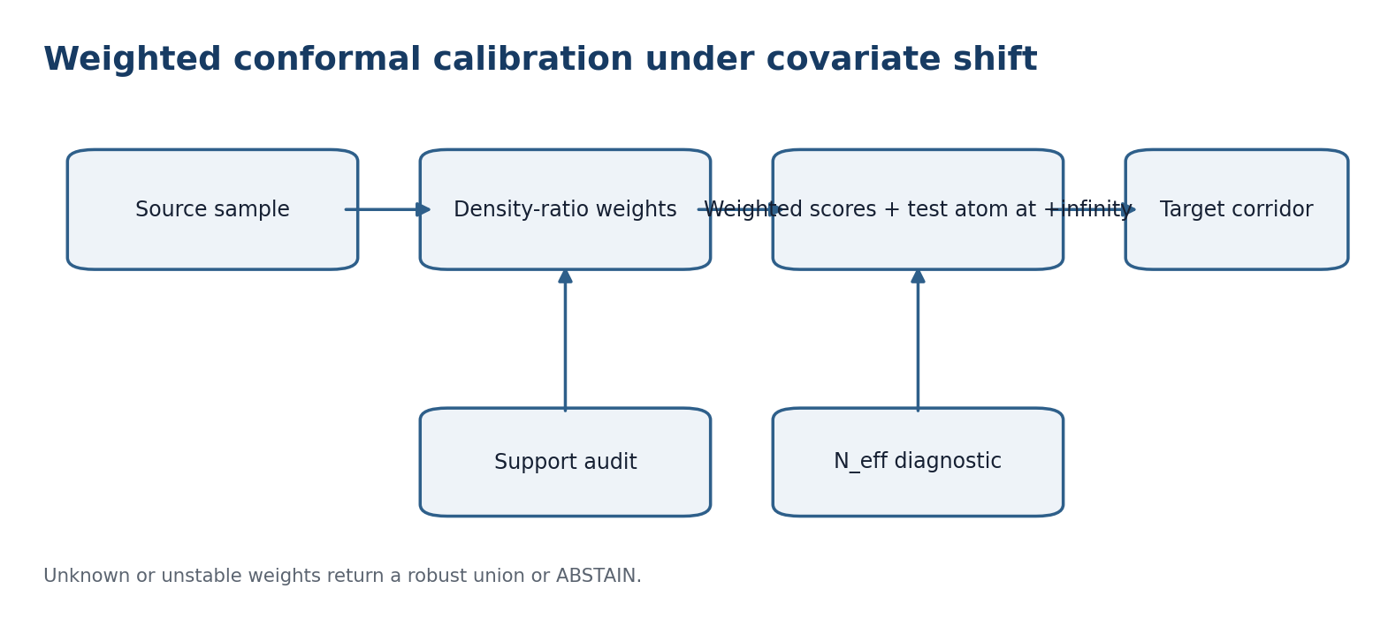
Figure 38.1. Weighted calibration requires support, a registered ratio model, and a finite-sample test atom.

38.1. Covariate-Shift Model
P_S(Y|X)=P_T(Y|X); w(x)=dP_T(X)/dP_S(X); P_T(X)<<P_S(X) [RU p. 184]
The conditional-law equality is a registered bridge assumption, not a consequence of similar histograms. If P_T(A)>0 but P_S(A)=0, w is undefined on A and the system returns support-gap regardless of the amount of source data outside A.

38.2. Weighted Prediction Set
p_i=w(X_i)/(w(x)+sum_j w(X_j)); p_test=w(x)/(w(x)+sum_j w(X_j)) [RU p. 184]
C_alpha(x)={y : s(x,y)<=Q_(1-alpha)(sum_i p_i delta_(s_i) + p_test delta_(+infinity))} [RU p. 184]
Theorem 38.1 - Conditional weighted coverage [THM]. Under a correct density ratio, invariant P(Y|X), independent calibration, and a registered score, the weighted conformal construction achieves target marginal coverage at least 1-alpha.
Proof. After weighting, the probability of each position in the combined sample is proportional to its target density. The weighted upper-tail rank is at most alpha; the +infinity atom preserves finite-sample conservatism.

38.3. What the Guarantee Does Not Say
Coverage remains marginal under the target law. It is not pointwise conditional coverage, does not establish causal transport, and does not permit changing the score after target responses are observed. Estimated weights add uncertainty; reusing the same target sample for weight fitting and coverage assessment requires sample splitting or another theorem.

38.4. Effective Size and Weight Instability
N_eff=(sum_i w_i)^2 / sum_i w_i^2 [RU p. 184]
N_eff is a diagnostic of weight concentration, not an exact number of independent observations. A preregistered lower threshold N_eff,min is evaluated before target outcomes. Failure yields status=weight-instability and prevents truth promotion.

38.5. Robustness over a Weight Set
C_alpha^rob(x)=union_{w in W} C_alpha^w(x) [RU p. 185]
Proposition 38.2 - Robust union [PROP]. If the true weight belongs to the registered set W and its corridor has coverage 1-alpha, the union corridor has no smaller coverage.
Proof. The true-weight corridor is contained in the union, so its coverage event implies union coverage.
Robustness costs width. If W is so broad that the union is practically uninformative, the strict output is ABSTAIN rather than post-result narrowing of W.

38.6. Transfer Registration Card
The card stores source_population, target_population, inclusion rules, support audit, weight model, weight-training split, clipping rule, W, N_eff,min, alpha, score, horizon, and publication rule. Weight clipping changes the effective target measure; its threshold and bias analysis must be preregistered.
Philosophical-phenomenological note. A weight does not itself transport the phenomenon. It recognises that some observed states must speak more loudly than others. Where the target world reveals what the source never saw, the weight must fall silent.

TRANSFER-CAL-CERT-v196i8. shift=covariate-only; support=P_T<<P_S; conditional-law=invariant; weights=registered; test-atom=plus-infinity; coverage=target-marginal-conditional-on-assumptions; N_eff=diagnostic; unknown-weight=robust-union-or-ABSTAIN; causal-transfer=not-claimed.

Chapter 39. E-Processes, Ville Inequality, and Optional Stopping
Russian source locator: pp. 186-187
Central question | How can evidence be monitored repeatedly without inflating a fixed-sample error claim?
Plain meaning | The rule for looking through time must be written before the result. A nonnegative supermartingale controls its running maximum.
Mathematical core | An e-process starts at one, remains nonnegative, and obeys a conditional supermartingale inequality under the registered null; Ville gives an anytime-valid boundary.
Boundary of inference | The stake must be predictable from the past and the guarantee applies only to the preregistered null and data stream.

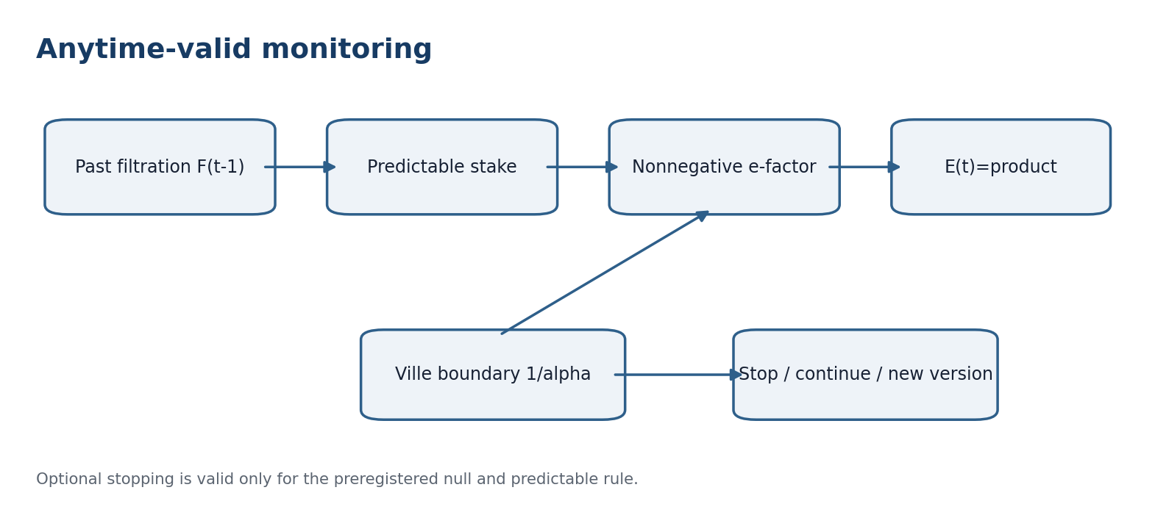
Figure 39.1. Predictable e-factors accumulate into an anytime-valid process with a fixed boundary.

39.1. Filtration and Predictability
E(0)=1; E(t)>=0; E[E(t)|F(t-1)]<=E(t-1) [RU p. 186]
F(t) is the information available after step t. A stake lambda(t) must be chosen using F(t-1). Using the current outcome to choose lambda(t) violates predictability and creates invalid-sequential-null.

39.2. Ville Inequality
P_0{sup_t E(t) >= 1/alpha} <= alpha [RU p. 186]
Theorem 39.1 - Ville inequality [THM]. For a nonnegative supermartingale E(t) with E(0)<=1 and alpha in (0,1), P_0(sup_t E(t)>=1/alpha)<=alpha.
Proof. Let tau be the first crossing of 1/alpha, truncated at T. Optional stopping for a nonnegative supermartingale gives E[E(tau wedge T)]<=1. On {tau<=T} the value is at least 1/alpha, so P(tau<=T)<=alpha. Let T tend to infinity.
Stopping at the first crossing preserves level alpha. It does not permit changing the null, loss, or data stream.

39.3. Bounded-Gain Example
e(t)=1+lambda(t)X(t); E(t)=product_{s=1}^t e(s) [RU p. 186]
Let X(t) lie in [-1,1] and satisfy E[X(t)|F(t-1)]<=0 under H0. For predictable lambda(t) in [0,1], e(t) is nonnegative and has conditional mean at most one, so the product is a nonnegative supermartingale. X(t) must be defined before the current response as a difference between registered losses of the method and matched-null.

39.4. Mixture of Stakes
E_mix(t)=sum_k pi_k E_k(t); pi_k>=0; sum_k pi_k=1 [RU p. 186]
Proposition 39.2 - Mixtures preserve e-validity [PROP]. A nonnegative convex combination of e-processes is an e-process.
Proof. Convex combination preserves nonnegativity, initial expectation at most one, and the conditional supermartingale inequality.

39.5. Versioning after Rebuilding
A local model rebuild changes the law of future gains. Continuation is permitted only when the rebuilding rule and updated stake were part of the null contract. Otherwise the current e-process closes and the new version starts from E(v,0)=1 with its own alpha budget. Old maximum evidence is not transferred as starting capital.

39.6. E-Value, P-Value, and Truth Layer
The truncated reciprocal of the running maximum is an anytime-valid p-process in the stated setting. It is statistical evidence against H0, not the probability that the authorial theory is true. A threshold crossing does not replace provenance, D/Dom, support, CGI<1, an external corpus, or the publication gate.
Philosophical-phenomenological note. Optional stopping tests not the patience of the investigator but the form of expectation. Rigour begins when the rule of looking through time is written before the result.

SEQ-E-CERT-v196i8. filtration=explicit; E0=1; nonnegative=yes; supermartingale-under-null=yes; stake=predictable; boundary=1/alpha; optional-stopping=Ville-valid; rebuild=new-version-unless-predeclared; version-budget=sum-alpha; truth-probability=not-claimed.

Chapter 40. Aggregation of PN.2 Branches and Regret Bounds
Russian source locator: pp. 188-189
Central question | How can several registered PN.2 branches be compared without silently declaring one branch true?
Plain meaning | The system treats branches as experts, learns their predictive weights, and keeps abstention as an explicit expert.
Mathematical core | Exponential weights control cumulative regret relative to the best fixed registered branch under bounded losses.
Boundary of inference | Small regret is neither a coverage guarantee nor evidence that the highest-weight branch is ontologically true.

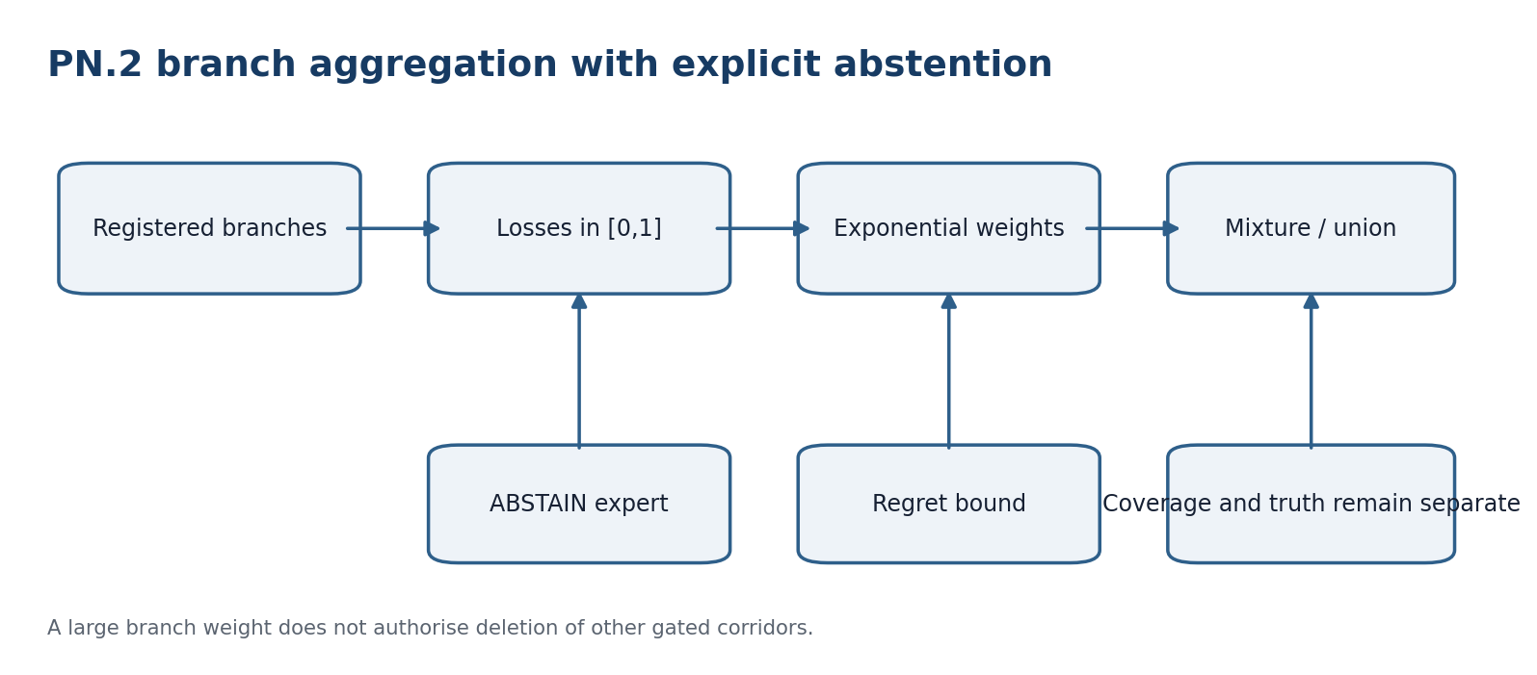
Figure 40.1. PN.2 branches are registered experts; regret, coverage, and truth remain separate channels.

40.1. Registered Experts
Let b=1,...,K be branches fixed before the data stream. Each branch outputs a forecast or ABSTAIN and incurs a bounded loss ell(t,b) in [0,1]. The KMA set {1/2,1/3,3/4,2/3,2,3} remains search metadata only: a match neither creates an expert nor closes a branch.

40.2. Exponential Weights
W(1,b)=1; W(t+1,b)=W(t,b) exp(-eta ell(t,b)); p(t,b)=W(t,b)/sum_j W(t,j) [RU p. 188]
Theorem 40.1 - Hedge regret bound [THM]. For losses in [0,1], the expected cumulative loss L(T) of the mixture satisfies L(T)-min_b L(T,b) <= ln(K)/eta + eta T/8.
Proof. Let Z(t)=sum_b W(t,b). The lower bound ln Z(T+1)>=-eta min_b L(T,b) follows from retaining the best branch term. Hoeffding's lemma gives ln(Z(t+1)/Z(t))<=-eta <p(t),ell(t)>+eta^2/8. Summation and division by eta yield the claim.
With eta=sqrt(8 ln(K)/T), the bound is of order sqrt(T ln K). Unknown T requires a registered doubling scheme or another anytime analysis.

40.3. Abstention Expert
ell(t,ABSTAIN)=c_A, 0<=c_A<=1 [RU p. 188]
The price c_A is fixed before test responses. Too large a price forces false certainty; too small a price makes the system uninformative.

40.4. Prediction Set of the Mixture
C_PN2(x)=union{C_b(x) : gate(b)=1} [RU p. 188]
If branches emit corridors, the safe branch-blind output remains the union of gated corridors. A large weight does not authorise deleting a corridor without a separate coverage argument. Regret concerns average mixture loss; coverage concerns future-set inclusion; the truth layer concerns evidence gates. These relations are not interchangeable.

40.5. Changing Branches
If the best branch may change over time, comparison with the best fixed branch is insufficient. A switch budget S and a tracking-regret algorithm must be preregistered. Adding a branch after inspecting errors creates a new registry version; the old Hedge guarantee applies only to the old K.

40.6. Relation to the Reper Architecture
An expert is not a naked lambda value. It is a packet containing source anchor, Reper, operator, Dom, loss, corridor, null, status, and revision. Two branches with the same lambda may remain different experts. A Block within a branch changes its output to ABSTAIN; historical weight cannot make an incomplete branch admissible.
Philosophical-phenomenological note. Multiplicity of branches is not a weakness of reason. It describes a future that has not yet become singular. The aggregator may learn among possibilities, but it must not turn a weight into an ontological verdict.

BRANCH-AGG-CERT-v196i8. branches=pre-registered; loss=[0,1]; weights=exponential; regret=ln(K)/eta+eta*T/8; abstention=explicit-expert; KMA=search-metadata-only; corridor=union-of-gated-branches; regret-not-equal-coverage; coverage-not-equal-truth; new-branch=new-version.

T1-EN-VALIDATION-v0.7
CONTROLLED ENGLISH TRANSLATION OF CHAPTERS 41-46
This checkpoint translates the independent-validation layer of the frozen Russian Volume I: frozen preregistration fields, data splitting, multiplicity control, pre-outcome domain selection, conservative power planning, group-disjoint calibration, the prediction-intervention boundary, and the executable EXT-RUN-000 protocol. The protocol is prepared but not executed.
Authority(T1-RU v197) > Authority(T1-EN v0.7); Status_EN(x) <= Status_RU(x)
Status firewall. truth_layer_promotion=0. EMP-PLAN is not EMP-OBS. A protocol-ready EXT-RUN is not a completed external run, and PASS in one registered population would not establish a universal physical law.

v0.7 Change-Set and Parity Scope
ID | Change | Status
T1-EN-CS-048 | Translated Chapters 41-46 with Russian source locators 190-203. | CLOSED-DOC
T1-EN-CS-049 | Preserved Holm familywise control and the union-bound error budget. | THM-PARITY
T1-EN-CS-050 | Preserved pre-outcome domain selection and the post-selection counterexample. | THM-PARITY
T1-EN-CS-051 | Preserved conservative Hoeffding power planning and cluster caveats. | THM/PLAN
T1-EN-CS-052 | Preserved group-level exchangeability, splitting, calibration, and null actions. | THM-PARITY
T1-EN-CS-053 | Preserved prediction/intervention nonidentifiability and conditional g-formula. | THM/COND
T1-EN-CS-054 | Translated EXT-RUN-000 without inventing source hashes or outcomes. | EMP-PLAN
T1-EN-CS-055 | Added six explanatory diagrams and a cumulative validation ledger. | DOC-QA

Part X. Preregistration, Power, and the Causal Boundary
This part turns the requirement of independent verification into a complete study design. It specifies who selects the domain, how many independent units are required, where the cluster lies, what counts as a prediction, and which additional assumptions are required before causal language is permitted.

Chapter 41. Independent Validation and Composition of Error Budgets
Russian source locator: pp. 190-192
Central question | How can a strict forecast be tested without allowing the result to influence the formula or threshold?
Plain meaning | Train, calibration, internal test, and external test are separated; multiplicity and error budgets are controlled by declared rules.
Mathematical core | Holm correction controls familywise error, and the union bound composes registered probabilistic error events.
Boundary of inference | A validation protocol is EMP-PLAN. It does not report that independent validation has already occurred.

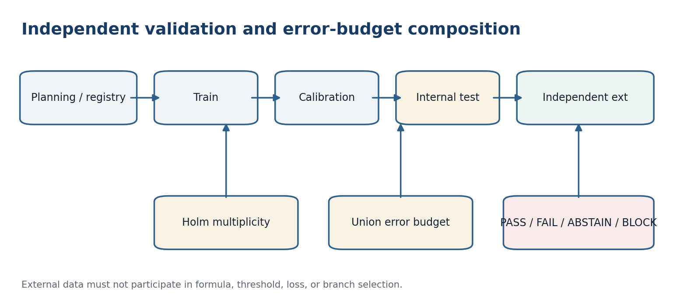
Figure 41.1. Frozen validation design, multiplicity control, and separate decision states.

41.1. Fields Frozen Before Unblinding
Block | Before unblinding | After unblinding
Objective | population, outcome, horizon | do not change
Data | source, unit, split, cluster | audit only
Method | adapter, score, loss, null | execute
Statistics | alpha, multiplicity, stopping | compute
Decision | PASS / FAIL / ABSTAIN / BLOCK | apply literally
Publication | positive and negative outcomes | publish

Freezing is evidenced by a timestamp, protocol owner, and hashes. A blank field is not completed after the result by a silent assumption.

41.2. Sample Splits
train -> model; cal -> corridor; test -> internal audit; ext -> external audit [RU p. 190]
An independent ext source does not guarantee statistical independence when objects are duplicated, instruments share calibration, or annotators use one hidden reference. The provenance graph must test these dependencies. Any change to features, loss, null, or threshold after test unblinding creates a new version and requires a fresh untouched test set.

41.3. Multiple Testing
p_(j) <= alpha / (m-j+1) [RU p. 190]
Theorem 41.1 - Holm familywise control [THM]. For valid individual p-values, the Holm step-down procedure controls the probability of at least one false rejection at level alpha without requiring independence of the p-values.
Proof. If the first false rejection occurs and m0 null hypotheses are true, the smallest true-null p-value is at most alpha/m0. The Bonferroni inequality bounds this event by alpha.

41.4. Evidence Levels
Level | Confirmed | Not implied
L0 | scheme and formulae | executability
L1 | unit/replay on synthetic data | domain validity
L2 | internal test | external transportability
L3 | independent ext | universality
L4 | multi-domain replication | metaphysical truth

Every level inherits unresolved blockers from previous levels. Moving from L2 to L3 requires a new source, not a new interpretation of the same test.

41.5. Decisions and Statuses
PASS means the preregistered criterion was met. FAIL means a valid completed test produced a negative result. ABSTAIN means the method does not authorise a definite object-level forecast. BLOCK means a prerequisite failed or the test was not executable. FAIL is not renamed ABSTAIN, and BLOCK is not included in the denominator of successful tests.

41.6. Error-Budget Composition
P(union_j E_j) <= sum_j alpha_j [RU p. 191]
Theorem 41.2 - Registered union budget [THM]. If P(E_j)<=alpha_j for every registered error event and sum_j alpha_j<=alpha_total, then the probability of at least one event in the family is at most alpha_total.
Proof. Apply subadditivity of probability to the union. Independence is not required.
CGI, delta_truth, corridor width, and regret do not have the required probability meaning and therefore cannot be inserted into this sum. They remain separate coordinates.

41.7. Immutable Artifact-1 Card
RIUD-TETRA-RUN006-029 -> PROOF-OBJ-RUN007-0029 -> FORMAL-CARD-RUN009-006 -> SIGNATURE-REVIEW-RUN013-001 [RU p. 191]
lambda=-0.992736565468; delta_truth=0.007263434532; CGI=0.140948882338 [RU p. 191]
The v196i8 layer changes none of these fields. Independent validation must be attached as a new linked object; it does not rewrite the old card.
Philosophical-phenomenological note. Independence begins not with a new table, but with refusing to let a future result rewrite a past rule. A negative outcome then becomes a completed fact rather than a defeat.

SEQ-VALID-CERT-v196i8. splits=train/cal/test/ext; multiplicity=Holm; error-budget=union-bound; blocker-safe=yes; optional-stopping=e-process-only; Artifact-1=frozen; independent-run=required; truth_layer_promotion=0.

Chapter 42. Domain Selection Before Outcome Disclosure and Protection Against Post-Selection
Russian source locator: pp. 193-194
Central question | What happens if many domains are inspected but only the most favourable one is reported?
Plain meaning | The nominal error becomes too optimistic unless the selection was independent of the external responses or explicitly corrected.
Mathematical core | The selection rule S uses planning information I0 only; conditioning then preserves validity of the selected p-value.
Boundary of inference | Selection using test outcomes requires a fresh holdout, multiplicity correction, or a proved selective-inference route.

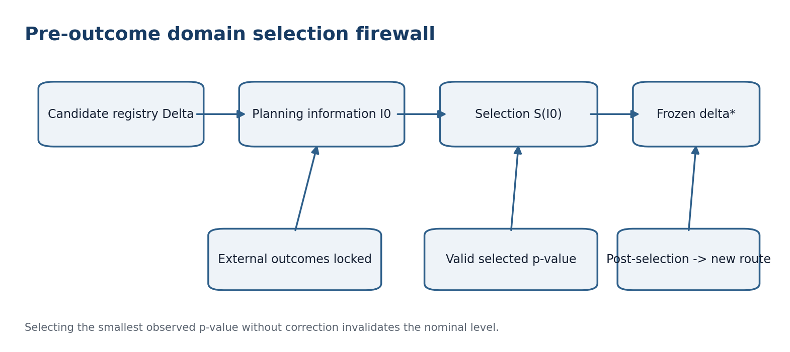
Figure 42.1. Domain selection is frozen before the key to external outcomes is released.

42.1. Candidate Space and Selection Map
Delta={delta_1,...,delta_M}; S:I0 -> Delta; delta*=S(I0) [RU p. 193]
I0 may contain source availability, ethics, units, cluster identifiers, cost, and minimum size, but not the external outcomes. D_ext is the finite data set in the selected domain; Dom(S) is the mathematical domain of the selection rule. These symbols remain distinct.

42.2. Validity of a Selected p-Value
Theorem 42.1 - Validity by conditioning [THM]. If for every fixed delta, P(p(delta)<=u | I0)<=u, and delta*=S(I0), then P(p(delta*)<=u)<=u.
Proof. Conditionally on I0, delta* is fixed. Apply the conditional validity inequality and then take expectation over I0.
A domain may therefore be chosen by logistics, scientific relevance, and previously established feasibility provided those criteria do not use the external responses.

42.3. Post-Selection Counterexample
P(min_{1<=m<=M} p_m <= alpha) = 1 - (1-alpha)^M [RU p. 193]
For M independent uniform p-values under H0, reporting only their minimum exceeds the nominal level whenever M>1. Agreement with a theoretical expectation does not remove the selection error.

42.4. Admissible Routes After Selection
Route | Requirement
A | Select on planning/train and use a new untouched ext set.
B | Include every inspected domain in a multiplicity procedure.
C | Condition on the selection event and use a proved selective-inference method.

Repeated holdout use is valid only under a mechanism specifically designed to control adaptivity. Repeatedly looking at an ordinary holdout does not become valid merely by calling it a holdout.

42.5. Freeze Register
Field | Frozen value | Block if violated
target | outcome, horizon, population | target-changed
domain | delta* and rule S | post-selection
adapter | code and hash | adapter-drift
score/loss | formula and units | metric-shopping
null | matched transformations | invalid-null
data | source/split/cluster | leakage
decision | alpha, power, PASS/FAIL | moving-threshold

The registry is signed before the external outcome key is released. When temporal order cannot be proved, the independence status is downgraded to unclear.

42.6. Relation to PN.2
PN.2 permits ambiguity among branches within a selected domain, but does not permit choosing the domain by whichever branch happened to look best. Domain and branch registries are frozen separately. A branch discovered after ext becomes a hypothesis of the next version.
Philosophical-phenomenological note. Selection becomes knowledge only when the result cannot secretly become the cause of its own selection. Preregistration breaks this circle and restores the future's right to surprise.

SELECT-CERT-v196i9. candidate-domains=frozen; selection=S(I0); external-outcomes=unseen; selected-p=valid-by-conditioning; post-selection-routes={new-holdout,multiplicity,selective-inference}; PN2-branch-discovery=new-version; truth_layer_promotion=0-before-ext.

Chapter 43. Power, Sample Size, and the Minimum Meaningful Effect
Russian source locator: pp. 195-196
Central question | How large must an external study be to distinguish a useful method from its matched null?
Plain meaning | The minimum useful gain Delta_min and tolerated miss probability beta determine a conservative lower bound.
Mathematical core | Hoeffding concentration applies to independent bounded gains; fixed-horizon and sequential rules remain distinct.
Boundary of inference | The formula is conservative and does not replace a cluster-aware design or missingness analysis.

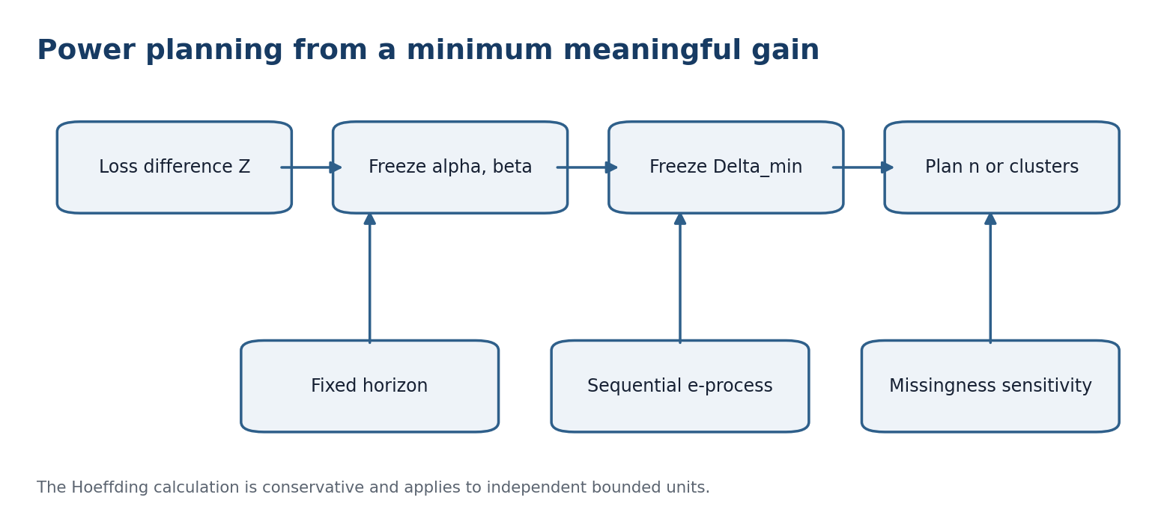
Figure 43.1. Power is planned from a domain-meaningful effect before external outcomes are observed.

43.1. Primary Gain
Z_i=L_null,i-L_KLT,i; -1<=Z_i<=1; mu=E[Z_i] [RU p. 195]
A positive mean denotes lower loss for the method. Loss, sign direction, and normalisation are fixed before data. For unbounded loss, another proved concentration result or a preregistered truncation with bias analysis is required.

43.2. Conservative Miss Bound
P(Zbar_n<=0) <= exp(-n Delta^2/2) [RU p. 195]
Theorem 43.1 - Hoeffding miss bound [THM]. For independent Z_i in [-1,1] with E[Z_i]>=Delta>0, the probability that the sample mean is nonpositive is at most exp(-n Delta^2/2).
Proof. Apply Hoeffding to Zbar_n-E[Zbar_n]<=-Delta. Each variable has range length 2, giving exponent -2 n^2 Delta^2/(4n).
n_plan = ceil(2 ln(1/beta) / Delta_min^2) [RU p. 195]
This is a one-sided demonstration bound for the sign of the effect. A complete test plan also fixes the false-positive level alpha.

43.3. Fixed-Horizon Interval
|Zbar-mu| <= sqrt(2 ln(2/alpha)/n) [RU p. 195]
The interval is for a fixed n. Repeated inspection requires the e-process or confidence-sequence route of Chapter 39.

43.4. Minimum Meaningful Effect
Delta_min is selected for domain usefulness, not expected statistical significance. Choosing Delta_min after ext to equal the observed gain is post hoc description, not power planning.

43.5. Cluster Design Effect
DE=1+(mbar-1)rho; N_eff approximately n/DE [RU p. 196]
This is a rough planning diagnostic, not a universal theorem for unequal clusters, complex weights, or temporal dependence. In the strict analysis, the independent unit is the cluster as defined in Chapter 44.

43.6. Attrition and Missing Outcomes
The initial size is increased by a registered expected fraction of invalid or lost units. Exclusions after inspecting Z_i are prohibited. A primary missing-outcome rule and sensitivity set are frozen; if plausible mechanisms reverse the sign, the decision is ABSTAIN.

43.7. Planning Table
Parameter | Meaning | Freeze time
alpha | false-positive decision | before ext
beta | miss of Delta_min | before ext
Delta_min | minimum useful effect | before ext
n / M | units / clusters | before ext
rho, mbar | cluster diagnostic | planning
attrition | loss reserve | planning
stopping | fixed or e-process | before first outcome

Philosophical-phenomenological note. Sample size measures how much resistance from the world a design is prepared to accept before deciding. A study that is too small neither confirms nor refutes; it gives the phenomenon insufficient opportunity to distinguish itself.

POWER-CERT-v196i9. gain=bounded[-1,1]; units=independent-or-clustered-explicitly; alpha=frozen; beta=frozen; delta_min=domain-meaningful; n_plan=ceil(2*ln(1/beta)/delta_min^2); fixed-horizon=Hoeffding; sequential=e-process; design-effect=diagnostic-only; missingness=sensitivity-audited.

Chapter 44. Cluster Dependence and Group Predictive Calibration
Russian source locator: pp. 197-198
Central question | Are one hundred rows from one patient, instrument, or document one hundred independent confirmations?
Plain meaning | No. Rows sharing a common origin form one group-level observational unit.
Mathematical core | Exchangeability and splitting are formulated for whole groups; within-group dependence may be arbitrary.
Boundary of inference | A group guarantee does not transfer to a new cluster type or epoch without a new bridge or calibration.

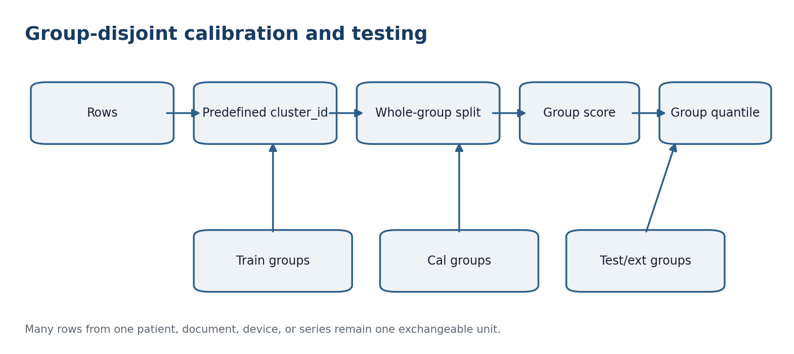
Figure 44.1. Whole groups, not individual rows, are assigned to train, calibration, test, and external sets.

44.1. Groups as Observational Units
D=G_1 disjoint_union ... disjoint_union G_M; exchangeability unit = group [RU p. 197]
The cluster identifier is defined by the domain: patient, family, instrument, laboratory, document, author, site, time block, or experimental series. Choosing a convenient cluster identifier after the result is forbidden.

44.2. Group Score
S_g = max{s_i : i in G_g} [RU p. 197]
The maximum is a conservative registered functional. It supports simultaneous group coverage but may produce wide corridors for large groups. Other group functionals are allowed only when preregistered.

44.3. Group Calibration Theorem
k=ceil((M+1)(1-alpha)); q=S_(k) [RU p. 197]
Theorem 44.1 - Marginal group calibration [THM]. If S_1,...,S_M and the new-group score S_(M+1) are exchangeable, the rule accepting the new group when S_(M+1)<=q has marginal group acceptance probability at least 1-alpha.
Proof. The rank of the new score among M+1 exchangeable scores is uniform with conservative tie handling; the chosen rank threshold leaves at most alpha mass in the upper tail.
The number of calibration units is M, not the total row count. Reports therefore disclose both counts and the distribution of group sizes.

44.4. Leakage-Free Splitting
Every row of one cluster_id belongs to exactly one of train, cal, test, or ext. Dividing one patient between train and test is leakage even with different time stamps unless the temporal forecasting task was separately registered. Leave-one-group-out and group cross-fitting require that the model for group g is trained without any row from G_g.

44.5. Matched Null at Group Level
g.D=(g.G_1,...,g.G_M); internal structure of each G_g is preserved [RU p. 198]
A randomisation null must preserve within-group dependence. Permuting individual rows between groups generally destroys the registered data-generating structure and is not an admissible transformation.

44.6. Unequal Sizes and New Group Types
When group size changes the score distribution, size is included in a preregistered stratum or weighting model. A new laboratory, instrument version, or epoch can break exchangeability and triggers target calibration, a justified weighted bridge, or ABSTAIN.

44.7. Example
Forty documents with one hundred fragments each do not provide n=4000 independent test units. A row split leaks near-duplicates, whereas a document split provides M=40 and tests transfer to a new document. In medicine the analogous unit is a patient; in physics it may be an independent experimental series when repeats share one drifting instrument.
Philosophical-phenomenological note. Repetition within one history deepens its description, but does not create many independent worlds. Group analysis recognises unity of origin before counting rows.

GROUP-CAL-CERT-v196i9. cluster-id=predefined; exchangeability=between-groups; within-group-dependence=arbitrary; score=registered-group-functional; quantile=ceil((M+1)(1-alpha)); split=group-disjoint; matched-null=whole-group; reported-n={rows,groups}; new-cluster-type=recalibrate-or-ABSTAIN.

Chapter 45. Prediction, Intervention, and the Limit of Causal Inference
Russian source locator: pp. 199-200
Central question | Does accurate prediction of Y from X determine what happens when X is forcibly changed?
Plain meaning | No. Observational association and intervention are distinct queries.
Mathematical core | The chapter proves nonidentifiability by observational equivalence and states a conditional g-formula under explicit assumptions.
Boundary of inference | Authorial language of foundation and consequence may guide modelling but does not identify a causal effect without a bridge.

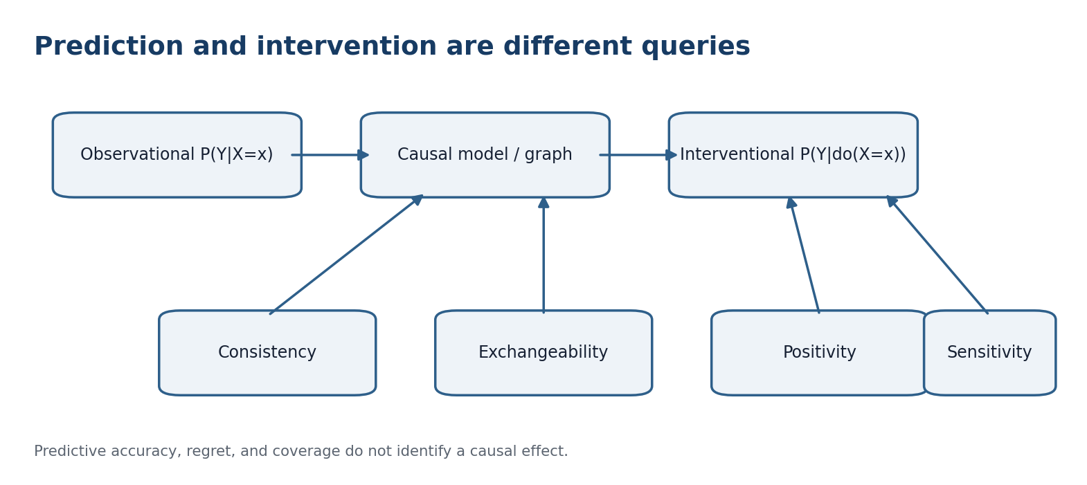
Figure 45.1. A causal answer requires a model and identification assumptions beyond predictive performance.

45.1. Two Different Questions
prediction: P(Y|X=x); intervention: P(Y|do(X=x)) [RU p. 199]
The two distributions coincide only under additional assumptions. High accuracy, low regret, and valid prediction-set coverage do not create those assumptions.

45.2. Nonidentifiability Counterexample
Model A: U~Bernoulli(1/2), X=U, Y=X. Model B: U~Bernoulli(1/2), X=U, Y=U. Both produce P(X=Y)=1 observationally. Under do(X=x), Model A gives Y=x; Model B leaves Y=U, so Y remains Bernoulli(1/2).
Theorem 45.1 - Observational nonidentifiability [THM]. The intervention effect X->Y is not identifiable from the observational distribution alone in any model class containing Models A and B.
Proof. The models induce the same observational law of (X,Y) but different interventional laws. Any functional of the observational law must have the same value in both and therefore cannot equal both causal answers.

45.3. Identification Bridge
consistency; Y(x) independent_of X | L; P(X=x|L=l)>0 [RU p. 199]
P(Y(x)=y)=sum_l P(Y=y|X=x,L=l) P(L=l) [RU p. 199]
Conditional proposition 45.2 - g-formula [COND]. Under consistency, conditional exchangeability, positivity, and a correctly specified target population, the intervention distribution is given by the displayed g-formula.
Proof. Expand over L by total probability, use exchangeability to replace the potential-outcome distribution by the observed conditional distribution among X=x, and use consistency to identify Y(x) with Y for units receiving x.

45.4. Positivity as a Dom Gate
If intervention x never occurs for a relevant l, the observed evidence D does not cover that part of the causal functional's Dom. Model extrapolation may be a useful hypothesis, but it is not a nonparametrically identified effect and must carry model-dependent status.

45.5. Foundation-Consequence and Cause-Action
The project notes distinguish reversible cause/action pairs from ambiguous foundation/consequence relations. This remains a philosophical-model heuristic for choosing graphs and branches. A statistical causal certificate is added only after specifying an intervention, potential outcomes or structural equations, covariates L, and identification assumptions.

45.6. Causal Transportability
Even an identified source-population effect does not automatically transport. The analysis must describe mechanism differences, selection nodes, effect modifiers, and target support. Weighted conformal calibration concerns predictive coverage and does not replace a causal transport formula.

45.7. Causal Bridge Card
Field | Mandatory content | Status if absent
estimand | effect and population | undefined
intervention | meaning of do(X=x) | ambiguous
graph/model | nodes and arrows | unidentified
confounders L | inclusion rule | exchangeability-block
positivity | support audit | support-gap
consistency | intervention versions | version-conflict
sensitivity | unmeasured confounding | conditional-only

Philosophical-phenomenological note. Prediction follows a phenomenon along its trace; causal inference asks what changes because of our action. Between trace and action lies not a word, but a bridge of assumptions.

CAUSAL-BRIDGE-CERT-v196i9. prediction-not-equal-intervention; observational-equivalence-counterexample=proved; estimand=required; consistency=required; exchangeability=required; positivity=required; g-formula=conditional; D/Dom=distinct; project-causal-language=model-hypothesis-until-bridged.

Chapter 46. Executable External Validation Protocol for Volume I
Russian source locator: pp. 201-203
Central question | Can the preceding mathematical conditions be executed on a new independent corpus without analytical discretion?
Plain meaning | The protocol card freezes every operational choice and returns one of four distinct decisions.
Mathematical core | Selection, power, clustering, null, coverage, stopping, multiplicity, provenance, and publication are composed in one blocker-safe route.
Boundary of inference | In this edition the card is protocol-ready-not-executed. No external source hash or outcome is invented.

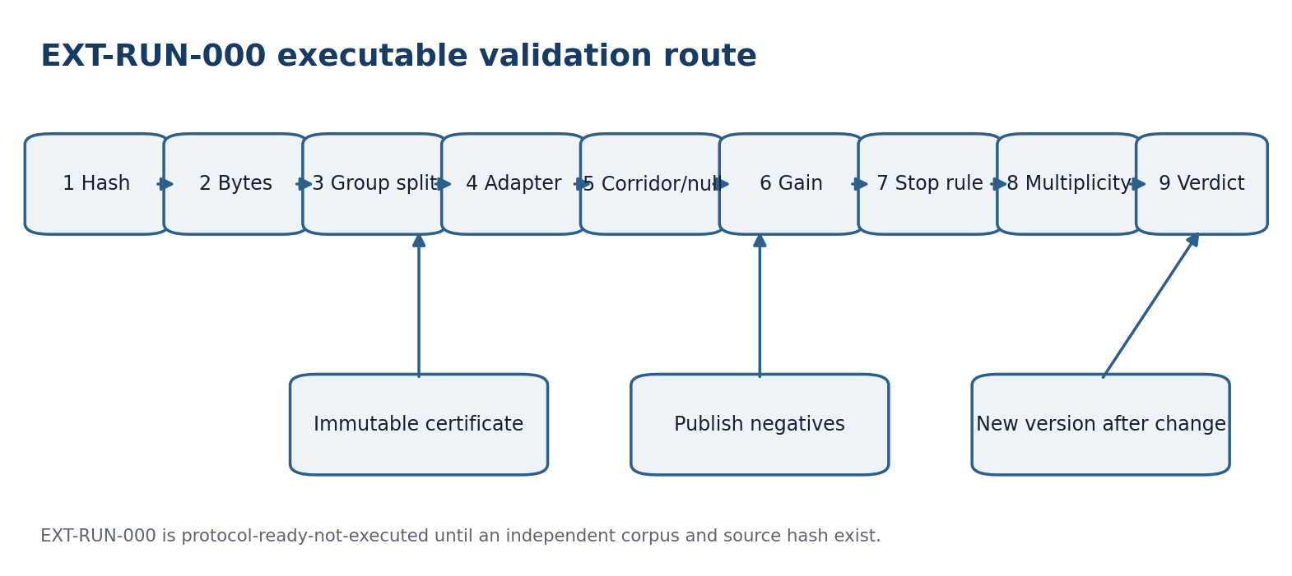
Figure 46.1. Nine-step EXT-RUN-000 route from frozen hashes to an immutable verdict certificate.

46.1. EXT-RUN-000 Object
EXT-RUN-000: protocol-ready-not-executed [RU p. 201]
This status is not FAIL because the test has not begun, and it is not PASS because no external unit has been evaluated. truth_layer_promotion remains zero.

46.2. Complete Registration Card
Section | Mandatory fields
Identity | project, run_id, owner, timestamp, version
Objective | domain, population, outcome, horizon, estimand-status
Data | unit, cluster, source, inclusion, hashes, privacy
Split | train, cal, test, ext, provenance-disjointness
Method | adapter, config, schema, code, environment, seed
Forecast | score, corridor, PN.2 branches, abstention
Comparison | loss, matched-null, gain, primary statistic
Errors | alpha, beta, delta_min, multiplicity, stopping
Decision | PASS, FAIL, ABSTAIN, BLOCK, publication rule

No field is left to analytical discretion after unblinding. Uncertainty is represented as a finite list of options with a planning-only selection rule.

46.3. Execution Algorithm
Step | Operation
1 | Verify timestamp and frozen hashes.
2 | Obtain external bytes and compute source_hash.
3 | Apply inclusion and group split without viewing outcomes.
4 | Run the adapter in blocker-safe mode.
5 | Construct the registered corridor and matched null.
6 | Compute group scores and primary gain.
7 | Apply the fixed-horizon or e-process rule.
8 | Apply multiplicity control.
9 | Issue the decision and immutable certificate.

If any mandatory step returns Block, downstream numerical outputs are not computed or are marked diagnostic-only.

46.4. Decision Rule
Decision in {PASS, FAIL, ABSTAIN, BLOCK} [RU p. 202]
PASS requires: no Block; independent domain selection; registered n or e-threshold reached; primary null rejected after multiplicity; gain in the required direction; coverage and support gates passed; and CGI<1. FAIL is a valid completed test whose primary criterion is not met. ABSTAIN is an object-level forecast decision counted in loss. BLOCK is a design violation.
Conclusion boundary. PASS supports the registered operational hypothesis only for the declared population and horizon. It is not a universal physical theorem of PN.2 and does not prove metaphysical truth.

46.5. Negative Results and Versioning
FAIL and BLOCK are published with the same provenance trace as PASS. Excluding a run after observing its result is forbidden. Any modification after FAIL creates EXT-RUN-001 or a later version with a new protocol and a new ext corpus; EXT-RUN-000 remains historical.

46.6. Causal Branch
By default EXT-RUN-000 is predictive. A causal claim additionally requires every CAUSAL-BRIDGE-CERT field: estimand, intervention, graph, L, positivity, consistency, and sensitivity. Missing causal fields do not block an honest predictive test, but they block causal language.

46.7. Artifact-1 Link
external_validation_id -> new linked object; existing lambda, delta_truth, CGI, status, and next-step remain unchanged [RU p. 202]

46.8. Final Status Ledger
Object | Status | Established | Next input
Blocker-safe E2E | formalized | absorption of Block | domain run
Weighted calibration | conditional theorem | coverage under bridge | target weights
E-process | conditional theorem | anytime level | null stream
PN.2 aggregation | regret theorem | Hedge bound | registered experts
Domain selection | proved | validity under I0 | frozen S
Power | conservative plan | Hoeffding bound | Delta_min, clusters
Group calibration | proved | group-level rank | exchangeable groups
Causal bridge | conditional | g-formula assumptions | graph and L
EXT-RUN-000 | protocol-ready-not-executed | complete card | independent corpus
Artifact-1 | frozen | signature-ready-not-truth-layer | publication-gate review

Philosophical-phenomenological note. A completed protocol is readiness to meet a result that need not agree with the theory. The possibility of an honest FAIL is what gives a future PASS content.

EXT-VALID-CERT-v196i9. selection=pre-outcome; power=alpha-beta-delta_min-frozen; clusters=group-level; prediction-not-causation; causal-bridge=conditional; EXT-RUN-000=protocol-ready-not-executed; negative-results=publish; Artifact-1=frozen; CGI<1=necessary-not-sufficient; KMA=metadata-only; truth_layer_promotion=0; next=obtain-independent-corpus-and-freeze-source-hash.

46.9. Completion Boundary
The validation layer distinguishes selection before and after outcomes, fixed and sequential horizons, rows and independent groups, prediction and intervention, negative results and protocol violations. The next scientific input is a genuinely independent corpus. Until it exists, the external certificate remains prepared but unexecuted.

T1-EN-CLOSURE-v0.8
CONTROLLED ENGLISH TRANSLATION OF CHAPTERS 47-52
This checkpoint closes the chapter layer of the frozen Russian Volume I. It translates the mathematical deepening from the typed evidence object to the main conditional forecast theorem and the internal Delta-Theta obstruction complex. Appendices A-G remain the subject of v0.9.
Derivative contract. Authority(T1-RU v197) > Authority(T1-EN). Formula IDs, theorem status, domain restrictions, counterexamples, and negative results are preserved. Formula IDs F055-F073 belong to Appendix C and remain reserved until T1-EN-APP-v0.9.

Controlled Change Set
ID | Change | Status
T1-EN-CS-056 | Translated typed Obs, Evidence, Reper, PackCert, and blocker-safe composition. | THM-PARITY
T1-EN-CS-057 | Translated PGL2-invariant cross-ratio, harmonic conjugate, set-valued forecast, and stability. | THM-PARITY
T1-EN-CS-058 | Translated five-limit lattice, time-information gate, and conditional PN.2 minimax bound. | THM/COND
T1-EN-CS-059 | Translated extended mismatch metric and stable set-valued rebuilding. | THM/COND
T1-EN-CS-060 | Translated typed RBD graph, substochastic kernel, contraction, and interval envelope. | THM-PARITY
T1-EN-CS-061 | Translated the main conditional theorem with A1-A14, B1-B8, and no-promotion firewall. | COND-PARITY
T1-EN-CS-062 | Translated the minimal obstruction complex and the conditional external E-bridge. | THM/OPEN
T1-EN-CS-063 | Added seven explanatory diagrams and cumulative closure registers. | DOC-QA

Part XI. Typed Closure of the Predictive Method
The final six chapters convert the preceding logic, validation, and database layers into a single typed mathematical architecture. The endpoint is not an unconditional prediction oracle. It is a partial, set-valued, proof-carrying method that returns ABSTAIN or BLOCK whenever an obligatory bridge is missing.

Chapter 47. Typed Space of Packets and Repers
Russian source locator: pp. 205-206
Central question | What is the smallest object that may enter a certified forecast?
Plain meaning | An observation becomes evidence only after type, source, units, domain, provenance, hash, adapter, loss, null, and gate are attached.
Mathematical core | PackCert morphisms preserve type, provenance, domain admissibility, and status monotonicity.
Boundary of inference | Internal NAPG products may be nonassociative; the traceable computational composition remains associative.

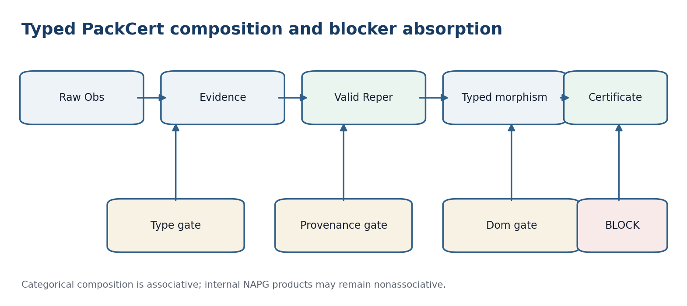
Figure 47.1. Typed composition and the absorbing BLOCK state.

47.1. Event and Evidence Carriers
F001 Obs := (event,state,time,source,unit,cluster,Dom,status) [RU p. 205]
F002 Evidence := Obs x {provenance,hash,adapter,loss,null,gate} [RU p. 205]
F003 D subset Obs; Dom(T) subset X; D != Dom(T) [RU p. 205]
D denotes actually presented data and foundations; Dom denotes the mathematical domain of an operator. Lexical similarity never authorizes their identification.

47.2. Reper as a Typed Quadruple
F004 Rep_i = (R_i,I_i,U_i;D_i) [RU p. 205]
F005 ValidRep(Rep) iff typed and distinct-denominators and provenance and Dom-gate [RU p. 205]
If U=D0 or I=R in the chosen affine chart, the cross-ratio is not evaluated. The status is Block(denominator-zero), unless a declared projective chart explicitly represents the point at infinity.

47.3. Category PackCert
F006 f:P->Q; type(Q)=f_t(type(P)); prov(Q) contains f_p(prov(P)) [RU p. 205]
F007 status(P)=Block => status(f(P))=Block [RU p. 205]
Theorem 47.1 - Soundness of typed composition [THM]. If f:P->Q and g:Q->R are admissible PackCert morphisms, then g o f:P->R is admissible and cannot raise status without a new certificate.
Proof. The output type of f matches the input type of g. Provenance is transported through both arrows. BLOCK absorption is transitive. Every nonblocked transition still presents its own gate certificate; therefore composition is closed and status-monotone.

47.4. Categorical Composition versus NAPG
F008 A(R1,R2,R3) := (R1 star R2) star R3 - R1 star (R2 star R3) [RU p. 206]
F009 A != 0 => bracket in metadata and branch-id in certificate [RU p. 206]
The internal products R star R, odot, and Hodge-star describe packet geometry and may be nonassociative. They do not replace categorical composition of traceable transformations. Bracketing is data.
Theorem 47.2 - No false completion [THM]. For every finite PackCert chain whose arrows absorb BLOCK, the presence of BLOCK at any intermediate stage excludes a final PASS.
Proof. Induct on chain length. The one-arrow case is the absorption rule. If the first k arrows end in BLOCK, the next arrow preserves BLOCK; hence PASS is impossible after any finite number of arrows.
Philosophical-phenomenological note. A type is not clerical decoration. It preserves distinctions without which an object ceases to be that object. BLOCK records the place where the world has not granted permission to continue.

PACK-TYPE-CERT v196i14. D-not-equal-Dom; Rep=(R,I,U,D0); category=PackCert; morphisms=typed-provenance-preserving; Block=absorbing; NAPG products remain separate; bracket=explicit; status-inflation=forbidden.

Chapter 48. Projective-Harmonic Forecast Operator
Russian source locator: pp. 207-208
Central question | How can a forecast be formulated when absolute scale is unreliable but four-point relations are stable?
Plain meaning | The cross-ratio supplies a projective invariant; the harmonic value lambda=-1 is a strict internal consistency gate.
Mathematical core | The forecast is a union of registered admissible branches, with separate ABSTAIN and BLOCK outcomes.
Boundary of inference | Projective invariance does not repair a wrong adapter, missing provenance, or an absent fourth point D0.

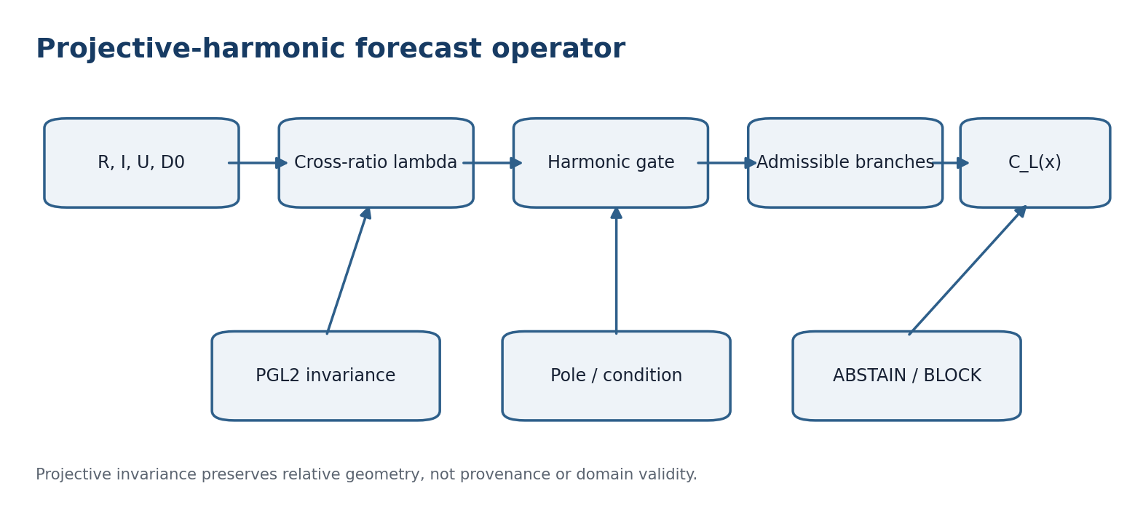
Figure 48.1. Projective invariant, harmonic gate, admissible branches, and conclusion states.

48.1. One-Dimensional Projective Model
F010 lambda(R,I;U,D0)=((U-R)(I-D0))/((U-D0)(I-R)) [RU p. 207]
F011 delta_truth(Rep)=|lambda(Rep)+1| [RU p. 207]
F012 lambda(R,I;U,D0)=([U,R][I,D0])/([U,D0][I,R]) [RU p. 207]

48.2. Projective Invariance
Theorem 48.1 - PGL2(K) invariance [THM]. For every projective transformation g represented by a nonsingular matrix G, lambda(gR,gI;gU,gD0)=lambda(R,I;U,D0) whenever both sides are defined.
Proof. For homogeneous vectors, [Gx,Gy]=det(G)[x,y]. Two determinant factors occur in both numerator and denominator and cancel. Rescaling any point representative also cancels pairwise.
F013 lambda o g = lambda; g in PGL_2(K) [RU p. 207]

48.3. Harmonic Conjugate
F014 D_h = [U(I+R)-2RI]/[2U-R-I] [RU p. 207]
The affine formula applies when 2U-R-I is nonzero. A zero denominator means that the harmonic conjugate is the point at infinity of the chosen chart; the correct action is to change charts, not to invent a finite value.
F015 lambda(0,1;3,3/2)=-1 [RU p. 207]

48.4. Set-Valued Forecast
F016 C_L(x)=union {Psi_r(x): r in A_L(D), gate(r,x)=1} [RU p. 207]
F017 C_L(x)=empty => ABSTAIN; Block nonempty => BLOCK [RU p. 207]
ABSTAIN means valid branches produced no admissible answer for the object and is included in predictive loss. BLOCK means an obligatory evidence condition failed and stops the run.
Theorem 48.2 - Equivariance of the forecast set [THM]. If adapter, gate, and Psi are equivariant under one g in PGL2(K), then C_L(gx)=g(C_L(x)).
Proof. Cross-ratio invariance preserves harmonic admissibility, gate equivariance preserves the admitted branch set, and Psi_gr(gx)=g Psi_r(x). The image of a union is the union of images.
F018 C_L(gx)=g(C_L(x)) [RU p. 208]

48.5. Perturbation Stability
F019 |Delta lambda| <= K_epsilon (||Delta R||+||Delta I||+||Delta U||+||Delta D0||) [RU p. 208]
On compact sets separated from both poles by epsilon, lambda is smooth and locally Lipschitz. Near a pole K_epsilon increases; a small harmonic defect with enormous sensitivity is not stable evidence.
Philosophical-phenomenological note. A projective invariant preserves relation, not the history by which points received their names. Harmony is a checkable four-position agreement, not a promise of truth.

PROJ-HARM-CERT v196i14. field-characteristic-not-2; cross-ratio=homogeneous; PGL2-invariance=proved; harmonic-conjugate=conditional-on-denominators; forecast=set-valued; empty=ABSTAIN; gate-violation=BLOCK; sensitivity=reported; truth_layer_promotion=0.

Chapter 49. Five Limits as an Admissibility Lattice
Russian source locator: pp. 209-210
Central question | What does a limit mean in the predictive method?
Plain meaning | It is a gate that excludes inadmissible Repers and actions, not a scalar objective that must be maximized.
Mathematical core | Political, ecological, spatial, temporal, and ontological predicates form an ordered vector of restrictions.
Boundary of inference | Tightening a component may only shrink the admissible set; an unregistered post-hoc relaxation is not allowed.

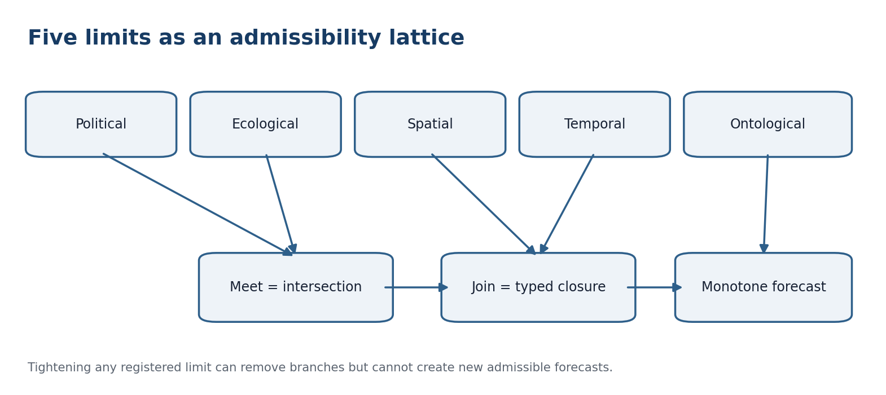
Figure 49.1. Five registered limits, meet, join, and monotone forecast sets.

49.1. Limit Vector and Strictness Order
F020 L=(L_pol,L_eco,L_space,L_time,L_onto) [RU p. 209]
F021 gate_L(r)=meet_{j=1}^5 l_j(r); l_j in {0,1,Block} [RU p. 209]
F022 L' >= L iff A_L'(D) subset A_L(D) [RU p. 209]
Theorem 49.1 - Monotonicity [THM]. If L-prime is no weaker than L, then A_Lprime(D) is a subset of A_L(D), and C_Lprime(x) is a subset of C_L(x).
Proof. The first inclusion defines the order. The union defining the forecast under L-prime ranges over a subset of the branches available under L and cannot add elements.
F023 L' >= L => A_L' subset A_L and C_L' subset C_L [RU p. 209]

49.2. Meet and Join
F024 A_(L meet M)=A_L intersection A_M [RU p. 209]
F025 A_(L join M)=closure(A_L union A_M) [RU p. 209]
Proposition 49.2 - Lattice laws [THM]. For a fixed universe of typed Repers and a type-preserving closure operator, meet and join are idempotent and commutative and satisfy absorption.
Proof. The result follows from intersection and closed union. A join used for publication must be preregistered; otherwise it becomes a post-hoc escape route.

49.3. Temporal Horizon and Information
F026 Forecast_t(h) is measurable with respect to F_t [RU p. 209]
F027 feature-time(x_k)<=t; outcome-time=t+h [RU p. 209]
Horizon is stored with its unit and synchronization rule. A conversion between time scales is a separate morphism with uncertainty. Features appearing after t are unavailable even when they occur in the same table.

49.4. PN.2 as a Limit on One Estimator
F028 inf_T sup_(theta in Theta) E_theta[L(T(X),theta)] >= c_PN2 > 0 [RU p. 210]
The constant depends on the model class, loss, and degree of observational indistinguishability. It is not a universal physical constant.
Theorem 49.3 - Two-point lower bound [THM]. Let theta0 and theta1 require distinct actions, let TV(P0,P1)<=tau<1, and let every wrong action cost at least c. Then every estimator T satisfies max(R0(T),R1(T)) >= c(1-TV(P0,P1))/2.
Proof. The sum of the two testing error probabilities is at least 1-TV(P0,P1). One error is at least half that sum; multiplying by the minimum error cost yields the bound.
F029 max(R0(T),R1(T)) >= c(1-TV(P0,P1))/2 [RU p. 210]

49.5. Five-Limit Certificate
Limit | Checked field | Missing-field status
L_pol | authority and publication regime | Block-authority
L_eco | impact budget and units | Block-impact
L_space | population, support, transport | ABSTAIN / Block-support
L_time | timestamp, horizon, leakage | Block-time
L_onto | types, estimand, D/Dom | Block-type

Philosophical-phenomenological note. A limit does not merely prohibit. It outlines the space in which action has a meaning. A forecast without limits appears free precisely because it does not know to which world it belongs.

FIVE-LIMIT-CERT v196i14. limits={political,ecological,spatial,temporal,ontological}; order=strictness; meet=intersection; join=typed-closure; monotonicity=proved; PN2=minimax-conditional; universal-physical-status=not-claimed.

Chapter 50. Mismatch Metric and Stable Rebuilding
Russian source locator: pp. 211-212
Central question | How does the method react when the current Reper no longer fits new data?
Plain meaning | It selects a registered nearest admissible replacement under an extended metric, loss, harmonic defect, and edit-complexity penalty.
Mathematical core | Compactness and lower semicontinuity provide existence; a positive gap provides uniqueness and perturbation stability.
Boundary of inference | A post-hoc convenient structure is not a rebuild. Candidate sets, penalties, and tie rules are frozen in advance.

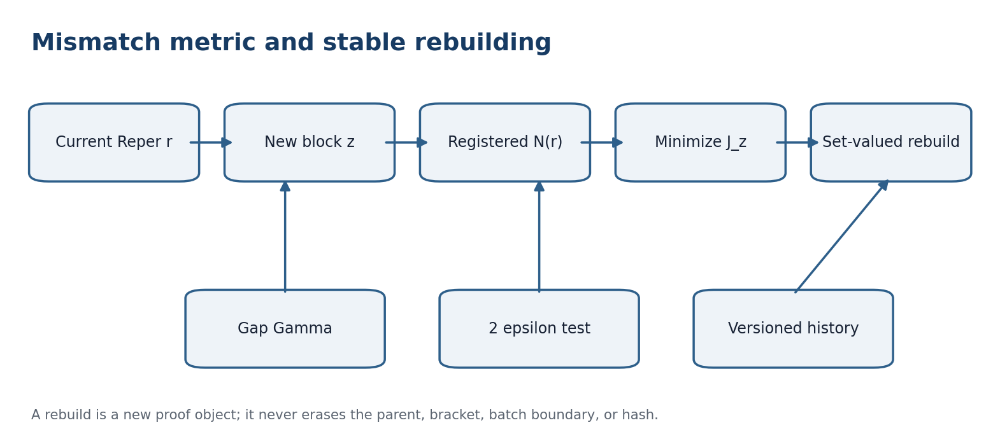
Figure 50.1. Registered neighbors, minimization, stability gap, and versioned history.

50.1. Mismatch Types
Code | Meaning | Required action
M-type | incompatible types | BLOCK
M-dom | outside Dom/support | ABSTAIN or BLOCK
M-harm | increased delta_truth | diagnostic / rebuild
M-loss | worse than matched null | FAIL / rebuild-version
M-prov | broken provenance or hash | BLOCK
M-shift | population or epoch change | recalibrate

50.2. Extended Reper Metric
F030 d_R(r,s)=w_phi||phi(r)-phi(s)||+w_lambda|lambda_r-lambda_s|+w_D d_D(D_r,D_s)+P(r,s) [RU p. 211]
F031 P(r,s)=infinity if type/provenance/bracket incompatible [RU p. 211]
Infinity is implemented by excluding a candidate before optimization, not by inserting an arbitrary large number whose scale could change the answer.

50.3. Nearest Rebuilding Operator
F032 J_z(s|r)=d_R(r,s)+alpha Loss_z(s)+beta delta_truth(s)+gamma Complexity(s<-r) [RU p. 211]
F033 R_z(r)=argmin_{s in N(r) intersection A_L(D union z)} J_z(s|r) [RU p. 211]
Theorem 50.1 - Existence [THM]. If N(r) intersection A_L is nonempty and compact and J_z is lower semicontinuous, then R_z(r) is nonempty.
Proof. A lower semicontinuous function attains its minimum on a nonempty compact set. The minimizer set is closed and therefore compact.

50.4. Uniqueness and Stability Gap
F034 Gamma=J_z(s2|r)-J_z(s*|r) [RU p. 211]
F035 Gamma>0 => R_z(r)={s*} [RU p. 211]
Theorem 50.2 - Stability of a finite choice [THM]. Suppose |J_zprime(s|r)-J_z(s|r)|<=epsilon for every candidate and Gamma>2epsilon. Then s* remains the unique minimizer after replacing z by z-prime.
Proof. The best value may increase by at most epsilon and every competitor may decrease by at most epsilon. The surviving advantage is at least Gamma-2epsilon>0.
F036 Gamma>2epsilon => argmin J_z' = argmin J_z [RU p. 212]

50.5. Nonassociative Revision History
F037 R_z2(R_z1(r)) != R_(z1 union z2)(r) in general [RU p. 212]
Sequential and batch rebuilding are distinct protocols. Every chain stores parent_id, bracket, batch boundary, hash, and deterministic tie rule. Merging chains creates a new proof object and never overwrites history.

50.6. Matched-Null Rebuilding
F038 Gain_rebuild=L(matched-null search)-L(KLT rebuild) [RU p. 212]
The matched null receives the same candidate set, search budget, and planning information. Comparing a rich search with a fixed random point exaggerates gain.
Philosophical-phenomenological note. Rebuilding is not erasure of the past. It becomes rational only when it preserves the trace of the failed form and states the rule that produced the new one.

REBUILD-STABILITY-CERT v196i14. mismatch=typed; distance=extended-metric; candidates=registered; argmin=set-valued; existence=compact-lsc; uniqueness=positive-gap; stability=gap-over-2epsilon; revision=versioned; matched-null=equal-search-budget.

Chapter 51. RBD as an Operator of Propagation and Contraction
Russian source locator: pp. 213-214
Central question | When can a Reper database participate in a mathematical forecast rather than remain a catalogue?
Plain meaning | Its nodes, edge types, weights, limits, provenance, damping, and stopping rule are typed explicitly.
Mathematical core | A substochastic kernel with alpha<1 gives a contraction and a unique fixed evidence vector.
Boundary of inference | The fixed vector is not a probability of truth, and the edge count does not imply that every edge has been externally validated.

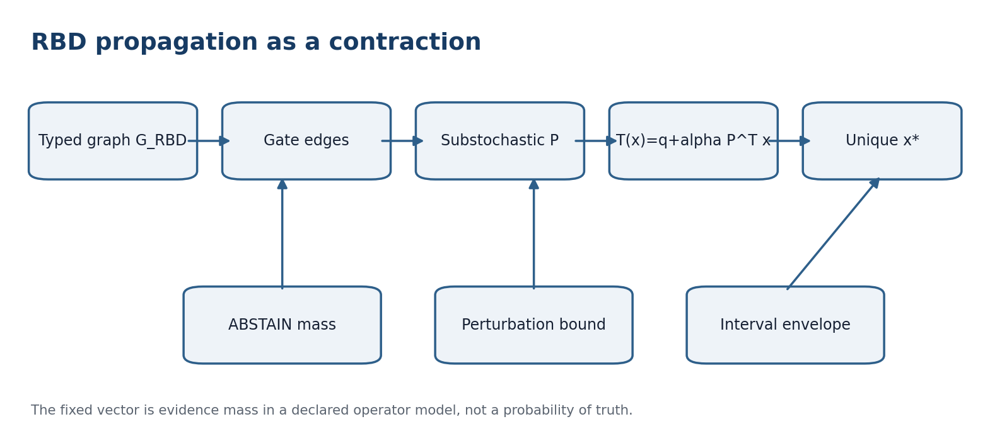
Figure 51.1. Typed graph filtering, abstention mass, contraction, and uncertainty envelope.

51.1. Audited Atlas v2.1 Counts
F039 |S|=236; |W|=1145; |V_R|=2212; |E_R|=2478 [RU p. 213]
These are counts of the attached Atlas v2.1 file, not universal sizes of the project. Every usable edge carries edge_type, source_id, work_id, confidence, limit tags, time span, and provenance.

51.2. Typed Graph and Substochastic Kernel
F040 G_RBD=(V,E,tau_V,tau_E,prov,w,L) [RU p. 213]
F041 P_ij=w_ij/max(1,sum_k w_ik); sum_j P_ij<=1 [RU p. 213]
F042 P_(i,ABSTAIN)=1-sum_j P_ij [RU p. 213]
Mass removed by gates is not silently redistributed. It enters an explicit abstention state. Separate adjacency matrices are constructed for each allowed route of node and edge types.

51.3. Propagation Operator
F043 T(x)=q+alpha P^T x; 0<=alpha<1 [RU p. 213]
Theorem 51.1 - Contraction [THM]. In the l1 norm, T is a contraction with coefficient at most alpha.
Proof. For a row-substochastic P, the induced l1 norm of P^T is at most one. Hence ||T(x)-T(y)||_1 = alpha||P^T(x-y)||_1 <= alpha||x-y||_1.
F044 ||T(x)-T(y)||_1 <= alpha||x-y||_1 [RU p. 213]
Corollary 51.1 - Unique fixed vector [THM]. Banach fixed-point theory gives a unique x*, and x^(k+1)=T(x^k) converges geometrically.
Proof. The affine contraction has a unique fixed point and the standard contraction estimate gives the rate.
F045 x*=(I-alpha P^T)^(-1)q [RU p. 213]
F046 ||x^(k)-x*||_1 <= alpha^k ||x^(0)-x*||_1 [RU p. 213]

51.4. Graph Perturbation
F047 ||x*-x'*||_1 <= [||q-q'||_1+alpha||(P-P')^T x'*||_1]/(1-alpha) [RU p. 213]
As alpha approaches one, the denominator becomes small and the fixed vector becomes sensitive to edge provenance. Alpha is selected before evaluation, and a sensitivity report is mandatory.

51.5. Interval Evidence Mass
F048 T_minus(x)<=T(x)<=T_plus(x) [RU p. 214]
F049 x_minus*<=x*<=x_plus* [RU p. 214]
The width x_plus*-x_minus* is epistemic uncertainty of the graph. It is reported separately from the predictive corridor for future Y.

51.6. Executability Boundary
The theorems apply to the declared typed kernel. They do not establish that all 2478 edges passed domain validation or that an external forecast was performed. Execution still requires a frozen adapter, target population, outcome, horizon, and independent ext corpus.
Philosophical-phenomenological note. A memory graph can amplify evidence and can also amplify a provenance error. Contraction makes propagation mathematically stable; validation of edges makes it historically meaningful.

RBD-CONTRACTION-CERT v196i14. atlas-counts={236,1145,2212,2478}; graph=typed; kernel=substochastic; abstention-mass=explicit; alpha<1; contraction=proved; fixed-point=unique; perturbation=bounded; external-run=not-executed.

Chapter 52. Main Conditional Theorem of the Predictive Method
Russian source locator: pp. 215-222
Central question | What exactly does the final theorem promise?
Plain meaning | It combines typed composition, projective invariance, monotone limits, stable rebuilding, RBD contraction, calibration, sequential testing, and multiplicity control.
Mathematical core | Every conclusion is conditional on explicit assumptions A1-A14 and bridge hypotheses B1-B8.
Boundary of inference | It does not promise an error-free future, a universal physical PN.2, or automatic promotion to a truth layer.

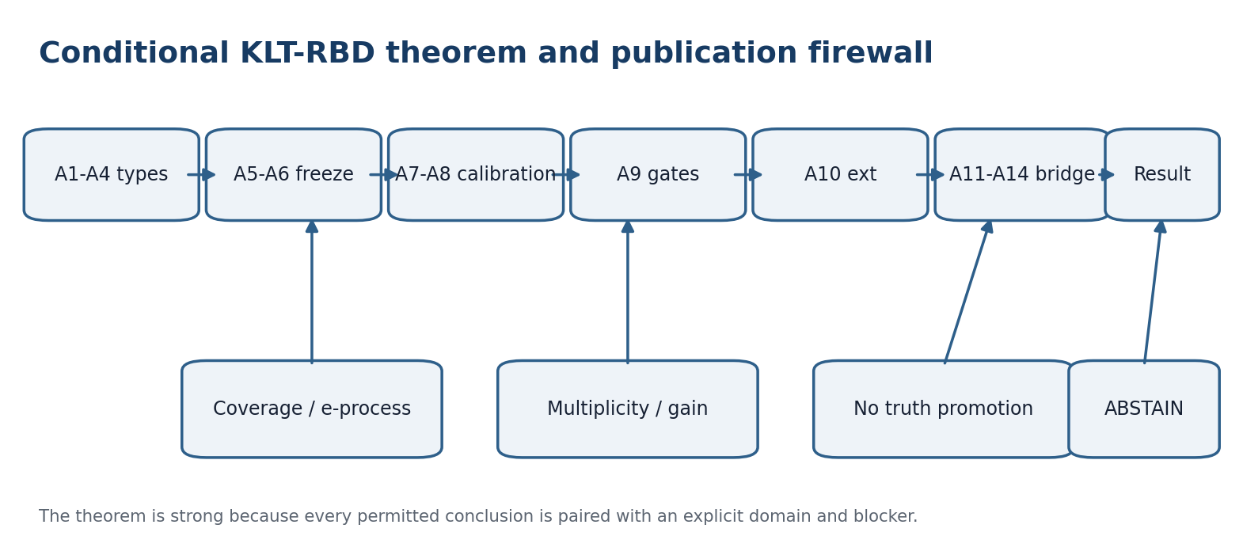
Figure 52.1. Assumptions, statistical guarantees, and the publication firewall of the main theorem.

52.1. Assumptions A1-A10
Code | Assumption | Violation
A1 | Obs/Evidence/Reper types agree | Block-type
A2 | D and Dom separated; support checked | Block-domain
A3 | provenance and hashes complete | Block-provenance
A4 | five limits registered | Block-limit
A5 | PN.2 branches and brackets fixed before outcome | post-selection
A6 | adapter, loss, and matched null frozen | invalid-comparison
A7 | calibration assumptions justified | coverage-not-claimed
A8 | cluster and time leakage excluded | Block-leakage
A9 | CGI<1 and blocker-safe gates passed | no-promotion
A10 | ext is independent and full decision is published | protocol-ready-only

Theorem 52.1 - Conditional soundness of KLT-RBD [THM]. Assume A1-A10. Let the projective-harmonic adapter construct C_L(x); let calibration provide marginal coverage at least 1-alpha_cov on the registered target population; let sequential decisions use a valid e-process with budget alpha_seq; let multiplicity have budget alpha_mult; and let the matched null receive the same search budget. Then: every intermediate BLOCK excludes PASS; noncoverage is at most alpha_cov within the calibration theorem domain; false sequential boundary crossing is at most alpha_seq; familywise error is at most alpha_mult; reported gain refers only to the declared loss, population, and horizon; and no truth-layer promotion follows automatically.
Proof. Compose Theorems 47.2, 48.1-48.2, 49.1, the registered calibration theorem, Ville inequality, and the registered multiplicity procedure. Equal search budgets make the risk difference operationally interpretable. None of these results identifies a frequency guarantee with truth of the theory.
F050 P{Y_new notin C_L(X_new)} <= alpha_cov [RU p. 215]
F051 P0{sup_t E_t >= 1/alpha_seq} <= alpha_seq [RU p. 215]
F052 FWER <= alpha_mult [RU p. 215]
F053 Risk_KLT <= Risk_matched-null - Delta_min [RU p. 215]

52.2. Composition of Budgets
F054 P(E_cov union E_seq union E_mult) <= alpha_cov+alpha_seq+alpha_mult [RU p. 216]
The sum is a safe union bound, not an exact total error. A sharper composition requires a proved dependence structure. All budgets are frozen before ext.

52.3. Status of the Closure Results
Statement | Status | Additional requirement
PGL2 invariance of lambda | proved | valid points and chart
monotonicity of five limits | proved | registered predicates
existence of rebuild | conditional theorem | compact/lsc or finite set
RBD contraction | proved for alpha<1 | validated typed kernel
forecast coverage | conditional | exchangeability or weighted bridge
gain over null | not externally executed | independent ext corpus
universal physical PN.2 | not claimed | domain-specific bridges
truth-layer promotion | 0 | certificate lock and publication gate

52.4. Immutable Artifact-1 Card
RIUD-TETRA-RUN006-029 -> PROOF-OBJ-RUN007-0029 -> FORMAL-CARD-RUN009-006 -> SIGNATURE-REVIEW-RUN013-001 [RU p. 216]
lambda=-0.992736565468; delta_truth=0.007263434532; CGI=0.140948882338 [RU p. 216]
status=signature-ready-not-truth-layer; next=certificate-lock/publication-gate review. The closure theorems do not rewrite any field of this card.

52.5. Typed Category of Quadratic NAPG Frames
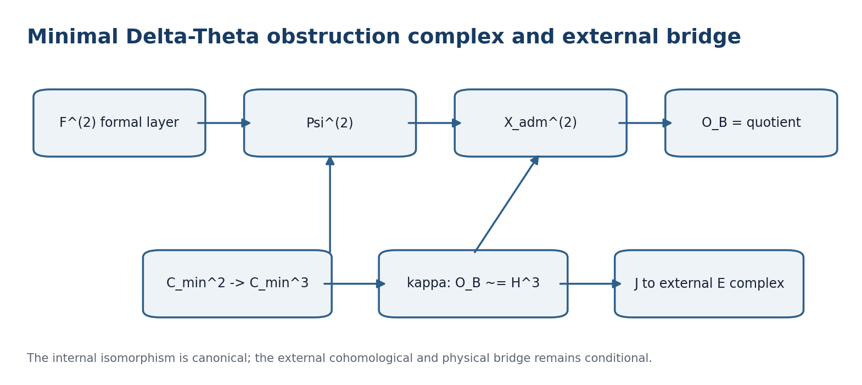
Figure 52.2. Minimal obstruction complex, canonical internal class, and conditional external bridge.
A quadratic NAPG frame is N=(K,A_bullet,odot,G,R;F_N^(2),X_N^(2),Psi_N^(2)). Here F^(2) is the formal admissible degree-at-most-two layer, X^(2) is the tested quadratic layer, and Psi^(2) is the linear evaluation map.
F074 X_N^(2)=Span_K{R odot R, R odot S + S odot R : R,S,R+S in R} [RU p. 216]
F075 O_B(N):=X_N^(2)/Im Psi_N^(2); Pi_N:X_N^(2)->O_B(N) [RU p. 216]
X^(2) is quadratic. It does not automatically contain the trilinear associator. Connecting the associator requires a separate typed encoding map.
F076 phi_X o Psi_N^(2) = Psi_N'^(2) o phi_F [RU p. 216]

52.6. Minimal Universal Cochain Complex
F077 C_min^n(N)=F_N^(2) for n=2; X_N^(2) for n=3; 0 otherwise [RU p. 216]
F078 delta_min^2(N):=Psi_N^(2); delta_min^n(N):=0 for n!=2 [RU p. 216]
F079 Theta_min,N = id_(X_N^(2)) [RU p. 217]
Lemma 52.1 - Existence of the complex [THM]. For every N in NAPG_q, (C_min(N),delta_min(N)) is a cochain complex.
Proof. The only potentially nonzero consecutive composition is delta_min^3 o delta_min^2. Since C_min^4=0 and delta_min^3=0, the composition vanishes. Every other composition contains a zero arrow.
Theorem 52.2 - Canonical realization of the quadratic obstruction [THM]. For every N in NAPG_q, kappa_N:O_B(N)->H^3(C_min(N)), kappa_N([x])=[x], is a canonical linear isomorphism.
Proof. Because delta_min^3=0, Ker delta_min^3=X_N^(2). Since Im delta_min^2=Im Psi_N^(2), the two quotient spaces are identical by definition.
F080 H^3(C_min(N))=X_N^(2)/Im Psi_N^(2)=O_B(N) [RU p. 217]
Scope of Theorem 52.2. This theorem solves the internal existence problem for C, delta, and Theta. It does not identify this H^3 with Hochschild, Chevalley-Eilenberg, de Rham, Quillen, analytic, topological, or physical cohomology.

52.7. Functoriality and Natural Invariance
Lemma 52.3 - Cochain transport [THM]. Every NAPG_q morphism f:N->N-prime defines a cochain map C_min(f), equal to phi_F in degree 2 and phi_X in degree 3.
Proof. The only nontrivial cochain condition is Psi_Nprime^(2) o phi_F = phi_X o Psi_N^(2), which is exactly F076.
Theorem 52.4 - Naturality of kappa [THM]. The family kappa_N is a natural isomorphism O_B => H^3 o C_min.
Proof. For [x], both routes through the naturality square yield [phi_X(x)]. If f is an isomorphism, the obstruction class is preserved under canonical transport.
F081 H^3(C_min(f)) o kappa_N = kappa_Nprime o phi_O [RU p. 217]

52.8. External E-Layer and Chain Bridge
An external E-layer is a functor E_bullet:NAPG_q->CoCh_K. A bridge J:C_min=>E is a natural cochain map. Its degree-2 and degree-3 components must satisfy the complete domain and chain conditions below.
F082 d_E^2 o J_N^2 = J_N^3 o Psi_N^(2); d_E^3 o J_N^3 = 0 [RU p. 218]
F083 E^3(f)oJ_N^3=J_Nprime^3 o phi_X; E^2(f)oJ_N^2=J_Nprime^2 o phi_F [RU p. 218]
Lemma 52.5 - Criterion for an external bridge [THM]. For fixed complexes E(N), maps J_N^2 and J_N^3 extend to a cochain map C_min(N)->E(N) exactly when F082 holds. The family is natural exactly when F083 also holds on the selected subcategory.
Proof. C_min is nonzero only in degrees 2 and 3, so these equalities exhaust the cochain and naturality conditions.

52.9. Bridge Hypotheses B1-B8
Code | Bridge hypothesis
B1 | N belongs to NAPG_q and F^(2), X^(2), Psi^(2) are complete linear data.
B2 | E is a genuine cochain complex: d_E^(n+1)d_E^n=0.
B3 | J^2 and J^3 are defined on the complete domains.
B4 | The chain equalities F082 hold.
B5 | Naturality F083 holds for the claimed invariance.
B6 | H^3(J_N) is injective for reverse detection.
B7 | A separate natural beta_Ass map encodes associator tests.
B8 | Topological, analytic, and physical meanings are separately defined and are not consequences of B1-B7.

Theorem 52.6 - Conditional natural external bridge [THM]. Under B1-B5, Pi_E,N:=H^3(J_N)o kappa_N is a well-defined natural linear map O_B(N)->H^3(E(N)). A nonzero external image implies a nonzero internal obstruction. The converse requires B6; complete preservation requires H^3(J_N) to be an isomorphism.
Proof. A cochain map induces a map in cohomology. Naturality follows by composing the naturality of kappa and H^3(J). Every map sends zero to zero, which proves one-way detection; reverse detection is precisely injectivity.
F084 Pi_E,N([x])=[J_N^3(x)]=[Theta_E,N(x)] [RU p. 219]
F085 H^3(E(f)) o Pi_E,N = Pi_E,Nprime o phi_O [RU p. 219]

52.10. Separate Associator Channel
Let T_Ass(N) be the linear span of admissible triples and A_N[x,y,z]=Ass_odot(x,y,z). A class in H^3(E) is typed only after a natural map beta_E,N:T_Ass(N)->Z^3(E(N)) has been defined and proved compatible with the actual associator.
F086 [Ass]_E := [beta_E,N(x,y,z)] in H^3(E(N)) [RU p. 219]
The formula additionally requires d_E^3 beta_E=0, independence of representation, naturality, and a proof that beta_E encodes the given associator rather than an arbitrary assigned cycle.

52.11. Counterexamples and Firewalls
Counterexample | Failure demonstrated
52.1 | Arrows C2->C3->C4 with delta3 delta2 !=0 do not define cohomology.
52.2 | A map not sending Im Psi into boundaries does not descend to O_B.
52.3 | A zero external bridge may erase a nonzero internal obstruction; reverse detection needs injectivity.
52.4 | Pointwise equal-looking maps need not be natural under isomorphism.
52.5 | Quadratic obstruction and associator defect are independent before beta_Ass is supplied.
52.6 | The tautological minimal complex creates no topology, metric, dynamics, field, curvature, or experiment.

52.12. Additional Assumptions A11-A14
Code | Additional assumption | Without it
A11 | state whether the complex is C_min or external E | only internal O_B is allowed
A12 | verify F082 and all map domains for E | Pi_E is undefined
A13 | verify naturality F083 | certificate depends on representation
A14 | prove B6 and/or B7 for reverse detection or associator claims | only one-way detection; associator claim prohibited

With A1-A14 and B1-B5, the internal class is invariant under NAPG_q isomorphisms; a nonzero external class certifies a nonzero quadratic obstruction; a zero external class does not exclude obstruction without B6; and neither kappa nor Pi_E promotes a truth layer or creates a physical conclusion.

52.13. Delta-Theta Proof-Obligation Register
ID | Obligation | Status | Boundary
DT-01 | type F^(2), X^(2), Psi^(2), O_B | closed for NAPG_q | not untyped models
DT-02 | concrete C and delta for every frame | closed internally | minimal two-stage complex
DT-03 | concrete Theta on all X^(2) | closed internally | Theta_min is not external realization
DT-04 | identify O_B with H^3 | closed | tautological by construction
DT-05 | functoriality and invariance | closed in NAPG_q | requires F076
DT-06 | existence of external E complex | conditional / model-open | not canonical
DT-07 | chain bridge J | conditional theorem | requires F082
DT-08 | naturality of external certificate | conditional theorem | requires F083
DT-09 | reverse detection from H^3(E) | model-open | requires injective H^3(J)
DT-10 | associator class in H^3 | open | requires beta_Ass or beta_E
DT-11 | analytic continuity and closure | open for infinite-dimensional classes | needs Banach/Hilbert bridge
DT-12 | physical or empirical interpretation | not claimed | B8 and independent protocol

52.14. Exact Replacement of Status 26.36
NAPG-DTHETA-CERT v196i14. For NAPG_q, C_min, delta_min, and Theta_min are constructed functorially and O_B ~= H^3(C_min) is proved. External E, natural J, injectivity of H^3(J), and beta_Ass remain conditional or open. Analytic, topological, physical, PN.2, and F-1-F-14 statuses are unchanged; truth_layer_promotion=0.

The internal result is not a logical trick: it removes ambiguity in domains, codomains, and functorial transport and exhibits the object that always exists. Its strength is limited because the minimal complex encodes exactly the quotient already selected as O_B. It is a universal comparison object and an interface specification, not a substitute for a richer external theory.
Philosophical-phenomenological note. The predictive theorem is strong not because it promises the future, but because it lists the conditions of its own limitation. Strict typing blocks the recurrent temptation to turn every nonzero H^3 into curvature of the universe.

MASTER-PRED-CERT v196i14. assumptions=A1-A14; bridge=B1-B8 typed; invariance=projective; limits=monotone; rebuild=stable-under-gap; RBD=contraction-alpha<1; coverage=conditional; e-process=conditional; matched-null=equal-budget; CGI<1=necessary-not-sufficient; EXT-RUN=not-executed; truth_layer_promotion=0.

T1-EN-APP-v0.9
CONTROLLED ENGLISH TRANSLATION OF APPENDICES A-G
Russian source locators: Appendix A pp. 151-156; Appendix B pp. 156-159; Appendices C-G pp. 223-235. The appendices are translated as evidence-bearing structures. They do not revise the chapter layer or create new mathematical or physical claims.
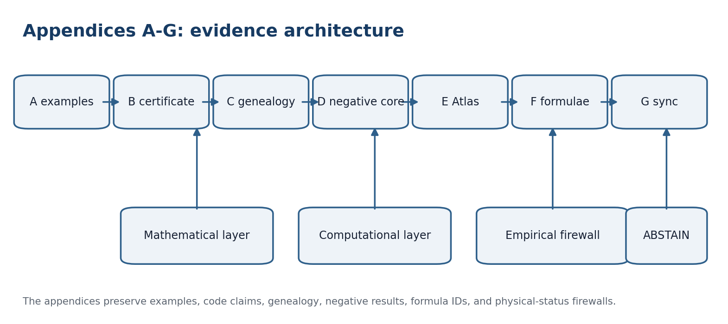
Figure A0.1. Appendices A-G connect exact examples, computational provenance, formula addressing, and empirical status firewalls.
Appendix | Function | Evidence boundary
A | Four exact PN.2 examples and counterexamples | abstract auxiliary algebras only
B | Source-documented computable certificate | NUM-SOURCE, not independent replay
C | Genealogy of the canonical construction | historical formulas do not auto-authorize truth
D | Negative PN.2 statements and repairs | underdefinition is repaired by typed inputs
E | Executable ten-stage Atlas protocol | protocol order and blockers are immutable
F | Stable registry F001-F086 | IDs are never renumbered after publication
G | PN.2 / F-1-F-14 synchronization | physical claims remain unvalidated

Appendix A. Explicit Examples and Counterexamples for PO-11
Central question | Why are explicit examples required?
Plain meaning | They test necessity of the assumptions, separate a scalar observable from the full state, and show when the factor 1/4 is sharp.
Mathematical core | All four constructions are exact finite-dimensional calculations with declared products, norms, triples, associators, structural coordinate, observables, and errors.
Boundary of inference | They do not identify the auxiliary algebra with the authorial physical object R-star-R and do not promote any F-hypothesis.

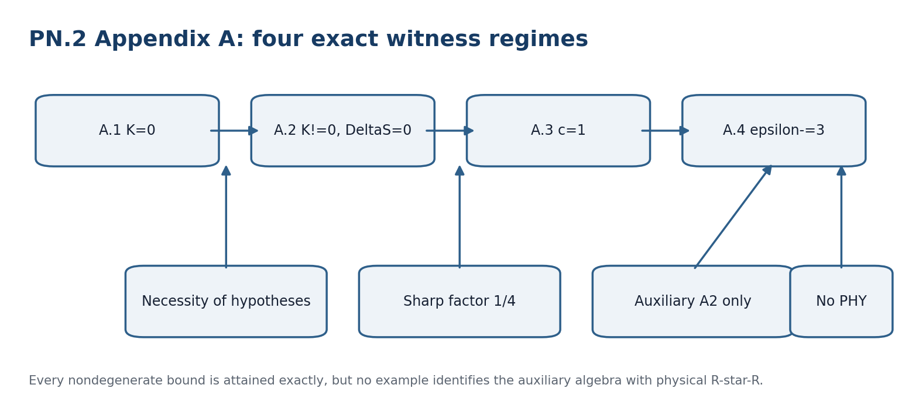
Figure A.1. Four witness regimes close PO-11 at the abstract theorem-package level.

A.0. Common Conventions and Auxiliary Algebra
Let B={b_L,b_R}, where b_L(x,y,z)=(x odot y) odot z and b_R(x,y,z)=x odot (y odot z). The signed protocol coordinate is Dfrak(b_L)=-1/2 and Dfrak(b_R)=+1/2. Hence Delta_D=1, the midpoint estimate is d_hat=0, and e_D=1/2. Relabeling the two bracketings changes the sign of Dfrak but preserves every PN.2 bound.
Dfrak(b_L)=-1/2; Dfrak(b_R)=+1/2; Delta_D=1; e_D(d_hat=0)=1/2 [RU p. 151]
Cases A.2-A.4 use the nonunital real algebra A2=R^2 with basis e1=(1,0), e2=(0,1):
e1 odot e1=e2; e2 odot e1=e2; e1 odot e2=-e2; e2 odot e2=0 [RU p. 151]
(alpha,beta) odot (gamma,delta)=(0, alpha gamma + beta gamma - alpha delta) [RU p. 151]
||(alpha,beta)||=2 sqrt(alpha^2+beta^2) [RU p. 151]
The operation is bilinear, closed, continuous, and submultiplicative for the declared norm. Finite dimensionality supplies completeness. A unit is not required for the abstract assumption A1; standard unitalization is possible without changing associator calculations on A2.

A.1. Associative Zero Example
Take A=R with ordinary multiplication, u=(1,2,3), and S(t)=|t|. Then r_L=r_R=6, K=0, Delta_R=0, Delta_S=0. With s_hat=6, d_hat=0, r_hat=6, one has e_S=0, e_D=1/2, e_R=0 and both PN.2 products equal zero.
e_S e_D=0=(1/4) Delta_S Delta_D; e_R e_D=0=(1/4)||K|| Delta_D [RU pp. 151-152]
Status: strict counterexample to every unconditional positive lower bound on a domain containing an associative point. It does not refute the minimax theorem because both right-hand sides vanish.

A.2. Nonassociative Example with Delta_S=0
For u=(e1,e1,e1), r_L=e2, r_R=-e2, K=2e2 and ||K||=4. Choose the natural but nonseparating scalar observable S(v)=||v||. Then S(r_L)=S(r_R)=2 and Delta_S=0 despite K nonzero.
e_S e_D=0=(1/4)Delta_S Delta_D; e_R e_D=2*(1/2)=1=(1/4)*4*1 [RU pp. 152-153]
Status: exact counterexample to replacing the full-state gap ||K|| by the difference of output norms. PN.2-R remains sharp.

A.3. Global c-Separation with c=1
Define S(alpha e1+beta e2)=2 beta. Every bracketed result lies on R e2, so for K=k e2 one has Delta_S=|S(K)|=2|k|=||K||. Thus S is globally c-separating on A2^3 with the exact constant c=1.
For u=(e1,2e1,3e1), r_L=6e2, r_R=-6e2, K=12e2, ||K||=Delta_S=24. Midpoint estimates give e_S=e_R=12 and e_D=1/2.
e_S e_D=6=(c/4)||K||Delta_D; e_R e_D=6=(1/4)||K||Delta_D [RU pp. 153-154]
Status: proves exact global separation for this observable and auxiliary algebra and shows that the coefficient 1/4 cannot be improved in general.

A.4. Exact Positive epsilon-minus on a Compact Domain
Omega={a,p,r in [1,2]; b,q,s in [-1/4,1/4]} subset A2^3 [RU p. 154]
K(x,y,z)=(0, 2apr+bpr-aps)=(0,p[(2a+b)r-as]) [RU p. 154]
The parameter q cancels identically. On Omega, g=a(2r-s)+br is minimized at a=1, b=-1/4, r=1, s=1/4, where g=3/2. Since p>=1, inf ||K||=2*(3/2)=3. For m=1 this gives the exact epsilon_minus=3.
epsilon_minus=inf_(u in Omega)||K(u)||/m(u)=3; c=1; kappa_Omega=3/4 [RU pp. 154-155]
The witness u_star=(e1-(1/4)e2,e1,e1+(1/4)e2) attains equality: r_L=(3/4)e2, r_R=-(3/4)e2, K=(3/2)e2, ||K||=Delta_S=3, and e_S=e_R=3/2.
e_S e_D=e_R e_D=3/4=(epsilon_minus Delta_D/4)m(u_star) [RU pp. 155-156]

A.5. PO-11 Closure and Status Boundary
Case | Associator / observable | Exact result | Status
A.1 | K=0; Delta_S=0 | both bounds 0=0 | associative counterexample
A.2 | K!=0; norm observable | Delta_S=0; PN.2-R 1=1 | scalar nonseparation
A.3 | linear S_sep | c=1; both bounds 6=6 | sharp global separation
A.4 | compact Omega | epsilon_minus=3; both bounds 3/4=3/4 | uniform exact domain

PO-11 STATUS. CLOSED-ABSTRACT for the canonical PN.2 theorem package. The appendix proves necessity and sharpness inside the declared auxiliary models. PO-1-PO-10 for physical R-star-R, physical meanings of Dfrak and S, hbar calibration, PN.1, and F-1-F-14 remain open.

Appendix B. Computable Certificate for PO-12

B.0. Purpose and Status Boundary
The Russian source records the reproducible certificate PN2-PO12-A2-v1.0 for A2 and the four Appendix A cases. This English derivative translates the certificate record. It does not assert a new independent replay of the archive.

B.1. Identifier, Environment, and Files
Field | Recorded value
Identifier | PN2-PO12-A2-v1.0
Archive | pn2_po12_cert_v1.0.zip
Environment | Python 3.10 or newer; standard library only
Core | pn2_cert.py
Tests | test_pn2_cert.py
Machine specification | manifest.json
Results | results.json and values.tsv
Deterministic builder | build_bundle.py
Instructions | README_RU.md
Digests | SHA256SUMS.txt

B.2. Structural Constants and Associator Tensor
C[2,1,1]=1; C[2,2,1]=1; C[2,1,2]=-1; all other C[k,i,j]=0 [RU p. 156]
A[m,i,j,k]=sum_l(C[l,i,j]C[m,l,k]-C[l,j,k]C[m,i,l]) [RU p. 156]
The only nonzero associator components are A[2,1,1,1]=2, A[2,2,1,1]=1, and A[2,1,1,2]=-1. Therefore the implementation obtains K(x,y,z)=(0,2apr+bpr-aps) exactly.

B.3. Exact Norm Handling, Dfrak, Observables, and Errors
The certificate stores the exact squared norm 4(alpha^2+beta^2). On the multiplication and associator image R e2, it uses ||(0,beta)||=2|beta|, avoiding irrational rounding in all certified equalities. The fixed coordinate gives Delta_D=1 and e_D=1/2. S_norm is used for A.2 and S_sep(alpha,beta)=2 beta for A.3-A.4.

B.4. Expected / Obtained Matrix
Case | Expected and source-recorded obtained values | Verdict
A.1 | r_L=r_R=6; K=0; ||K||=Delta_S=e_S=e_R=0; e_D=1/2; bounds 0=0 | PASS
A.2 | r_L=(0,1); r_R=(0,-1); K=(0,2); ||K||=4; Delta_S=e_S=0; e_R=2; PN.2-R 1=1 | PASS
A.3 | r_L=(0,6); r_R=(0,-6); K=(0,12); ||K||=Delta_S=24; c=1; e_S=e_R=12; bounds 6=6 | PASS
A.4 | r_L=(0,3/4); r_R=(0,-3/4); K=(0,3/2); ||K||=Delta_S=epsilon-=3; kappa=3/4; bounds 3/4=3/4 | PASS

B.5. Certification of c=1 and epsilon-minus=3
Because K always lies in R e2, Delta_S=|S_sep(K)|=||K|| identically. Hence c=1 on A2^3 and is sharp on any domain containing a nonzero K witness. For Omega, the exact interval proof gives ||K||>=3, while u_star attains 3. The certificate also checks 729 rational grid points and includes an outside-domain point with p=1/2 yielding ||K||=3/2, confirming domain dependence.

B.6. Source-Recorded Commands
python3 pn2_cert.py --report [source command]
python3 -m unittest -v test_pn2_cert.py [source command]
python3 build_bundle.py [source command]
sha256sum -c SHA256SUMS.txt [source command]
Expected source-reported outcome: PASS; Ran 11 tests; OK; every values.tsv row has PASS.

B.7. SHA-256 Ledger
Object | SHA-256
pn2_po12_cert_v1.0.zip | bbcb2715a3e5ab7688dfe1ad317a68f23b163ae10915982216111142ce7da2ad
README_RU.md | 4e08346221388e5b70ae64a649ca1146653e6b9df8f608d80a4f4e22a6c0df62
build_bundle.py | e75160342cc59a1207fcb62a356c72b455a1c91d4e553564c5a3edde2f8c52cb
manifest.json | 87c39b11cfb6bbc27659e20e84c914b60851cb4caa481d3056695dca7dcddf69
pn2_cert.py | 97880a92707f718d0282c87afd6e0d3e291aa7226cc836a0817b1e71d25a0113
results.json | 2baa4af2480ea6fcfcbab0afa3d455ced8b5aa4280d92fb3602c80d532c9dd7b
test_pn2_cert.py | 51c1b090bb47ada673d711b931be112c63f367d3b39afaafe48a25007d973bcd
values.tsv | 758aa6a68abd42b98e6f90e8f39c889379cf2aeb847dc345be21c7394f9134f2

B.8. Exact Coverage and Non-Coverage
- Establishes the published A2 structural constants, product, associator, and all four exact examples.
- Establishes Delta_D=1, e_D=1/2, global c=1, exact epsilon_minus=3, kappa_Omega=3/4, and equality cases.
- Records deterministic rebuild properties of the source package using the Python standard library.
- Does not identify A2 with physical R-star-R or establish physical meanings of Dfrak, S, c, epsilon_minus, or kappa.
- Does not close PO-1-PO-10, connect the model to hbar or PN.1, validate F-1-F-14, or establish universal physical validity.
PO-12 STATUS. CLOSED-ABSTRACT / NUM-SOURCE for the four auxiliary examples. Independent replay and transfer to physical R-star-R remain OPEN.

Appendix C. Full Genealogy of the Canonical Construction
The purpose of this appendix is to show the dependency chain from the earlier monograph 5.0 to Chapters 47-52. Symbols are normalized, but the order of conceptual dependence is preserved.

C.1. Reper and the Harmonic Criterion
F055 Rep_i=(R_i,I_i,U_i;D_i) [RU p. 223]
F056 Truth(Rep) iff cr(U,I;R,D)=-1 [RU p. 223]
F057 lambda=((U-R)(I-D))/((U-D)(I-R)) [RU p. 223]
F058 delta_truth=|lambda+1| [RU p. 223]
In the frozen Volume I, Truth in the historical expression names an internal harmonic gate. Publication still requires provenance, valid Dom and D, a matched null where applicable, CGI<1 as a necessary diagnostic, and independent validation.

C.2. KPF/RPHD Architectural Extension
F059 KPF/RPHD v1.0 = Reper v1.0 + Limit-Causal v1.0 + (Xi,Delta,Upsilon)+T_cs^L+CGI [RU p. 223]
The plus sign is an architectural module composition, not vector-space addition. Each module has its own type, domain, and gate.

C.3. Packet Transformation and Causal Assembly
F060 T_pack=T_change*T_action [RU p. 223]
F061 T_cs^L=T_cs+T_{Delta|L}+T_{Xi|L}+T_{Upsilon|L}+S_{P@S} [RU p. 223]

C.4. Historical Forecast Chain
F062 Forecast=Pi_L[Upsilon_L o Delta_L o Xi_L(RBD_lambda)], CGI<1 [RU p. 223]
Pi_L is now read as projection into the registered admissible-limit set. CGI<1 is necessary for the internal gate but is not sufficient for truth-layer promotion or physical realization.
Historical node | v196i14 deepening | Result
Rep(R,I,U;D) | typed PackCert object | Chapter 47
cross-ratio=-1 | PGL2 invariance and harmonic conjugate | Chapter 48
Pi_L | five-limit lattice | Chapter 49
T_change | stable versioned rebuilding | Chapter 50
RBD_lambda | substochastic contraction | Chapter 51
Forecast / CGI | conditional master theorem | Chapter 52

Philosophical-phenomenological note. Genealogy does not weaken the novelty of a strict continuation. It shows where an intuition first received a name and where that name later acquired proof obligations.

Appendix D. PN.2: Negative Statements and Repair

D.1. No Global Machine from an Untyped Input
F063 X alone does not determine (size(X),dim(X)) without D_X and a type contract [RU p. 225]
A diagonal argument selects two admissible interpretations of the same visible X with different target values. A single machine sees the same input and must fail in at least one interpretation.

D.2. A Triple Does Not Determine a Reper
F064 (R,I,U) does not determine a Reper [RU p. 225]
F065 (R,I,U;D0) -> Reper if ValidRep=1 [RU p. 225]
Without D0 the cross-ratio is not defined and harmonic authorization is unavailable. Any procedure that reconstructs D0 must expose the reconstruction rule as an adapter and include it in the matched-null comparison.

D.3. Hole and Versioned Repair
F066 Hole(P)={k in Required(P): missing(k) or invalid(k)} [RU p. 225]
F067 Repair(P,h)=(P-prime, revision-edge P->P-prime, certificate h) [RU p. 225]
F068 Hole(P)=empty iff completeness-gate(P)=1 [RU p. 225]
Theorem D.1 - Impossibility of a traceless repair [THM]. In PackCert there is no admissible morphism that maps a packet with a nonempty Hole and no new witness h to complete-PASS.
Proof. A nonempty Hole creates a mandatory Block. Block is absorbing under every ordinary morphism. Only a separate repair object may supply the missing witness and create a new version.
Philosophical-phenomenological note. A negative theorem does not close knowledge. It identifies which question was underdefined. Repair begins not with a stronger answer, but with a more complete input.

Appendix E. Executable Ten-Stage Atlas Protocol
The protocol reproduces the ten stages of predictive_protocol_v2_0.csv. Every stage has a typed input, output, and blocking condition. Reordering the stages creates a new protocol_id.
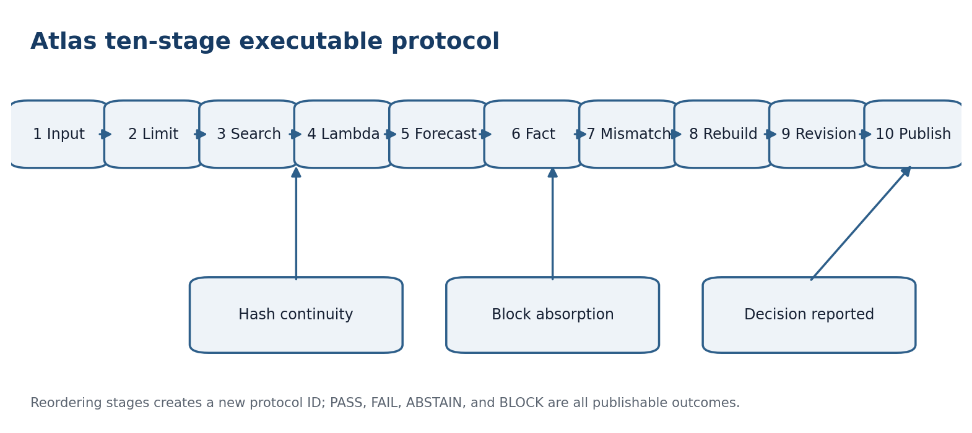
Figure E.1. Ten-stage Atlas route with hash continuity, Block propagation, and publication gate.
# | Stage | Input -> output | Block
1 | InputEventStateLimit | C@C, context -> typed input | missing type/time
2 | LimitGate | typed input, L -> admissible input | limit unknown/violated
3 | ReperSearch | RBD, input -> candidates | no typed route
4 | LambdaClosure | candidates -> lambda, delta | denominator/provenance
5 | ForecastBuild | gated Repers -> C_L(x) | empty -> ABSTAIN
6 | FactAttach | new fact -> immutable observation | hash/time missing
7 | MismatchDetect | forecast, fact -> mismatch code | loss undefined
8 | NearestRebuild | mismatch, N(r) -> argmin set | candidate registry absent
9 | RevisionChain | old, new -> versioned edge | parent/hash absent
10 | PublishSnapshot | certificates -> signed snapshot | publication gate

E.1. Protocol Invariants
F069 hash(output_k)=hash(input_{k+1}) [RU p. 226]
F070 timestamp(output_k)<=timestamp(output_{k+1}) [RU p. 226]
F071 Block_k=1 => Block_j=1 for every j>k [RU p. 226]

E.2. Minimal Run Ledger
The ledger stores run_id, stage_id, input_hash, output_hash, code_version, environment_hash, seed, operator, timestamp, status, Block reason, and parent-certificate reference. For sensitive data, a hash and access schema are published instead of the bytes.

E.3. Read-Only Atlas Snapshot
File | Rows | Meaning
sources.csv | 236 | sources
works.csv | 1145 | work units
repers.csv | 2212 | Reper nodes
reper_edges.csv | 2478 | typed edges
predictive_protocol_v2_0.csv | 10 | protocol stages

The counters describe the attached archive state and must be recomputed for every new version_hash. Counts do not replace semantic validation.

E.4. Publication Decision
F072 Publish iff no-Block and hashes-closed and protocol-frozen and decision-reported [RU p. 226]
truth_layer_promotion remains a separate field even when Publish is true. PASS, FAIL, ABSTAIN, and BLOCK are reported under the same rule; otherwise publication would depend on the outcome.
RIUD-TETRA-RUN006-029 -> PROOF-OBJ-RUN007-0029 -> FORMAL-CARD-RUN009-006 -> SIGNATURE-REVIEW-RUN013-001 [RU p. 227]
lambda=-0.992736565468; delta_truth=0.007263434532; CGI=0.140948882338; truth_layer_promotion=0 [RU p. 227]
Philosophical-phenomenological note. A protocol turns a sequence of actions into an object that can be repeated. It preserves not only a successful path, but also the stopping point, because stopping is knowledge about the boundary of the method.

Appendix F. Formula Registry F001-F086
The registry supplies stable identifiers for the mathematical layer. Existing IDs are not reassigned. A removed formula is marked deprecated; a new formula receives the next free identifier. Registration does not increase evidence status.

F.1. Registry F001-F015
ID | Formula | Role / status
F001 | Obs := (event,state,time,source,unit,cluster,Dom,status) | raw observation object
F002 | Evidence := Obs x {provenance,hash,adapter,loss,null,gate} | evidence extension
F003 | D subset Obs; Dom(T) subset X; D != Dom(T) | D/Dom barrier
F004 | Rep_i = (R_i,I_i,U_i;D_i) | canonical Reper quadruple
F005 | ValidRep(Rep) iff typed and distinct-denominators and provenance and Dom-gate | Reper validity
F006 | f:P->Q; type(Q)=f_t(type(P)); prov(Q) contains f_p(prov(P)) | packet morphism
F007 | status(P)=Block => status(f(P))=Block | Block absorption
F008 | A(R1,R2,R3) := (R1 star R2) star R3 - R1 star (R2 star R3) | NAPG associator
F009 | A != 0 => bracket in metadata and branch-id in certificate | bracket as mandatory metadata
F010 | lambda(R,I;U,D0)=((U-R)(I-D0))/((U-D0)(I-R)) | Volume I cross-ratio
F011 | delta_truth(Rep)=|lambda(Rep)+1| | harmonic defect
F012 | lambda(R,I;U,D0)=([U,R][I,D0])/([U,D0][I,R]) | homogeneous cross-ratio
F013 | lambda o g = lambda; g in PGL_2(K) | projective invariance
F014 | D_h = [U(I+R)-2RI]/[2U-R-I] | harmonic conjugate
F015 | lambda(0,1;3,3/2)=-1 | harmonic check example

F.2. Registry F016-F030
ID | Formula | Role / status
F016 | C_L(x)=union {Psi_r(x): r in A_L(D), gate(r,x)=1} | set-valued Reper forecast
F017 | C_L(x)=empty => ABSTAIN; Block nonempty => BLOCK | ABSTAIN versus BLOCK
F018 | C_L(gx)=g(C_L(x)) | forecast equivariance
F019 | |Delta lambda| <= K_epsilon (||Delta R||+||Delta I||+||Delta U||+||Delta D0||) | local stability away from poles
F020 | L=(L_pol,L_eco,L_space,L_time,L_onto) | five-limit vector
F021 | gate_L(r)=∧_{j=1}^5 ℓ_j(r) | limit gate
F022 | L' >= L iff A_L'(D) subset A_L(D) | strictness order
F023 | L' >= L => A_L' subset A_L and C_L' subset C_L | forecast monotonicity
F024 | A_(L meet M)=A_L intersection A_M | meet of limits
F025 | A_(L join M)=closure(A_L union A_M) | join as typed closure
F026 | Forecast_t(h) is measurable with respect to F_t | information-time measurability
F027 | feature-time(x_k)<=t; outcome-time=t+h | anti-leakage time order
F028 | inf_T sup_(theta in Theta) E_theta[L(T(X),theta)] >= c_PN2 > 0 | PN.2 minimax limit
F029 | max(R0(T),R1(T)) >= c(1-TV(P0,P1))/2 | two-point lower bound
F030 | d_R(r,s)=w_phi||phi(r)-phi(s)||+w_lambda|lambda_r-lambda_s|+w_D d_D(D_r,D_s)+P(r,s) | extended Reper metric

F.3. Registry F031-F045
ID | Formula | Role / status
F031 | P(r,s)=infinity if type/provenance/bracket incompatible | hard incompatibility penalty
F032 | J_z(s|r)=d_R(r,s)+alpha Loss_z(s)+beta delta_truth(s)+gamma Complexity(s<-r) | rebuild objective
F033 | R_z(r)=argmin_{s in N(r) intersection A_L(D union z)} J_z(s|r) | set-valued rebuild
F034 | Gamma=J_z(s2|r)-J_z(s*|r) | stability gap
F035 | Gamma>0 => R_z(r)={s*} | perturbation stability
F036 | Gamma>2epsilon => argmin J_z' = argmin J_z | versioned rebuild chain
F037 | R_z2(R_z1(r)) != R_(z1 union z2)(r) in general | nonassociativity of revision
F038 | Gain_rebuild=L(matched-null search)-L(KLT rebuild) | honest rebuild gain
F039 | |S|=236; |W|=1145; |V_R|=2212; |E_R|=2478 | Atlas v2.1 counters
F040 | G_RBD=(V,E,tau_V,tau_E,prov,w,L) | typed RBD graph
F041 | P_ij=w_ij/max(1,sum_k w_ik); sum_j P_ij<=1 | substochastic kernel
F042 | P_{i,⊥}=1−Σ_j P_{ij} | ABSTAIN mass
F043 | T(x)=q+alpha P^T x; 0<=alpha<1 | propagation operator
F044 | ||T(x)-T(y)||_1 <= alpha||x-y||_1 | contraction bound
F045 | x*=(I-alpha P^T)^(-1)q | fixed vector

F.4. Registry F046-F060
ID | Formula | Role / status
F046 | ||x^(k)-x*||_1 <= alpha^k ||x^(0)-x*||_1 | convergence rate
F047 | ||x*-x'*||_1 <= [||q-q'||_1+alpha||(P-P')^T x'*||_1]/(1-alpha) | fixed-point perturbation
F048 | T_minus(x)<=T(x)<=T_plus(x) | interval operators
F049 | x_minus*<=x*<=x_plus* | fixed-point envelope
F050 | P{Y_new notin C_L(X_new)} <= alpha_cov | conditional predictive coverage
F051 | P0{sup_t E_t >= 1/alpha_seq} <= alpha_seq | sequential error budget
F052 | FWER <= alpha_mult | multiplicity budget
F053 | Risk_KLT <= Risk_matched-null - Delta_min | operational gain criterion
F054 | P(E_cov union E_seq union E_mult) <= alpha_cov+alpha_seq+alpha_mult | union error budget
F055 | Rep_i=(R_i,I_i,U_i;D_i) | historical Reper formula
F056 | Truth(Rep) iff cr(U,I;R,D)=-1 | historical harmonic gate
F057 | lambda=((U-R)(I-D))/((U-D)(I-R)) | computable lambda coordinate
F058 | delta_truth=|lambda+1| | harmonic defect
F059 | KPF/RPHD v1.0 = Reper v1.0 + Limit-Causal v1.0 + (Xi,Delta,Upsilon)+T_cs^L+CGI | architectural module sum
F060 | T_pack=T_change*T_action | historical change-action composition

F.5. Registry F061-F075
ID | Formula | Role / status
F061 | T_cs^L=T_cs+T_{Delta|L}+T_{Xi|L}+T_{Upsilon|L}+S_{P@S} | limit-dependent causal operator
F062 | Forecast=Pi_L[Upsilon_L o Delta_L o Xi_L(RBD_lambda)], CGI<1 | historical forecast chain
F063 | X alone ↛ (size(X),dim(X)) without D_X and a type contract | negative PN.2-A core
F064 | (R,I,U) ↛ Rep | insufficiency of a triple
F065 | (R,I,U;D0) -> Reper if ValidRep=1 | repair by fourth element
F066 | Hole(P)={k in Required(P): missing(k) or invalid(k)} | packet hole
F067 | Repair(P,h)=(P-prime, revision-edge P->P-prime, certificate h) | versioned repair
F068 | Hole(P)=empty iff completeness-gate(P)=1 | completeness criterion
F069 | hash(output_k)=hash(input_{k+1}) | stage hash continuity
F070 | timestamp(output_k)<=timestamp(output_{k+1}) | temporal monotonicity
F071 | Block_k=1 => Block_j=1 for every j>k | Block propagation to publication
F072 | Publish iff no-Block and hashes-closed and protocol-frozen and decision-reported | publication gate
F073 | N_formula(new-layer v196i14)=73 | formula-count receipt
F074 | X_N^(2)=Span_K{R odot R, R odot S + S odot R : R,S,R+S in R} | quadratic layer definition
F075 | O_B(N):=X_N^(2)/Im Psi_N^(2); Pi_N:X_N^(2)->O_B(N) | quadratic obstruction quotient

F.6. Registry F076-F086
ID | Formula | Role / status
F076 | phi_X o Psi_N^(2) = Psi_N'^(2) o phi_F | frame-morphism compatibility
F077 | C_minⁿ(N)=F_N^(2) for n=2; C_minⁿ(N)=X_N^(2) for n=3; C_minⁿ(N)=0 for n≠2,3 | minimal complex
F078 | delta_min^2(N):=Psi_N^(2); delta_min^n(N):=0 for n!=2 | minimal differential
F079 | Theta_min,N = id_(X_N^(2)) | canonical internal bridge
F080 | H³(C_min•(N))=Ker δ_min³/Im δ_min²=X_N^(2)/Im Ψ_N^(2)=O_B(N) | canonical isomorphism
F081 | H^3(C_min(f)) o kappa_N = kappa_Nprime o phi_O | naturality of kappa
F082 | d_E^2 o J_N^2 = J_N^3 o Psi_N^(2); d_E^3 o J_N^3 = 0 | external-chain equalities
F083 | E^3(f)oJ_N^3=J_Nprime^3 o phi_X; E^2(f)oJ_N^2=J_Nprime^2 o phi_F | naturality of J
F084 | Pi_E,N([x])=[J_N^3(x)]=[Theta_E,N(x)] | conditional external certificate
F085 | H³(E•(f)) ∘ Π_E,N = Π_E,N′ ∘ φ_O | naturality of Pi_E
F086 | [Ass]_E := [β_E,N(x,y,z)] ∈ H³(E•(N)) | separate associator class only with beta bridge

F073 N_formula(new-layer v196i14)=73 [RU p. 229]
FORMULA-REGISTRY-CERT. numbering=stable; F001-F086=complete; renumbering=forbidden; deletion=deprecated; F084-F086 remain conditional on declared external bridge hypotheses; physical status unchanged.

Appendix G. Canonical Synchronization of PN.2 and F-1-F-14
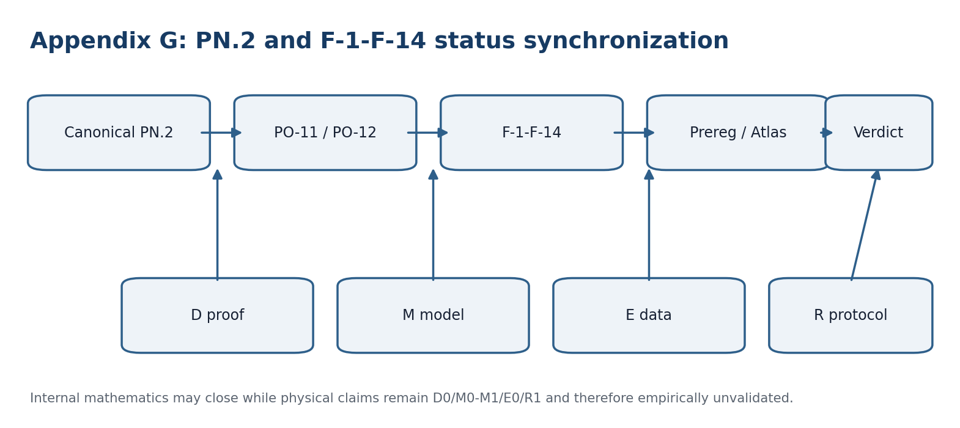
Figure G.1. Mathematical closure, model completeness, empirical data, and protocol execution remain separate axes.

G.1. Editorial Layers and Priority Rule
Layer | Role | Reading rule
Part V / section 21.7 | historical editorial source | preserved as provenance; old PO list is not current
Part VII / section 27.2 | canonical theorem package | controls formulas, boundaries, and abstract PO-11/PO-12 closure
verification protocol | methodological operationalization | defines H0, observables, systematics, falsifiers; not data
F-1-F-14 atlas | visual testability map | R1 protocol concept; no E-status promotion
Appendix G | synchronization layer | resolves wording, priority, status codes, references, notation

The historical label Full PN.2 Text v1.1 in section 21.7 is read as provenance. Full Canonical PN.2 Text v1.0 in section 27.2 is the controlling source after PO-11 and PO-12 closure.

G.2. Canonical Formulations F-1-F-14
ID | Canonical title | Exact controlled English formulation
F-1 | Ontology of time | R-star-R is a physical algebra of time, not only a mathematical model.
F-2 | Fundamentality | PN.2 is more fundamental than Robertson-Heisenberg uncertainty or noise-disturbance principles.
F-3 | PN.2 implies PN.1 | Quantum uncertainty is derived from the associator through a representation rho.
F-4 | hbar calibration | A physically justified regime ||K|| approximately hbar exists with correct units and coefficient.
F-5 | Induced commutator | [x,y]z:=K(x,y,z) defines an admissible operator commutator after representation; bilinearity, antisymmetry, Jacobi or a replacement, and domains must be checked.
F-6 | Seven-component time | Seven R-star-R objects form an internal multicomponent structure of time.
F-7 | FOS and Time*Space | FOS and Time*Space have an observable physical realization; space is a layered projection and Minkowski-Einstein spacetime is a section.
F-8 | Time-flow operator | The hierarchy A>Hpx>R3>R2>R1>{i hbar,iH}, T=sum pi_(i+1->i), and dR/dtau=T(R) describe physical time flow.
F-9 | Complexity monotonicity | For a physically defined C(R)=sum w_i Dim_i(R), dC/dtau>=0.
F-10 | Associator dynamics | nabla_T K=J_T is a correct covariant field equation with defined sources, dimensions, and variational principle.
F-11 | Early Universe | Dynamics of K imply maximal initial coherence or another observable cosmological regime.
F-12 | Localization in matter | The associator physically localizes in matter and produces measurable effects.
F-13 | Finite observer branch | The structural nesting accessible to an observer is physically finite.
F-14 | Gravity and cosmology | PN.2 gives testable corrections to GR/quantum theory, or removes singularities, or explains the dark sector.

F-14 uses logical OR, not cumulative AND. Its branches must be preregistered separately as F-14a, F-14b, and F-14c with distinct models and falsifiers.

G.3. Two-Coordinate Priority Scale
ID | Ptest | Pclaim | Canonical decision
F-1 | P1 | P4 | laboratory effective nonassociativity may precede ontology
F-2 | P0 | P4 | formal reduction and novel prediction first
F-3 | P0 | P0 | strict operator bridge; physical implication remains open
F-4 | P0 | P0 | independent dimensional calibration
F-5 | P0 | P0 | types, domains, antisymmetry, Jacobi or replacement
F-6 | P2 | P3 | identify components before seven-component physics
F-7 | P2 | P3 | reduction theorem and distinguishable invariant first
F-8 | P0->P1 | P2 | valid generator before trajectories and physics
F-9 | P0->P1 | P2 | define C and weights, then early sign test
F-10 | P0->P2 | P2 | covariance and variational origin before field data
F-11 | P3 | P3 | cosmological template frozen before confirmatory data
F-12 | P1 | P1 | controlled lab test after source and amplitude definition
F-13 | P2->P3 | P4 | resource cutoff before ontological finiteness claim
F-14 | P3 | P3 | test F-14a/b/c separately; no omnibus claim

P0=formal bridges and types; P1=controlled laboratory test; P2=dynamics and geometry; P3=field/cosmological test; P4=synthetic ontological or metatheoretical claim.

G.4. Unified D/M/E/R/C Evidence Scale
Axis | Scale | Meaning | Current result
D proof | D0/D1/D2 | no theorem / conditional / proved | PN2-7.1 D2 inside A1-A4; PN2-9.1 D1; physical F claims D0
M model | M0/M1/M2 | phrase / ansatz / computable forward model | F-1-F-14 M0-M1; no complete M2
E data | E0-E4 | formulation / calibration / pilot / replication / robust result | all F claims E0
R protocol | R0-R3 | none / concept / prereg-ready / executed | protocol and atlas R1, not data
C computation | C0/C1 | no checkable calculation / exact internal certificate | A.1-A.4 and PO-12 C1 for auxiliary A2

G.5. Notation and Formula Freeze
The associator object is written R-star-R only. R*R is not used for it. star_H is reserved for the Hodge operator and odot for the basic nonassociative product. Mathematical indices remain typographic; underscores are restricted to machine identifiers.
e_S(u;s_hat)e_D(u;d_hat) >= (1/4) Delta_S(u) Delta_D [RU p. 234]
e_R(u;r_hat)e_D(u;d_hat) >= (1/4)||K(u)|| Delta_D [RU p. 234]
e_S(u;s_hat)e_D(u;d_hat) >= (c/4)||K(u)|| Delta_D [RU p. 234]
e_R(u;r_hat)e_D(u;d_hat) >= (epsilon_minus Delta_D/4)m(u), u in Omega [RU p. 234]
nabla_T K=J_T; dR/dtau=T(R); dC/dtau>=0; C(R)=sum w_i Dim_i(R) [RU p. 234]
Every comparison between ||K|| and hbar requires an independent dimensional map.

G.6. Proof Ledger after PO-11 and PO-12
Object | Status | Established | Not established
PN2-7.1 | D2 | local minimax bound under A1-A4 | physical meaning and universality
PN2-9.1 | D1 | uniform form for epsilon_minus>0 on fixed Omega | global constant without coercivity
PO-11 | closed abstract | four explicit constructions A.1-A.4 | transfer to physical R-star-R
PO-12 | closed abstract / C1 | internal computable certificate for A2 | independent replication and physical certificate
F-1-F-14 | D0/M0-M1/E0/R1 | falsifiable verification programme | experimental confirmation

No diagram, simulation, internal certificate, or parameter coincidence changes E0 to E1-E4. Promotion requires calibration, frozen protocol, data, and independent replication.

G.7. Canonical Companion-File Map
File | Recorded SHA-256 | Role
PN2_verify_protocol_v1.docx | df02c167f71383d90f170df41b17ebdf82c5d96c3405af798ca4099cb04428fc | editable methodological protocol
PN2_verify_illustrated_v1.pdf | 2d08c8a504fa649a701c1e6707ec4a09870c00c4a174d9cef50a2e7dd01f7fd6 | illustrated protocol edition
pn2_f1_f14_atlas_ru_v1.pdf | 4a15ca6a73a71767a593f0b26ac26b78ddc14cb874c143231efa18500f2bf62c | standalone F-1-F-14 atlas

SHA-256(canonical exact F-1-F-14 strings)=87665008c2cf5b84faceaa669c4a70b2e8a2de7f8bcddea1ced3198578e63ddc [RU p. 235]

G.8. Publication Formula and Status
Controlled publication statement: A mathematical model of structural uncertainty is proposed; a minimax theorem is proved inside the model; the physical bridges F-1-F-14 are formulated as a falsifiable programme of independent verification.
APPENDIX-G VERDICT. PN.2 mathematics and physical programme synchronized; F001-F086 notation frozen; PO-11/PO-12 abstract closure preserved; F-1-F-14 remain E0; independent EXT-RUN absent; truth_layer_promotion=0.

T1-EN-ASSEMBLY-v0.10
CONTROLLED ENGLISH UNIFIED MASTER, NAVIGATION LAYER, AND GLOBAL CROSS-REFERENCE AUDIT
ASSEMBLY SCOPE. This layer reorganizes navigation and audit metadata only. It does not change mathematical content, formulae, theorem hypotheses, proof status, negative results, physical hypotheses, or the absence of an independent EXT-RUN.

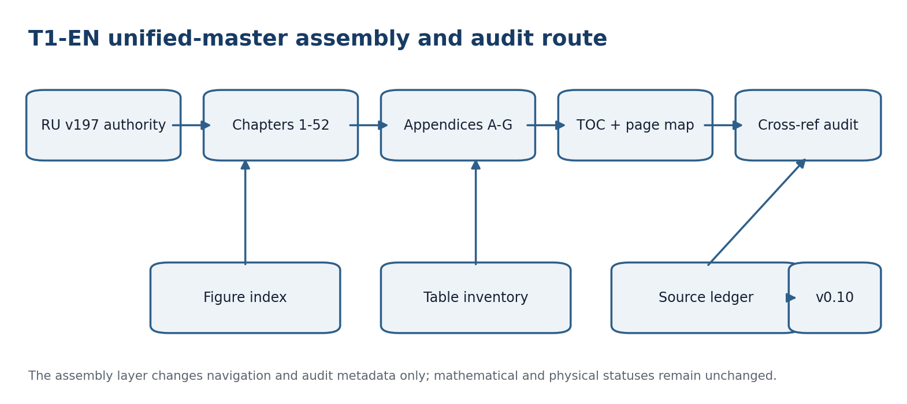
Figure T1-EN-ASSEMBLY-001. Unified-master assembly and audit route.

1. Assembly Passport
Field | Fixed value
Author | Ivan Borisovich Kurpishev
Canonical authority | T1-RU v197 > T1-EN v0.11
Content layer | 52 chapters + Appendices A-G
Formula registry | F001-F086
Static navigation | front chapter/appendix maps with RU and EN pages
Updateable navigation | Word TOC field for Heading 1-2
Internal links | chapter, appendix, and figure bookmarks
Scientific status | preserved from RU source; no promotion
Physical status | F-1-F-14 E0; EXT-RUN absent
Next checkpoint | T1-EN-FC-v0.12

2. Updateable Word Table of Contents
The verified static TOC is located in the front chapter and appendix maps. The field below is provided for Word users and is marked for update on document open. The static map remains the release-controlled pagination record.
Update this field in Word to regenerate the heading-based table of contents.
TOC CONTRACT. The Word TOC may be regenerated from Heading 1-2. Regeneration may change displayed pagination in an editor, but it cannot change Russian source locators, stable formula IDs, or evidence status.

3. Exact Figure Index
Stable ID | Caption / linked object | EN p.
T1-FIG-001 | Figure T1-EN-START-001. Authority chain of the controlled English derivative. | 5
T1-FIG-002 | Figure T1-EN-START-002. Staged route from translation contract to frozen English release. | 16
T1-FIG-003 | Figure 1.1. Stratified layers of Time@Space and their admissible reductions. | 19
T1-FIG-004 | Figure 2.1. The C@C object, versioning, and the transition to evidence gates. | 21
T1-FIG-005 | Figure 3.1. Commutative square for a Hodge-compatible packet morphism. | 24
T1-FIG-006 | Figure 4.1. Packet/Reper morphism and the components that must be preserved or explicitly transformed. | 27
T1-FIG-007 | Figure 5.1. Reper tetrahedron: realised content R, invariant I, possibilities U, and sufficient foundation D. | 29
T1-FIG-008 | Figure 6.1. Harmonic Reper quadruple and the value λ=−1. | 32
T1-FIG-009 | Figure 7.1. Evidence-status ladder and the mandatory gates between levels. | 35
T1-FIG-010 | Figure 8.1. Packet correspondence of the logical laws to Reper components and the packet syllogism. | 38
T1-FIG-011 | Figure 9.1. Three independently justified projective roles and the two bridge obligations. | 42
T1-FIG-012 | Figure 10.1. FOS as a compatible Reper carrier, world reduction, and the early PN.2 bridge. | 45
T1-FIG-013 | Figure 11.1. Reduced NAPG deformation complex: operation, constraint, tangent quotient, and obstruction. | 48
T1-FIG-014 | Figure 12.1. Formula-chain audit, FCOC carrier, and the quotient required to cross the Fano barrier. | 50
T1-FIG-015 | Figure 13.1. KLT-RBD ingest, evidence graph, and set-valued prediction output. | 52
T1-FIG-016 | Figure 14.1. EX-CERT evidence passport and the monotonicity rule for status. | 54
T1-FIG-017 | Figure 15.1. Notation firewall and three-layer source passport. | 56
T1-FIG-018 | Figure 16.1. Prior-art classes and the authorial synthesis boundary. | 58
T1-FIG-019 | Figure 17.1. The complex Reper requires a chart, separation estimate, and an explicit real-reduction map. | 63
T1-FIG-020 | Figure 18.1. The operator construction produces a conjugacy class or central diagnostic only after the domain gates are satisfied. | 65
T1-FIG-021 | Figure 19.1. Proof-cleaning separates the classical constructions and the authorial bridge identities. | 67
T1-FIG-022 | Figure 20.1. Typed reference edges preserve direction, role, and status. | 69
T1-FIG-023 | Figure 21.1. Hidden bracketing creates two state targets and two structural targets for one estimator. | 70
T1-FIG-024 | Figure 22.1. Prediction is authorized only after D/Dom, PN.2, calibration, and blocker gates. | 72
T1-FIG-025 | Figure 23.1. A test matrix must contain positive witnesses, matched nulls, and counterexamples. | 74
T1-FIG-026 | Figure 24.1. The export firewall separates an abstract theorem from an empirical observation. | 75
T1-FIG-027 | Figure 25.1. The typed route from source through action and insertion to semigroup evolution. | 77
T1-FIG-028 | Figure 26.1. Structure constants and weighted two-step paths carry the same based finite-dimensional data. | 79
T1-FIG-029 | Figure 27.1. The canonical PN.2 route separates theorem, exact models, source certificate, and physical transfer. | 84
T1-FIG-030 | Figure 28.1. The forecast horizon is controlled by the weakest of five typed limit functions. | 89
T1-FIG-031 | Figure 29.1. A valid miss triggers a local, constrained, versioned update with rollback. | 90
T1-FIG-032 | Figure 30.1. Cross-domain transfer is partial and carries an explicit curvature or path discrepancy. | 91
T1-FIG-033 | Figure 31.1. Computational replay, independent rerun, and empirical observation are distinct evidence levels. | 92
T1-FIG-034 | Figure 32.1. A domain adapter preserves types, units, D, Dom, and the source anchor. | 97
T1-FIG-035 | Figure 33.1. Path, byte, and semantic identity are different relations; provenance records the transformation path. | 99
T1-FIG-036 | Figure 34.1. Identifiability, support, matched-null, and independent-source gates are conjunctive. | 101
T1-FIG-037 | Figure 35.1. Calibration produces branch corridors; the branch-blind output is their gated union. | 103
T1-FIG-038 | Figure 36.1. Ten-stage KLT-RBD computational contract with a blocker-safe interface at every step. | 105
T1-FIG-039 | Figure 37.1. Block is an absorbing result with a preserved reason and trace. | 108
T1-FIG-040 | Figure 38.1. Weighted calibration requires support, a registered ratio model, and a finite-sample test atom. | 110
T1-FIG-041 | Figure 39.1. Predictable e-factors accumulate into an anytime-valid process with a fixed boundary. | 112
T1-FIG-042 | Figure 40.1. PN.2 branches are registered experts; regret, coverage, and truth remain separate channels. | 114
T1-FIG-043 | Figure 41.1. Frozen validation design, multiplicity control, and separate decision states. | 117
T1-FIG-044 | Figure 42.1. Domain selection is frozen before the key to external outcomes is released. | 119
T1-FIG-045 | Figure 43.1. Power is planned from a domain-meaningful effect before external outcomes are observed. | 121
T1-FIG-046 | Figure 44.1. Whole groups, not individual rows, are assigned to train, calibration, test, and external sets. | 123
T1-FIG-047 | Figure 45.1. A causal answer requires a model and identification assumptions beyond predictive performance. | 125
T1-FIG-048 | Figure 46.1. Nine-step EXT-RUN-000 route from frozen hashes to an immutable verdict certificate. | 127
T1-FIG-049 | Figure 47.1. Typed composition and the absorbing BLOCK state. | 131
T1-FIG-050 | Figure 48.1. Projective invariant, harmonic gate, admissible branches, and conclusion states. | 132
T1-FIG-051 | Figure 49.1. Five registered limits, meet, join, and monotone forecast sets. | 134
T1-FIG-052 | Figure 50.1. Registered neighbors, minimization, stability gap, and versioned history. | 136
T1-FIG-053 | Figure 51.1. Typed graph filtering, abstention mass, contraction, and uncertainty envelope. | 138
T1-FIG-054 | Figure 52.1. Assumptions, statistical guarantees, and the publication firewall of the main theorem. | 140
T1-FIG-055 | Figure 52.2. Minimal obstruction complex, canonical internal class, and conditional external bridge. | 141
T1-FIG-056 | Figure A0.1. Appendices A-G connect exact examples, computational provenance, formula addressing, and empirical status firewalls. | 146
T1-FIG-057 | Figure A.1. Four witness regimes close PO-11 at the abstract theorem-package level. | 147
T1-FIG-058 | Figure E.1. Ten-stage Atlas route with hash continuity, Block propagation, and publication gate. | 152
T1-FIG-059 | Figure G.1. Mathematical closure, model completeness, empirical data, and protocol execution remain separate axes. | 157
T1-FIG-060 | Figure T1-EN-ASSEMBLY-001. Unified-master assembly and audit route. | 160

4. Table Inventory by Chapter and Appendix
Section | Linked title | Tables | EN page span
CH-01 | Time@Space and Stratified Ontology | 8 | 19-20
CH-02 | C@C: event@state as the Minimal Object | 8 | 21-22
CH-03 | Packet Objects and the Category Pack | 11 | 23-25
CH-04 | Packet Morphisms, Reductions, and Conservation Laws | 8 | 26-27
CH-05 | Reper(R,I,U;D): Definition and Axioms | 14 | 28-30
CH-06 | Projective-Harmonic Cross-Ratio | 11 | 31-33
CH-07 | D/Dom and Sufficient Foundation | 15 | 34-36
CH-08 | Packet Laws of Logic and Rules of Inference | 13 | 37-41
CH-09 | Desargues–Kurpishev Theorem | 6 | 42-44
CH-10 | Kurpishev FOS, Seven Size@Dimensions, and PN.2 | 4 | 45-47
CH-11 | NAPG: Nonassociative Packet Geometry | 4 | 48-49
CH-12 | PILOT-01, Formula Chains, and the Fano Barrier | 4 | 50-51
CH-13 | RBD/RPD and KLT-RBD as a Computational Architecture | 4 | 52-53
CH-14 | Examples, Counterexamples, and Evidence Passports | 3 | 54-55
CH-15 | Glossary, Notation, Formulae, and Bibliography | 5 | 56-57
CH-16 | Historical-Mathematical Prior Art and the Boundary of the Authorial Contribution | 12 | 58-62
CH-17 | Complex Cross-Ratio and Reper Geometry on CP¹ | 2 | 63-64
CH-18 | Matrix and Operator Cross-Ratio | 3 | 65-66
CH-19 | Evidence-Level Refinement of the Desargues–Kurpishev Theorem | 3 | 67-68
CH-20 | Subject Index, Formula Index, and Cross-Reference System | 3 | 69
CH-21 | Canonical Mathematical Construction of Kurpishev PN.2 | 4 | 70-71
CH-22 | PN.2 as a Constraint and Driver of the KLT-RBD Predictive Method | 3 | 72-73
CH-23 | PN.2 Examples, Counterexamples, and Computational Tests | 2 | 74
CH-24 | Export of PN.2 to Physics, Chemistry, Biology, and DNA: Boundaries and Verification Programme | 4 | 75-76
CH-25 | Operators of Action, Change, and Reversal | 3 | 77-78
CH-26 | Nonassociative Packet Reper Algebra of Size@Dimensions | 9 | 79-83
CH-27 | Canonical PN.2 with Appendices A–B and Philosophical Blocks | 12 | 84-87
CH-28 | Predictive Limits and the Finite Horizon of Reper Action | 3 | 88-89
CH-29 | Adaptive Rebuilding of the Reper Graph | 2 | 90
CH-30 | Predictive Reper Bundle | 2 | 91
CH-31 | Computational Certification and the Evidence-Status Boundary | 8 | 92-95
CH-32 | Strict Specification of KLT-RBD Domain Adapters | 4 | 96-98
CH-33 | Identity, Provenance, and Data Integrity | 4 | 99-100
CH-34 | Identifiability, Transportability, and Independent Verification | 4 | 101-102
CH-35 | Forecast Corridors, Conformal Calibration, and Abstention | 4 | 103-104
CH-36 | KLT-RBD Computational Contract and Final Audit | 6 | 105-107
CH-37 | End-to-End Blocker-Safe Adapter and Reproducibility | 4 | 108-109
CH-38 | Weighted Calibration under Covariate Shift | 3 | 110-111
CH-39 | E-Processes, Ville’s Inequality, and Optional Stopping | 3 | 112
CH-40 | Aggregation of PN.2 Branches and Regret Bounds | 5 | 113-115
CH-41 | Independent Verification and Composition of Error Budgets | 5 | 116-118
CH-42 | Domain Selection before Result Disclosure and Protection against Post-Selection | 5 | 119
CH-43 | Power, Sample Size, and the Minimum Meaningful Effect | 4 | 120-121
CH-44 | Cluster Dependence and Groupwise Predictive Calibration | 3 | 122-123
CH-45 | Prediction, Intervention, and the Limit of Causal Inference | 4 | 124-125
CH-46 | Executable External Validation Protocol for Volume I | 9 | 126-129
CH-47 | Typed Space of Packets and Repers | 3 | 130-131
CH-48 | Projective-Harmonic Prediction Operator | 3 | 132-133
CH-49 | Five Limits as an Admissibility Lattice | 4 | 134
CH-50 | Mismatch Metric and Stable Rebuilding | 4 | 135-136
CH-51 | RBD as a Propagation and Contraction Operator | 3 | 137-138
CH-52 | Main Conditional Theorem of the Predictive Method | 12 | 139-145
APP-A | Explicit Examples and Counterexamples for PO-11 (§27.2.A) | 3 | 146-147
APP-B | Computable Certificate for PO-12 (§27.2.B) | 4 | 148-149
APP-C | Complete Genealogy of the Canonical Construction | 2 | 150
APP-D | PN.2: Negative Statements and Repairs | 1 | 151
APP-E | Executable Ten-Stage Atlas Protocol | 3 | 152
APP-F | Formula Register of Edition v196i14 | 7 | 153-156
APP-G | Canonical Synchronisation of PN.2 and F-1–F-14 | 7 | 157-159

The inventory covers 316 tables in the chapter and appendix layer. Front-matter and assembly-control tables are recorded separately in the global audit rather than assigned to a scientific chapter.

5. Consolidated Bibliography and Source-Card Ledger
ID | Artifact | Class | Role | Status | Bytes | SHA-256
SRC-T1-001 | tom1_v197_ru.pdf | canonical RU freeze | authority for chapters, appendices, formula IDs, and status lock | INTERNAL-CANONICAL | 7,333,052 | 5a2021c02428e3e395fe81e029c46cd26b4a0e06ceb7dbfc89befddffd84a7d8
SRC-T1-002 | tom1_en_v0_9.docx | English predecessor | source of the complete chapter and appendix layer | PREDECESSOR | 4,159,036 | 3757d1820f6014088a832e37219e8119ae1b6784ca40443d339ffc89e8b2b703
SRC-T1-003 | tom1_en_v0_9.pdf | rendered predecessor | pagination and visual baseline | PREDECESSOR-QA | 6,547,072 | e7058ddfa07776df6c589d056ed3b8ee89ecc576839d343fa853aedcb448f19c
SRC-T1-004 | monograph5_0_ru.pdf | legacy monograph | C@C, Reper, NAPG, KLT/RBD legacy layer | INTERNAL-LEGACY | 14,300,260 | ea84bab141342eb6dc91926ef01f8130fa1dbdb0487a4f279a4e09aed5337fef
SRC-T1-005 | monograph5_1_ru_full_text.html | legacy master corpus | genealogy, RPD/RBD, KPF/RPHD, predictive mathematics | INTERNAL-LEGACY | 564,004 | 7c61593ee9641e8841abccc2917f55c134735183f9b24352d5b7d63e7265fd3a
SRC-T1-006 | PILOT01_PREPRINT_RU_FINAL.pdf | authorial preprint | formula-chain audit, FCOC, Fano barrier | INTERNAL-PRIMARY | 413,030 | 9e1606df415d42683ed295ff675e07e0411ba8ac2f9158adce46ae4b5e6cdbe0
SRC-T1-007 | monographiaNAPG (1).docx | authorial mathematical source | stratified time, Hodge packets, NAPG model | INTERNAL-PRIMARY | 53,914 | ba675fbaa11f506921787037342862bcafc67a23f3ae69ba000dad2493ed4044
SRC-T1-008 | main_SIGMA_freeze (1).tex | journal source | associator rigidity and reduced deformation layer | INTERNAL-PRIMARY | 98,795 | e321aab8351e34c147ce93ce8706db74b7e7add980beb89621b4f2e0416f7c6c
SRC-T1-009 | Kurpishev_arXiv_SIGMA_submission_bundle (1).zip | submission bundle | publication provenance for SIGMA/arXiv layer | INTERNAL-BUNDLE | 573,438 | d6f9a550f1d392e8844fe0f3f89ca6be400aeaad997042b17b0b1cd85c0866aa
SRC-T1-010 | fos_journal_ru_v5_6.tex | journal source | FOS and Desargues-Kurpishev line | INTERNAL-PRIMARY | 36,623 | 134cd1d32862ad1ce923f9cc58d675d0c582b372e9ab57f1cdef69784622d93a
SRC-T1-011 | FOS_JOURNAL_SPLIT_v5_6_PACKAGE.zip | journal package | source bundle and assets for FOS publication | INTERNAL-BUNDLE | 18,969,180 | e375dce884c823743d45688551dc0880328da48e2bb29deb8ee21f1e53a9a18b
SRC-T1-012 | tom2_v1_0(1).pdf | cross-volume canonical source | NAPG 3.0 and weakest-link architecture | INTERNAL-CANONICAL | 14,049,188 | dbbb5552dae7872f18b32c98d8e8584e562b545d20761bd6425c14d38f4db81f
SRC-T1-013 | tom3_en_v1_0.pdf | terminology comparator | frozen English terminology and status firewall | INTERNAL-CANONICAL | 4,102,656 | b7b48782cd9e6b792c610df2eae4bba3b84afaab9fc8045b98fd1be913499d29
SRC-T1-014 | KLT_RBD_CHEM_FIPS_DEPOSIT_MASTER_v1_3 (1).pdf | registration dossier | application-layer provenance; no mathematical validation | LEGAL-PROVENANCE | 375,750 | a0f521d84d3d2a6afe7bed18fb180079bc461c4ea611e02d62325c6ce7772616
SRC-T1-015 | KLT_RBD_GLOBAL_REPER_DATABASE_v2_2_ARTIFACT_NAMING_AND_DOSSIER_RUN_016 (2).zip | RBD bundle | artifact naming and dossier architecture | INTERNAL-BUNDLE | 3,185,609 | 585696548649291e905fc653696173fbd633fd9e993745a0e87a03934b4917b2
SRC-T1-016 | KLT5_1_FLUTTER_SDK_PACKAGE.zip | software package | program-layer provenance; not theorem evidence | SOFTWARE-PROVENANCE | 3,019,939 | d373e55bab5e63fa4c5b68688527efd6b53d30b2f71e8182716004b290f999fe

A complete hash proves byte identity of the listed artifact, not the correctness of its mathematics or its physical interpretation. Classical prior art cited in Chapter 15 remains bibliographic metadata carried by the Russian source unless a later audit supplies exact edition and locator records.

6. Global Cross-Reference Audit
Audit object | Expected | Observed | Verdict
Chapters | 52 | 52 | PASS
Appendices A-G | 7 | 7 | PASS
Formula IDs F001-F086 | 86 | 86 | PASS
Figure captions in unified master | 60 | 60 | PASS
Chapter/appendix table assignments | all sections | 59 | PASS
Static TOC rows | 59 | 59 | PASS
Internal navigation targets | 52+7+figures | 119 | PASS
Russian source locators | preserved | preserved | PASS
Evidence-status promotion | 0 | 0 | PASS
Independent EXT-RUN | not executed | not executed | OPEN / NON-VETO FOR ASSEMBLY

Status_EN(x) <= Status_RU(x)
Formula_EN(x) = Formula_RU(x); ID_EN(x) = ID_RU(x)
NUM != EXT-RUN != EMP-OBS

7. Assembly Change Set and Obligations
ID | Obligation | Status
T1-EN-PO-018 | Unified master, verified static TOC, RU-to-EN page map, and internal links | CLOSED-DOC
T1-EN-PO-019 | Figure index, chapter-level table inventory, and source-card ledger | CLOSED-DOC
T1-EN-PO-020 | Global structural and cross-reference audit | CLOSED-QA
T1-EN-PO-021 | Independent bilingual formula and theorem-status audit | NEXT / OPEN
T1-EN-PO-022 | Freeze-candidate controlled diff and detached receipt | FUTURE
T1-EN-PO-023 | Immutable English release | FUTURE

ASSEMBLY VERDICT. CONTROLLED ENGLISH UNIFIED MASTER COMPLETE. Static and updateable navigation installed; chapter and appendix parity preserved; formula IDs continuous; source and object ledgers assembled; independent bilingual mathematical audit remains open; truth_layer_promotion=0.

NEXT CHECKPOINT. T1-EN-AUDIT-v0.11: bilingual formula-by-formula comparison, theorem/definition/status parity, source-card verification, untranslated-fragment scan, and controlled cross-format diff. No freeze decision is made at v0.10.

T1-EN-AUDIT-v0.11
BILINGUAL MATHEMATICAL, FORMULA, STATUS, AND SOURCE AUDIT
AUDIT VERDICT. AUTHORIAL BILINGUAL AUDIT PASSED. The English master is eligible to proceed to T1-EN-FC-v0.12. This verdict does not claim an externally signed independent audit and does not change any Russian theorem, formula, physical hypothesis, or empirical status.

Appendix H. Bilingual Mathematical and Evidence-Status Audit
This appendix records the audit of the controlled English derivative against the frozen Russian authority tom1_v197_ru.pdf. The audit used two separate routes: structural extraction from the English DOCX and formula/status extraction from the Russian searchable PDF. The verifier was separated from the document-building step, but it was not an external institution or an independently signed reviewer.

H.1. Authority, Scope, and Method
Authority(T1-RU v197) > Authority(T1-EN v0.11)
Status_EN(x) ≤ Status_RU(x), truth_layer_promotion = 0
The audit covered: 52 chapter headings; Appendices A-G; 86 formula identifiers; Russian source-page locators; theorem, proposition, lemma, definition, model, numerical, physical-hypothesis, empirical-plan, refuted, open, and abstention status labels; negative statements and counterexamples; source-card hashes; and the boundary between bilingual reference material and untranslated scientific prose.
Audit layer | Method | Coverage | Verdict
Structure | DOCX heading/table extraction | 52 chapters; A-G; maps and bookmarks | PASS
Formula registry | RU PDF first-occurrence extraction + EN Appendix F comparison | F001-F086 | PASS AFTER 8 CORRECTIONS
Status firewall | Token and context audit | THM/COND/MODEL/NUM/PHY-HYP/EMP-PLAN/EMP-OBS/OPEN/REFUTED/ABSTAIN | PASS
Language boundary | Cyrillic scan with allowed bilingual tables | scientific prose and captions | PASS
Sources | hash-format and provenance-role audit | 16 source/artifact entries | PASS
External independence | signature/identity/receipt check | external bilingual reviewer | OPEN NON-VETO

H.2. Formula Parity F001-F086
All 86 identifiers occur exactly once in the normative Appendix F registry and remain tied to their Russian first-page locators. The audit distinguishes mathematical parity from typographic identity: ASCII aliases may be readable, but parity-critical omissions, domain changes, or altered target objects are not permitted.
ID | v0.10 registry form | v0.11 audited form | Reason
F021 | gate_L(r)=meet_{j=1}^5 l_j(r); l_j in {0,1,Block} | gate_L(r)=∧_{j=1}^5 ℓ_j(r) | Removed an explanatory codomain clause from the formula cell; restored the canonical meet formula.
F042 | P_(i,ABSTAIN)=1-sum_j P_ij | P_{i,⊥}=1−Σ_j P_{ij} | Restored the canonical bottom-state symbol ⊥ instead of silently identifying it with a prose label.
F063 | X alone does not determine (size(X),dim(X)) without D_X and a type contract | X alone ↛ (size(X),dim(X)) without D_X and a type contract | Restored the non-determination arrow ↛.
F064 | (R,I,U) does not determine a Reper | (R,I,U) ↛ Rep | Restored the canonical statement that a triple does not determine a Reper.
F077 | C_min^n(N)=F_N^(2) for n=2; X_N^(2) for n=3; 0 otherwise | C_minⁿ(N)=F_N^(2) for n=2; C_minⁿ(N)=X_N^(2) for n=3; C_minⁿ(N)=0 for n≠2,3 | Made the degree condition n≠2,3 explicit.
F080 | H^3(C_min(N))=X_N^(2)/Im Psi_N^(2)=O_B(N) | H³(C_min•(N))=Ker δ_min³/Im δ_min²=X_N^(2)/Im Ψ_N^(2)=O_B(N) | Restored the omitted Ker δ³ / Im δ² cohomology quotient.
F085 | H^3(E(f)) o Pi_E,N = Pi_E,Nprime o phi_O | H³(E•(f)) ∘ Π_E,N = Π_E,N′ ∘ φ_O | Restored the complex marker E• and the naturality notation.
F086 | [Ass]_E := [beta_E,N(x,y,z)] in H^3(E(N)) | [Ass]_E := [β_E,N(x,y,z)] ∈ H³(E•(N)) | Restored the external complex marker E• and cohomology target.
FORMULA VERDICT. 86/86 IDs present; 86/86 Russian source locators preserved; 8 precision corrections applied; 0 identifiers renumbered; 0 formulas promoted in status.

H.3. Definitions, Theorems, and Status Parity
The audit checked that translated labels do not strengthen the Russian source. In particular, “conditional theorem” remains conditional; model assumptions are not restated as facts; a computational certificate remains NUM-SOURCE unless independently rerun; and the physical programme F-1-F-14 remains E0 with EXT-RUN absent.
Boundary | Required relation | Observed in v0.11 | Verdict
Definition / theorem | DEF does not become THM | labels and hypotheses preserved | PASS
Conditional result | COND does not become unconditional | main closure theorem remains COND | PASS
Numerical evidence | NUM-SOURCE ≠ EXT-RUN | certificate replay not claimed | PASS
Empirical programme | EMP-PLAN ≠ EMP-OBS | EXT-RUN-000 remains not executed | PASS
Physical hypotheses | F-1-F-14 remain D0/M0-M1/E0/R1 | no validation claim | PASS
Negative results | REFUTED/counterexample statements remain visible | preserved across chapters and appendices | PASS
Blocker semantics | BLOCK/ABSTAIN cannot be converted to PASS | absorbing rules preserved | PASS

H.4. Terminology and Language Boundary
The Cyrillic scan found Russian text only in the intentional bilingual terminology ledger, the Russian-title column of the chapter map, and the Russian-title column of the appendix map. No unregistered Russian paragraph, theorem, figure caption, formula role, or scientific table cell remains in the English narrative layer.
Controlled object | Normative English form | Audit result
Reper / D/Dom / NAPG / KLT-RBD | preserved technical forms | PASS
событие@состояние | event@state | PASS
Время@Пространство | Time@Space | PASS
достаточное основание | sufficient foundation | PASS
воздержание | ABSTAIN | PASS
принцип слабейшего звена | weakest-link principle | PASS
ПН.2 Курпишева | Kurpishev PN.2 | PASS

H.5. Negative Results, Counterexamples, and Source Cards
The audit explicitly searched for preservation of counterexamples and forbidden implications. The Desargues-Kurpishev identification bridges remain conditional; the operator cross-ratio spectrum is not equated with strict equality; a triple does not determine a Reper; finite examples do not prove universal coverage; prediction is not intervention; and numerical reproducibility is not physical validation.
hash equality ≠ correct formula ≠ valid physical model
P(Y | X=x) ≠ P(Y | do(X=x)) without a causal bridge
The consolidated source-card ledger retains artifact names, roles, and SHA-256 digests. Hashes are treated as identity and provenance evidence only. The source ledger does not authorize mathematical or physical truth by itself.

H.6. Controlled Diff v0.10 → v0.11
Change ID | Object | Change | Status
T1-EN-CS-077 | release identity | updated cover, passport, header, footer, and authority line to v0.11 | DOC
T1-EN-CS-078 | Appendix F | applied eight parity-critical formula-registry corrections | PARITY
T1-EN-CS-079 | Appendix H | added bilingual formula/status/source audit and verifier boundary | AUDIT
T1-EN-CS-080 | language scan | restricted Cyrillic to intentional bilingual maps and ledger | QA
T1-EN-CS-081 | evidence firewall | reconfirmed no EXT-RUN and no EMP-OBS | PARITY
T1-EN-CS-082 | next gate | set T1-EN-FC-v0.12 as the next checkpoint | DOC

H.7. Audit Obligations
Obligation | Content | Status
T1-EN-PO-021 | bilingual structural and formula audit | CLOSED-AUTHORIAL-AUDIT
T1-EN-PO-022 | formula registry precision corrections | CLOSED-PARITY
T1-EN-PO-023 | definition/theorem/status non-promotion audit | CLOSED-PARITY
T1-EN-PO-024 | negative-result and counterexample preservation | CLOSED-QA
T1-EN-PO-025 | untranslated-fragment boundary audit | CLOSED-QA
T1-EN-PO-026 | source-card and hash-format audit | CLOSED-QA
T1-EN-PO-027 | externally signed bilingual review | OPEN NON-VETO
T1-EN-PO-028 | freeze-candidate controlled diff and detached receipt | NEXT
T1-EN-PO-029 | immutable English release | FUTURE

H.8. Decision and Boundary of Conclusion
DECISION. T1-EN-AUDIT-v0.11 is accepted as the audited authorial English master and may proceed to T1-EN-FC-v0.12. The next stage must create a controlled diff against v0.11, a detached release receipt, final no-change verification, and an explicit freeze-candidate decision.
NUM-SOURCE ≠ EXT-RUN ≠ EMP-OBS
Physical verdict for F-1-F-14 = ABSTAIN / OPEN
No experimental data were introduced. No theorem was strengthened. No Russian source object was overwritten. Any future scientific correction must be introduced through a documented change-set and a new version.
Field | Fixed value
Release | T1-EN-AUDIT-v0.11
Canonical source | tom1_v197_ru.pdf
Predecessor | tom1_en_v0_10.docx / pdf
Formula parity | F001-F086; 8 precision corrections; 0 renumbering
Status parity | truth_layer_promotion=0
External audit | OPEN NON-VETO
Next checkpoint | T1-EN-FC-v0.12

T1-EN-FC-v0.12
FREEZE CANDIDATE · CONTROLLED DIFF · NO-CHANGE VERIFICATION · DETACHED RELEASE RECEIPT
CANDIDATE VERDICT. ACCEPTED FOR T1-EN-FREEZE-v1.0. The scientific and audit body inherited from v0.11 is unchanged under the normalized comparison contract. The present checkpoint adds release-control metadata only. This is an authorial freeze decision, not an external scientific certification.

Appendix I. Freeze Candidate, Controlled Diff, and Detached Release Receipt
Appendix I records the transition from the audited English master v0.11 to the freeze candidate v0.12. The candidate does not revise the scientific corpus. It fixes predecessor hashes, defines a reproducible semantic comparison, preserves formula and media manifests, records the allowed metadata-only changes, and creates an unsigned detached receipt contract for the final files.

I.1. Authority and Candidate Scope
Authority(T1-RU v197) > Authority(T1-EN v0.12)
Status_EN(x) ≤ Status_RU(x), truth_layer_promotion = 0
v0.12 = v0.11 scientific/audit body + freeze-control metadata
The canonical Russian source remains tom1_v197_ru.pdf. The audited predecessor is tom1_en_v0_11.docx / pdf. The no-change comparison covers the ordered content beginning with Chapter 1 and ending with Appendix H, including all paragraphs, tables, theorem/status statements, negative results, and the normative formula registry.
Field | Fixed value
Candidate | T1-EN-FC-v0.12
Canonical Russian source | tom1_v197_ru.pdf
RU SHA-256 | 5a2021c02428e3e395fe81e029c46cd26b4a0e06ceb7dbfc89befddffd84a7d8
Audited predecessor DOCX | tom1_en_v0_11.docx
Predecessor DOCX SHA-256 | 28ddbfc7e047940671a3930b8d9bf16e7dbc7ddad8ed3b322a24b3ec660024d6
Audited predecessor PDF | tom1_en_v0_11.pdf
Predecessor PDF SHA-256 | 8daa5a2583e46bd5b201b510ec7a53e650bb335eac186e4bb5878f0b9a6b460a
Candidate scientific scope | Chapters 1-52 and canonical Appendices A-G; audit Appendix H verified separately
New release-control scope | Appendix I and active release metadata only
Next gate | T1-EN-FREEZE-v1.0

I.2. No-Scientific-Change Verification Contract
The comparison uses four independent manifests. The scientific manifest serializes Chapter 1 through Appendix G and excludes derivative navigation metadata. The audit manifest serializes Appendix H separately. The formula manifest serializes F001-F086 by stable identifier. The media manifest serializes each embedded word/media object by name, size, and SHA-256. A PASS requires equality in all four channels. Assembly page numbers may be corrected without changing scientific content.
PASS_no-change ⇔ H_science(v0.11)=H_science(v0.12) ∧ H_audit(v0.11)=H_audit(v0.12) ∧ H_F(v0.11)=H_F(v0.12) ∧ H_media(v0.11)=H_media(v0.12)
Channel | Predecessor value | Required candidate value | Gate
Scientific corpus | 5c9f75267839d69f2eaf00ffad77fd37237dccc1c284973276e74c647b40b9c0 | 5c9f75267839d69f2eaf00ffad77fd37237dccc1c284973276e74c647b40b9c0 | 2059 blocks
Audit Appendix H | d770a618915b4c5e1035e0463f23bfa32d9237dc5a22c4136b4a975272ba1dfd | d770a618915b4c5e1035e0463f23bfa32d9237dc5a22c4136b4a975272ba1dfd | 35 blocks
Formula registry | f40a8840b075c6c797b59d23c3c00c2ac79165a4f2534ee619588bf91b235ab0 | f40a8840b075c6c797b59d23c3c00c2ac79165a4f2534ee619588bf91b235ab0 | 86/86
Embedded media | 835421d94355a5d406a0a5f940c35eab4bc3c7f8bb1966e9b675241b4f06c697 | 835421d94355a5d406a0a5f940c35eab4bc3c7f8bb1966e9b675241b4f06c697 | 61/61
NO-CHANGE BOUNDARY. Equality of normalized document content is a release-control result. It does not independently prove the correctness of the mathematics, the truth of physical hypotheses, or the validity of an unexecuted external experiment.

I.3. Controlled Diff v0.11 → v0.12
Change ID | Object | Permitted change | Classification
T1-EN-FC-001 | cover and active passport | checkpoint identity v0.11 → v0.12; next gate v1.0 | METADATA
T1-EN-FC-002 | header and footer | active release label updated to T1-EN-FC-v0.12 | METADATA
T1-EN-FC-003 | navigation metadata | workflow state and displayed EN page locators corrected; v1.0 set as next | NAVIGATION
T1-EN-FC-004 | Appendix I | added no-change contract, receipt schema, and freeze decision | RELEASE CONTROL
T1-EN-FC-005 | detached receipt | generated after final DOCX/PDF hashes become available | PROVENANCE
T1-EN-FC-006 | scientific body | no permitted change | LOCKED
T1-EN-FC-007 | formula registry F001-F086 | no permitted change | LOCKED
T1-EN-FC-008 | statuses and negative results | no permitted change | LOCKED

I.4. Detached Release Receipt Contract
The detached receipt is a JSON sidecar created after the final DOCX and PDF are rendered and accepted. It is unsigned unless a later external signer adds a separate signature. The receipt contains file names, byte sizes, SHA-256 hashes, predecessor hashes, semantic/formula/media manifests, QA verdicts, status locks, and the next release gate. It deliberately contains no self-hash field.
Receipt = (source, predecessor, candidate, semantic manifests, QA, status lock, next gate)
Receipt field | Requirement | Interpretation boundary
receipt_id | T1-EN-FC-v0.12-RECEIPT | stable identifier, not a signature
candidate hashes | final DOCX and PDF SHA-256 | file identity and integrity
predecessor hashes | v0.11 DOCX/PDF SHA-256 | controlled lineage
semantic manifests | science, audit H, F001-F086, media digests | no-scientific-change evidence
QA evidence | render count, ZIP/PDF checks, placeholder scan | publication hygiene
status lock | truth_layer_promotion=0; EXT-RUN absent | no evidence promotion
signature status | UNSIGNED AUTHORIAL RECEIPT | external signature not implied

I.5. Freeze Gate Matrix
Gate | Acceptance criterion | v0.12 decision | Effect of failure
Authority | RU v197 remains canonical | PASS | BLOCK
Scientific no-change | science and audit-H digests exact match | PASS | BLOCK
Formula parity | F001-F086 exact manifest match | PASS | BLOCK
Media parity | embedded media manifest exact match | PASS | BLOCK
Status firewall | no theorem/model/physical promotion | PASS | BLOCK
Document integrity | DOCX ZIP integrity and searchable PDF | PASS | BLOCK
Visual QA | all pages render without clipping/overlap | PASS | BLOCK
External signed review | not required for authorial freeze | OPEN NON-VETO | NO PROMOTION
EXT-RUN / EMP-OBS | not required for documentary freeze | ABSENT | PHYSICAL ABSTAIN

I.6. Freeze-Candidate Decision
AUTHORIAL DECISION. Final render, integrity, no-change, and visual-QA gates have passed. T1-EN-FC-v0.12 is accepted as the sole source for T1-EN-FREEZE-v1.0. No other predecessor may be promoted directly to v1.0.
T1-EN-FREEZE-v1.0 := immutable publication copy of accepted T1-EN-FC-v0.12
The freeze operation must create new files rather than rename or overwrite the candidate. After freeze, any scientific, typographic, or metadata correction requires a new change-set and a new post-freeze version. The v1.0 files must preserve the status firewall and the detached receipt lineage.

I.7. Boundary of Conclusion
hash equality ≠ mathematical proof ≠ physical validation
NUM-SOURCE ≠ EXT-RUN ≠ EMP-OBS
The freeze candidate establishes editorial identity, controlled lineage, and no-scientific-change continuity. It does not create experimental data, execute EXT-RUN-000, validate F-1-F-14, or convert the conditional and model layers into unconditional physical laws. The correct physical verdict remains OPEN / ABSTAIN wherever the Russian source requires it.

I.8. Release Card
Field | Fixed value
Candidate | T1-EN-FC-v0.12
Predecessor | T1-EN-AUDIT-v0.11
Canonical authority | T1-RU v197
Scientific corpus SHA-256 | 5c9f75267839d69f2eaf00ffad77fd37237dccc1c284973276e74c647b40b9c0
Audit Appendix H SHA-256 | d770a618915b4c5e1035e0463f23bfa32d9237dc5a22c4136b4a975272ba1dfd
Formula manifest SHA-256 | f40a8840b075c6c797b59d23c3c00c2ac79165a4f2534ee619588bf91b235ab0
Media manifest SHA-256 | 835421d94355a5d406a0a5f940c35eab4bc3c7f8bb1966e9b675241b4f06c697
Detached receipt ID | T1-EN-FC-v0.12-RECEIPT
Receipt signature status | UNSIGNED AUTHORIAL RECEIPT
Candidate decision | ACCEPTED FOR FREEZE
Next checkpoint | T1-EN-FREEZE-v1.0

I.9. Final QA Evidence
QA object | Observed result | Verdict
DOCX package | ZIP integrity test; no corrupt member | PASS
DOCX render | 176 A4 pages rendered to PNG | PASS
PDF render | 176/176 pages rendered independently with pdftoppm | PASS
PDF structure | searchable text; tagged; no encryption; A4 portrait | PASS
Visual inspection | all-page contact sheets plus full-size review of release pages | PASS
Page-map anchors | Chapter 1 p.19; Appendix H p.169; Appendix I p.173 | PASS
Placeholder scan | reserved placeholder tokens absent | PASS
Status firewall | truth_layer_promotion=0; EXT-RUN and EMP-OBS absent | PASS
FINAL QA VERDICT. PASS. T1-EN-FC-v0.12 is accepted as the freeze candidate. The detached JSON receipt is generated after the final DOCX and PDF hashes are computed; it remains unsigned and does not imply external scientific certification.

